Table-4: Result of Labeled Searching
Sample  Input | Applicable section | Applicability Result | Applicability Ratio | Result
Input 1 | 320B  506 |  | 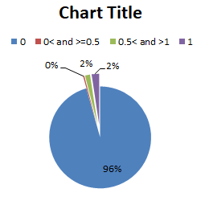
  ApplicablityRatio | Section Count
  0 | 240
  0< and >=0.5 | 1
  0.5< and >1 | 4
  1 | 6
  351
  352
  320G
  320H
  326
  506
  320B
Input 2 | 506 |  | 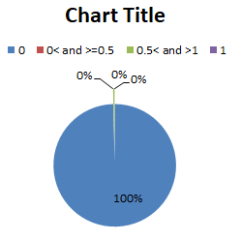 | 506
  ApplicablityRatio | Section Count
  0 | 250
  0< and >=0.5 | 0
  0.5< and >1 | 1
  1 | 0
Input 3 | 363  506 |  | 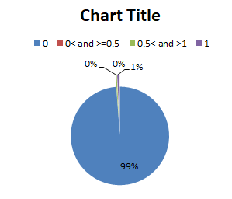
  ApplicablityRatio | Section Count
  0 | 248
  0< and >=0.5 | 0
  0.5< and >1 | 1
  1 | 2
  294
  363
  278
Input 4 | 376D  506 |  | 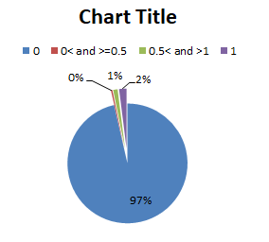
  ApplicablityRatio | Section Count
  0 | 242
  0< and >=0.5 | 1
  0.5< and >1 | 3
  1 | 5
  351
  352
  375A
  375F
  376
  355
  506
  376D
  376D
Input 5 | 312 |  | 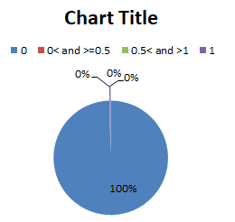 | 312
  ApplicablityRatio | Section Count
  0 | 250
  0< and >=0.5 | 0
  0.5< and >1 | 0
  1 | 1

