Supplementary Tables

Table S1. The primer pairs and their annealing temperatures used in endpoint RT-PCR and Sanger sequencing to confirm the genome sequences of Australian grapevine Pinot gris virus (GPGV) isolates that were generated by high throughput sequencing (HTS).
FORWARD primer name | FORWARD primer sequence (5’-3’) | Position¹ | REVERSE primer name | REVERSE primer sequence (5’-3’) | Position¹ | Annealing Temp (°C) | Amplicon size | Reference
GPG-14F | AATTGATCCCGTGTAGTGC | 22 | GPG-632R | TCCGAGGACGATGAACCTC | 642 | 56 | 620 | Glasa et al 2014
GPGV_F9 | GATGAGGTATGGGATGGATG | 513 | GPGV_R9 | TGGAGACTTACAGAATAATGCCC | 866 | 58 | 293 | This paper
GPGV_F10 | CAGACCCTTGAGTCCTCATAT | 790 | GPGV_R10 | GCTTGTTGGTATGATGTTGG | 1496 | 56 | 706 | This paper
GPGV_F11 | ATTTGAGCCTGAGGAGGA | 1347 | GPGV_R11 | GCTTGACGTTGACAGATTC | 1954 | 56 | 607 | This paper
GPGV_F12 | CTGAAGGCTTCTTTGATCC | 1772 | GPGV_R12 | GTGGTTTGAGACCCTCGAGAA | 2167 | 58 | 395 | This paper
GPGV_F13 | CAGATTGAATCATCAGGTGA | 2028 | GPGV_R13 | TTGATTGCAAGGTCTTCCACC | 2671 | 60 | 643 | This paper
GPGV_F16 | CACCATGGTCTTCGTTTTC | 2587 | GPGV_R16 | TTTGTCTCTCCAGTCTTCTG | 3238 | 54 | 652 | This paper
GPGV_F17 | AAAGGGAAAGGGGTTGAGTC | 2878 | GPGV_R17 | ACCATTCGGGAAAAGAGT | 3340 | 56 | 463 | This paper
GPGV_F18 | TCGGGTTCAAATGAGATACT | 3173 | GPGV_R18 | ATATGATTATCGGAACACAACC | 3804 | 56 | 631 | This paper
GPGV_F6 | ACCTCAAGCACATTACACTC | 3594 | GPGV_R6 | GCCAAGAAAGTCATCTCATC | 4545 | 55 | 952 | This paper
GPGV_F14 | GAATTTCAGTGCTGTTTATCC | 4382 | GPGV_R14 | CATCACCAGCAAAACAAACG | 5196 | 60 | 814 | This paper
GPGVRepF | TGAGGCATTCGATGTTTCCCA | 4940 | GPGVRepR | ACCCAATCAAGCCATGAACCT | 5461 | 60 | 521 | Saldarelli et al 2015
GPGV_F8 | GGCAGACCTCAAAGAATCAG | 5317 | GPGV_R8 | CCTCACAGAAATGGCATAAC | 6218 | 54 | 902 | This paper
GPGV_F19 | CCACGTGTTTATCCACCG | 6038 | GPGV_R19 | TTCTGTGTAACCTGACATC | 6364 | 60 | 326 | This paper
DetF | TGGTCTGCAGCCAGGGGACA | 6225 | DetR | TCACGACCGGCAGGGAAGGA | 6812 | 60 | 700 | Morelli et al 2014
¹ Position equivalent the genome sequence of the GPGV reference isolate NC_015782

Table S2. The GenBank accession numbers for 168 GPGV genome sequences available on NCBI and their respective country of origin.
Accession no. | Country | Accession no. | Country | Accession no. | Country | Accession no. | Country | Accession no. | Country | Accession no. | Country | Accession no. | Country
BK011060 | Italy | BK011085 | China | BK011109 | Uruguay | MH087439 | Italy | MN458411 | France | MN458435 | France | MN458459 | France
BK011061 | Italy | BK011086 | China | FR877530 | Italy | MH087440 | Italy | MN458412 | France | MN458436 | France | MN458460 | France
BK011062 | Italy | BK011087 | China | KF134123 | Slovak and Czech | MH087441 | Italy | MN458413 | France | MN458437 | France | MT414711 | Greece
BK011063 | Italy | BK011088 | China | KF134124 | Slovak and Czech | MH087442 | Italy | MN458414 | France | MN458438 | France | MW815134 | Greece
BK011064 | Italy | BK011089 | Italy | KF134125 | Slovak and Czech | MH087443 | Italy | MN458415 | France | MN458439 | France | MZ220969 | British Columbia
BK011065 | Italy | BK011090 | Italy | KF686810 | Slovak and Czech | MH087444 | Italy | MN458416 | France | MN458440 | France | MZ220970 | British Columbia
BK011066 | Italy | BK011091 | Italy | KM491305 | France | MH087445 | Italy | MN458417 | France | MN458441 | France | MZ344578 | British Columbia
BK011067 | Italy | BK011092 | Italy | KP693444 | Czech Republic | MH087446 | Italy | MN458418 | France | MN458442 | France | MZ344580 | British Columbia
BK011068 | Italy | BK011093 | Italy | KP693445 | Czech Republic | MH087447 | Italy | MN458419 | France | MN458443 | France | NC_015782 | Italy
BK011069 | Italy | BK011094 | Italy | KP693446 | Czech Republic | MH802023 | British Columbia | MN458420 | France | MN458444 | France | OL961512 | Russia
BK011070 | Italy | BK011095 | Italy | KP693447 | Czech Republic | MK514520 | California | MN458421 | France | MN458445 | France | ON237610 | Switzerland
BK011071 | Italy | BK011096 | Italy | KP693448 | Czech Republic | MK514521 | California | MN458422 | France | MN458446 | France | ON548147 | Russia
BK011072 | Italy | BK011097 | Italy | KR528581 | Korea | MK514522 | California | MN458423 | France | MN458447 | France | ON548148 | Russia
BK011073 | China | BK011098 | Italy | KT894101 | California | MK514523 | California | MN458424 | France | MN458448 | France | ON548149 | Russia
BK011074 | China | BK011099 | Italy | KU194413 | British Columbia | MK514524 | California | MN458425 | France | MN458449 | France | ON548150 | Russia
BK011075 | China | BK011100 | Italy | KU312039 | Italy | MK514525 | California | MN458426 | France | MN458450 | France | ON548151 | Russia
BK011076 | China | BK011101 | Italy | KU508673 | China | MK514526 | California | MN458427 | France | MN458451 | France | ON548152 | Russia
BK011078 | Italy | BK011102 | France | KU949328 | Slovakia | MK514527 | California | MN458428 | France | MN458452 | France | ON548153 | Russia
BK011079 | Italy | BK011103 | France | KX522755 | Germany | MK514528 | California | MN458429 | France | MN458453 | France | ON567239 | Russia
BK011080 | British Columbia | BK011104 | China | KY706085 | France | MK514531 | California | MN458430 | France | MN458454 | France | ON620246 | Russia
BK011081 | Italy | BK011105 | China | KY747493 | Pakistan | MK514532 | California | MN458431 | France | MN458455 | France | ON620247 | Russia
BK011082 | China | BK011106 | China | KY747494 | Pakistan | MK514533 | California | MN458432 | France | MN458456 | France | ON620248 | Russia
BK011083 | China | BK011107 | China | LC601811 | Japan | MN093125 | France | MN458433 | France | MN458457 | France | ON620249 | Russia
BK011084 | China | BK011108 | Uruguay | LC601812 | Japan | MN228488 | Belgium | MN458434 | France | MN458458 | France | ON620250 | Russia

Table S3. The sample identity, RT-PCR results, number of raw reads generated from metagenomic high-throughput sequencing (HTS), number of reads after quality trimming, number of contigs generated by SPAdes, number of viral contigs, number of grapevine Pinot gris virus (GPGV) contigs, GPGV contig size, its percentage similarity to reference genome NC_015782.2, depth and mapped reads calculated using Geneious in each grapevine sample sequenced.
Sample Identity | RT-PCR | RT-qPCR (Ct value) | Total number of raw reads | Reads after trimming (Fastp) | No of viral contigs | No of GPGV contigs | Assembled GPGV contig size (nt) | Percentage similarity to Reference genome NC_015782.2 (at the end) | Depth (Geneious) | Mapped reads (Geneious) | Other viruses
CK1 | NA | NA | NA | NA | NA | NA | NA | NA | NA | NA | NA
2.1 | + | 20.1 | 30198881 | 29489728 | 29 | 6 | 7183 | 99.42% | 14 | 699 | RSPaV
2.12 | + | 25.6 | 1399151 | 1387616 | 39 | 3 | 7251 | 97.96% | 19 | 903 | RSPaV
2.17 | + | 25.7 | 2532276 | 2515923 | 145 | 5 | 6700 | 98.41% | 89 | 4300 | GLRaV 1, GLRaV 3, GVA, RSPaV
5.5^{b} | + | 22.9 | 1572989 | 1566231 | 18 | 7 | 7162 | 98.24% | 7 | 320 | RSPaV
5.6 | + | 24.9 | 11935852 | 11908338 | 127 | 1 | 7265 | 98.17% | 8 | 411 | RSPaV, LR3, GVA
5.13^{b} | + | 24.1 | 3367102 | 3352925 | 1197 | 3 | 7047 | 98.24% | 16 | 756 | RSPaV, LR3
5.14 | + | 23.9 | 6607729 | 6590758 | 755 | 1 | 7426 | 98.34% | 16 | 756 | RSPaV, GVA
5.17 | + | 23.4 | 3148666 | 3133701 | 23 | 2 | 7338 | 98.24% | 11 | 516 | RSPaV
5.21ª | + | 23.5 | 2020590 | 2011880 | 31 | 3 | 7449 | 98.84% | 5 | 227 | RSPaV, LR3
5.22 | + | 20.3 | 2436767 | 2427356 | 16 | 2 | 7381 | 98.33% | 22 | 1062 | RSPaV, LR3
5.24^{b} | + | 21.8 | 1719154 | 1711195 | 42 | 2 | 7288 | 97.73% | 7 | 331 | RSPaV
8.6 | + | 31 | 10976041 | 10945015 | 2674 | 12 | 7286 | 97.55% | 53 | 2578 | RSPaV
8.7 | + | 31.4 | 2181942 | 2176512 | 45 | 1 | 7357 | 98.28% | 40 | 1917 | None
8.28 | + | 29.2 | 11919689 | 11879972 | 179 | 1 | 7249 | 98.49% | 25 | 1192 | RSPaV, GFkV,
8.29 | + | 31.2 | 5601426 | 5584651 | 17 | 3 | 7267 | 98.43% | 10 | 482 | RSPaV, GVA
8.33 | + | 33 | 2422424 | 2413789 | 53 | 2 | 7267 | 98.74% | 5 | 246 | RSPaV
8.38 | + | 23.3 | 5027466 | 5011921 | 57 | 1 | 7490 | 98.31% | 30 | 1432 | RSPaV
8.47 | + | 29.4 | 10909383 | 10875757 | 63 | 1 | 7072 | 98.26% | 13 | 611 | RSPaV
LT6ª | + | 19.8 | 2255212 | 2243583 | 28 | 3 | 7177 | 98.14% | 10 | 498 | RSPaV
LT7^{b} | + | 24 | 3858481 | 3842999 | 125 | 5 | 6990 | 98% | 5 | 218 | RSPaV
9.1 | + | 22 | 19352457 | 19305864 | 47 | 9 | 7227 | 97.48% | 80 | 3861 | RSPaV
9.2 | + | 21 | 12910078 | 12878157 | 38 | 1 | 7274 | 98.45% | 32 | 1567 | RSPaV
9.3 | + | 22.1 | 32193380 | 32121154 | 29 | 1 | 7319 | 98.31% | 84 | 4044 | LR3
9.4 | + | 22.3 | 11502466 | 11476928 | 23 | 2 | 7329 | 98.26% | 33 | 1600 | None
9.5 | + | 21.8 | 9996248 | 9974732 | 62 | 1 | 7270 | 98.20% | 76 | 3672 | GFkV, LR1, GVA
9.6 | + | 20.9 | 15475505 | 15438113 | 19 | 1 | 7329 | 98.40% | 117 | 5680 | RSPaV
9.9 | + | 21.2 | 9601270 | 9581148 | 52 | 1 | 7231 | 97.95% | 70 | 3391 | RSPaV
9.1 | + | 21.7 | 21710874 | 21650287 | 87 | 5 | 7274 | 98.27% | 45 | 2157 | RSPaV
9.11 | + | 22 | 11337043 | 11314547 | 75 | 2 | 7280 | 98.45% | 23 | 1092 | RSPaV
9.13 | + | 20.3 | 10604062 | 10580901 | 74 | 6 | 7366 | 98.09% | 123 | 5946 | GFkV
9.14 | + | 23.6 | 9760651 | 9743467 | 46 | 7 | 7284 | 98.34% | 120 | 5819 | GFkV
* a- sequences confirmed with Sanger sequencing
* b- sequences with gaps and low coverage areas confirmed with Sanger sequencing

Supplementary Figures
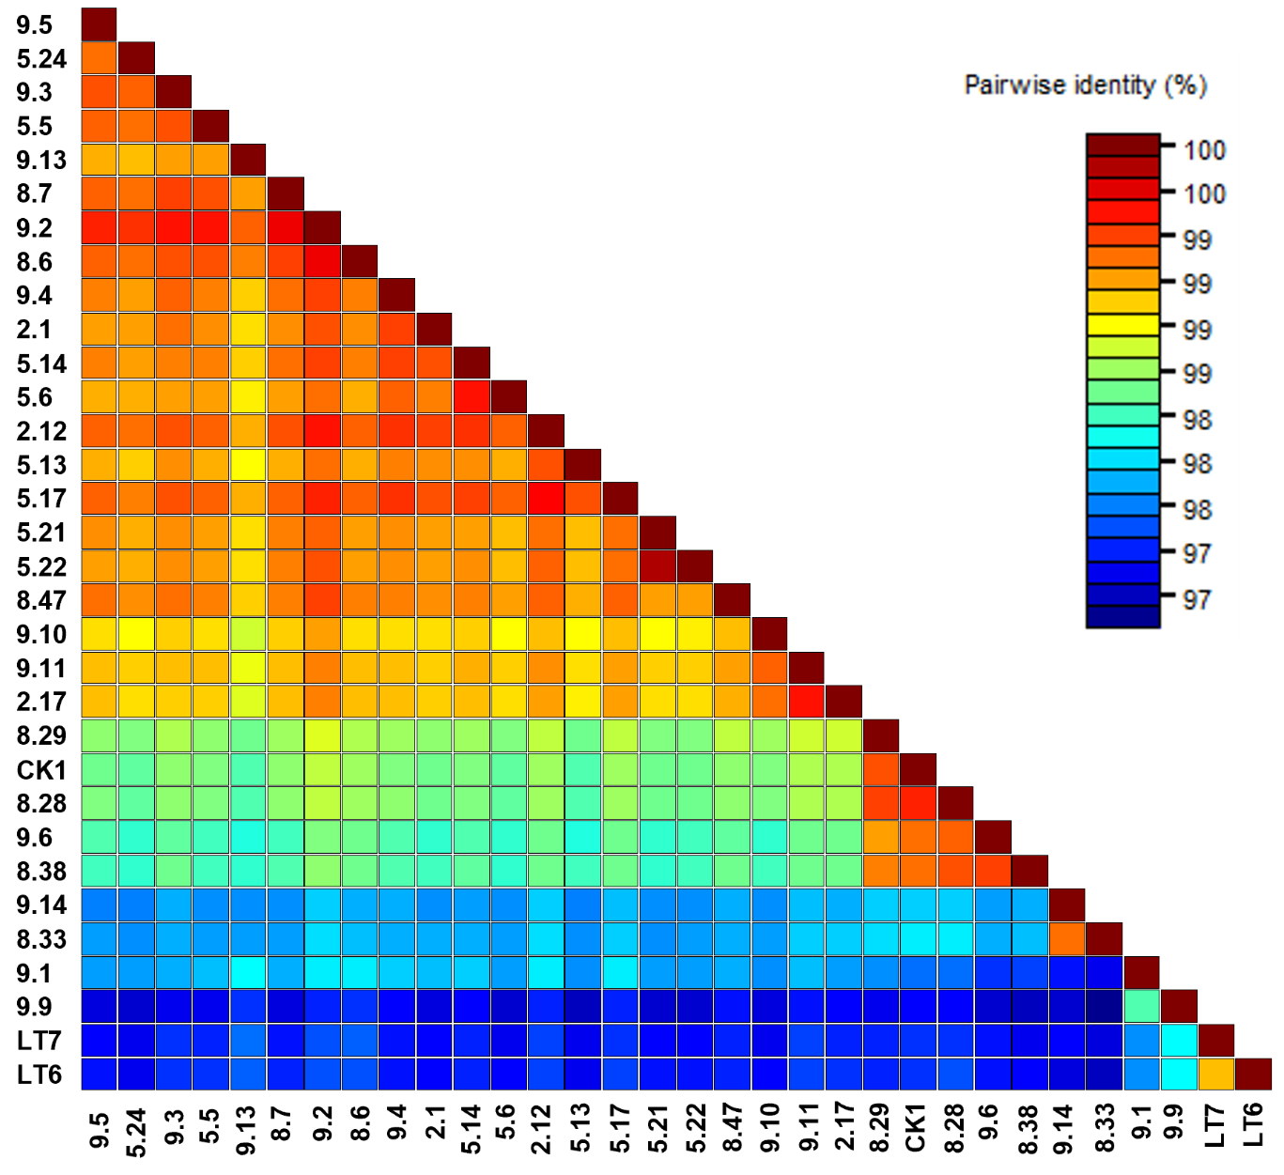

Figure S1. Percentage identity for thirty-two sequences of Grapevine pinot gris virus (GPGV) which were de novo assembled from high throughput sequencing (HTS) datasets.

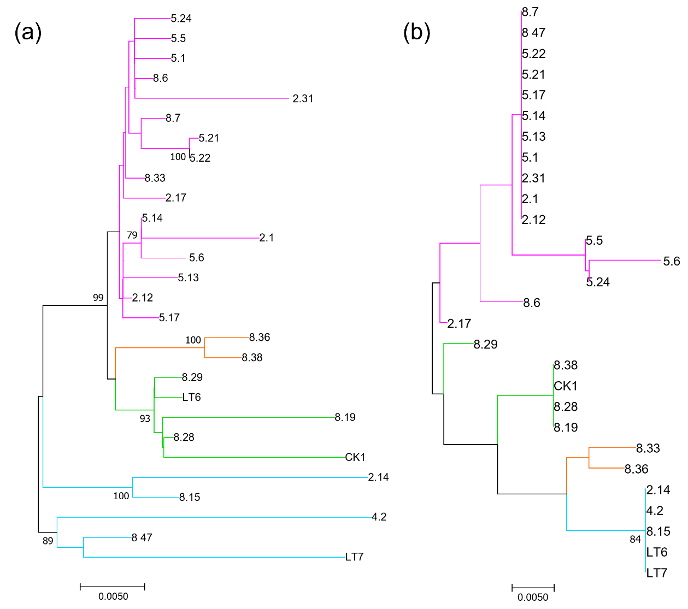

Figure S2. Maximum likelihood tree with 1000 bootstrap replicates inferred from amino acid sequences of the protein encoding Open reading frames (ORFs) of the thirty-two sequences of grapevine Pinot gris virus (GPGV) datasets. The scale bar corresponds to the number of substitutions per site. (a) RNA-dependent RNA polymerase protein (RdRp, ORF1) (b) Coat protein (CP, ORF3). The scale bar corresponds to the number of substitutions per site. Bootstrap values (>70%) are reported at the nodes.

