Appendices

Appendix I: Search strategy from MEDLINE (Ovid) Database (Search conducted on 04/07/2022)
Database: MEDLINE via (Ovid)  Date: 04/07/2022 | Search Words | Limits ( filter, limits and refine) | Number of Records
 |  | Publication dates: 2002-2022 and English language.
#1 | exp circumcision, Female or female genital mutilation.mp. |  | 2017
#2 | (“female genital mutilation” or “female circumcision” or “female genital cutting” or “traditional female genital surgery” or infibulate*or reinfibulat* or defibulat* or clitoridect*).mp. [mp=title,abstract, original title,name of substance word, subject heading word, floating sub-heading word, keyword heading word, organism supplementary concept word, protocol supplementary concept word, rare disease supplementary concept word, unique identifier, synonyms] |  | 1905
#3 | ((((ritual* or traditional* or ceremon* or sociali#ation*) adj3(practice* or cut or cutting or surg*)) or circumcis*or excis*)adj3(female* or wom#n or girl*or child* or adolescen*)).mp. |  | 3537
#4 | (FGM or FGC or TFGS or FGMC).mp |  | 1846
#5 | “FGM/C”.mp |  | 191
#6 | 1 or 2 or 3 or 4 or 5 |  | 4979
#7 | exp Men/ |  | 4910
#8 | (husband or brother or father).mp |  | 40572
#9 | exp “Transients and Migrants”/ or exp “Emigrants and Immigrants”/ |  | 26149
#10 | migrant.mp. or exp “Transients and Migrants”/ |  | 19643
#11 | 7 or 8 or 9 or 10 |  | 77341
#12 | 6 and 11 |  | 209
# 13 | Exp Developed Countries/ |  | 20900
# 14 | (((((((GERMAN* and GREECE) or greek*) and ICELAND*) or IRELAND or irish or ISRAEL*) and ITALY) or Italian* or JAPAN* or KOREA*) and MEXIC*).mp. |  | 1249
#15 | ((((((((AUSTRALIA* and AUSTRIA* AND BELGIUM*) or Belgian*) and CANAD*and CHILE*) or DENMARK* or Danish*) and FINLAND) or Finnish and FRANCE) or French).mp. |  | 76018
#16 | ((((((((((((SPAIN or spanish) and SWED* and SWITZERLAND) or swiss) and TURK* and “UNITED KINGDOM”) or “UK” or Britain or British) and England) or English) and scot* and wales) or welsh) and “UNITED STATES”) or “USA” or America*).mp. |  | 637764
#17 | (((((((((((NETHERLAND* or Holland* or dutch) and “low countries”) or europe* and NEW ZEALAND*” and NORWAY) or norwegian*) and POLAND) or polish and PORTUGAL) or Portuguese).mp. |  | 14594
#18 | 13 or 14 or 15 or 16 or 17 |  | 736786
#19 | 12 and 18 |  | 34

Appendix II: Data extraction instrument (QARI data extraction instrument)
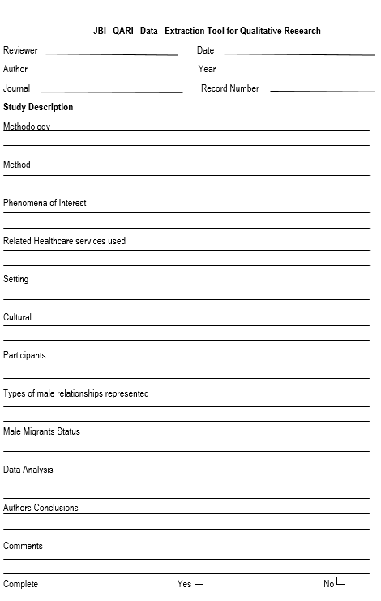
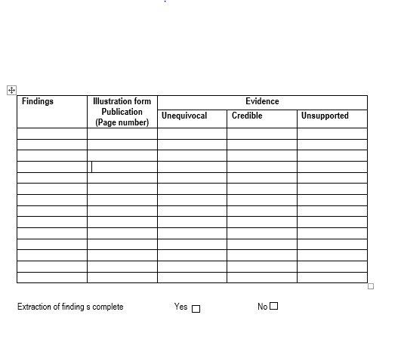

Appendix III: Appraisal Instruments (QARI Appraisal Instruments)
