Supporting Information Submitted to Journal of Polymer Research

MS ref NO. JPOL-D-00418
Ansa-metallocene Catalyst based on 3-phenyl and 4-methyl Substituted: Catalyst Evaluation in Conjugated and Non-conjugated Diene Polymerization
Amjad Ali^{1,7}, Muhammad Nadeem², Ahmad Naveed^{1*}, Tariq Aziz³, Khurram Tufail⁴, Jamile Mohammadi Moradian^{1,} Naushad Ahmad⁵ Chanez Maouche¹, Tahir Rasheed⁶, Fan Zhiqiang⁷, Li Guo¹*
¹Research School of Polymeric Materials, School of Materials Science & Engineering, Jiangsu University, Zhenjiang, 212013, P.R China.
²School of life sciences, Wuchang University of Technology, Wuhan, 430223, PR China.
³Westlake University, School of Engineering Yunqi Campus, Hangzhou, Zhejiang 310024 P.R China.
⁴College of Physics, Qingdao University, Qingdao, 266071, P.R China.
⁵ Department of Chemistry, College of Science, King Saud University, Riyadh-11451, Kingdom of Saudi Arabia.
⁶Interdisciplinary Research Center for Advanced Materials, King Fahd University of Petroleum and Minerals (KFUPM), Dhahran 31261, Saudi Arabia.
⁷MOE Key Laboratory of Macromolecular Synthesis and Functionalization, Department of Polymer Science and Engineering, Zhejiang University, Hangzhou, 310027, P.R China.
*Corresponding author, E-mail: ahmadnaveed@ujs.edu.cn (Ahmad Naveed); liguo@ujs.edu.cn (Li Guo)

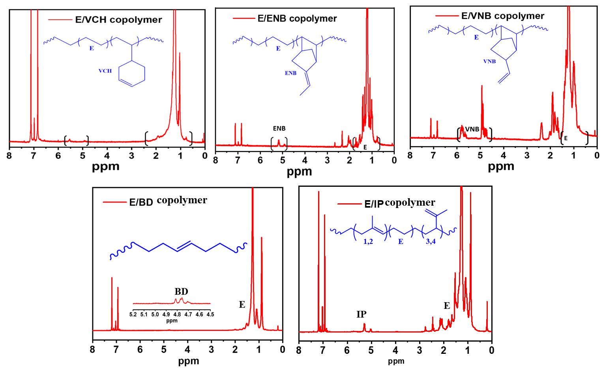
Figure S1 E/diene copolymers catalyzed with rac-Me₂Si[2-Me-4-Ph-Ind]₂ZrCl₂ /borate system.
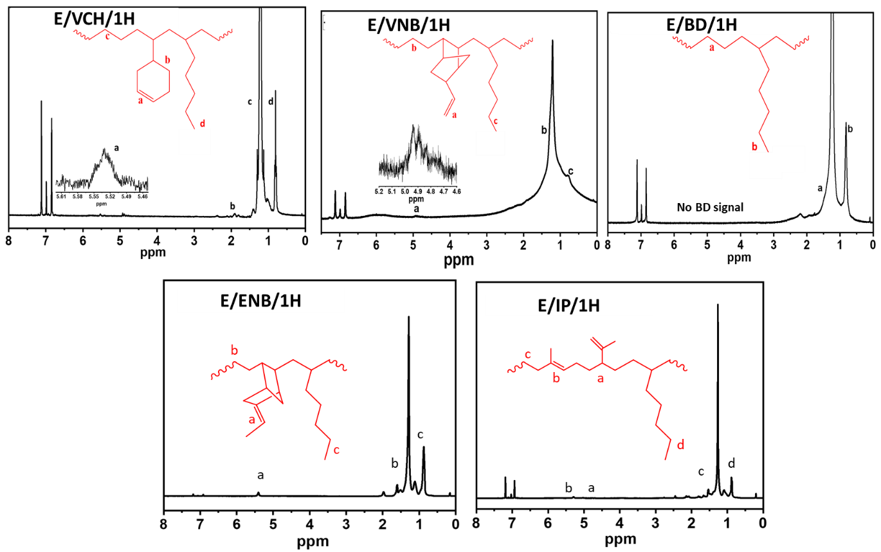
Figure S2. E/diene/1H terpolymers catalyzed with rac-Me₂Si[2-Me-4-Ph-Ind]₂ZrCl₂ /borate system.
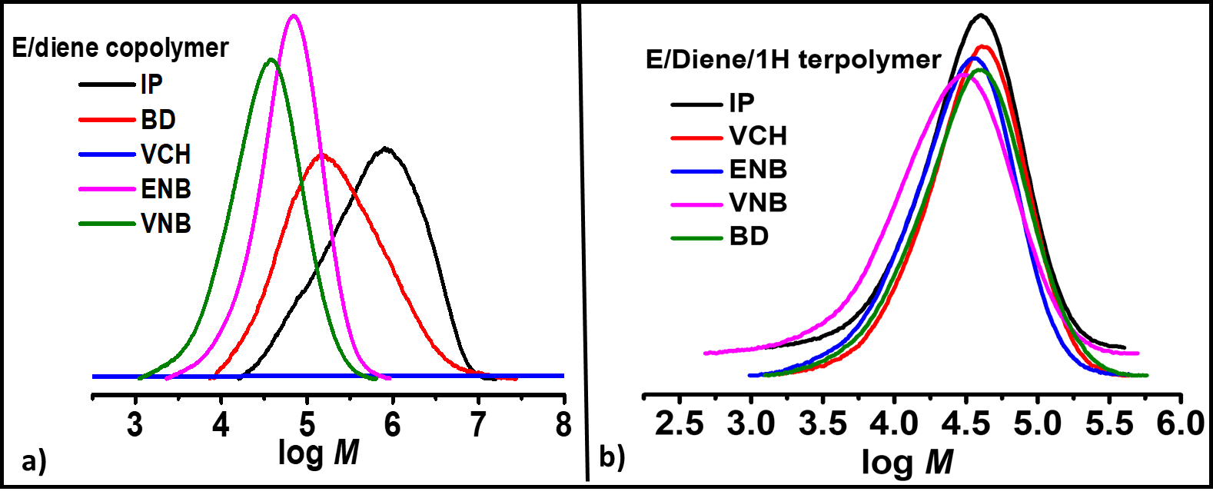
Figure S3. a) MWD of E/diene copolymers b) E/diene/1H terpolymers catalyzed with rac-Me₂Si[2-Me-4-Ph-Ind]₂ZrCl₂ /borate system.

