Supplementary Information

Tree communities and functional traits determine herbivore compositional turnover
Ming-Qiang Wang et al.

Study sites and sampling
The detail information of the study sites and sampling protocols are provided in appendix and can also be found in Wang et al. 2022. The study was conducted at the BEF-China tree diversity experiment, which is located in subtropical southeast China, Jiangxi province (29°08′–29°11′N, 117°90′–117°93′E), and is currently the largest tree diversity experiment worldwide (Bruelheide et al. 2014). The mean annual temperature is 16.7°C, and the mean annual precipitation is 1,821 mm (Yang et al. 2013). In total, the experiment comprises of 566 study plots (25.8 × 25.8 m) at two large study sites (Site A and Site B, 4 km apart from each other), which were established in 2009 (Site A) and 2010 (Site B). For the experimental design, 400 tree seedlings were randomly planted (20 rows and 20 columns) within each plot, with a mean planting distance of 1.29 m. The tree species composition is largely non-overlapping between the two study sites (except for eight tree species that occur in the 24-species mixtures of both sites). In this study, we focused on 64 randomly distributed study plots that ranged in tree species richness from monoculture to mixtures of 2, 4, 8 16, 24 species (Fig. 1; Fig. S1). For the species pool, 32 locally common broadleaved tree species were considered in the two sites, with 16 non-overlapping species specific to each site (Table S1). In our study design, there were sixteen monocultures, and eight, four, two, one and one mixtures of 2, 4, 8, 16 and 24 species, respectively, at each study site. In total, 55 plots were used for statistical analysis, because nine plots had to be excluded due to high mortality of trees (Fig. 1). We used a beating method to sample Lepidoptera larvae, a key component of the herbivore community in both subtropical and tropical forests (Forister et al. 2015; Zhang et al. 2017). Caterpillars were sampled during a total of six periods over 2017 and 2018 (April, June and September in each year). We placed a white sheet (1.5 × 1.5 m) on the ground and beat tree branches to dislodge the Lepidoptera larvae (Schuldt et al. 2014b). In each plot, 80 living trees were sampled from the first rows of trees. Due to the random planting design, our sampling adequately covered the full range of tree richness and identity at the plot level. All caterpillars were placed individually in tubes filled with 99.5% ethanol and stored at −20°C before further processing.
DNA sequencing and species delimitation
Lepidoptera DNA extraction was performed by using DNeasy Blood & Tissue Kits (QIAGEN), following the manufacturer’s instructions. We used a universal primer pairs, LCO1490 and HCO2198 (Folmer, Black, Hoeh, Lutz, & Vrijenhoek, 1994) to amplify COI sequences of caterpillars. Polymerase chain reaction (PCR) conditions were as follows: an initial denaturation for 2 min at 94°C, followed by 29 cycles of 50 s at 94°C, annealing for 50 s at 50°C, elongation 1 min at 72°C, and a final extension step of 72°C for 6 min. The products amplified by PCR were resolved by electrophoresis in 1.0% agarose gel, and samples with clean single bands were sequenced after PCR purification using BigDye v3.1 on an ABI 3730xl DNA Analyser (Applied Biosystems, Carlsbad, CA, USA). We employed MAFFT (Katoh et al. 2002) to align the COI sequences and used MEGA v7.0 (Kumar et al. 2016) to translate COI sequences into amino acid sequences to test the existence of stop codons, followed by manual adjustments. Subsequently, we used a Perl-based DNA barcode aligner (Chesters, 2019) to align the Lepidoptera sequences against the references, which is moth adults and was collected from the study sites by light trap. For species delimitation, three methods were used to infer MOTUs: hierarchical clustering with BLASTclust (https://blast.ncbi.nlm.nih.gov/Blast.cgi), Automatic Barcode Gap Discovery (ABGD)(Puillandre et al. 2012), and Poisson Tree Processes model (PTP) (Zhang et al. 2013). For further analyses, we selected and used the most consistent result (BLASTclust) through comparing HA Rand index among the three methods (see Wang et al. 2019). Therefore, MOTUs were clustered using the BLASTclust from the blast package with a 97.8% similarity threshold in the study (Ratnasingham & Hebert 2013). We used Statistical Assignment Package (Munch et al. 2008) via reference data and GenBank database to taxonomically identified Lepidoptera MOTUs (see also Wang et al. 2019).

Community-weighted mean trait values, functional diversity, structural diversity and environmental covariates
For relevant characteristics (including nutritional and defensive functional traits) of the tree species, we considered a range of leaf functional traits which have been widely found to influence herbivores (Pérez-Harguindeguy et al. 2003; Schuldt et al. 2014a; Muiruri et al. 2019; Wang et al. 2022). We included specific leaf area (SLA), leaf dry matter content (LDMC), leaf toughness (LT), the ratio of leaf carbon to nitrogen (C:N) content in the analysis. To characterize leaf traits at the plot level, for all leaf traits we calculated the community-weighted mean values (CWMs) for each plot weighted by tree wood volume. The tree wood volume was estimated from data of basal area and height of trees in the center of each plot in October 2016 (Fichtner et al. 2017). We used tree volume also as an additional predictor to represent plot-level wood volume of each tree species. All traits were measured on a minimum of five randomly sampled, mature, undamaged and sun-exposed leaves of at least five tree individuals for each species (Kröber et al. 2014) following the standardized protocols (Pérez-Harguindeguy et al. 2013). We calculated tree functional diversity (tree FD) as the mean pairwise distance in trait values among tree species, again weighted by tree wood volume, and expressed as Rao's Q (Ricotta & Moretti 2011).
Tree species phylogenetic composition for each study plot was quantified with nonmetric multidimensional scaling (NMDS) analysis (for site A and site B respectively) based on Morisita-Horn distances. We firstly calculated the mean pairwise distance between tree species with R package “picante”. Subsequently, the minimum number of required dimensions in the NMDS based on the reduction in stress value was determined in the analysis (k = 2 in our case). To acquire maximum variance on the first dimension, we centered the results, and used the principal components rotation. Moreover, the relationships with environmental covariates (see below) were obtained by fitting their standardized values to the ordination on the basis of a regression with the NMDS axis scores (Quinn & Keough 2002).
To test the potential effects of plant structural diversity on Lepidoptera zeta diversity, both tree vertical structure diversity (tree VSD) and horizontal structure diversity (tree HSD) were used to represent the heterogeneity of tree stratification at the plot level. Tree VSD was calculated based on tree crown projection area among all individual trees, and tree HSD was quantified as the spatial variation in crown projection area within each study plot based on Moran’s I (details see Schuldt et al. 2019). The two metrics indicate the vertical stratification of tree height and the horizontal variation of the tree stratification, respectively. A previous study has provided evidence that both these metrics have effects on Lepidoptera herbivores (Schuldt et al. 2019).
Due to the heterogeneous topography of the study plots, plot means of slope and elevation as environmental covariates were included to test potential effects of environmental variation. All environmental data were obtained from a 5 m resolution digital elevation model based on differential GPS measurements (Scholten et al. 2017).

Supplementary results
For the Sørensen version of MS-GDM, all predictors jointly explained 22% to 43% (for site A) and 29% to 72% (for site B) of the variance in zeta diversity of Lepidoptera herbivores at the zeta orders, with the highest explanatory power observed at ζ₃ for both sites (Table 2). Differences in tree phylogenetic composition and CWM tree volume were also main drivers of Lepidoptera species turnover between plots of two sites, as the amplitudes of I-spline are obviously higher than the other predictors (except ζ₁₂ of site B) (Fig. 4; Table 2). Similar to the Simpson version of MS-GDM, the importance of phylogenetic NMDS2 for site B decreased with increasing zeta orders (Fig. 4; Table 2). Differences in tree species richness weakly drove the herbivore species turnover at lower zeta orders. Difference in CWM C:N had similar, consistent degree of effects on Lepidoptera species turnover compared to CWM tree volume variation across zeta orders in site A. There was a consistent pattern in site A that differences in CWM SLA and CWM LT had moderate amplitudes of I-spline compared to the other predictors, and difference in CWM SLA was more important than difference in CWM LT to Lepidoptera species turnover. However, the effect of differences in CWM SLA also increased from lower to higher zeta order in site A. Similar to the Simpson version of MS-GDM in site B, besides tree phylogenetic composition and CWM volume, differences in CWM SLA and tree functional diversity also had relatively higher and consistent amplitudes of I-spline, which were more significant than the other factors with increasing number of zeta order, while decreasing influence of differences in CWM LT was observed from low to high zeta orders (Fig. 4; Table 3). It should be noted that geographic distance, differences in CWM LDMC, slope and tree vertical structure diversity were relatively strong predictors of Lepidoptera species turnover at lower zeta order (ζ₃) compared to higher zeta orders in site B (Fig.4; Table 2).

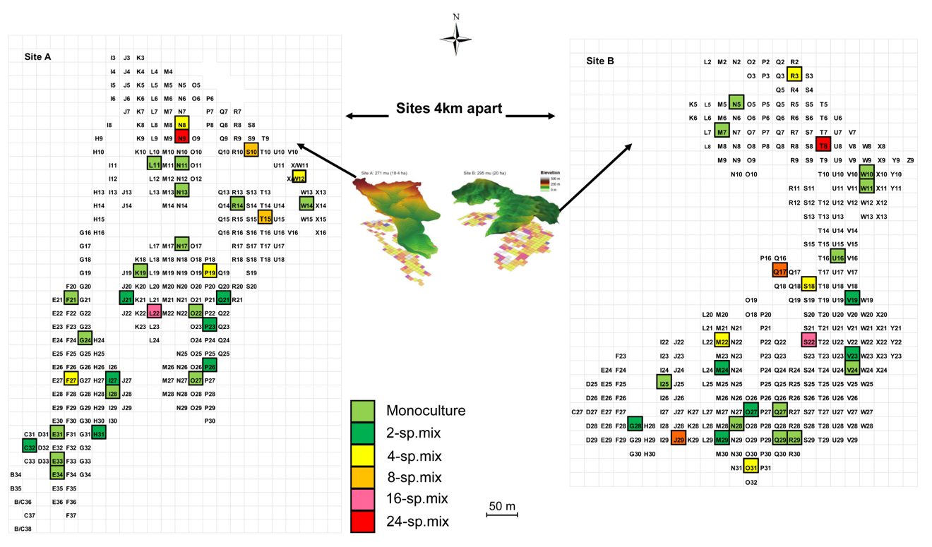
Fig S1. Overview of the two experimental sites of BEF-China (left: Site A, right: Site B) and the study plots selected for the current study (with bold-black outline). Levels of tree species richness are indicated by color. Each study plot has a size of 25.8 m 25.8 m. For more information on all very intensively studied plots and the tree species richness gradient of the other plots, see supplementary Figure S1.

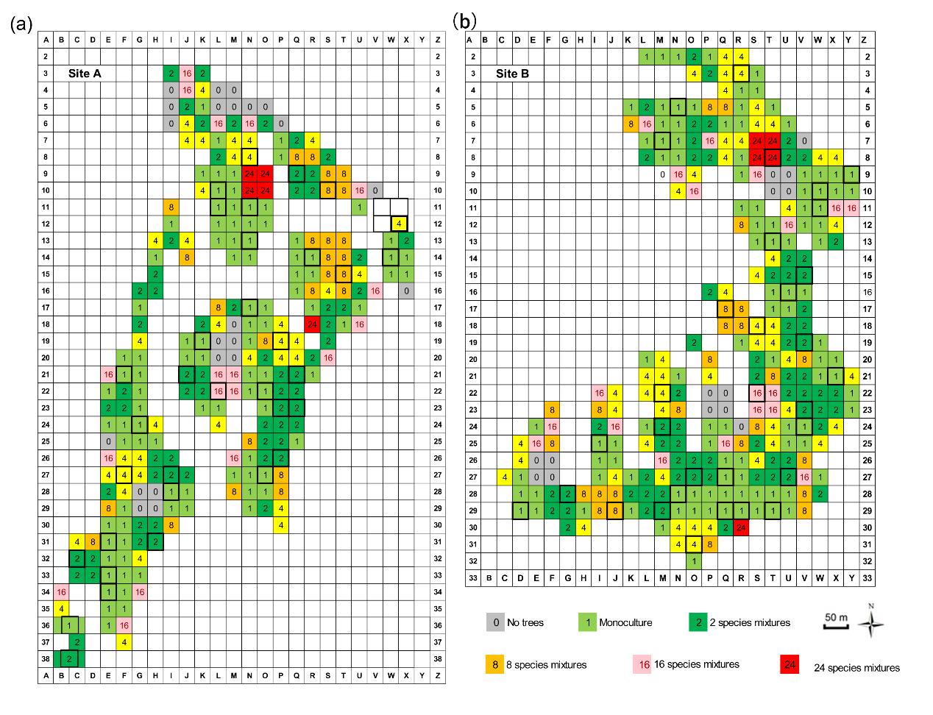
Fig S2. Overview of the experimental sites of BEF-China (a: Site A, b: Site B) and the study plots selected for the all very intensively study plots (with black outline). Levels of tree species richness are indicated by color. Each study plot has a size of 25.8 m 25.8 m.

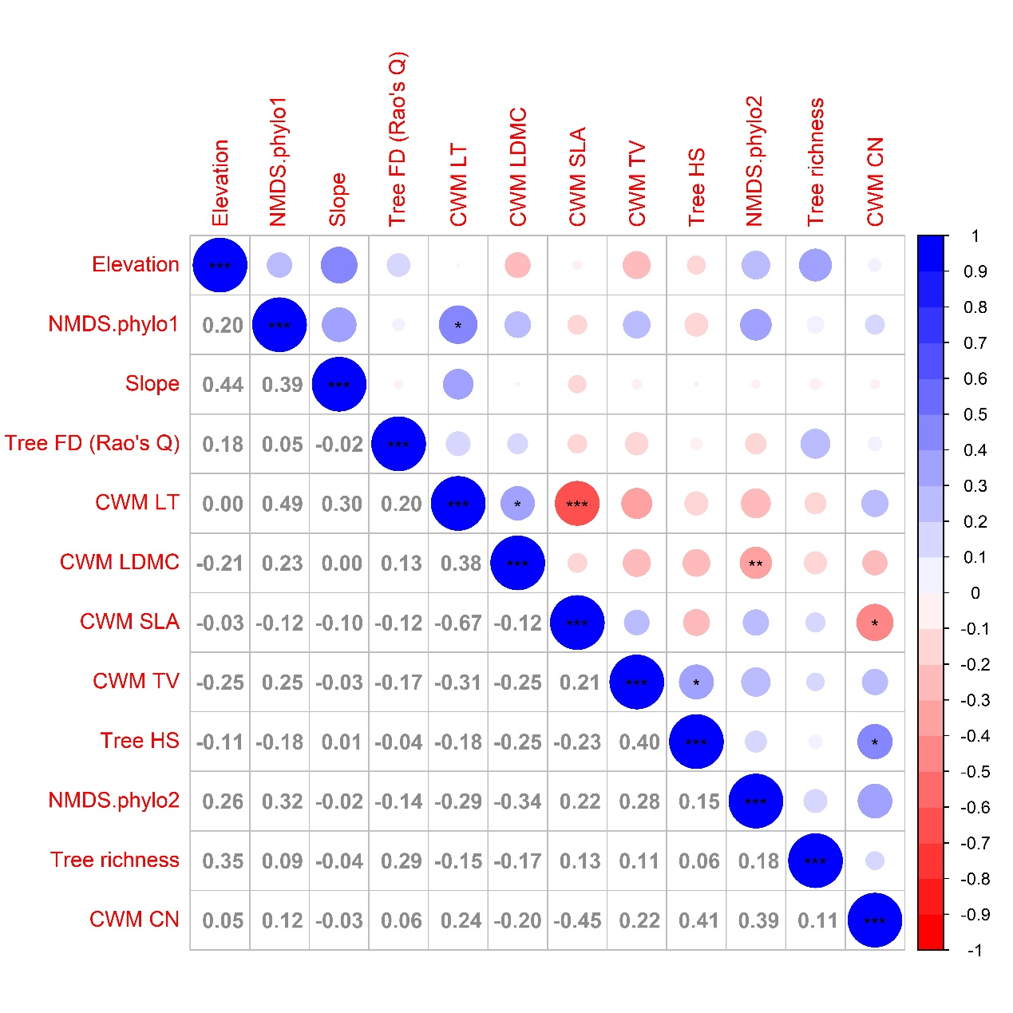
Fig S3. Relationships among the predictors used in the Multi-Site generlized dissimilarity modeling (MS-GDM) for site A. Values are Pearson’s correlation coefficients r, significances are indicated by asterisks: *** P < 0.001, ** P < 0.01, * P ≤ 0.05.

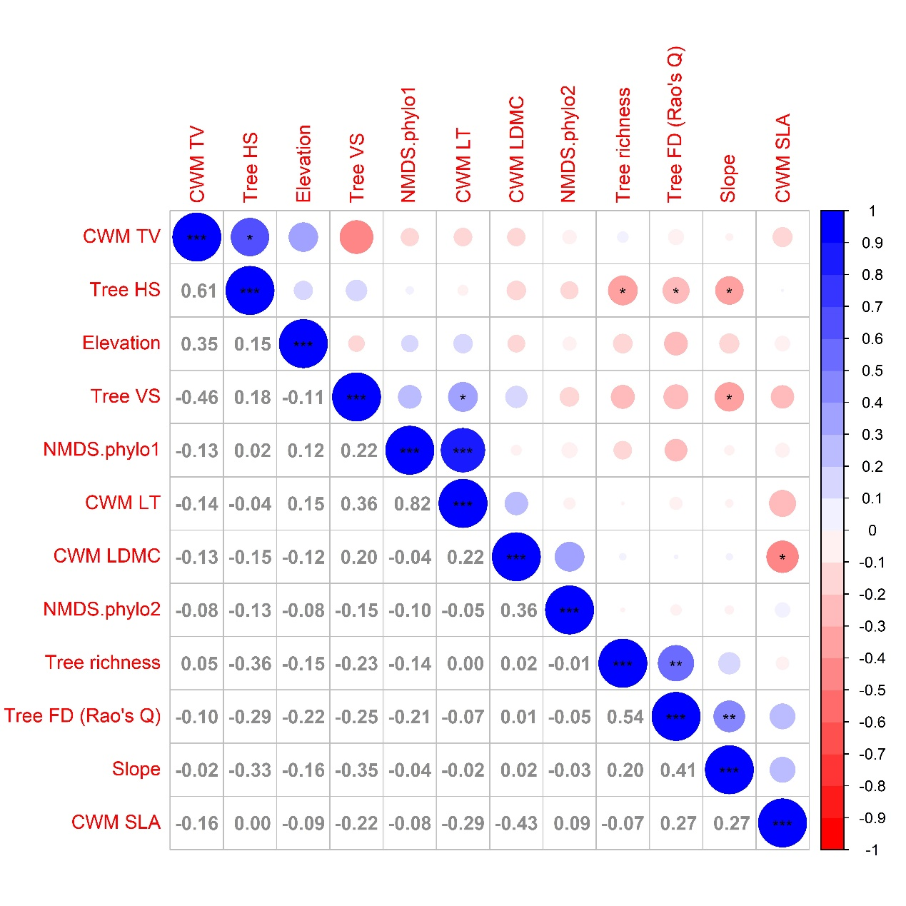
Fig S4. Relationships among the predictors used in the Multi-Site generlized dissimilarity modeling (MS-GDM) for site B. Values are Pearson’s correlation coefficients r, significances are indicated by asterisks: *** P < 0.001, ** P < 0.01, * P ≤ 0.05.

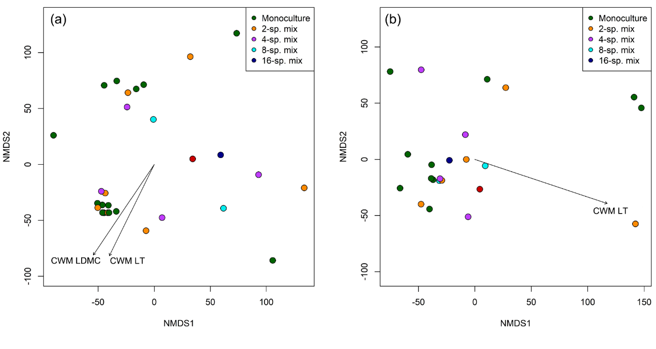
Fig S5. Ordination plot of the non-metric multidimensional scaling (NMDS) analysis of (a) tree phylogenetic composition of Site A, (b) tree phylogenetic composition of Site B across the study plots (filled circles) in the BEF-China experiment. Stress = 0.16, 0.15, respectively. Arrows indicate significant (at p < 0.05) correlations of environmental variables with NMDS axes scores. Lengths of arrows are proportional to the strength of correlations. See Table S4-S5 in Supplementary Material for abbreviations and statistical values.

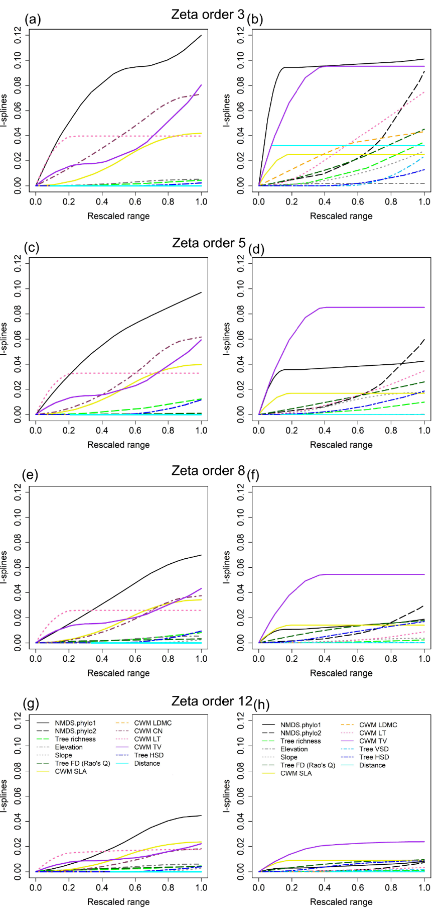
Fig S6. Results of the multi-site generalized dissimilarity modellings examining the impacts of differences in environmental variables and spatial distance on compositional turnover of Lepidoptera herbivores at ζ3 (a), ζ5 (c), ζ8 (e), ζ12 (g) for site A and ζ3 (b), ζ5 (d), ζ8 (f), ζ12 (h) for site B. The variables were transformed into I-splines using the Sørensen zeta diversity.

Table S1. Tree species composition in very intensively studied plots of BEF-China tree diversity experiment

Site | Plot | Tree richness |  |  | Tree species composition
A | E31 |  | 1 | Quercus fabri
A | E33 |  | 1 | Lithocarpus glaber
A | E34 |  | 1 | Castanea henryi
A | F21 |  | 1 | Quercus serrata
A | G24 |  | 1 | Koelreuteria bipinnata
A | I28 |  | 1 | Liquidambar formosana
A | K19 |  | 1 | Schima superba
A | L10 |  | 1 | Castanopsis eyrei
A | L11 |  | 1 | Castanopsis sclerophylla
A | N11 |  | 1 | Sapindus saponaria
A | N13 |  | 1 | Triadica sebifera
A | N17 |  | 1 | Rhus chinensis
A | O22 |  | 1 | Cyclobalanopsis myrsinifolia
A | O27 |  | 1 | Choerospondias axillaris
A | R14 |  | 1 | Cyclobalanopsis glauca
A | W14 |  | 1 | Nyssa sinensis
A | C32 |  | 2 | C. henryi; N. sinensis
A | H31 |  | 2 | L. formosana; S. mukorossi
A | I27 |  | 2 | C. axillaris; S. sebiferum
A | J21 |  | 2 | K. bipinnata; L. glaber
A | P23 |  | 2 | S. superba; R. chinensis
A | P26 |  | 2 | Q. serrata; C. sclerophylla
A | Q21 |  | 2 | Q. fabri; C. glauca
A | Q9 |  | 2 | C. myrsinifolia; C. eyrei
A | F27 |  | 4 | Q. serrata; Ch. axillaris; S. sebiferum; C. sclerophylla
A | N8 |  | 4 | S. superba; Q. fabri; Rh. chinensis; C. glauca
A | P19 |  | 4 | C. henryi; L. formosana; S. mukorossi; N. sinensis
A | W12/X12 |  | 4 | K. bipinnata; C. myrsinifolia; L. glaber; C. eyrei
A | S10 |  | 8 | C. henryi; L. formosana; Q. serrata; C. axillaris; S. mukorossi; N. sinensis; S. sebiferum; C. sclerophylla
A | T15 |  | 8 | S. superba; K. bipinnata; Q. fabri; R. chinensis; C. glauca; C. myrsinifolia; L. glaber; C. eyrei
A | L22 |  | 16 | C. henryi; S. superba; L. formosana; Q. serrata; K. bipinnata; Q. fabri; C. axillaris; R. chinensis; C. glauca; S. saponaria; N. sinensis; T. sebifera; C. myrsinifolia; L. glaber; C. eyrei; C. sclerophylla
A | N9 |  | 24 | All 16 tree species + additional tree species in Site Aª
B | D29 |  | 1 | Meliosma flexuosa
B | I25 |  | 1 | Manglietia yuyuanensis
B | M7 |  | 1 | Betula luminifera
B | N28 |  | 1 | Idesia polycarpa
B | N5 |  | 1 | Ailanthus altissima
B | Q27 |  | 1 | Alniphyllum fortunei
B | Q29 |  | 1 | Machilus leptophylla

Site | Plot | Tree richness |  | Tree species composition
B | R29 | 1 | Castanopsis fargesii
B | T13 | 1 | Machilus thunbergii
B | T29 | 1 | Quercus phillyraeoides
B | U16 | 1 | Elaeocarpus japonicus
B | V24 | 1 | Elaeocarpus chinensis
B | W10 | 1 | Phoebe bournei
B | W11 | 1 | Elaeocarpus glabripetalus
B | X21 | 1 | Machilus grijsii
B | Y9 | 1 | Celtis biondi
B | G28 | 2 | B. luminifera; C. fargesii
B | M24 | 2 | C. biondii; E. glabripetalus
B | M29 | 2 | E. japonicus; P. bournei
B | O27 | 2 | M. yuyuanensis; Q. phillyreoides
B | U27 | 2 | I. polycarpa; M. grijsii
B | V15 | 2 | A. altissima; M. flexuosa
B | V19 | 2 | E. chinensis; M. thunbergii
B | V23 | 2 | A. fortunei; M. leptophylla
B | M22 | 4 | A. fortunei; E. chinensis; M. thunbergii; M. leptophylla
B | O31 | 4 | C. biondii; E. glabripetalus; E. japonicus; P. bournei
B | R3 | 4 | B. luminifera; C. fargesii; M. yuyuanensis; Q. phillyreoides
B | S18 | 4 | A. altissima; I. polycarpa; M. flexuosa; M. grijsii
B | J29 | 8 | A. altissima; C. biondii; E. glabripetalus; E. japonicus; I. polycarpa; M. flexuosa; M. grijsii; P. bournei
B | Q17 | 8 | A. fortunei; B. luminifera; C. fargesii; E. chinensis; M. thunbergii; M. leptophylla; M. yuyuanensis; Q. phillyreoides
B | S22 | 16 | A. altissima; A. fortunei; B. luminifera; C. fargesii; C. biondii; E. chinensis; E. glabripetalus; E. japonicus; I. polycarpa; M. flexuosa; M. grijsii; M. thunbergii; M. leptophylla; M. yuyuanensis; P. bournei; Q. phillyreoides
B | T8 | 24 | All 16 tree species +additional tree species in Site B^{b}

Note: ª Additional tree species in site A: T. cochinchinensis, C. carlesii, D. glaucifolia, M. azedarach, A. davidii, Da. oldhamii, Q. acutissima, Cinnamomum camphora
^{b} Additional tree species in site B: C. eyrei, C. sclerophylla, Cin. camphora, C. glauca, Da. oldhamii, D. glaucifolia, L. glaber, S. superba

Table S2. The specific value of zeta diversity at each zeta order for the two study sites.

Zeta order | Zeta diversity (Site A) | Zeta diversity (Site B)
1 | 39.53 | 36.32
2 | 11.43 | 10.87
3 | 5.92 | 5.36
4 | 3.68 | 3.12
5 | 2.46 | 1.96
6 | 1.70 | 1.28
7 | 1.20 | 0.85
8 | 0.85 | 0.57
9 | 0.61 | 0.38
10 | 0.44 | 0.25
11 | 0.31 | 0.16
12 | 0.23 | 0.10
13 | 0.16 | 0.07
14 | 0.11 | 0.04
15 | 0.08 | 0.02
16 | 0.06 | 0.01
17 | 0.04 | 0.01
18 | 0.02 | 0.00
19 | 0.02 | 0.00
20 | 0.01 | 0.00
21 | 0.01 | 0.00
22 | 0.00 | 0.00
23 | 0.00 | 0.00
24 | 0.00 | 0.00
25 | 0.00 | 0.00
26 | 0.00
27 | 0.00
28 | 0.00
29 | 0.00
30 | 0.00

Table S3. The specific value of zeta ratio at each zeta order for the two study sites.

Zeta order | Zeta ratio (Site A) | Zeta ratio (Site B)
1 | 0.289 | 0.299
2 | 0.518 | 0.493
3 | 0.622 | 0.582
4 | 0.669 | 0.629
5 | 0.692 | 0.653
6 | 0.704 | 0.664
7 | 0.712 | 0.666
8 | 0.716 | 0.665
9 | 0.718 | 0.660
10 | 0.718 | 0.652
11 | 0.716 | 0.641
12 | 0.713 | 0.628
13 | 0.708 | 0.610
14 | 0.700 | 0.587
15 | 0.690 | 0.558
16 | 0.676 | 0.521
17 | 0.659 | 0.472
18 | 0.638 | 0.407
19 | 0.611 | 0.317
20 | 0.577 | 0.191
21 | 0.535 | 0.000
22 | 0.482 | NA
23 | 0.414 | NA
24 | 0.321 | NA
25 | 0.193
26 | 0.000
27 | NA
28 | NA
29 | NA

Table S4. Summary results of normalized stochasticity ratio (NST) based on specified taxonomic dissimilarity index and null model algorithm.
Group | Size | ST.i.ruzicka | NST.i.ruzicka | MST.i.ruzicka | SES.i.ruzicka | RC.i.ruzicka
SiteA | 435 | 0.8446 | 0.8223 | 0.6667 | 0.0095 | 0.0054
SiteB | 300 | 0.8694 | 0.8587 | 0.6181 | 0.1683 | 0.1079

Table S5. Table S6. Environmental correlates of tree phylogenetic community dissimilarity (NMDS on Morisita-Horn dissimilarity) across the study plots. Correlation coefficients, explained variation (R²) and probabilities (based on 1000 permutations) for the relationships between environmental variables and the NMDS axes scores. Significant P-values are indicated in bold.

 | NMDS1 | NMDS2 | R² | P
Tree MPD | 0.994 | 0.109 | 0.04 | 0.623
Tree MNTD | 0.715 | 0.699 | 0.02 | 0.814
Tree species richness | 0.997 | 0.077 | 0.06 | 0.413
Elevation | 0.854 | -0.521 | 0.09 | 0.274
Tree FD (Rao's Q) | -0.748 | -0.664 | 0.03 | 0.732
CWM SLA | 0.763 | 0.646 | 0.05 | 0.474
CWM LDMC | -0.556 | -0.831 | 0.46 | 0.001
CWM C:N | 0.995 | -0.102 | 0.17 | 0.078
CWM LT | -0.439 | -0.898 | 0.40 | 0.001
CWM TV | 0.906 | -0.424 | 0.11 | 0.241
Tree VSD | -0.248 | 0.969 | 0.01 | 0.876
Tree HSD | 0.584 | 0.812 | 0.07 | 0.400

Table S6. Environmental correlates of tree phylogenetic community dissimilarity (NMDS on Morisita-Horn dissimilarity) across the study plots. Correlation coefficients, explained variation (R²) and probabilities (based on 1000 permutations) for the relationships between environmental variables and the NMDS axes scores. Significant P-values are indicated in bold.

 | NMDS1 | NMDS2 | R² | P
Tree MPD | -0.743 | 0.669 | 0.02 | 0.841
Tree MNTD | -0.393 | 0.920 | 0.05 | 0.557
Tree species richness | -0.302 | -0.953 | 0.02 | 0.766
Elevation | 0.232 | -0.973 | 0.08 | 0.415
Tree FD (Rao's Q) | -0.462 | -0.887 | 0.04 | 0.655
CWM SLA | -0.317 | -0.948 | 0.00 | 0.976
CWM LDMC | -0.997 | 0.083 | 0.02 | 0.776
CWM C:N | 0.854 | 0.520 | 0.09 | 0.368
CWM LT | 0.948 | -0.317 | 0.60 | 0.001
CWM TV | -0.062 | -0.998 | 0.07 | 0.496
Tree VSD | 0.727 | -0.687 | 0.01 | 0.862
Tree HSD | 0.137 | -0.991 | 0.06 | 0.567

Table S7 Summary of results of the multi-site generalized dissimilarity modellings (MS-GDM) examining the effects of differences in environmental variables and spatial distance on compositional turnover of Lepidoptera herbivore assemblages at four zeta orders (ζ3, ζ5, ζ8, ζ12). The MS-GDMs were performed using the Sørensen zeta diversity. For each MS-GDM, model’s explained variance was calculated as the Pearson R² between the observed and predicted zeta values.
Model | Environmental differences  and distance (Sørensen for Site A) |  |  |  | Model | Environmental differences  and distance (Sørensen for Site B)
ζ order | ED/AICc | Predictor | ΣI-splines |  | ζ order | ED/AICc | Predictor | ΣI-splines
3 | 0.43/-11521 | (Intercept) | 0.295 |  | 3 | 0.72/-7389 | (Intercept) | 0.380
 |  | NMDS.phylo1 | -0.120 |  |  |  | NMDS.phylo1 | -0.101
 |  | NMDS.phylo2 | 0.000 |  |  |  | NMDS.phylo2 | -0.091
 |  | Tree richness | -0.004 |  |  |  | Tree richness | -0.035
 |  | Elevation | -0.005 |  |  |  | Elevation | -0.002
 |  | Slope | 0.000 |  |  |  | Slope | -0.028
 |  | Tree FD (Rao's Q) | 0.000 |  |  |  | Tree FD (Rao's Q) | -0.045
 |  | CWM SLA | -0.042 |  |  |  | CWM SLA | -0.025
 |  | CWM LDMC | 0.000 |  |  |  | CWM LDMC | -0.043
 |  | CWM C:N | -0.073 |  |  |  | CWM LT | -0.075
 |  | CWM LT | -0.040 |  |  |  | CWM TV | -0.095
 |  | CWM TV | -0.080 |  |  |  | Tree VSD | -0.023
 |  | Tree HSD | -0.002 |  |  |  | Tree HSD | -0.013
 |  | Distance | 0.000 |  |  |  | Distance | -0.016
ζ order | ED/AICc | Predictor | ΣI-splines |  | ζ order | ED/AICc | Predictor | ΣI-splines
5 | 0.42/-57409 | (Intercept) | 0.221 |  | 5 | 0.67/-65590 | (Intercept) | 0.206
 |  | NMDS.phylo1 | -0.095 |  |  |  | NMDS.phylo1 | -0.042
 |  | NMDS.phylo2 | 0.000 |  |  |  | NMDS.phylo2 | -0.060
 |  | Tree richness | -0.011 |  |  |  | Tree richness | -0.011
 |  | Elevation | -0.006 |  |  |  | Elevation | 0.000
 |  | Slope | 0.000 |  |  |  | Slope | -0.017
 |  | Tree FD (Rao's Q) | 0.000 |  |  |  | Tree FD (Rao's Q) | -0.025
 |  | CWM SLA | -0.044 |  |  |  | CWM SLA | -0.016
 |  | CWM LDMC | 0.000 |  |  |  | CWM LDMC | 0.000
 |  | CWM C:N | -0.061 |  |  |  | CWM LT | -0.031
 |  | CWM LT | -0.035 |  |  |  | CWM TV | -0.087
 |  | CWM TV | -0.058 |  |  |  | Tree VSD | 0.000
 |  | Tree HSD | -0.011 |  |  |  | Tree HSD | -0.018
 |  | Distance | 0.000 |  |  |  | Distance | 0.000
ζ order | ED/AICc | Predictor | ΣI-splines |  | ζ order | ED/AICc | Predictor | ΣI-splines
8 | 0.35/-72654 | (Intercept) | 0.161 |  | 8 | 0.50/-81013 | (Intercept) | 0.115
 |  | NMDS.phylo1 | -0.071 |  |  |  | NMDS.phylo1 | -0.020
 |  | NMDS.phylo2 | 0.000 |  |  |  | NMDS.phylo2 | -0.030
 |  | Tree richness | -0.006 |  |  |  | Tree richness | -0.003
 |  | Elevation | -0.004 |  |  |  | Elevation | 0.000
 |  | Slope | -0.001 |  |  |  | Slope | -0.004
 |  | Tree FD (Rao's Q) | -0.004 |  |  |  | Tree FD (Rao's Q) | -0.018
 |  | CWM SLA | -0.035 |  |  |  | CWM SLA | -0.014
 |  | CWM LDMC | 0.000 |  |  |  | CWM LDMC | 0.000
 |  | CWM C:N | -0.038 |  |  |  | CWM LT | -0.008
 |  | CWM LT | -0.024 |  |  |  | CWM TV | -0.053
 |  | CWM TV | -0.045 |  |  |  | Tree VSD | 0.000
 |  | Tree HSD | -0.009 |  |  |  | Tree HSD | -0.016
 |  | Distance | 0.000 |  |  |  | Distance | 0.000
ζ order | ED/AICc | Predictor | ΣI-splines |  | ζ order | ED/AICc | Predictor | ΣI-splines
12 | 0.22/-91308 | (Intercept) | 0.106 |  | 12 | 0.29/-103622 | (Intercept) | 0.059
 |  | NMDS.phylo1 | -0.043 |  |  |  | NMDS.phylo1 | -0.008
 |  | NMDS.phylo2 | 0.000 |  |  |  | NMDS.phylo2 | -0.009
 |  | Tree richness | -0.006 |  |  |  | Tree richness | 0.000
 |  | Elevation | -0.004 |  |  |  | Elevation | 0.000
 |  | Slope | -0.003 |  |  |  | Slope | 0.000
 |  | Tree FD (Rao's Q) | -0.005 |  |  |  | Tree FD (Rao's Q) | -0.011
 |  | CWM SLA | -0.024 |  |  |  | CWM SLA | -0.009
 |  | CWM LDMC | 0.000 |  |  |  | CWM LDMC | 0.000
 |  | CWM C:N | -0.019 |  |  |  | CWM LT | -0.002
 |  | CWM LT | -0.019 |  |  |  | CWM TV | -0.027
 |  | CWM TV | -0.020 |  |  |  | Tree VSD | -0.003
 |  | Tree HSD | -0.005 |  |  |  | Tree HSD | -0.008
 |  | Distance | 0.000 |  |  |  | Distance | 0.000
Note: CWM C:N, Community-weighted mean value of the ratio of leaf carbon to nitrogen concentration; CWM LDMC, Community-weighted mean value of leaf dry matter content; CWM LT, Community-weighted mean value of leaf toughness; CWM SLA, Community-weighted mean value of specific leaf area; CWM TV, Community-weighted mean value of tree volume; FD, Functional diversity; NMDS.phylo1, phylogenetic composition of the tree communities (NMDS scores on one axis); NMDS.phylo2, phylogenetic composition of the tree communities (NMDS scores on the other axis); Tree HSD, tree horizontal structure diversity; Tree VSD, tree vertical structure diversity; ED, explained deviance; AICc, Akaike information criterion.

References

Bruelheide, H., Nadrowski, K., Assmann, T., Bauhus, J., Both, S., Buscot, F. et al. (2014). Designing forest biodiversity experiments: general considerations illustrated by a new large experiment in subtropical China. Methods Ecol Evol, 5, 74-89.
Fichtner, A., Hardtle, W., Li, Y., Bruelheide, H., Kunz, M. & von Oheimb, G. (2017). From competition to facilitation: how tree species respond to neighbourhood diversity. Ecol Lett, 20, 892-900.
Forister, M.L., Novotny, V., Panorska, A.K., Baje, L., Basset, Y., Butterill, P.T. et al. (2015). The global distribution of diet breadth in insect herbivores. Proceedings of the National Academy of Sciences of the United States of America, 112, 442-447.
Katoh, K., Misawa, K., Kuma, K. & Miyata, T. (2002). MAFFT: a novel method for rapid multiple sequence alignment based on fast Fourier transform. Nucleic Acids Res, 30, 3059-3066.
Kröber, W., Zhang, S., Ehmig, M. & Bruelheide, H. (2014). Linking xylem hydraulic conductivity and vulnerability to the leaf economics spectrum--a cross-species study of 39 evergreen and deciduous broadleaved subtropical tree species. PloS one, 9, e109211.
Kumar, S., Stecher, G. & Tamura, K. (2016). MEGA7: Molecular evolutionary genetics analysis version 7.0 for bigger datasets. Mol Biol Evol, 33, 1870-1874.
Muiruri, E.W., Barantal, S., Iason, G.R., Salminen, J.P., Perez-Fernandez, E. & Koricheva, J. (2019). Forest diversity effects on insect herbivores: do leaf traits matter? New Phytol, 221, 2250-2260.
Munch, K., Boomsma, W., Huelsenbeck, J.P., Willerslev, E. & Nielsen, R. (2008). Statistical Assignment of DNA Sequences Using Bayesian Phylogenetics. Systematic Biology, 57, 750-757.
Pérez-Harguindeguy, N., Díaz, S., Garnier, E., Lavorel, S., Poorter, H., Jaureguiberry, P. et al. (2013). New handbook for standardised measurement of plant functional traits worldwide. Australian Journal of Botany, 61, 167-234.
Pérez-Harguindeguy, N., Díaz, S., Vendramini, F., Cornelissen, J.H.C., Gurvich, D.E. & Cabido, M. (2003). Leaf traits and herbivore selection in the field and in cafeteria experiments. Austral Ecology, 28, 642-650.
Puillandre, N., Lambert, A., Brouillet, S. & Achaz, G. (2012). ABGD, Automatic Barcode Gap Discovery for primary species delimitation. Mol Ecol, 21, 1864-1877.
Quinn, G.P. & Keough, M.J. (2002). Experimental Design and Data Analysis for Biologists. Cambridge University Press, Cambridge.
Ratnasingham, S. & Hebert, P.D. (2013). A DNA-based registry for all animal species: the barcode index number (BIN) system. PloS one, 8, e66213.
Ricotta, C. & Moretti, M. (2011). CWM and Rao's quadratic diversity: a unified framework for functional ecology. Oecologia, 167, 181-188.
Scholten, T., Goebes, P., Kühn, P., Seitz, S., Assmann, T., Bauhus, J. et al. (2017). On the combined effect of soil fertility and topography on tree growth in subtropical forest ecosystems—a study from SE China. Journal of Plant Ecology, 10, 111-127.
Schuldt, A., Assmann, T., Bruelheide, H., Durka, W., Eichenberg, D., Hardtle, W. et al. (2014a). Functional and phylogenetic diversity of woody plants drive herbivory in a highly diverse forest. New Phytol, 202, 864-873.
Schuldt, A., Bruelheide, H., Chen, S.M., Chi, X.L., Wall, M. & Assmann, T. (2014b). Woody plant phylogenetic diversity mediates bottom-up control of arthropod biomass in species-rich forests. Oecologia, 176, 171-182.
Schuldt, A., Ebeling, A., Kunz, M., Staab, M., Guimarães-Steinicke, C., Bachmann, D. et al. (2019). Multiple plant diversity components drive consumer communities across ecosystems. Nat Commun, 10, 1460.
Wang, M.-Q., Li, Y., Chesters, D., Anttonen, P., Bruelheide, H., Chen, J.-T. et al. (2019). Multiple components of plant diversity loss determine herbivore phylogenetic diversity in a subtropical forest experiment. J Ecol, 107, 2697-2712.
Wang, M.-Q., Yan, C., Luo, A., Li, Y., Chesters, D., Qiao, H.-J. et al. (2022). Phylogenetic relatedness, functional traits, and spatial scale determine herbivore co-occurrence in a subtropical forest. Ecol Monogr, 92, e01492.
Yang, X., Bauhus, J., Both, S., Fang, T., Härdtle, W., Kröber, W. et al. (2013). Establishment success in a forest biodiversity and ecosystem functioning experiment in subtropical China (BEF-China). Eur J Forest Res, 132, 593-606.
Zhang, J., Bruelheide, H., Chen, X., Eichenberg, D., Kröber, W., Xu, X. et al. (2017). Tree diversity promotes generalist herbivore community patterns in a young subtropical forest experiment. Oecologia, 183, 455-467.
Zhang, J., Kapli, P., Pavlidis, P. & Stamatakis, A. (2013). A general species delimitation method with applications to phylogenetic placements. Bioinformatics, 29, 2869-2876.

