Milliampere-level hydrovoltaic power generation through the asymmetric electric double layer of water-graphite interface
Dunren He¹, Wanyi Nie², Huihui Huang^{1,*}
¹Key Laboratory for Micro/Nano Optoelectronic Devices of Ministry of Education & Hunan Provincial Key Laboratory of Low-Dimensional Structural Physics and Devices, School of Physics and Electronics, Hunan University, Changsha 410082, China.²Center for Integrated Nanotechnologies, Los Alamos National Laboratory, Los Alamos, NM, USA.

Details of the first principles calculations.
We have employed the first-principles^{72,73} to perform all Spin-polarization density functional theory (DFT) calculations within the generalized gradient approximation (GGA) using the Perdew-Burke-Ernzerhof (PBE) ⁷⁴ formulation. We have chosen the projected augmented wave (PAW) potentials^{75,76} to describe the ionic cores and take valence electrons into account using a plane wave basis set with a kinetic energy cutoff of 400 eV. Partial occupancies of the Kohn−Sham orbitals were allowed using the Gaussian smearing method and a width of 0.05 eV. A geometry optimization was considered convergent when the energy change was smaller than 0.02 eV Å⁻¹. The vacuum spacing in a direction perpendicular to the plane of the structure is 15 Å. n the calculations, a k-point mesh with a spacing of ca. 0.03 A˚⁻¹ was adopted. The long-range interactions (DFT-DF3) are considered as a correction in all the calculation. Spin polarization was included for the correct description of magnetic properties. P-type graphene cell was doped by one hole, and N-type graphene cell was doped by one electron⁷⁷.
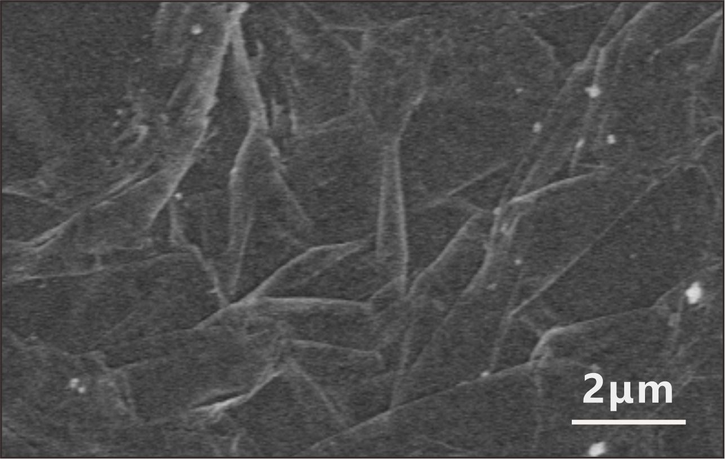
Figure S1. SEM image for the surface morphology of a typical graphite foil prepared.
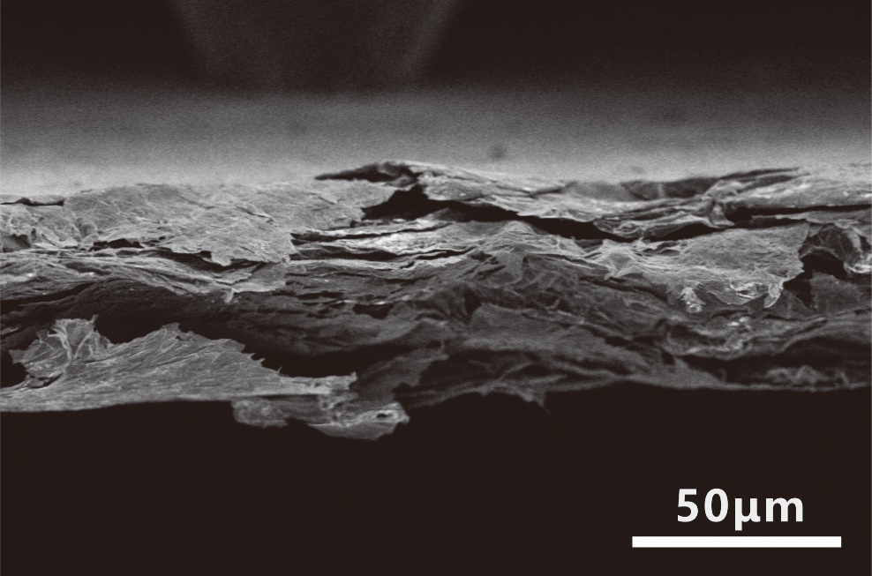
Figure S2. SEM image for the cross-section morphology of a typical graphite foil prepared.
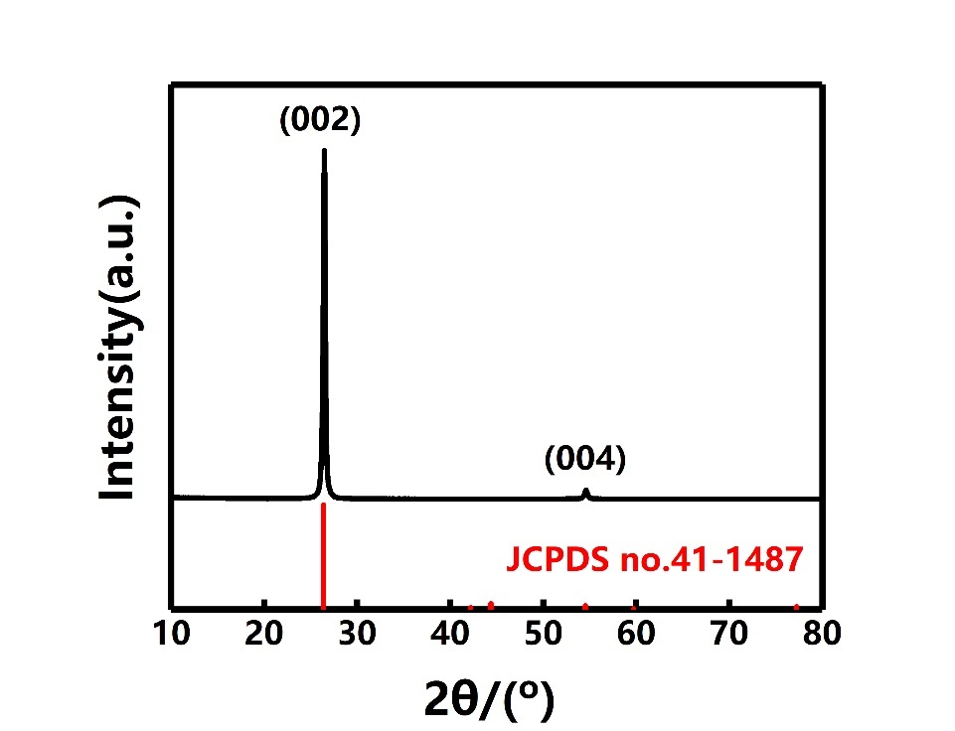
Figure S3. The XRD patterns of graphite foil and the standard card of graphite (JCPDS no. 411487).

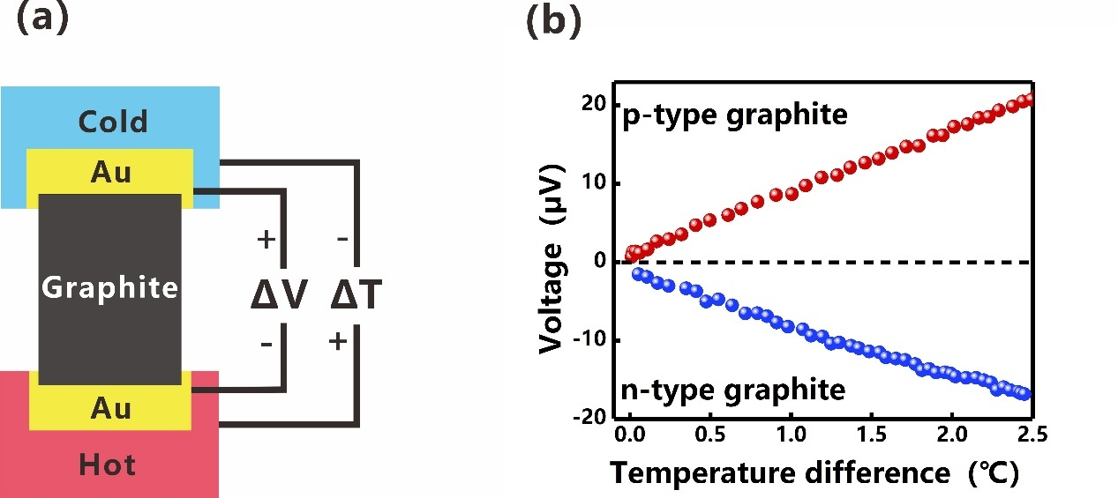
Figure S4. (a) Schematic illustration of the apparatus for measuring Seebeck coefficient at room temperature in in nitrogen atmospheres. (b) Measurement results of the P-type graphite and the N-type graphite.
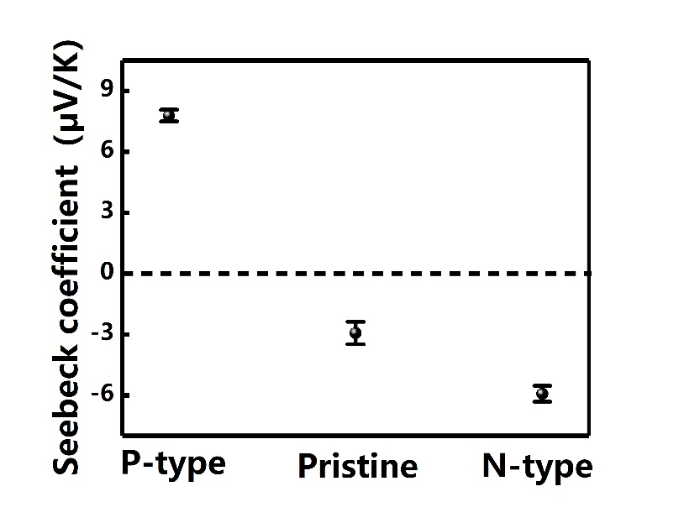
Figure S5. The average room temperature (290 K) Seebeck coefficient of the P-type, pristine and N-type graphite foils from multiple measurements (n is 5).
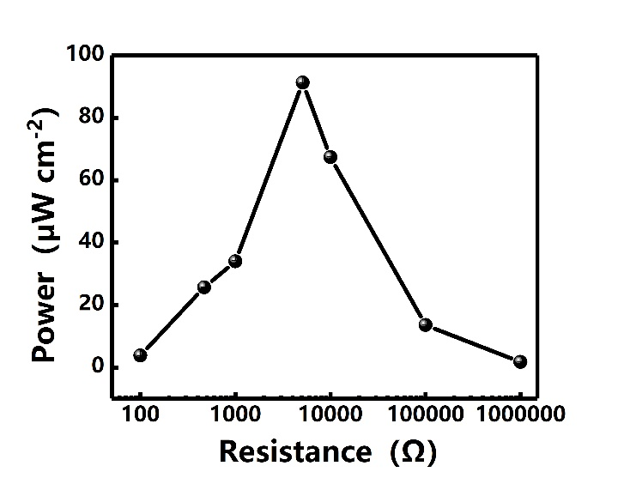
Figure S6. Power density of the WG-HEG as a function of external resistance ranging from 100 Ω to 10⁶ Ω.
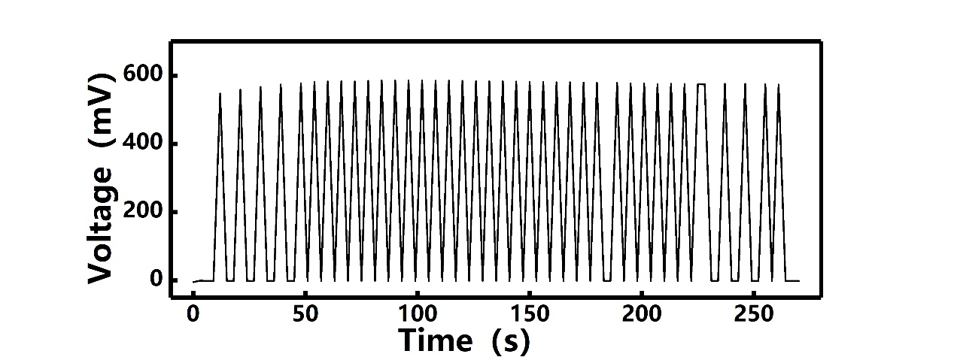
Figure S7. Voltage output of the WG-HEG in response to periodic pulling graphene in and out of Tap water.
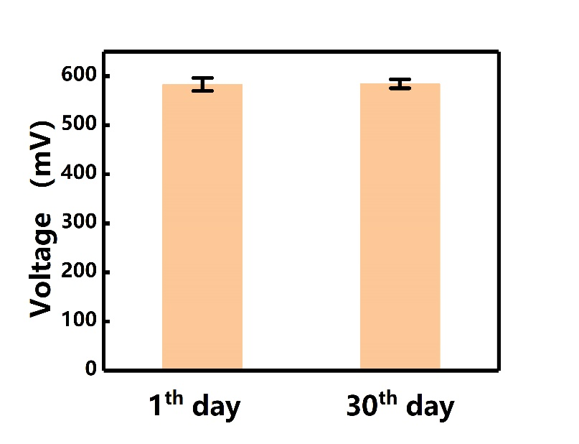
Figure S8. Open-circuit voltage from samples after being exposed to the ambient environment for 30 days and relatively fresh samples.
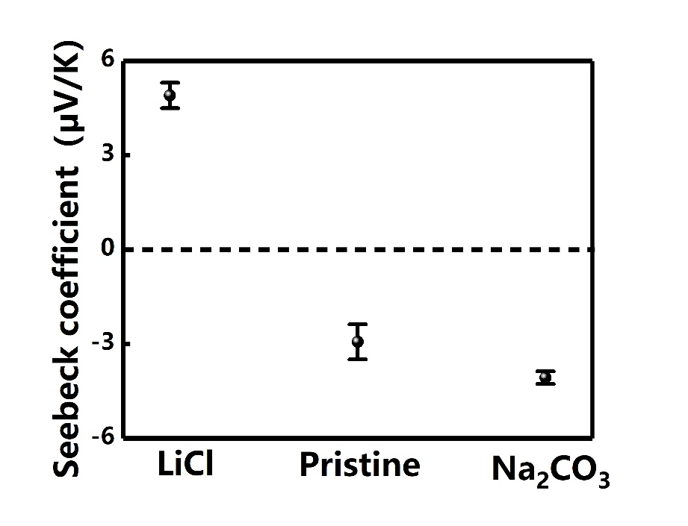
Figure S9. The average room temperature (290 K) Seebeck coefficient of the LiCl-treated, pristine and Na₂CO₃-treated graphite foils from multiple measurements (n is 5).
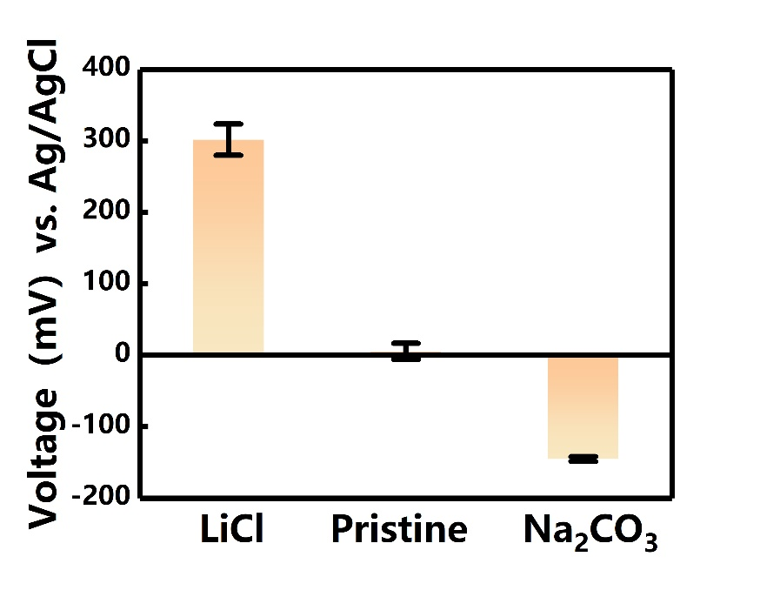
Figure S10. The open-circuit voltage between graphite foils (LiCl-treated, pristine and Na₂CO₃-treated) and an Ag/ AgCl reference electrode at room temperature.
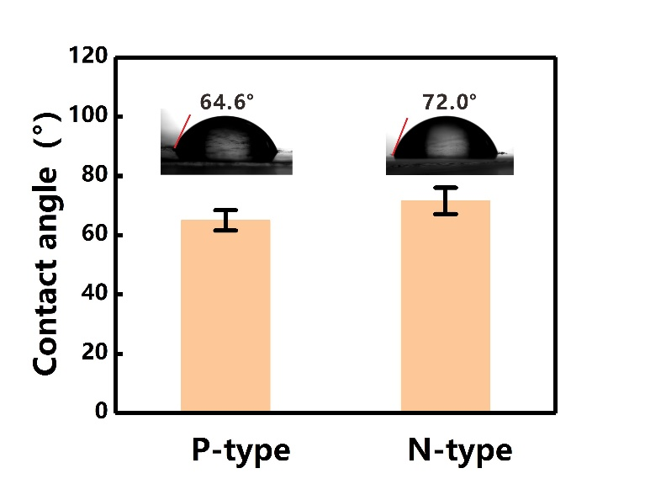
Figure S11. Water contact angels of the P-type and N-type graphite foils.

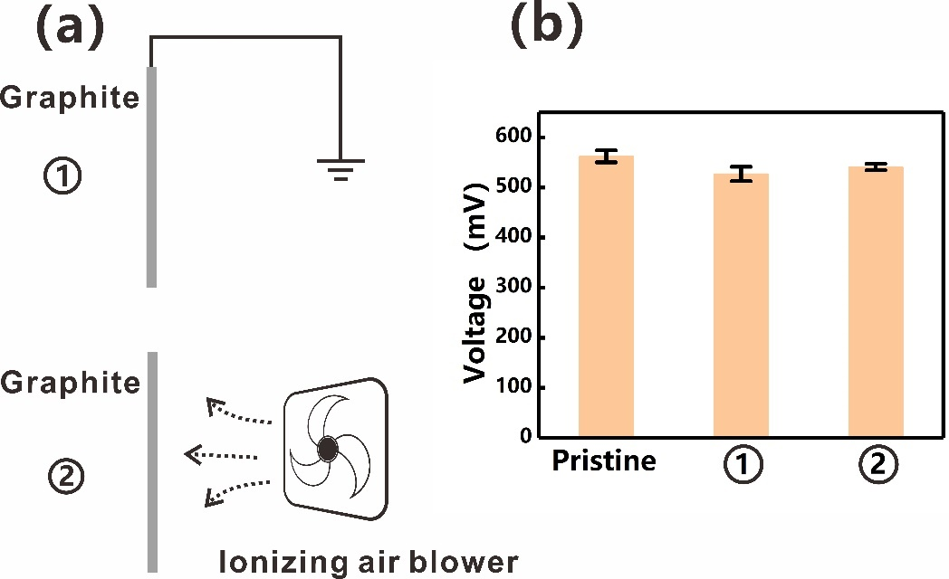
Figure S12.(a) ①Grounding and ②using an ionizing air blower for 1 hour. (b) Measurement results after removing possible pre-existing charges on surfaces.

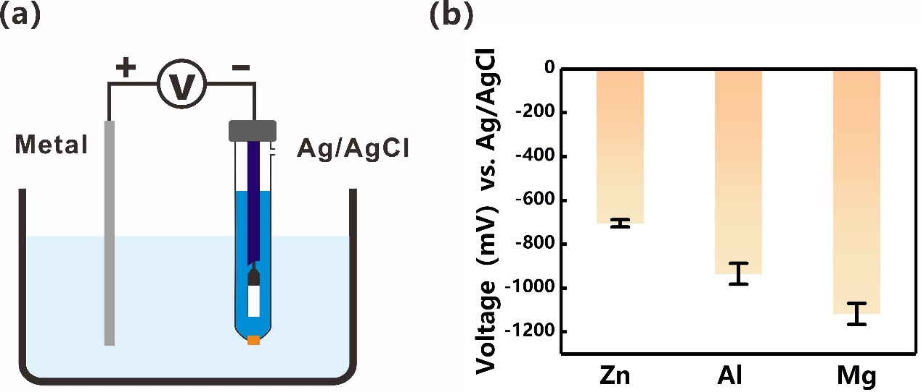
Figure S13(a) Schematic illustration of the apparatus for measuring (b) the open-circuit voltage between active materials (zinc, aluminum and magnesium) and an Ag/ AgCl reference electrode at room temperature.
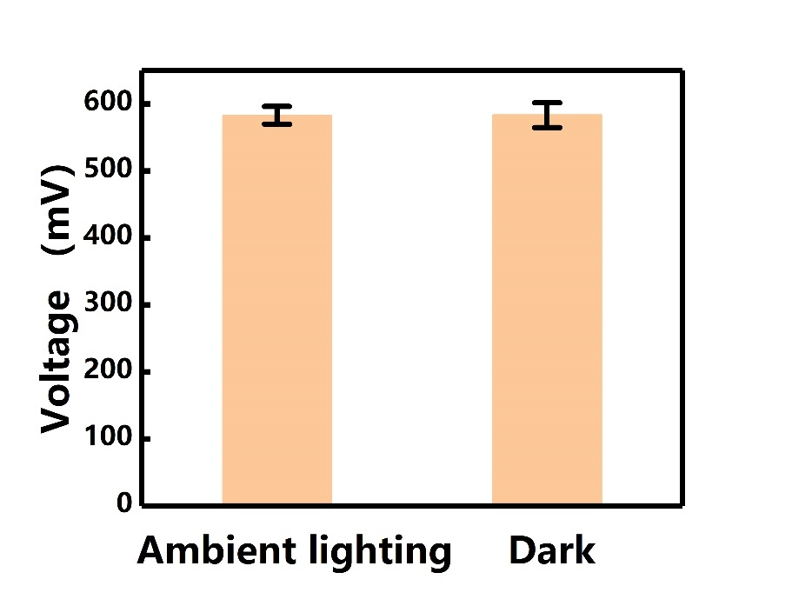
Figure S14. Open-circuit voltage from the WG-HEG devices with ambient lighting and in the dark.

Table S1. The performance comparison of reported hydroelectric generators.
Hydroelectricity | Materials（Electrode） | Series number | Parallel number | Voltage  （V） | Current  （mA） | Refs
Moisture-induced
 | Protein wires*  （Au） | 17 | 5 | 10 | 0.0011 | 1¹
 | Polyelectrolyte  (carbon tape） | 1600 | 500 | 1000 | 0.016 | 2²
 | Ionic liquid  (Ag/AgCl*) | 4 | 4 | 1 | 0.05 | 3³
 | Nafion* and poly ( n-isopropylacrylamide )  （carbon paper） | 2 | 2 | 4 | 0.04 | 4⁴
 | Carbon-coated cotton fabric  （Fe*） | 4 | 4 | 1.2 | 0.08 | 5⁵
 | Kraft paper  And reassembled graphite  (--) | 30 | 1 | 12 | 0.000025 | 6⁶
 | Poly(4-styrensulfonic  acid) *  (Au) | 3 | 1.5cm² | 2.3 | 0.2 | 7⁷
 | Graphene oxide* and sodium polyacrylate  (Au\Ag) | 68 | - | 26.2 | - | 8⁸
 | Graphene oxide*  （Au） | 60 | - | 11.2 | - | 9⁹
 | Graphene oxide*  （silver paste） | 5 | - | 2 | - | 10¹⁰
 | Graphene oxide*  （Al*） | 5 | 5 | 1.32 | 10.5 | 11¹¹
 | Ionic hydrogel and functionalized carbon  （-） | 5 | 5 | 3 | 0.03 | 12¹²
 | Poly(vinyl alcohol), phytic acid* and glycerol-water binary solvent  （Ag/Cu*） | 260 | 300 | 210 | 7 | 13¹³
 | Graphene oxide*  （Au） | 8 | 8 | 1.21 | 0.00397 | 14¹⁴
 | Titanium dioxide  （indium tin oxide/Al*） | 3 | 3 | 1.3 | 0.025 | 15¹⁵
 | Biological nanofibrils  （Pt） | 4 | 4 | 0.4 | 0.0001 | 16¹⁶
 | Protein nanofibrils  （ITO/Ti） | 5 | 5 | 2.44 | 0.00961 | 17¹⁷
 | Polyvinyl alcohol and Poly (4-styrensulfonic acid) *  （carbon tape） | 10 | 10 | 9.2 | 0.0102 | 18¹⁸
 | Carbon black  （Cu*） | 60 | - | 33 | - | 19¹⁹
 | Fluorinated oxidized graphene*  （-） | 15 | 4 | 10 | 0.005 | 20²⁰
 | Geobacter sulfurreducens  (ITO) | 4 | 4 | 1.07 | 0.001 | 21²¹
 | Cellulose nanofiber  （Cu*） | 4 | - | 3 | - | 22²²
 | Molybdenum disulfide  （stainless-steel） | 12 | 1 | 1.7 | 0.00233 | 23²³
 | Biological nanofibrils  （Pt） | 3 | 3 | 250 | 0.00012 | 24²⁴
 | High-valent metal cation  （Au） | 4 | 4 | 0.35 | 0.00175 | 25²⁵
 | poly(4-styrensulfonic acid) * and poly(vinyl alcohol)  （Ag nanowires） | 2 | 2 | 1.2 | 0.004 | 26²⁶
 | HCl*/polyvinyl alcohol  （carbon nanotube） | 6 | - | 1.5 | - | 27²⁷
 | Graphene oxide*  （Ag wire） | 10 | 10 | 3 | 0.042 | 28²⁸
 | MXene/cellulose/  polystyrene sulfonic acid*  (Ag nanowires) | 4 | 4 | 1.1 | 0.0058 | 29²⁹
 | Cationic silk nanofibrils  (Pt) | 3 | 3 | 0.36 | 0.00035 | 30³⁰
 | LiCl-loaded cellulon paper and carbon-black-loaded cellulon paper  （carbon tape） | 3 | 2 | 2 | 0.01 | 31³¹
 | Nanochannel anodic aluminum oxide  （nanoporous carbon nanotubes/In-Ga*） | 20 | 1 | 18 | 0.0012 | 32³²
 | Sodium alginate , silicon dioxide nanofiber , and reduced graphene oxide  （Au） | 21 | 16 | 11 | 1.3 | 33³³
 | Poly([2-(methacryloyloxy)ethyl] Dimethyl-(3-sulfopropyl) ammonium hydroxide-co-acrylicacid) *  （Au） | 5 | - | 2 | - | 34³⁴
 | Graphene oxide*  （Ag/AgCl ink*） | 6 | 1 | 1.9 | 0.0334 | 35³⁵
 | Graphene oxide*  (Au/Ag) | 15 | 1 | 18 | 0.00012 | 36³⁶
 | Electroactive bacteria  (ITO) | 30 | 30 | 10 | 0.052 | 37³⁷
 | TiO2 nanowires/cotton fibers and an asymmetrically distributed polypyrrole  (Fe*) | 3 | 3 | 1.45 | 0.018 | 38³⁸
 | Poly (4-styrensulfonic acid) *  (Al*) | 5 | 5 | 5.5 | 0.0047 | 39³⁹
 | Polyvinyl alcohol  (Al* /Au-coated stainless-steel) | 5 | 5 | 3.2 | 0.00014 | 40⁴⁰
 | Print paper  (Stainless  steel metal plate) | 5 | 5 | 1 | 0.00012 | 41⁴¹
 | Graphene oxide/ reduced graphene oxide*  (Ag*) | 175 | 1 | 192 | 0.17 | 42⁴²
 | Polyacrylonitrile and sodium dodecyl benzene sulfonate  (ITO/Zn*/Al*) | 5 | 5 | 3.6 | 0.012 | 43⁴³
 | TiO₂/ZrO₂ composite nanofiber membrane  (ITO/ Au-coated Al) | 4 | 4 | 2.98 | 0.00001582 | 44⁴⁴
 | 3-Acrylamidopropyl[trimethylammo-nium] chloride and poly (sodium4-styrene sulfonate)  (Ag) | 5 | 5 | 0.045 | 0.0000008 | 45⁴⁵
 | Graphene oxide*  (carbon) | 5 | 5 | 11.9 | 0.0827 | 46⁴⁶
 | Sulfonic acid*/LiCl  (Ag*/Pt) | 20 | 6 | 10 | 0.24 | 69⁶⁹
 | Phytic acid*  (tin and indium*) | 280 | 40 | 210 | 28 | 70⁷⁰
Liquid-induced
 | cellulose/carbon nanotubes  （Cu*） | 1 | 6 | 0.16 | 0.0007 | 47⁴⁷
 | CuO nanowires  （silver paste） | 4 | 4 | 0.75 | 0.0012 | 48⁴⁸
 | Single-layer MoS₂  (silver paste) | 3 | 3⁴⁹ | 14 | 0.000015 | 49⁴⁹
 | Silicon nanowires  （graphite） | 3 | 4 | 3.7 | 0.0012 | 50⁵⁰
 | Graphene and  polytetrafluoroethylene  （-） | 3 | 3 | 1.1 | 0.008 | 51⁵¹
 | Carbon nanotube/transition metal oxide  （-） | 8 | 1 | 1.8 | 0.04 | 52⁵²
(Tribovoltaic effect) | Water  (Pt/ indium gallium zinc oxide/Al*) | 6 | 3 | 2.5 | 0.014 | 53⁵³
(Tribovoltaic effect) | Water  (silicon/Al*) | 3 | 1 | 2.7 | 0.0007 | 54⁵⁴
Evaporation-induced
 | carbon black  （multiwalled carbon  nanotube） | 4 | 4 | 1.25 | 0.0001 | 55⁵⁵
 | Al₂O₃ and carbon black  （conductive carbon paste） | 6 | 6 | 16 | 0.00845 | 56⁵⁶
 | MoS₂/SiO₂  （silver paste） | 6 | 6 | 4.2 | 0.0024 | 57⁵⁷
 | Carbon black/PVA  (Fe*) | 100 | 101.07 | 10 | 2.2 | 58⁵⁸
 | poly(styrene sulfonicacid) and polyacrylicacid cellulose  (conductive carbon ink) | 2 | 1 | 0.8 | 0.00045 | 59⁵⁹
 | Functionalized conductive carbon black  (Cu*) | 6 | 6 | 3.7 | 0.34 | 60⁶⁰
 | Nanostructured silicon nanowire arrays  (graphite/PEDOT:PSS/ cellulose fabric/) | 4 | - | 2.4 | - | 61⁶¹
 | Silicon nanowire arrays  (graphite/Ag) | 4 | - | 1.1 | - | 62⁶²
 | Carbon nanospheres and TiO₂ nanowires  (carbon ink) | 4 | 4 | 6.2 | 0.00055 | 63⁶³
 | Reduced graphene oxide*  (super-aligned carbon nanotube buckypapers) | 6 | 1 | 2.34 | 0.1 | 64⁶⁴
 | A piece of wood  (carbon paste) | 4 | 4 | 1.2 | 0.04 | 65⁶⁵
 | Al₂O₃  (carbon paste) | 6 | 6 | 14.8 | 0.0022 | 66⁶⁶
 | PEDOT:PSS*  (gold-coated electrode) | 4 | 4 | 3.1 | 0.1834 | 67⁶⁷
 | SiO₂ nanofiber  (Al*) | 5 | 5 | 2.1 | 0.0017 | 68⁶⁸
Only one of the works with similar performance is selected to be displayed in the main text, and the work displayed in the main text is in brackets.
6/49(49)
41/55(55)
14/26/29/51(51)
31/17(17)
50/57(57)
12/28(28)
37/46(46)
Additionally, no work utilizing active electrode materials was presented in the main text. In the form, active electrode materials are denoted in red font, while acidic materials are indicated in blue font. Both types of materials are marked with asterisks. It is essential to emphasize that meticulous consideration should be given to eliminating any potential contributions resulting from the interaction between the liquid and metal electrodes. If the electrodes or functional channels comprise active materials, they may come into contact with water, leading to the formation of a metal-air battery under ambient conditions. This process would cause electrochemical energy to be irreversibly converted into electricity. Thus, contributions resulting from the metal-air battery should be avoided, as they may lead to inaccurate or misleading results⁷¹.

References
1. Liu, X. et al. Power generation from ambient humidity using protein nanowires. Nature. 578, 550-554 (2020).
2. Wang, H. et al. Bilayer of polyelectrolyte films for spontaneous power generation in air up to an integrated 1,000 V output. Nat. Nanotechnol. 16, 811-819 (2021).
3. Lv, D. et al. Defect-enhanced selective ion transport in an ionic nanocomposite for efficient energy harvesting from moisture. Energ. Environ. Sci. 15, 2601-2609 (2022).
4. Liu, C. et al. Hydrovoltaic energy harvesting from moisture flow using an ionic polymer–hydrogel–carbon composite. Energ. Environ. Sci. 15, 2489-2498 (2022).
5. Bae, J., Yun, T. G., Suh, B. L., Kim, J. & Kim, I. Self-operating transpiration-driven electrokinetic power generator with an artificial hydrological cycle. Energ. Environ. Sci. 13, 527-534 (2020).
6. Moreira, K. S., Lermen, D., Dos Santos, L. P., Galembeck, F. & Burgo, T. A. L. Flexible, low-cost and scalable, nanostructured conductive paper-based, efficient hygroelectric generator. Energ. Environ. Sci., (2021).
7. Xu, T. et al. An efficient polymer moist-electric generator. Energ. Environ. Sci. 12, 972-978 (2019).
8. Huang, Y. et al. All-region-applicable, continuous power supply of graphene oxide composite. Energ. Environ. Sci. 12, 1848-1856 (2019).
9. Cheng, H. et al. Spontaneous power source in ambient air of a well-directionally reduced graphene oxide bulk. Energ. Environ. Sci. 11, 2839-2845 (2018).
10. Liang, Y. et al. Electric power generation via asymmetric moisturizing of graphene oxide for flexible, printable and portable electronics. Energ. Environ. Sci. 11, 1730-1735 (2018).
11. Zhao, F., Liang, Y., Cheng, H., Jiang, L. & Qu, L. Highly efficient moisture-enabled electricity generation from graphene oxide frameworks. Energ. Environ. Sci. 9, 912-916 (2016).
12. Zhang, Y. et al. An asymmetric hygroscopic structure for moisture‐driven hygro‐ionic electricity generation and storage. Adv. Mater., 2201228 (2022).
13. Yang, S. et al. Ionic Hydrogel for Efficient and Scalable Moisture‐Electric Generation. Adv. Mater., 2200693 (2022).
14. Yang, C., Huang, Y., Cheng, H., Jiang, L. & Qu, L. Rollable, Stretchable, and Reconfigurable Graphene Hygroelectric Generators. Adv. Mater. 31, 1805705 (2019).
15. Shen, D. et al. Self-Powered Wearable Electronics Based on Moisture Enabled Electricity Generation. Adv. Mater. 30, 1705925 (2018).
16. Li, M. et al. Biological Nanofibrous Generator for Electricity Harvest from Moist Air Flow. Adv. Funct. Mater. 29, 1901798 (2019).
17. Liu, J. et al. Moisture-enabled hydrovoltaic power generation with milk protein nanofibrils. Nano Energy. 102, 107709 (2022).
18. He, W. et al. Textile-based moisture power generator with dual asymmetric structure and high flexibility for wearable applications. Nano Energy. 95, 107017 (2022).
19. Zhang, K. et al. Enhancing output performance of surface-modified wood sponge-carbon black ink hygroelectric generator via moisture-triggered galvanic cell. Nano Energy, 107288 (2022).
20. Fan, K. et al. Spontaneous power generation from broad-humidity atmospheres through heterostructured F/O-bonded graphene monoliths. Nano Energy. 91, 106605 (2022).
21. Ren, G. et al. A facile and sustainable hygroelectric generator using whole-cell Geobacter sulfurreducens. Nano Energy. 89, 106361 (2021).
22. Lee, S., Eun, J. & Jeon, S. Facile fabrication of a highly efficient moisture-driven power generator using laser-induced graphitization under ambient conditions. Nano Energy. 68, 104364 (2020).
23. He, D. et al. Electricity generation from phase-engineered flexible MoS2 nanosheets under moisture. Nano Energy. 81, 105630 (2021).
24. Yang, W. et al. Asymmetric ionic aerogel of biologic nanofibrils for harvesting electricity from moisture. Nano Energy. 71, 104610 (2020).
25. Chen, N. et al. MEG actualized by high-valent metal carrier transport. Nano Energy. 65, 104047 (2019).
26. Wang, H. et al. Transparent, self-healing, arbitrary tailorable moist-electric film generator. Nano Energy. 67, 104238 (2020).
27. Luo, Z., Liu, C. & Fan, S. A moisture induced self-charging device for energy harvesting and storage. Nano Energy. 60, 371-376 (2019).
28. Shao, C. et al. Wearable fiberform hygroelectric generator. Nano Energy. 53, 698-705 (2018).
29. Li, P., Su, N., Wang, Z. & Qiu, J. A Ti₃C₂Tx MXene-Based Energy-Harvesting Soft Actuator with Self-Powered Humidity Sensing and Real-Time Motion Tracking Capability. ACS Nano, (2021).
30. Yang, W. et al. Quaternized Silk Nanofibrils for Electricity Generation from Moisture and Ion Rectification. ACS Nano. 14, 10600-10607 (2020).
31. Tan, J. et al. Self-sustained electricity generator driven by the compatible integration of ambient moisture adsorption and evaporation. Nat. Commun. 13, (2022).
32. Zhang, Y. et al. Sustainable power generation for at least one month from ambient humidity using unique nanofluidic diode. Nat. Commun. 13, (2022).
33. Wang, H. et al. Moisture adsorption-desorption full cycle power generation. Nat. Commun. 13, (2022).
34. Long, Y. et al. Moisture-induced autonomous surface potential oscillations for energy harvesting. Nat. Commun. 12, 5287 (2021).
35. Kim, S. et al. Neuromorphic van der Waals crystals for substantial energy generation. Nat. Commun. 12, (2021).
36. Huang, Y. et al. Interface-mediated hygroelectric generator with an output voltage approaching 1.5 volts. Nat. Commun. 9, 4166 (2018).
37. Ren, G. et al. Hydrovoltaic effect of microbial films enables highly efficient and sustainable electricity generation from ambient humidity. Chem. Eng. J. 441, 135921 (2022).
38. Xie, J., Wang, Y. & Chen, S. Textile-Based Asymmetric Hierarchical Systems for Constant Hydrovoltaic Electricity Generation. Chemical engineering journal (Lausanne, Switzerland : 1996), 133236 (2021).
39. Sun, Z. et al. Nanofiber fabric based ion-gradient-enhanced moist-electric generator with a sustained voltage output of 1.1 volts. Mater Horiz. 8, 2303-2309 (2021).
40. Sun, Z. et al. Electrospun nanofiber fabric: an efficient, breathable and wearable moist-electric generator. J. Mater. Chem. A. 9, 7085-7093 (2021).
41. Gao, X. et al. Electric power generation using paper materials. J. Mater. Chem. A. 7, 20574-20578 (2019).
42. Yang, L. et al. A moisture-enabled fully printable power source inspired by electric eels. Proceedings of the National Academy of Sciences. 118, e2023164118 (2021).
43. Sun, Z., Wen, X., Wang, L., Yu, J. & Qin, X. Capacitor-inspired high-performance and durable moist-electric generator. Energ. Environ. Sci. 15, 4584-4591 (2022).
44. Wang, L. et al. Flexible, self-cleaning, and high-performance ceramic nanofiber-based moist-electric generator enabled by interfacial engineering. Science China. Technological sciences. 65, 450-457 (2022).
45. Lu, W. et al. Anion-cation heterostructured hydrogels for all-weather responsive electricity and water harvesting from atmospheric air. Nano Energy. 104, 107892 (2022).
46. Yang, C. et al. Transfer learning enhanced water-enabled electricity generation in highly oriented graphene oxide nanochannels. Nat. Commun. 13, (2022).
47. Chen, J. et al. Knittable Composite Fiber Allows Constant and Tremendous Self‐Powering Based on the Transpiration‐Driven Electrokinetic Effect. Adv. Funct. Mater. 32, 2203666 (2022).
48. Jin, H. et al. Identification of water-infiltration-induced electrical energy generation by ionovoltaic effect in porous CuO nanowire films. Energ. Environ. Sci., (2020).
49. Aji, A. S., Nishi, R., Ago, H. & Ohno, Y. High output voltage generation of over 5 V from liquid motion on single-layer MoS2. Nano Energy. 68, 104370 (2020).
50. Shao, B. et al. Freestanding silicon nanowires mesh for efficient electricity generation from evaporation-induced water capillary flow. Nano Energy. 94, 106917 (2022).
51. Kwak, S. S. et al. Triboelectrification-Induced Large Electric Power Generation from a Single Moving Droplet on Graphene/Polytetrafluoroethylene. ACS Nano. 10, 7297-7302 (2016).
52. Zhao, T. et al. A Fiber Fluidic Nanogenerator Made from Aligned Carbon Nanotubes Composited with Transition Metal Oxide. ACS Materials Letters. 3, 1448-1452 (2021).
53. Huang, Y. et al. Flexible Liquid‐Based Continuous Direct‐Current Tribovoltaic Generators Enable Self‐Powered Multi‐Modal Sensing. Adv. Funct. Mater., 2209484 (2022).
54. Yan, Y. et al. Direct Current Electricity Generation from Dynamic Polarized Water–Semiconductor Interface. The Journal of Physical Chemistry C. 125, 14180-14187 (2021).
55. Xue, G. et al. Water-evaporation-induced electricity with nanostructured carbon materials. Nat. Nanotechnol. 12, 317 (2017).
56. Li, L. et al. A hydrovoltaic power generation system based on solar thermal conversion. Nano Energy. 99, 107356 (2022).
57. Yoon, S. G. et al. Evaporative electrical energy generation via diffusion-driven ion-electron-coupled transport in semiconducting nanoporous channel. Nano Energy. 80, 105522 (2021).
58. Li, L. et al. A novel, flexible dual-mode power generator adapted for wide dynamic range of the aqueous salinity. Nano Energy. 85, 105970 (2021).
59. Shin, S. et al. Carbon anchored conducting polymer composite linkage for high performance water energy harvesters. Nano Energy. 74, 104827 (2020).
60. Li, L. et al. Sustainable and flexible hydrovoltaic power generator for wearable sensing electronics. Nano Energy. 72, 104663 (2020).
61. Shao, B. et al. Bioinspired Hierarchical Nanofabric Electrode for Silicon Hydrovoltaic Device with Record Power Output. ACS Nano, (2021).
62. Qin, Y. et al. Constant Electricity Generation in Nanostructured Silicon by Evaporation‐Driven Water Flow. Angewandte Chemie International Edition. 59, 10619-10625 (2020).
63. Ji, B. et al. Intelligent multiple-liquid evaporation power generation platform using distinctive Jaboticaba-like carbon nanosphere@TiO2 nanowires. J. Mater. Chem. A. 7, 6766-6772 (2019).
64. Zhang, G. et al. Harvesting environment energy from water-evaporation over free-standing graphene oxide sponges. Carbon. 148, 1-8 (2019).
65. Zhou, X. et al. Harvesting Electricity from Water Evaporation through Microchannels of Natural Wood. ACS Appl. Mater. Inter. 12, 11232-11239 (2020).
66. Shao, C. et al. Large-Scale Production of Flexible, High-Voltage Hydroelectric Films Based on Solid Oxides. ACS Appl. Mater. Inter. 11, 30927-30935 (2019).
67. Yun, T. G. et al. Ion-permselective conducting polymer-based electrokinetic generators with maximized utility of green water. Nano Energy. 94, 106946 (2022).
68. Sun, Z. et al. Ceramic Nanofiber-Based Water-Induced Electric Generator. ACS Appl Mater Interfaces. 13, 56226-56232 (2021).
69. Zhang, H. et al. High-Performance, Highly Stretchable, Flexible Moist-Electric Generators via Molecular Engineering of Hydrogels. Adv. Mater., e2300398 (2023).
70. Li, Q. et al. Moist‐Electric Generator with Efficient Output and Scalable Integration Based on Carbonized Polymer Dot and Liquid Metal Active Electrode. Adv. Funct. Mater., 2211013 (2023).
71. Wang, X. et al. Hydrovoltaic technology: from mechanism to applications. Chem. Soc. Rev. 51, 4902-4927 (2022).
72. Kresse, G. & Furthmüller, J. Efficiency of ab-initio total energy calculations for metals and semiconductors using a plane-wave basis set. Comp. Mater. Sci. 6, 15-50 (1996).
73. Kresse, G. & Furthmüller, J. Efficient iterative schemes forab initio total-energy calculations using a plane-wave basis set. Physical Review B. 54, 11169-11186 (1996).
74. Perdew, J. P., Burke, K. & Ernzerhof, M. Generalized Gradient Approximation Made Simple. Phys. Rev. Lett. 77, 3865-3868 (1996).
75. Kresse, G. & Joubert, D. From ultrasoft pseudopotentials to the projector augmented-wave method. Physical Review B. 59, 1758-1775 (1999).
76. Blöchl, P. E. Projector augmented-wave method. Physical Review B. 50, 17953-17979 (1994).
77. Hong, G. et al. On the Mechanism of Hydrophilicity of Graphene. Nano Lett. 16, 4447-4453 (2016).

