Supplemental Material

Table S1. General characteristics of included studies
Last name of first author  (Year) | Total N  (% female) | Mean age | % of NYHA class III/IV | % LVEF <40%  (mean EF) | Follow-up period | HF definition | Comorbidity definition | Outcome measures | Recruitment setting
Adams (2012) | 985 (37.8) | 69 | 32.7 | NR (30.5) | 12 years | Clinical criteria | MI  DM | Mortality (all-cause) | Inpatient
Agrinier (2017) | 352 (24.1) | 65 | 100 | NR (22.3) | 15 years | Clinical criteria | HTN  DM  HL  CKD | Mortality (all-cause) | Inpatient
Ausili (2016) | 1,192 (41.8) | 72 | 40.8 | NR (44.6) | NR | Unspecified | HTN  DM  CKD | Self-care (SCHFI) | Outpatient
Bannay (2018) | 245 (31.0) | 65 | NR | 60 (34) | 1 year | Unspecified | DM  CAD | Readmission (HF-related) | Inpatient
Bektas (2017) | 186 (31.0) | 76 | 21 | NR (NR) | 2 years | Clinical criteria | COPD | Mortality (all-cause) | Outpatient
Bottle (2014) | 70,108 (49.5) | 78 | NR | NR (NR) | 30-days | Diagnosis code | Stroke  Pneumonia  IHD  Dementia  Arrythmia  HVD  PVD  HTN  COPD  CKD  Obesity  Any mental health (except dementia) | Readmission (HF-related)  Readmission (Non-HF-related) | Inpatient and Outpatient
Bottle (2019) | 6,360 (44.5) | NR* | NR | NR (NR) | 1 year | Diagnosis code | Per extra comorbidity | Readmission (all-cause) | Outpatient
Castro (2021) | 463 (70.0) | 61 | NR | 100 (27) | 1.9 years | Clinical criteria | CKD  Stroke  Cancer  HTN  AF  DM  DL  Depression | Mortality (in-hospital) | Inpatient
Chamberlain (2017) | 121 (50.4) | 71 | NR | 49.6 (41.9) | NR | Clinical criteria | CCI | Self-care (SCHFI) | Inpatient
Chaudhry (2013) | 758 (50.5) | 80 | 30.3 | NR (NR) | 20 years | Clinical criteria | Obesity  CAD  CKD  DM  Stroke  COPD  Anemia | Readmission (all-cause) | Outpatient
Comin-Colet (2016) | 1,037 (30.1) | 71 | 45.1 | 33.7 (NR) | NR | Clinical criteria | CCI | HRQoL (KCCQ, EQ-5D, EQ-VAS) | Outpatient
Drozd (2021) | 1,794 (26.9) | 70 | 30.7 | NR (32) | 5 years | Clinical criteria | DM  COPD  CKD | Mortality (all-cause) | Outpatient
Ebner (2016) | 331 (17.0) | 64 | NR | 76 (34.7) | 2 years | Clinical criteria | Obesity | Mortality (all-cause) | Outpatient
Echouffo-Tcheugui (2016) | 364,480 (48.7) | 75 | NR | NR (NR) | 1 year | Diagnosis code | DM | Mortality (in-hospital)  Hospital LOS >4 days | Inpatient
Franco (2019) | 1,105 (52) | 79 | 25 | NR (21%) | 1 year | Clinical criteria | CCI | Mortality (all-cause) | Inpatient
Huang (2017) | 129 (57.4) | 75 | NR | 52 (NR) | 3.1 years | Clinical criteria | CCI | Mortality (all-cause) | Inpatient
Khafaji (2015) | 5,005 (37.4) | 60 | 75.2 | 36.96 (NR) | 1 year | Clinical criteria | DM  CKD  COPD/asthma  STEMI  HVD  Stroke  PVD | Mortality (in-hospital)  Mortality (all-cause) | Inpatient
Korda (2017) | 5,074 (42.4) | 80 | NR | NR (NR) | 30 days | Diagnosis code | CVD  COPD  Anemia  Dementia  CCI | Mortality (all-cause)  Readmission (all-cause) | Inpatient
Lawson (2021) | 698,983 (49.7) | NR* | NR | NR (NR) | 30 days | Diagnosis code | HTN  AF  DM  COPD  Asthma  Depression  Cancer  CKD  CVA  Dementia  Anemia  Arthrosis  Rheumatoid arthritis | Readmission (all-cause)  Readmission (HF-related)  Readmission (Non-HF-related) | Inpatient
Le Corvoisier (2014) | 555 (66.1) | 85 | NR | NR (NR) | Until discharge or death | Clinical criteria | CVD | Mortality (in-hospital) | Inpatient
Lee (2017) | 580 (41.0) | 66 | 34 | NR (NR) | 2 years | Unspecified | CCI | Self-care (EHFScB-9) | Inpatient and Outpatient
Manemann (2016) | 1,714 (56.2) | 76 | NR | NR (NR) | 4.2 years | Multiple | CAD  Arrhythmia  Stroke  HTN  HL  DM  Arthritis  Osteoporosis  Asthma  COPD  CKD  Cancer  Depression  Dementia  Schizophrenia  Substance abuse | Mortality (all-cause)  Readmission (all-cause) | Inpatient and Outpatient
Matsuoka (2016) | 227 (37.4) | 68 | 4.8 | 32.2 (46.5) | NR | Unspecified | HTN  CKD  AF  DM | Self-care (EHFScB-9) | Outpatient
Maymon (2021) | 8,332 (49.5) | NR* | NR | NR (NR) | 30 days | Diagnosis code | DM  HTN  IHD  COPD  AF  Renal Failure  Anemia  Valvular disease  Obesity  MI  PVD | Readmission (all-cause) | Inpatient
Mulla (2021) | 721 (46.0) | 71 | 21 | NR (40) | 1 year &  10 years | Multiple | CCI  DM  HTN  DL  COPD  PVD  AF/A-Flutter  IHD  MI  CVA | Mortality (all-cause) | Inpatient
Munoz-Rivas (2019) | 1,501,811 (54.9) | 79 | NR | NR (NR) | 5-years | Diagnosis code | DM  CCI | Mortality (in-hospital)  Readmission (all-cause)  Hospital LOS >4 days | Inpatient
Nayar (2018) | 4,319 (49.5) | 77 | NR | NR (NR) | NR | Diagnosis code | CCI | Mortality (in-hospital) | Inpatient
Ogah (2014) | 262 (47.3) | 56 | 92.4 | NR (39.7) | 6 months | Clinical criteria | AF  DM | Readmission (all-cause) | Inpatient
Omersa (2016) | 34,406 (54.8) | 78 | NR | NR (NR) | 1 year | Diagnosis code | HTN  AF  MI  IHD  DM  CKD  COPD  Cancer | Readmission (HF-related) | Inpatient
Park (2021) | 3,818 (47.2) | 71 | 41.8 | 53.3 (40.2) | 7 years | Clinical criteria | AF  HTN  DM  IHD | Mortality (all-cause) | Inpatient
Sharma (2018) | 73,878 (54.4) | NR* | NR | NR (NR) | 30 days | Unspecified | Per extra non-cardiovascular comorbid | Mortality (all-cause)  Readmission (all-cause)  Readmission (HF-related) | Inpatient
Sokoreli (2018) | 779 (35.0) | NR* | 90 | 42 (NR) | 1 year | Clinical criteria | DM  MI  COPD  Cancer | Readmission (all-cause) | Inpatient
Streng (2018) | 3,499 (29.7) | 71 | 43.6 | NR (66) | 2.1 years | Multiple | DM  CKD  COPD  Stroke  Thyroid problem  Anemia  Obesity  PAD | HRQoL(KCCQ) | Inpatient and Outpatient
Sze (2021) | 467 (33.0) | NR* | 22.0 | NR (NR) | 1.5 years | Clinical criteria | CCI  MI  PVD  HTN  CVA  DM  Dementia  COPD  Depression  Anemia  Urinary incontinence | Mortality (all-cause) | Outpatient
Targher (2017) | 6,926 (37.0) | 69 | 84.9 | NR (39.2) | 1 year | Clinical criteria | DM  HTN  Stroke  COPD  Obesity  CKD | Mortality (in-hospital)  Mortality (all-cause)  Readmission (all-cause) | Inpatient and Outpatient
Van den Berge (2021) | 334 (34.0) | NR* | 40 | NR (NR) | 1 year | Clinical criteria | HTN  AF  DM  COPD  CKD  CVA | HRQoL (KCCQ, EQ-5D, EQ-VAS) | Inpatient
Van Deursen (2014) | 3,226 (39.7) | 66 | 28.2 | 49.98 (NR) | 11.7 months | Clinical criteria | CKD  Anemia  DM  COPD  Stroke  Sleep apnea  Hypothyroidism  Hyperthyroidism | Mortality (all-cause)  Readmission (HF-related) | Outpatient
Voors (2017) | 2,516 (26.6) | 69 | 60.5 | 31 (NR) | 1.8 years | Clinical criteria | DM  COPD | Mortality (all-cause)  Readmission (all-cause) | Inpatient and Outpatient
Wakabayashi (2017) | 4,842 (42.1) | 73 | 81.4 | NR (53.3) | NR | Clinical criteria | COPD | Mortality (in-hospital) | Inpatient
Wienbergen (2018) | 949 (25.3) | 70 | 70.5 | NR (NR) | 1 year | Unspecified | Anemia  COPD  Cancer | Mortality (all-cause) | Inpatient and Outpatient
Wray (2021) | 1,500 (NR) | 78 | NR | NR (NR) | 30 days | Diagnosis code | Acute coronary syndrome  Coronary atherosclerosis  HVD  Arrhythmia  Other unspecified heart disease  Stroke  CKD  COPD  DM  Dementia  Cancer  Chronic liver disease  Severe hematologic disorders  Iron deficiency  Depression  Chronic lung disorder  Asthma  Nephritis  Urinary tract disorders  Other psychiatric disorders  Peptic ulcer and other Specified GI tract disorders  Other GI tract disorders  Decubitus skin ulcer | Readmission (all-cause) | Inpatient
Zaharova (2021) | 73 (49.3) | 65 | 53.4 | NR (NR) | NR | Clinical criteria | CCI | Self-care (SCHFI) | Outpatient
Note. Studies are listed in alphabetical order. * mean age not reported; AF, atrial fibrillation; CAD, coronary artery disease; CCI, Charlson Comorbidity Index; CKD, chronic kidney disease; COPD, chronic obstructive pulmonary disease; CVA, cerebrovascular accident; CVD, cerebrovascular disease; DL, dyslipidemia; DM, diabetes mellitus; EHFScB-9, 9-item European Heart Failure Self-care Behavior Scale; EQ-5D, EuroQoL-5 Dimension; EQ-VAS, EuroQoL Visual Analog; HF, heart failure; HL, hyperlipidemia; HRQoL, health-related quality of life; HTN, hypertension; HVD, heart valve disease; IHD, ischemic heart disease; KCCQ, Kansas City Cardiomyopathy Questionnaire; LOS, length of stay; LVEF, left ventricular ejection fraction; MI, myocardial infarction; NR, not reported; NYHA, New York Heart Association; PAD, peripheral artery disease; PVD, peripheral vascular disease; SCHFI, Self-Care of Heart Failure Index; STEMI, ST segment elevation myocardial infarction

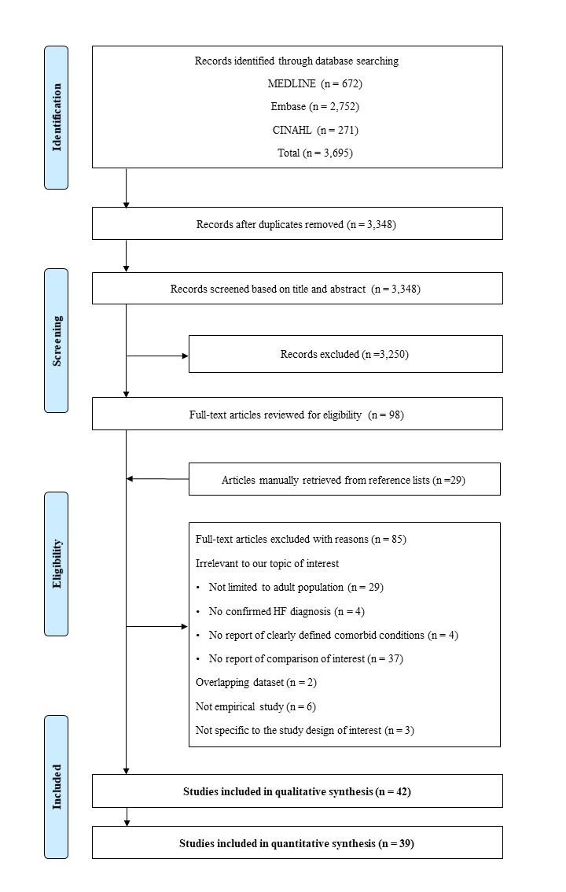
Figure S1. The flow diagram of literature search and selection process

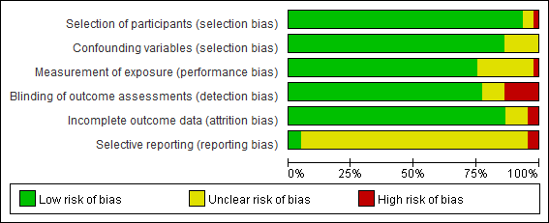
Figure S2. The summary of risk of bias

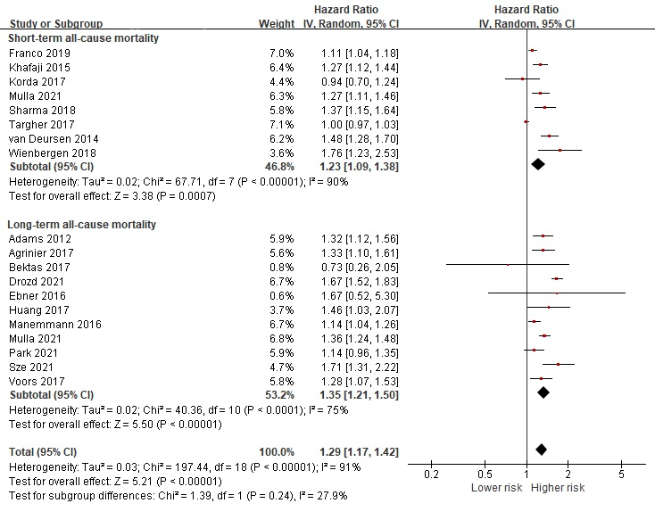

Figure S3. Forest plot of the pooled analysis evaluating the effect of comorbidities on all-cause mortality based on follow-up period
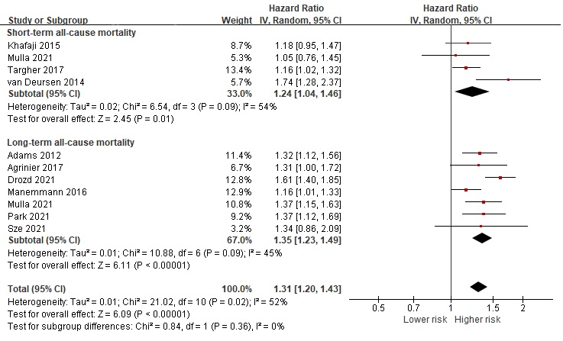
Figure S4. Forest plot of the pooled analysis evaluating the effect of diabetes mellitus on all-cause mortality in heart failure patients based on follow-up period

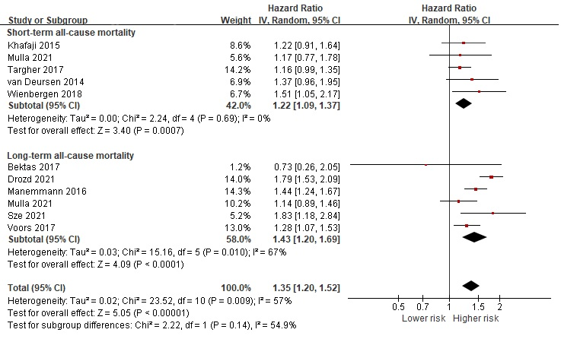
Figure S5. Forest plot of the pooled analysis evaluating the effect of chronic obstructive pulmonary disease on all-cause mortality in heart failure patients based on follow-up period

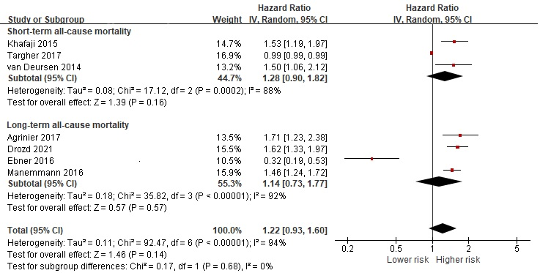
Figure S6. Forest plot of the pooled analysis evaluating the effect of chronic kidney disease on all-cause mortality in heart failure patients based on follow-up period

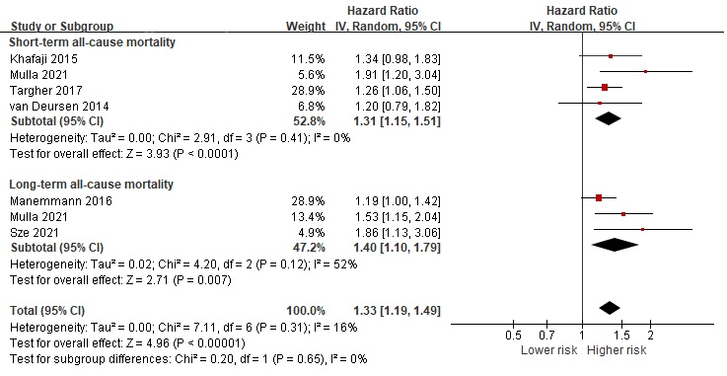
Figure S7. Forest plot of the pooled analysis evaluating the effect of stroke on all-cause mortality in heart failure patients based on follow-up period

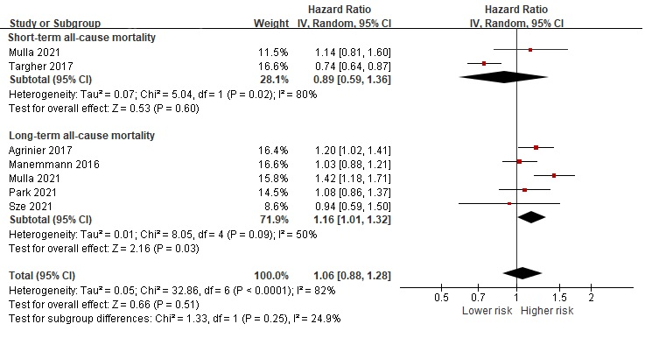
Figure S8. Forest plot of the pooled analysis evaluating the effect of hypertension on all-cause mortality in heart failure patients based on follow-up period

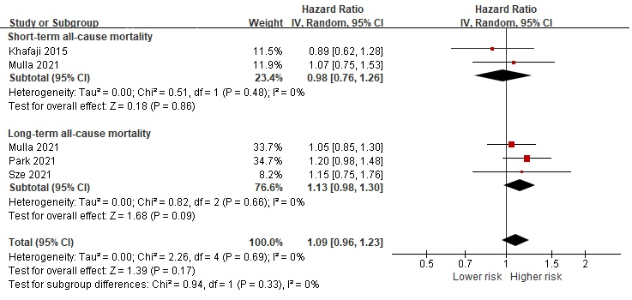
Figure S9. Forest plot of the pooled analysis evaluating the effect of ischemic heart disease on all-cause mortality in heart failure patients based on follow-up period

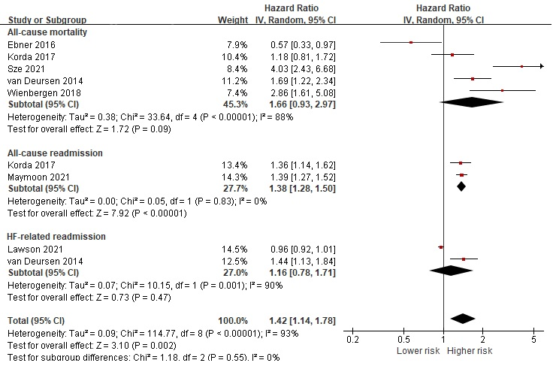
Figure S10. Forest plot of the pooled analysis evaluating the effect of anemia on health outcomes in heart failure patients

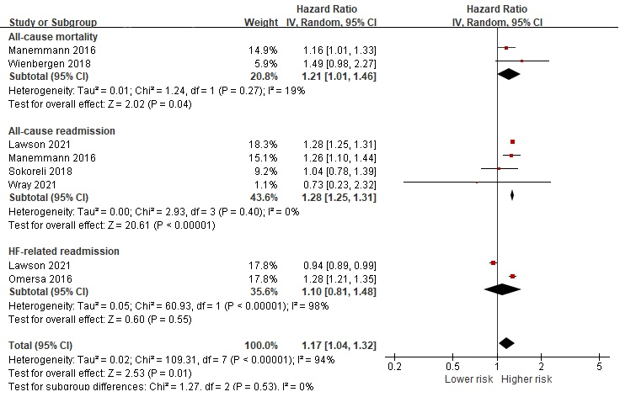
Figure S11. Forest plot of the pooled analysis evaluating the effect of cancer on health outcomes in heart failure patients

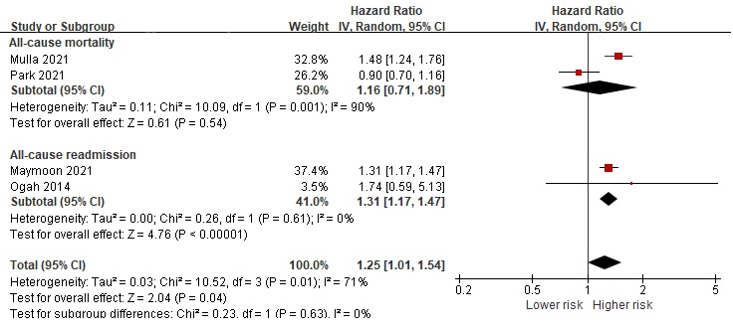
Figure S12. Forest plot of the pooled analysis evaluating the effect of atrial fibrillation on health outcomes in heart failure patients

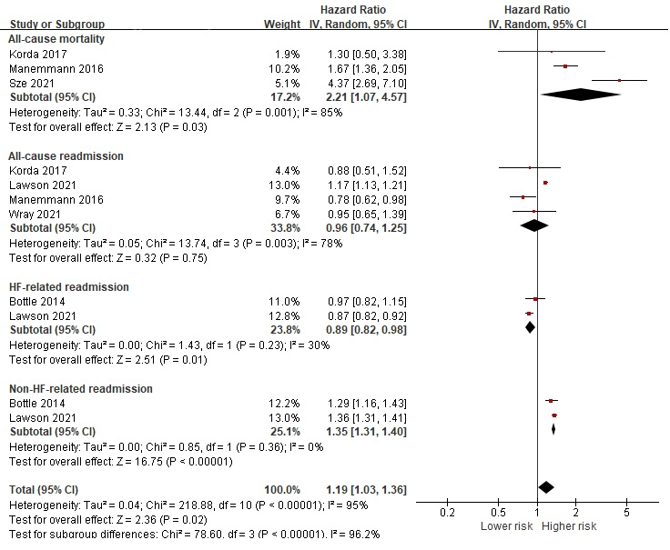
Figure S13. Forest plot of the pooled analysis evaluating the effect of dementia on health outcomes in heart failure patients

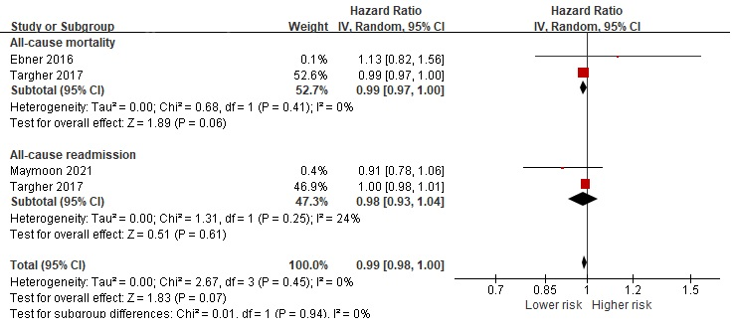
Figure S14. Forest plot of the pooled analysis evaluating the effect of obesity on health outcomes in heart failure patients

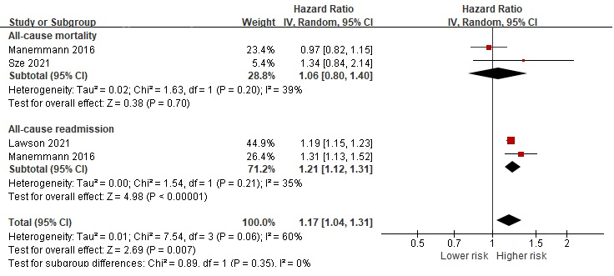
Figure S15. Forest plot of the pooled analysis evaluating the effect of depression on health outcomes in heart failure patients

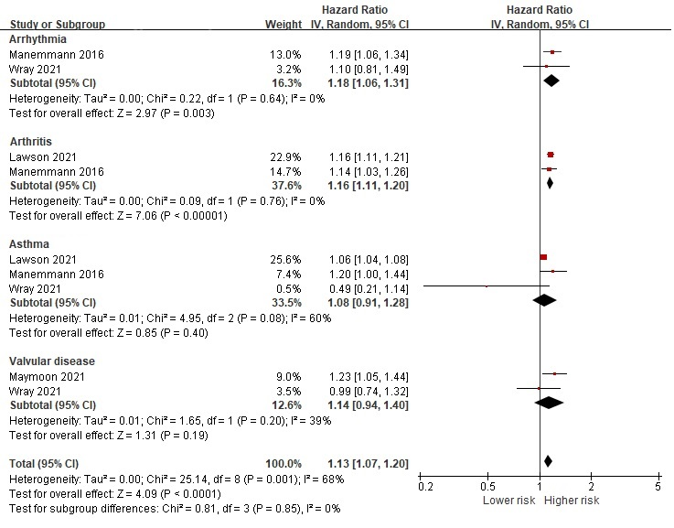
Figure S16. Forest plot of the pooled analysis evaluating the effect of arrhythmia, arthritis, asthma and valvular disease on all-cause readmission in heart failure patients

