Supporting information

Synergistic Effect of Perovskites and Nitrogen-Doped Carbon Hybrid Materials for Improving Oxygen Reduction Reaction
R. Rohib,^{1,2} Saeed Ur Rehman,¹ Eunjik Lee,^{1*} Changki Kim,¹ Hyunjoon Lee,¹ Seung-Bok Lee,^{1,2} Gu-Gon Park^{1,2*}
¹Fuel Cell Laboratory, Korea Institute of Energy Research (KIER), 152 Gajeong-ro, Yuseoung-gu, Daejeon, 34129, Republic of Korea
²Department of Energy Engineering, University of Science and Technology, 217 Gajeong-ro, Yuseong-gu, Daejeon 34113, Republic of Korea
*Corresponding author: ejlee21@kier.re.kr (Eunjik Lee), gugon@kier.re.kr (Gu-Gon Park)

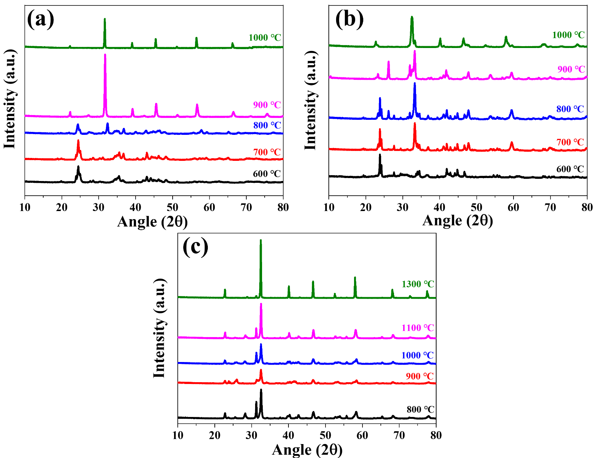
Figure S1 XRD patterns of (a) BSCF, (b) PBCO, (c) NBCFM at different heat treatment temperatures
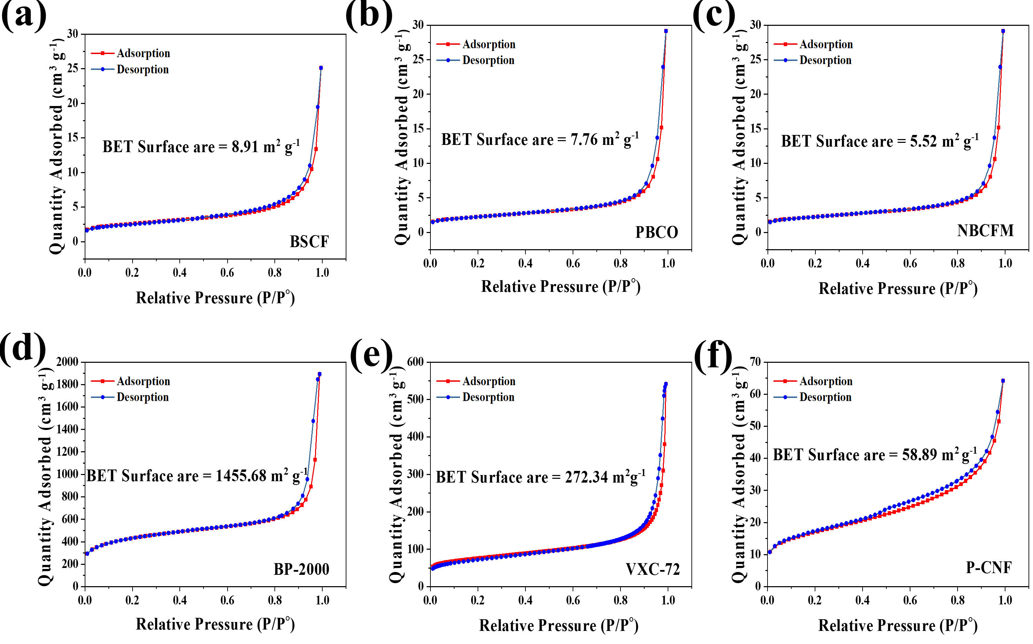
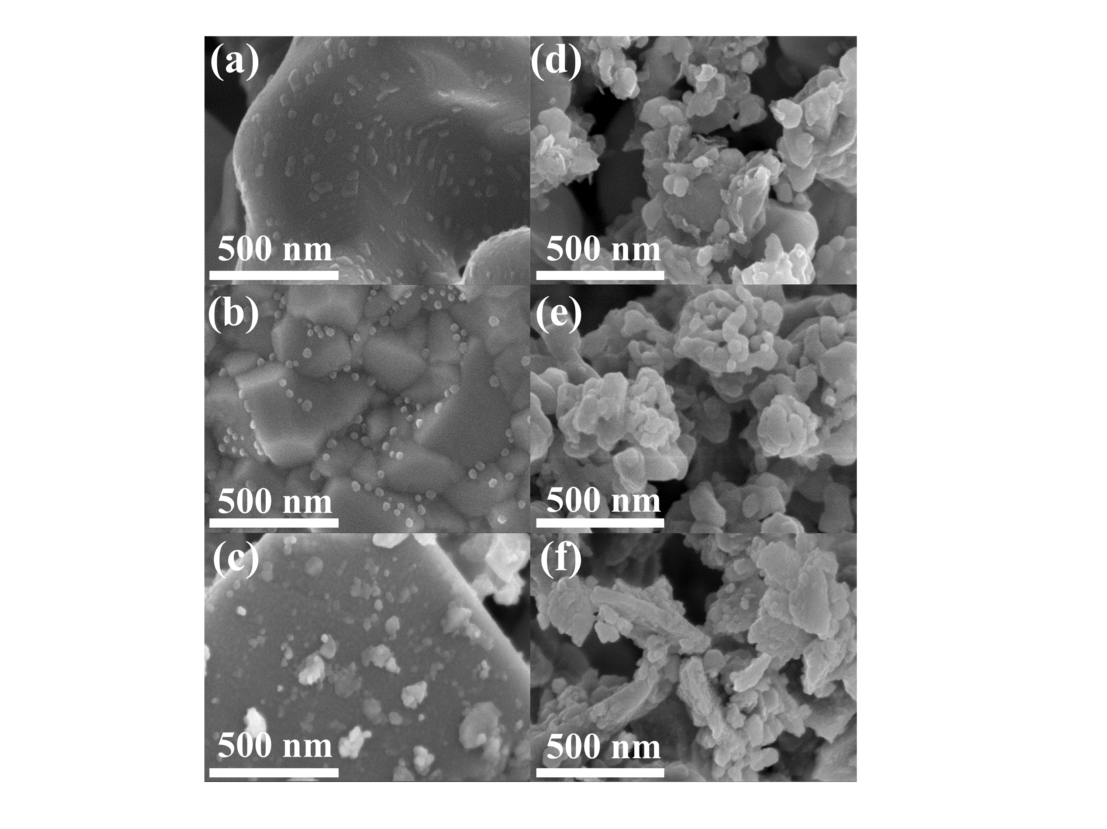
Figure S3 BET analysis of nitrogen adsorption-desorption isotherm curves (a) BSCF, (b) PBCO, (c) NBCFM, (d) BP-2000, (e) VXC-72 and (f) P-CNF samples.
Figure S2 SEM images of perovskite materials (a-c) before and (d-f) after ball mailing. The agglomerated structure with micrometer size successfully reduced became 10 - 100 nm by ball milling process
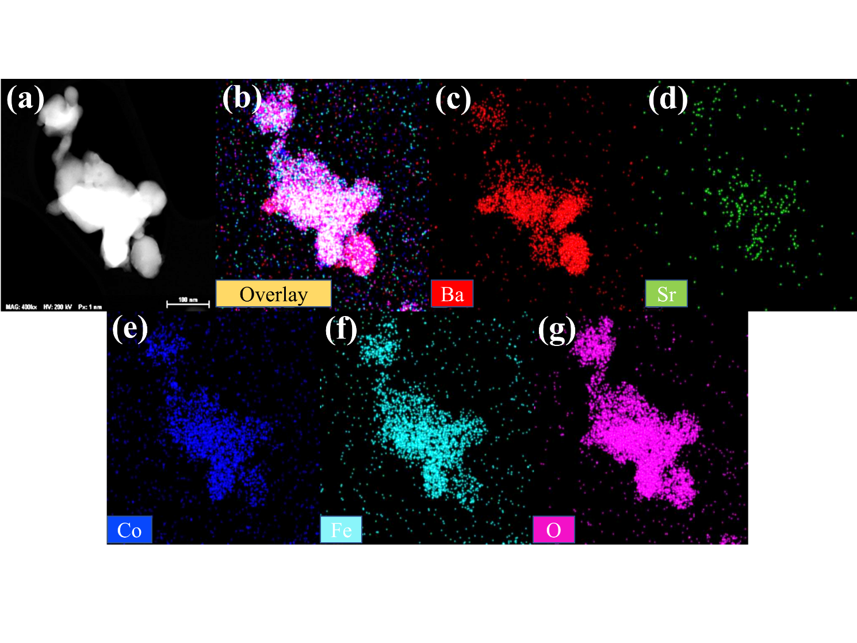
Figure S4 (a) TEM- HAADF image and (b-g) TEM-EDS mapping of BSCF sample
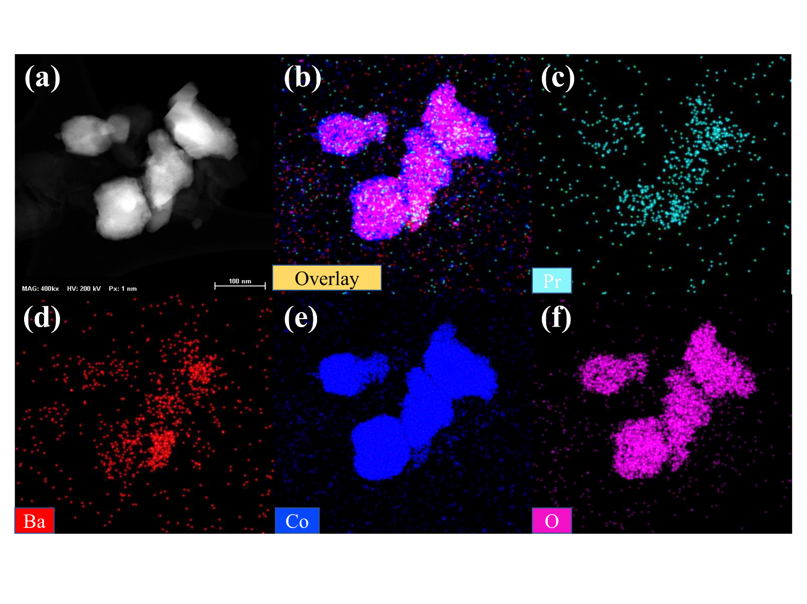
Figure S5 (a) TEM- HAADF image and (b-f) TEM-EDS mapping of PBCO sample

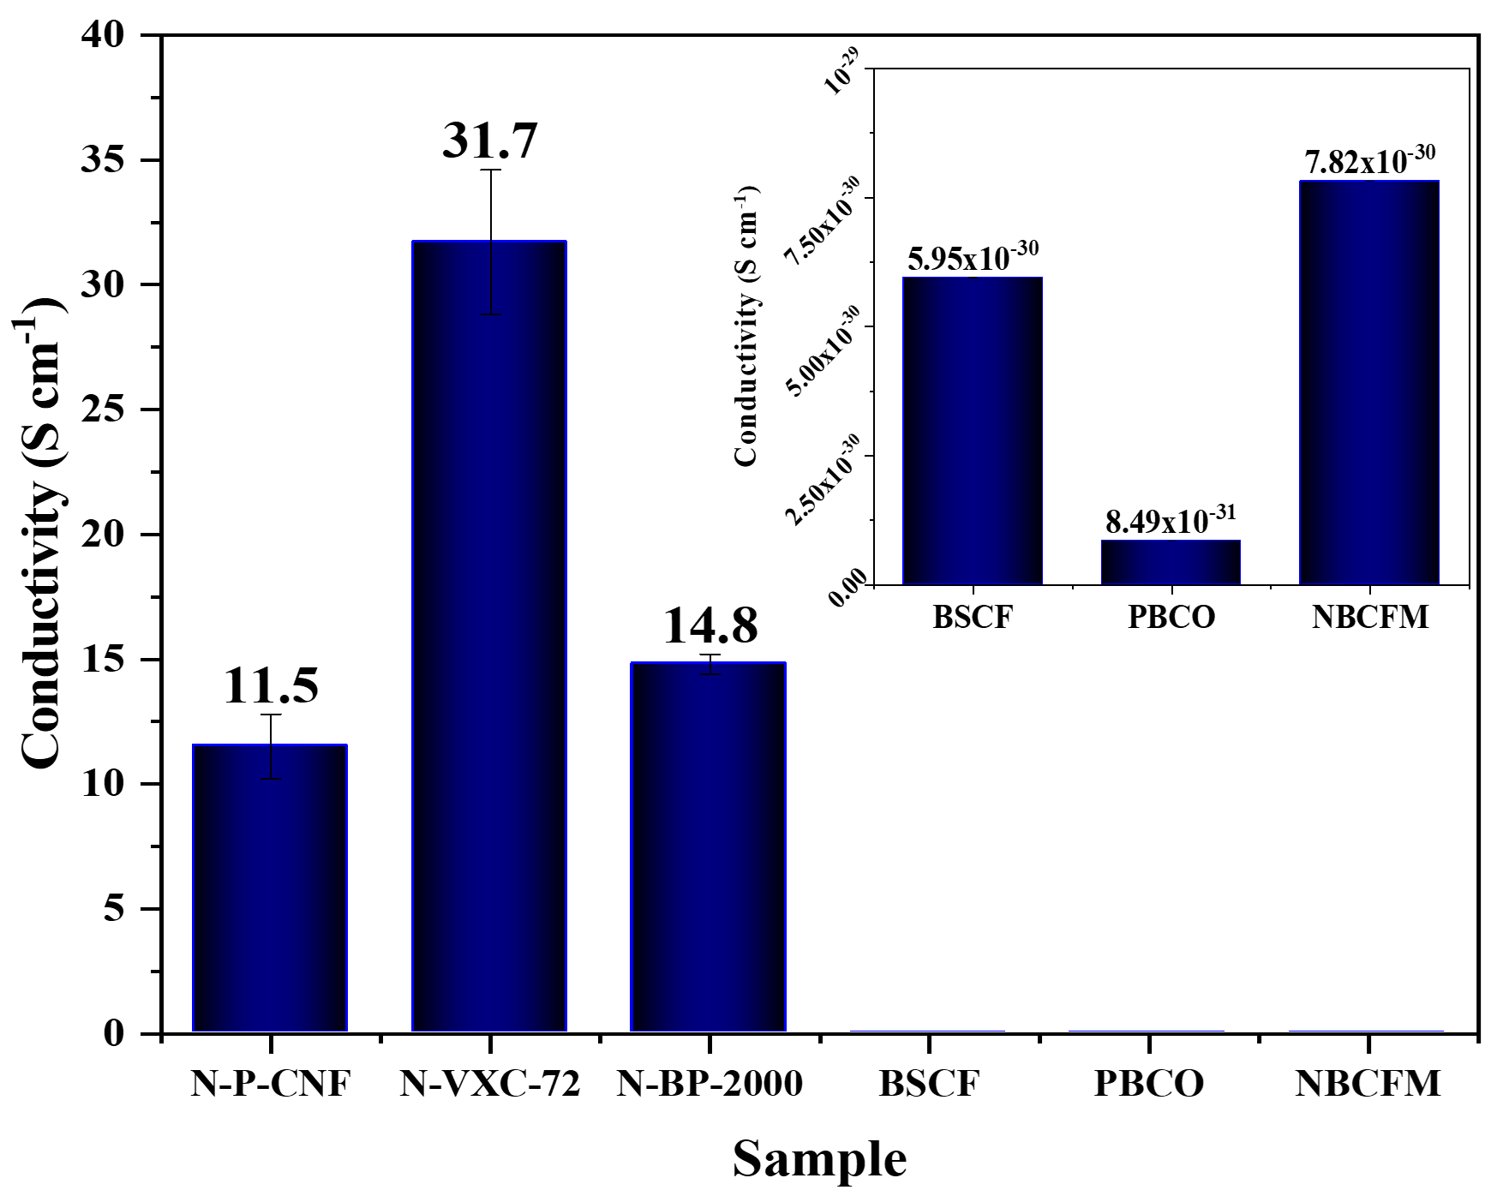
Figure S6. Comparison of powder electrical conductivity of perovskite and N-doped carbon materials. Inset images, the electrical conductivity of perovskite material in different scale bar

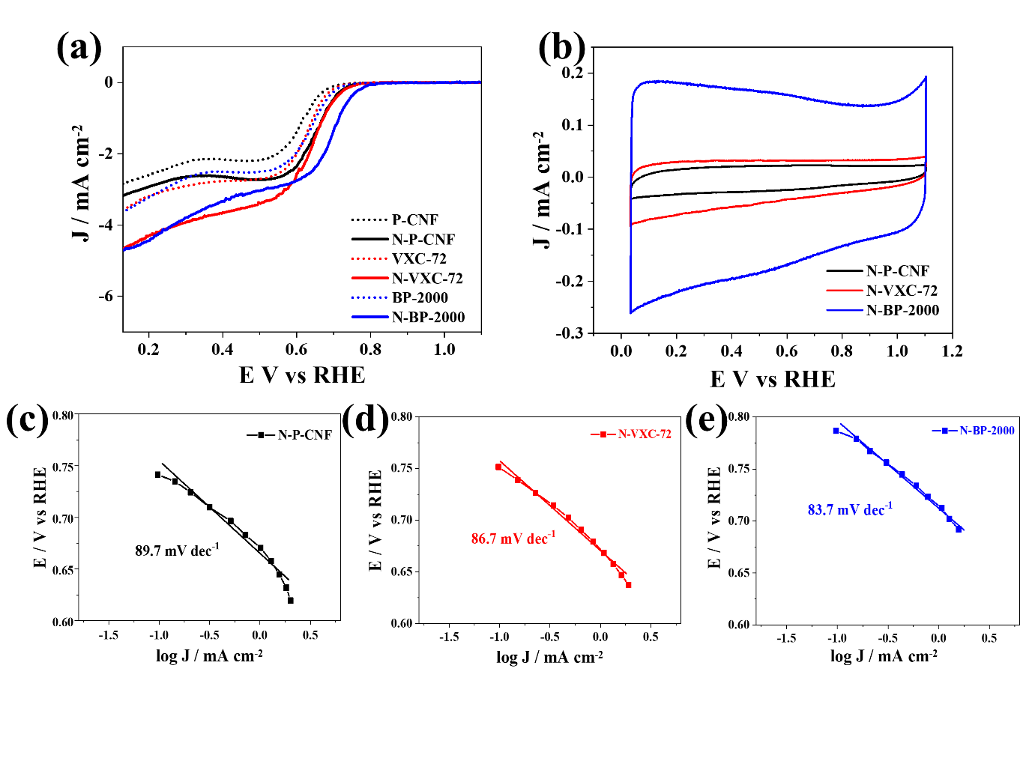
Figure S7. a) The comparison of LSV curves of carbon before and after treatment at 900 °C for 1 h under NH₃ environment. (b) The CVs curve of N-doped carbon shows the carbon capacitance correspond to the carbon surface area. Tafel slop plot obtained from LSV curves was calculated for (c) N-PCNF (d) N-VXC-72, and (e) N-BP-2000
Tabel S1. Electrochemical properties of carbon before and after heat treatment under NH₃ and pure perovskite materials
Material | Half-wave potential  (V) |  |  |  | Current Density  (mA cm⁻²) |  |  | Tafel Slope  (mV dec⁻¹)
Material | Pristine | N-doped |  | Improvement | Pristine | N-doped | Improvement | Pristine | N-doped
P-CNF | 0.59 | 0.64 | 3.2% |  | 2.18 | 2.42 | 11.0% | 97.5 | 89.7
VXC-72 | 0.62 | 0.66 | 4.7% |  | 2.71 | 3.39 | 25.1% | 84.3 | 86.7
BP-2000 | 0.63 | 0.69 | 9.5% |  | 2.63 | 3.14 | 19.4% | 86.8 | 83.7
BSCF | 0.50 | - | - |  | 1.06 | - | - | 169.7 | -
PBCO | 0.56 | - | - |  | 1.56 | - | - | 112.3 | -
NBCFM | 0.57 | - | - |  | 2.26 | - | - | 110.1 | -

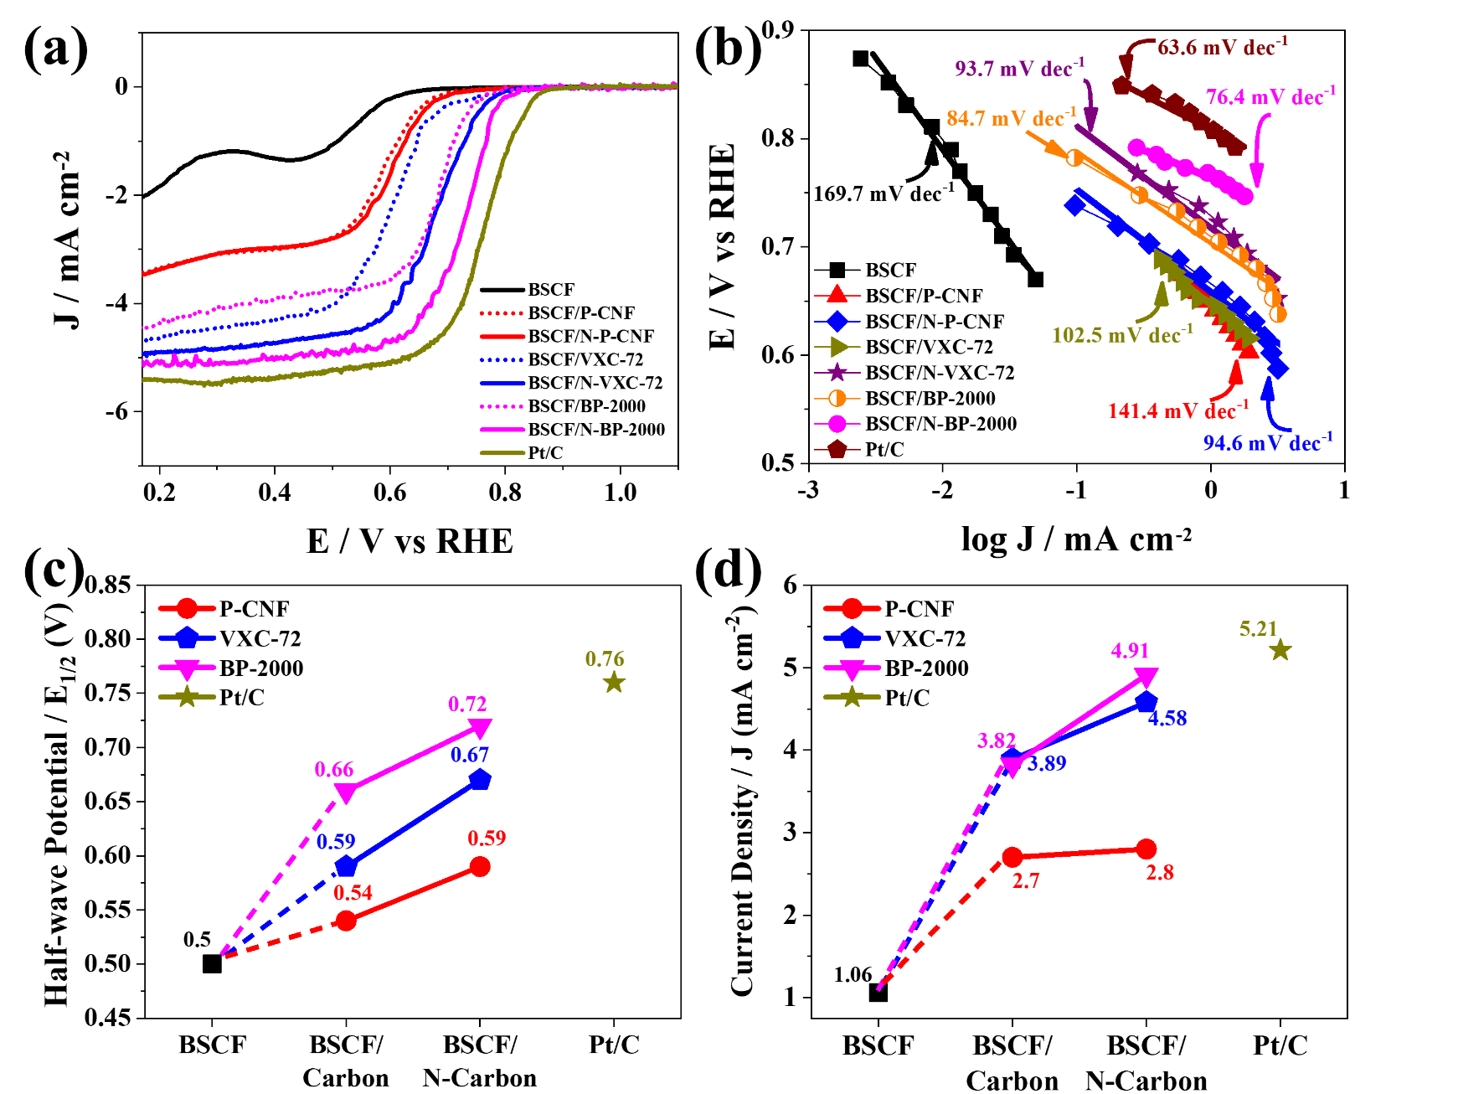
Figure S8. Comparison of ORR polarization curves of pure BSCF and its hybrid using various type of carbon before and after nitriding process; dashed line (pristine carbon) and solid line (N-doped carbon) at the rotating speed 1600 rpm in 0.1 M KOH corresponding to b) Tafel slope. The interpretation of N-doped carbon addition effect on the c) half-wave potential and d) current density of hybridized BSCF .

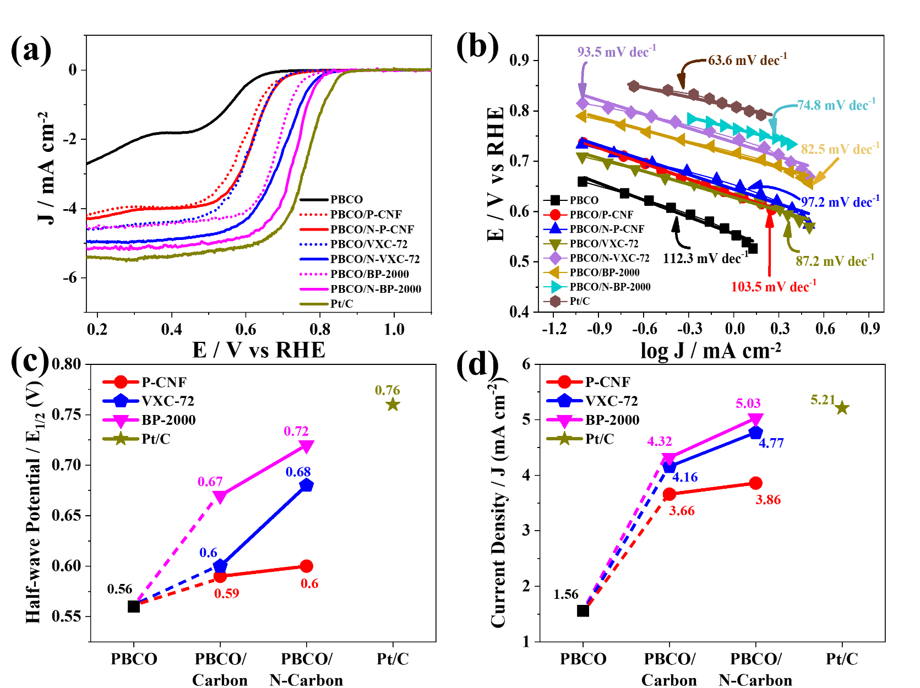
Figure S9 Comparison of ORR polarization curves of pure PBCO and its hybrid using various type of carbon before and after nitriding process; dashed line (pristine carbon) and solid line (N-doped carbon) at the rotating speed 1600 rpm in 0.1 M KOH corresponding to b) Tafel slope. The interpretation of N-doped carbon addition effect on the c) half-wave potential and d) current density of hybridized PBCO .

