Supplementary Figures

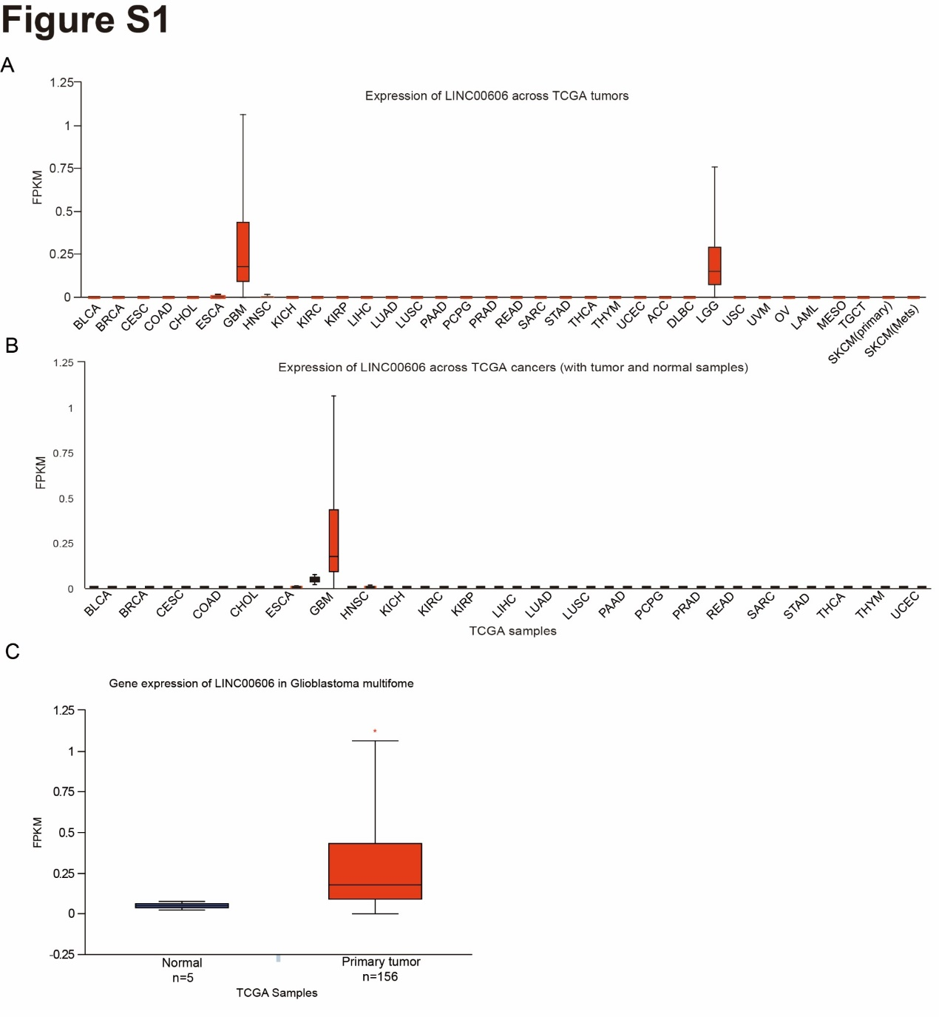
Fig. S1. Expression pattern of LINC00606 according to the pan-cancer and GBM databases.
(A) The pan-cancer expression level of LINC00606 was analyzed in the TCGA database.
(B, C) Analysis of glioma and normal brain tissues in the TCGA database shows that the expression of LINC00606 was significantly higher in glioma than normal brain tissues (normal: n = 5; primary tumors: n = 156).

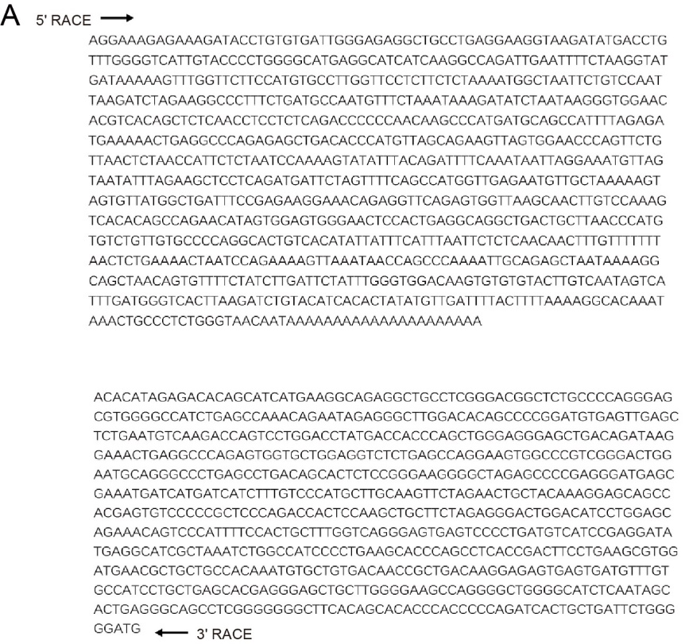
Fig. S1.1. RACE PCR product sequencing for LINC00606.
(A) The 5′-3′ RACE PCR sequencing results for LINC00606. Top: sequencing results for 5′ RACE; bottom: sequencing results for 3′ RACE (only some of the sequencing results are displayed).

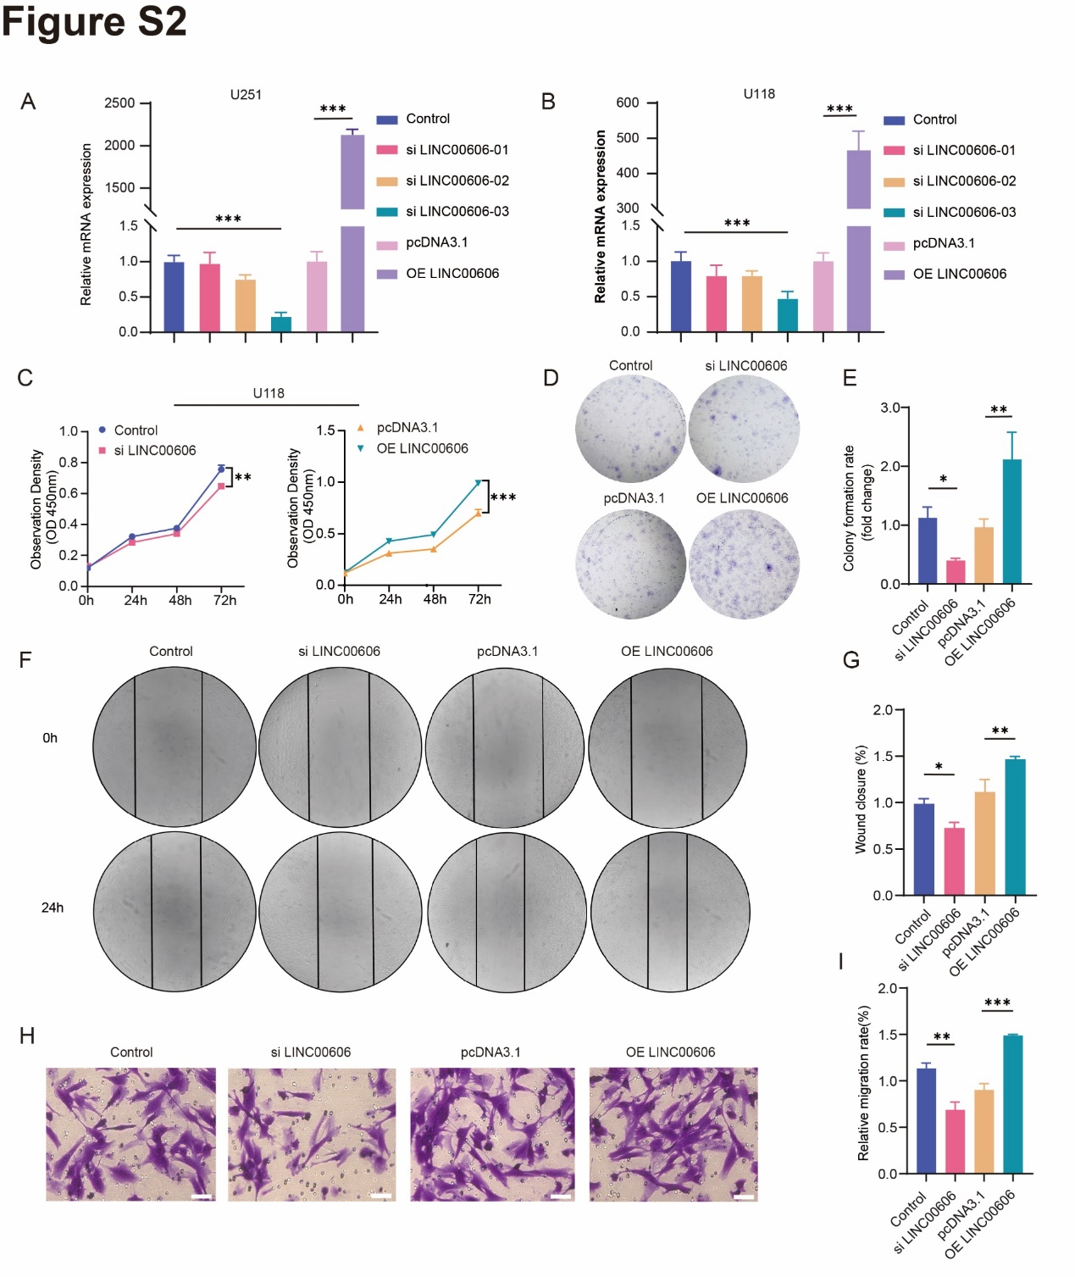
Fig. S2. Knockdown of LINC00606 hinders the tumor-promoting functions of U118 cells.
(A, B) The expression level of LINC00606 following transfection of U251 and U118 cells with control siRNA (Control), LINC00606 siRNA (siLINC00606), control plasmid (pcDNA3.1), and LINC00606-overexpression plasmid (OE LINC00606).
(C) A CCK-8 assay was performed to evaluate the proliferation rate of U118 cells following transfection with control siRNA (Control), LINC00606 siRNA (siLINC00606), control plasmid (pcDNA3.1), and LINC00606-overexpression plasmid (OE LINC00606). The OD value was measured at 450 nm.
(B, C) Colony formation assay showing that LINC00606 overexpression in U118 cells promoted cell proliferation. Statistical analysis of colony numbers was performed using Image J.
(D, E) A wound-healing assay was performed to detect the migration ability of U118 cells following transfection with siLINC00606 or OE LINC00606. Photos were taken at 0 and 24 h. A histogram was used for statistical analysis of wound-healing.
(F, G) A Transwell assay was performed to detect the migration ability of U118 cells following transfection with siLINC00606 or OE LINC00606. The number of migrated cells was analyzed using Image J. Scale bars represent 50μm.
Data are expressed as the mean ± SD of three independent experiments. *P < 0.05; **P < 0.01; ***P < 0.001.

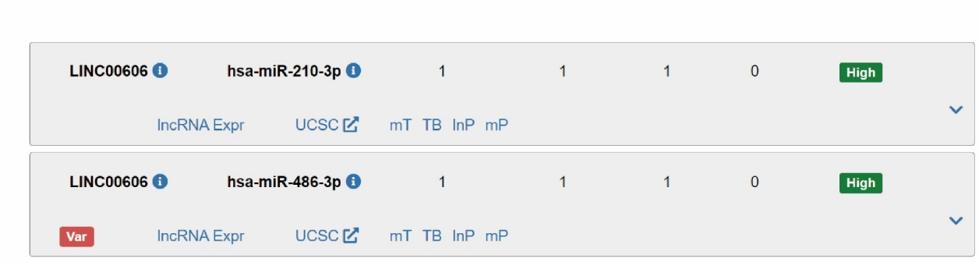
Fig. S3. Target miRNA prediction for LINC00606.
DIANA Tools miRNA–lncRNA results showing two interactions for LINC00606: miR-210-3p and miR-486-3p.

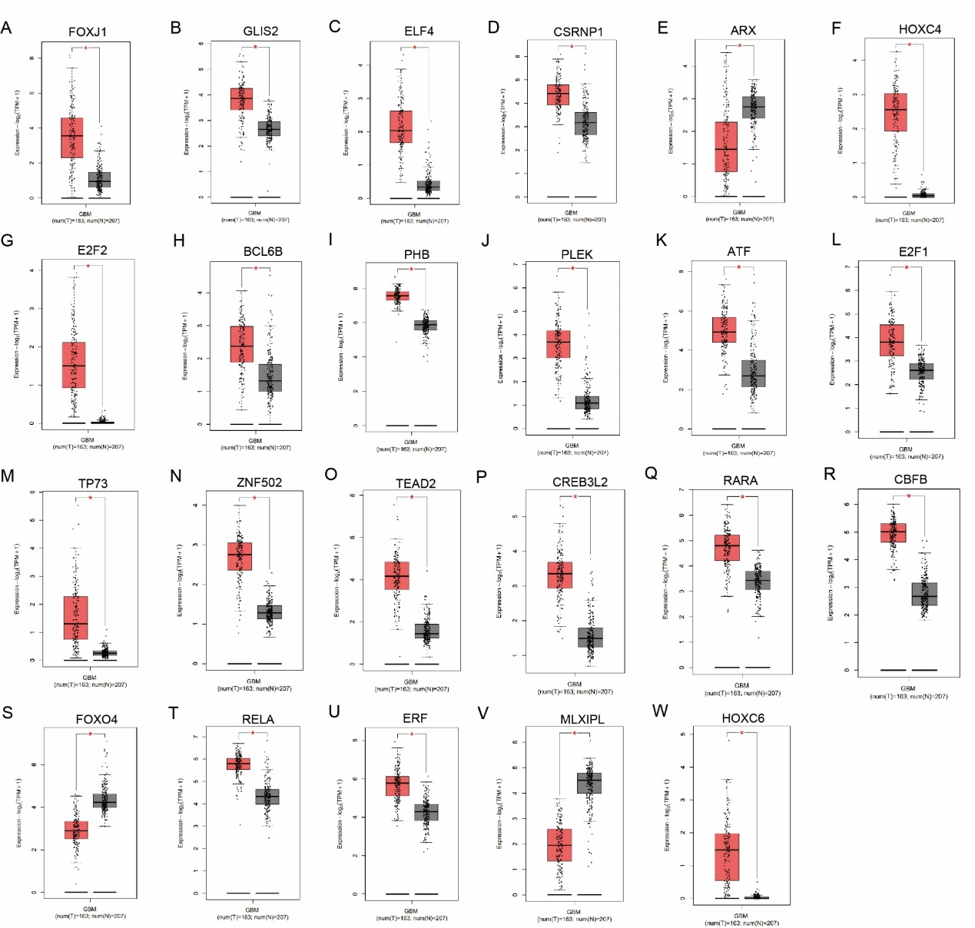
Fig. S4. In the TCGA and GETx databases, 23 transcription factors are differentially expressed between GBM and normal tissues.
(A–W) The TCGA database was used to analyze the differential expression of 23 transcription factors between GBM (n = 163) and normal (n = 207) tissue samples. The 23 transcription factors include: ARX, ATF, BCL6B, CBFB, CREB3L2, CSRNP1, E2F1, E2F2, ELF4, ERF, FOXJ1, FOXO4, CLIS2, HOXC4, HOXC6, MLXIPL, PHB, PLEK, RALA, RARA, TEAD2, TP73, and ZNF502. The results of TCF12 are shown in Fig. 4E.

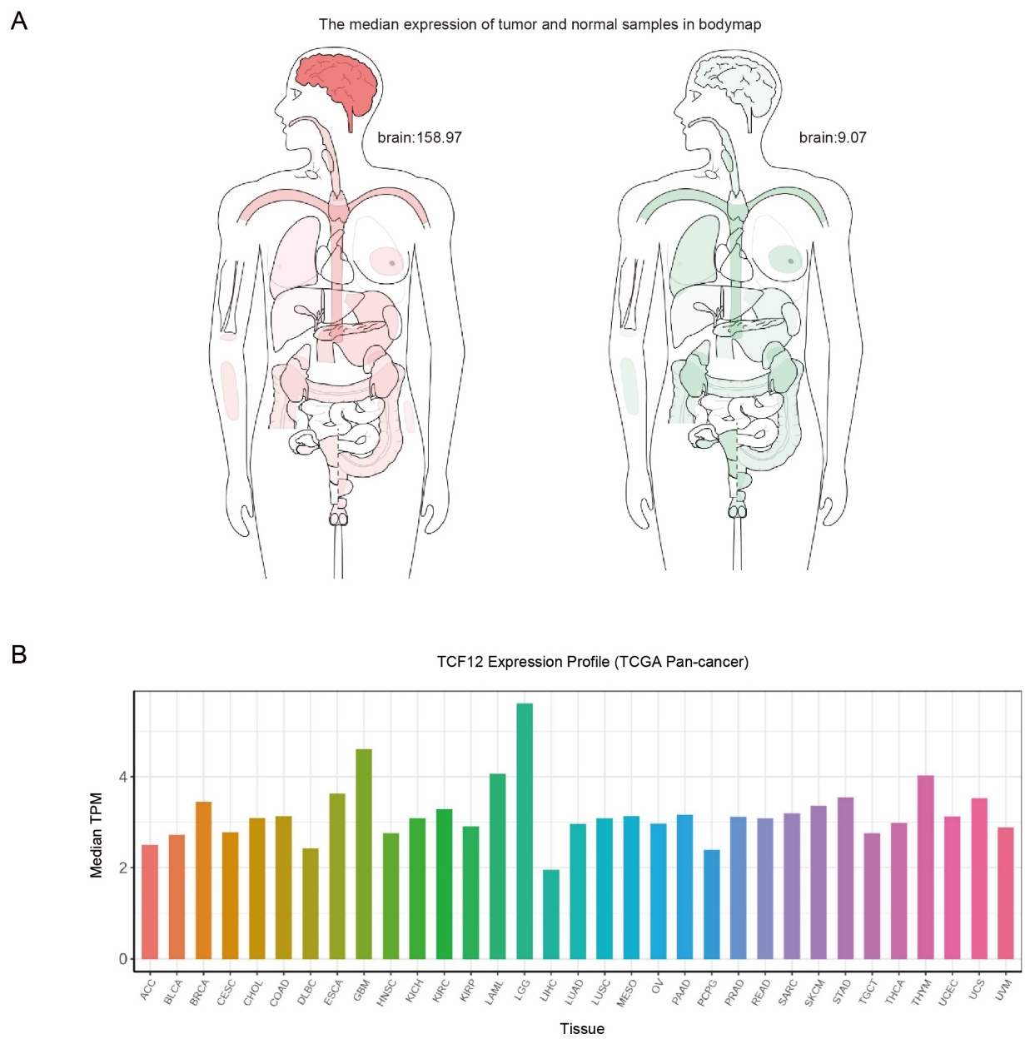
Fig. S5. Analysis of differentially expressed target genes in the TCGA and GETx databases.
(A) The median expression of tumor and normal samples shown as a body map, according to data from the TCGA and GETx databases.
(B) The pan-cancer expression of TCF12 was analyzed using the TCGA and GETx databases.

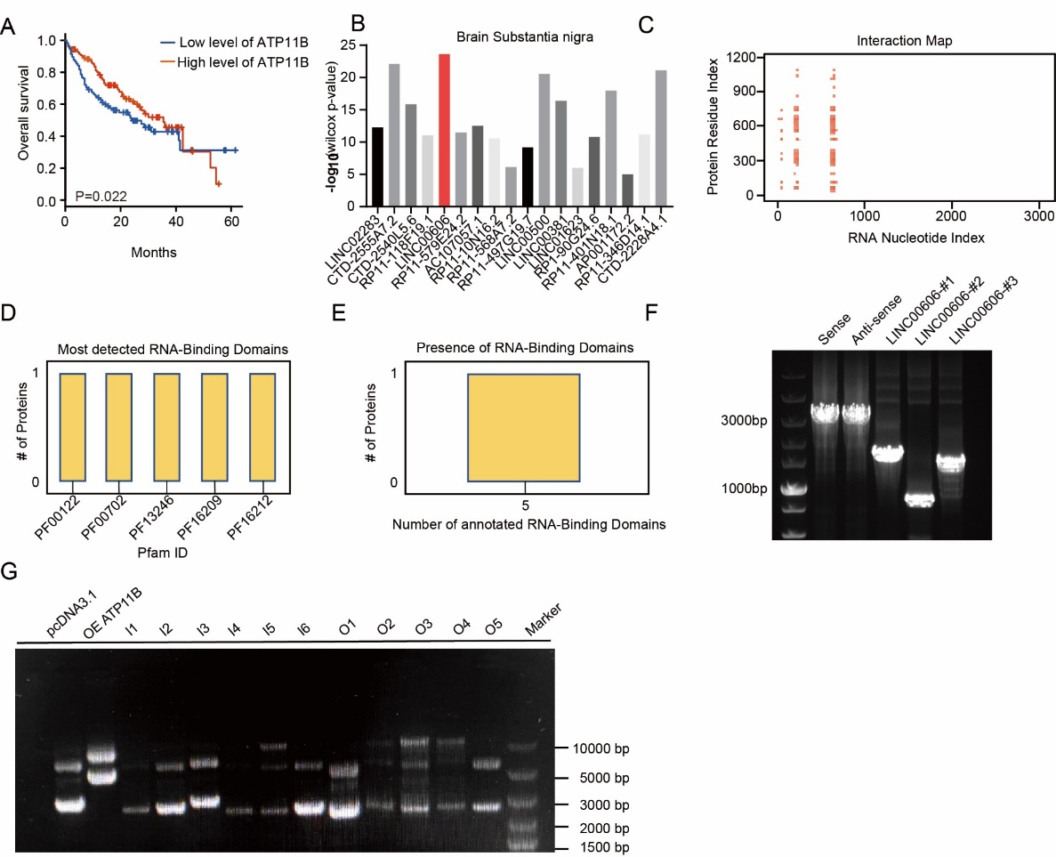
Fig. S6. Relationship between the RNA-binding domains and the protein interaction of LINC00606 and ATP11B.
(A) Kaplan–Meier analysis of the overall survival of 120 GBM patients in the high-level ATP11B (n = 47) and low-level ATP11B (n = 73) groups. (B) Analysis of the relative expression levels of lncRNAs in U251 cells according to RIP-seq (Wilcoxon test).
(C) Interaction map of the RNA nucleotide index (LINC00606) and protein residue index (ATP11B) as predicted by catRAPID.
(D, E) RNA-binding domains in LINC00606 and ATP11B as predicted by catRAPID.
(F) Agarose gel electrophoresis of successfully constructed LINC00606 PCR products truncated according to the secondary structure.
(G) Agarose gel electrophoresis of successfully constructed intracellular and extracellular PCR products of ATP11B truncated according to the transmembrane domains.
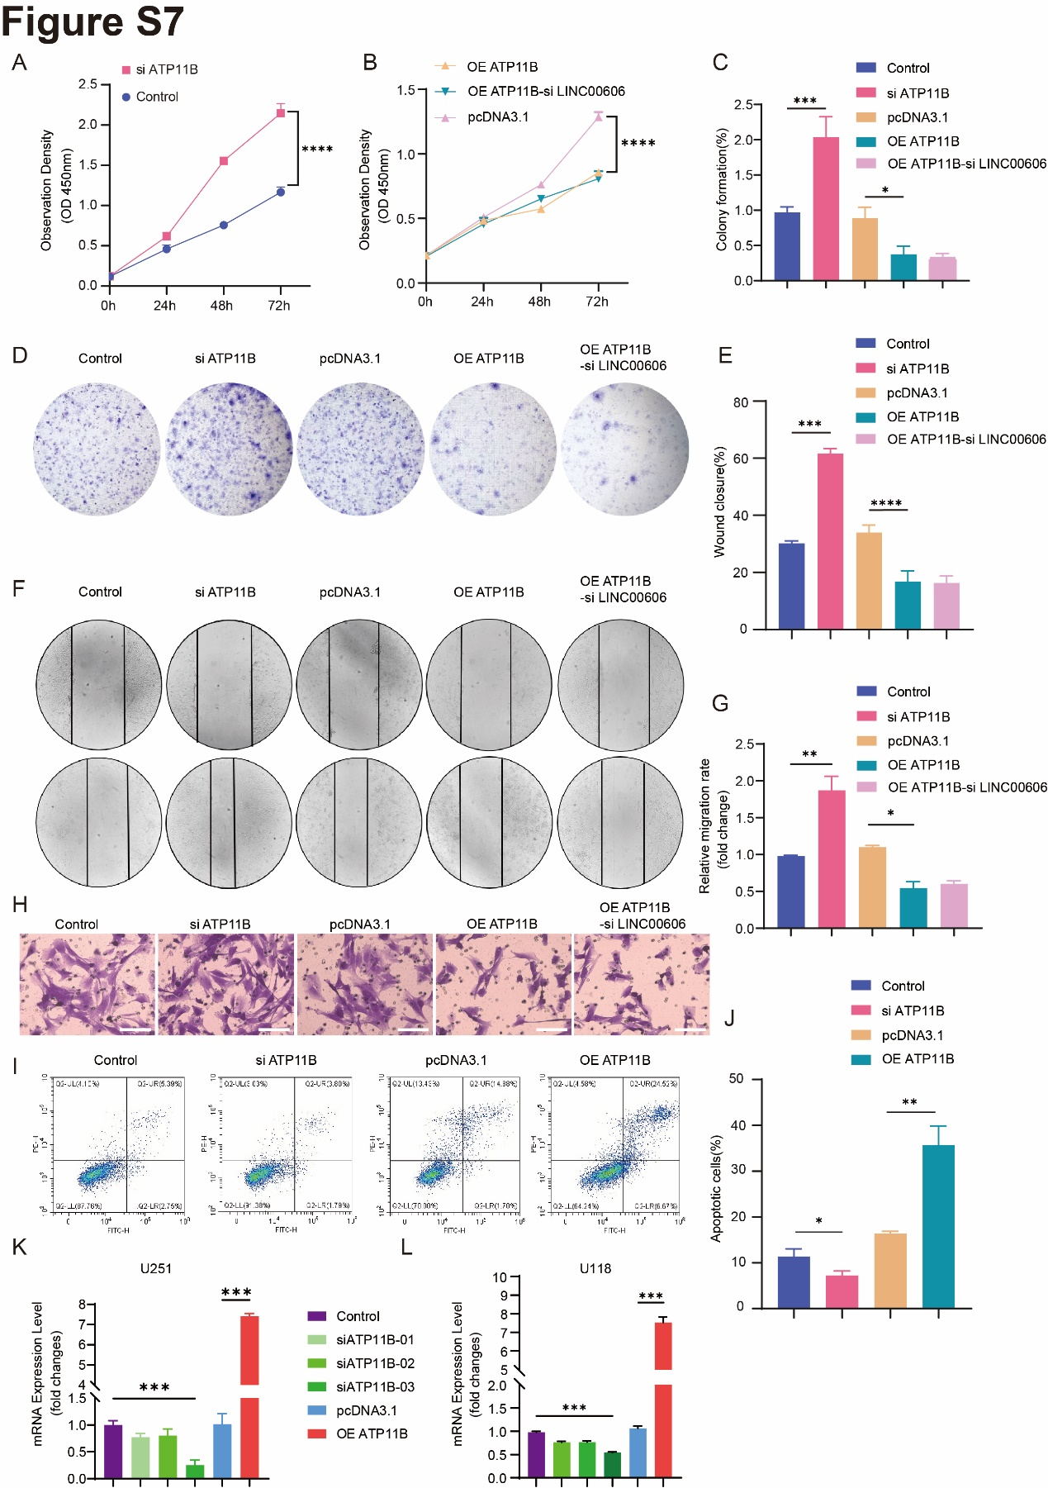
Fig. S7. LINC00606 overexpression promotes the malignant behavior of U118 cells by decreasing ATP11B expression.
(A) The CCK-8 assay was applied to evaluate the proliferation rate of U118 cells following transfection with control siRNA (Control) or ATP11B siRNA (siATP11B).
(B) The CCK-8 assay was applied to evaluate the proliferation rate of U118 cells following transfection with the control plasmid (pcDNA3.1) or the ATP11B-overexpression plasmid (OE ATP11B) and co-transfection of the ATP11B-overexpression plasmid and LINC00606 siRNA.
(C, D) Colony formation assay of U118 cells showing that knockdown of ATP11B promotes cell proliferation. Statistical analysis of colony number was performed using Image J.
(E, F) A wound-healing assay was used to detect the migration ability of U118 cells with or without siATP11B and OE ATP11B. Photos were taken at 0 and 24 h. A histogram was used for statistical analysis of wound-healing.
(G, H) A Transwell assay was performed to detect the migration ability of U118 cells with or without siATP11B and OE ATP11B. The number of migrated cells was analyzed using Image J. Scale bars represent 100μm.
(I, J) Flow cytometry was used to analyze the apoptosis level of U118 cells with or without knockdown and overexpression of ATP11B.
(K, L) The expression level of ATP11B following transfection of U251 and U118 cells with control siRNA (Control), ATP11B siRNA (siATP11B), control plasmid (pcDNA3.1), and ATP11B-overexpression plasmid (OE ATP11B).
Data are expressed as the mean ± SD of three independent experiments. *P < 0.05; **P < 0.01; ***P < 0.001.

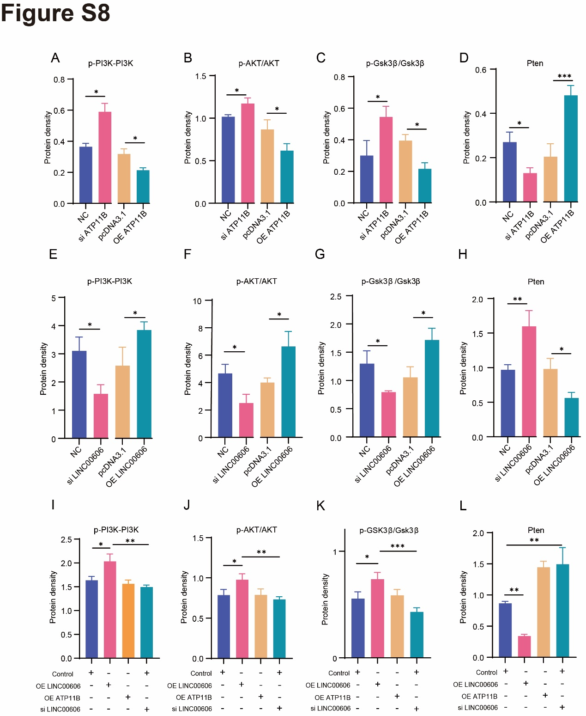
Fig. S8. Quantitative analysis of protein expression.
(A–L) Immunoblotting of p-PI3K, PI3K, p-AKT, AKT, p-GSK3β, GSK3β, and PTEN expression levels regulated by ATP11B and LINC00606 in U251 cells. Endogenous vinculin or GAPDH was used as the internal control.
Data are expressed as the mean ± SD of three independent experiments. *P < 0.05; **P < 0.01; ***P < 0.001.

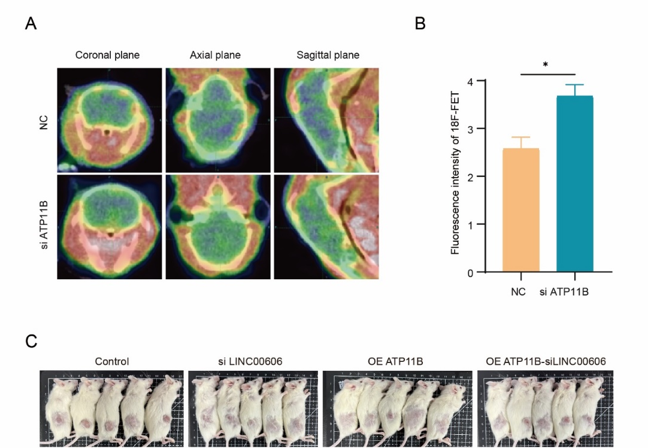
Fig. S9. ATP11B inhibits glioma cell growth in nude mice.
(A) ¹⁸F-FET PET images of the mouse brain showing the expression level of L-type acid amino transporter (LAT) (green).
(B) Quantitative analysis of the fluorescence intensity of ¹⁸F-FET in the mouse brain injected with U251 cells expressing control siRNA (NC) and ATP11B siRNA (siATP11B).
Data are expressed as the mean ± SD, n ≥ 3; *P < 0.05.
(C) The subcutaneous tumor model in vivo; sizes of the xenografted tumor samples were recorded by photography.

