SUPPORTING INFORMATION

Chemistry
- General Methods and Materials. All reagents and solvents were obtained from commercially available sources and were used without further purification. 3-(4-(aminomethyl)-1-oxoisoindolin-2-yl)piperidine-2,6-dione HCl salt, Catalog#:SYNNAAX405291 was obtained from Synnovator, INC., 3-(5-amino-1-oxoisoindolin-2-yl)piperidine-2,6-dione (EN300-1272845) and 3-(5-bromo-1-oxoisoindolin-2-yl)piperidine-2,6-dione (EN300-6478894) were obtained from Enamine. Reactions were set up in air and carried out under nitrogen atmosphere. Nuclear magnetic resonance (NMR) spectra were obtained on a Bruker NMR spectrometer at 500 MHz for 1H-NMR spectra and 125 MHz for 13C-NMR spectra. Chemical shifts (ppm) are reported relative to the solvent peak. Signals are designated as follows: s, singlet; d, doublet; dd, doublet of doublet; t, triplet; q, quadruplet; m, multiplet. Coupling constants (J) are expressed in Hertz. High resolution mass spectral data were obtained on a Waters Xevo G2 QTof mass spectrometer. The purity of final compounds was performed on an Acquity UPLC BEH C18 1.7 µm, 2.1 x 50 mm column (Waters Corporation, Milford, MA) using an Acquity ultra performance liquid chromatography system. The flow rate was 0.7 mL/min. The sample injection volume was 3 µL. The UPLC column was maintained at 50 °C and the gradient program started at 90% A (0.1% formic acid in MilliQ H2O), changed to 95% B (0.1% formic acid in Acetonitrile) over 2.5 min, held for 0.35 minutes, then to 90% A over 0.05 minutes.
N-((2-(2,6-dioxopiperidin-3-yl)-1-oxoisoindolin-4-yl)methyl)-4-fluorobenzamide (SJ7095). To a vial equipped with a stir bar was added 3-(4-(aminomethyl)-1-oxoisoindolin-2-yl)piperidine-2,6-dione HCl salt (0.092 mmol, 1.0 equiv) and THF (500 µL) followed by 4-fluorobenzoyl chloride (0.18 mmol, 2.0 equiv) and DIPEA (0.27 mmol, 3 equiv). The reaction was stirred at room temperature for 2 hr. The reaction was checked by UPLC then diluted with DMSO (1 mL). Purification was performed on the Waters purification/analytical LC/UV/ELSD system and the gradient program started at 90% A (0.1% formic acid in MilliQ H₂O), changed to 40% B (0.1% formic acid in Acetonitrile) over 10.3 min, then changed to 95% B over 2 min, held for 1 minutes, then changed to 90% A over 0.25 minutes and held for 1.75 min. The flow rate is 30 mL/min. Evaporation was carried out using a TurboVap® LV evaporator to afford N-((2-(2,6-dioxopiperidin-3-yl)-1-oxoisoindolin-4-yl)methyl)-4-fluorobenzamide (SJ7095, 15 mg, 0.038 mmol, 41%. Purity > 95%). ¹H NMR (500 MHz, DMSO) δ 10.95 (s, 1H), 9.06 (t, J = 5.8 Hz, 1H), 7.89 (dd, J = 8.4, 5.6 Hz, 2H), 7.57 (d, J = 7.4 Hz, 1H), 7.49 (d, J = 7.5 Hz, 1H), 7.44 (t, J = 7.5 Hz, 1H), 7.28 – 7.21 (m, 2H), 5.08 (dd, J = 13.3, 5.1 Hz, 1H), 4.53 – 4.44 (m, 3H), 4.37 (d, J = 17.3 Hz, 1H), 2.86 (ddd, J = 18.1, 13.4, 5.3 Hz, 1H), 2.60 – 2.52 (m, 1H), 2.37 – 2.27 (m, 1H), 2.02 – 1.92 (m, 1H). ¹³C NMR (126 MHz, MeOD) δ 173.27, 170.77, 170.05, 167.65, 164.92 (d, J = 251 Hz), 140.50, 134.01, 131.56, 131.27, 130.25, 129.60 (d, J = 9.07 Hz), 128.42, 122.11, 115.09 (d, J = 22.3 Hz), 52.26, 46.78, 39.92, 30.96, 22.73. LCMS (m/z) M+H = 396.5. HRMS: calcd for C₂₁H₁₈FN₃O₄ + H: 396.1359; found: 396.1348 [M + H].

N-(2-(2,6-dioxopiperidin-3-yl)-1-oxoisoindolin-5-yl)-3-methylbenzamide (SJ0040). To a vial equipped with a stir bar was added 3-(5-amino-1-oxoisoindolin-2-yl)piperidine-2,6-dione (0.075 mmol, 1.0 equiv) and THF (500 µL) followed by 3-methylbenzoyl chloride (0.150 mmol, 2.0 equiv) and DIPEA (0.225 mmol, 3 equiv). The reaction was stirred at room temperature for 2 hrs. The reaction was checked by UPLC then diluted with DMSO (1 mL). Purification was performed on the Waters purification/analytical LC/UV/ELSD system and the gradient program started at 90% A (0.1% formic acid in MilliQ H₂O), changed to 40% B (0.1% formic acid in Acetonitrile) over 10.3 min, then changed to 95% B over 2 min, held for 1 minutes, then changed to 90% A over 0.25 minutes and held for 1.75 min. The flow rate is 30 mL/min. Evaporation was carried out using a TurboVap® LV evaporator to afford
N-(2-(2,6-dioxopiperidin-3-yl)-1-oxoisoindolin-5-yl)-3-methylbenzamide (SJ0040, 14 mg, 0.038 mmol, 50%, Purity > 95%). ¹H NMR (500 MHz, DMSO) δ 11.02 (s, 1H), 10.55 (s, 1H), 8.17 (d, J = 1.8 Hz, 1H), 7.86 (dd, J = 8.3, 1.8 Hz, 1H), 7.83 – 7.76 (m, 2H), 7.74 (d, J = 8.3 Hz, 1H), 7.50 – 7.43 (m, 2H), 5.12 (dd, J = 13.3, 5.2 Hz, 1H), 4.50 (d, J = 17.2 Hz, 1H), 4.36 (d, J = 17.2 Hz, 1H), 2.94 (ddd, J = 17.3, 13.7, 5.4 Hz, 1H), 2.68 – 2.59 (m, 1H), 2.48 – 2.34 (m, 4H), 2.11 – 1.99 (m, 1H). ¹³C NMR (126 MHz, DMSO) δ 173.42, 171.59, 168.37, 166.60, 143.58, 142.96, 138.30, 135.12, 132.92, 128.87, 128.68, 127.17, 125.42, 123.99, 120.41, 114.86, 52.05, 47.67, 31.69, 22.99, 21.43. LCMS (m/z) M+H = 378.5. HRMS: calcd for C₂₁H₁₉N₃O₄ + H: 378.1454; found: 378.1451 [M + H].
3-(5-(benzo[d]isoxazol-3-ylamino)-1-oxoisoindolin-2-yl)piperidine-2,6-dione (SJ3149). To a vial equipped with a stir bar was added 3-(5-bromo-1-oxoisoindolin-2-yl)piperidine-2,6-dione (0.31 mmol, 1.0 equiv), benzo[d]isoxazol-3-amine (0.46 mmol, 1.5 equiv), (9,9-dimethyl-9H-xanthene-4,5-diyl)bis(diphenylphosphane) (Xantphos, 0.031 mmol, 0.1 equiv), Tris(dibenzylideneacetone)dipalladium (0.031 mmol, 0.1 equiv) and potassium carbonate (0.62 mmol, 2.0 equiv), followed by DMSO (3mL). The reaction was heated to 120 ºC in a microwave reactor for 1 hr. The reaction mixture was checked by UPLC and filtered through a pile of celite. Purification was performed on the Waters purification/analytical LC/UV/ELSD system and the gradient program started at 80% A (0.1% formic acid in MilliQ H₂O), changed to 60% B (0.1% formic acid in Acetonitrile) over 10.5 min, then changed to 95% B over 1.5 min, held for 0.80 minutes, then changed to 80% A over 0.2 minutes and held for 2 min. The flow rate is 30 mL/min. Evaporation was carried out using a TurboVap® LV evaporator to afford 3-(5-(benzo[d]isoxazol-3-ylamino)-1-oxoisoindolin-2-yl)piperidine-2,6-dione (SJ3149, 22 mg, 0.058 mmol, 19%, Purity > 95%). ¹H NMR (500 MHz, DMSO) δ 10.92 (s, 1H), 9.93 (s, 1H), 8.15 – 8.07 (m, 1H), 7.95 (d, J = 1.8 Hz, 1H), 7.71 – 7.62 (m, 2H), 7.63 – 7.56 (m, 2H), 7.35 (ddd, J = 8.0, 5.7, 2.2 Hz, 1H), 5.03 (dd, J = 13.3, 5.2 Hz, 1H), 4.42 (d, J = 17.1 Hz, 1H), 4.28 (d, J = 17.1 Hz, 1H), 2.85 (ddd, J = 17.2, 13.6, 5.4 Hz, 1H), 2.58 – 2.51 (m, 1H), 2.34 – 2.24 (m, 1H), 1.98 – 1.90 (m, 1H). ¹³C NMR (126 MHz, DMSO) δ 173.41, 171.67, 168.47, 161.62, 155.36, 144.46, 144.39, 131.25, 124.86, 124.41, 123.46, 122.18, 117.93, 116.89, 111.93, 110.16, 51.99, 47.66, 31.72, 23.06. LCMS (m/z) M+H = 377.4. HRMS: calcd for C₂₀H₁₆N₄O₄ + H: 377.1250; found: 377.1252 [M + H].

Analytical spectrums for SJ7095 (HNMR, CNMR, UPLC/MS and HRMS)

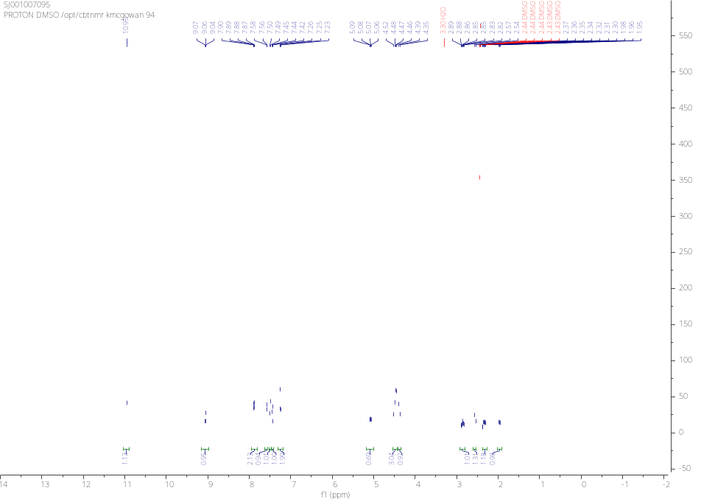
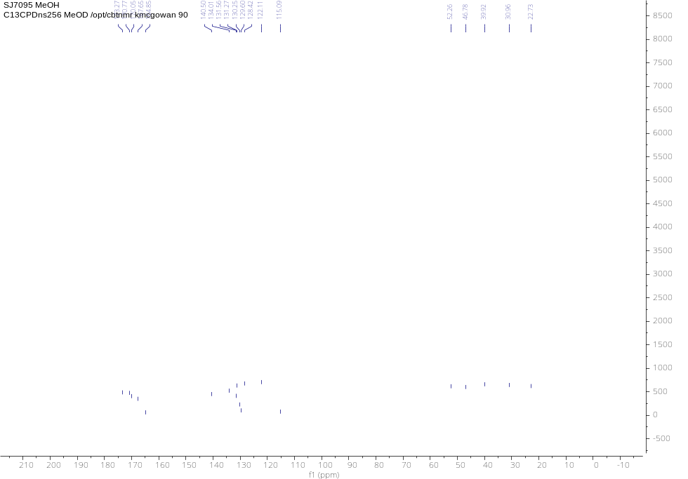
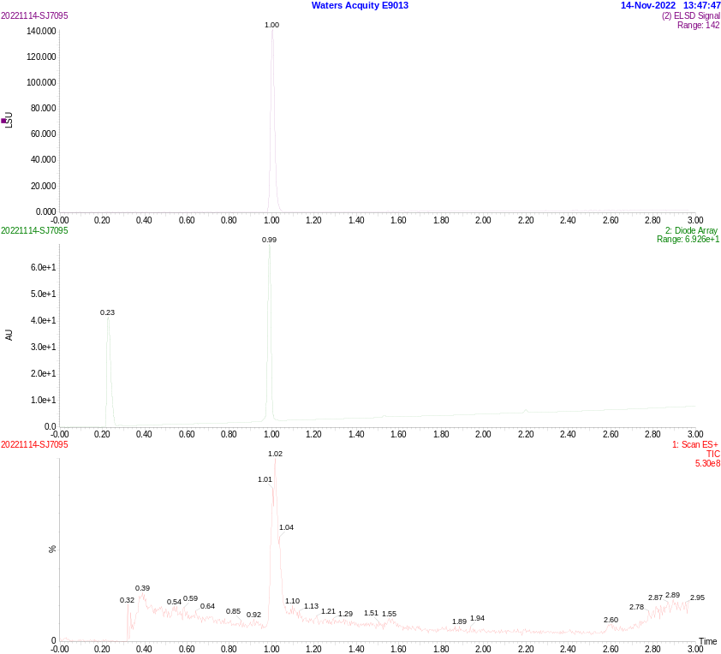

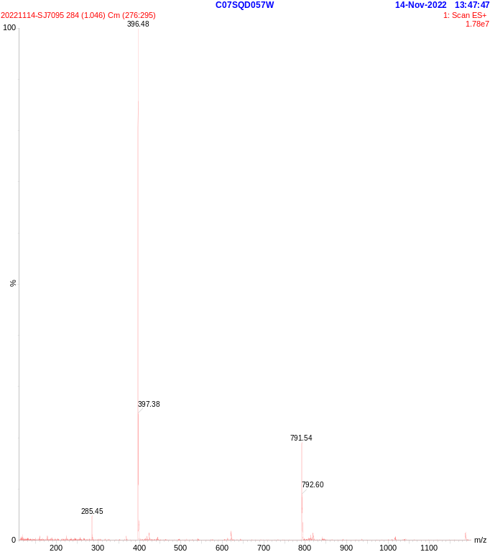
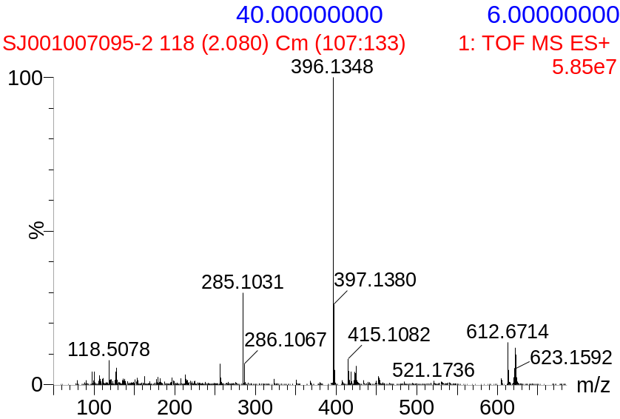

Analytical spectrums for SJ0040 (HNMR, CNMR, UPLC/MS and HRMS)

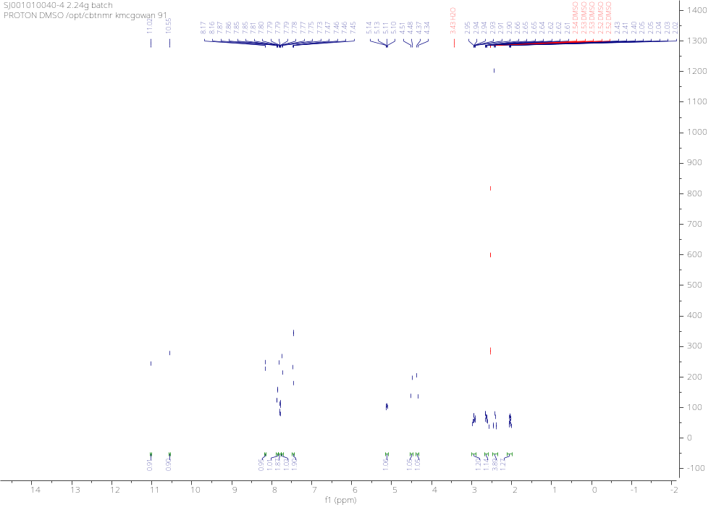
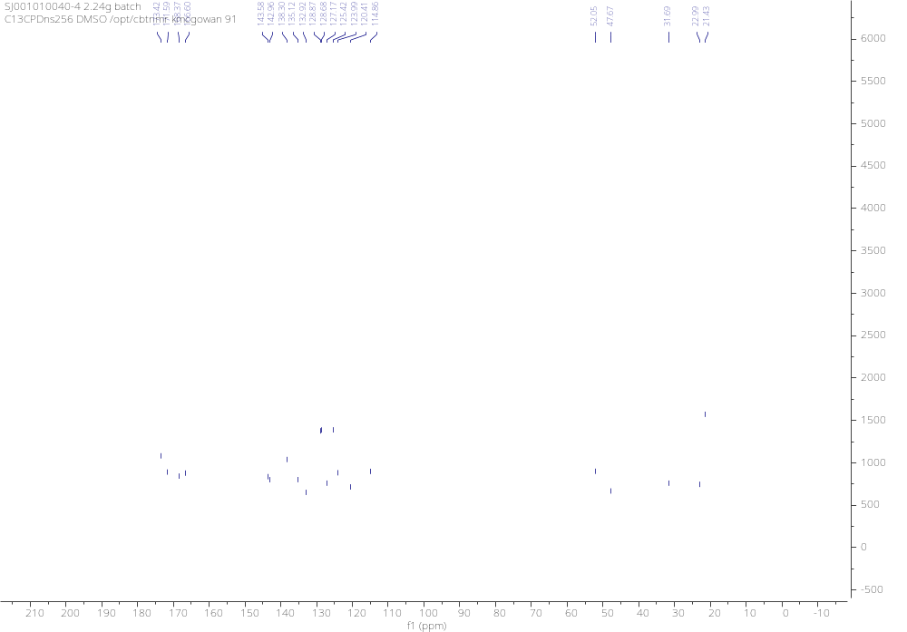
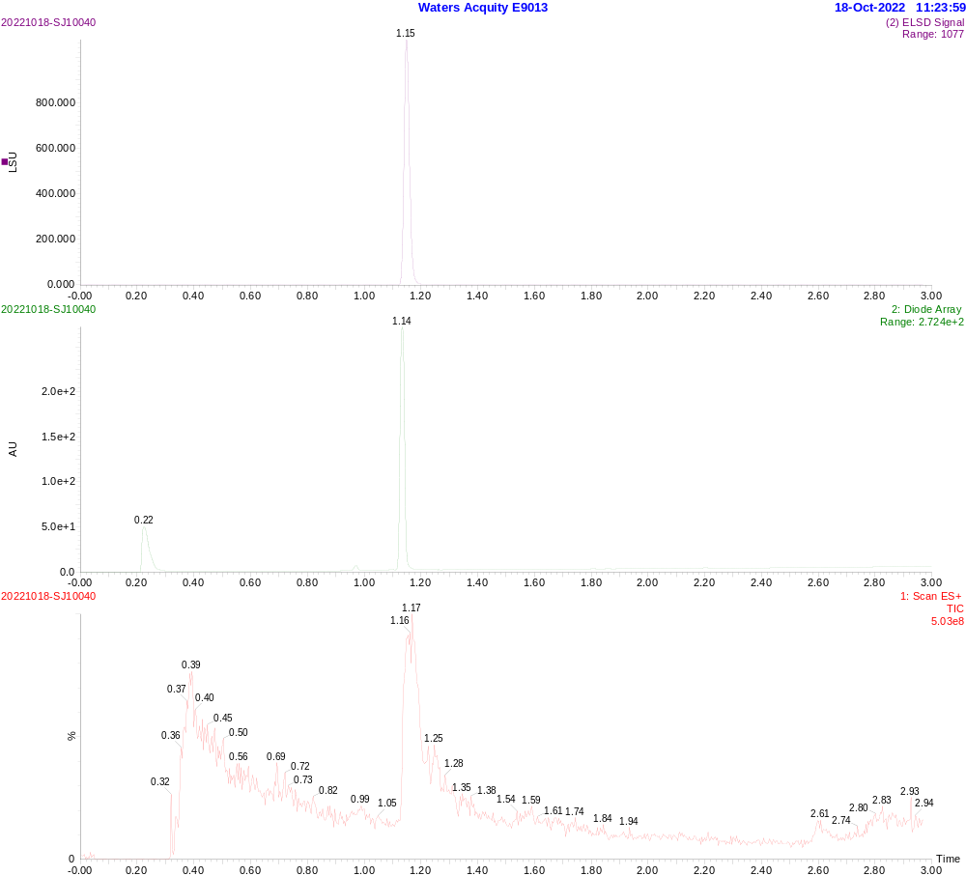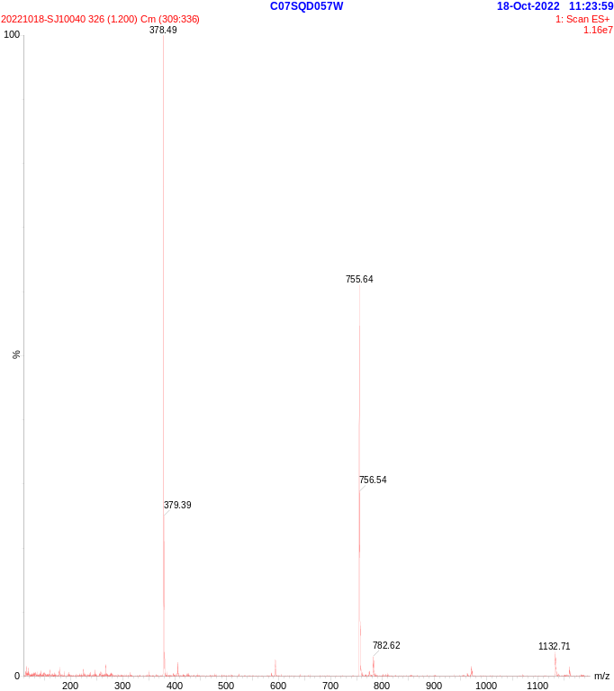
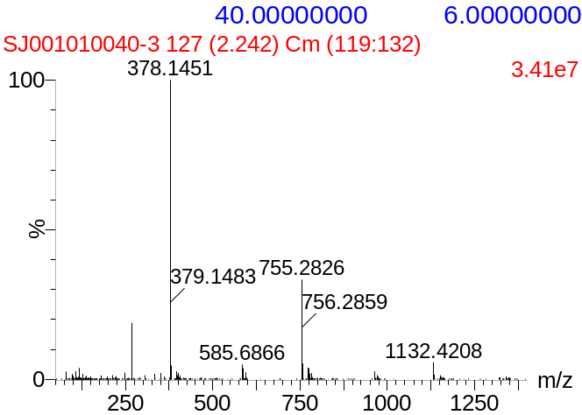

Analytical spectrums for SJ3149 (HNMR, CNMR, UPLC/MS and HRMS)

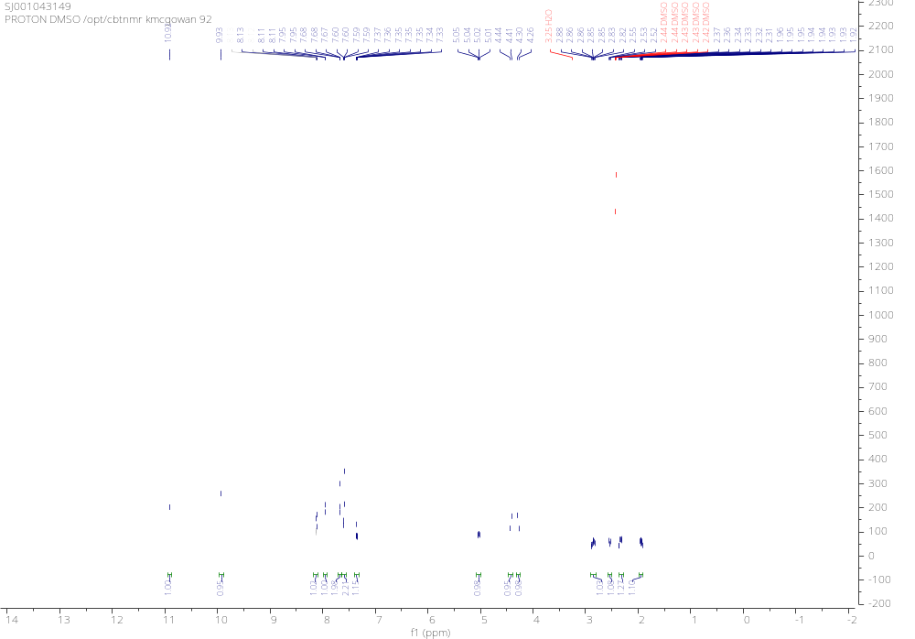
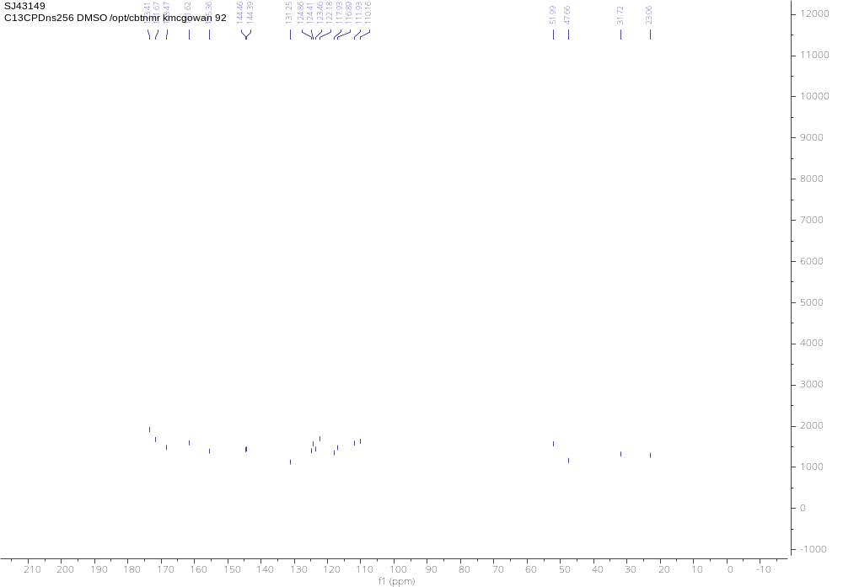
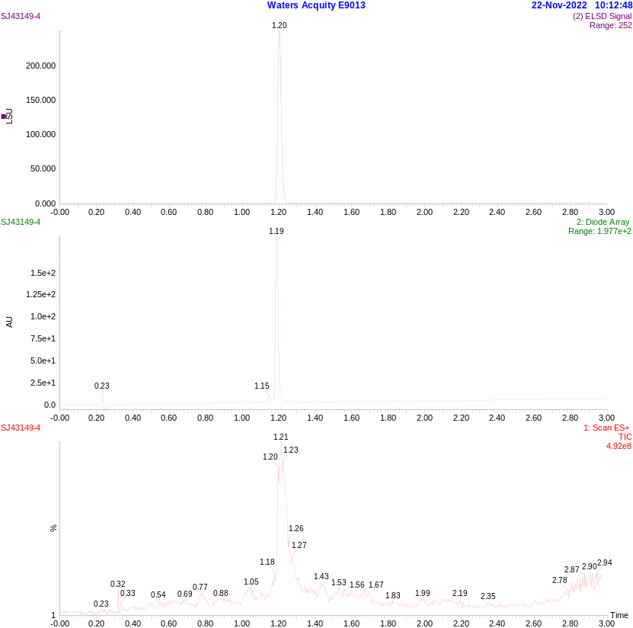

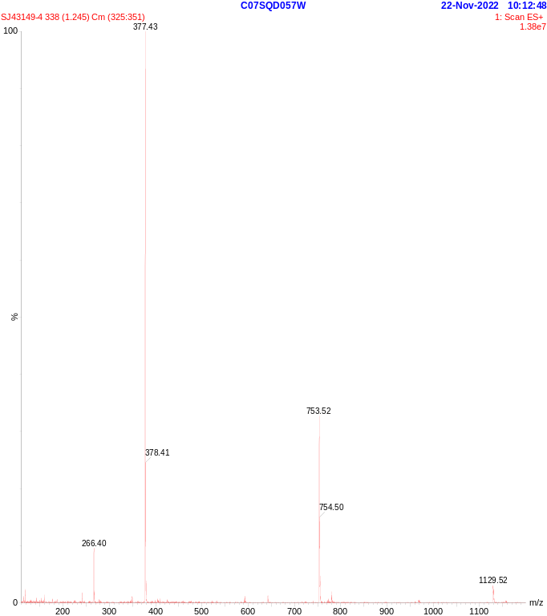
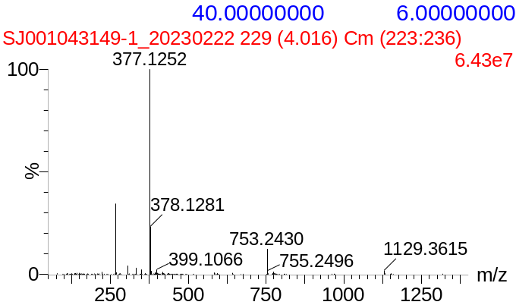

SI Table SB1: Data collection and model refinement statistics for the structure of CK1α+CRBN+DDB1 in complex with SJ3149 (PDB code: 8G66).

Data Collection
Resolution range (Å) | 48.25-3.45 (3.54-3.45)
Space Group | P1
Unit cell dimensions
a, b, c (Å) | 86.66 109.71 112.34
α, β, γ (°) | 105.489 94.408 100.034
Wavelength (Å) | 1.0000
Total reflections | 225,172 (12,090)
Unique reflections | 49,793 (3,410)
Multiplicity | 4.5 (3.4)
Completeness (%) | 97.1 (90.2)
I/σI | 8.6 (1.8)
R_{merge} | 0.177 (0.770)
R_{meas} | 0.204 (0.902)
CC_{1/2} | 0.970 (0.708)
Model Refinement
R_{work}/R_{free} | 0.2134/0.2730
Number of atoms
Protein | 21,267
SJ001043149/Zn²⁺ | 28/2
Water | 0
RMSD
Bond length (Å) | 0.052
Bond angles (°) | 1.01
Ramachandran plot (%)
Favored | 95.83
Allowed | 4.17
Outliers | 0.00
Clash scoreª | 10.77
MolProbity scoreª | 2.41
Average B-factor (Å) | 122.92
Protein | 122.95
SJ001043149/Zn²⁺ | 98.92/113.15
PDB code | 8G66
Values from the highest resolution shell are shown in parentheses. ªGenerated with MolProbity.

