EXTENDED DATA

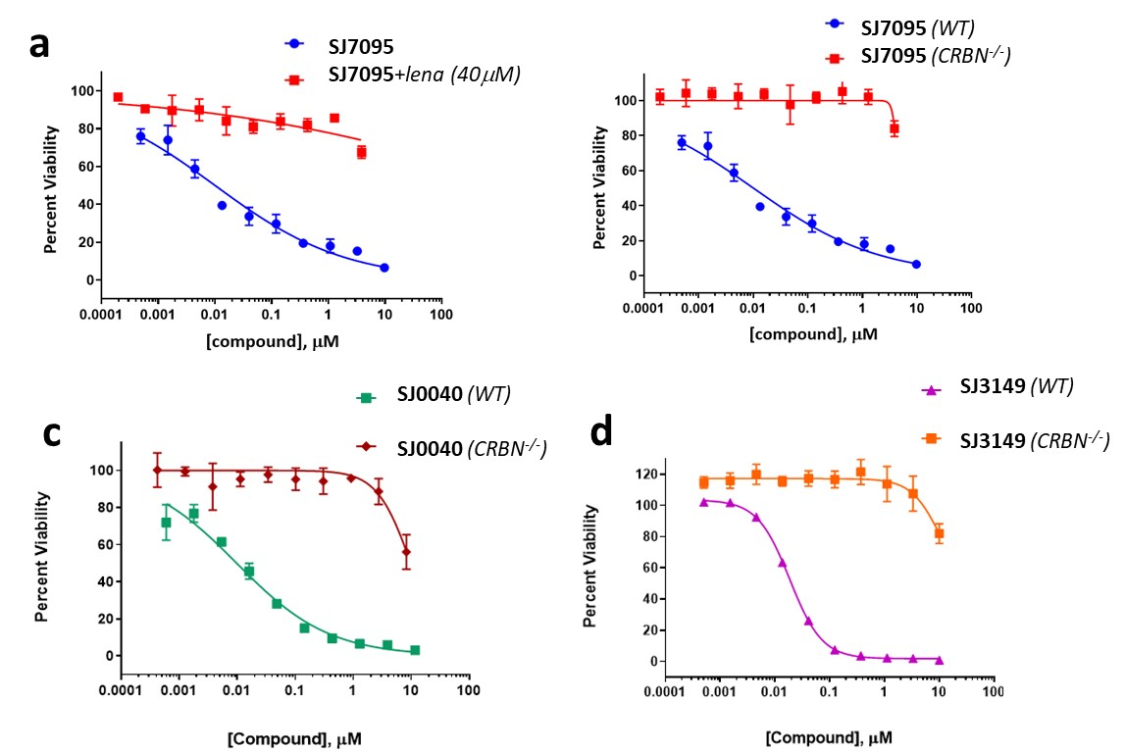
Extended Data Fig. 1| Cereblon-dependancy of CK1α degrader cytotoxicity in MOLM-13 cell line. a. Effect of SJ7095 on MOLM-13 viability in the absence and presence of lenalidomide (40 μM). b. Effect of SJ7095 on viability of wild type and CRBN–/– MOLM-13 cells. c. Effect of SJ0040 on viability of wild type and CRBN–/– MOLM-13 cells. d. Effect of SJ3149 on viability of wild type and CRBN–/– MOLM-13 cells.

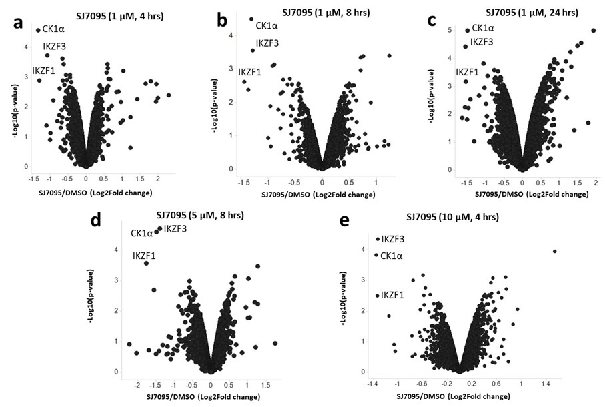
Extended Data Fig. 2| TMT proteomics in MOLM-13 after incubation with SJ7095 at different concentrations and timepoints. a. 1 µM, 4 h. b. 1 µM, 8 h. c. 1 µM, 24 h. d. 5 µM, 8 h. e. 10 µM, 4 h. Each treatment was run in duplicate.

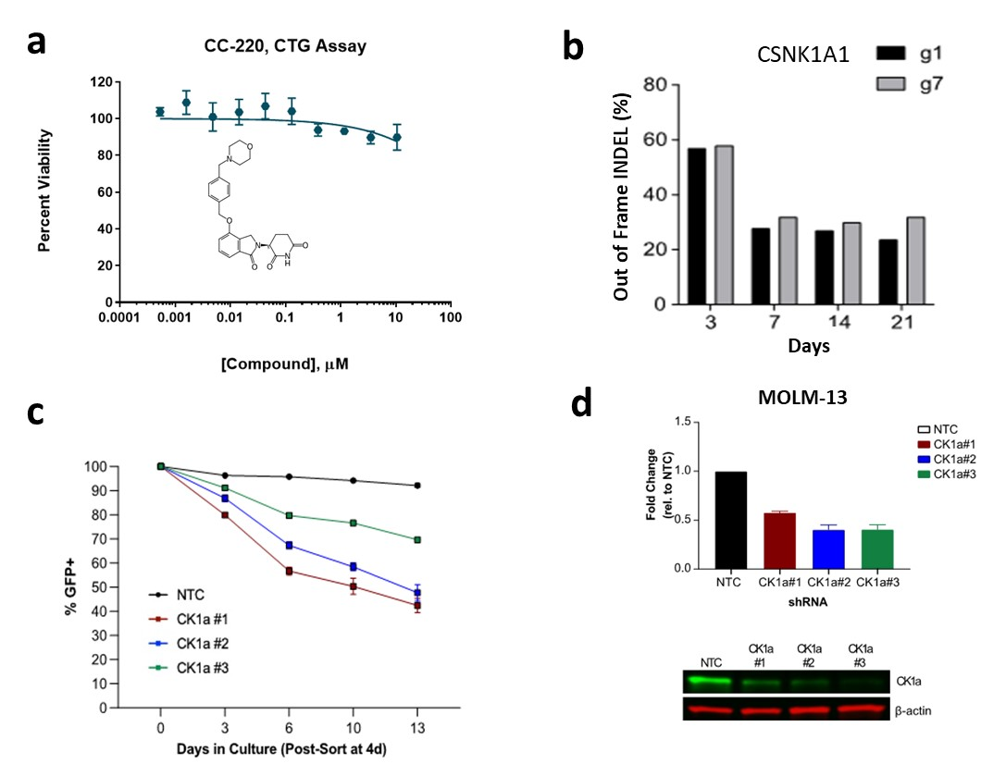
Extended Data Fig. 3| MOLM-13 cells are highly dependent on CK1α expression. a. MOLM-13 cells viability measured in the CTG assay after 72 h incubation with rising concentrations of iberdomide (CC-220). b. CRISPR genomic editing of MOLM-13 cells using RNA guides against CK1α and determining the relative change of out-of-frame INDEL (define) frequency at different time points. c. GFP percentage measured over time following shRNA-targeted silencing of CK1α. d. Representative immunoblot of CK1α expression after shRNA treatment and corresponding relative expression of 3 replicates.

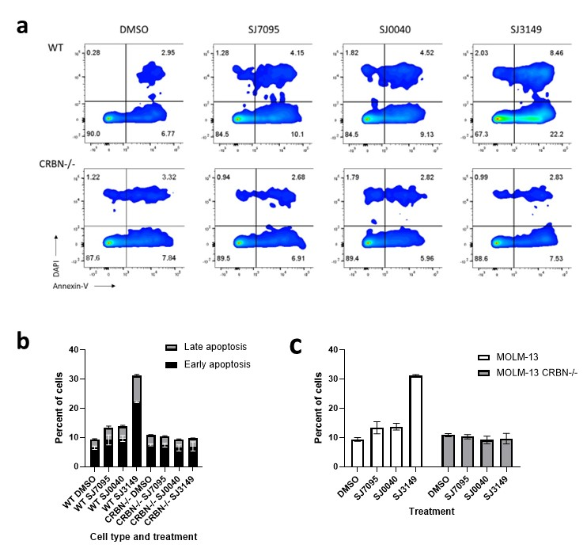
Extended Data Fig. 4| Annexin V staining data in wild type MOLM-13 and CRBN-/- MOLM-13 cells after 24 hours incubation. a. Representative images of triplicate flow cytometry results for annexin V cell surface expression. The x-axis is annexin V signal and the y-axis is DAPI signal. For each plot, the lower right quadrant is early apoptosis, and the upper right quadrant is late apoptosis. b. Stacked bar graph showing the mean percentage of cells in each apoptotic stage. Error bars indicate standard deviation. c. Bar graph showing the mean total percent of apoptotic cells in each condition. Error bars indicate standard deviation.

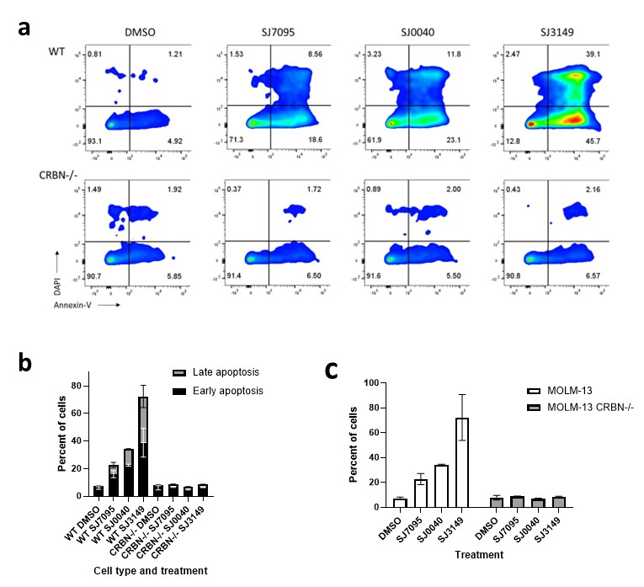
Extended Data Fig. 5| Annexin V staining data in wild type MOLM-13 and CRBN-/- MOLM-13 cells after 24 hours incubation. a. Representative images of triplicate flow cytometry results for annexin V cell surface expression. The x-axis is annexin V signal and the y-axis is DAPI signal. For each plot, the lower right quadrant is early apoptosis, and the upper right quadrant is late apoptosis. b. Stacked bar graph showing the mean percentage of cells in each apoptotic stage. Error bars indicate standard deviation. c. Bar graph showing the mean total percent of apoptotic cells in each condition. Error bars indicate standard deviation.

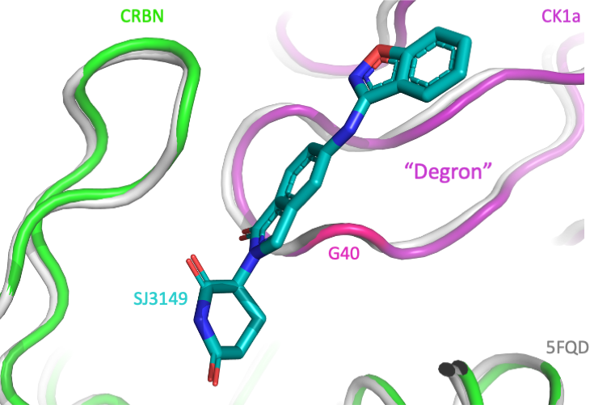
Extended Data Fig. 6| Ribbon diagram of SJ3149 (cyan sticks) at the interface of CRBN (green) and CK1α (purple) overlaid onto 5FQD (grey). SJ3149 contacts the CK1α “degron” loop (purple), including G40 (pink) that is essential for recruitment of CK1α to CRBN.

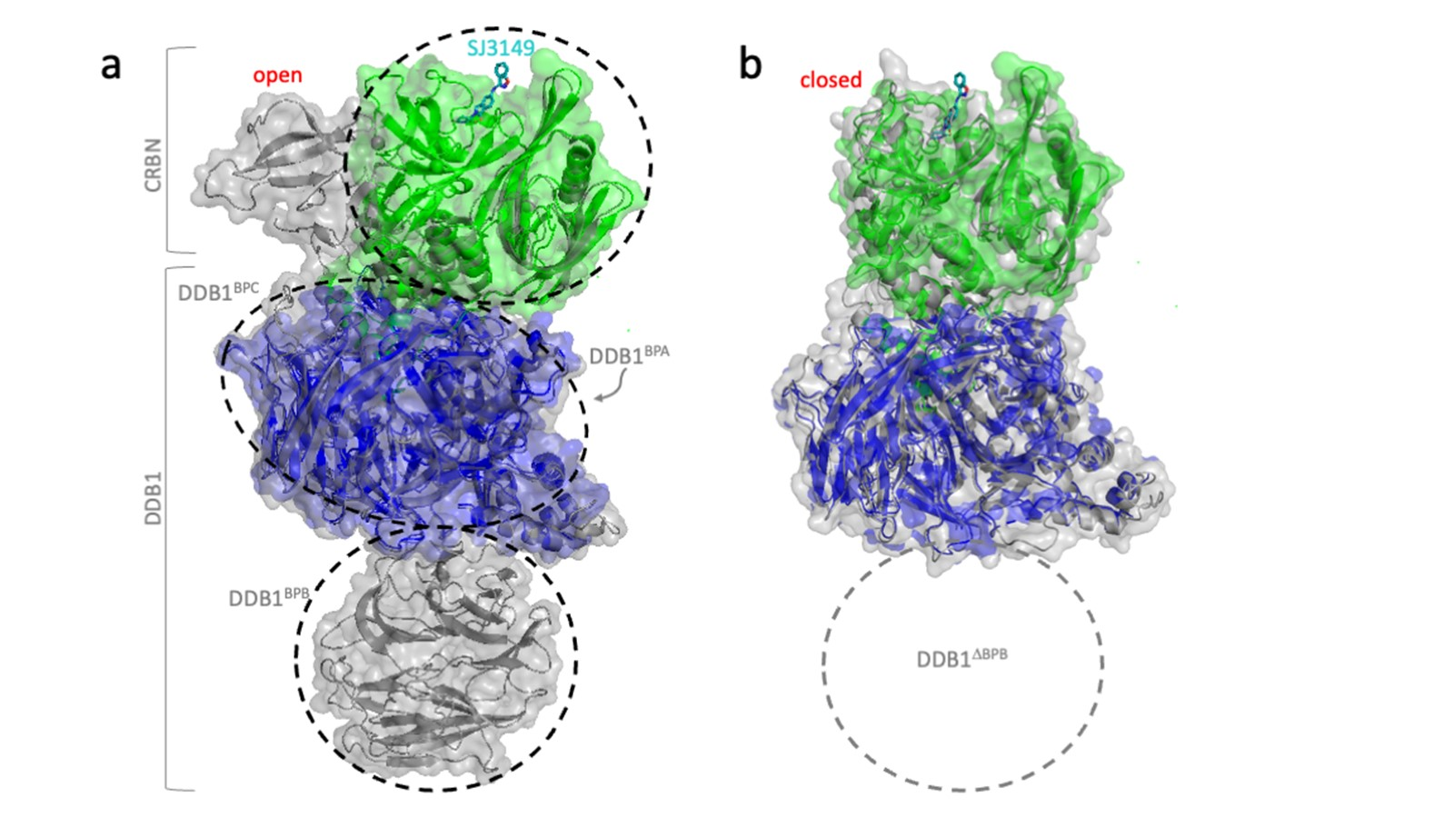
Extended Data Fig. 7| Comparison of the “open” (PDB: 8CVP) and “closed” (PDB: 8D81) states of CRBN (4) shows that CRBN adopts a closed conformation in the CK1α+CRBN+DDB1+ligand quaternary complex. (A) Overlay of open CRBN (8CVP; grey) depicts CRBN in the “open” state with poor overlap of CRBN (green) from our model illustrating that CRBN from our model exists in the “closed” conformation. Full-length DDB1 of 8CVP (grey) overlaid with DDB1^{∆BPB} (blue) from our structure remains largely unchanged. SJ3149 (cyan sticks) shows binding to the thalidomide binding domain of CRBN (green) and interaction with the β-hairpin “sensor loop”. The benzisoxazol of SJ3149 is solvent exposed. Black dashes indicate domain boundaries; CK1α was excluded for clarity. (B) The structural overlap of the domains of “closed” CRBN (8D81; grey) with CRBN^{∆1-40} (green) and DDB1^{∆BPB} (blue) shows that CRBN is in the “closed” state.

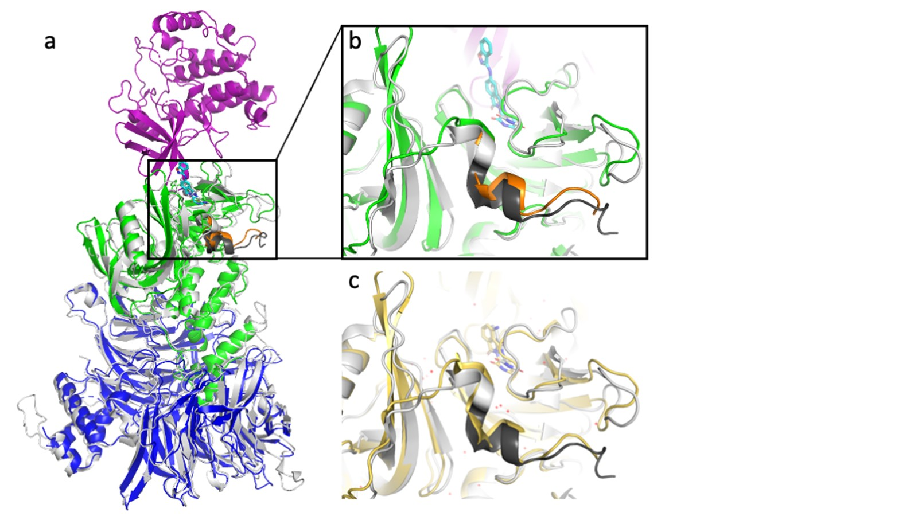
Extended Data Fig. 8| The N-terminal “belt” (orange) of the Lon domain wraps around the thalidomide binding domain (TBD) to stabilize the closed CRBN conformation. (A) Closed CRBN-DDB1 complex (8D81; grey, with safety belt shown in dark grey) bound to Pomalidomide (grey sticks) superimposed onto our quaternary structure with domain colors as above, SJ3149 shown as cyan sticks, and belt region shown in orange. (B-C) Zoom of superposition for (B) our SJ3149-bound structure and (C) Lenalidomide-bound 5FQD (yellow), both showing a closed belt.

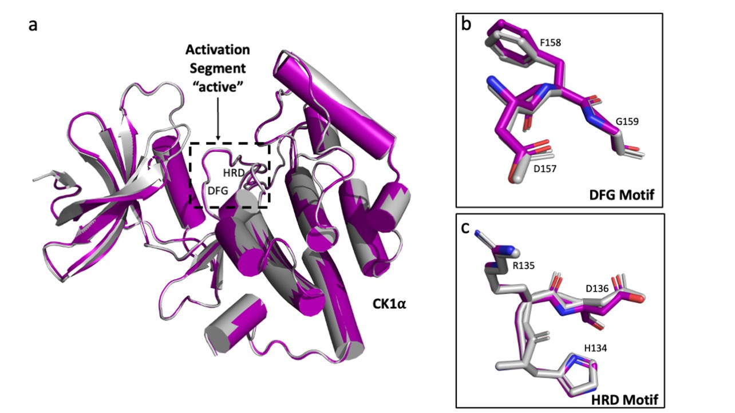
Extended Data Fig. 9| CK1α in the quaternary complex is in the active state. (A) Overlay of our CK1α (purple) with active CK1α from 5FQD (grey); other components of the quaternary complex are excluded for clarity. The disordered activation segment depicting the active conformation of CK1α is highlighted within the dashed box. CK1α’s DFG motif (B) and HRD motif (C) are in the “active” conformation.

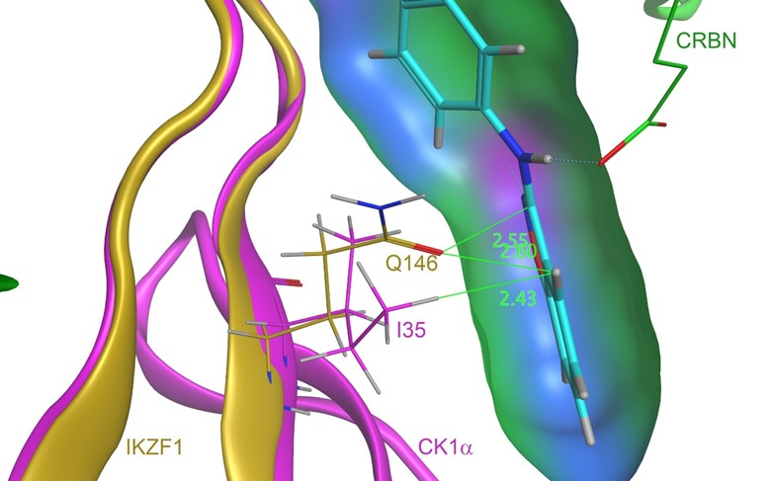

Extended Data Fig. 10| IKZF1 from the IKZF1-CRBN-DDB1 (PDB: 6H0F7) complex is aligned onto the CK1α protein in the SJ3149-CK1α-CRBN-DDB1 complex. SJ3149 is depicted by its property-mapped Gauss-Connolly molecular surface, where green represents hydrophobic patches and blue and purple represent polar patches [Molecular Operating Environment (MOE) 2022.2]. Distances (Å) are shown in green. I35 of CK1α is positioned next to the hydrophobic patch created by the six-membered aromatic carbon ring of SJ3149. In IKZF1, Q146, which is a polar residue, is positioned next to the hydrophobic patch of the ligand. This incompatibility could be responsible for the inactivity of Series SJ3149 in IKZF1. IKZF1 is shown in gold, CRBN in green and CK1α in purple.

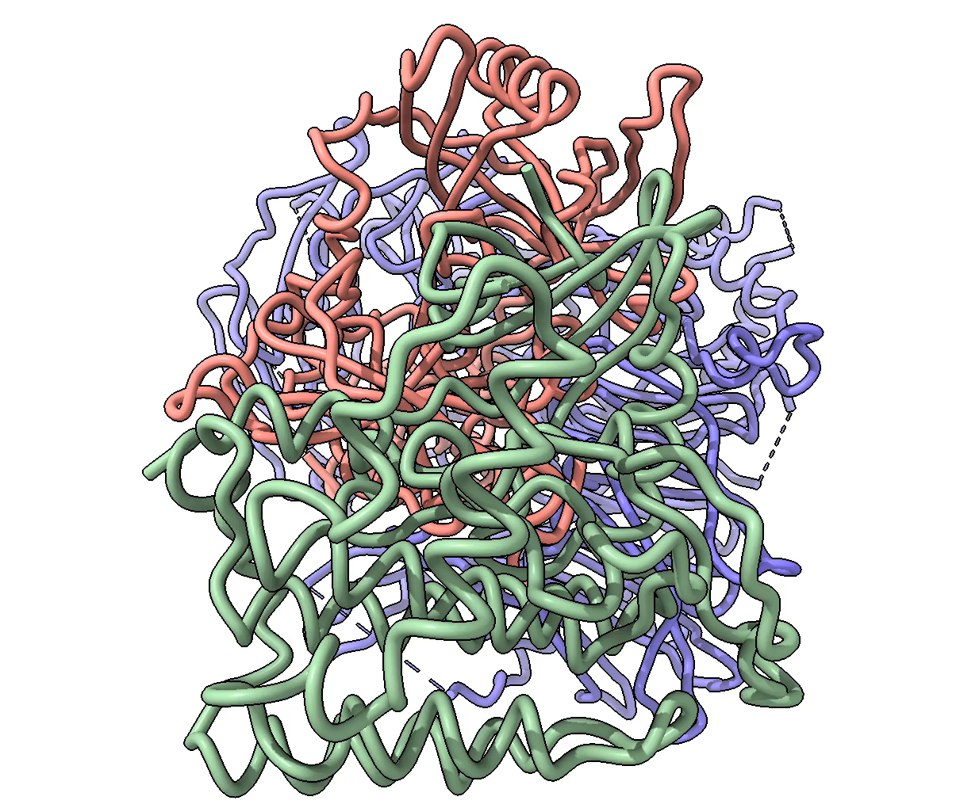
CRBN

SJ3149
DDB1

CK1⍺

Extended Data Video| Morph of CK1⍺ domain rotation when bound to SJ3149 vs. lenalidomide (5FQD). Yellow lines for orientation.

