Supplementary Materials
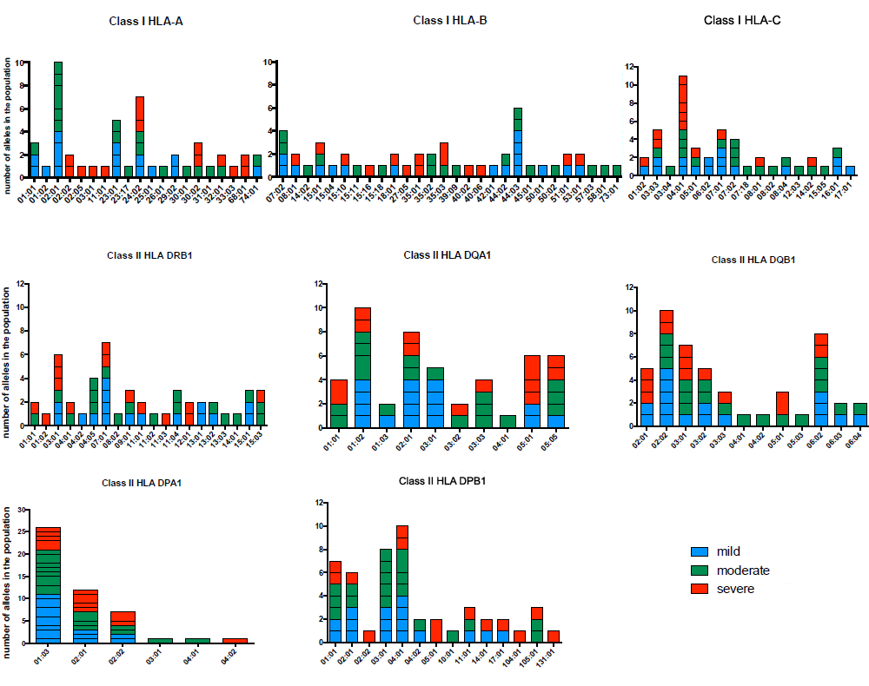
FIG S1: Number of Human Leukocyte Antigen (HLA) alleles class I and II.

