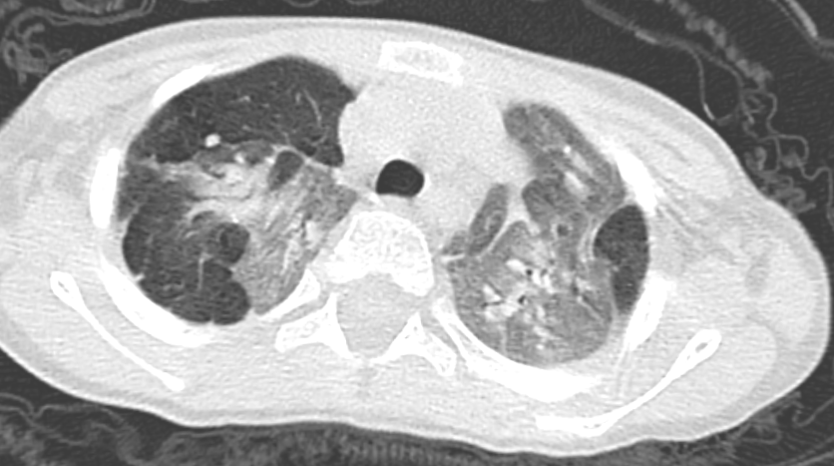
Figure S1 - Diffuse ground glass opacity and mosaic attenuation with interstitial lung disease appearance in a 1.5-year-old male with failure to thrive and recurrent respiratory tract infections.

