SUPPLEMENTARY INFORMATION

Synthesis and molecular-based analysis of betulin derivatives as strong multidrug reversal agents targeting P-glycoprotein

Jerónimo Laiolo^{1, †}, Dafni G. Graikioti^{2, †}, Cecilia L. Barbieri³, Antonia I. Antoniou², D. Mariano A. Vera^{3, ***}, Constantinos M. Athanassopoulos^{2, **}, María C. Carpinella^{4, *}

¹ Fine Chemical and Natural Products Laboratory, IRNASUS CONICET-UCC, Universidad Católica de Córdoba, Córdoba, Argentina.
² Synthetic Organic Chemistry Laboratory, Department of Chemistry, University of Patras, GR-26504, Patras, Greece.
³ Department of Chemistry and Biochemistry, College of Exact and Natural Sciences, Universidad Nacional de Mar del Plata - QUIAMM – INBIOTEC CONICET, Mar del Plata, Argentina
⁴ Fine Chemical and Natural Products Laboratory, IRNASUS CONICET-UCC and CIDIE CONICET-UCC, Universidad Católica de Córdoba, Córdoba, Argentina.

* Corresponding author. Email: ceciliacarpinella@ucc.edu.ar (M.C. Carpinella).
** Corresponding author. Email: kath@upatras.gr (C. M. Athanassopoulos).
*** Corresponding author. Email: dmavera@yahoo.com (D.M.A. Vera).

† Equal first author contribution.

Table of Contents
General procedure for the synthesis of phenylethylamines 4
Synthesis of nitrostyrenes 4
Synthesis of phenylethylamines 4
Molecular modeling supplementary Figures S1-S7 6
Experimenal NMR and HLPC spectra 14
Fig. S8. ¹H-NMR spectrum of compound 3a. 14
Fig. S9. ¹³C-NMR spectrum of compound 3a. 15
Fig. S10. ¹H-NMR spectrum of compound 3b. 15
Fig. S11. ¹³C-NMR spectrum of compound 3b. 16
Fig. S12. ¹H-NMR spectrum of compound 3c. 16
Fig. S13. ¹³C-NMR spectrum of compound 3c. 17
Fig. S14. ¹H-NMR spectrum of compound 3d. 17
Fig. S15. ¹³C-NMR spectrum of compound 3d. 18
Fig. S16. ¹H-NMR spectrum of compound 3e. 18
Fig. S17. ¹³C-NMR spectrum of compound 3e. 19
Fig. S18. ¹H-NMR spectrum of compound 4. 19
Fig. S19. ¹³C-NMR spectrum of compound 4. 20
Fig. S20. ¹H-NMR spectrum of compound 6a. 20
Fig. S21. ¹³C-NMR spectrum of compound 6a. 21
Fig. S22. ¹H-NMR spectrum of compound 6b. 21
Fig. S23. ¹³C-NMR spectrum of compound 6b. 22
Fig. S24. ¹H-NMR spectrum of compound 6c. 22
Fig. S25. ¹³C-NMR spectrum of compound 6c. 23
Fig. S26. ¹H-NMR spectrum of compound 6d. 23
Fig. S27. ¹³C-NMR spectrum of compound 6d. 24
Fig. S28. ¹H-NMR spectrum of compound 6e. 24
Fig. S29. ¹³C-NMR spectrum of compound 6e. 25
Fig. S30. ¹H-NMR spectrum of compound 6f. 25
Fig. S31. ¹³C-NMR spectrum of compound 6f. 26
Fig. S32. ¹H-NMR spectrum of compound 6g. 26
Fig. S33. ¹³C-NMR spectrum of compound 6g. 27
Fig. S34. ¹H-NMR spectrum of compound 6h. 27
Fig. S35. ¹³C-NMR spectrum of compound 6h. 28
Fig. S36. ¹H-NMR spectrum of compound 6i 28
Fig. S37. ¹³C-NMR spectrum of compound 6i 29
Fig. S38. ¹H-NMR spectrum of compound 6j. 29
Fig. S39. ¹³C-NMR spectrum of compound 6j 30
Fig. S40. ¹H-NMR spectrum of compound 6l 30
Fig. S41. ¹³C-NMR spectrum of compound 6l. 31
Fig. S42. ¹H-NMR spectrum of compound 6m. 31
Fig. S43. ¹³C-NMR spectrum of compound 6m 32
Fig. S44. HPLC chromatogram of compound 3a. 32
Fig. S45. HPLC chromatogram of compound 3b. 33
Fig. S46. HPLC chromatogram of compound 3c. 33
Fig. S47. HPLC chromatogram of compound 3d. 34
Fig. S48. HPLC chromatogram of compound 3e. 34
Fig. S49. HPLC chromatogram of compound 4. 35
Fig. S50. HPLC chromatogram of compound 6a. 35
Fig. S51. HPLC chromatogram of compound 6b. 36
Fig. S52. HPLC chromatogram of compound 6c. 36
Fig. S53. HPLC chromatogram of compound 6d. 37
Fig. S54. HPLC chromatogram of compound 6e. 37
Fig. S55. HPLC chromatogram of compound 6f. 38
Fig. S56. HPLC chromatogram of compound 6g 38
Fig. S57. HPLC chromatogram of compound 6h. 39
Fig. S58. HPLC chromatogram of compound 6i. 39
Fig. S59. HPLC chromatogram of compound 6j 40
Fig. S60. HPLC chromatogram of compound 6k. 40
Fig. S61. HPLC chromatogram of compound 6l 41
Fig. S62. HPLC chromatogram of compound 6m. 41

General procedure for the synthesis of phenylethylamines

Synthesis of nitrostyrenes
In a round bottom flask glacial acetic acid (14.6 mL) and ammonium acetate (41.6 mmol) were added and the suspension was stirred until dissolution of the white solid. Then, nitromethane (61.4 mmol) and the corresponding benzaldehyde (10.2 mmol) were added, and the mixture was heated under reflux for 3 h. After completion of the reaction, the mixture was condensed to dryness and the residue was subjected to FCC, affording the corresponding nitrostyrenes as yellow solids.
3,4-Dimethoxynitrostyrene
Yield: 85%; R_{f} (PhMe/AcOEt 8:2): 0.51; m.p.=140-140.8 ^{ο}C; ¹H NMR (600 MHz, CDCl₃) δ 8.20 (d, J=15.8 Hz, 1 H), 8.05 (d, J=16 Hz, 1 H), 7.43-7.46 (m, 1 H), 7.30 (br s, 1 H), 6.77-6.80 (m, 1 H), 3.84 (s, 6 H); ¹³C NMR (151 MHz, CDCl₃) δ 150.3, 149.4, 139.2, 138.7, 124.4, 124.0, 113.5, 112.6, 55.9, 55.9.
3,4,5-Trimethoxynitrostyrene
Yield: 82%; R_{f} (PhMe): 0.28; m.p.: 120-121 ^{ο}C; ¹H NMR (600 MHz, CDCl₃) δ 8.20 (d, J=16 Hz, 1 H), 8.05 (d, J=16.2 Hz, 1 H), 7.06 (s, 2 H), 3.89 (s, 6 H), 3.88 (s, 3 H); ¹³C NMR (151 MHz, CDCl₃) δ 153.6, 140.3, 138.2, 134.6, 124.9, 106.9, 60.8, 56.2.

Synthesis of phenylethylamines
A solution of the corresponding nitrostyrene (2.93 mmol) in ethanol (EtOH) (28 mL) and 6 M HCl_{(aq)} (6 mmol) was subjected to hydrogenation over 10% Pd/C (220 mg) at ambient temperature and pressure. After 48 h filtration of the reaction mixture through Celite®, removal of the solvent under reduced pressure and FCC purification were received the corresponding phenylethylamines as pale-yellow oils.
3,4-Dimethoxyphenylethylamine
Yield: 70%; R_{f} (DCM/MeOH/NH₃ 8:2:0.2): 0.30; ¹H NMR (600 MHz, CDCl₃) δ 6.73-6.76 (m, 2 H), 6.72-6.74 (m, 1 H), 3.88 (s, 6 H), 3.42 (br s, 2 H), 3.04-3.06 (m, 2 H), 2.67-2.69 (m, 2 H); ¹³C NMR (151 MHz, CDCl₃) δ 150.6, 147.9, 132.8, 121.5, 113.7, 112.4, 55.9, 55.8, 43.6, 39.7.
3,4,5-Trimethoxyphenylethylamine
Yield: 65%; Rf (DCM/MeOH/NH₃ 9:1:0.1): 0.39; ¹H NMR (600 MHz, CDCl₃) δ 6.36-6.38 (m, 2 H), 3.90 (s, 6 H), 3.88 (s, 3 H), 3.51 (br s, 2 H), 3.05-3.07 (m, 2 H), 2.67-2.69 (m, 2 H); ¹³C NMR (151 MHz, CDCl₃) δ 152.9, 136.4, 134.8, 105.5, 60.8, 56.2, 40.3, 38.3.

Molecular modeling supplementary figures.
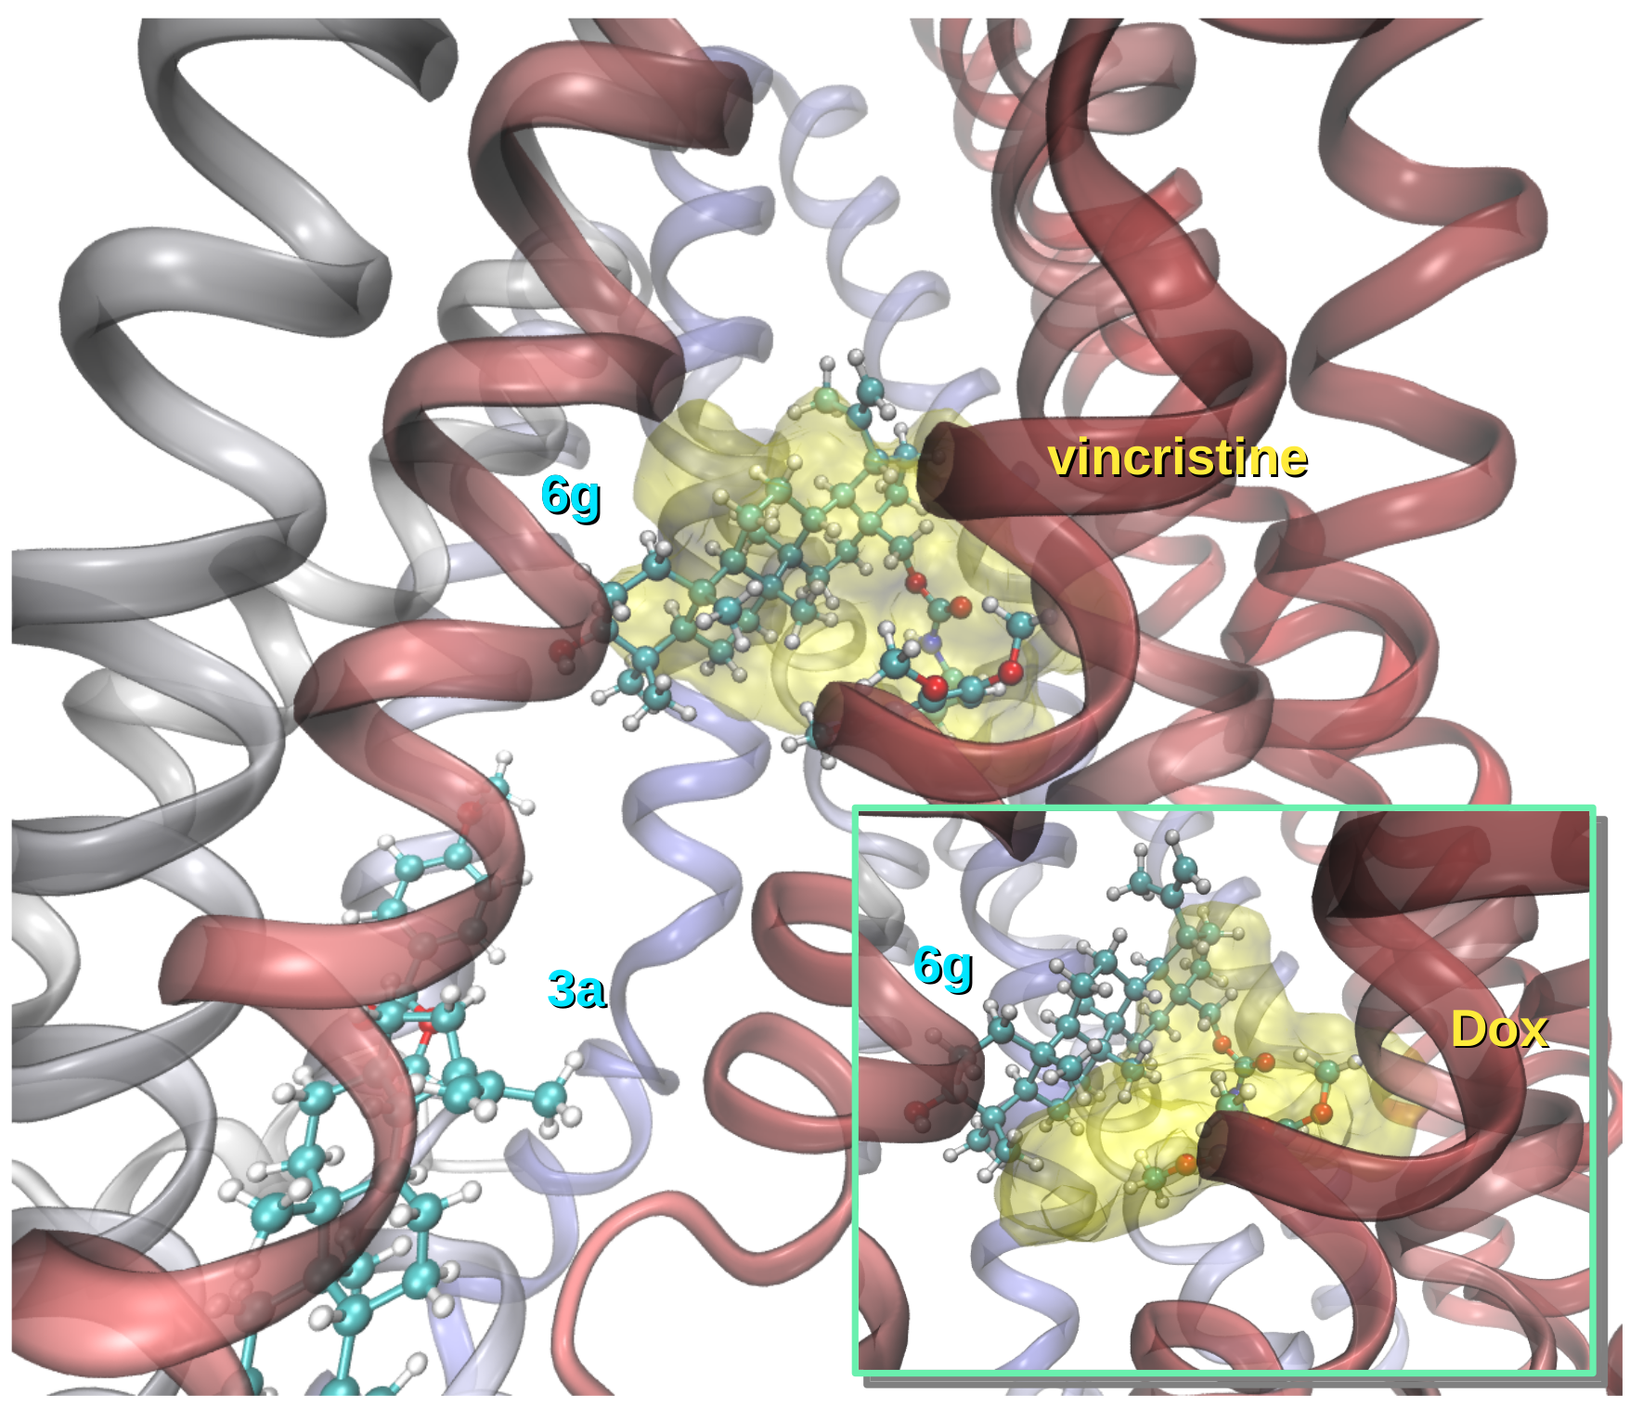
Fig. S1. Superimposition of the modes of binding of compounds 3a, 6g and the reference chemotherapeutics vincristine and doxorubicin (Dox) as a yellow translucent surface. All structures taken from a representative snapshot the most populated cluster of a trajectory; α-helices colored according to the sequence from red to blue.

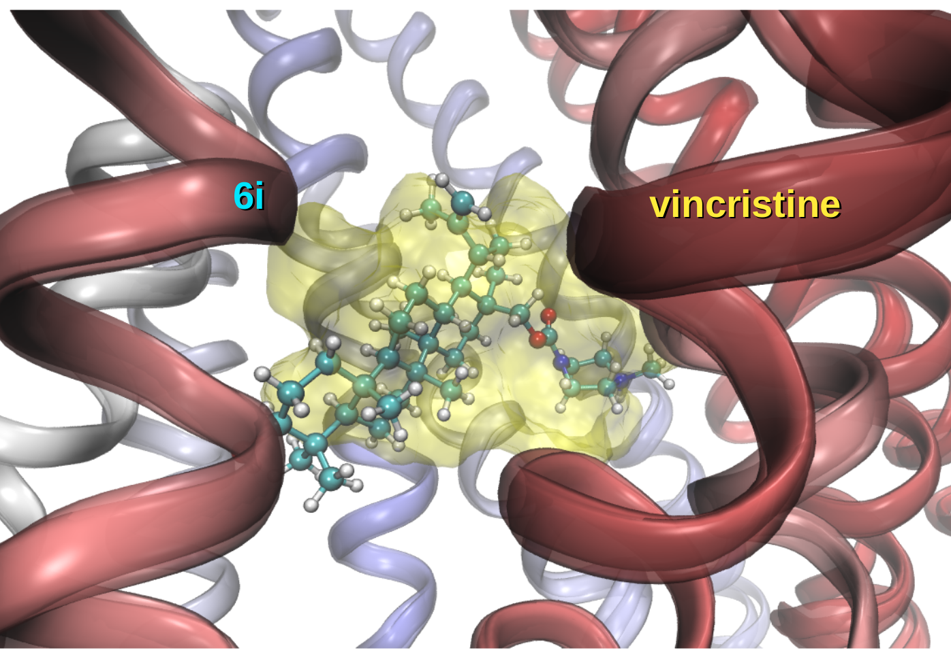
Fig. S2. Same as Fig. S1 for compound 6i.

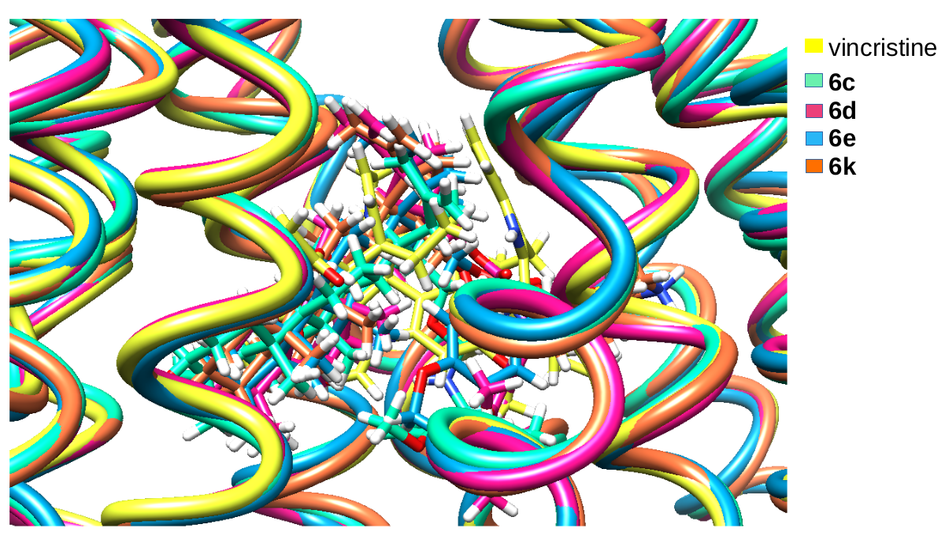
Fig. S3. Various active subject compounds superimposed to vincristine. Structures aligned from a representative snapshot of the most populated cluster of each trajectory.

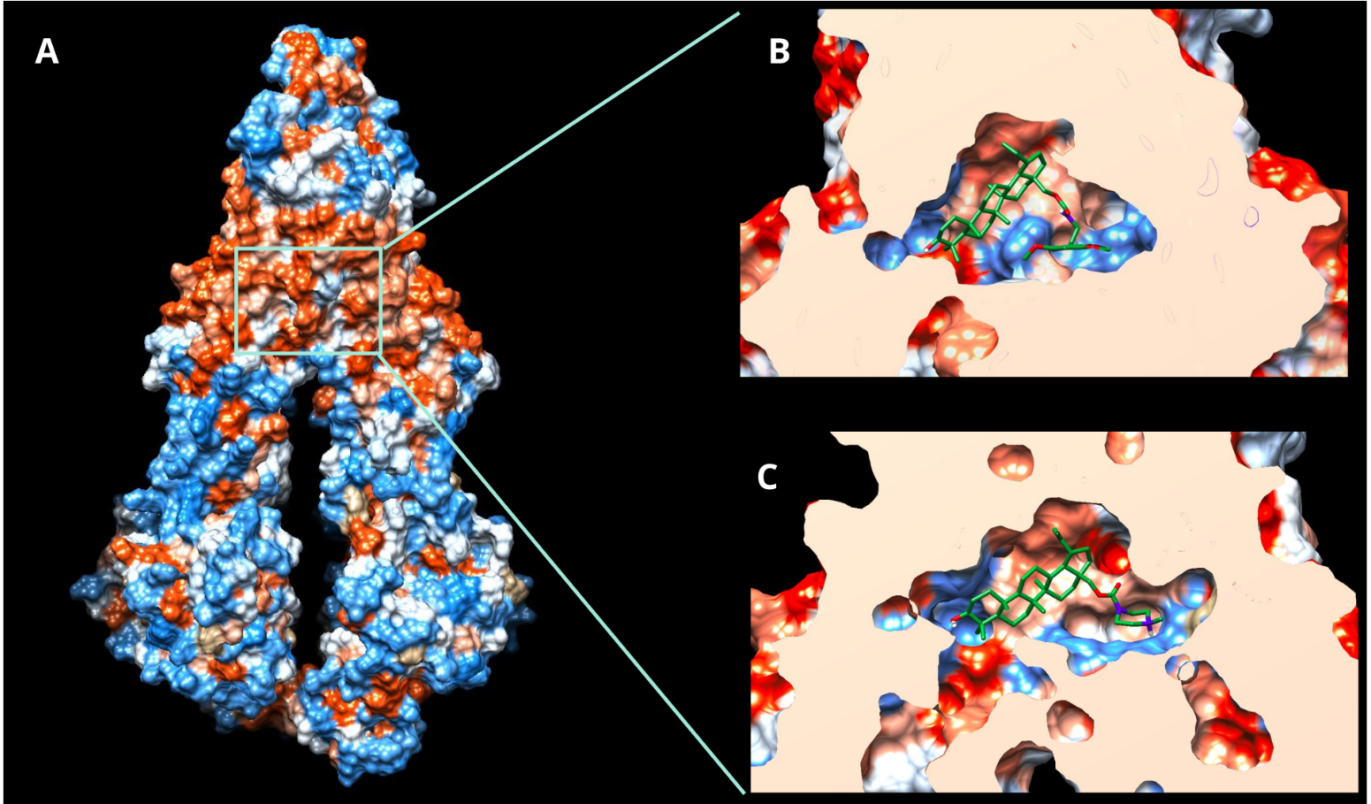
Fig. S4. A) hydrophobicity surface (orange = most hydrophobic). B) Frontal cortex showing compound 6g and C) frontal cortex showing compound 6i.

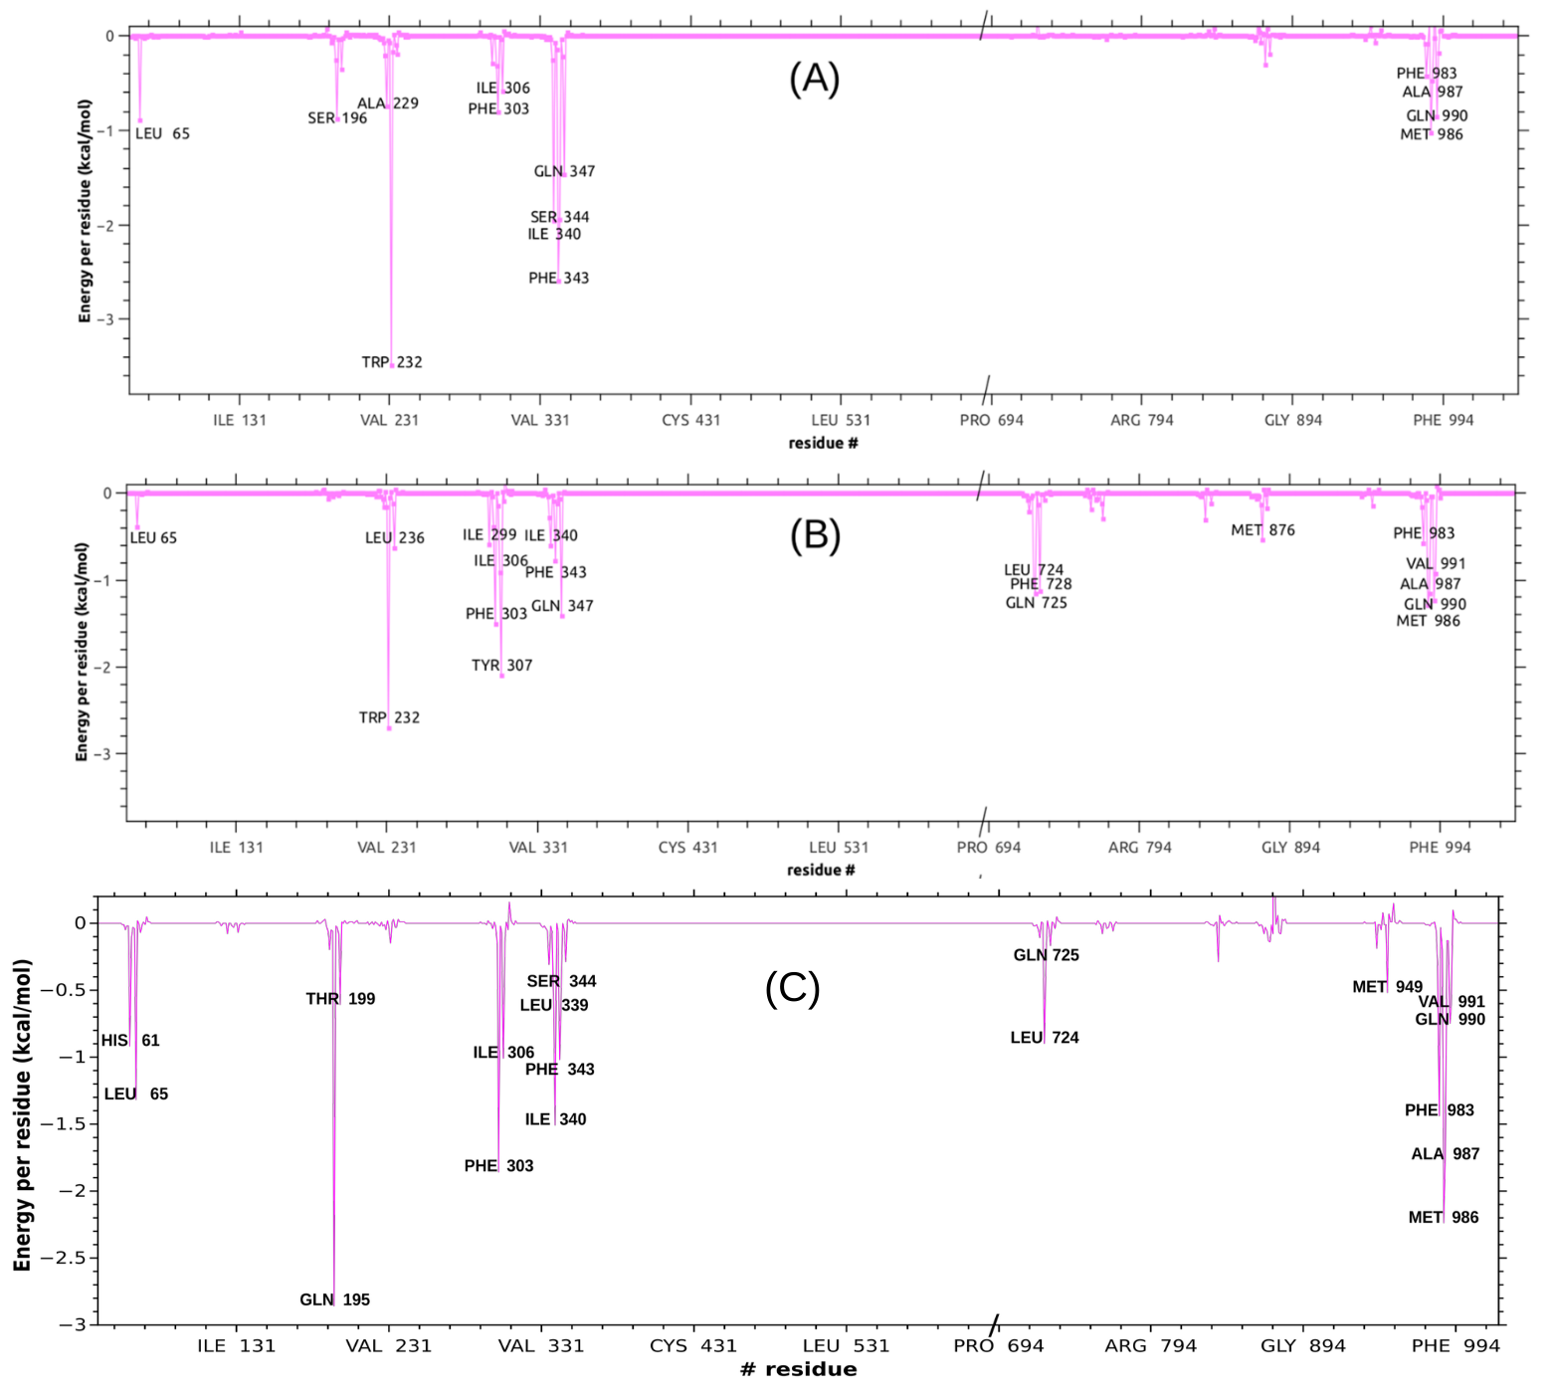
Fig. S5. Same as in main text Fig. 8. A-B) Doxorubicin and tariquidar simulations, respectively reproduced from Laiolo et al. [1] and C) compound 6m.

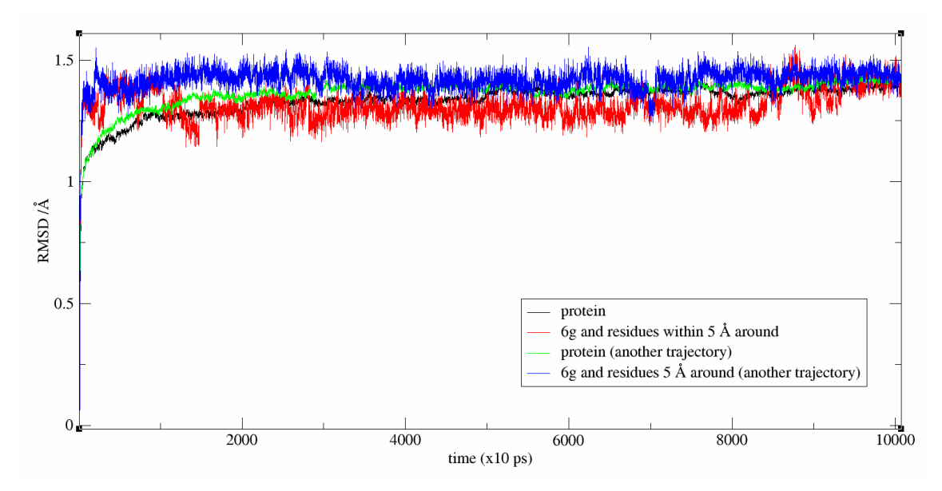
Fig. S6. RMSd analyses of two trajectories for the complex P-gp/compound 6g.

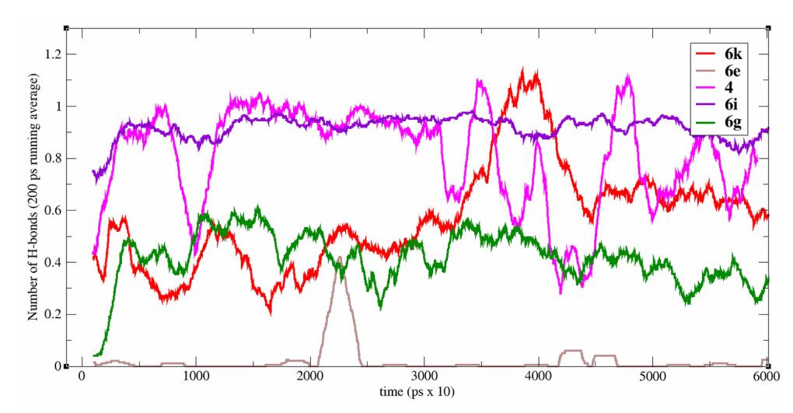
Fig. S7. H-bond monitored and averaged (200 ps running average) for compounds 6k, 6e, 4, 6i and 6g. Most simulations were between 0.5 and 1.5 total average number of H-bonds.

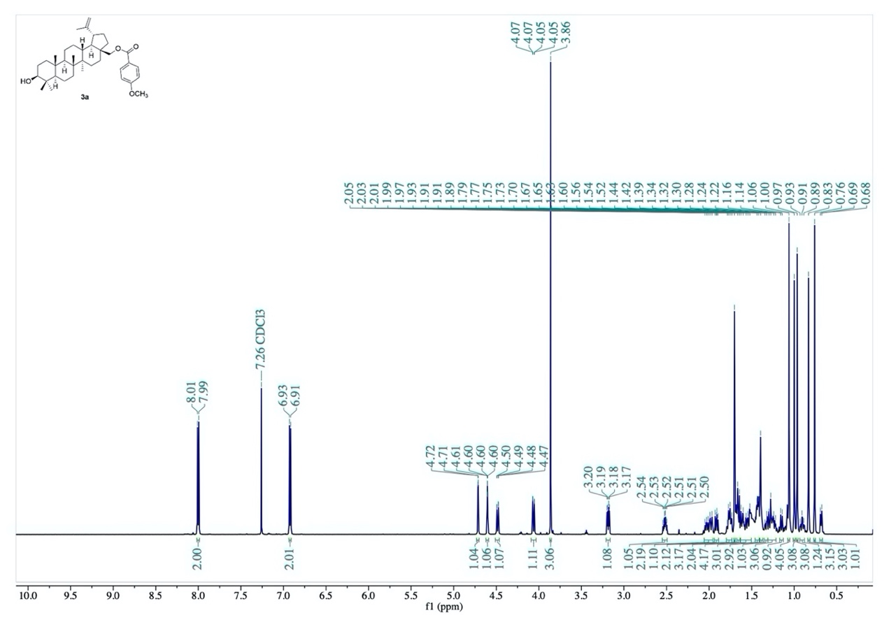
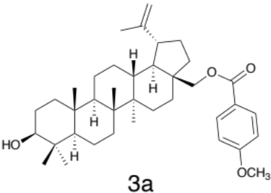
Experimental NMR and HLPC spectra

Fig. S8. ¹H-NMR spectrum of compound 3a.

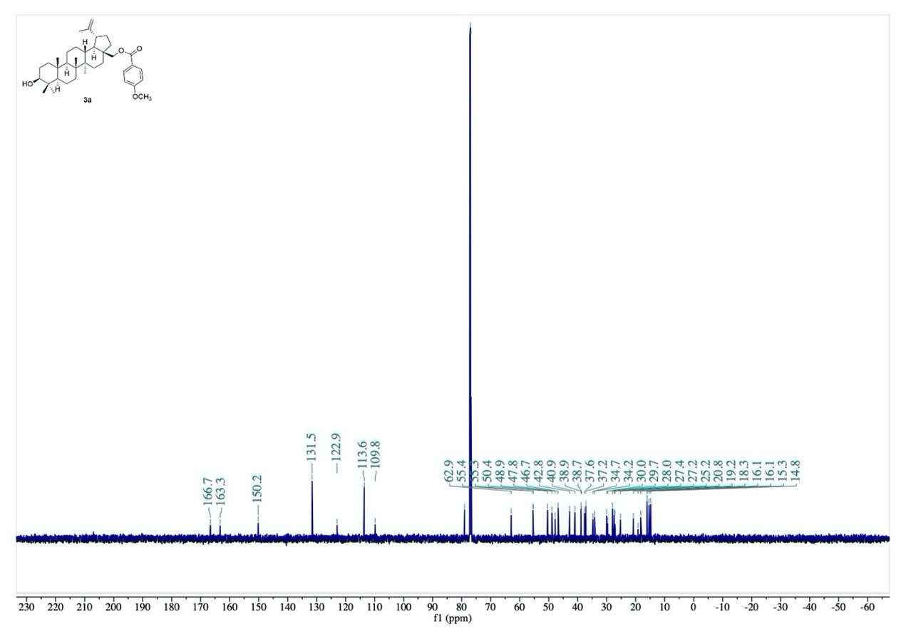
Fig. S8. ¹H-NMR spectrum of compound 3a.

Fig. S9. ¹³C-NMR spectrum of compound 3a.

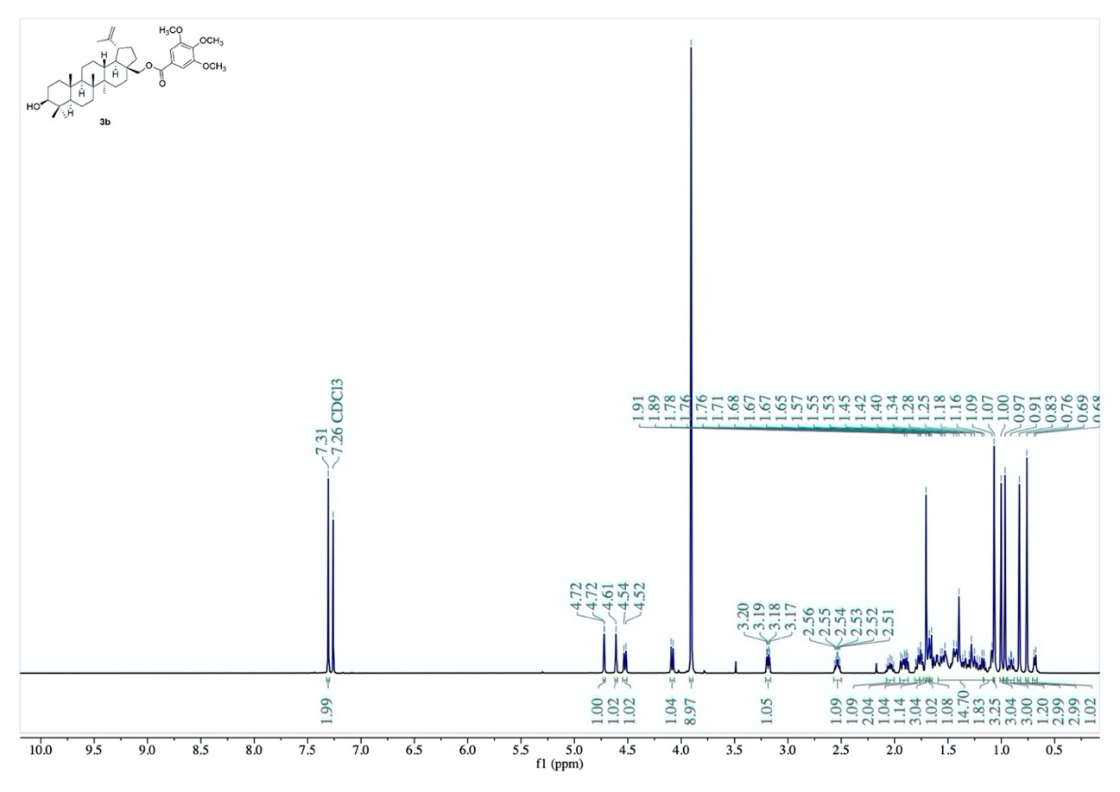
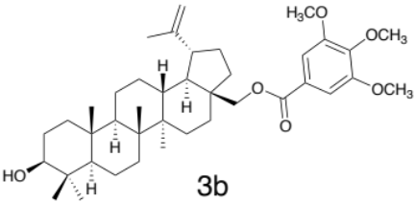

Fig. S10. ¹H-NMR spectrum of compound 3b.
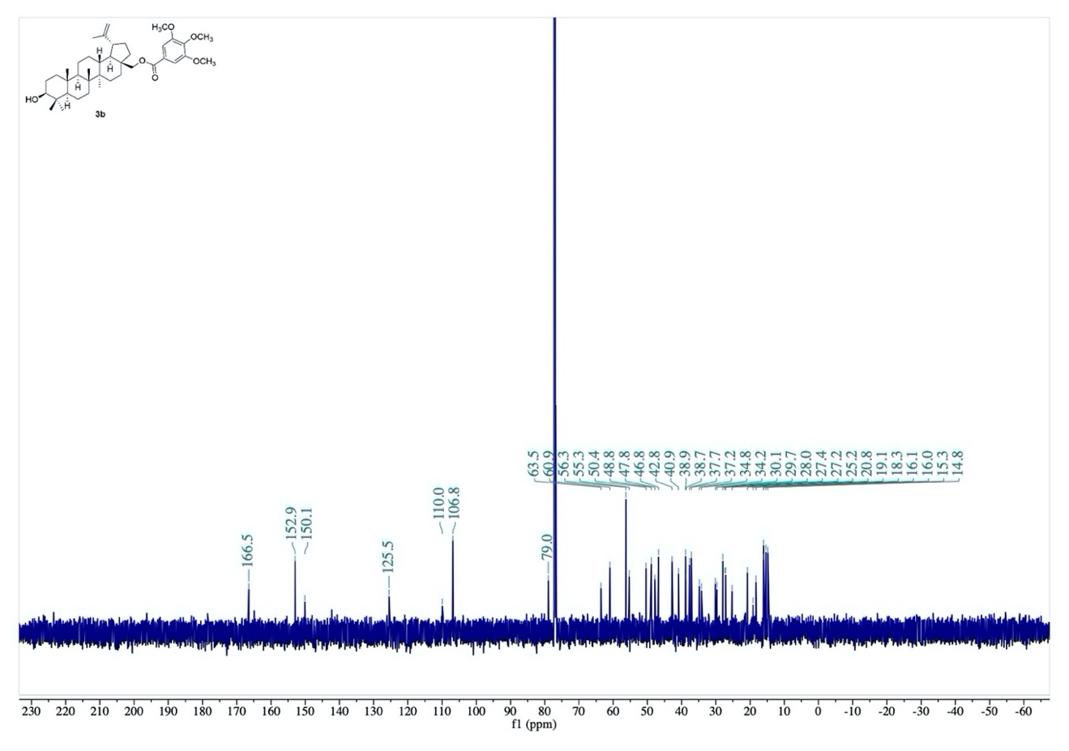

Fig. S11. ¹³C-NMR spectrum of compound 3b.
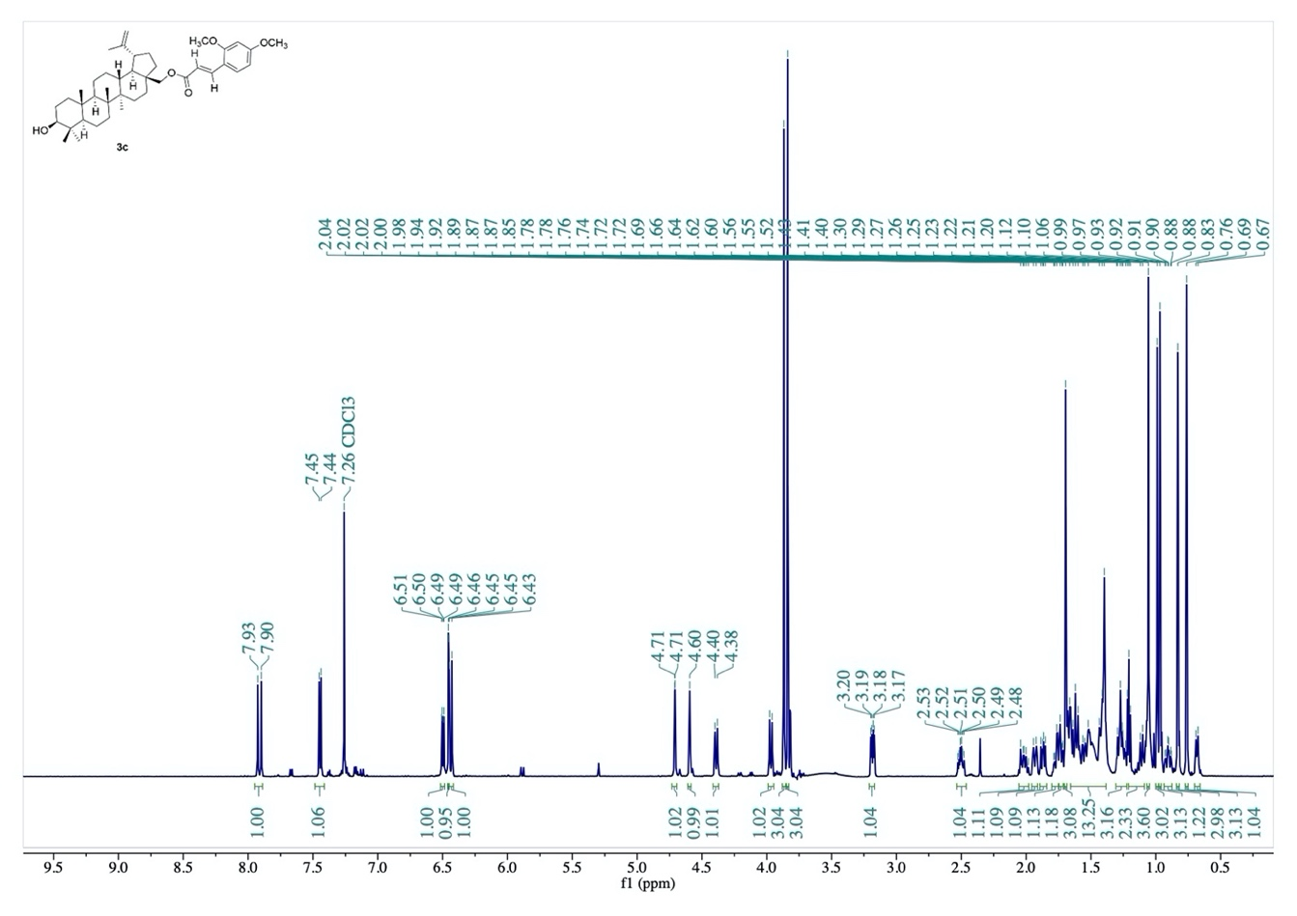
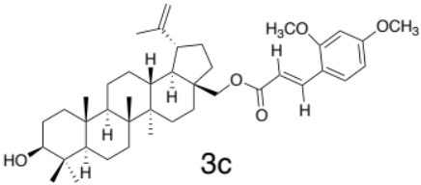

Fig. S12. ¹H-NMR spectrum of compound 3c.
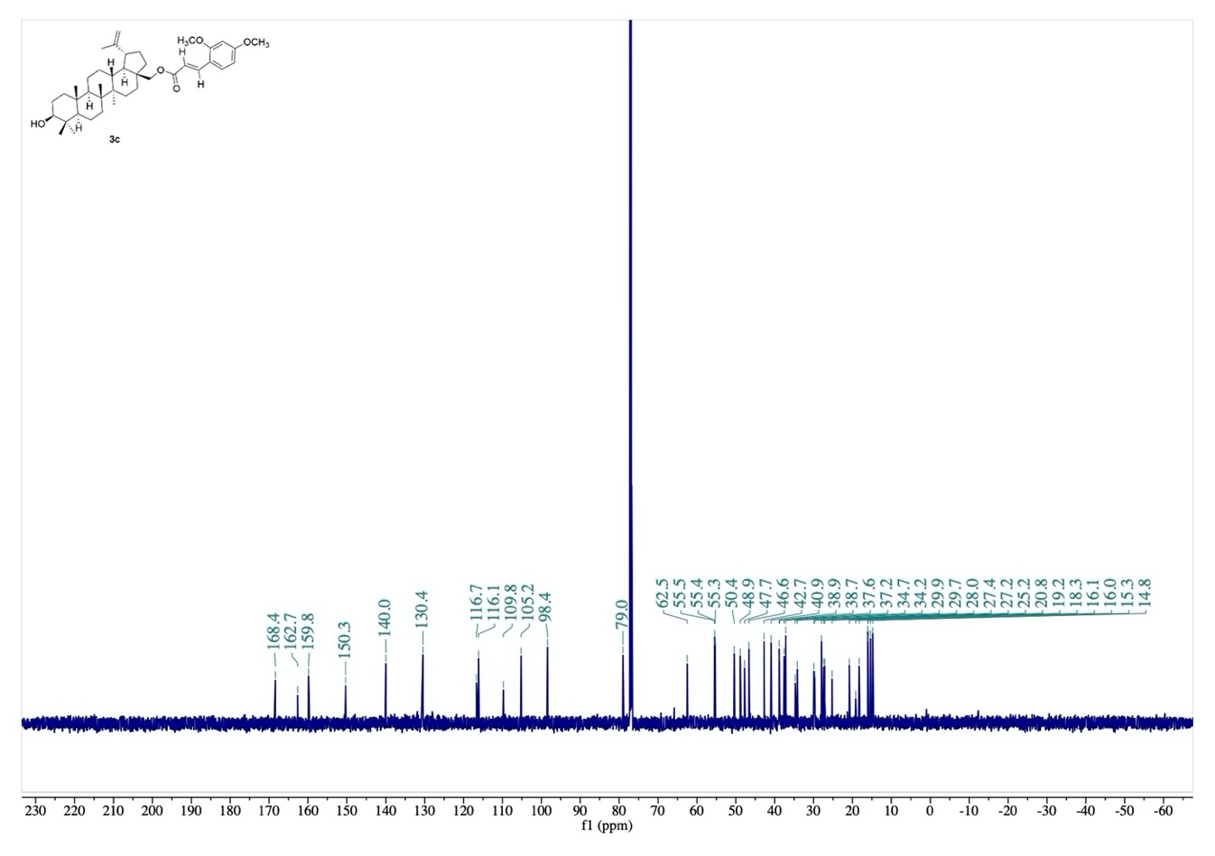

Fig. S13. ¹³C-NMR spectrum of compound 3c.
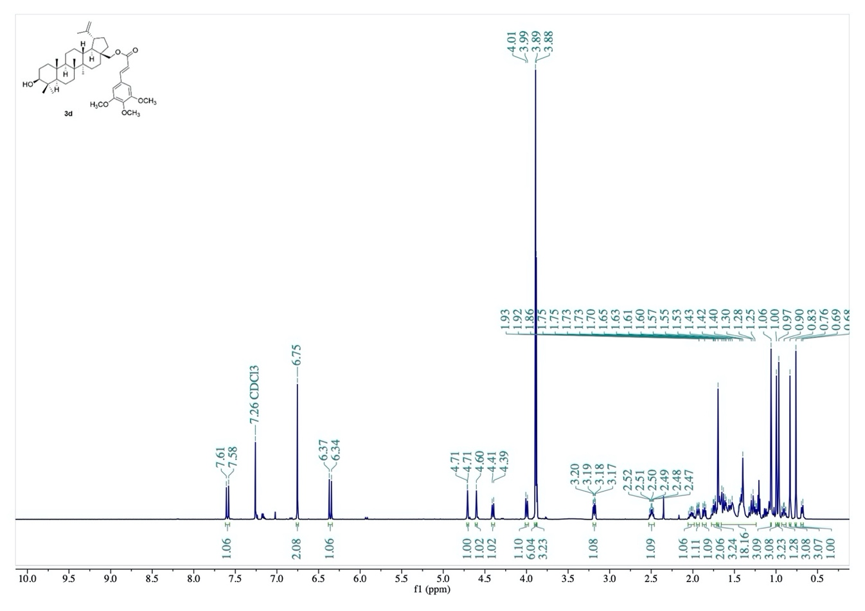
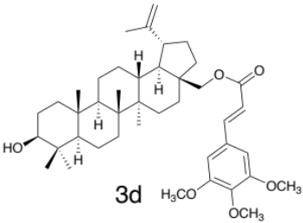

Fig. S14. ¹H-NMR spectrum of compound 3d.
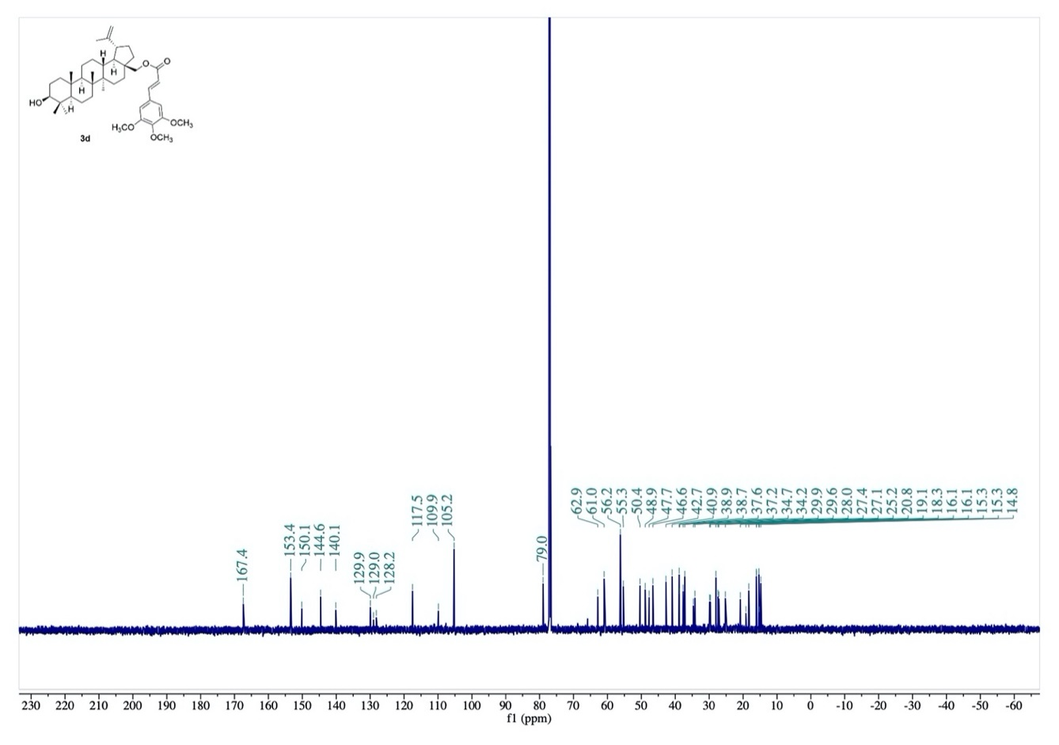

Fig. S15. ¹³C-NMR spectrum of compound 3d.
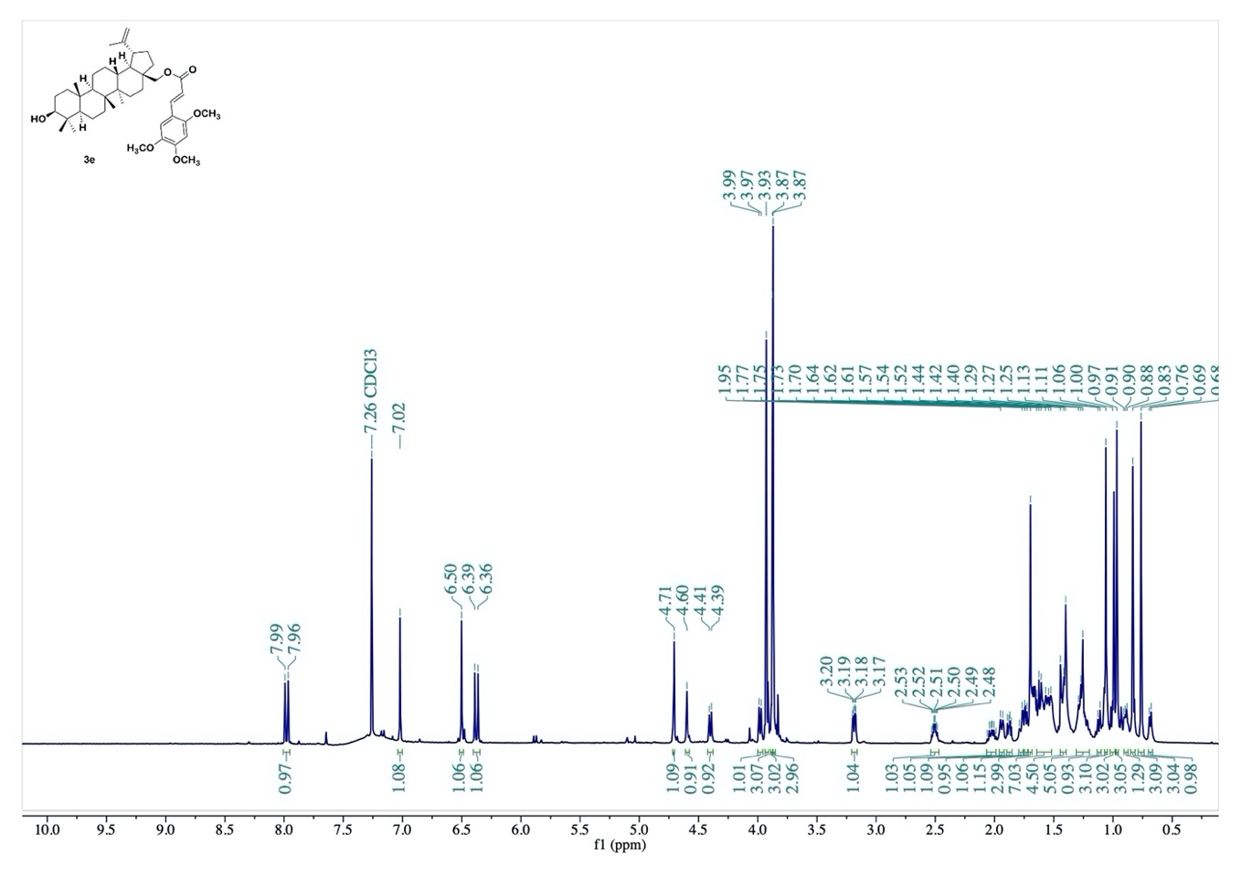
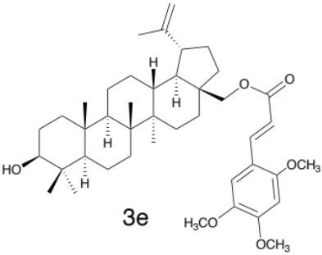

Fig. S16. ¹H-NMR spectrum of compound 3e.
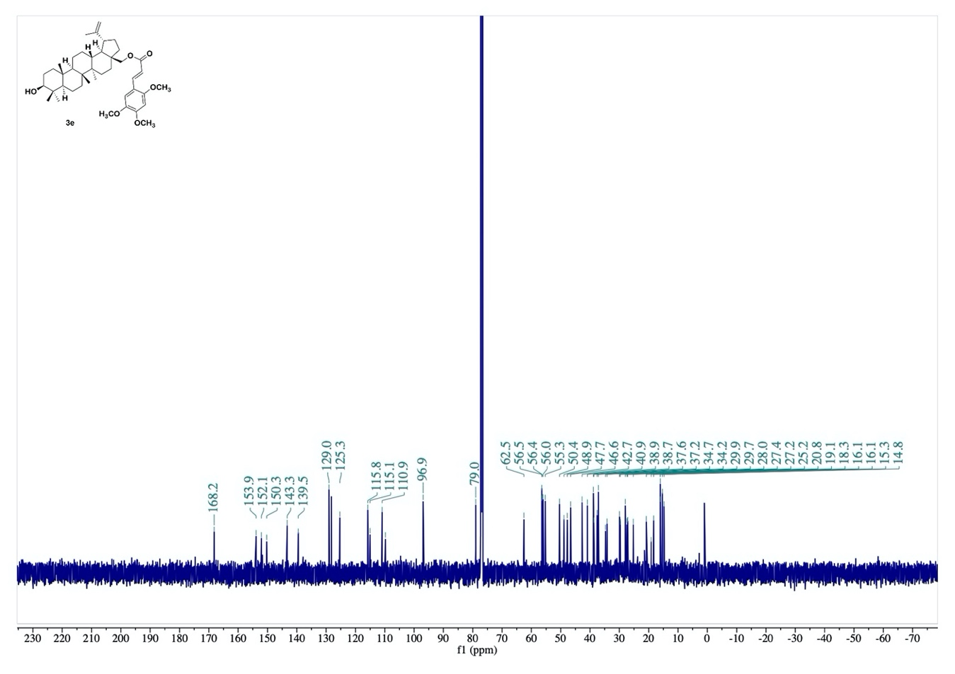

Fig. S17. ¹³C-NMR spectrum of compound 3e.
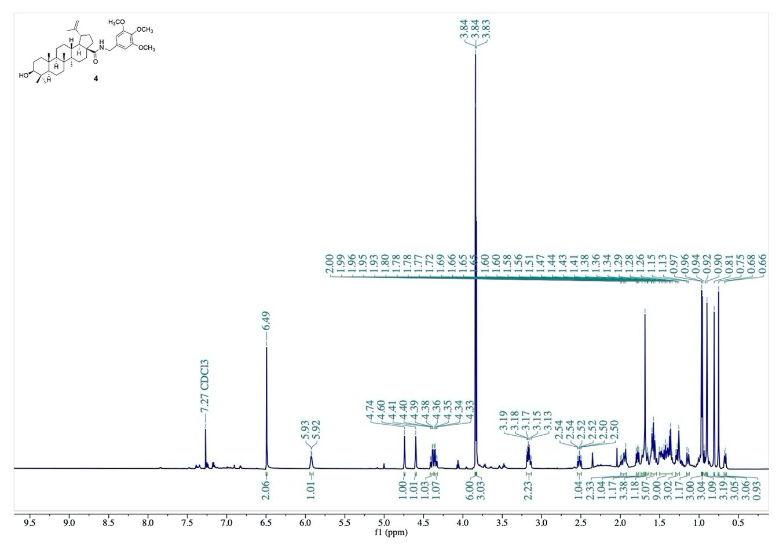
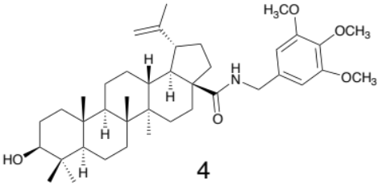

Fig. S18. ¹H-NMR spectrum of compound 4.
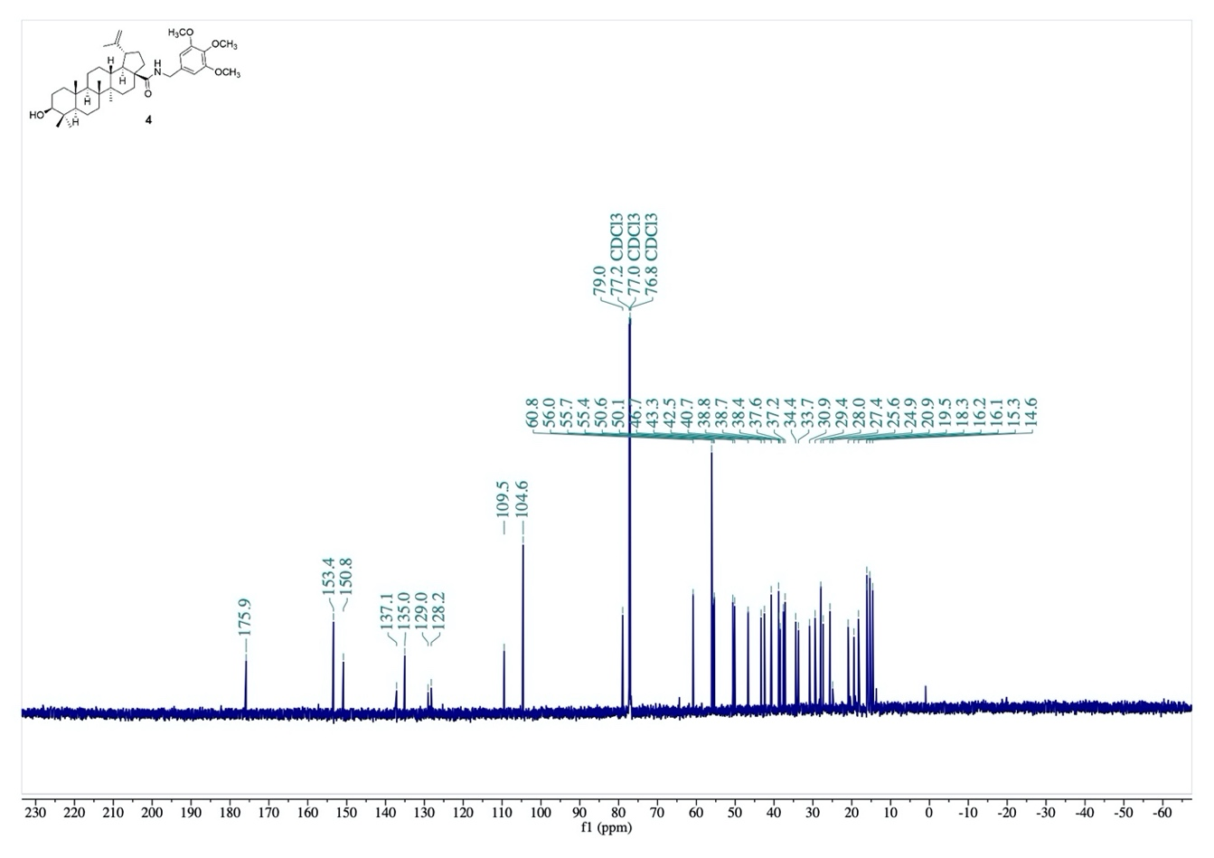

Fig. S19. ¹³C-NMR spectrum of compound 4.
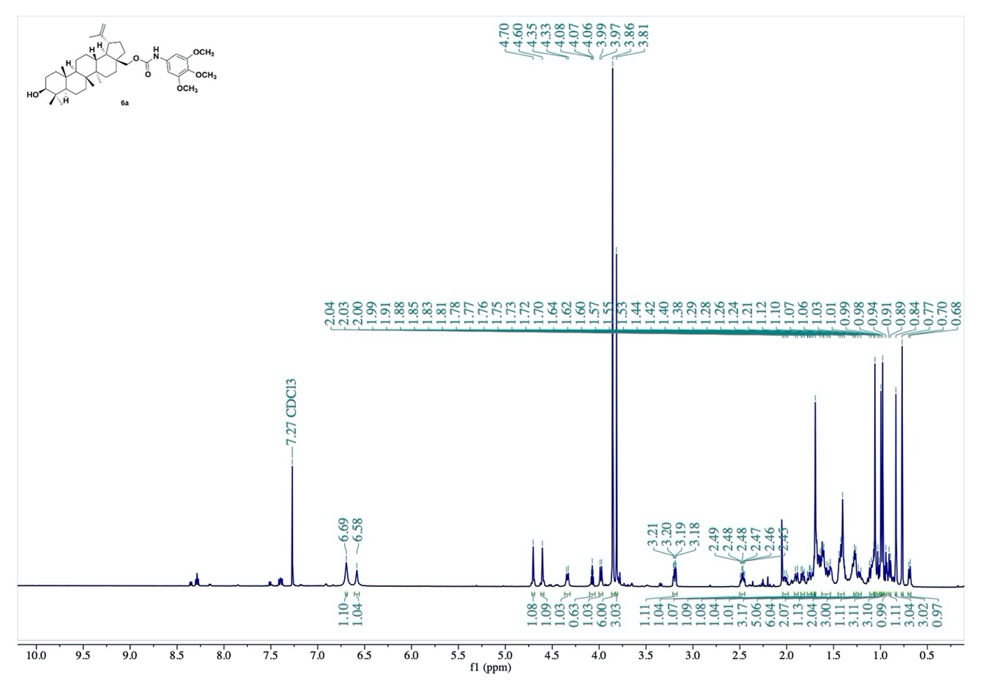
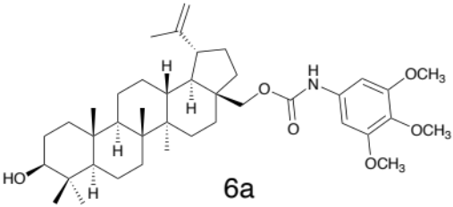

Fig. S20. ¹H-NMR spectrum of compound 6a.
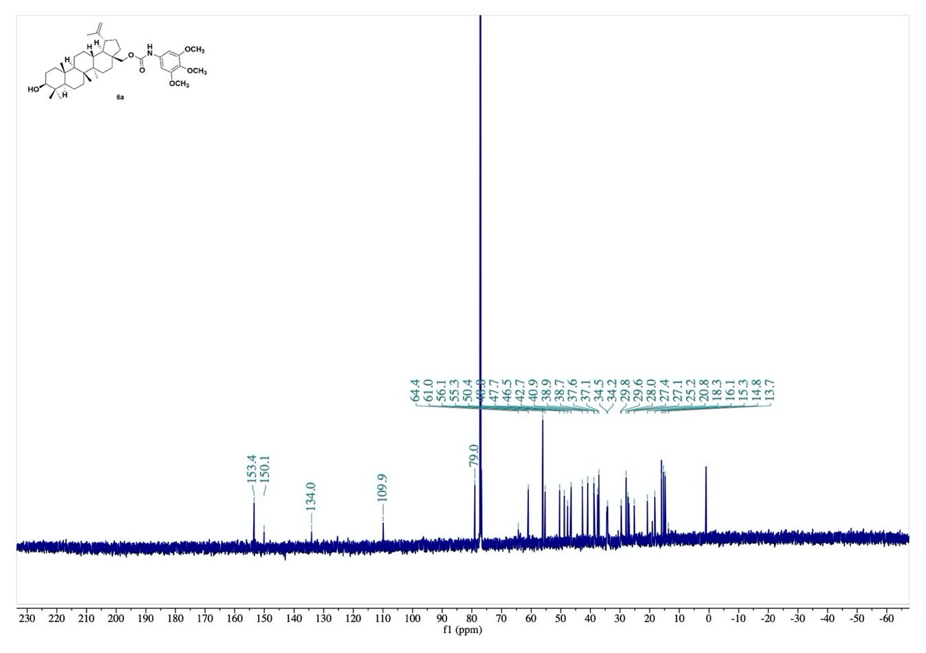

Fig. S21. ¹³C-NMR spectrum of compound 6a.
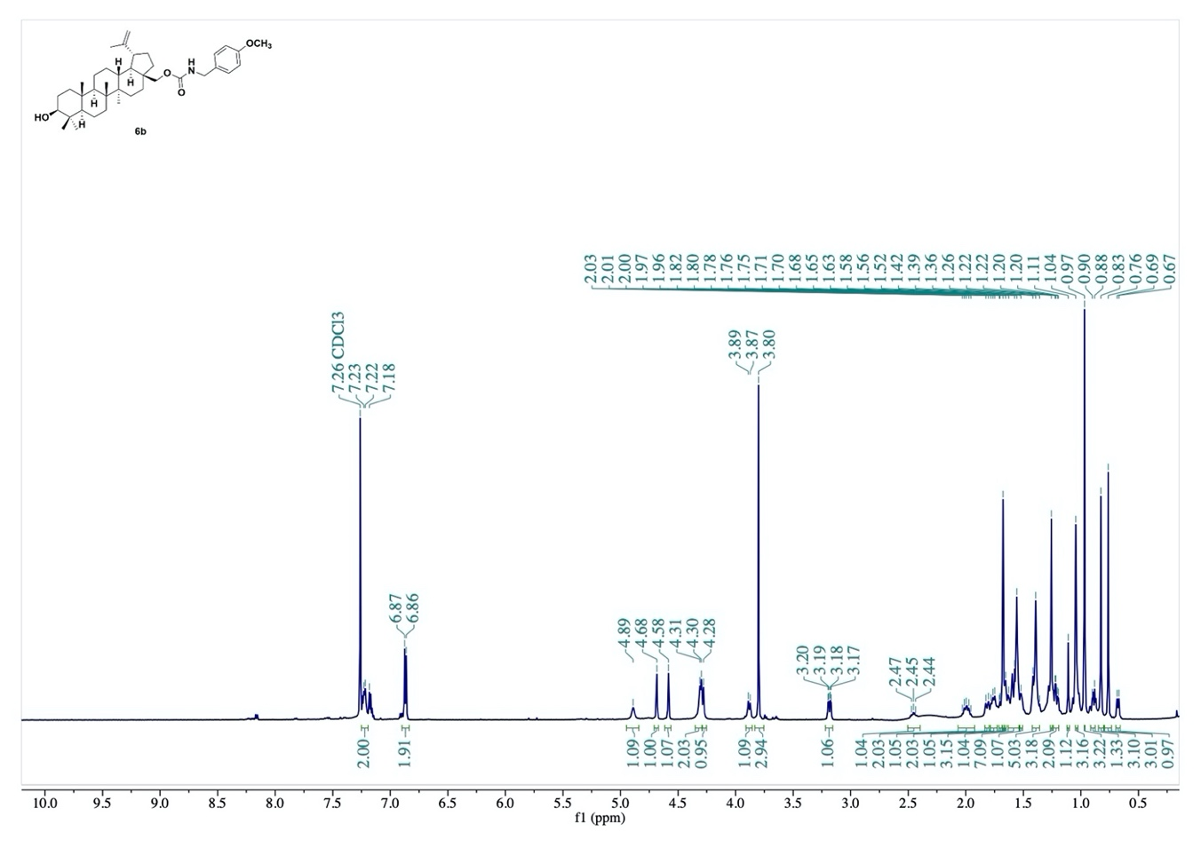
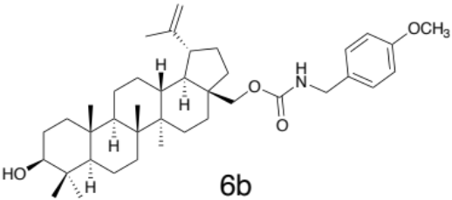

Fig. S22. ¹H-NMR spectrum of compound 6b.
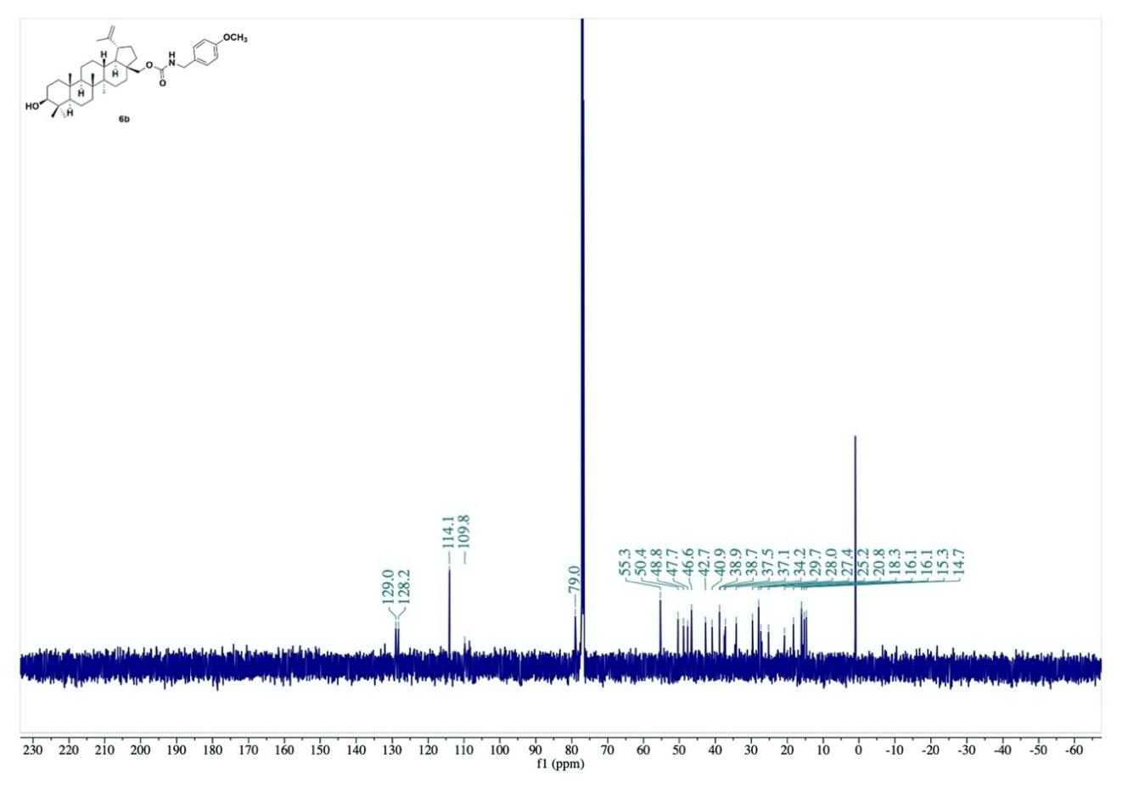

Fig. S23. ¹³C-NMR spectrum of compound 6b.
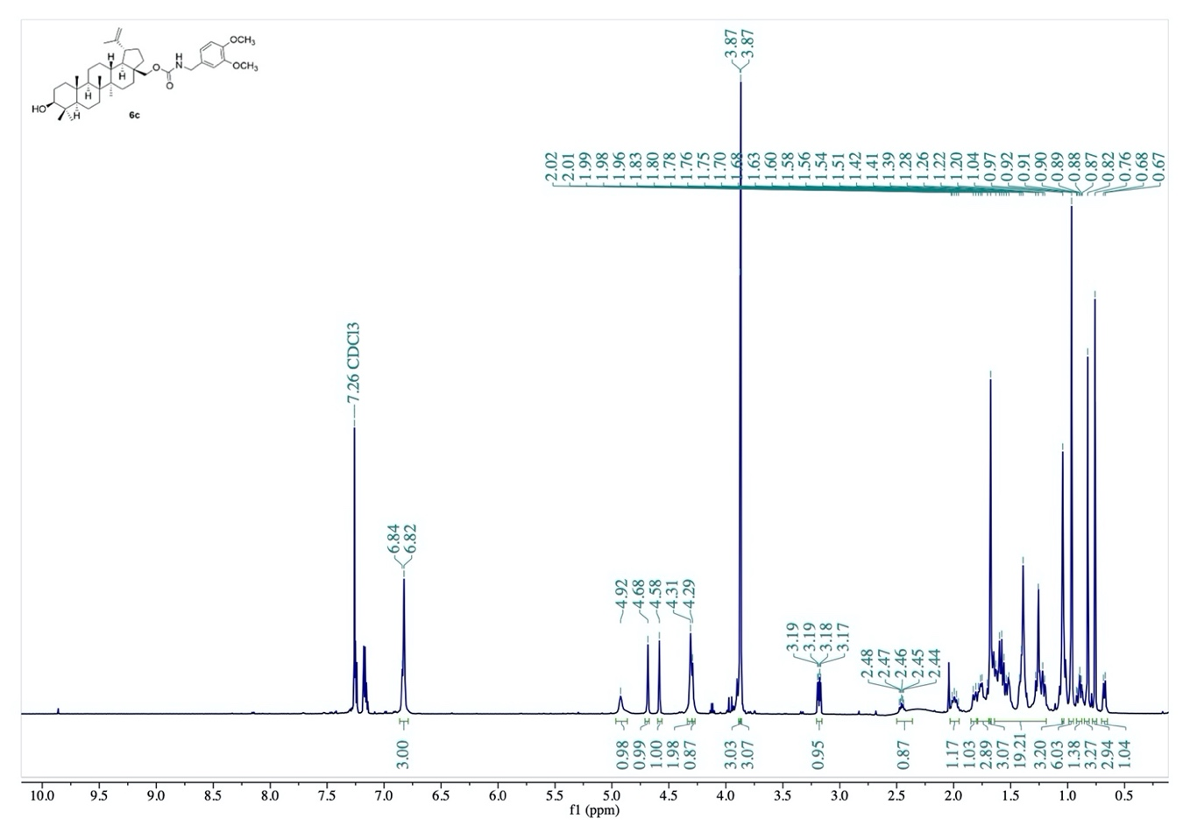
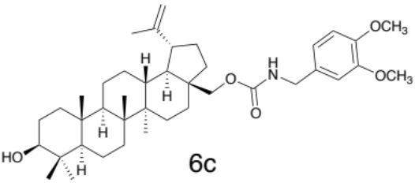

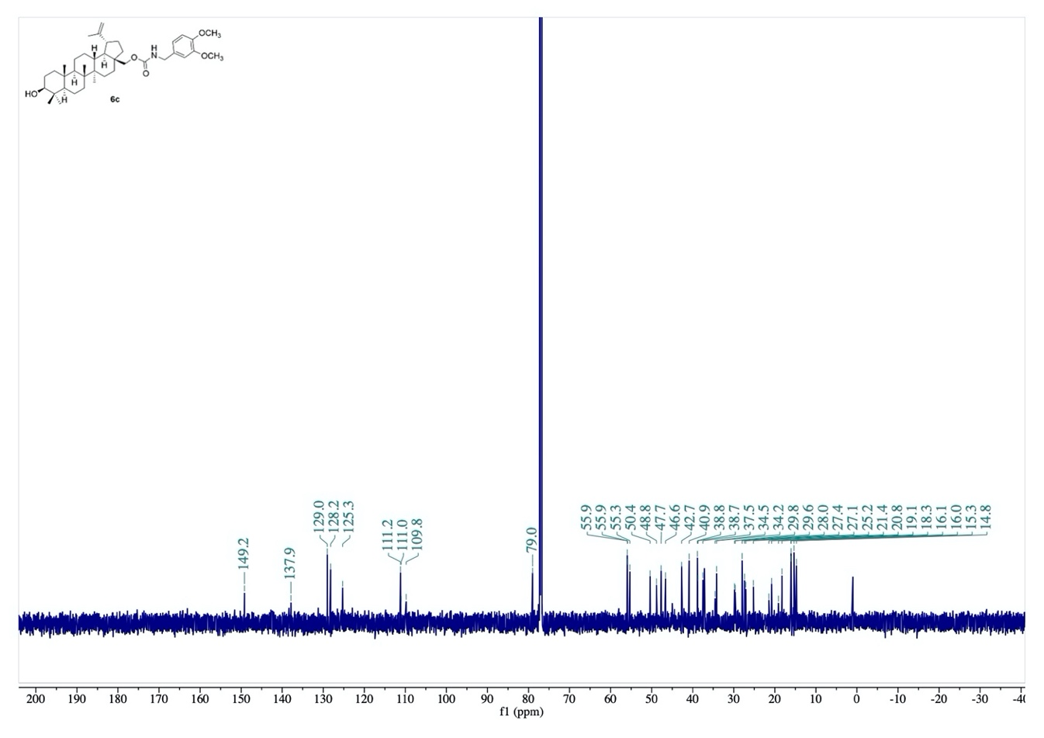
Fig. S24. ¹H-NMR spectrum of compound 6c.

Fig. S25. ¹³C-NMR spectrum of compound 6c.
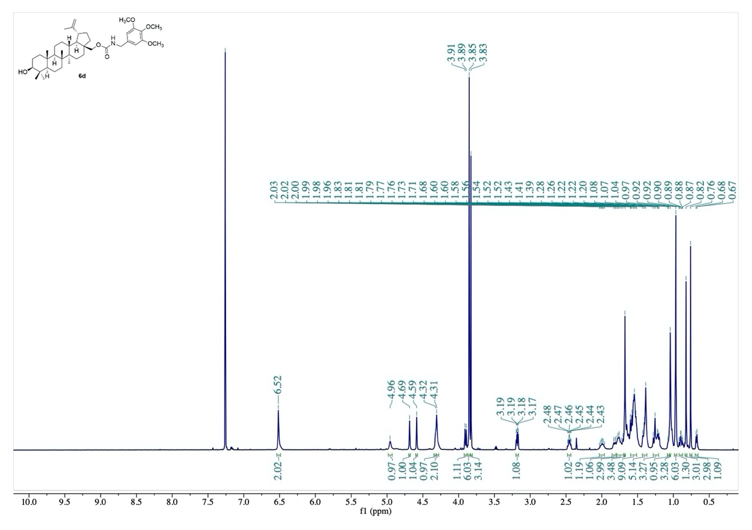
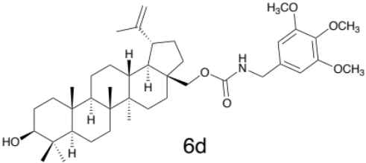

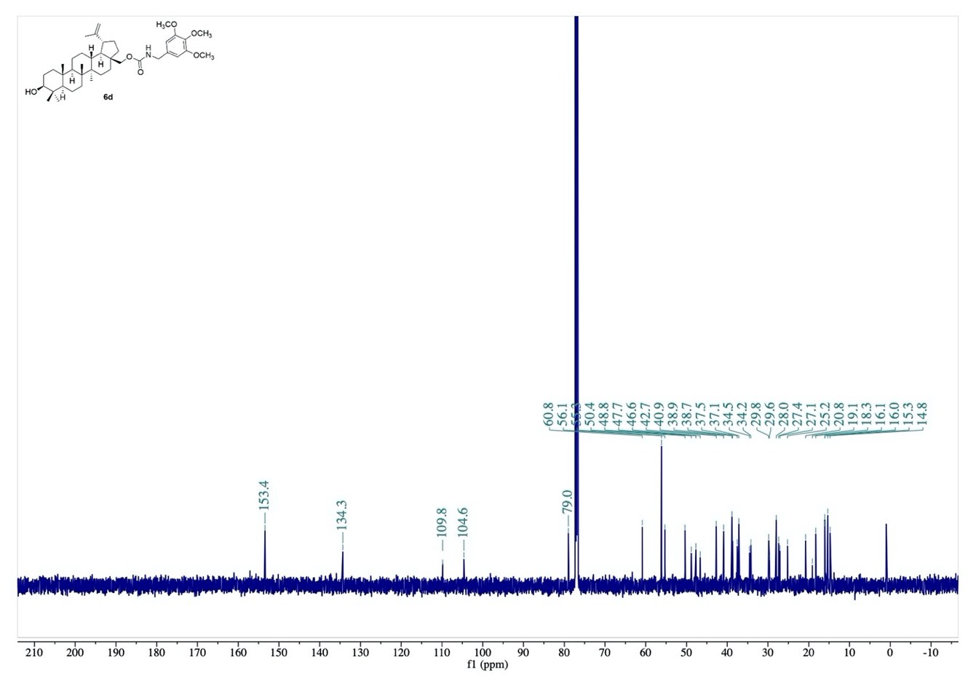
Fig. S26. ¹H-NMR spectrum of compound 6d.

Fig. S27. ¹³C-NMR spectrum of compound 6d.

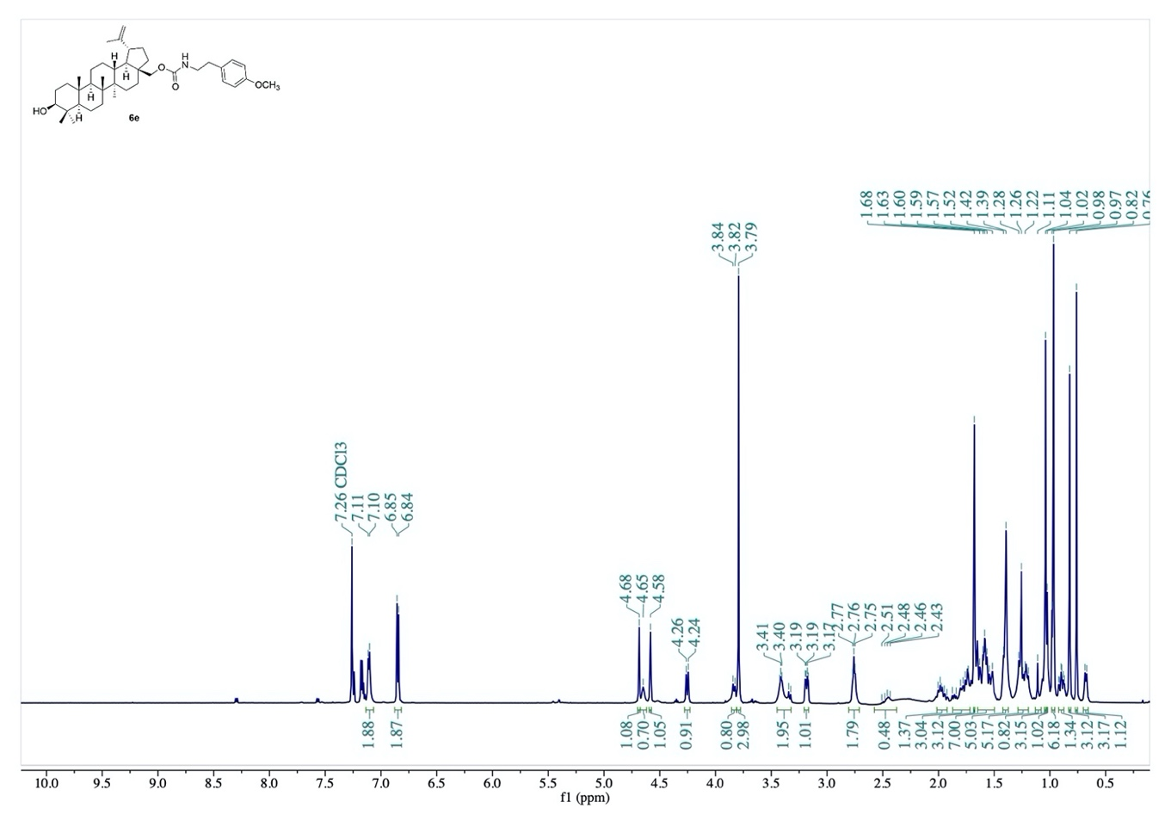
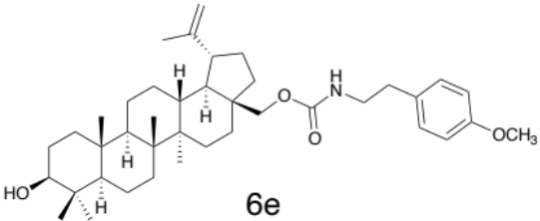

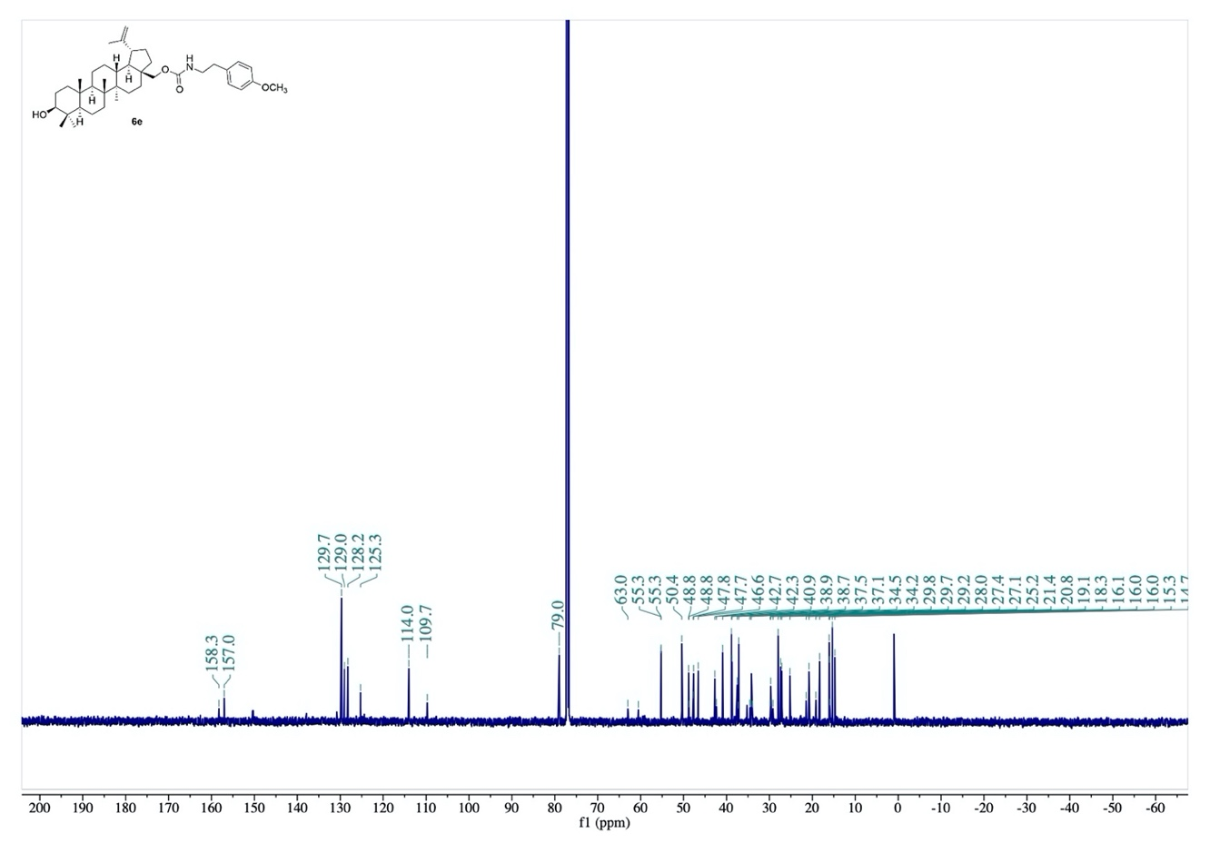
Fig. S28. ¹H-NMR spectrum of compound 6e.

Fig. S29. ¹³C-NMR spectrum of compound 6e.
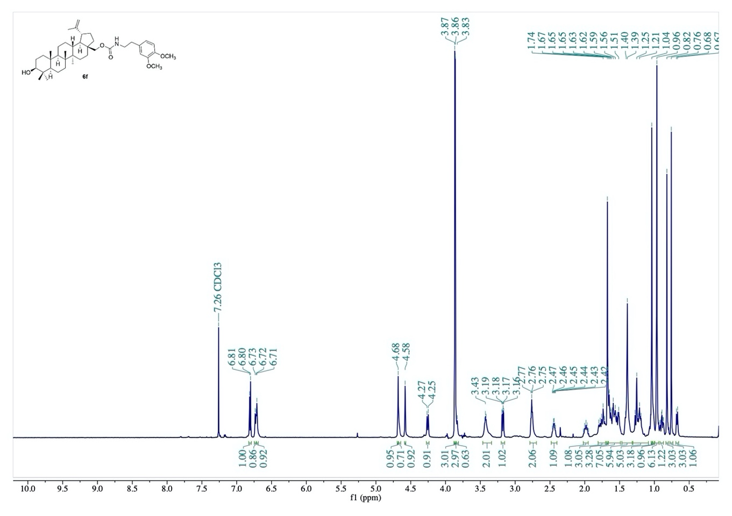
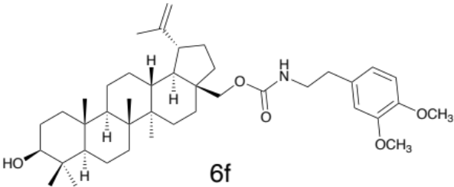

Fig. S30. ¹H-NMR spectrum of compound 6f.
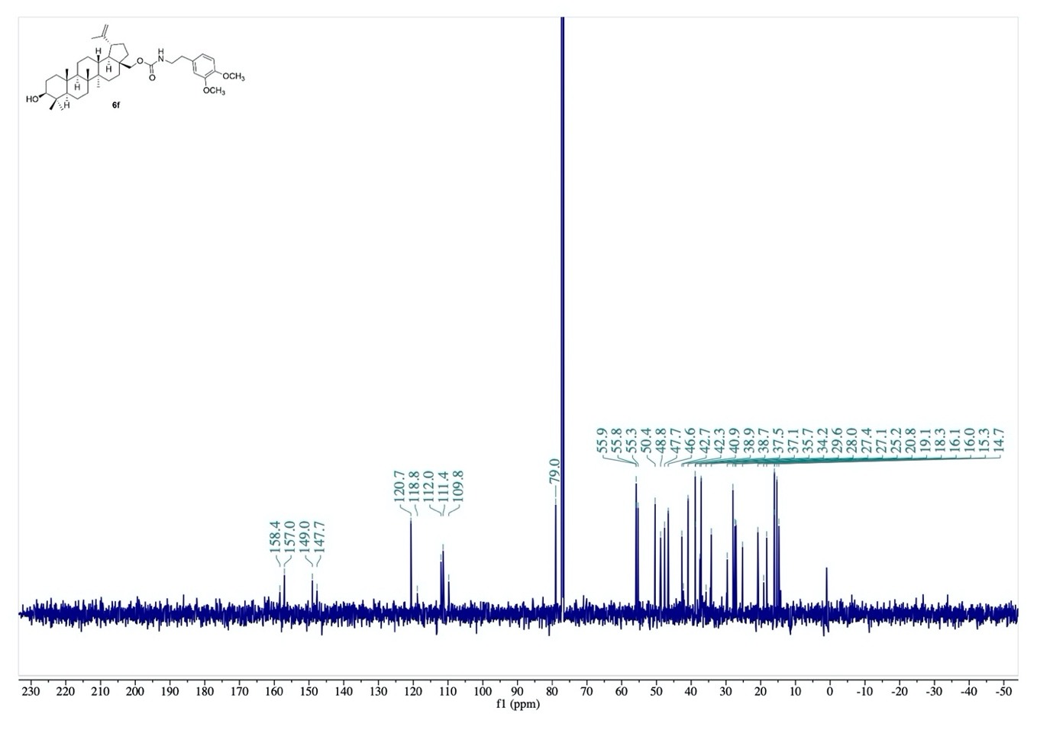

Fig. S31. ¹³C-NMR spectrum of compound 6f.
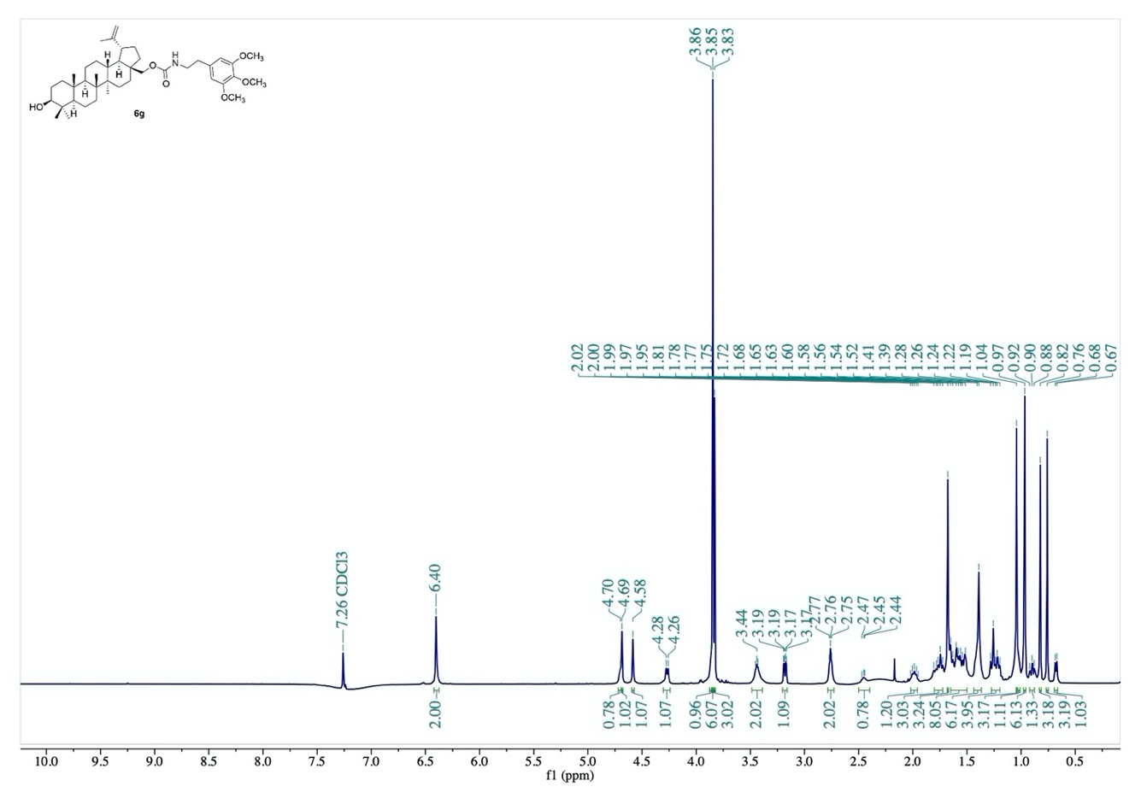
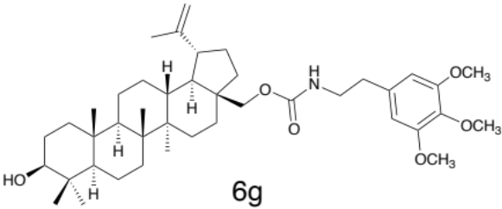

Fig. S32. ¹H-NMR spectrum of compound 6g.
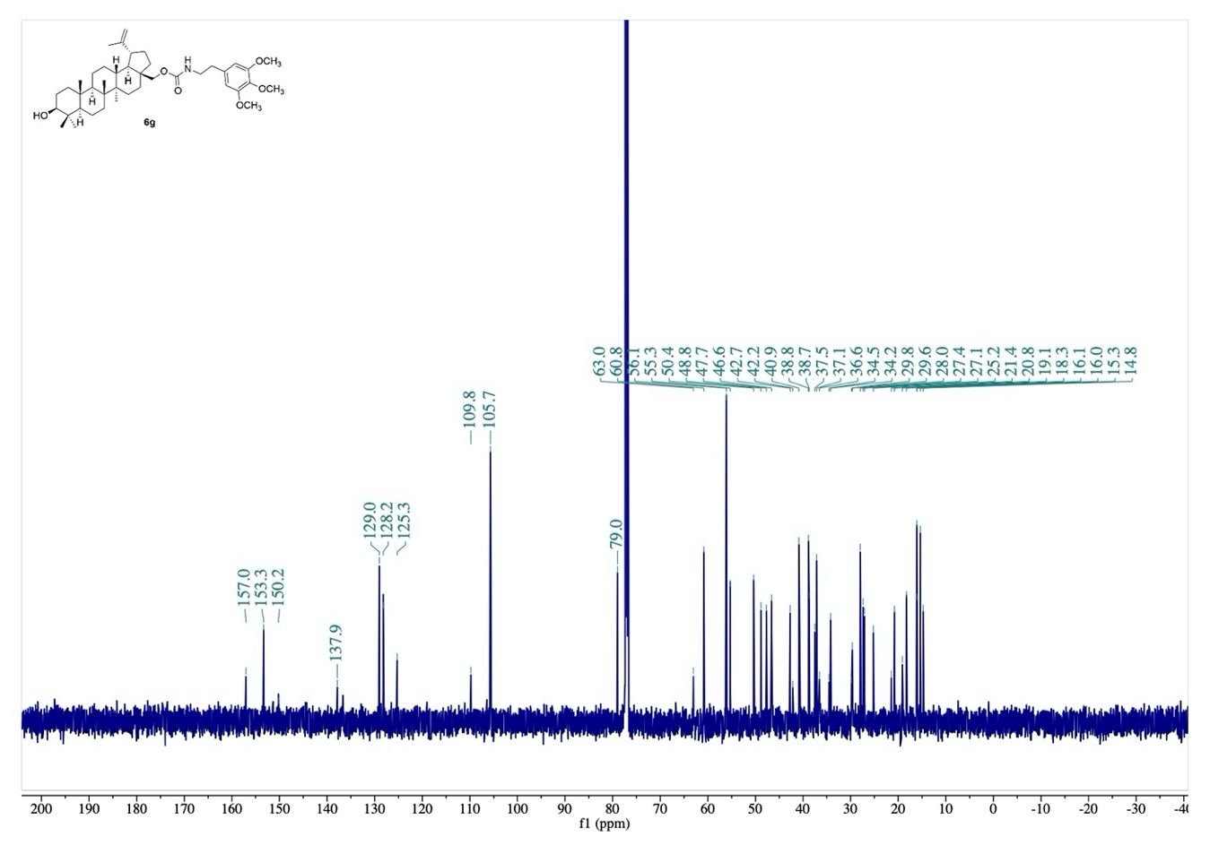

Fig. S33. ¹³C-NMR spectrum of compound 6g.

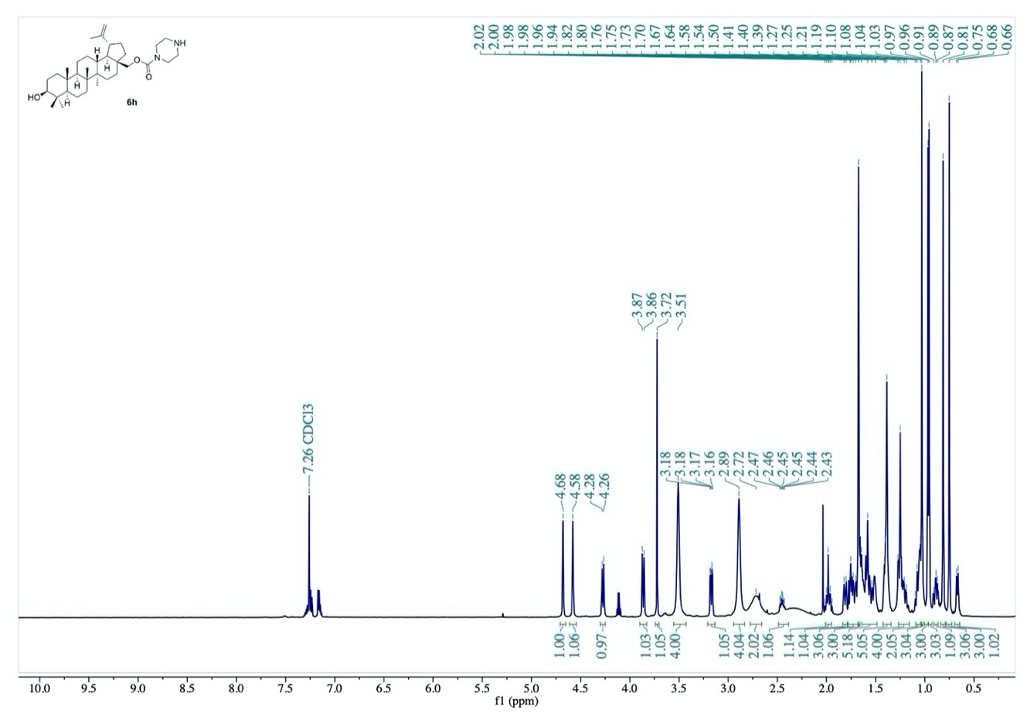
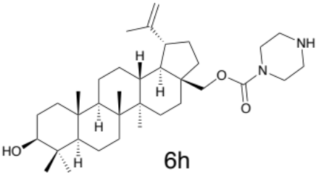

Fig. S34. ¹H-NMR spectrum of compound 6h.
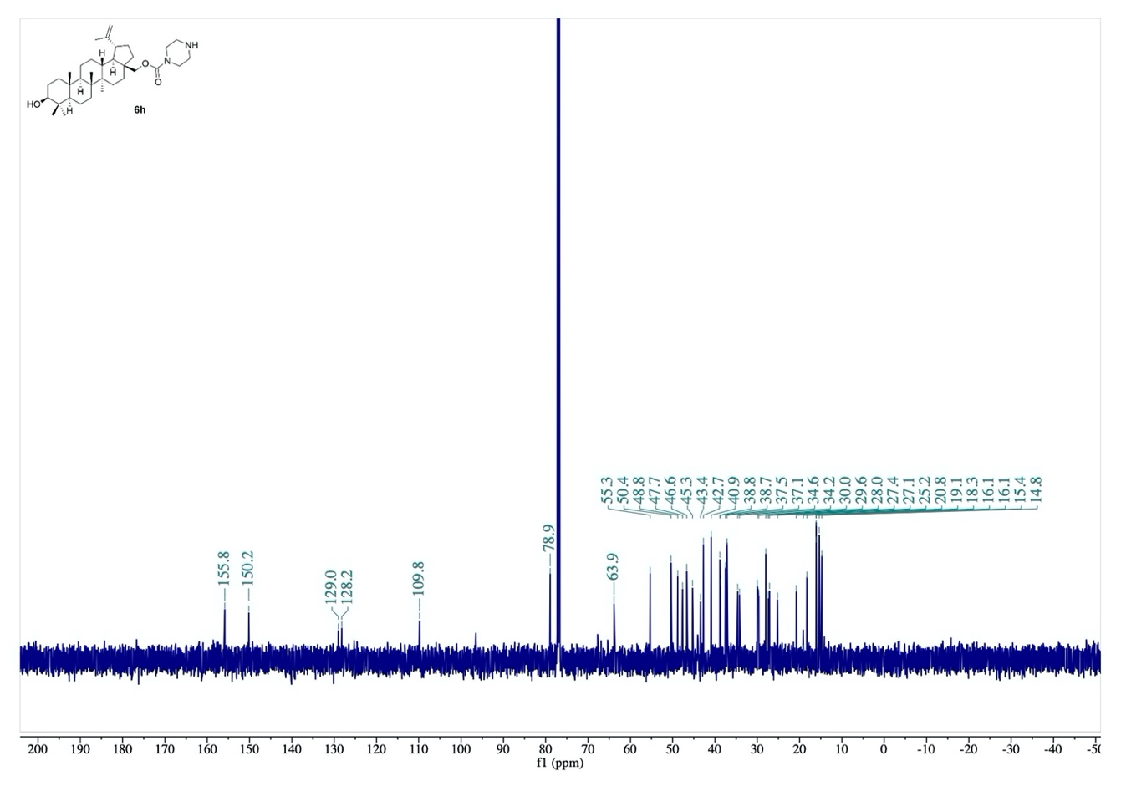

Fig. S35. ¹³C-NMR spectrum of compound 6h.
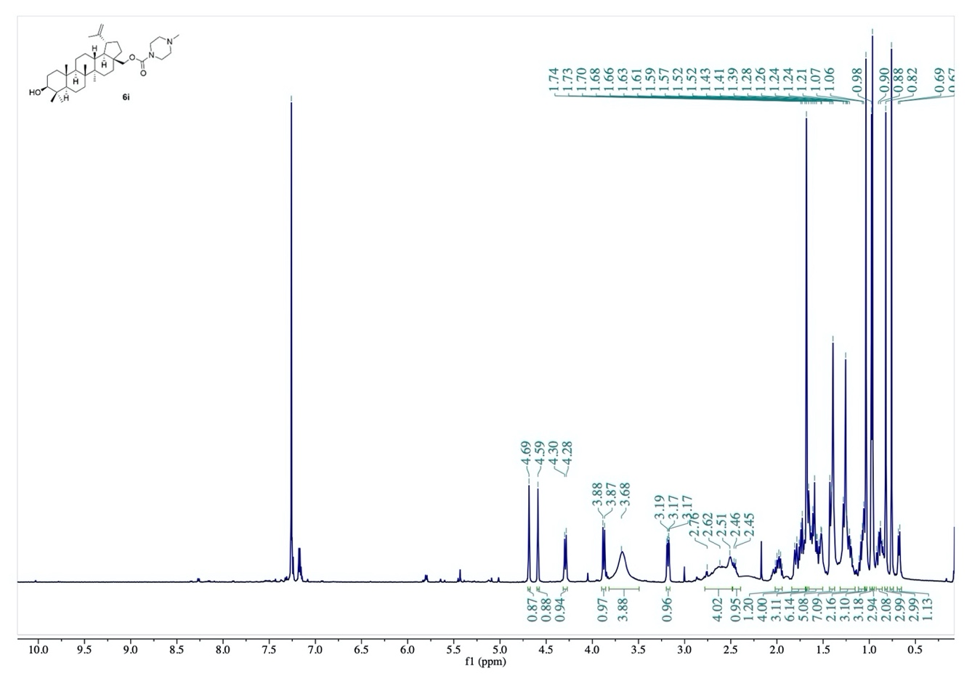
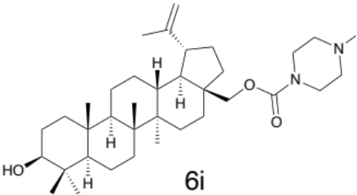

Fig. S36. ¹H-NMR spectrum of compound 6i.
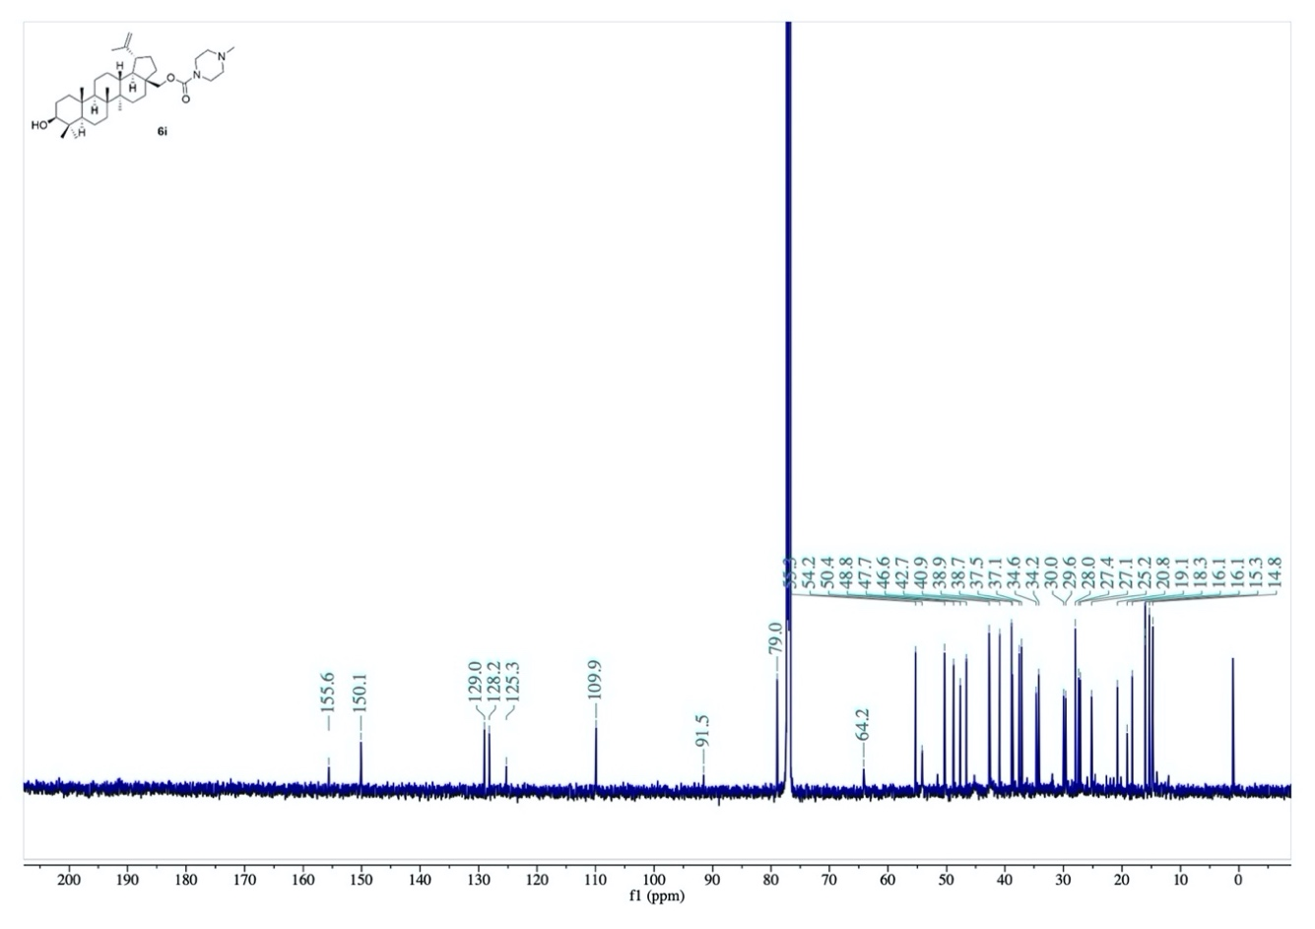

Fig. S37. ¹³C-NMR spectrum of compound 6i.

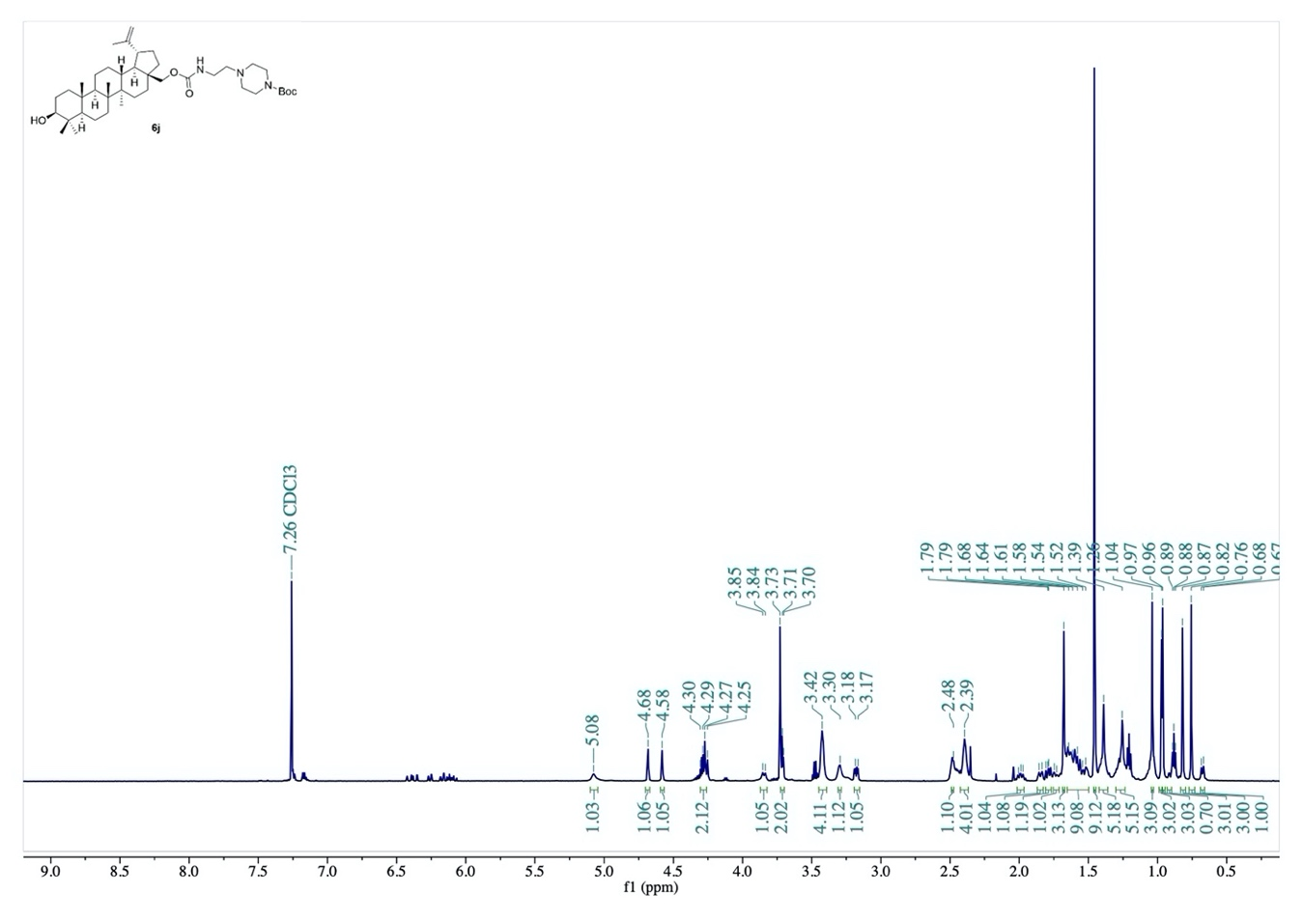
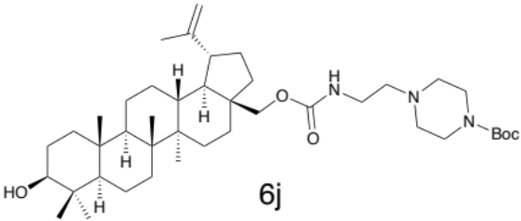

Fig. S38. ¹H-NMR spectrum of compound 6j.
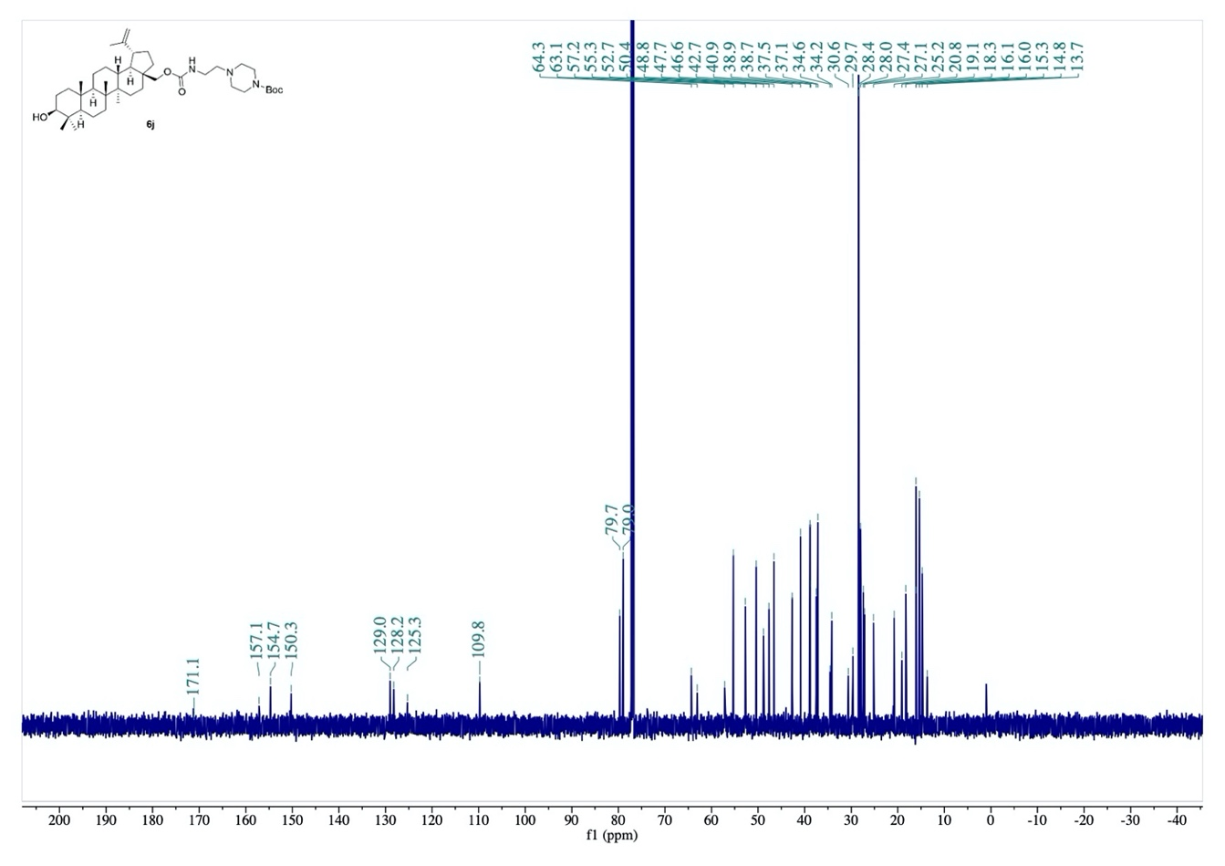

Fig. S39. ¹³C-NMR spectrum of compound 6j.

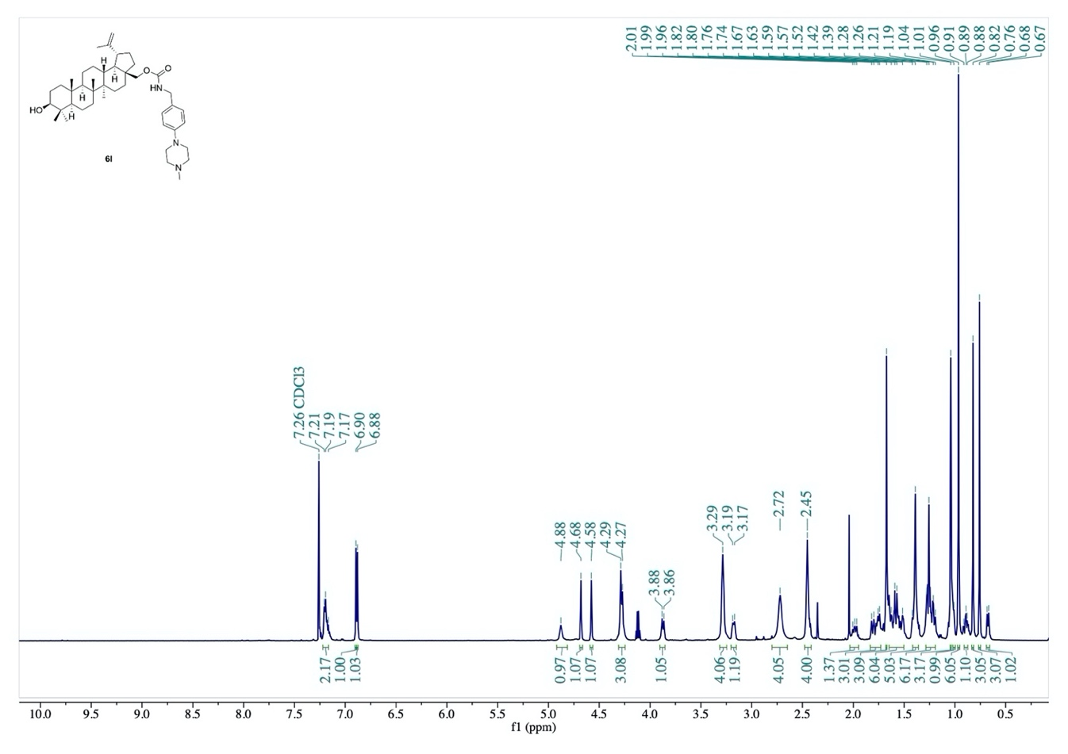
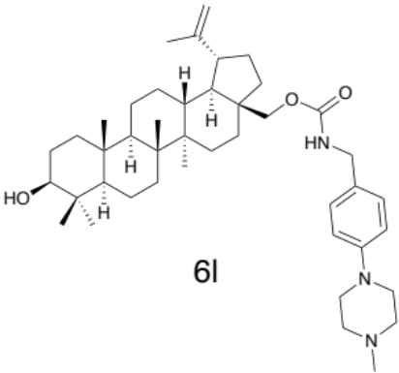

Fig. S40. ¹H-NMR spectrum of compound 6l.
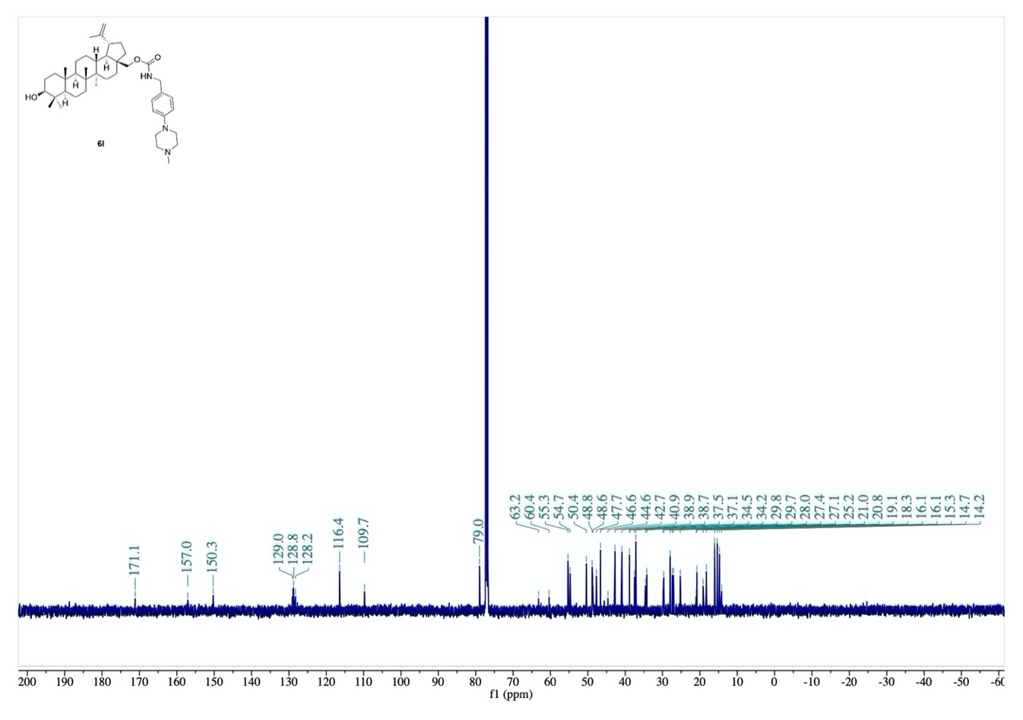

Fig. S41. ¹³C-NMR spectrum of compound 6l.

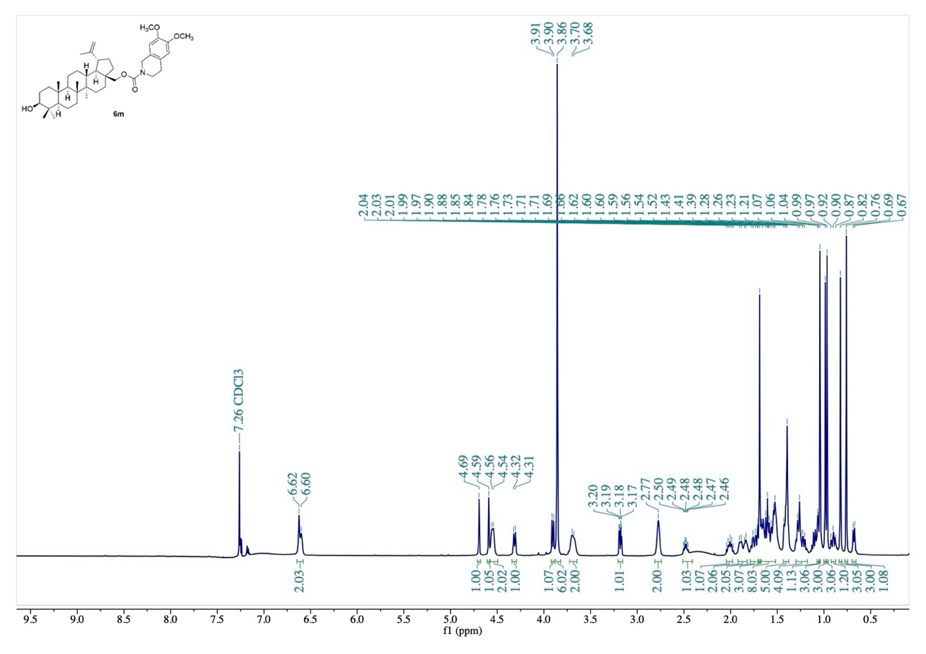
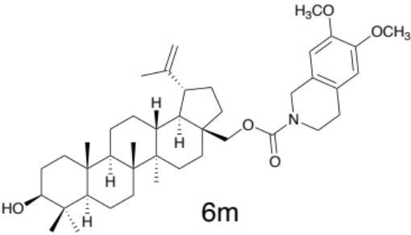

Fig. S42. ¹H-NMR spectrum of compound 6m.
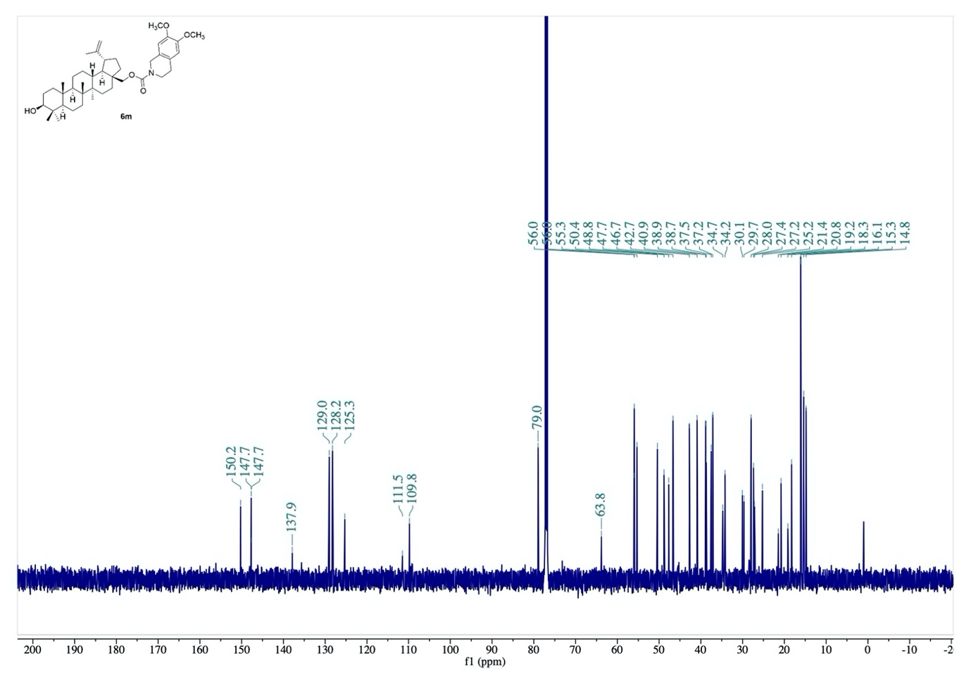

Fig. S43. ¹³C-NMR spectrum of compound 6m.
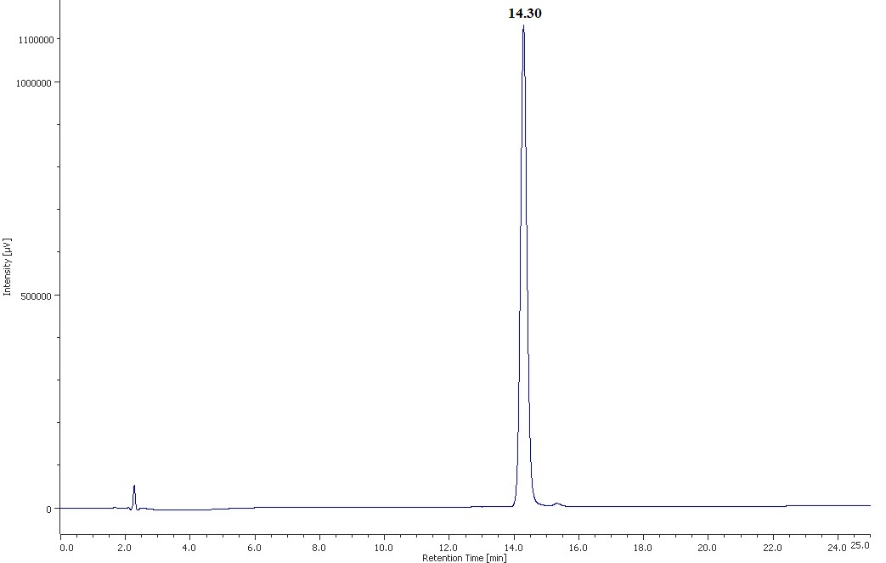

Fig. S44. HPLC chromatogram of compound 3a.

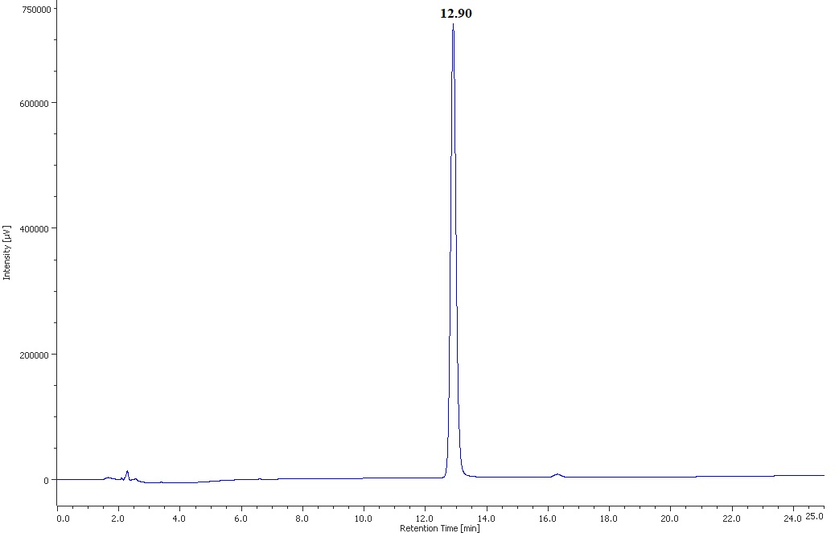

Fig. S45. HPLC chromatogram of compound 3b.
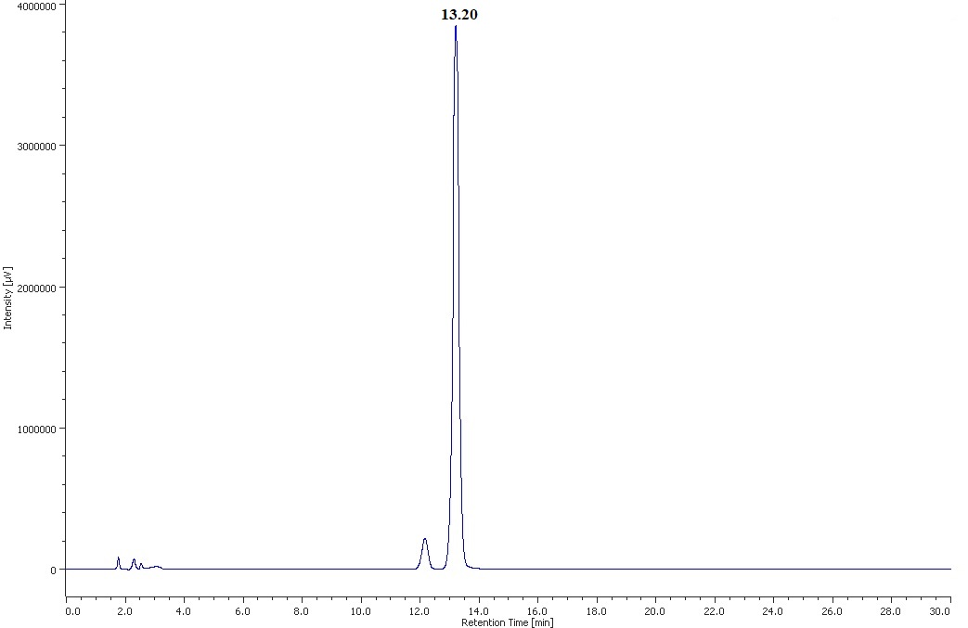

Fig. S46. HPLC chromatogram of compound 3c.

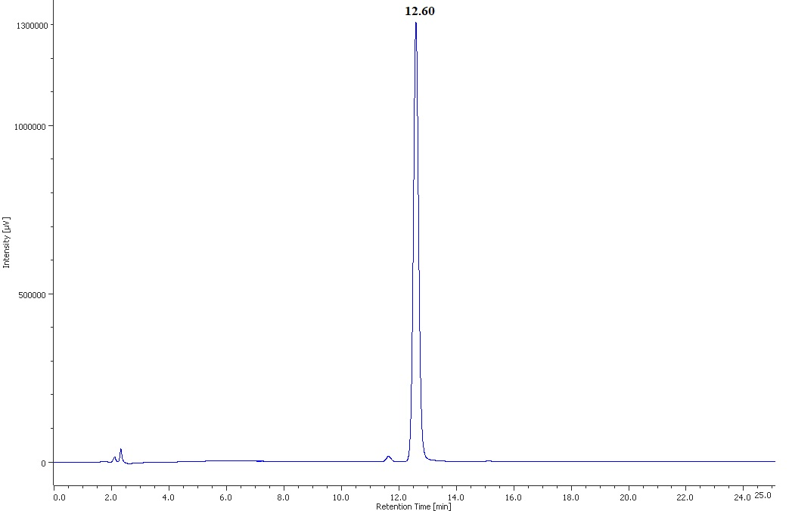

Fig. S47. HPLC chromatogram of compound 3d.
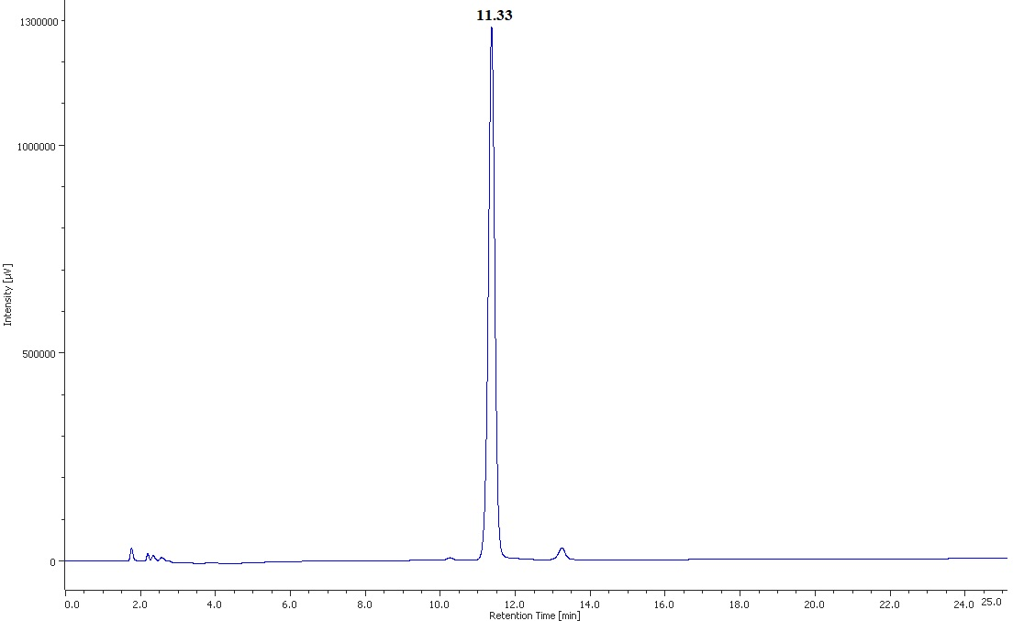

Fig. S48. HPLC chromatogram of compound 3e.

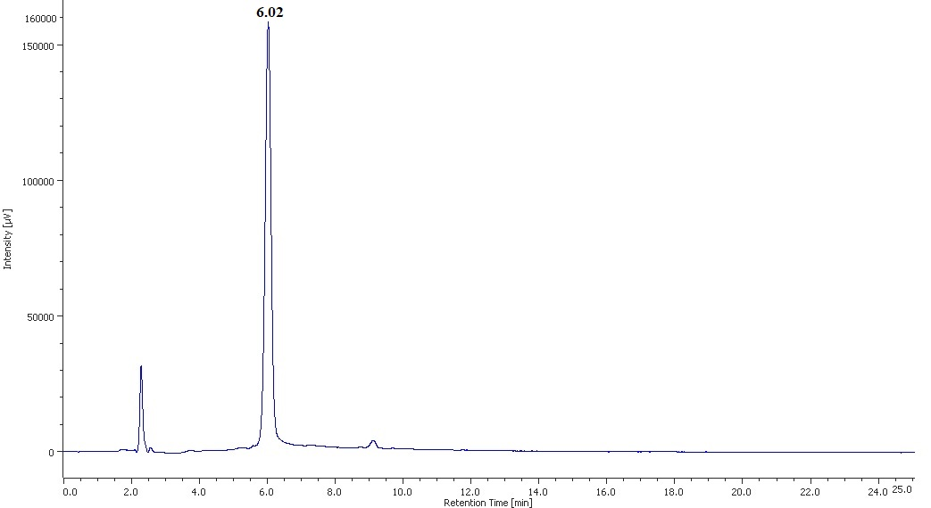

Fig. S49. HPLC chromatogram of compound 4.

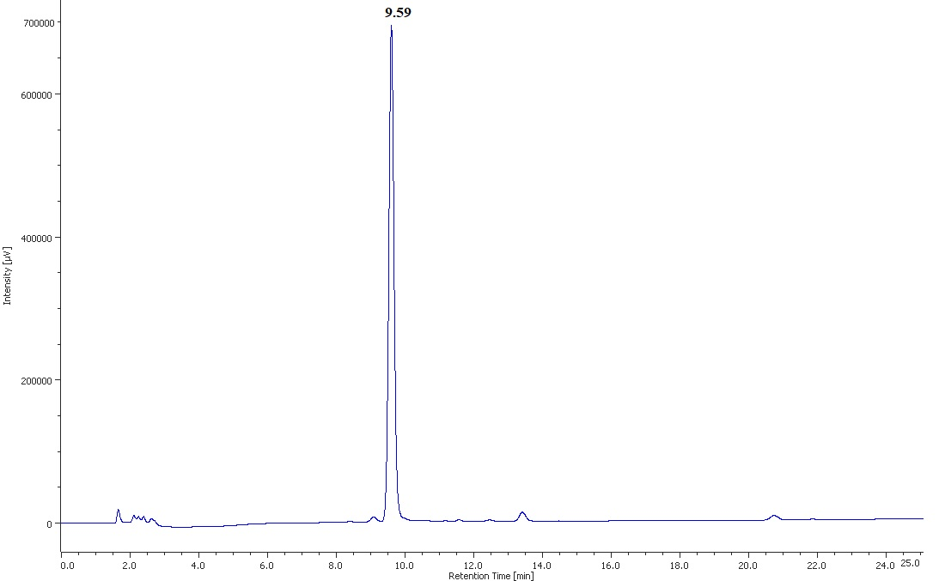

Fig. S50. HPLC chromatogram of compound 6a.
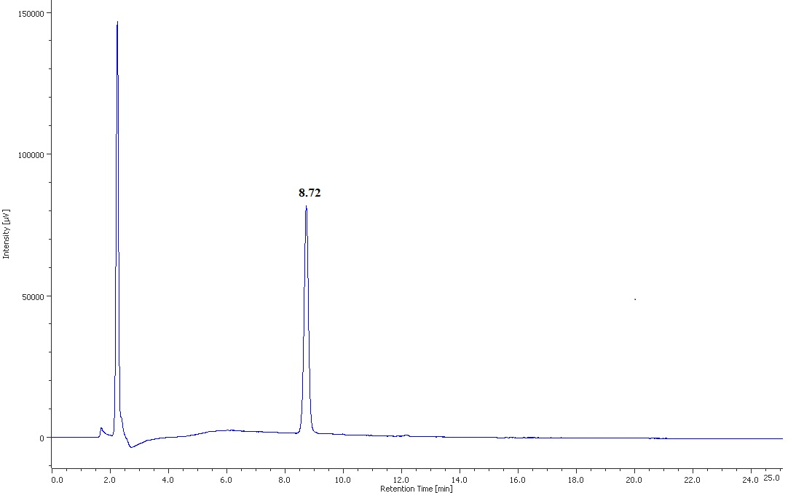

Fig. S51. HPLC chromatogram of compound 6b.

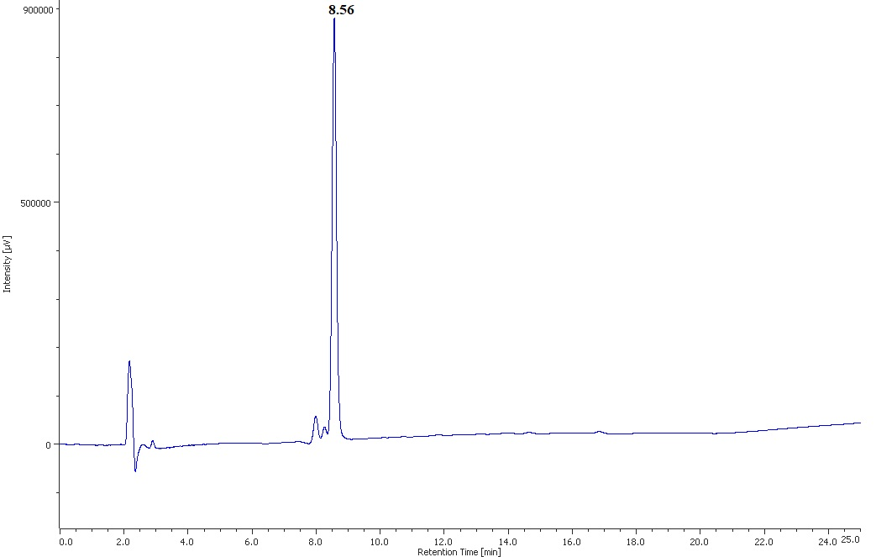

Fig. S52. HPLC chromatogram of compound 6c.
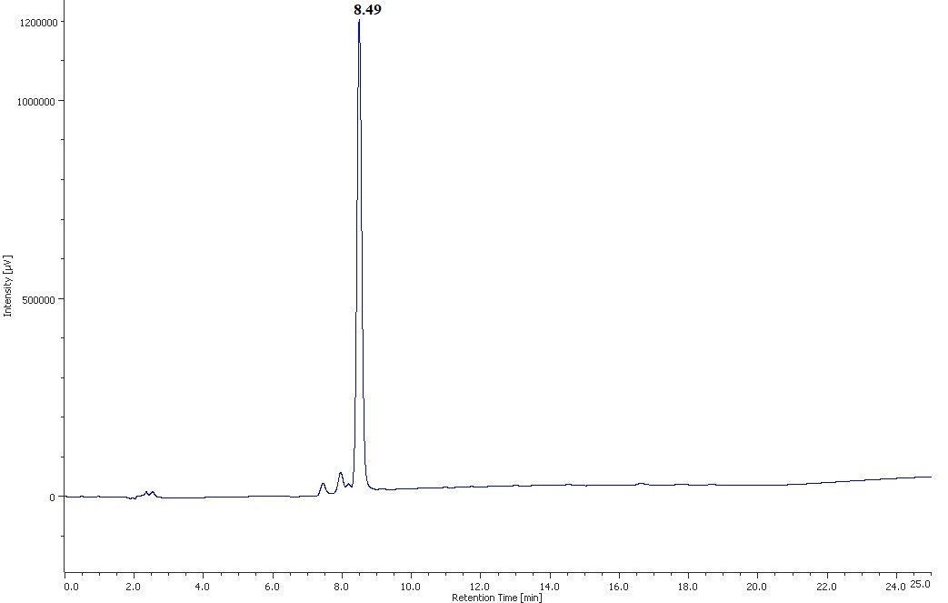

Fig. S53. HPLC chromatogram of compound 6d.

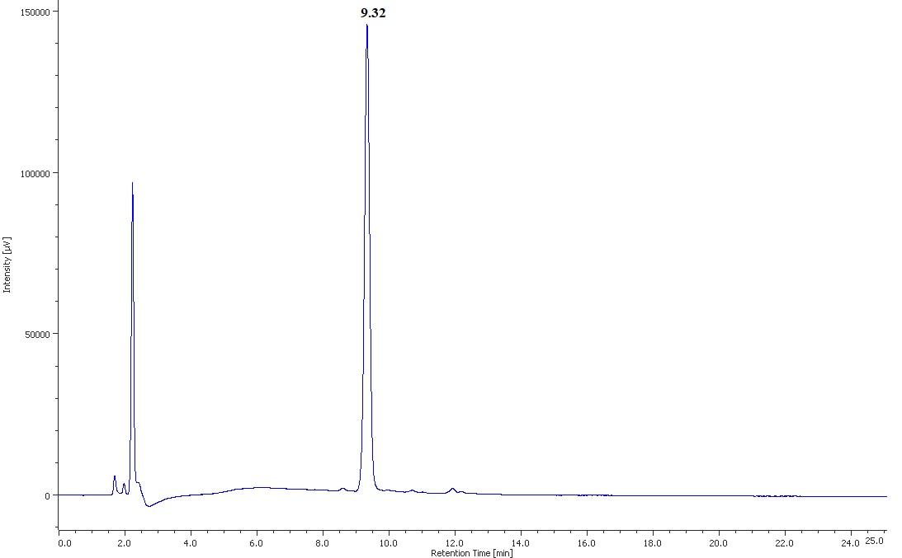

Fig. S54. HPLC chromatogram of compound 6e.

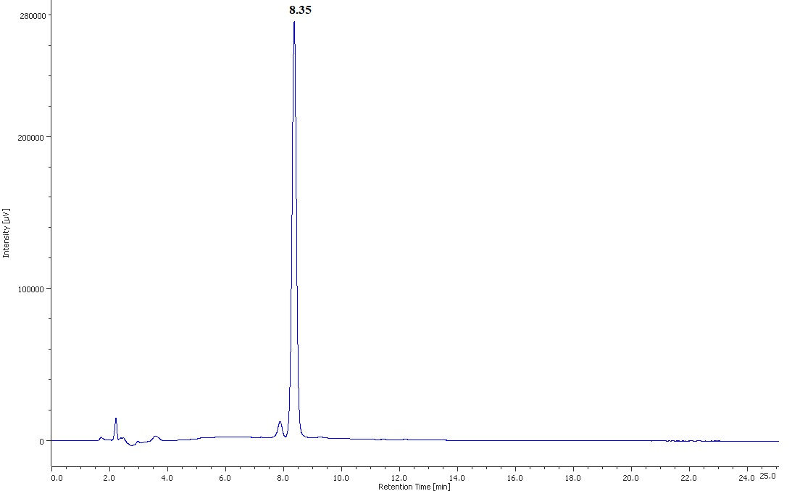

Fig. S55. HPLC chromatogram of compound 6f.

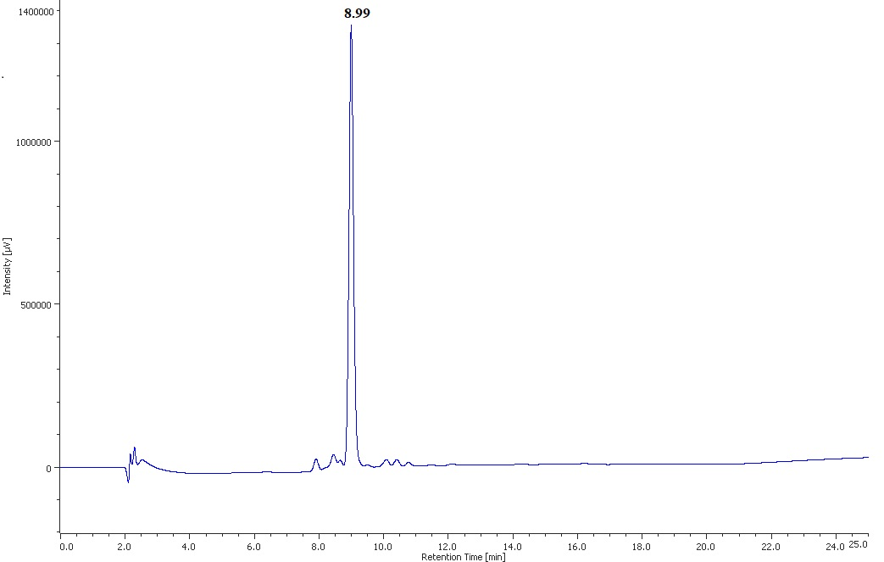

Fig. S56. HPLC chromatogram of compound 6g.

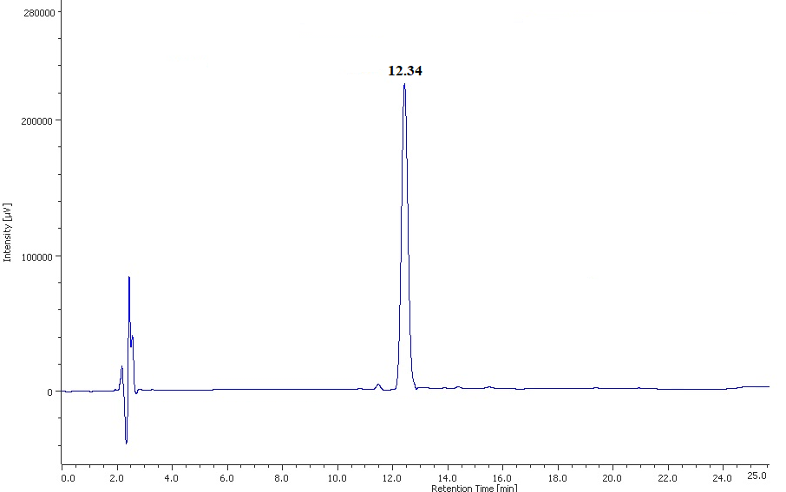

Fig. S57. HPLC chromatogram of compound 6h.

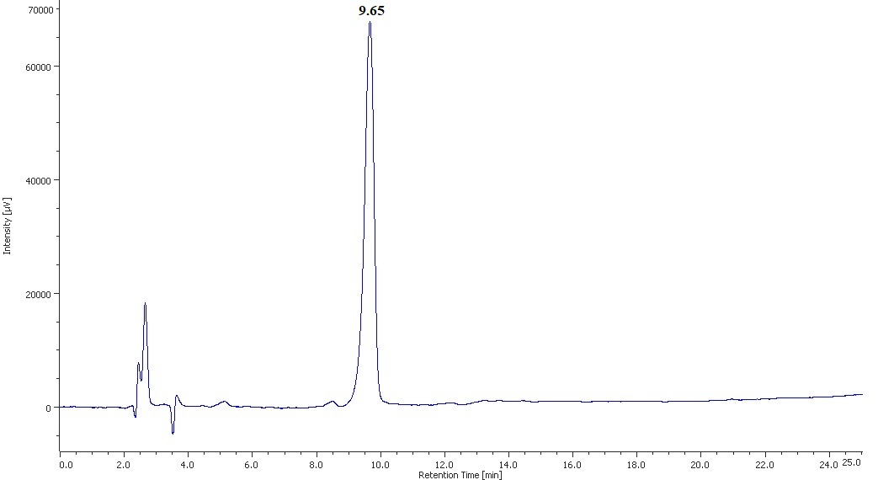

Fig. S58. HPLC chromatogram of compound 6i.

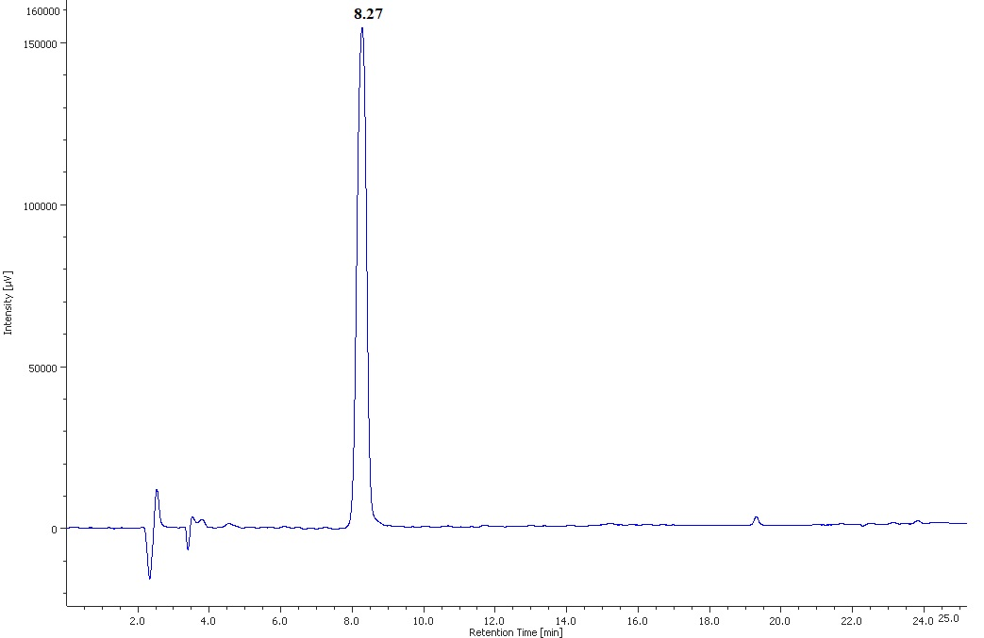

Fig. S59. HPLC chromatogram of compound 6j.

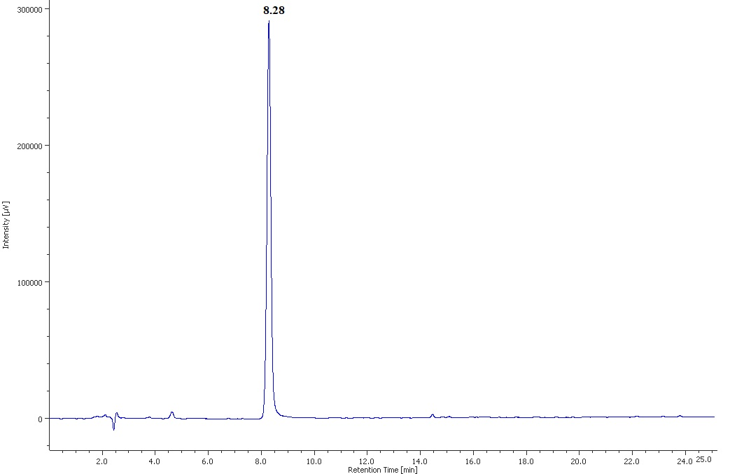

Fig. S60. HPLC chromatogram of compound 6k.
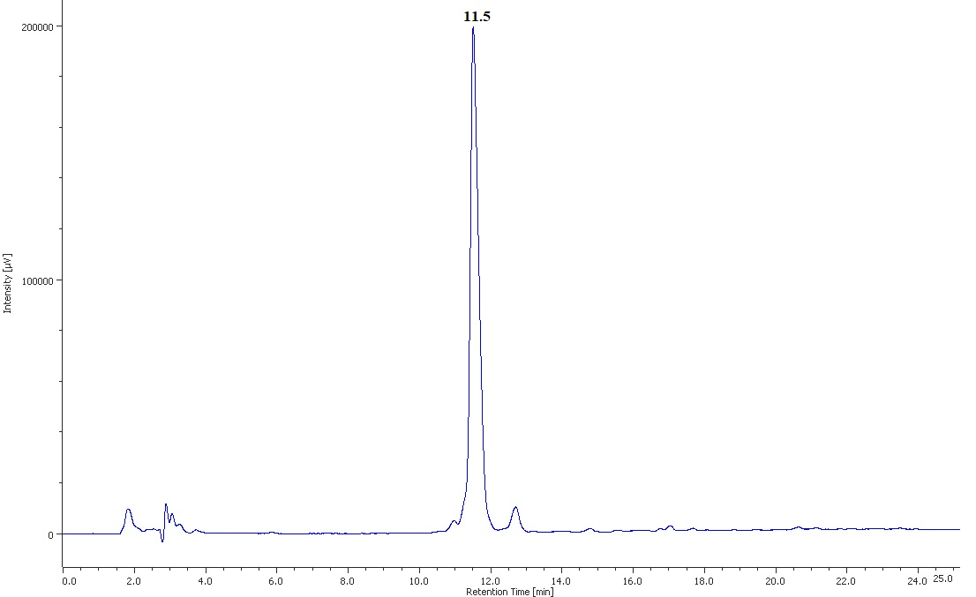

Fig. S61. HPLC chromatogram of compound 6l.

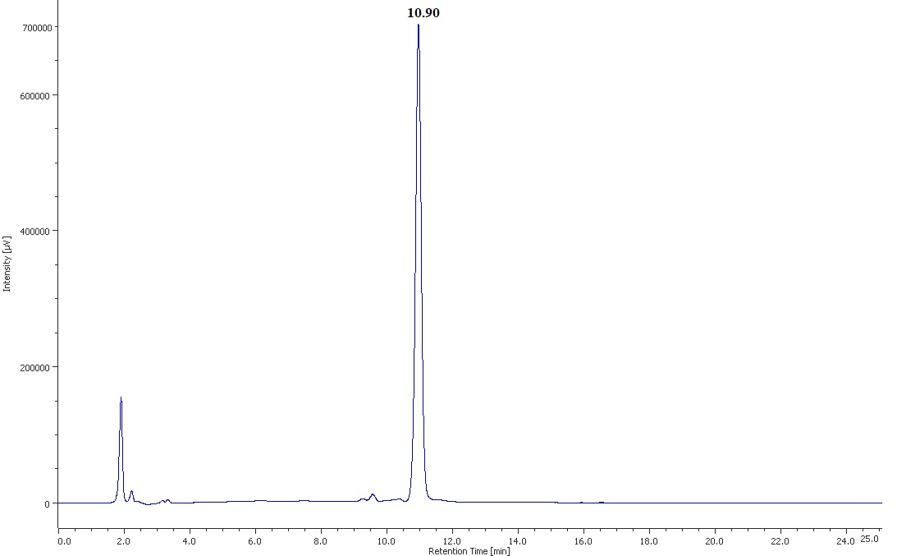

Fig. S62. HPLC chromatogram of compound 6m.

[1] J. Laiolo, P.A. Lanza, O. Parravicini, C. Barbieri, D. Insuasty, J. Cobo, D. Vera, R.D. Enriz, M.C. Carpinella, Structure activity relationships and the binding mode of quinolinone-pyrimidine hybrids as reversal agents of multidrug resistance mediated by P-gp, Sci. Rep., 11 (2021) 1-18.

