Host factors underlying genetic susceptibility to Xanthomonas infection: a study of a neglected tropical disease in passion fruit (Passiflora alata)

Supplementary Figures

Supplementary Fig. S1: Schematic representation of the experiment in which leaf samples of Passiflora alata were inoculated with Xanthomonas axonopodis pv. passiflorae. Control samples were inoculated with a 0.85% NaCl solution. Five days after infection (DAI), the leaves were collected, and total RNA extracted for library preparation and sequencing.
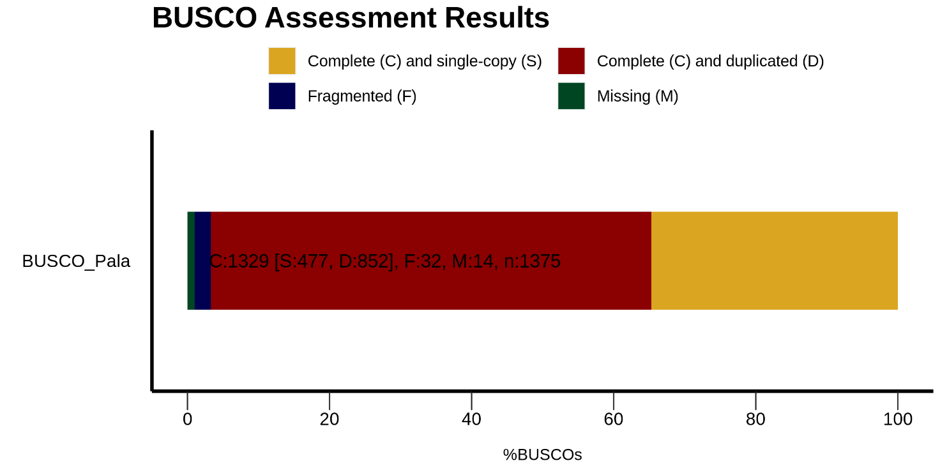
Supplementary Fig. S2: BUSCO assessment results. Assembly is 96.6% complete and there were only 2.32% fragmented and 1.02% missing genes.

Supplementary Fig. S3: Open reading frames identified in Passiflora alata transcriptome assembly using the TransDecoder tool. “Complete ORFs” (75%) are shown in blue. These are sequences in which the first and the stop codons were found. “Partial 5’ prime” (7%) sequences are in yellow and are sequences that contain the start codon but lack the stop codon; “Partial 3’ primer” sequences (12%) are in green and lack the start codon; “internal ORFs” (6%) are in red and are sequences that lack both codons.

Supplementary Fig. S4: Pearson correlation of 4 differentially expressed genes (LOB, SWEET10, TIR-NBS-LRR and CC-NBS-LRR) selected from RNA-seq analysis by RT-qPCR. The fold changes are shown for the 4 genes identified using RNA-seq compared to those obtained by RT-qPCR.

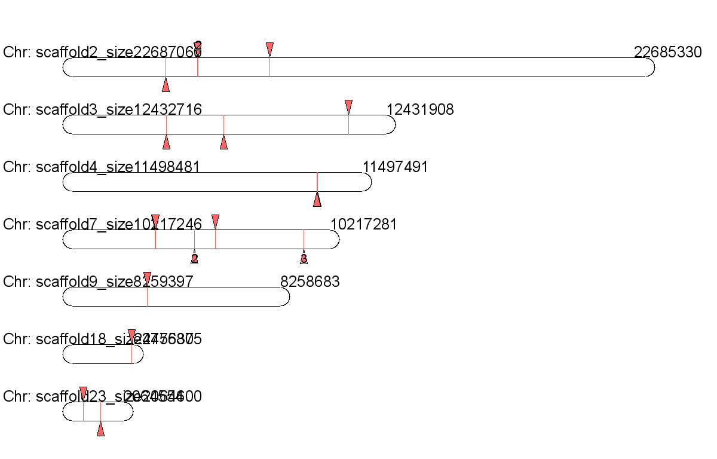
Supplementary Fig. S5: Genome location of SWEET10 copies in the Passiflora organensis genome. For more information, please see Supplementary File 1 (Excel spreadsheet).

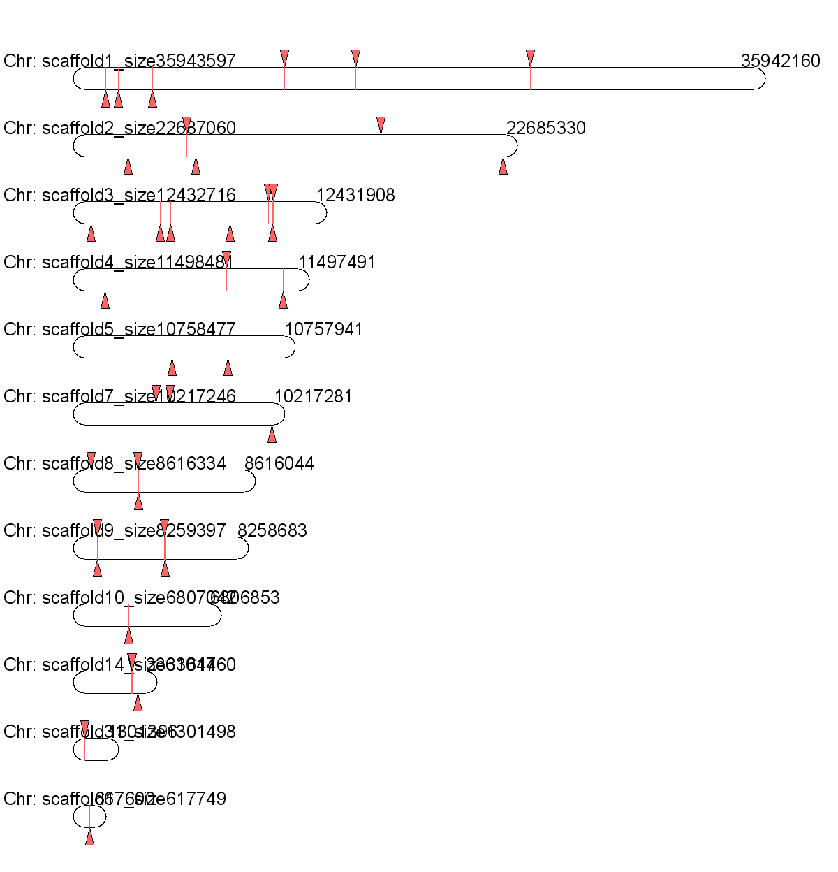
Supplementary Fig. S6: Genome location of LOB1 copies in the Passiflora organensis genome. For more information, please see Supplementary File 1 (Excel spreadsheet).

Supplemental Tables
Supplementary Table S1. List of primers used for RNA-Seq validation.
Gene name | Primer sequence (Forward 5’ → 3’) | Primer sequence (Reverse 3’ → 5’)
SWEET10 | AGGACCCTAGCTTTCTTTGGTG | GGTTCCAGTCAGTTCCATACGT
LOB1 | CTTTGGACGTGATTGAGTGCTG | AGGTTTCGTCTCGTCAACATGA
CC-NBS-LRR | TGCGTCTGGAAAGCTACTGATT | AGCGCCATCAAAACCAGTACTA
TIR-NBS-LRR | TGAAAAACTGCCGTAGACTGAA | AAGCGGTGACCAGTACTTGAAT
ß-Actin | TGTTATGGTAGGGATGGGTC | TTCTCTCTATTTGCCTTGGG
GAPDH | TGGCAGTGATGGAATGGACT | CCGATGTTTGTTGTGGGTGT

Supplementary Table S2: List of down−regulated transcripts in Passiflora alata leaves, detected 5 days after infection with Xanthomonas axonopodis pv. passiflorae.
ID | Log₂ (fold change) | FDR | Description
TRINITY_DN1376_c0_g1_i83 | −11.3076 | 1.50569375422697E−15 | DEAD−box ATP−dependent RNA helicase
TRINITY_DN2085_c0_g1_i5 | −11.274 | 1.21805770734422E−16 | Protein FAR1−RELATED SEQUENCE
TRINITY_DN10288_c0_g1_i1 | −11.1837 | 3.84283142345541E−14 | Belongs to the RNase T2 family
TRINITY_DN5516_c0_g1_i14 | −11.1486 | 3.93260363160486E−16 | RAVE protein 1 C terminal
TRINITY_DN2982_c0_g1_i15 | −11.1069 | 2.41593070026528E−12 | Involved in chlorophyll biosynthesis. Catalyzes Mg ion insertion into protoporphyrin IX to yield Mg-protoporphyrin IX
TRINITY_DN2988_c0_g1_i8 | −10.9846 | 6.19040941792307E−16 | Ribonuclease H protein
TRINITY_DN202_c0_g1_i8 | −10.8679 | 1.09826795400784E−15 | Sodium−coupled neutral amino acid transporter
TRINITY_DN4497_c0_g1_i51 | −10.7009 | 3.92260358216581E−13 | Lipid binding
TRINITY_DN2243_c0_g1_i64 | −10.5706 | 9.73064104809473E−14 | Unknown function
TRINITY_DN4003_c0_g1_i23 | −10.515 | 1.3994926771795E−13 | Mechanosensitive ion channel protein
TRINITY_DN3136_c0_g1_i55 | −10.5073 | 2.74865240016963E−12 | Oligopeptide transporter
TRINITY_DN7360_c0_g1_i39 | −10.345 | 9.19279541059888E−14 | Belongs to the mitochondrial carrier (TC 2.A.29) family
TRINITY_DN3259_c0_g1_i2 | −10.2918 | 6.17951203200781E−12 | Belongs to the short−chain dehydrogenase/reductase (SDR) family
TRINITY_DN639_c0_g1_i51 | −10.2904 | 5.72912271730096E−12 | Beta−D−xylosidase
TRINITY_DN327_c1_g1_i2 | −10.1084 | 6.43385982495234E−11 | Transcription factor
TRINITY_DN3718_c0_g1_i5 | −10.0635 | 4.96461757940607E−09 | Protein BPS1. chloroplastic−like
TRINITY_DN3602_c0_g1_i3 | −9.80895 | 4.39412425452435E−12 | zinc finger
TRINITY_DN6982_c0_g1_i59 | −9.7667 | 2.41593070026528E−12 | CRT−like, chloroquine−resistance transporter−like
TRINITY_DN33143_c0_g1_i25 | −9.69749 | 4.06844119525916E−12 | XS domain
TRINITY_DN6564_c0_g1_i34 | −9.58667 | 2.62777305971176E−10 | HAD−hydrolase−like
TRINITY_DN1973_c0_g1_i27 | −9.57949 | 3.59234419557784E−10 | HAD superfamily, subfamily IIIB (Acid phosphatase)
TRINITY_DN7101_c0_g1_i2 | −9.54962 | 7.03564708280595E−10 | Calcium−dependent protein kinase
TRINITY_DN8267_c0_g2_i6 | −9.47691 | 2.12901116316812E−11 | Malate transporter
TRINITY_DN7865_c0_g1_i5 | −9.45652 | 7.93008694450432E−09 | Ubiquitin carboxyl−terminal hydrolase
TRINITY_DN5534_c1_g1_i33 | −9.44837 | 5.64933816359501E−11 | Longifolia
TRINITY_DN10718_c0_g1_i9 | −9.40917 | 4.54269085221151E−11 | RNA polymerase II transcription regulator recruiting activity
TRINITY_DN3725_c0_g1_i8 | −9.34221 | 4.54269085221151E−11 | Regulator of Ty1 transposition protein 107 BRCT domain
TRINITY_DN8151_c0_g1_i6 | −9.27927 | 3.26705962963704E−08 | Subtilisin−like protease
TRINITY_DN283_c0_g1_i27 | −9.24634 | 1.36757833625576E−10 | Cinnamyl alcohol dehydrogenase
TRINITY_DN4900_c0_g1_i6 | −9.16495 | 4.08462580977344E−09 | HPC2 and ubinuclein domain
TRINITY_DN7389_c0_g1_i25 | −9.13804 | 8.5668096022697E−10 | NatA auxiliary
TRINITY_DN3669_c0_g1_i93 | −9.12867 | 2.02914939328054E−10 | Peptidyl−tRNA hydrolase ICT1
TRINITY_DN9292_c0_g2_i1 | −9.11661 | 1.8276454068717E−10 | RWP−RK domain
TRINITY_DN8115_c1_g1_i1 | −9.07222 | 6.24807748174348E−10 | RNA−binding protein
TRINITY_DN7466_c0_g1_i18 | −9.05475 | 4.74241005659097E−09 | Carboxy−terminal domain
TRINITY_DN7865_c0_g1_i8 | −9.05009 | 4.74241005659097E−09 | Ubiquitin carboxyl−terminal hydrolase
TRINITY_DN5948_c0_g1_i35 | −9.0002 | 2.80178419414239E−09 | Polycomb group protein EMBRYONIC FLOWER
TRINITY_DN3665_c0_g1_i15 | −8.89411 | 5.53437741346343E−09 | Subtilase family
TRINITY_DN8743_c0_g1_i10 | −8.85291 | 1.77112703673425E−09 | Isoform X1
TRINITY_DN12077_c0_g1_i5 | −8.85282 | 0.0478148950400404 | WRKY transcription factor
TRINITY_DN6042_c0_g1_i13 | −8.84126 | 0.0436691020901421 | Belongs to the peptidase A1 family
TRINITY_DN16784_c0_g1_i4 | −8.82823 | 0.0432765127640048 | DNA polymerase
TRINITY_DN2796_c0_g1_i1 | −8.82116 | 0.0488649361223602 | Belongs to the protein kinase superfamily
TRINITY_DN8663_c0_g1_i6 | −8.82081 | 0.000322604626698081 | Ribonuclease H protein
TRINITY_DN14752_c0_g1_i8 | −8.78767 | 8.19034057199956E−08 | Protein of unknown function (DUF632)
TRINITY_DN2059_c0_g1_i17 | −8.78064 | 2.23291408455983E−07 | Deaminase
TRINITY_DN8276_c0_g1_i1 | −8.77772 | 1.15783449491715E−08 | Domain−containing protein
TRINITY_DN3435_c0_g1_i33 | −8.74894 | 1.79791917439048E−09 | PWWP domain
TRINITY_DN17370_c0_g1_i24 | −8.72515 | 6.17433685753817E−07 | RNA uridylyltransferase activity
TRINITY_DN6326_c0_g2_i12 | −8.70826 | 1.4635963254707E−08 | Cysteine desulfurase 2
TRINITY_DN3895_c0_g1_i12 | −8.6872 | 1.98156679221209E−07 | Belongs to the Casparian strip membrane proteins (CASP) family
TRINITY_DN628_c0_g1_i2 | −8.6725 | 9.86373794017644E−08 | Unknown
TRINITY_DN1164_c2_g1_i11 | −8.6459 | 8.01854209232208E−08 | Belongs to the mitochondrial carrier (TC 2.A.29) family
TRINITY_DN5284_c0_g1_i4 | −8.63173 | 3.4419949001449E−05 | WRKY transcription factor
TRINITY_DN16421_c0_g1_i45 | −8.62057 | 3.48878896410042E−07 | Inactive protein kinase
TRINITY_DN1607_c1_g1_i6 | −8.61876 | 5.84897855231006E−07 | Calmodulin−like protein
TRINITY_DN5284_c0_g1_i3 | −8.61597 | 3.48594297585971E−05 | WRKY transcription factor
TRINITY_DN4630_c0_g1_i24 | −8.61118 | 1.25418484582068E−07 | Belongs to the peptidase S10 family
TRINITY_DN2961_c0_g1_i35 | −8.61097 | 5.62439589709612E−06 | deSI−like protein
TRINITY_DN14304_c0_g1_i6 | −8.59289 | 1.56715580364911E−06 | Serine threonine−protein kinase
TRINITY_DN1701_c0_g1_i3 | −8.53073 | 5.30890269564962E−05 | Acyclic terpene utilization family protein AtuA
TRINITY_DN10053_c0_g1_i38 | −8.52462 | 2.79875607865431E−08 | Lys−63−specific deubiquitinase
TRINITY_DN6767_c0_g1_i25 | −8.45804 | 1.49282694494117E−07 | COP1−interacting protein 7
TRINITY_DN6657_c0_g1_i13 | −8.43272 | 5.8044821311322E−07 | Amino acid permease
TRINITY_DN407_c1_g1_i3 | −8.43135 | 0.00024560027183331 | Leucine−rich repeat−containing protein
TRINITY_DN4705_c0_g1_i27 | −8.43079 | 2.59033184858826E−07 | Zinc phosphodiesterase ELAC protein
TRINITY_DN4560_c0_g1_i1 | −8.41659 | 4.55244099442E−07 | Unknown
TRINITY_DN8307_c0_g1_i19 | −8.38388 | 8.17955639641478E−07 | Belongs to the TRAFAC class myosin−kinesin ATPase superfamily. Kinesin family
TRINITY_DN9069_c0_g1_i12 | −8.37259 | 1.0509016589529E−06 | Isoform X1
TRINITY_DN3516_c0_g1_i31 | −8.37071 | 2.5283908498719E−08 | Coiled−coil domain−containing protein 93
TRINITY_DN5155_c0_g1_i8 | −8.34122 | 0.000463750557449433 | RETICULATA−related protein
TRINITY_DN312_c0_g1_i1 | −8.33041 | 0.00011484507494824 | Belongs to the NPH3 family
TRINITY_DN5690_c0_g1_i38 | −8.30078 | 1.16753610694088E−07 | Post−GPI attachment to proteins factor
TRINITY_DN3744_c0_g1_i5 | −8.2963 | 9.75537366649225E−06 | Unknown
TRINITY_DN1316_c0_g1_i53 | −8.26153 | 5.50676721439701E−08 | Belongs to the major facilitator superfamily. Sugar transporter (TC 2.A.1.1) family
TRINITY_DN8996_c0_g1_i39 | −8.23943 | 1.34118126448726E−07 | Uncharacterized conserved protein (DUF2054)
TRINITY_DN9684_c1_g2_i9 | −8.21781 | 2.69580783951686E−06 | 187−kDa microtubule−associated protein
TRINITY_DN5399_c0_g1_i8 | −8.20841 | 2.22508602230228E−06 | TBC1 domain family member
TRINITY_DN18238_c0_g1_i1 | −8.20098 | 9.27218440790158E−06 | Belongs to the protein kinase superfamily. Ser Thr protein kinase family
TRINITY_DN5459_c0_g1_i7 | −8.17324 | 9.29280415250394E−05 | DEAD−box ATP−dependent RNA helicase
TRINITY_DN4588_c0_g1_i54 | −8.15405 | 2.85376317388399E−06 | Unknown function
TRINITY_DN4750_c0_g1_i12 | −8.14473 | 5.75100634397624E−05 | Nucleolar MIF4G domain−containing protein
TRINITY_DN15276_c0_g1_i20 | −8.12527 | 5.19308614064783E−06 | This Mg−dependent enzyme. catalyzes the hydrolysis of ATP coupled with transport of calcium
TRINITY_DN8044_c0_g1_i17 | −8.0945 | 2.70295754537538E−06 | PhoD−like phosphatase
TRINITY_DN12899_c0_g1_i3 | −8.09249 | 0.000322435630199797 | Unknown function
TRINITY_DN11912_c0_g1_i14 | −8.08973 | 7.11791291016114E−06 | Serine threonine−protein kinase
TRINITY_DN18846_c1_g1_i9 | −8.08878 | 8.92749725941463E−08 | Ribonuclease H protein
TRINITY_DN3618_c0_g1_i4 | −8.06002 | 1.22862054629496E−05 | Unknown function
TRINITY_DN7599_c0_g1_i6 | −8.05366 | 2.33403886159071E−07 | Unknown function
TRINITY_DN4003_c0_g1_i4 | −8.05221 | 2.40545640131859E−05 | Mechanosensitive ion channel protein 10−like
TRINITY_DN3712_c0_g1_i1 | −8.04199 | 5.17846426973236E−05 | Cell division cycle and apoptosis regulator protein
TRINITY_DN6529_c0_g1_i2 | −8.00115 | 0.000134376633847374 | Unknown function
TRINITY_DN8931_c0_g1_i37 | −7.99889 | 5.05681287580217E−07 | alpha−N−acetylglucosaminidase−like
TRINITY_DN78080_c0_g1_i2 | −7.98002 | 0.000127472251860976 | Unknown
TRINITY_DN8288_c0_g1_i11 | −7.97407 | 7.49670961034036E−07 | Auxin response factors (ARFs): transcriptional factors that bind to the DNA sequence 5'−TGTCTC−3' found in auxin−responsive promoter elements (AuxREs)
TRINITY_DN5885_c0_g1_i4 | −7.94526 | 1.17830538870224E−05 | Pentatricopeptide repeat−containing protein At4g35850
TRINITY_DN1522_c0_g1_i15 | −7.94351 | 9.68488626099401E−07 | SPX domain−containing membrane protein
TRINITY_DN5438_c0_g1_i6 | −7.91976 | 2.42693123141974E−06 | Forkhead associated domain
TRINITY_DN6564_c0_g1_i3 | −7.91204 | 1.37280383329825E−06 | HAD−hydrolase−like

Supplementary Table S3: List of up−regulated transcripts in Passiflora alata leaves, detected 5 days after infection with Xanthomonas axonopodis pv. passiflorae.
ID | Log₂ (fold change) | FDR | Description
TRINITY_DN4004_c0_g1_i1 | 12.291134502534 | 2.79E−03 | Belongs to the peptidase A1 family
TRINITY_DN456_c0_g1_i49 | 12.1684983977643 | 6.32E−02 | Belongs to the glycosyltransferase 2 family
TRINITY_DN2906_c0_g1_i12 | 11.6971145381479 | 3.78E−04 | (−)−Germacrene D synthase−like
TRINITY_DN2906_c0_g1_i12 | 11.3534758531696 | 2.15E+03 | Assists the folding of proteins upon ATP hydrolysis
TRINITY_DN3741_c0_g1_i4 | 11.1175265989332 | 2.14E+00 | Transcription factor
TRINITY_DN944_c0_g1_i14 | 10.8887034243858 | 4.26E+00 | Chromosome transmission fidelity
TRINITY_DN7360_c0_g1_i34 | 10.7383393498779 | 5.13E−01 | Belongs to the mitochondrial carrier (TC 2.A.29) family
TRINITY_DN2243_c0_g1_i52 | 10.5877166438556 | 1.18E+01 | Unknown function
TRINITY_DN7461_c0_g1_i9 | 10.5688707848506 | 4.39E+02 | Asp/Glu/Hydantoin racemase
TRINITY_DN1965_c0_g3_i3 | 10.5239069008366 | 8.21E+01 | Pentatricopeptide repeat−containing protein
TRINITY_DN244_c0_g1_i61 | 10.4425581055868 | 8.21E+01 | ABC transporter C family member
TRINITY_DN4136_c1_g1_i1 | 10.3756433570872 | 3.29E+04 | Omega−6 fatty acid desaturase, endoplasmic reticulum isozyme
TRINITY_DN10288_c0_g1_i19 | 10,3573917214501 | 1,81E+04 | Belongs to the RNase T2 family
TRINITY_DN5516_c0_g1_i1 | 10,2169585427804 | 2,33E+01 | RAVE protein 1 C terminal
TRINITY_DN2514_c0_g1_i1 | 10,2097345421372 | 1,40E+00 | PRLI−interacting factor
TRINITY_DN327_c1_g1_i1 | 10,0226002350337 | 5,73E+02 | Transcription factor bHLH35
TRINITY_DN6564_c0_g1_i6 | 9,96622748084146 | 1,22E+02 | HAD−hydrolase−like
TRINITY_DN3817_c0_g1_i7 | 9,95437313577108 | 2,00E+02 | NF−X1−type zinc finger protein
TRINITY_DN310_c0_g1_i5 | 9,91887275590637 | 8,82E+04 | Rho GTPase−activating protein
TRINITY_DN8115_c1_g1_i2 | 9,91718091035298 | 4,39E+02 | RNA−binding protein
TRINITY_DN3663_c0_g1_i2 | 9,78313900245829 | 5,90E+02 | Mitochondrial fission protein
TRINITY_DN4654_c0_g1_i2 | 9,77672834348553 | 1,44E+03 | Protein present in Fab1, YOTB, Vac1, and EEA1
TRINITY_DN1417_c0_g1_i1 | 9,64546643416936 | 1,42E+04 | U3 small nucleolar RNA−associated protein
TRINITY_DN6982_c0_g1_i64 | 9,63735645908037 | 6,58E+03 | CRT−like, chloroquine−resistance transporter−like
TRINITY_DN3259_c0_g1_i9 | 9,62016209809181 | 2,80E+05 | Belongs to the short−chain dehydrogenases reductases (SDR) family
TRINITY_DN4911_c0_g2_i1 | 9,61868536338388 | 1,20E+04 | Heat stress Transcription factor
TRINITY_DN4570_c0_g1_i45 | 9,61369405776473 | 1,22E+03 | Mannosyltransferase involved in glycosylphosphatidylinositol−anchor biosynthesis
TRINITY_DN3165_c0_g1_i11 | 9,58895789340931 | 6,94E+03 | Probable zinc−ribbon domain
TRINITY_DN33143_c0_g1_i10 | 9,54097956131326 | 6,25E+04 | XS domain
TRINITY_DN4003_c0_g1_i16 | 9,53949984500819 | 1,97E+05 | Mechanosensitive ion channel protein
TRINITY_DN5757_c0_g1_i23 | 9,46012991136638 | 3,80E+04 | Pre−mRNA−splicing factor
TRINITY_DN1724_c0_g1_i10 | 9,45258049686654 | 3,23E+03 | Glutamate−gated receptor that probably acts as a non− selective cation channel
TRINITY_DN51138_c0_g1_i1 | 9,44215116835893 | 4,53E+03 | Xyloglucan galactosyltransferase KATAMARI1
TRINITY_DN10188_c0_g1_i9 | 9,43485015370801 | 1,08E+05 | 21 kDa protein−like
TRINITY_DN7101_c0_g1_i10 | 9,41082491155803 | 3,10E+08 | Calcium−dependent protein kinase/calmodulin−like protein 3
TRINITY_DN3817_c0_g1_i35 | 9,3248711258057 | 6,03E+04 | NF−X1−type zinc finger protein
TRINITY_DN9292_c0_g2_i2 | 9,2289710235796 | 1,41E+04 | RWP−RK domain
TRINITY_DN6013_c0_g1_i8 | 9,11236603940827 | 2,46E+05 | AAA domain
TRINITY_DN7043_c0_g1_i47 | 9,09630948.576973 | 1,37E+08 | ATP−dependent RNA helicase
TRINITY_DN8293_c0_g1_i3 | 9,08493757385143 | 1,78E+05 | External alternative NAD(P)H−ubiquinone oxidoreductase B1
TRINITY_DN3602_c0_g1_i2 | 9,04609054417444 | 2,61E+05 | Zinc finger
TRINITY_DN5534_c1_g1_i22 | 9,03531191463543 | 1,61E+04 | Longifolia
TRINITY_DN3338_c0_g1_i25 | 8,98067299717382 | 1,06E+06 | DCD
TRINITY_DN8151_c0_g1_i2 | 8,97435399315276 | 1,44E+05 | Subtilisin−like protease
TRINITY_DN1137_c0_g1_i24 | 8,97300616610225 | 2,46E+09 | Unknown function
TRINITY_DN3685_c0_g1_i5 | 8,97217445051475 | 1,08E+06 | Bifunctional aspartokinase homoserine dehydrogenase
TRINITY_DN7490_c0_g2_i18 | 8,96580963241633 | 1,31E+06 | MRNA−decapping enzyme−like protein
TRINITY_DN4056_c0_g1_i4 | 8,93448039764142 | 7,04E+04 | Polyubiquitin−like
TRINITY_DN1607_c1_g1_i1 | 8,87841117810941 | 1,49E+05 | Calmodulin−like protein
TRINITY_DN4900_c0_g1_i8 | 8,84510782268163 | 0.0478948231599538 | HPC2 and ubinuclein domain
TRINITY_DN6369_c0_g1_i6 | 8,82808087232017 | 2,11E+06 | Catalyzes the reduction of fatty acyl−CoA to fatty alcohols
TRINITY_DN10113_c0_g1_i5 | 8,82714186930824 | 1,74E+07 | Unknown function
TRINITY_DN7490_c0_g2_i13 | 8,82245879011184 | 4,73E+05 | mRNA−decapping enzyme−like
TRINITY_DN22405_c0_g1_i2 | 8,80740729683751 | 0.0466608535043865 | Pentatricopeptide repeat−containing protein
TRINITY_DN1842_c0_g1_i9 | 8,79612145671188 | 6,31E+05 | Splicing regulatory glutamine lysine−rich protein 1 isoform X1
TRINITY_DN6527_c0_g1_i2 | 8,79323251693292 | 0.0488079462615189 | Methionine
TRINITY_DN19211_c0_g1_i14 | 8,78554273666131 | 0.0488649361223602 | Ribonuclease H protein At1g65750
TRINITY_DN17370_c0_g1_i12 | 8,78100061988082 | 2,42E+07 | RNA uridylyltransferase activity
TRINITY_DN9055_c0_g1_i11 | 8,77272816784975 | 2,14E+07 | RESURRECTION1
TRINITY_DN11264_c0_g1_i7 | 8,74225133544281 | 4,24E+09 | Belongs to the helicase family. Dicer subfamily
TRINITY_DN3089_c0_g1_i2 | 8,74141014197364 | 1,37E+08 | Unknown function
TRINITY_DN10053_c0_g1_i45 | 8,73081748858108 | 4,08E+05 | Lys−63−specific deubiquitinase
TRINITY_DN1701_c0_g1_i4 | 8,70877277621091 | 5,15E+06 | Acyclic terpene utilization family protein AtuA
TRINITY_DN5548_c0_g1_i10 | 8,62575524055084 | 1,89E+07 | Cleavage and polyadenylation specificity factor subunit
TRINITY_DN9289_c0_g1_i17 | 8,61933265256844 | 4,13E+06 | Sodium hydrogen exchanger
TRINITY_DN6389_c0_g1_i5 | 8,51943261270488 | 7,56E+08 | ATP−dependent RNA helicase
TRINITY_DN34930_c0_g1_i2 | 8,46269080935348 | 8,19E+06 | Belongs to the TRAFAC class myosin−kinesin ATPase superfamily. Kinesin family
TRINITY_DN7775_c0_g1_i28 | 8,44377693208325 | 0.000127472251860976 | Acyl−CoA N−acyltransferase with RING FYVE PHD−type zinc finger protein
TRINITY_DN3712_c0_g1_i20 | 8,42577233895025 | 6,87E+06 | Cell division cycle and apoptosis regulator protein
TRINITY_DN700_c0_g1_i5 | 8,40923592792038 | 3,35E+09 | UDP−N−acetylglucosamine transferase subunit ALG14
TRINITY_DN3610_c0_g2_i20 | 8,37023369507597 | 3,45E+08 | Belongs to the glycosyl hydrolase 1 family
TRINITY_DN4212_c0_g1_i10 | 8,35856912985015 | 9,36E+07 | SWR1 complex subunit
TRINITY_DN27090_c0_g1_i4 | 8,33678597808368 | 4,91E+07 | GATA transcription factor
TRINITY_DN4314_c0_g1_i79 | 8,29913666008907 | 1,75E+08 | Structural maintenance of chromosome protein
TRINITY_DN8011_c0_g1_i7 | 8,29543457398685 | 1,00E+08 | RNA recognition motif
TRINITY_DN24178_c0_g1_i1 | 8,28171724980861 | 0.000188258934210275 | Protein of unknown function (DUF2985)
TRINITY_DN23078_c0_g1_i3 | 8,2297457242818 | 2,25E+07 | Belongs to the expansin family
TRINITY_DN3665_c0_g1_i17 | 8,22706073319655 | 5,31E+09 | Subtilase family
TRINITY_DN27891_c0_g2_i2 | 8,21271750925031 | 1,60E+09 | Plant protein of unknown function (DUF863)
TRINITY_DN8743_c0_g1_i13 | 8,18067586016401 | 4,63E+07 | Isoform X1
TRINITY_DN2961_c0_g1_i3 | 8,17525595113943 | 1,18E+08 | deSI−like protein
TRINITY_DN7474_c0_g1_i24 | 8,13189242723029 | 1,03E+08 | Adenosine deaminase−like
TRINITY_DN10027_c0_g1_i2 | 8,09629764722522 | 4,16E+07 | Unknown
TRINITY_DN5731_c0_g1_i1 | 8,06936943710709 | 7,46E+08 | F−box protein
TRINITY_DN27090_c0_g2_i4 | 8,05738924378241 | 4,74E+07 | GATA transcription factor
TRINITY_DN6860_c0_g1_i3 | 8,05332536207782 | 4,65E+08 | MACPF domain−containing protein
TRINITY_DN8348_c0_g3_i1 | 8,03925336654204 | 9,53E+07 | Triose−phosphate Transporter family
TRINITY_DN8279_c0_g1_i11 | 8,03551945164662 | 1,46E+08 | SWEET10
TRINITY_DN2699_c0_g1_i21 | 8,03534022587125 | 6,15E+08 | protein modification by small protein removal
TRINITY_DN10183_c0_g1_i1 | 8,03213024989325 | 1,30E+08 | DNA annealing helicase and endonuclease
TRINITY_DN4003_c0_g1_i6 | 8,01858148763271 | 0.00046497628974275 | Mechanosensitive ion channel protein 10−like
TRINITY_DN2490_c1_g1_i4 | 8,00033033664681 | 0.000602858531463603 | Lysine−specific histone demethylase 1 homolog
TRINITY_DN5466_c0_g1_i35 | 7,990947516593 | 3,40E+07 | DUF21 domain−containing protein
TRINITY_DN10718_c0_g1_i2 | 7,98120880822388 | 7,00E+09 | RNA polymerase II transcription regulator recruiting activity
TRINITY_DN8484_c0_g1_i41 | 7,97580587441363 | 1,56E+08 | Belongs to the glycosyltransferase 8 family
TRINITY_DN5747_c0_g1_i3 | 7,9425873341528 | 0.00011884810558712 | GPI−anchor
TRINITY_DN7941_c0_g1_i2 | 7,93969980160685 | 0.0019687867679474 | Protein of unknown function (DUF668)
TRINITY_DN5813_c0_g1_i8 | 7,91562063110496 | 4,66E+09 | F−actin−capping protein subunit beta
TRINITY_DN6412_c0_g1_i5 | 7,90756408884236 | 3,31E+07 | Belongs to the enoyl−CoA hydratase isomerase family

