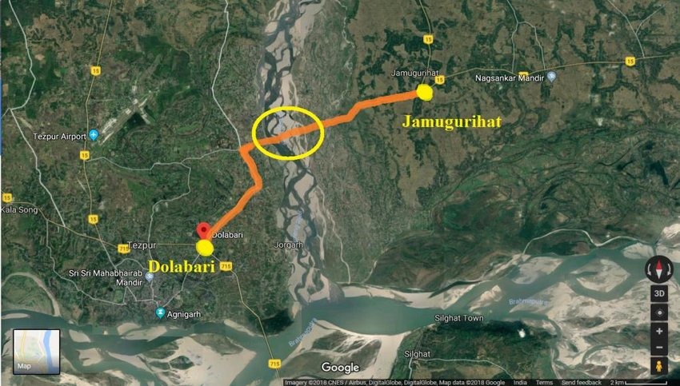
Plate 1: Sand casting area near the river Jia Bharali
Source: (Taipodia et.al., 2020)
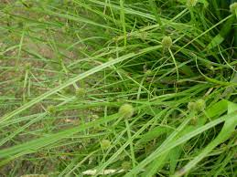
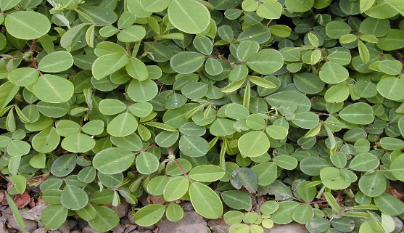
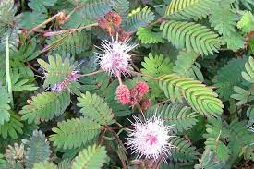
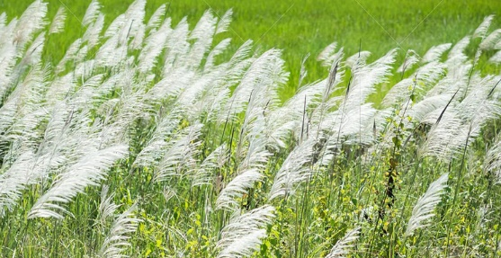
Desmodium Triflorum
Kyllinga brevifolia Rottb
Mimosa podica Linn.
Saccharum Spontaneum Linn

Plate 2: Vegetation found in the sand/silt casting areas of the study area

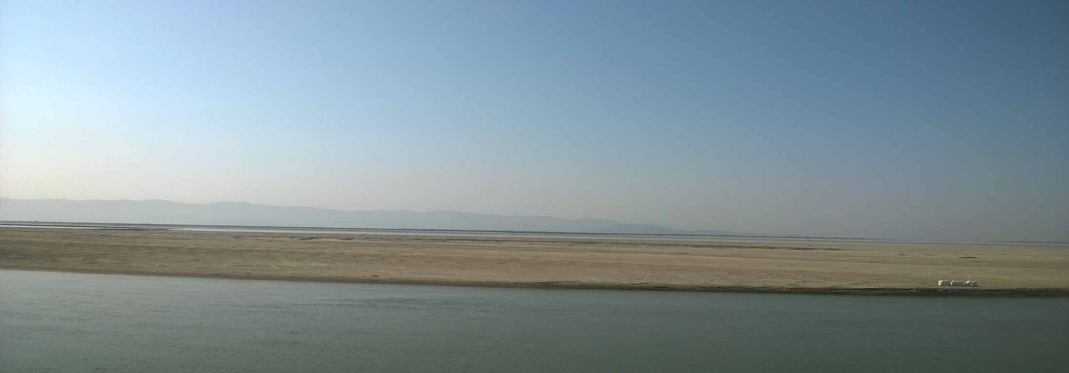
Plate 4: Early Existence of Chuwaguri Village which is now completely underwater.

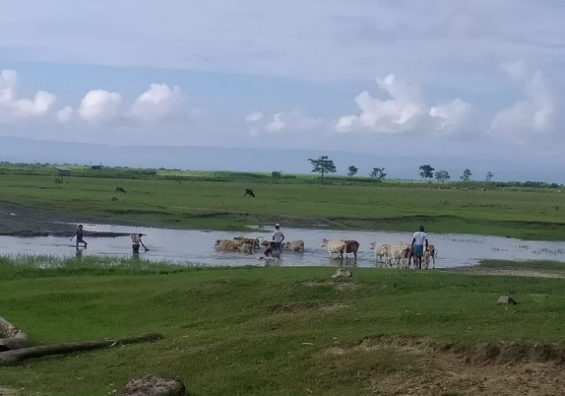
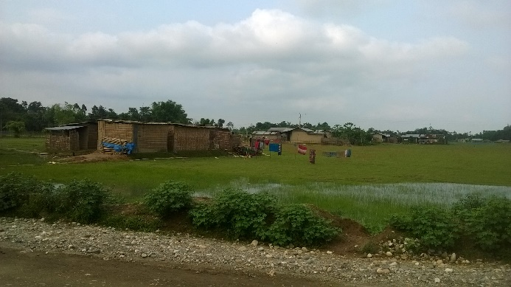
a
b

Plate 5: a) Miri Tapu, b) Conversion of agricultural land into a settled area near Panibharal-Biswanath ghat road

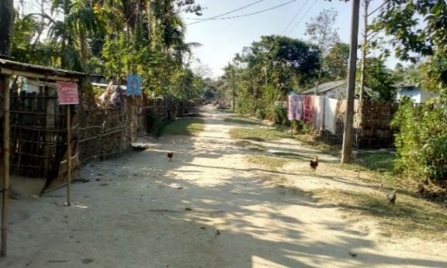
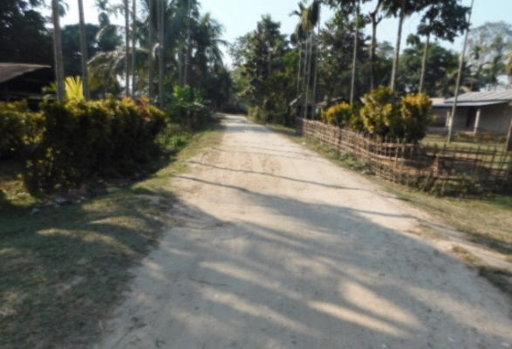
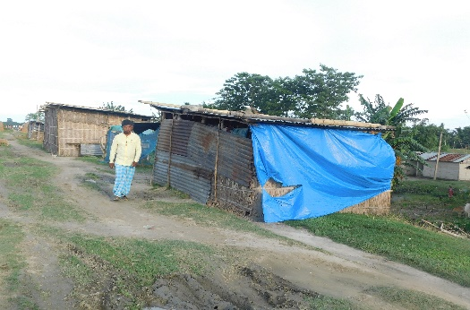
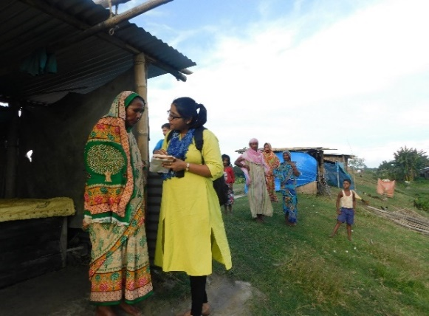
(c)
(b)
(a)
(d)

Plate 6: (a, b): Linear arrangement of houses along the village road of Mukhargarh and 3no Kumalia Village, (c, d): Temporary construction houses on the embankment during the flood at 4no Kumalia Village

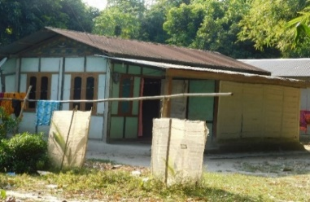
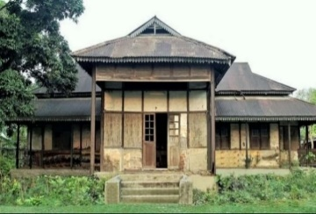
A
B

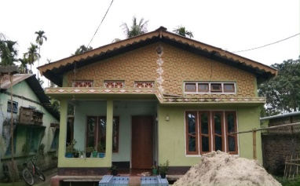
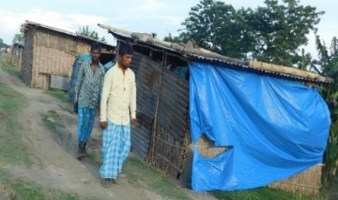
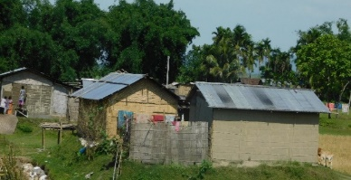
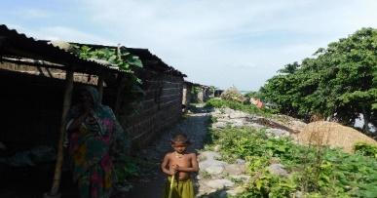
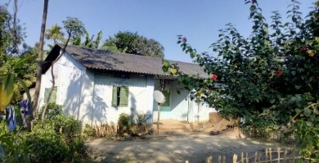
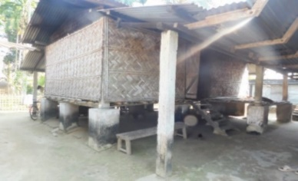
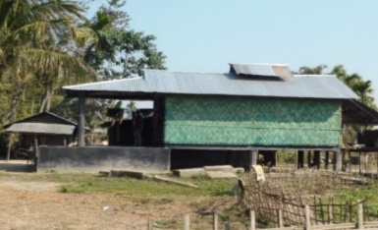
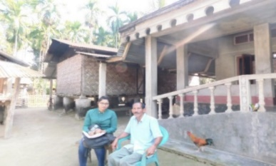
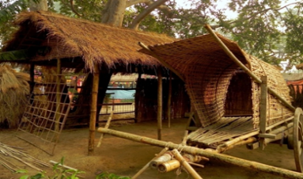
C
D
E
F
G
H
I
J

Plate 7: Different types of houses located in the study area

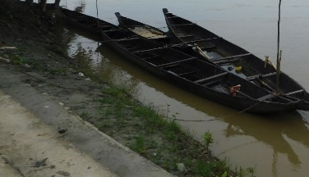
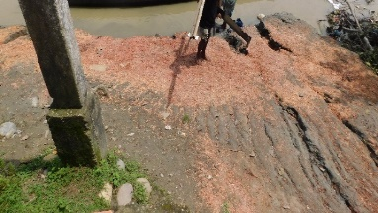
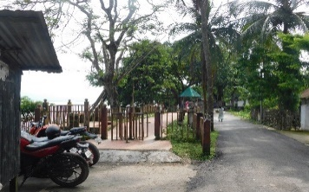
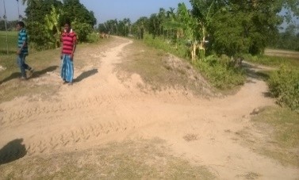
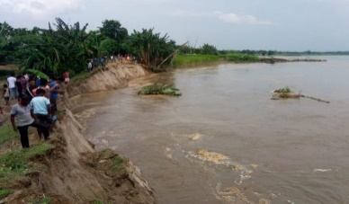
a (i)
a (ii)
b
c (i)
c (ii)

Plate 8: Embankments in the study area- a (i) Remaining portion of embankment of Biswanath town village, a (ii) Eroded portion of embankment of Biswanath town village, b) Construction of view point above the dilapidated embankment of Biswanath town village, c (i) 4TH number embankment in 4no Kumalia, c (ii) Erosion of the 3rd embankment in 4no Kumalia

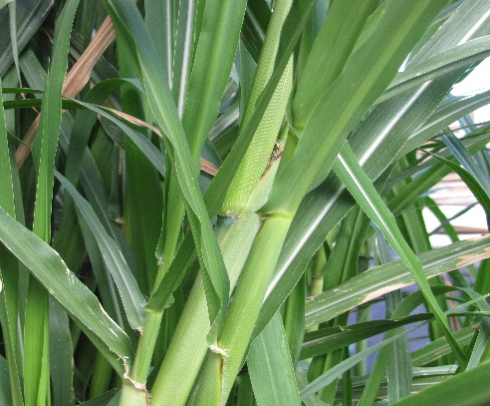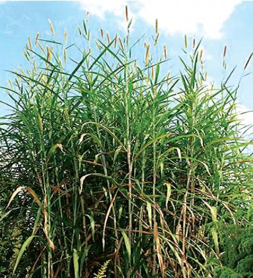
b
a
Plate 9: a, b: Napier-grass

