Supplemental Figures

Figure S1: Specific induction of KRAS variant expression. In our cell-based system, transcriptomic analyses were performed and first quantified the inducibility and specificity of our engineered locus containing a panel of KRAS mutations. A) Gene expression increased significantly for KRAS and little-to-none for other RAS genes. Each mutation label is shown once, with the row tick marks tilted toward the corresponding label. Most mutations were run in duplicate. We observed some variability in baseline KRAS levels within 2×. Different cell line replicates varied between the different RAS proteins at baseline, but were within 8×. B) Each cell line’s baseline and induced levels were used to make construct-specific fold changes, which emphasize the specificity for KRAS and are also used in our further analyses. We measured an induced fold-change (FC) between 3 and 10 for all KRAS alleles and below 2 for all HRAS and NRAS except for one replicate of G12R.
Endogenous versus exogenous KRAS was quantified using the allele fractions of the expected mutations called from the RNA-Seq reads. All cell lines (+doxy) had a high proportion of the exogenous KRAS compared to endogenous, indicating that the predominant signal in our study for the differential effects between mutants is driven by the mutant itself and not up-regulation of the native KRAS locus.
Figure S2: Example Images of Western blot gels used to generate Figure 1 pERK/pAKT heatmaps. Data were collected in triplicate, normalized to housekeeping genes, and reported as the ratio of, for example, pERK to total ERK (tERK). One replicate is shown here for brevity.

Figure S3: Pathway enrichment reveals that KRAS mutations activate cell differentiation and inflammation programs. Pathways with positive enrichment have their ranks colored red and with depletion blue. We used the A) MSigDB Hallmarks and B) Pathway Interaction Database (PID). For each pathway, we show the Normalized Enrichment Factor (NES), and multiple testing adjusted p-value (padj). Gene ranks are colored red for the top-15 up-regulated pathways and blue for the top-5 down-regulated pathways. Of note and somewhat surprisingly, PID has a RAS signaling pathway, the genes of which are distinct from the RAS Hallmark signature (no genes in common), demonstrating the difference between the pathway activation (via PTMs and conformational regulation) and downstream transcriptional responses or signatures. Thus, combining the two resources provide added insight into how we interpret gene expression changes in our dataset. C) Our data was also compared to established immunologic signatures, which revealed strong immune activation upon KRAS allele induction. D) The top cell type signatures were highly represented by immune subsets and ductal cell types from across multiple organs.

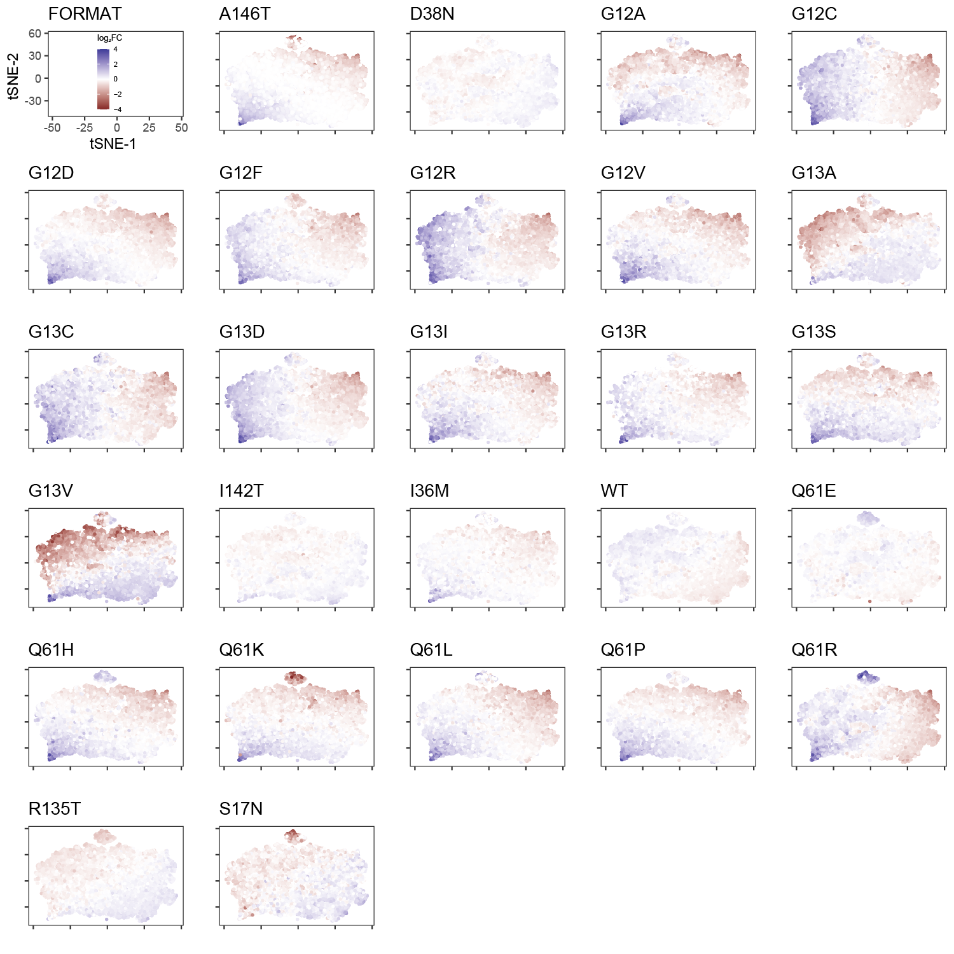
Figure S4: Transcriptomic fingerprints of all mutations visually represent the global heterogeneity across the uniform cell system. The first panel shows the format of the other panels. Each panel shows the induction gene expression changes for the indicated mutation.

A
Figure S5: RAS Pathway visualization showing the weight of each gene in PCA, reveals differences in extracellular, cytoplasmic, and nuclear localization of the signaling cascade. Each panel shows a different PC, as indicated in the legend. Coloring is by the weight of each gene in defining the indicated PC. A) Overall, the positive direction of PC1 indicates greater expression of GAPs, GEFs, RAL, and REL, with lower expression of RTKs, genes upstream of RAS, RAS, AKT, ERK, and NFKB1. B) The positive direction of PC2 (next page) indicates greater expression of RTKs, RAS, RAL, and NFKB1, with lower expression of PCLG1, PI3K, and ERK. C) The positive direction of PC3 (next page) indicates greater expression of GRIN receptors, RasGRPs, PI3K, and PLCE1, with lower expression of other RTKs and GAPs.
B
C
Figure S6: Heterogeneity in ERBB and PI3K-AKT pathway gene expression across KRAS mutations. A) Venn diagram of genes across the RAS, ERBB, and PI3K-AKT pathways. Using the presentation style of Figure 3, we show the relative similarities of KRAS mutations across the first three PCs derived using B) only the expression of PI3K-AKT pathway genes or C) only the expression of ERBB pathway genes. Even though these pathways have many more genes than the RAS pathway, the global organization of mutations is like what we identified from the RAS pathway. D) Using a 1-dimensional MDS (multidimensional scaling) of each of the three pathways, we sought to understand if activations of the three pathways were concordant across mutations or variable. We found they are highly concordant. We then visualized the most variable genes (which also have the weights of the highest magnitude in PCA) within each pathway and their contribution to the top three PCs for E) PI3K-AKT and F) ERBB.

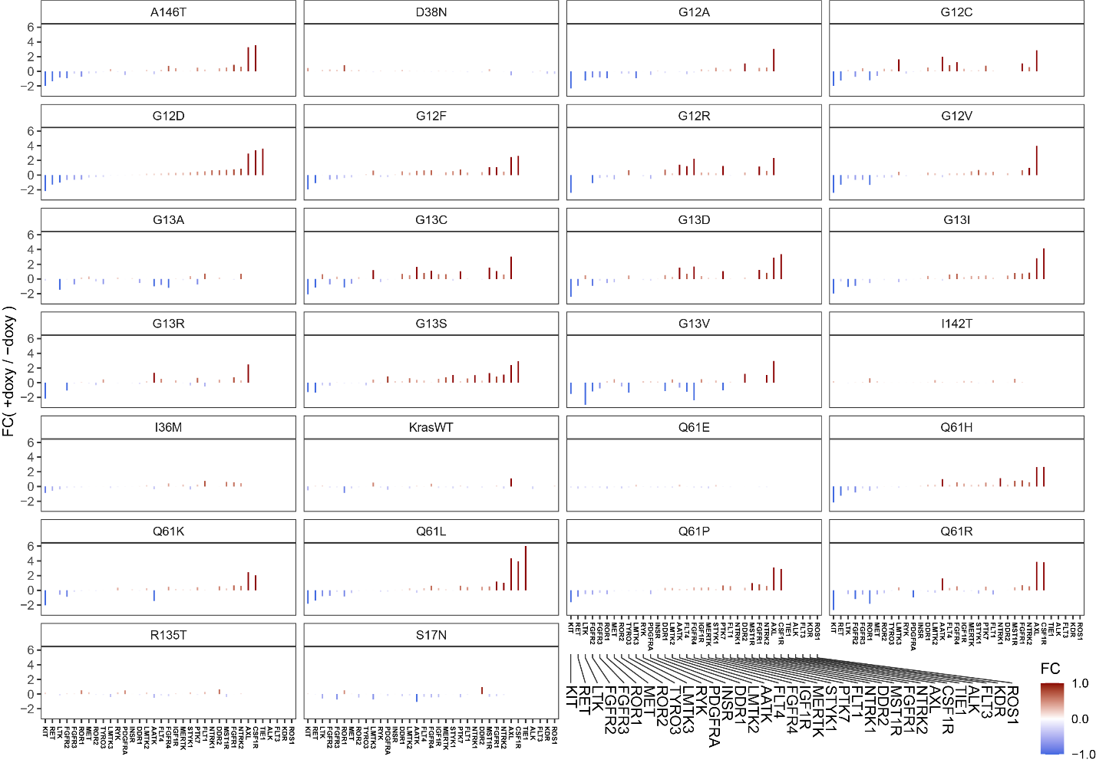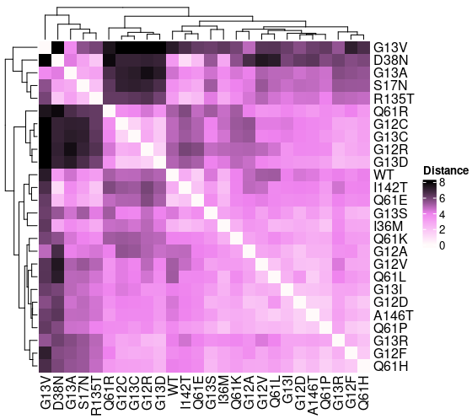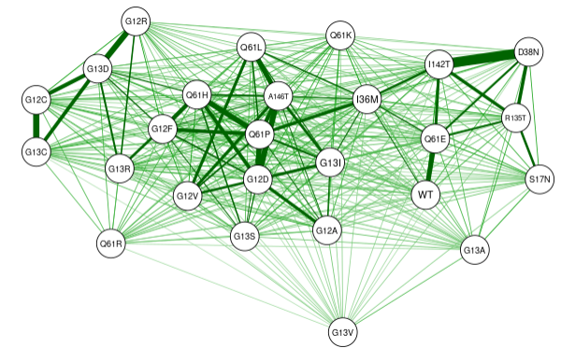
B
C
A
Figure S7: KRAS Mutations produce different receptor tyrosine kinase (RTK) signatures. A) RTK Signatures. Each panel shows the fold-change (FC) of receptor tyrosine kinases (RTKs) after induction of each KRAS mutant. RTKs are ordered by their FC in G12D. The gene names are listed in very small text under each column, and mapped to larger text in the third column; gene order is the same in all columns. B) Distance of each mutation to all other mutations quantified and visualized as a heatmap. C) Similarity (1/distance) of each mutation is shown as a weighted network where thick lines correspond to the most similar mutations.
Figure S8: Expanded cytokine panel data reveals additional features of the immune-reactive KRAS mutations. Compare to Figure 4, but here expanded to include more proteins with greater technical variability across samples, and that are not all secreted. Samples that did not return a reliable value for a given protein are indicated with hashed fill.

