Supplementary Material

E-cigarette Aerosols versus Cigarette Smoke: Harm Reduction in Levels of Harmful and Potentially Harmful Constituents and Cytotoxicity

Zehong Wu*, Jing Xu, Te Xu, Xinduo Li, Quan Luo, An Luo, Yilan Huang, Xingtao Jiang*

RELX Lab, Shenzhen RELX Tech. Co,. Ltd., Shenzhen, China

*Corresponding Author: Zehong Wu, e-mail: cruise.wu@relxtech.com; Xingtao Jiang, e-mail: xingtao.jiang@relxtech.com.

Table S1. The concentrations of carbonyls in standard mixture solutions.
No. | Standard mixed solution* (μL) | DNPH# (μL） | Final concentration (μg/mL)
Std-1 | 10 | 990 | 0.1
Std-2 | 50 | 950 | 0.5
Std-3 | 100 | 900 | 1
Std-4 | 500 | 500 | 5
Std-5 | 1000 | 0 | 10
*Eight standard carbonyl-2,4-DNPHs (352603, o2si, 500mg/L) were diluted to 10 μg/mL in DNPH solution to get the standard mixed solution.
#1.689 g DNPH (HPLC, Aladdin) was firstly dissolved in 250 mL acetonitrile (HPLC, Supelco) and 1.4 mL perchloric acid (Analytically pure, Guangzhou Chemical Reagent Factory), then diluted by 250 mL ultrapure water (Milli-Q Direct 8) to obtain DNPH solution.

Table S2. The instrument parameters of UPLC in carbonyls analysis.
Column: ACQUITY UPLC HSS T3 2.1×100 mm×1.8 μm
Column temperature: 40 ℃; Mobile phase A: ultrapure water; Mobile phase B: acetonitrile;
Injection volume：4 μL; Flowing rate: 0.3 mL/min; UV determine wavelength: 365 nm;
The gradient procedure:
Time（min） | Mobile phase A（%） | Mobile phase B（%）
0 | 50 | 50
4 | 32 | 68
10 | 32 | 68
11 | 50 | 50
14 | 50 | 50

Figure S1. The UPLC analysis of eight standard carbonyls with gradient concentrations.
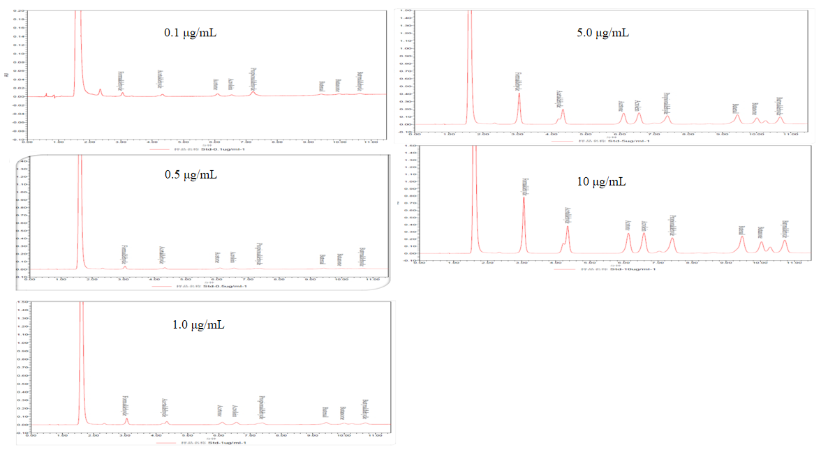
Figure S2. The standard curves of carbonyls in UPLC analysis.
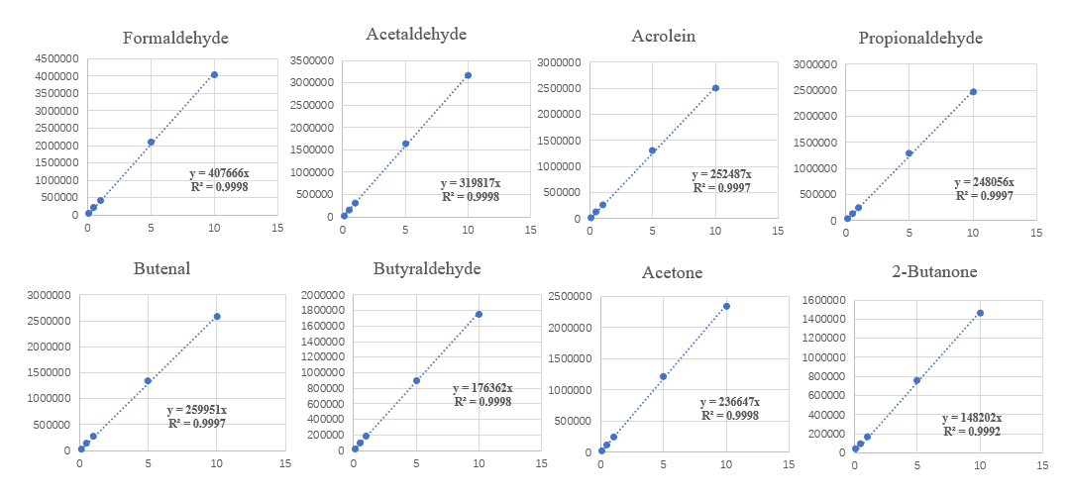
Figure S3. The UPLC analysis of ECM, ECT and CS.
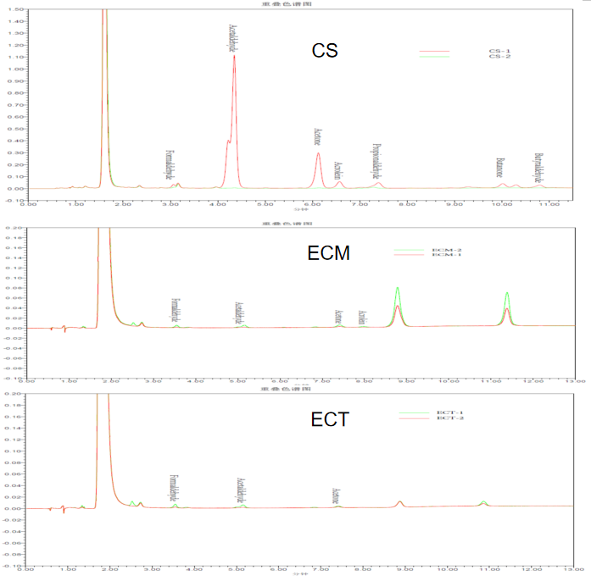

Table S3. The concentrations of VOCs in standard mixture solutions.
No. | Concentration（μg/ml）
No. | 1,3-Butadiene | Isoprene | Acrylonitrile | Benzene | Methylbenzene | Benzene-d₆*
Std-1 | 1 | 10.8 | 3.6 | 4 | 4 | 40
Std-2 | 2.5 | 27 | 9 | 10 | 10 | 40
Std-3 | 5 | 54 | 18 | 20 | 20 | 40
Std-4 | 10 | 108 | 36 | 40 | 40 | 40
Std-5 | 20 | 216 | 72 | 80 | 80 | 40
* Benzene-d6 as the internal standard.

Figure S4. The standard curves of VOCs in GC-MS analysis.
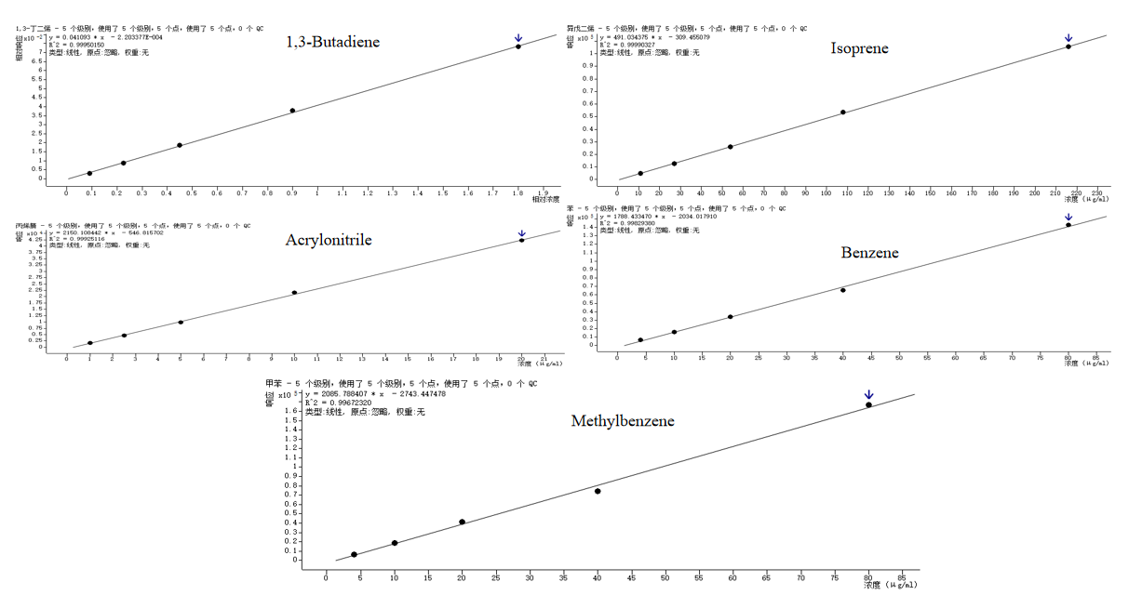

Table S4. The concentrations of TSNAs in standard mixed solutions.
No. | TSNAs mixed solution* (μL) | Internal standard mixed solution# (μL) | Ammonium acetate△ (μL) | TSNAs (ng/ml)
Std-1 | Std-3 (100) | 45 | 855 | 0.1
Std-2 | Std-5 (100) | 45 | 855 | 0.5
Std-3 | 10 | 50 | 940 | 1.0
Std-4 | 20 | 50 | 930 | 2.0
Std-5 | 50 | 50 | 900 | 5.0
*The concentrations of NNN, NAB, NAT, NNK (Toronto Research Chemicals, US) in TSNAs mixed acetonitrile solution were 100 ng/mL; # The concentrations of NNN-d₄, NAB-d₄, NAT-d₄, NNK-d₄ (Toronto Research Chemicals, US) in TSNAs internal standard mixed acetonitrile solution were 20 ng/ml; △7.708g ammonium acetate diluted in 1000 mL ultrapure water.

Table S5. The instrument parameters of UPLC-MS/MS in TSNAs analysis.
Column temperature: 40 ℃; Mobile phase A: ultrapure water (10mM ammonium acetate);
Mobile phase B: acetonitrile (0.1% acetic acid); Injection volume：5 μL; Flowing rate：0.4 mL/min;
The gradient procedure:
Time（min） | Mobile phase A（%） | Mobile phase B（%）
0 | 90 | 10
2 | 60 | 40
4 | 40 | 60
6 | 10 | 90
9 | 10 | 90
9.5 | 90 | 10
15 | 90 | 10

Figure S5. The standard curves of TSNAs in UPLC-MS/MS analysis.
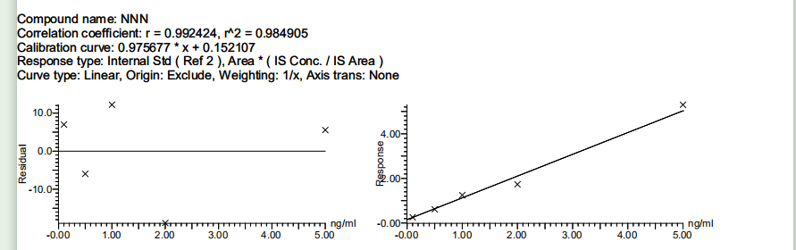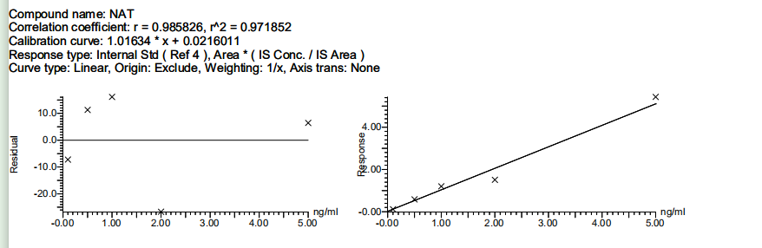
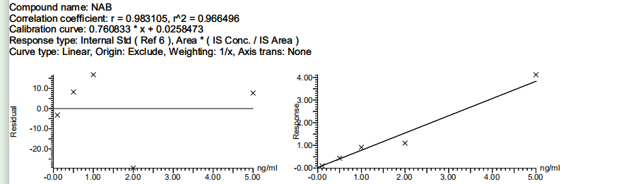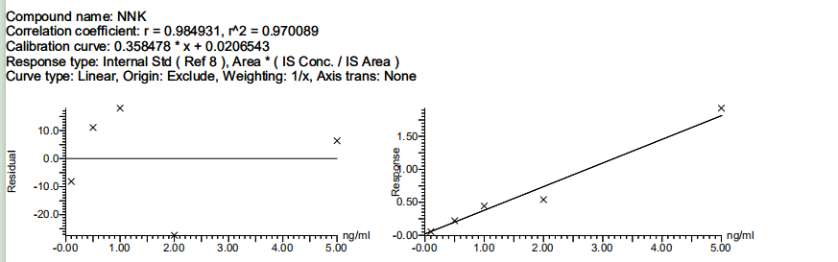

Table S6. The concentrations of PAHs in standard mixture solution.
No. | PAHs mixed solution* (μL) | Acetonitrile (μL) | Concentrations of PAHs (ng/mL)
Std-1 | Std-3 (100) | 900 | 10
Std-2 | 25 | 975 | 50
Std-3 | 50 | 950 | 100
Std-4 | 100 | 900 | 200
Std-5 | 250 | 750 | 500
* The concentration of PAHs in the mix solution was 2 μg/mL, which diluted by acetonitrile from the standard mixture solution (Contains 16 PAHs, 347786, o2si, 200mg/L 1mL).

Figure S6. The standard curves of PAHs in GC-MS/MS analysis.
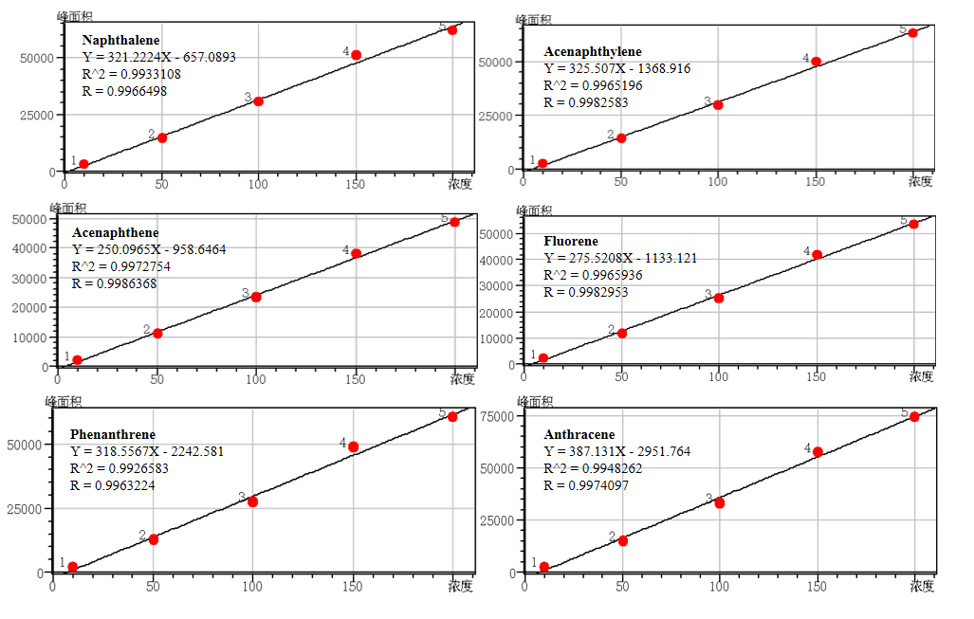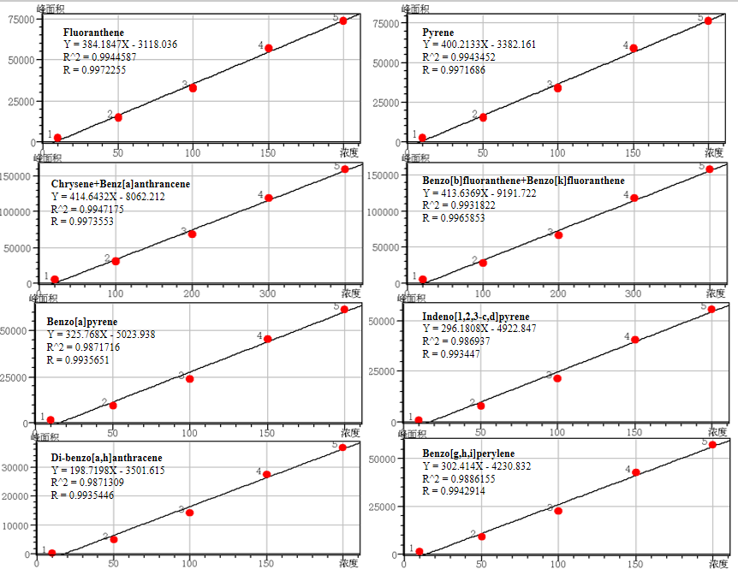

Figure S7. Standard curves of the metal concentration analysis by ICP-MS.
Figure S8. The metal elements analysis of ECM by ICP-MS.
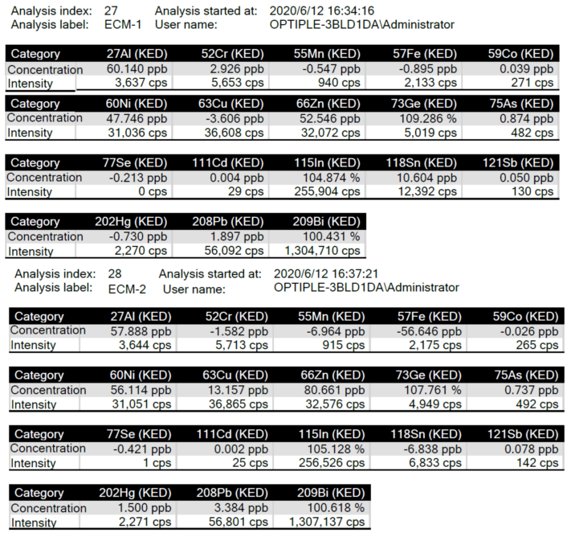
Figure S9. The metal elements analysis of ECT by ICP-MS.
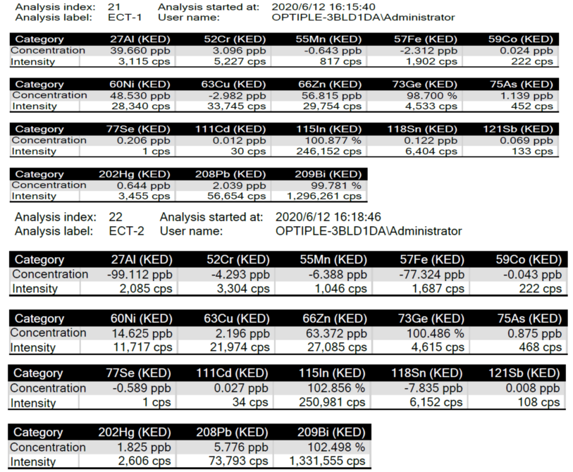

Figure S10. The metal elements analysis of CS by ICP-MS.
