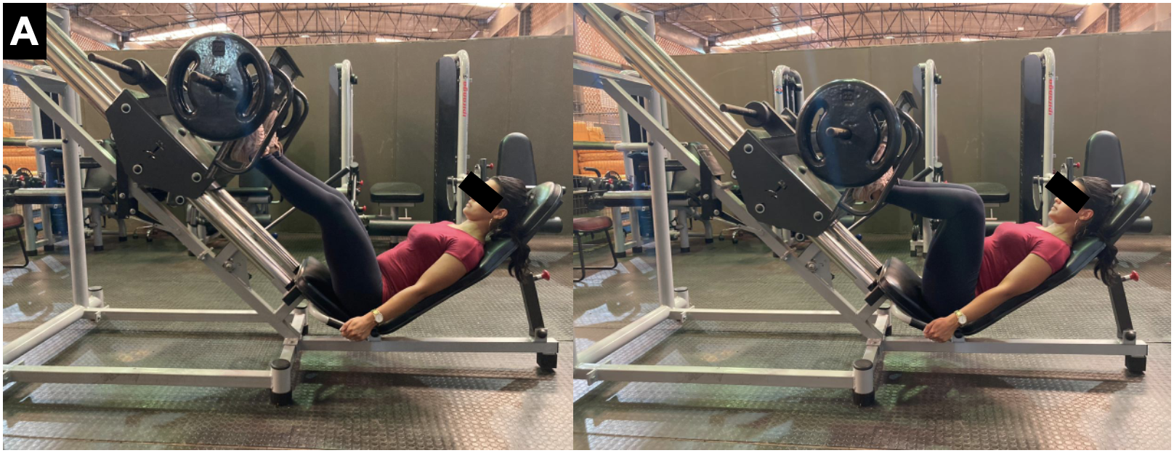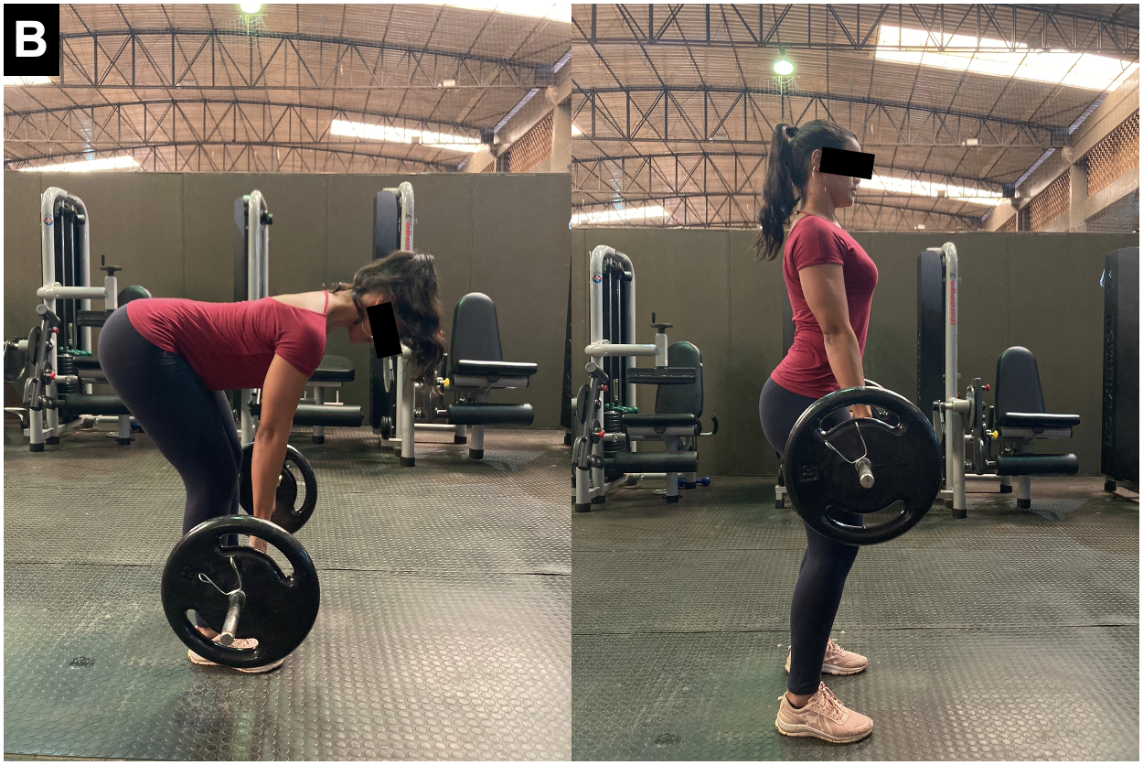

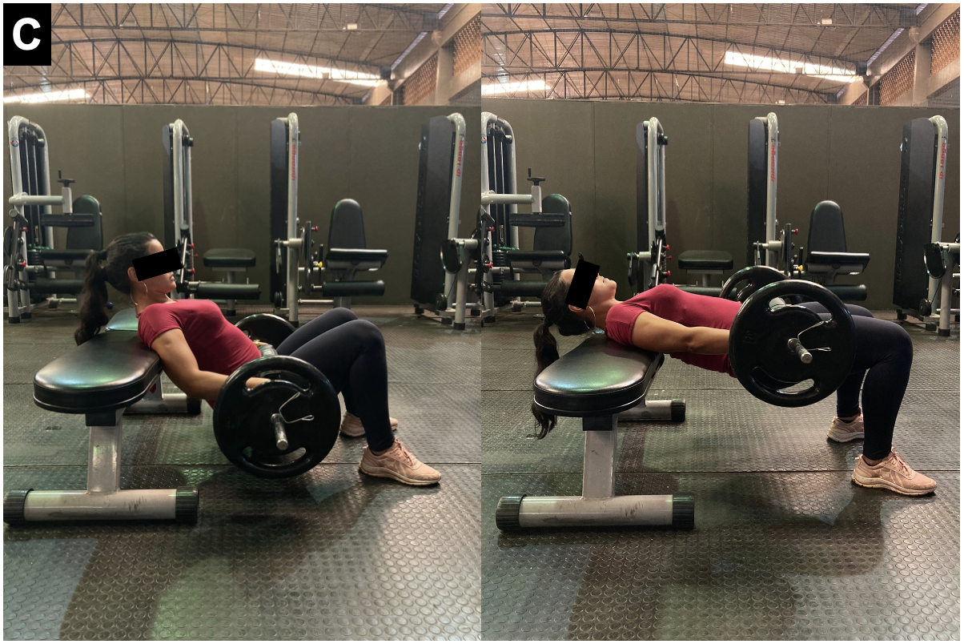
Supplemental digital content. Illustrative photos of 45º leg press (A), stiff-leg deadlift (B), and barbell hip thrust (C) exercises.

