Extended data tables/figures
Extended Data Table 1: Pharmacokinetic parameters for the 2-compartment model of NNC2215 in LYD pigs.
Pharmacokinetic parameter | Unit | Parameter value
Volume of distribution of the central compartment | L/kg | 0.0482
Volume of distribution of the peripheral compartment | L/kg | 0.0723
Clearance | L/h/kg | 0.131ª
Distribution clearance | L/h/kg | 0.0621
Residual error | % | 10.8
Data are typical values from non-linear mixed effects model.
ª Interindividual variation: 34%.

Extended Data Table 2: Parameters for the minimal model in LYD pigs.
Parameter | Description | Unit | Parameter value
P2 |  | 1/h | 0.372ª
SI_{max} | Maximum insulin sensitivity index |  | 0.00673
SIEC50 | Glucose level giving 50% of SI_{max} | mM | 50 (fixed)
VG | Volume of distribution for glucose | l/kg | 0.218 (fixed)
GB | Steady-state glucose level | mM | 7.62^{b}
SG | Rate constant for insulin-independent glucose production and elimination | 1/h | 1.12
G0 | Plasma glucose at time 0 (for initialisation) | mM | 5.34
Residual error |  | % | 10%
Data are typical values from non-linear mixed effects model.
Endogenous insulin was confirmed by bioanalysis to have been suppressed by the somatostatin infusion, and hence this contribution was set to 0 in the model.
ª Interindividual variation: 86%.
^{b} Interindividual variation: 38%. Correlation with P2: 44%.

Extended Data Table 3: Non-compartmental analysis of clearance, volume of distribution and elimination half-life of NNC2215, insulin degludec and human insulin after intravenous administration in rats and LYD pigs.
 | Rat |  |  |  | LYD pig
 | Cl  (L/h/kg) | V_{z}  (L/kg) | T_{½}  (h) |  | Cl  (L/h/kg) | V_{z}  (L/kg) | T_{½}  (h)
NNC2215 | 53.8±8.2 | 0.41±0.07 | 1.44±0.09 |  | 0.168±0.022 | 0.46±0.06 | 1.9±0.07
Insulin degludec | 10.7±1.6 | 0.10±0.04 | 1.65±0.54 |  | 0.071±0.007 | 0.19±0.02 | 1.8±0.08
Human insulin | 367 | 0.623 | 0.28 |  | 1.488±0.482 | 0.28±0.08 | 0.12±0.04
Data are mean±SD of independent measurements, rat studies n = 5-8 (n = 8 for NNC2215 study), pig studies n = 3-8 (n = 3 for NNC2215, n = 8 for degludec and human insulin).

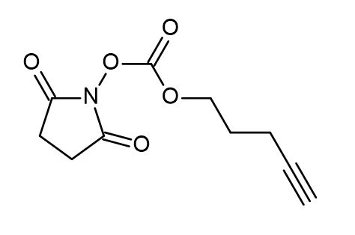
Extended Data Fig. 1: O-succinimidyl pentyn-1-oxycarbonyl.

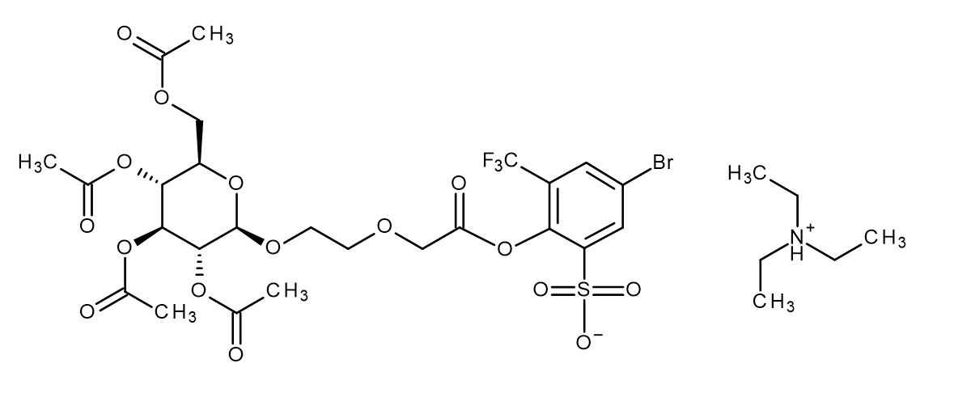
Extended Data Fig. 2: O-peracetyl-D-glucosyl-beta-ethylenoxy-acetyl active ester.

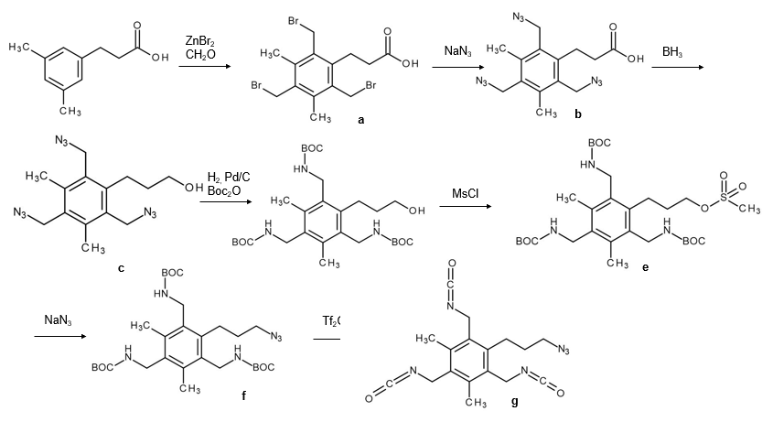
Extended Data Fig. 3: Synthesis of roof propyl azide tris-isocyanate.
a, Trisbromomethyl acid. b, Carboxy tris-azide. c, Alcohol tris-azide. d, Alcohol tris-Boc. e, O-mesylate tris-Boc. f, Azide tris-Boc. g, Propyl azide tris-isocyanate.

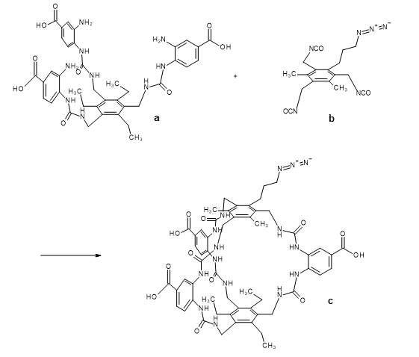
Extended Data Fig. 4: Synthesis of the macrocycle roof propyl azide.
a, Compound 25c³⁴. b, Propyl azide tris-isocyanate (Extended Data Fig. 3g). c, Macrocycle roof propyl azide.

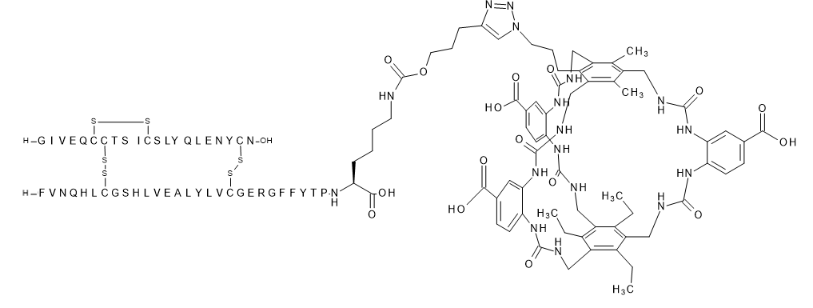
Extended Data Fig. 5: Control compound NNC2215a.

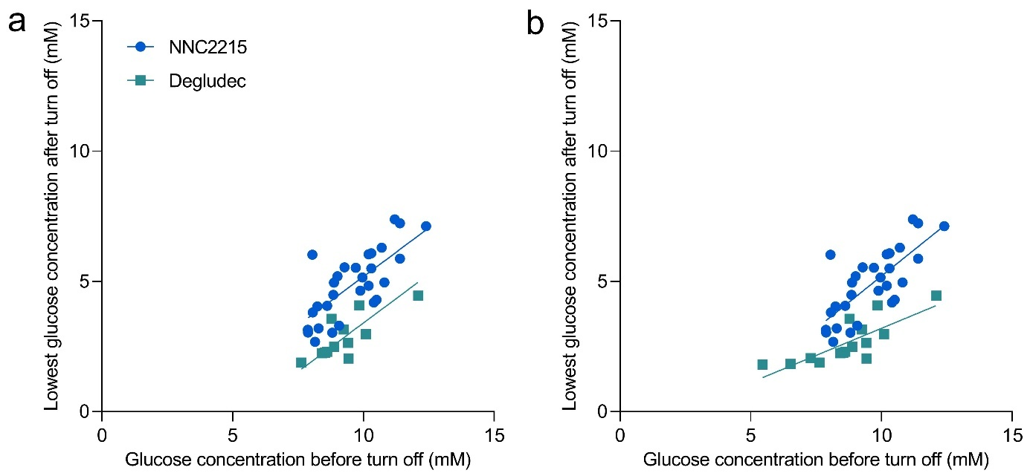
Extended Data Fig. 6: Exploratory correlation analyses from pig study of protection against hypoglycaemia – lowest glucose concentration after turning off the glucose infusion vs. the glucose concentration immediately prior to turning off the glucose infusion.
a, The degludec data set has been truncated so the range of glucose concentrations before turn off of glucose infusion is the same in the two groups. Slopes for NNC2215 and insulin degludec are not statistically significantly different (p=0.35). Intercepts for NNC2215 and insulin degludec are statistically significantly different (p<0.0001). The estimated difference between NNC2215 and insulin degludec in the drop in glucose was 1.7 mM. b, Data from all animals, including those insulin degludec treated animals with lower starting glucose values, illustrating that counterregulation sets in in those animals and the estimated slope becomes significantly different (p<0.04). All doses are contained in the plots.

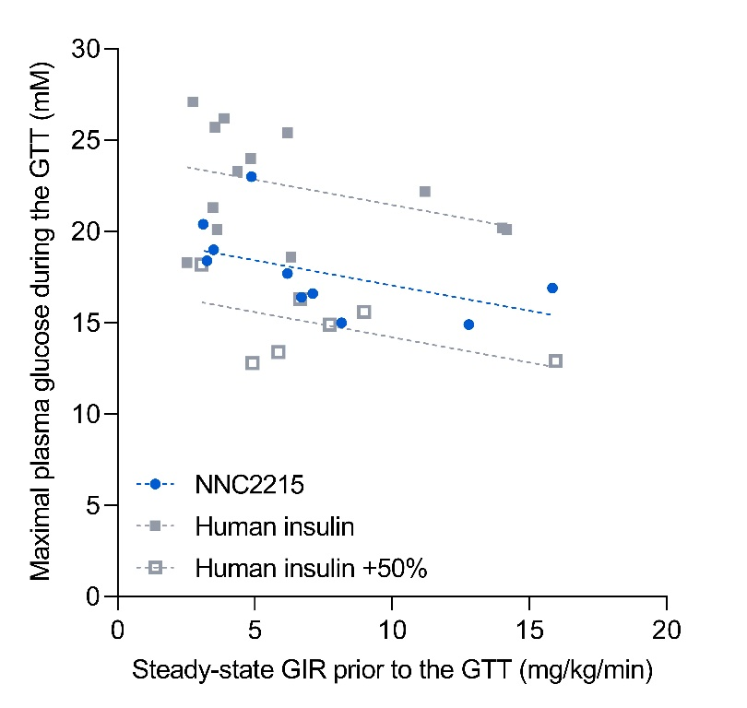
Extended Data Fig. 7: Linear regression of maximal plasma glucose concentration during the GTT vs. steady-state GIR prior to the GTT in rats.
For each animal, the maximal plasma glucose concentration during the GTT was plotted against the steady-state GIR prior to the GTT, which represents the quantitative effect of the constant insulin infusion. Slopes for NNC2215, human insulin and human insulin +50% are not statistically significantly different (p=0.97). The slope for the three groups pooled is -0.311 mM/(mg/kg/min). Importantly, the Y-axis intercepts (i.e. the maximal plasma glucose concentration during the GTT) for NNC2215, human insulin and human insulin +50% are statistically significantly different (p<0.0001) with the intercept of the NNC2215 group being in between the human insulin group, which was higher, and the human insulin +50% group, which was lower. Quantitatively, the maximal plasma glucose concentration during the GTT evaluated at GIR=0 mg/kg/min prior to the GTT was reduced by 18% for NNC2215 vs. human insulin and by 30% for NNC2215 vs. human insulin +50%. Thus, the glucose sensitive effect of NNC2215 was less than the effect of 50% additional human insulin but corresponded more closely to 30% additional human insulin (50% * 18/30). Evaluated at GIR=15 mg/kg/min prior to the GTT, the effect of NNC2215 during the GTT corresponded to 32% additional human insulin.

Supplementary information

Supplementary methods
1. Preparation of O-succinimidyl pentyn-1-oxycarbonyl
A solution of bis(trichloromethyl)carbonate (52.9 g, 178 mmol) in dry tetrahydrofuran (215 mL) was added dropwise to a solution of pent-4-yn-1-ol (13.6 g, 162 mmol) in dry tetrahydrofuran (80 mL) over 15 minutes at 0ºC. The reaction mixture was stirred for 1 hour under cooling and then overnight at room temperature. The solvent was removed under reduced pressure and the residue (yellow oil) was purified by vacuum distillation (p = 0.2 Torr, T = 80-95ºC) to give pent-4-yn-1-yl carbonochloridate as off-white liquid. Yield: 16.3 g (69%). ¹H NMR spectrum (300 MHz, CDCl₃, dH): 4.44 (q, J=6.2 Hz, 2 H); 2.41-2.31 (m, 2 H); 2.04-1.90 (m, 3 H).

To a solution of N-hydroxysuccinimide (12.8 g, 111 mmol) in dry tetrahydrofuran (450 mL) cooled at -5 ºC was added triethylamine (15.5 mL, 111 mmol, with forming of fine precipitate). A solution of the above chloroformate, pent-4-yn-1-yl carbonochloridate, (16.3 g, 111 mmol) in dry tetrahydrofuran (90 mL) was added dropwise over 10 min under intensive stirring (a precipitate triethylamine hydrochloride was gradually formed). The resulting suspension was stirred for 2 hours at -5 ºC and then overnight at room temperature. The white solid was filtered off and solvent was removed in vacuo. The residue was dissolved in ethyl acetate (500 mL) and washed with 1 M aqueous solution of potassium hydrogen sulfate (2 x 300 mL), brine (3 x 300 mL) and dried over anhydrous sodium sulfate. After filtration, the solvent was removed under reduced pressure and the crude product was purified by column chromatography (Silica gel 60, 0.040-0.063 mm; eluent: cyclohexane/ethyl acetate 3:1-1:1) giving pure O-succinimidyl pentyn-1-oxycarbonyl (Extended Data Fig. 1) as off-white liquid. Yield: 9.41 g (38%). RF (SiO₂, cyclohexane-ethyl acetate 1:1): 0.40. ¹H NMR spectrum (300 MHz, CDCl₃, dH): 4.46 (t, J=6.2 Hz, 2 H); 2.84 (s, 4 H); 2.40-2.32 (m, 2 H); 2.04-1.93 (m, 3 H). LC-MS: 226.4 (M+H)+.

2. Preparation of O-peracetyl-D-glucosyl-beta-ethylenoxy-acetyl active ester
1-alpha-bromo-O-peracetyl-D-glucoside (4.71 g, 11.5 mmol) was dissolved in anhydrous 1,4-dioxane (6 mL) and diethylene glycol (7.60 mL). Silver carbonate (3.47 g, 12.6 mmol) was added in one portion (gas evolution after short induction period). The resulting mixture was stirred at ambient temperature for 3 hours. Afterwards, it was diluted with ethyl acetate (80 mL), filtered through a celite pad, washed with ethyl acetate (3 x 30 mL) and the filtrate was evaporated. The oily residue was dissolved in water (80 mL) and extracted with dichloromethane (4 x 60 mL). Combined organic extracts were dried over anhydrous magnesium sulfate, filtered and evaporated in vacuo. The residue was purified by flash column chromatography (Silica gel 60, 0.040-0.063 mm; eluent: dichloromethane/ethyl acetate 1:1 to 0:1) to give 1-beta-hydroxyethyl-O-peracetyl-D-glucoside as a waxy white solid. Yield: 3.55 g (71%). ¹H NMR spectrum (300 MHz, CDCl₃, dH): 5.22 (t, J=9.6 Hz, 1 H); 5.10 (t, J=9.6 Hz, 1 H); 5.00 (dd, J=9.4 and 7.9 Hz, 1 H); 4.62 (d, J=7.9 Hz, 1 H); 4.32-4.22 (m, 1 H); 4.20-4.11 (m, 1 H); 4.04-3.90 (m, 1 H); 3.80-3.55 (m, 8 H); 2.09 (s, 3 H); 2.06 (s, 3 H); 2.03 (s, 3 H); 2.01 (s, 3 H). LC-MS: 454.1 (M+H₂O)⁺, 437.1 (M+Na)⁺.

To a well stirred solution of the given 1-beta-hydroxyethyl-O-peracetyl-D-glucoside (3.54 g, 8.11 mmol) and bis(acetoxy)iodobenzene (6.27 g, 19.5 mmol) in acetonitrile (40 mL) and water (10 mL) was added (2,2,6,6-tetramethylpiperidin-1-yl)oxyl (51.0 mg, 0.32 mmol) in one portion. The reaction mixture was stirred overnight and concentrated in vacuo. The residue was treated with 10 % aqueous solution of sodium sulfite (40 mL) and stirred for 30 min. Afterwards, pH of the solution was adjusted with concentrated hydrochloric acid to pH = 2. The aqueous layer was extracted with dichloromethane (3 x 60 mL). The organic extracts were combined, dried over anhydrous magnesium sulfate, filtered and evaporated. The residue was purified by flash column chromatography (Silica gel 60, 0.040-0.063 mm; eluent: acetonitrile/water 30:1 + 0.5 % of formic acid). After freeze-drying, the residue was treated with dry diethyl ether (60 mL). A white solid was filtered, washed with dry diethyl ether (3 x 20 mL) and dried in vacuo affording 1-beta-carboxyethyl-O-peracetyl-D-glucoside as a white solid. Yield: 2.93 g (80%). ¹H NMR spectrum (300 MHz, CDCl₃, dH): 5.22 (t, J=9.5 Hz, 1 H); 5.10 (t, J=9.6 Hz, 1 H); 5.01 (dd, J=9.5 and 8.0 Hz, 1 H); 4.63 (d, J=7.9 Hz, 1 H); 4.30-4.24 (m, 1 H); 4.22-4.12 (m, 3 H); 4.05-3.93 (m, 1 H); 3.85-3.65 (m, 4 H); 2.09 (s, 3 H); 2.06 (s, 3 H); 2.03 (s, 3 H); 2.01 (s, 3 H). LC-MS: 468.1 (M+H₂O)⁺, 449.2 (M-H)-.

The given 1-beta-carboxyethyl-O-peracetyl-D-glucoside (2.77 g, 6.15 mmol) was dissolved in dry dichloromethane (30 mL), and triethylamine (2.60 mL, 18.5 mmol) was added. The mixture was cooled to 0 ºC and 5-bromo-2-hydroxy-3-(trifluoromethyl)benzenesulfonyl chloride (4, 2.50 g, 7.38 mmol) was added in three portions over 10 min. The mixture was stirred under cooling for 30 min, then at room temperature overnight. Solvent was evaporated in vacuo. To the residue, ethyl acetate (40 mL) was added. The resulting suspension was filtered through celite pad, and filtrate was evaporated. The residue was purified by flash column chromatography (Silica gel 60, 0.040-0.063 mm; eluent: dichloromethane/2-propanol 100:0 to 90:10 + 0.5% of triethylamine) giving O-peracetyl-D-glucosyl-beta-ethylenoxy-acetyl active ester (Extended Data Fig. 2) as white foam. Yield: 3.34 g (63%). ¹H NMR spectrum (300 MHz, DMSO-d₆, dH): 8.83 (bs, 0.8 H); 8.11 (dd, J=2.6 and 0.6 Hz, 1 H); 7.99 (dd, J=2.6 and 0.6 Hz, 1 H); 5.26 (t, J=9.5 Hz, 1 H); 4.95-4.82 (m, 2 H); 4.81-4.72 (m, 1 H); 4.35 (d, J=2.4 Hz, 2 H); 4.23-4.12 (m, 1 H); 4.06-3.93 (m, 2 H); 3.88-3.77 (m, 1 H); 3.75-3.57 (m, 3 H); 3.09 (q, J=7.3 Hz, 4.8 H); 2.02 (s, 3 H); 1.99 (s, 3 H); 1.98 (s, 3 H); 1.93 (s, 3 H); 1.17 (t, J=7.2 Hz, 7.2 H). ¹⁹F NMR spectrum (282 MHz, DMSO-d₆, dF): -59.98. LC-MS: 751.3 and 753.3 (M-H)-.

3. Preparation of the macrocycle roof propyl azide
a. Synthesis of the trisbromomethyl acid
3-(3,5-dimethylphenyl)propanoic acid (5.00 g, 28.1 mmol, 1 eq.) was dissolved in HBr/AcOH (33%, 53 mL). Paraformaldehyde (8.84 g, 295 mmol, 10.5 eq.) and ZnBr₂ (10.1 g, 44.9 mmol, 1.6 eq.) were added and the reaction mixture was heated to 100 °C for 18 hours. The reaction was cooled, and the precipitate isolated by filtration, washing with acetic acid (50 mL) and water (800 mL) to give the product (Extended Data Fig. 3a) (12.2 g, 26.6 mmol, 95%) as white crystals. ¹H NMR (400 MHz, DMSO-d₆) δ 4.75 (d, J = 1.5 Hz, 6H), 3.14 – 2.96 (m, 2H), 2.58 (d, J = 18.5 Hz, 2H), 2.40 (d, J = 1.1 Hz, 6H).

b. Synthesis of the carboxy tris-azide
The trisbromomethyl acid (14.0 g, 30.6 mmol, 1 eq.) was dissolved in anhydrous DMF (12.0 mL), and NaN₃ (11.9 g, 184 mmol, 6 eq.) was added in 4 portions over 20 min. The reaction mixture was left to stir for 40 hours and then quenched with 1 M HCl (400 mL). The resultant suspension was extracted with EtOAc (3 × 1.5 L) and the combined organics washed with water (5 × 400 mL), brine (400 mL) and dried (Na₂SO₄). The solvents were evaporated under reduced pressure to an oil which crystallised upon standing to give the product (Extended Data Fig. 3b) (9.89 g, 28.8 mmol, 94%). ¹H NMR (400 MHz, CDCl₃) δ 4.54 (s, 4H), 4.51 (s, 2H), 3.25 – 3.10 (m, 2H), 2.72 – 2.57 (m, 2H), 2.48 (d, J = 0.7 Hz, 6H). ¹³C NMR (101 MHz, CDCl₃) δ 177.51, 140.23, 139.05, 132.37, 130.94, 49.04, 48.79, 35.37, 25.18, 16.73.

c. Synthesis of the alcohol tris-azide
The carboxy tris-azide (9.89 g, 28.8 mmol, 1 eq.) was dissolved in anhydrous THF (30 mL), and 1 M BH₃.THF in THF (58 mL, 58.0 mmol, 2 eq.) was added dropwise. After stirring for 5 hours, further 1 M BH₃.THF in THF (20 mL, 20.0 mmol, 0.7 eq.) was added and the reaction was stirred for 16 hours. The reaction was quenched with saturated aqueous NaHCO₃ (60 mL). The THF was removed under a stream of nitrogen and the remnants extracted with EtOAc (100 mL). The organic layer was dried (Na₂SO₄) and concentrated under reduced pressure. The crude product was purified by flash chromatography (petroleum ether 40/60 with increasing EtOAc). The fractions containing the product were combined and the solvent removed under vacuum to yield the product (Extended Data Fig. 3c) (4.42 g, 13.4 mmol, 47%) as white crystals. ¹H NMR (400 MHz, CDCl₃) δ 4.53 (s, 4H), 4.50 (s, 2H), 3.77 (t, J = 5.9 Hz, 2H), 2.99 – 2.88 (m, 2H), 2.46 (s, 6H), 1.86 – 1.74 (m, 2H).

d. Synthesis of the alcohol tris-Boc
The alcohol tris-azide (1.40 g, 4.25 mmol, 1 eq.) and Boc₂O (4.18 g, 19.1 mmol, 4.5 eq.) were dissolved in anhydrous THF (80 mL). A slurry of Pd/C (200 mg, 10% w/w) in DCM was added, followed by Et₃N (1.80 mL, 12.8 mmol, 3 eq.). The reaction was placed under an atmosphere of hydrogen and stirred overnight. The reaction mixture was centrifuged, and the supernatant was concentrated under reduced pressure before being redissolved in EtOAc (100 mL) and washed with 5% aqueous KHSO₄ (100 mL), saturated aqueous NaHCO₃ (100 mL) and brine (100 mL), then dried (Na₂SO₄). The organic solvents were removed in vacuo and the crude product was purified by flash chromatography (petroleum ether 40/60 with increasing EtOAc). The fractions containing the product were combined and the solvent removed under vacuum to yield the product (Extended Data Fig. 3d) (2.02 g, 3.64 mmol, 86%) as a white solid. ¹H NMR (400 MHz, CDCl₃) δ 4.37 (d, J = 11.0 Hz, 7H), 3.72 (t, J = 5.7 Hz, 2H), 2.94 – 2.77 (m, 2H), 2.36 (s, 6H), 1.76 – 1.65 (m, 2H), 1.44 (d, J = 2.4 Hz, 27H). MS [2M+H-Boc]⁺ calculated for C₅₃H₉₁N₆O₁₂ requires: 1003.7, found: 1003.6.

e. Synthesis of the O-mesylate tris-Boc
The alcohol tris-Boc (4.41 g, 7.99 mmol, 1 eq.) was dissolved in anhydrous DCM (16 mL). Et₃N (2.80 mL, 20.0 mmol, 2.5 eq.) was added and the reaction cooled to 0°C, followed by addition of MsCl (0.62 mL, 8.00 mmol, 1 eq.) over a period of 10 min. The reaction was left to stir at room temperature for 3 hours, then cooled to 0°C and more MsCl (0.40 ml, 5.17 mmol, 0.65 eq.) was added. After 3 hours stirring at room temperature, the reaction mixture was diluted with DCM (60 mL) and partitioned with brine (60 mL). The organics were dried (Na₂SO₄) and concentrated under reduced pressure. The crude product was purified by flash chromatography (petroleum ether 40/60 with increasing EtOAc). The fractions containing the product were combined and the solvent removed under vacuum to yield the product (Extended Data Fig. 3e) (4.85 g, 7.70 mmol, 96%) as a white solid. ¹H NMR (400 MHz, CDCl₃) δ 4.38 – 4.29 (m, 9H), 3.11 (s, 3H), 2.99 – 2.78 (m, 2H), 2.36 (s, 6H), 1.89 (dq, J = 11.8, 5.9 Hz, 2H), 1.43 (s, 27H). MS (electrospray) [M+Na]⁺ calculated for C₃₀H₅₁N₃NaO₉S requires: 652.3, found: 652.3.

f. Synthesis of the azide tris-Boc
The O-mesylate tris-Boc (1.31 g, 2.08 mmol, 1 eq.) was dissolved in anhydrous DMF (21 mL), NaN₃ (676 mg, 10.4 mmol, 5 eq.) was added and the reaction stirred at room temperature for 22 hours. The reaction mixture was diluted with water (100 mL) and extracted with Et2O (5 × 50 mL). The organic layer was dried (MgSO₄) and concentrated under reduced pressure. The crude oil was purified by reverse phase flash chromatography. The fractions containing the product were combined and the solvent removed under vacuum to yield the product (Extended Data Fig. 3f) (800 mg, 1.39 mmol, 67%) as a white solid. ¹H NMR (400 MHz, CDCl₃) δ 4.50 – 4.19 (m, 9H), 3.43 (t, J = 6.7 Hz, 2H), 2.86 – 2.72 (m, 2H), 2.37 (s, 6H), 1.79 – 1.68 (m, 2H), 1.45 (s, 27H). MS (electrospray) [2M+H-Boc]⁺ calculated for C₅₃H₈₉N₁₂O₁₀ requires: 1053.7, found: 1053.6.

g. Synthesis of the propyl azide tris-isocyanate
The azide tris-Boc (350 mg, 0.617 mmol, 1 eq.) was dissolved in anhydrous dichloromethane (6 mL), followed by addition of anhydrous 2-chloropyridine (0.51 mL, 5.46 mmol, 9 eq.). Triflic anhydride (0.46 mL, 2.73 mmol, 4.5 eq.) was added dropwise to the reaction mixture and the reaction stirred at room temperature for a further 30 min after addition was complete. The solvent was removed under vacuum to give a crude solid. The product was extracted with boiling petroleum ether 40/60 3 times, the extracts combined and concentrated under vacuum until a precipitate was observed. This suspension was then reheated to the boiling point until a solution was obtained, which was then cooled in a freezer at -18 °C overnight. The product crystals were then obtained by filtration, washing with cold petroleum ether 40/60 and drying under high vacuum to yield the product (Extended Data Fig. 3g) (170 mg, 0.480 mmol, 79%). ¹H NMR (400 MHz, CDCl₃) δ 4.50 (s, 6H), 3.49 (t, J = 6.2 Hz, 2H), 2.92 – 2.76 (m, 2H), 2.48 (s, 6H), 1.79 (dq, J = 11.9, 6.1 Hz, 2H).

h. Synthesis of the macrocycle roof propyl azide
The half macrocycle was synthesised according to Tromans et al.¹⁶,³⁴ (Extended Data Fig. 4a). The half marocycle (315 mg, 0.363 mmol, 1 eq.) was dissolved in anhydrous DMF (26 mL) and anhydrous pyridine (60 mL) and heated to 45ºC. The propyl azide tris-isocyanate (Extended Data Fig. 4b) (154 mg, 0.435 mmol, 1.2 eq.) was then added as a solution in anhydrous toluene (2.5 mL) over 10 hours and the reaction mixture left to stir for a further 6 hours. The reaction mixture was then concentrated under vacuum and the crude residue precipitated with 1 M aqueous HCI (1000 mL), filtered, washed with water and dried. The filtered material was dissolved in EtOH/water 1:1 mixture (30 mL) and NaOH (144 mg, 3.60 mmol, 10 eq.) was added. The reaction was stirred at 40 ºC for 6 hours. The reaction was cooled to room temperature and the organic solvent removed under vacuum. The crude product was then precipitated with 1 M aqueous HCI (400 mL), filtered, washed with 1 M aqueous HCI and dried. The crude solid was then dissolved in acetone/water, dry loaded onto C18 column and purified by reverse phase flash chromatography. The fractions containing the product were combined and the solvent removed under vacuum to yield the product (Extended Data Fig. 4c) (278 mg, 0.244 mmol, 68%) as a white solid. ¹H NMR (400 MHz, DMSO-d₆) δ 8.14 – 8.11 (m, 6H), 8.10 – 8.03 (m, 3H), 7.91 (d, J = 13.4 Hz, 3H), 7.59 (dd, J = 8.6, 2.0 Hz, 3H), 7.47 (s, 3H), 6.58 (s, 1H), 6.51 (d, J = 5.6 Hz, 2H), 6.42 (s, 1H), 6.34 (t, J = 5.6 Hz, 2H), 4.59 – 4.08 (m, 12H), 2.89 (s, 2H), 2.73 – 2.59 (m, 8H), 2.39 (s, 6H), 1.67 (s, 2H), 1.23 – 1.04 (m, 9H). MS (electrospray), [M+H]⁺ calculated for C₅₆H₆₄N₁₅O₁₂ requires:1138.5, found: 1138.4.

4. Preparation of insulin conjugate NNC2215
DesB30 human insulin (1.96 g, 343 mmol) was dissolved in 150 mM K₂CO₃ buffer (50 mL) and pH was checked to be 10.5. O-Succinimidyl pentyn-1-oxycarbonyl (Extended Data Fig. 1) (116 mg, 515 mmol) was dissolved in DMSO (1 mL) and added to the insulin solution. After 1 hour, the reaction was acidified using TFA, and the B29-alkyne was purified by RP-HPLC on C18 column using 0.1% TFA in water as buffer A and 0.1% TFA in acetonitrile as buffer B. The product was isolated by lyophilisation, 0.75 g (38% yield). LCMS measured 1454.9, calculated 1455.1 for [M+4H]⁴⁺.

The given B29-alkyne insulin (255 mg, 44 mmol) was dissolved in 40 mM phosphate buffer (30 mL) at pH 7.5 and mixed with a solution of O-peracetyl-D-glucosyl-beta-ethyleneoxy-acetyl active ester (Extended Data Fig. 2) (66 mg, 88 mmol) in DMSO (1 mL). The mixture was gently stirred for 2 days, while the reaction was monitored by LCMS analysis. The reaction mixture was then acidified using TFA, and the B1-O-peracetyl-glycoside B29-alkyne insulin was purified by RP-HPLC on C18 column using 0.1% TFA in water as buffer A and 0.1% TFA in acetonitrile as buffer B. The product was isolated by lyophilisation, 72 mg (26% yield). LCMS measured 1563.1, calculated 1563.2 for [M+4H]⁴⁺.

The given B1-O-peracetyl-glycoside B29-alkyne insulin (78 mg, 12 mmol) was dissolved in 400 mM Na₂CO₃ buffer (20 mL) at pH 10.5. Saponification of the O-acetyl esters were monitored by LCMS analysis. After 6 hours, the reaction mixture was acidified using TFA, and the B1-glycoside B29-alkyne insulin was purified by RP-HPLC on C18 column using 0.1% TFA in water as buffer A and 0.1% TFA in acetonitrile as buffer B. The product was isolated by lyophilisation, 45 mg (62% yield). LCMS measured 1520.9, calculated 1521.2 for [M+4H]⁴⁺.

The given B1-glycoside B29-alkyne insulin (20 mg, 3 mmol) and macrocycle roof propyl azide (Extended Data Fig. 4c) were dissolved in a mixture of DMSO (1.5 mL) and 2 M triethanolamine acetate (1.5 mL). Tris(3-hydroxypropyltriazolylmethyl)amine was added (1 mg, 1.9 umol), and the reaction mixture was degassed, flushed with argon and kept under argon atmosphere. CuI was added (1 mg, 5.2 umol) and click reaction was monitored by LCMS analysis. After 2 hours, the reaction mixture was acidified using TFA and NNC2215 (Fig. 1a) was purified by RP-HPLC on C18 column using 0.1% TFA in water as buffer A and 0.1% TFA in acetonitrile as buffer B. The product was isolated by lyophilisation, 12.8 mg (60% yield). LCMS measured 1805.5 and 1444.8, calculated 1805.8 for [M+4H]⁴⁺ and 1444.8 for [M+5H]⁵⁺. High-resolution MS: 7214.1821, calculated 7214.1894 for C₃₂₅H₄₆₁N₇₉O₉₇S₆. An analytical sample of NNC2215 was treated with trypsin followed by TCEP. LCMS of the reaction mixture showed the macrocycle attached to the B23-B29 fragment: 1054.2, calculated 1054.0 for [M+2H]²⁺, and the glucoside attached to the B1-B22 fragment: 1376.0, calculated 1376.2 for [M+2H]²⁺, along with free A-chain 1192.7, calculated 1192.0 for [M+2H]²⁺.

5. Preparation of control compound NNC2215a (without glucoside)
NNC2215a (Extended Data Fig. 5) was prepared as described for NNC2215, except the glycoside conjugation step to B1 was omitted. LCMS measured 1740.0 and 1392.0, calculated 1739.7 for [M+4H]⁴⁺ and 1392.0 for [M+5H]⁵⁺. High-resolution MS: 6950.1033, calculated 6950.1048 for C₃₁₅H₄₄₅N₇₉O₈₉S₆.

