Supplementary appendix Figure 1. PRISMA Flow Diagram.
Supplementary appendix Figure 2. Cluset-rank plots.
Supplementary appendix Table 1. Baseline Characteristics of included Studies
Supplementary appendix Table 2. Methodological quality and risk of bias evaluation.
Supplementary appendix Table 3. The details of SURCA and mean rank of main network meta-analysis.
Supplementary appendix Table 4. The details of SURCA and mean rank of subgroup analysis comparing different selective COX-2 inhibitor and traditional NSAIDs.
Supplementary appendix Table 5. The details of results for subgroup analyses.
Supplementary appendix Table 6. Detailed results of network meta-analysis for pain (Red) and function (Blue) (Data are standardised mean difference, from the top left to the bottom right, higher comparator vs lower comparator, and their related 95% CI)

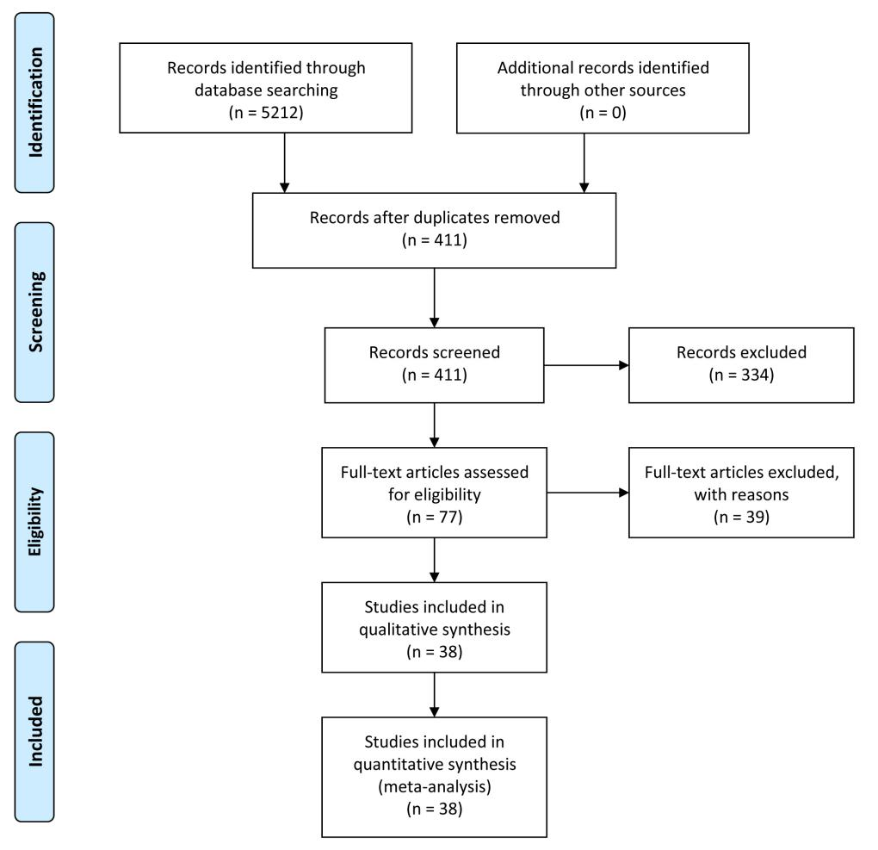
Supplementary appendix Figure 1. PRISMA Flow Diagram.
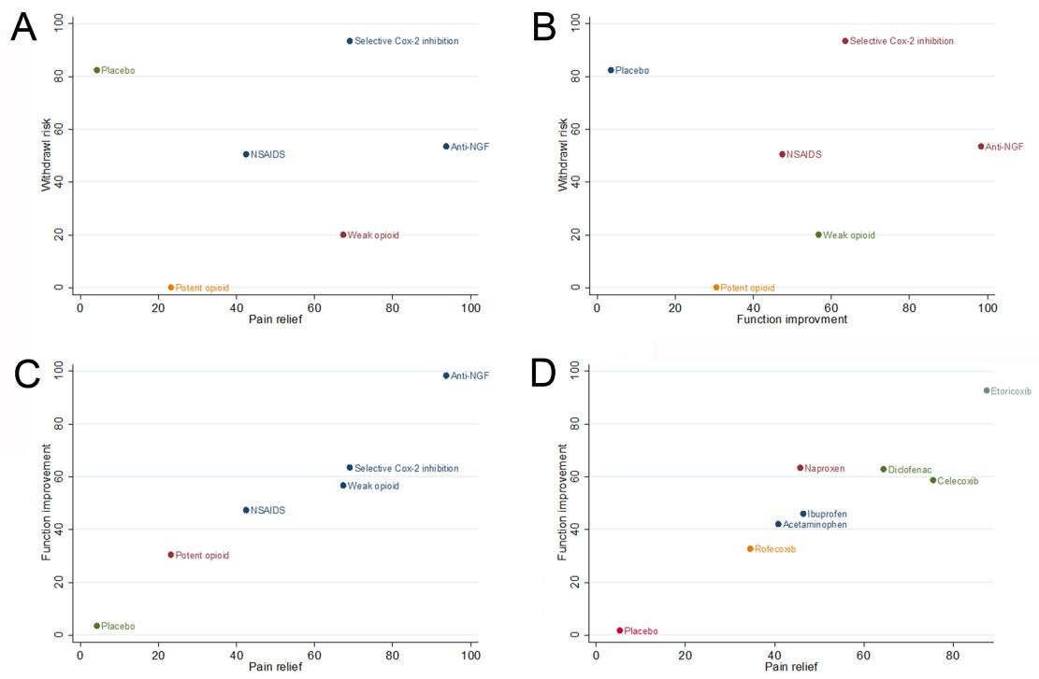
Supplementary appendix Figure 2. Cluset-rank plots. (A) The cluster-rank plot of pain relief and withdrawal rate for main network meta-analysis. (B) The cluster-rank plot of function improvement and withdrawal rate for main network meta-analysis. (C) The cluster-rank plot of pain relief and function improvement for main network meta-analysis. (C) The cluster-rank plot of pain relief and function improvement for subgroup analysis comparing different selective COX-2 inhibitor and traditional NSAIDs.(The cluster-rank value is the product of the abscissa and ordinate of each treatment).

Supplementary appendix Table 1. Baseline Characteristics of included Studies
Author | No. | Year | Sample Size | Mean age | Gender ratio | Target joint | Route of administration | Funded or  Sponsored | Experimental intervention | Control intervention I | Control intervention II | Follow-up period
Kivitz A et al.[27] | 1 | 2006 | 370 | 61.76 | 146/224 | Hip/Knee | Oral | Yes | Oxymorphone | Placebo | - | 14
Zacher J et al. [28] | 2 | 2003 | 516 | 63.05 | 101/415 | Hip/Knee | Oral | Yes | Etoricoxib | Diclofenac | - | 42
Spierings EL et al.[7] | 3 | 2013 | 610 | 57.41 | 229/381 | Hip/Knee | Itravenous | Yes | Placebo | Tanezumab | Oxycodone | 112
Puopolo A et al. [29] | 4 | 2007 | 548 | 62.56 | 133/415 | Hip/Knee | Oral | No | Placebo | Etoricoxib | Ibuprofen | 84
Vojtaššák J et al.[30] | 5 | 2011 | 287 | 65.52 | 80/207 | Hip/Knee | Oral | No | Hydromorphone | Placebo | - | 112
Prior MJ et al.[31] | 6 | 2014 | 542 | 61.7 | 139/403 | Hip/Knee | Oral | No | Acetaminophen | Placebo | - | 84
Emery P et al.[31] | 7 | 2008 | 248 | 64.02 | 134/114 | Hip | Oral | Yes | Celecoxib | Diclofenac | - | 84
McKenna F et al.[32] | 8 | 2001 | 600 | 61.67 | 208/392 | Knee | Oral | Yes | Placebo | Celecoxib | Diclofenac | 42
Altman RD et al.[33] | 9 | 2015 | 385 | 64.13 | 89/296 | Hand | Topical | No | Diclofenac | Placebo | - | 56
Bookman AA et al.[33] | 10 | 2004 | 248 | 61.8 | 91/157 | Knee | Topical | No | Diclofenac | Placebo | - | 28
Schnitzer TJ et al.[8] | 11 | 2019 | 696 | 60.83 | 243/453 | Hip/Knee | Itravenous | Yes | Tanezumab | Placebo | - | 112
Mayorga AJ et al.[9] | 12 | 2016 | 196 | NR | 86/110 | Knee | Itravenous | Yes | Placebo | Fulranumab | Oxycodone | 84
Ekman EF et al.[10] | 13 | 2014 | 828 | 61.12 | 329/499 | Knee | Itravenous | Yes | Placebo | Tanezumab 5mg,10mg | Naproxen | 56
Ekman EF et al.[10] | 14 | 2014 | 840 | 59.85 | 304/534 | Hip/Knee | Itravenous | Yes | Placebo | Tanezumab 5mg,10mg | Naproxen | 56
Gibofsky A et al.[34] | 15 | 2014 | 305 | 61.63 | 102/203 | Hip/Knee | Oral | Yes | Diclofenac | Placebo | - | 84
Essex MN et al.[35] | 16 | 2016 | 367 | 64.77 | 120/247 | Knee | Oral | Yes | Celecoxib | Naproxen | Placebo | 42
Reed K et al.[36] | 17 | 2018 | 676 | 60.77 | 251/425 | Hip/Knee | Oral | Yes | Acetaminophen | Placebo | - | 84
Essex MN et al.[37] | 18 | 2012 | 589 | 60.38 | 199/390 | Knee | Oral | Yes | Celecoxib | Naproxen | - | 180
Leung AT et al.[38] | 19 | 2002 | 501 | 63.16 | 109/392 | Hip/Knee | Oral | Yes | Placebo | Etoricoxib | Naproxen | 84
Gordo AC et al.[39] | 20 | 2016 | 388 | 62.95 | 106/282 | Knee | Oral | Yes | Celecoxib | Ibuprofen | Placebo | 42
Niethard FU et al.[40] | 21 | 2005 | 237 | 66 | 87/150 | Knee | Topical | No | Diclofenac（Gel） | Placebo | - | 21
Tiseo PJ et al.[11] | 22 | 2014 | 215 | 59.3 | 67/148 | Knee | Itravenous | Yes | Placebo | Fasinumab | - | 168
Yoo MC et al.[41] | 23 | 2014 | 239 | 63 | 25/214 | Knee | Oral | Yes | Etoricoxib | Celecoxib | - | 84
DeLemos BP et al.[42] | 24 | 2011 | 1001 | 60.02 | 369/632 | Hip/Knee | Oral | Yes | Tramadol | Celecoxib | Placebo | 84
Reginster JY et al.[43] | 25 | 2006 | 997 | 62.77 | 279/718 | Hip/Knee | Oral | No | Placebo | Etoricoxib | Naproxen | 84
Reginster JY et al.[43] | 26 | 2006 | 463 | 65.7 | 116/347 | Hip/Knee | Oral | No | Etoricoxib | Naproxen | - | 280
Gana TJ et al.[44] | 27 | 2006 | 1011 | 58.15 | 380/631 | Hip/Knee | Oral | Yes | Placebo | Tramadol | - | 84
Svensson O et al.[45] | 28 | 2006 | 156 | 58.66 | 49/107 | Hip | Oral | Yes | Naproxen | Placebo | - | 42
Svensson O et al.[45] | 29 | 2006 | 355 | 60.11 | 84/271 | Knee | Oral | Yes | Naproxen | Placebo | - | 42
Nagashima H et al.[12] | 30 | 2011 | 83 | 59.03 | 25/57 | Knee | Itravenous | Yes | Tanezumab | Placebo | - | 56
Dakin P et al.[15] | 31 | 2019 | 421 | 60.6 | 149/272 | Hip/Knee | Itravenous | Yes | Placebo | Fasinumab | - | 112
Brown MT et al.[14] | 32 | 2013 | 621 | 62.32 | 237/384 | Hip | Itravenous | Yes | Placebo | Tanezumab | - | 224
Lane NE et al.[13] | 33 | 2010 | 444 | 58.7 | 182/262 | Knee | Itravenous | Yes | Placebo | Tanezumab | - | 112
Rauck R et al.[46] | 34 | 2012 | 981 | 59.7 | 354/627 | Hip/Knee | Oral | Yes | Placebo | Hydromorphone | - | 84
Miceli-Richard C et al.[47] | 35 | 2015 | 779 | 70 | 196/583 | Knee | Oral | No | Acetaminophen | Placebo | - | 42
Varadi G et al.[48] | 36 | 2013 | 75 | 61.28 | 27/48 | Knee | Topical | Yes | Ibuprofen | Placebo | - | 14
Altman RD et al.[49] | 37 | 2006 | 483 | 62.2 | 160/323 | Hip/Knee | Oral | Yes | Acetaminophen | Placebo | - | 84
Schnitzer TJ et al.[50] | 38 | 2009 | 376 | 59.77 | 141/235 | Knee | Oral | Yes | Acetaminophen | Rofecoxib | - | 28
Day R et al.[51] | 39 | 2000 | 809 | 63.86 | 162/647 | Hip/Knee | Oral | Yes | Placebo | Rofecoxib 12.5mg Qd,25mg Qd | Ibuprofen | 42
Ehrich EW et al.[52] | 40 | 1999 | 219 | 63.5 | 63/156 | Knee | Oral | No | Placebo | Rofecoxib | - | 42
Cannon GW et al.[53] | 41 | 2000 | 784 | 63.6 | 255/529 | Hip/Knee | Oral | No | Rofecoxib | Diclofenac | - | 365
Supplementary appendix Table 2. Methodological quality and risk of bias evaluation.
Article | 1.Sequence generation | 2.Allocation concealment | 3.Blinding | 4.Incomplete outcome data | 5.Selective outcome reporting | 6.Other source of bias
Kivitz A et al.[27] | Low risk | Low risk | Low risk | Low risk | Low risk | High risk
Zacher J et al. [28] | Low risk | Low risk | Low risk | Low risk | Low risk | Low risk
Spierings EL et al.[7] | High risk | Low risk | Low risk | Low risk | Low risk | Unclear risk
Puopolo A et al. [29] | Low risk | Low risk | Low risk | Low risk | Low risk | Unclear risk
Vojtaššák J et al.[30] | Low risk | Low risk | Low risk | Low risk | Low risk | Unclear risk
Prior MJ et al.[31] | Low risk | Low risk | Low risk | Low risk | Low risk | Unclear risk
Emery P et al.[31] | Low risk | Low risk | Low risk | Low risk | Low risk | Unclear risk
McKenna F et al.[32] | Low risk | Low risk | Low risk | Low risk | Low risk | Unclear risk
Altman RD et al.[33] | Unclear risk | Low risk | Low risk | Low risk | Low risk | Unclear risk
Bookman AA et al.[33] | Unclear risk | Low risk | Low risk | Low risk | Low risk | Low risk
Schnitzer TJ et al.[8] | Low risk | Low risk | Low risk | Low risk | Low risk | Unclear risk
Mayorga AJ et al.[9] | Low risk | Low risk | Low risk | Low risk | Low risk | Unclear risk
Ekman EF et al.[10] | Low risk | Low risk | Low risk | Low risk | Low risk | Unclear risk
Ekman EF et al.[10] | Low risk | Low risk | Low risk | Low risk | Low risk | Unclear risk
Gibofsky A et al.[34] | Unclear risk | Low risk | Low risk | Low risk | Low risk | Unclear risk
Essex MN et al.[35] | Unclear risk | Low risk | Low risk | Low risk | Low risk | Unclear risk
Reed K et al.[36] | Low risk | Low risk | Low risk | Low risk | Low risk | Unclear risk
Essex MN et al.[37] | Low risk | Low risk | Low risk | Low risk | Low risk | Unclear risk
Leung AT et al.[38] | Low risk | Low risk | Low risk | Low risk | Low risk | Unclear risk
Gordo AC et al.[39] | Low risk | Low risk | Low risk | Low risk | Low risk | Unclear risk
Niethard FU et al.[40] | Low risk | Low risk | Low risk | Low risk | Low risk | High risk
Tiseo PJ et al.[11] | Low risk | Low risk | Low risk | Low risk | Low risk | Unclear risk
Yoo MC et al.[41] | Low risk | Unclear risk | Low risk | Low risk | Low risk | Unclear risk
DeLemos BP et al.[42] | Unclear risk | Low risk | Low risk | Low risk | Low risk | Low risk
Reginster JY et al.[43] | Low risk | Low risk | Low risk | Low risk | Low risk | Low risk
Reginster JY et al.[43] | Low risk | Low risk | Low risk | Low risk | Low risk | Low risk
Gana TJ et al.[44] | Low risk | Low risk | Low risk | Low risk | Low risk | Low risk
Svensson O et al.[45] | Unclear risk | Unclear risk | Low risk | Low risk | Low risk | Low risk
Svensson O et al.[45] | Unclear risk | Unclear risk | Low risk | Low risk | Low risk | Low risk
Nagashima H et al.[12] | High risk | Low risk | Low risk | Low risk | Low risk | Unclear risk
Dakin P et al.[15] | Low risk | Low risk | Low risk | Low risk | Low risk | Unclear risk
Brown MT et al.[14] | Unclear risk | Low risk | Low risk | Low risk | Low risk | Unclear risk
Lane NE et al.[13] | Low risk | Low risk | Low risk | Low risk | Low risk | Unclear risk
Rauck R et al.[46] | Unclear risk | Low risk | Low risk | Low risk | Low risk | Unclear risk
Miceli-Richard C et al.[47] | Unclear risk | Unclear risk | Low risk | Low risk | Low risk | Unclear risk
Varadi G et al.[48] | Unclear risk | Unclear risk | Low risk | Low risk | Low risk | Unclear risk
Altman RD et al.[49] | Low risk | Low risk | Low risk | Low risk | Low risk | Unclear risk
Schnitzer TJ et al.[50] | Unclear risk | Low risk | Low risk | Low risk | Low risk | Unclear risk
Day R et al.[51] | Low risk | Low risk | Low risk | Low risk | Low risk | Low risk
Ehrich EW et al.[52] | Low risk | Low risk | Low risk | Low risk | Low risk | Unclear risk
Cannon GW et al.[53] | Low risk | Low risk | Low risk | Low risk | Low risk | Unclear risk

Supplementary appendix Table 3. The details of SURCA and mean rank of main network meta-analysis.
Treatment | SMD (95%CI)  for pain relief | SURCA  for pain relief, % | Mean rank for pain relief | SMD (95%CI)  for Function imrovement | SURCA  for Function imrovement, % | Mean rank for Function imrovement
Placebo | Reference | 4.2 | 5.8 | Reference | 3.5 | 5.8
Anti-NGF | 4.25 (2.87,5.63) | 93.7 | 1.3 | 4.90 (3.46,6.33) | 98.3 | 1.1
Potent opioids | 0.90 (-1.04,2.84) | 23.2 | 4.8 | 1.20 (-0.81,3.21) | 30.5 | 4.5
Weak opioids | 3.03 (0.04,6.02) | 67.3 | 2.6 | 2.42 (-0.68,5.52) | 56.7 | 3.2
Selective cox-2 inhibition | 2.92 (1.58,4.26) | 69 | 2.5 | 2.56 (1.17,3.95) | 63.5 | 2.8
NSAIDs | 1.92 (0.92,2.93) | 42.5 | 3.9 | 2.03 (0.97,3.09) | 47.4 | 3.6

Supplementary appendix Table 4. The details of SURCA and mean rank of subgroup analysis comparing different selective COX-2 inhibitor and traditional NSAIDs.
Treatment | SMD (95%CI)  for pain relief | SURCA  for pain relief, % | Mean rank for pain relief | SMD (95%CI)  for Function imrovement | SURCA  for Function imrovement, % | Mean rank for Function imrovement
Placebo | Reference | 5.3 | 7.6 | Reference | 1.7 | 7.9
Acetaminophen | 1.42 (-0.31,3.15) | 40.8 | 5.1 | 1.71 (0.23,3.20) | 42 | 5.1
Celecoxib | 2.62 (1.00,4.23) | 75.5 | 2.7 | 2.26 (0.89,3.63) | 58.7 | 3.9
Diclofenac | 2.21 (0.80,3.62) | 64.4 | 3.5 | 2.35 (1.15,3.55) | 62.9 | 3.6
Etoricoxib | 3.20 (1.17,5.24) | 87.5 | 1.9 | 3.41 (1.88,4.93) | 92.7 | 1.5
Ibuprofen | 1.59 (-0.90,4.08) | 46.4 | 4.8 | 1.87 (0.14,3.60) | 46 | 4.8
Naproxen | 1.65 (0.01,3.28) | 45.7 | 4.8 | 2.38 (0.86,3.89) | 63.4 | 3.6
Rofecoxib | 1.16 (-1.13,3.44) | 34.5 | 5.6 | 1.38 (-0.58,3.35) | 32.7 | 5.7

Supplementary appendix Table 5. The details of results for subgroup analyses.
Treatment | Network-meta analysis |  |  | Subgroup analysis
Treatment | SMD (95%CI)  for pain relief | SMD (95%CI)  for function improvement | OR (95%CI)  for withdral due to AEs | SMD (95%CI)  for pain relief | SMD (95%CI)  for function improvement | OR (95%CI)  for withdral due to AEs
Anti-NGF | 4.25 (2.87,5.63) | 4.90 (3.46,6.33) | 1.36 (0.82,2.27) | 4.30 (2.85,5.74) | 4.96 (3.42,6.50) | 0.36 (-0.22,0.94)
Potent opioids | 0.90 (-1.04,2.84) | 1.20 (-0.81,3.21) | 8.63 (5.42,13.77) | 1.13 (-1.10,3.36) | 1.47 (-0.90,3.84) | 2.19 (1.54,2.84)
Weak opioids | 3.03 (0.04,6.02) | 2.42 (-0.68,5.52) | 3.27 (1.89,5.66) | 3.07 (-0.05,6.20) | 2.47 (-0.85,5.79) | 1.49 (1.04,1.93)
Selective cox-2 inhibition | 2.92 (1.58,4.26) | 2.56 (1.17,3.95) | 0.89 (0.64,1.24) | 3.07 (1.40,4.74) | 2.75 (0.98,4.53) | -0.10 (-0.58,0.37)
NSAIDs | 1.92 (0.92,2.93) | 2.03 (0.97,3.09) | 1.36 (1.04,1.77) | 2.08 (0.80,3.36) | 2.22 (0.83,3.61) | 0.39 (-0.01,0.80)

Supplementary appendix Table 6. Detailed results of network meta-analysis for pain (Red) and function (Blue) (Data are standardised mean difference, from the top left to the bottom right, higher comparator vs lower comparator, and their related 95% CI)
Etoricoxib | 1.15 (-0.56,2.86) | 1.06 (-0.65,2.76) | 1.53 (-0.52,3.59) | 1.03 (-0.68,2.74) | 1.69 (-0.42,3.81) | 2.02 (-0.40,4.45) | 3.41 (1.88,4.93)
0.59 (-1.54,2.72) | Celecoxib | -0.09 (-1.64,1.45) | 0.38 (-1.60,2.37) | -0.12 (-1.87,1.63) | 0.55 (-1.46,2.55) | 0.88 (-1.45,3.20) | 2.26 (0.89,3.63)
0.99 (-1.16,3.14) | 0.40 (-1.39,2.20) | Diclofenac | -0.48 (-2.50,1.55) | -0.03 (-1.84,1.79) | -0.64 (-2.49,1.22) | -0.97 (-3.03,1.10) | -2.35 (-3.55,-1.15)
1.61 (-1.50,4.73) | 1.03 (-1.68,3.73) | 0.62 (-2.17,3.42) | Ibuprofen | -0.50 (-2.69,1.68) | -0.16 (-2.44,2.11) | -0.49 (-3.09,2.10) | -1.87 (-3.60,-0.14)
1.56 (-0.48,3.60) | 0.97 (-0.87,2.81) | 0.57 (-1.41,2.55) | -0.05 (-2.94,2.83) | Naproxen | -0.66 (-2.78,1.45) | -0.99 (-3.44,1.45) | -2.38 (-3.89,-0.86)
1.79 (-0.87,4.44) | 1.20 (-1.15,3.54) | 0.80 (-1.37,2.96) | 0.17 (-2.85,3.20) | 0.23 (-2.14,2.59) | Acetaminophen | -0.33 (-2.46,1.80) | -1.71 (-3.20,-0.23)
2.05 (-0.92,5.02) | 1.46 (-1.25,4.17) | 1.06 (-1.35,3.46) | 0.43 (-2.92,3.79) | 0.49 (-2.27,3.25) | 0.26 (-2.21,2.74) | Rofecoxib | -1.38 (-3.35,0.58)
3.20 (1.17,5.24) | 2.62 (1.00,4.23) | 2.21 (0.80,3.62) | 1.59 (-0.90,4.08) | 1.65 (0.01,3.28) | 1.42 (-0.31,3.15) | 1.16 (-1.13,3.44) | Placebo

