Supplementary information

Design and synthesis of novel pyrazole-benzofuran hybrids: in vitro α-glucosidase inhibitory activity, kinetic and molecular modeling study
Fateme Azimi ª, Homa Azizian ^{b}, Mohammad Najafi ^{c}, Ghadamali khodarahmi ª, Motahareh hassanzadeh ª, Lotfollah Saghaei ª, Jahan B. Ghasemi ^{d}, Hojjat Sadeghi-aliabadi ª, Mohammad Ali Faramarzi ^{e}, Bagher Larijani ^{f}, Farshid Hassanzadeh ^{a,*}, Mohammad Mahdavi ^{f,*}

ª Department of Medicinal Chemistry, Faculty of Pharmacy and Pharmaceutical Science, Isfahan University of Medical Science, Hezar Jerib, 817416-73461, Isfahan, Iran
^{b} Department of Medicinal Chemistry, School of Pharmacy-International Campus, Iran University of Medical Science, Tehran, Iran
^{c} Department of Chemistry, Isfahan University of Technology, Isfahan, 84156-83111, Iran
^{d} School of Chemistry, University College of Science, University of Tehran, P.O. Box 14155-6455, Tehran, Iran
^{e} Department of Pharmaceutical Biotechnology, Faculty of Pharmacy, Tehran University of Medical Sciences, P.O. Box 14155-6451, Tehran 1417614411, Iran
^{f} Endocrinology and Metabolism Research Center, Endocrinology and Metabolism Research Institute, Tehran University of Medical Sciences, Tehran, Iran

Fig. S1. ¹H NMR spectra of N'-((1,3-Diphenyl-1H-pyrazol-4-yl)methylene)benzofuran-2-carbohydrazide (8a) 6
Fig. S2. ¹³C NMR spectra of N'-((1,3-Diphenyl-1H-pyrazol-4-yl)methylene)benzofuran-2-carbohydrazide (8a) 7
Fig. S3. ¹H NMR spectra of N'-((1-Phenyl-3-p-tolyl-1H-pyrazol-4-yl)methylene)benzofuran-2-carbohydrazide (8b) 8
Fig. S5. ¹H NMR spectra of N'-((3-(4-Methoxyphenyl)-1-phenyl-1H-pyrazol-4-yl)methylene)benzofuran-2-carbohydrazide (8c) 10
Fig. S7. ¹H NMR spectra of N'-((3-(4-hydroxyphenyl)-1-phenyl-1H-pyrazol-4-yl)methylene)benzofuran-2-carbohydrazide (8d) 12
Fig. S8. ¹³C NMR spectra of N'-((3-(4-hydroxyphenyl)-1-phenyl-1H-pyrazol-4-yl)methylene)benzofuran-2-carbohydrazide (8d) 13
Fig. S9. ¹H NMR spectra of N'-((3-(4-Nitrophenyl)-1-phenyl-1H-pyrazol-4-yl)methylene)benzofuran-2-carbohydrazide (8e) 14
Fig. S10. ¹³C NMR spectra of N'-((3-(4-Nitrophenyl)-1-phenyl-1H-pyrazol-4-yl)methylene)benzofuran-2-carbohydrazide (8e) 15
Fig. S11. ¹H NMR spectra of N'-((3-(4-Bromophenyl)-1-phenyl-1H-pyrazol-4-yl)methylene)benzofuran-2-carbohydrazide (8f) 16
Fig. S12. ¹³C NMR spectra of N'-((3-(4-Bromophenyl)-1-phenyl-1H-pyrazol-4-yl)methylene)benzofuran-2-carbohydrazide (8f) 17
Fig. S13. ¹H NMR spectra of N'-((3-(4-Chlorophenyl)-1-phenyl-1H-pyrazol-4-yl)methylene)benzofuran-2-carbohydrazide (8g) 18
Fig. S14. ¹³C NMR spectra of N'-((3-(4-Chlorophenyl)-1-phenyl-1H-pyrazol-4-yl)methylene)benzofuran-2-carbohydrazide (8g) 19
Fig. S15. ¹H NMR spectra of N'-((3-(4-Fluorophenyl)-1-phenyl-1H-pyrazol-4-yl)methylene)benzofuran-2-carbohydrazide (8h) 20
Fig. S16. ¹³C NMR spectra of N'-((3-(4-Fluorophenyl)-1-phenyl-1H-pyrazol-4-yl)methylene)benzofuran-2-carbohydrazide (8h) 21
Fig. S17. ³H NMR spectra of N'-((1-Phenyl-3-(4-(trifluoromethyl)phenyl)-1H-pyrazol-4-yl)methylene)benzofuran-2-carbohydrazide (8i) 22
Fig. S18. ¹³C NMR spectra of N'-((1-Phenyl-3-(4-(trifluoromethyl)phenyl)-1H-pyrazol-4-yl)methylene)benzofuran-2-carbohydrazide (8i) 23
Fig. S19. ¹H NMR spectra of N'-((3-Phenyl-1-p-tolyl-1H-pyrazol-4-yl)methylene)benzofuran-2-carbohydrazide (8j) 24
Fig. S21. ¹H NMR spectra of N'-((1,3-Dip-tolyl-1H-pyrazol-4-yl)methylene)benzofuran-2-carbohydrazide (8k) 26
Fig. S22. ¹³C NMR spectra of N'-((1,3-Dip-tolyl-1H-pyrazol-4-yl)methylene)benzofuran-2-carbohydrazide (8k) 27
Fig. S23. ¹H NMR spectra of N'-((3-(4-Methoxyphenyl)-1-p-tolyl-1H-pyrazol-4-yl)methylene)benzofuran-2-carbohydrazide (8l) 28
Fig. S24. ¹³C NMR spectra of N'-((3-(4-Methoxyphenyl)-1-p-tolyl-1H-pyrazol-4-yl)methylene)benzofuran-2-carbohydrazide (8l) 29
Fig. S25. ¹H NMR spectra of N'-((3-(4-Hydroxyphenyl)-1-p-tolyl-1H-pyrazol-4-yl)methylene)benzofuran-2-carbohydrazide (8m) 30
Fig. S26. ¹³C NMR spectra of N'-((3-(4-Hydroxyphenyl)-1-p-tolyl-1H-pyrazol-4-yl)methylene)benzofuran-2-carbohydrazide (8m) 31
Fig. S27. ¹H NMR spectra of N'-((3-(4-Bromophenyl)-1-p-tolyl-1H-pyrazol-4-yl)methylene)benzofuran-2-carbohydrazide (8n) 32
Fig. S28. ¹³C NMR spectra of N'-((3-(4-Bromophenyl)-1-p-tolyl-1H-pyrazol-4-yl)methylene)benzofuran-2-carbohydrazide (8n) 33
Fig. S29. ¹H NMR spectra of N'-((3-(4-Chlorophenyl)-1-p-tolyl-1H-pyrazol-4-yl)methylene)benzofuran-2-carbohydrazide (8o) 34
Fig. S30. ¹³C NMR spectra of N'-((3-(4-Chlorophenyl)-1-p-tolyl-1H-pyrazol-4-yl)methylene)benzofuran-2-carbohydrazide (8o) 35

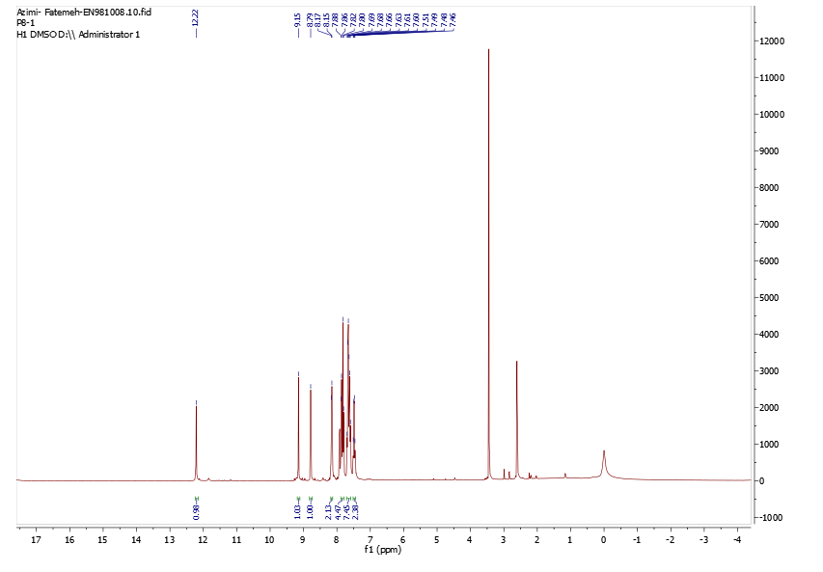
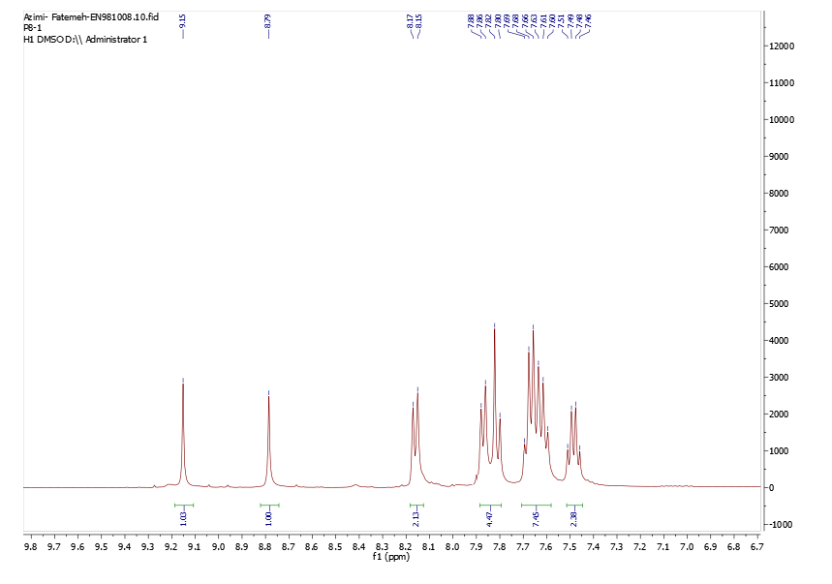
Fig. S1. ¹H NMR spectra of N'-((1,3-Diphenyl-1H-pyrazol-4-yl)methylene)benzofuran-2-carbohydrazide (8a)
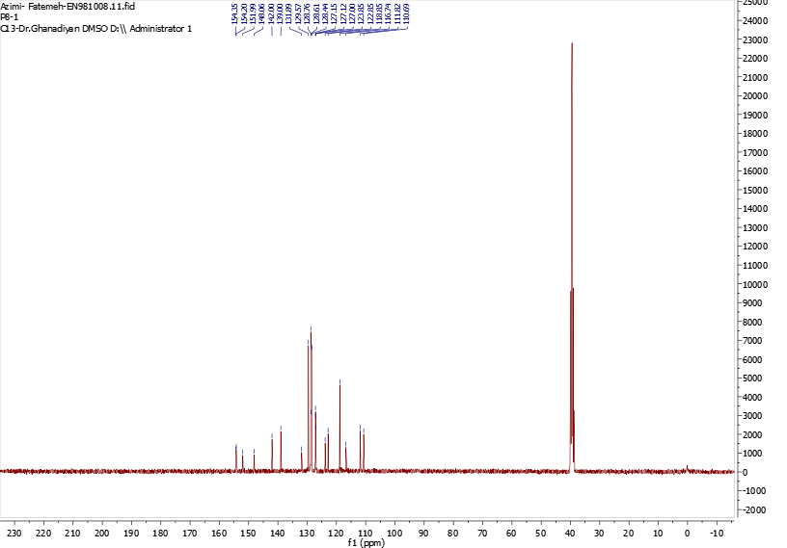
Fig. S2. ¹³C NMR spectra of N'-((1,3-Diphenyl-1H-pyrazol-4-yl)methylene)benzofuran-2-carbohydrazide (8a)

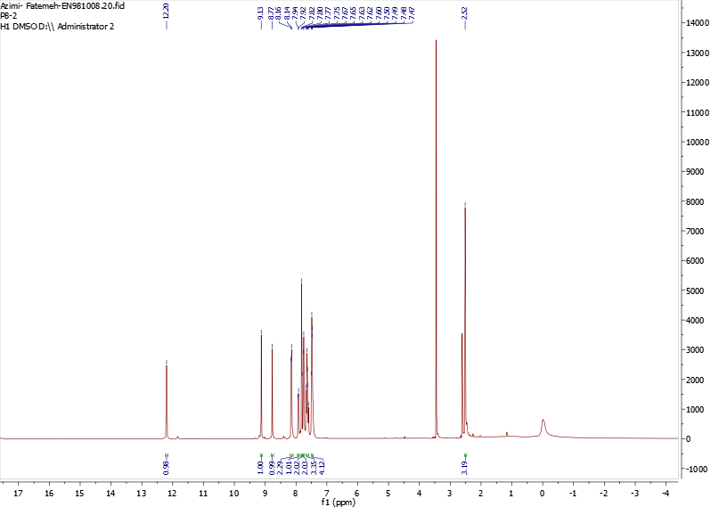
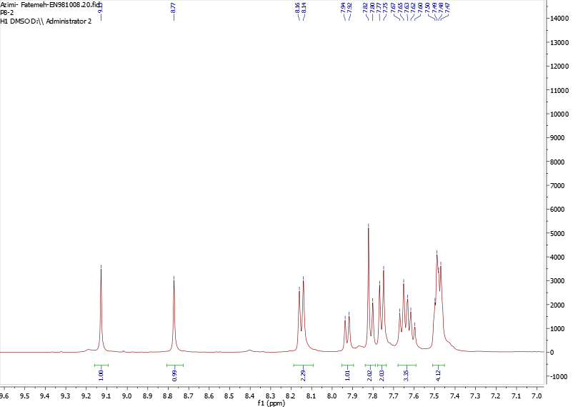
Fig. S3. ¹H NMR spectra of N'-((1-Phenyl-3-p-tolyl-1H-pyrazol-4-yl)methylene)benzofuran-2-carbohydrazide (8b)
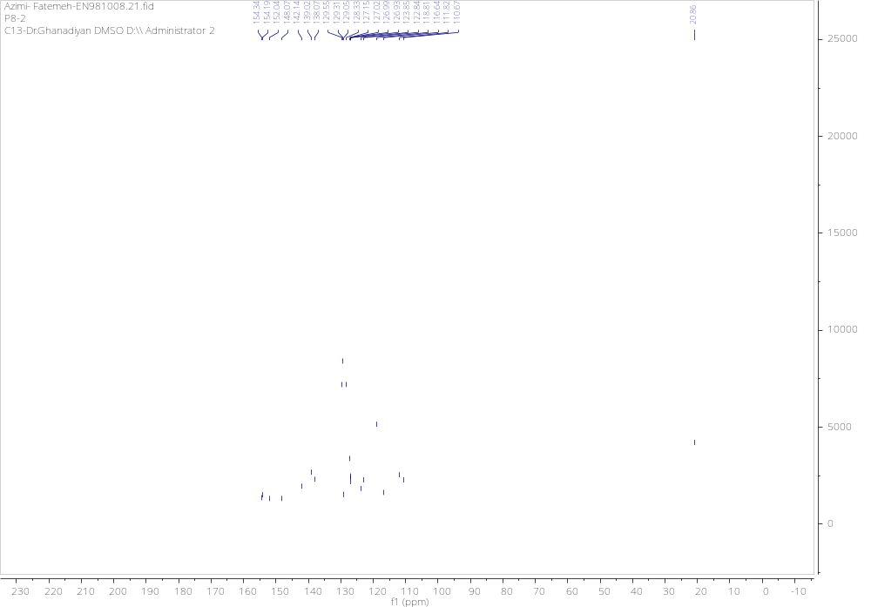Fig. S4. ¹³C NMR spectra of N'-((1-Phenyl-3-p-tolyl-1H-pyrazol-4-yl)methylene)benzofuran-2-carbohydrazide (8b)

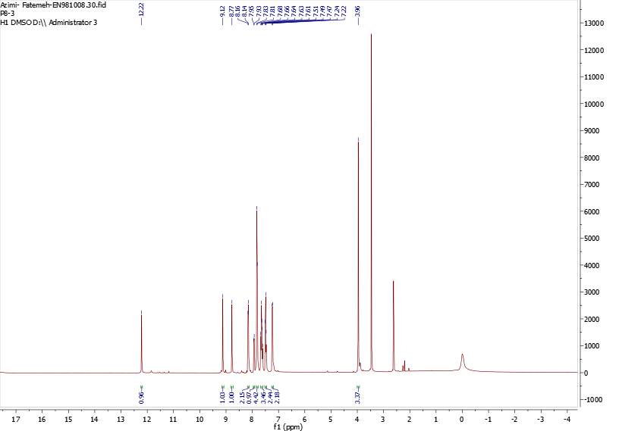
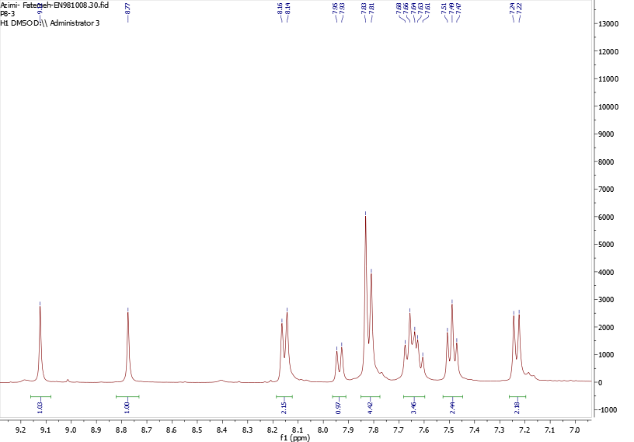
Fig. S5. ¹H NMR spectra of N'-((3-(4-Methoxyphenyl)-1-phenyl-1H-pyrazol-4-yl)methylene)benzofuran-2-carbohydrazide (8c)
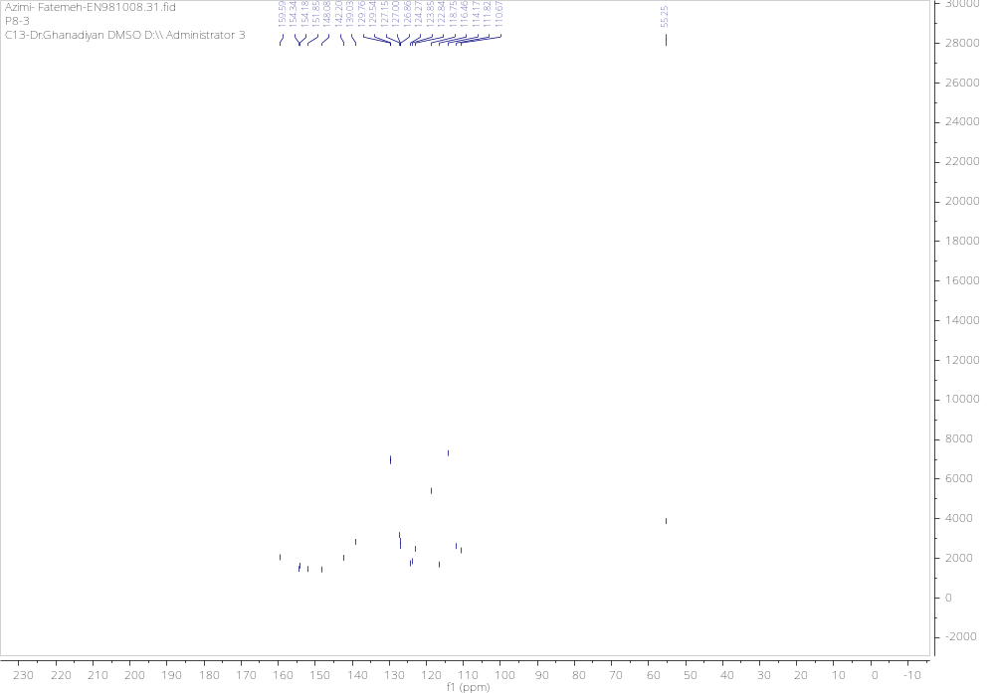 Fig. S6. ¹³C NMR spectra of N'-((3-(4-Methoxyphenyl)-1-phenyl-1H-pyrazol-4-yl)methylene)benzofuran-2-carbohydrazide (8c)

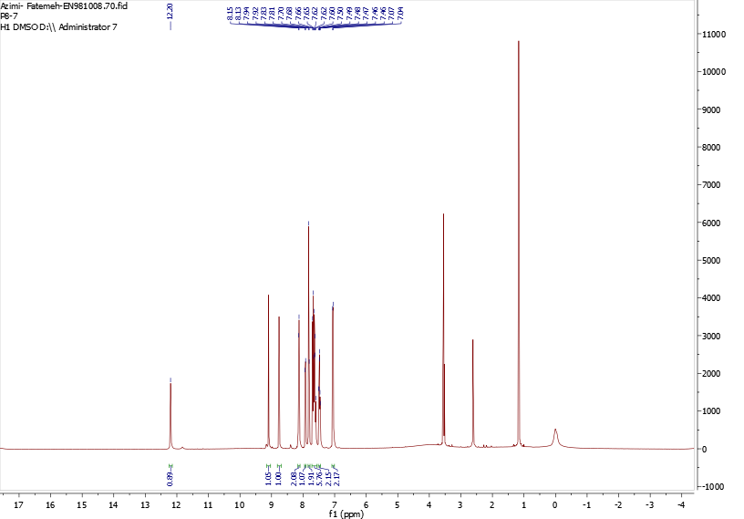
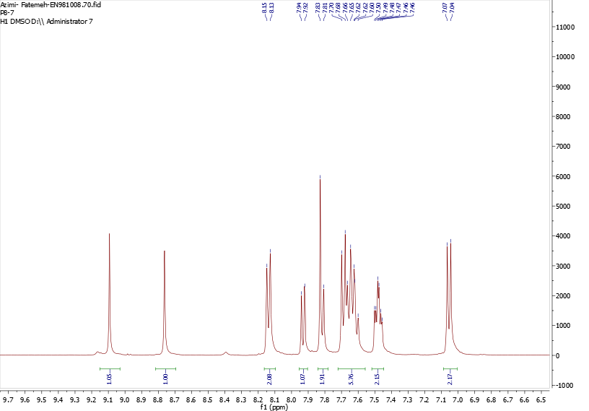
Fig. S7. ¹H NMR spectra of N'-((3-(4-hydroxyphenyl)-1-phenyl-1H-pyrazol-4-yl)methylene)benzofuran-2-carbohydrazide (8d)
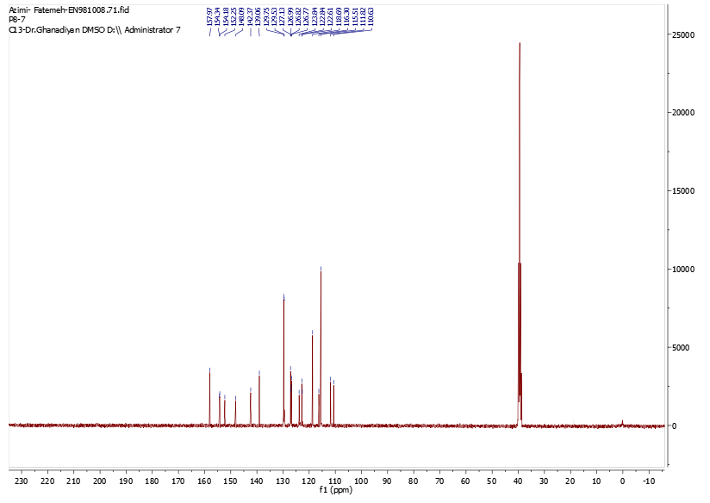
Fig. S8. ¹³C NMR spectra of N'-((3-(4-hydroxyphenyl)-1-phenyl-1H-pyrazol-4-yl)methylene)benzofuran-2-carbohydrazide (8d)

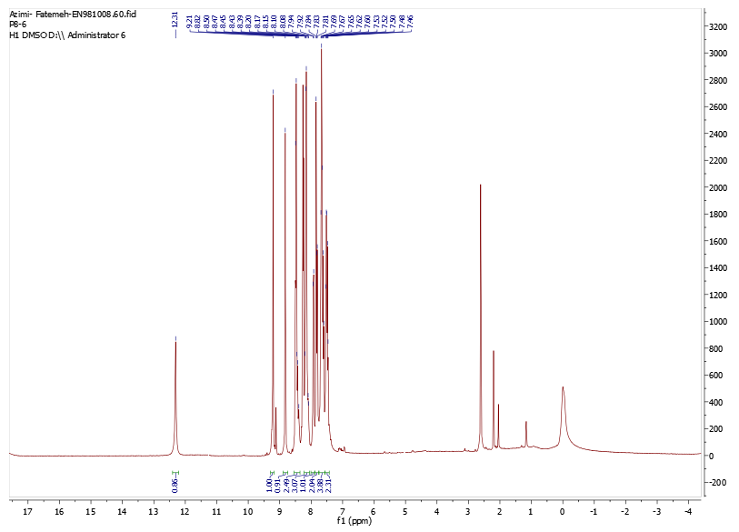
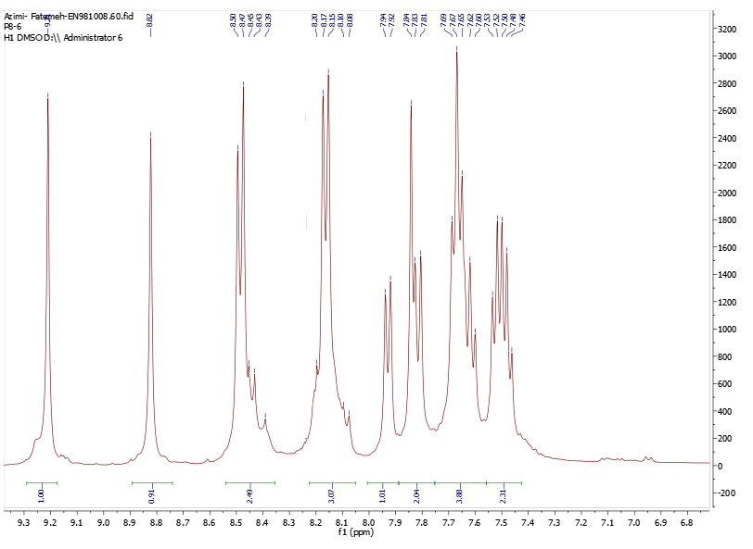
Fig. S9. ¹H NMR spectra of N'-((3-(4-Nitrophenyl)-1-phenyl-1H-pyrazol-4-yl)methylene)benzofuran-2-carbohydrazide (8e)
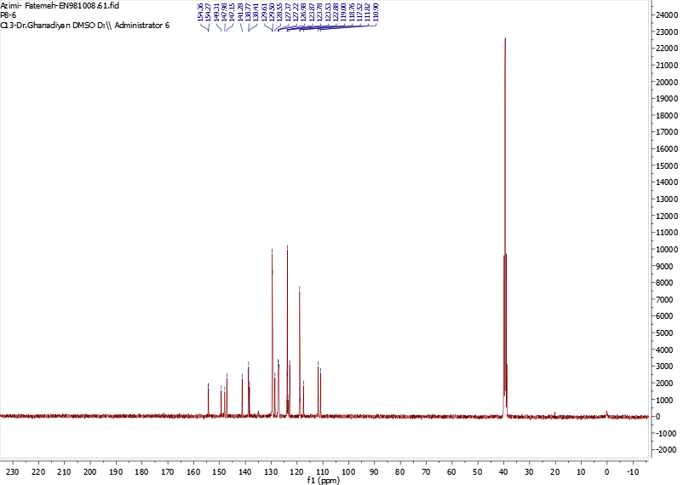
Fig. S10. ¹³C NMR spectra of N'-((3-(4-Nitrophenyl)-1-phenyl-1H-pyrazol-4-yl)methylene)benzofuran-2-carbohydrazide (8e)

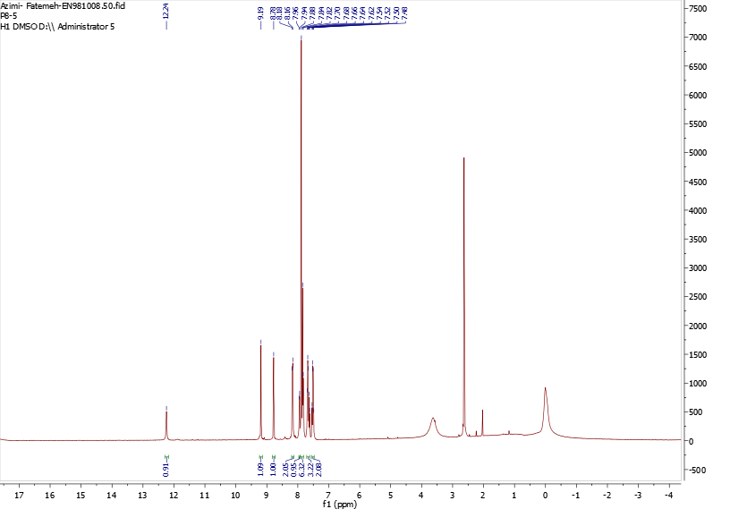
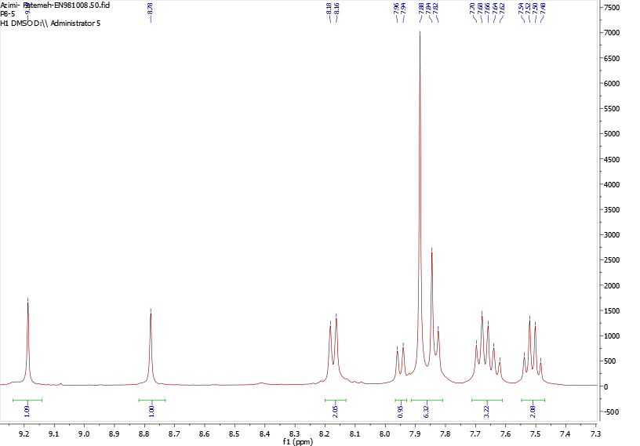
Fig. S11. ¹H NMR spectra of N'-((3-(4-Bromophenyl)-1-phenyl-1H-pyrazol-4-yl)methylene)benzofuran-2-carbohydrazide (8f)
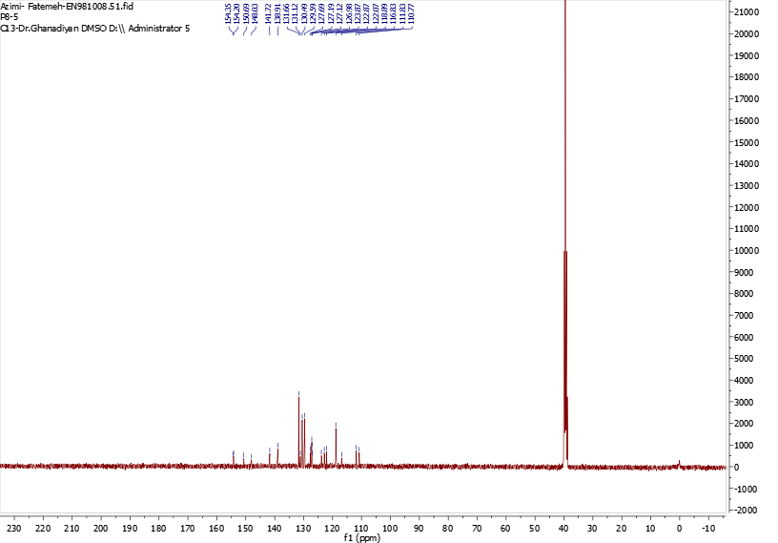
Fig. S12. ¹³C NMR spectra of N'-((3-(4-Bromophenyl)-1-phenyl-1H-pyrazol-4-yl)methylene)benzofuran-2-carbohydrazide (8f)

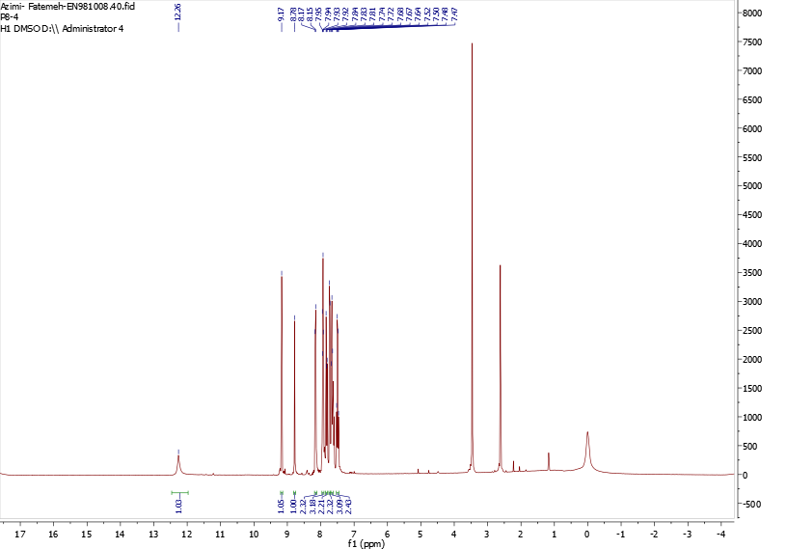
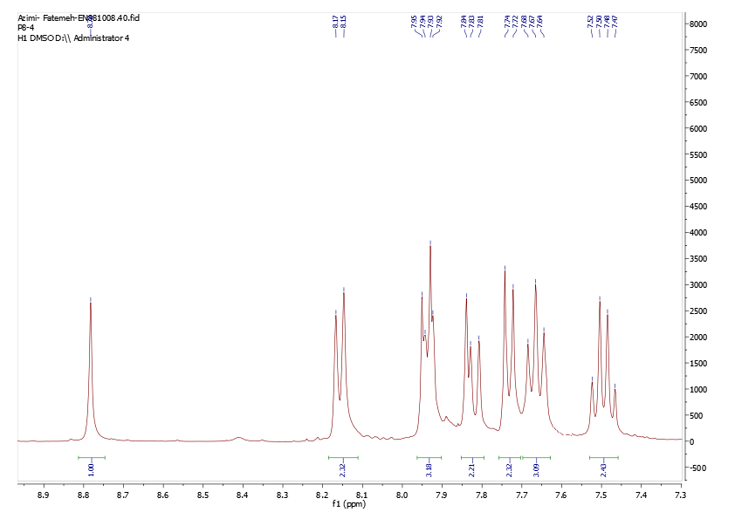
Fig. S13. ¹H NMR spectra of N'-((3-(4-Chlorophenyl)-1-phenyl-1H-pyrazol-4-yl)methylene)benzofuran-2-carbohydrazide (8g)
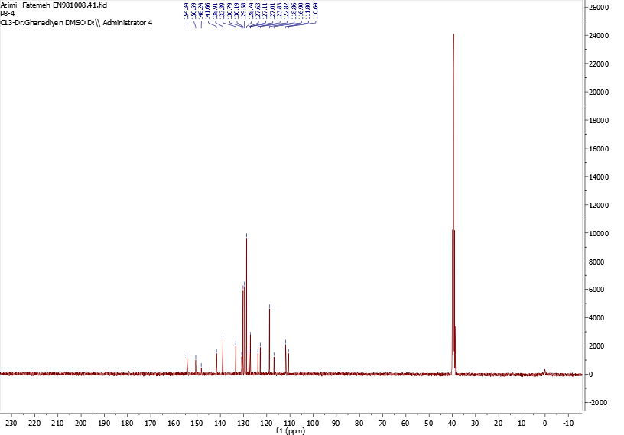
Fig. S14. ¹³C NMR spectra of N'-((3-(4-Chlorophenyl)-1-phenyl-1H-pyrazol-4-yl)methylene)benzofuran-2-carbohydrazide (8g)

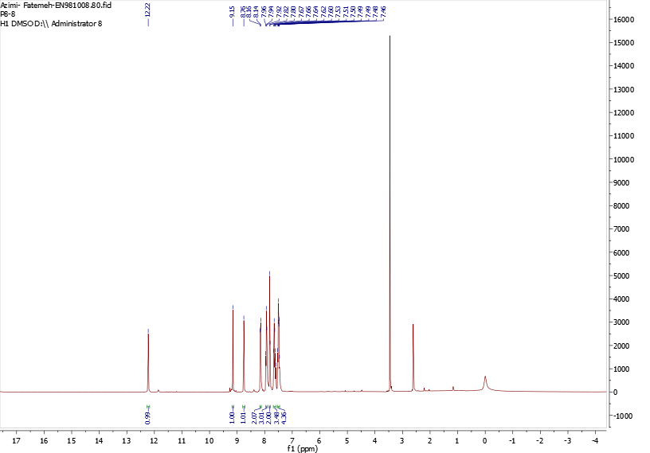
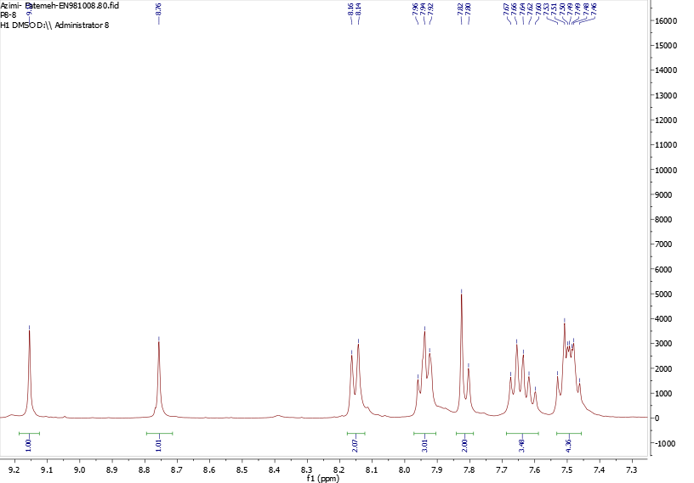
Fig. S15. ¹H NMR spectra of N'-((3-(4-Fluorophenyl)-1-phenyl-1H-pyrazol-4-yl)methylene)benzofuran-2-carbohydrazide (8h)
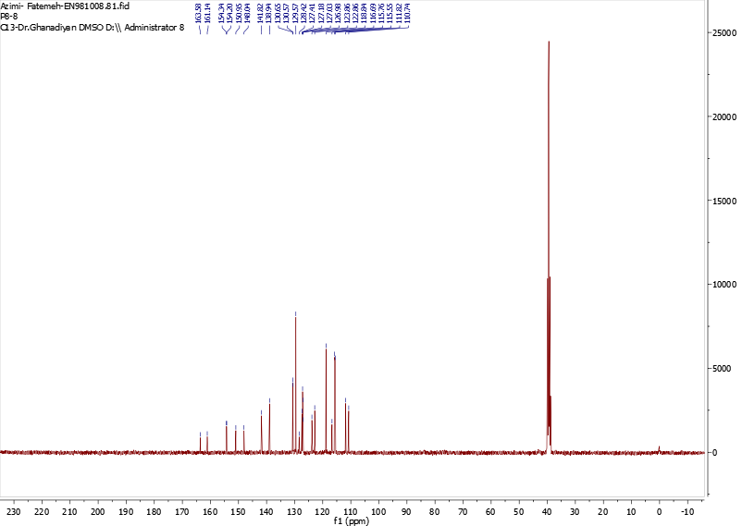
Fig. S16. ¹³C NMR spectra of N'-((3-(4-Fluorophenyl)-1-phenyl-1H-pyrazol-4-yl)methylene)benzofuran-2-carbohydrazide (8h)

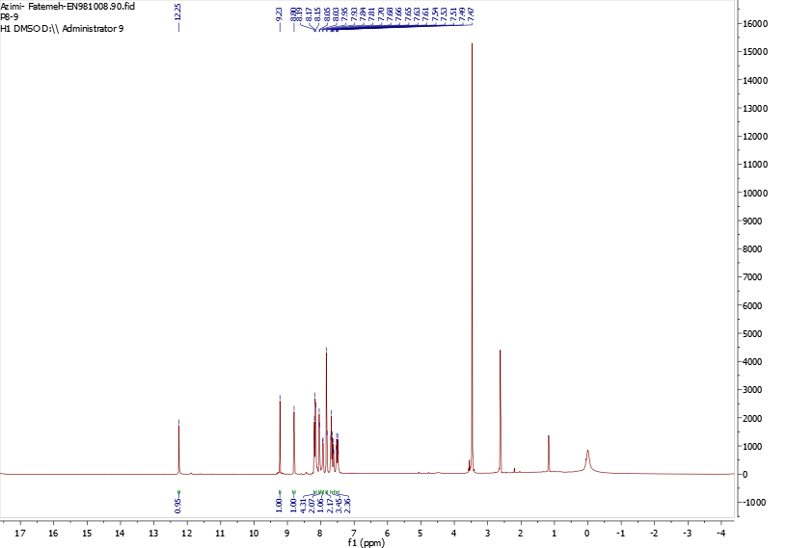
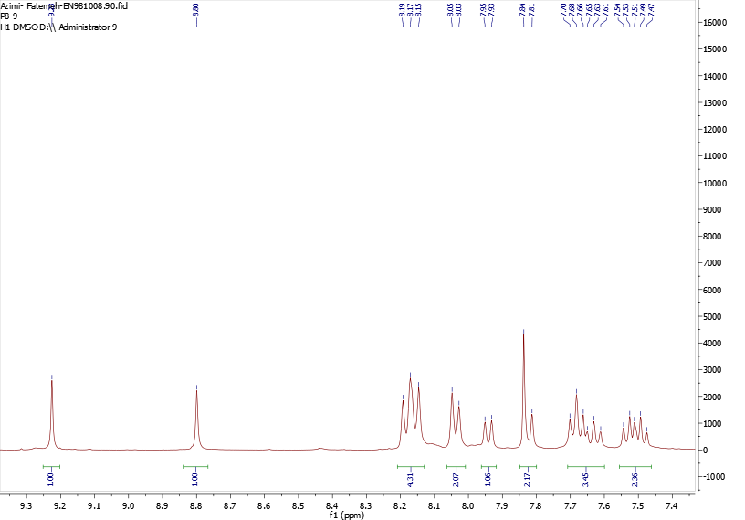
Fig. S17. ³H NMR spectra of N'-((1-Phenyl-3-(4-(trifluoromethyl)phenyl)-1H-pyrazol-4-yl)methylene)benzofuran-2-carbohydrazide (8i)
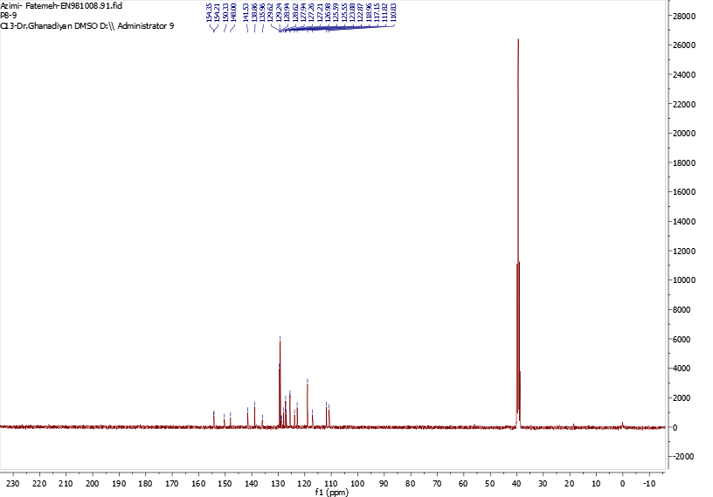
Fig. S18. ¹³C NMR spectra of N'-((1-Phenyl-3-(4-(trifluoromethyl)phenyl)-1H-pyrazol-4-yl)methylene)benzofuran-2-carbohydrazide (8i)

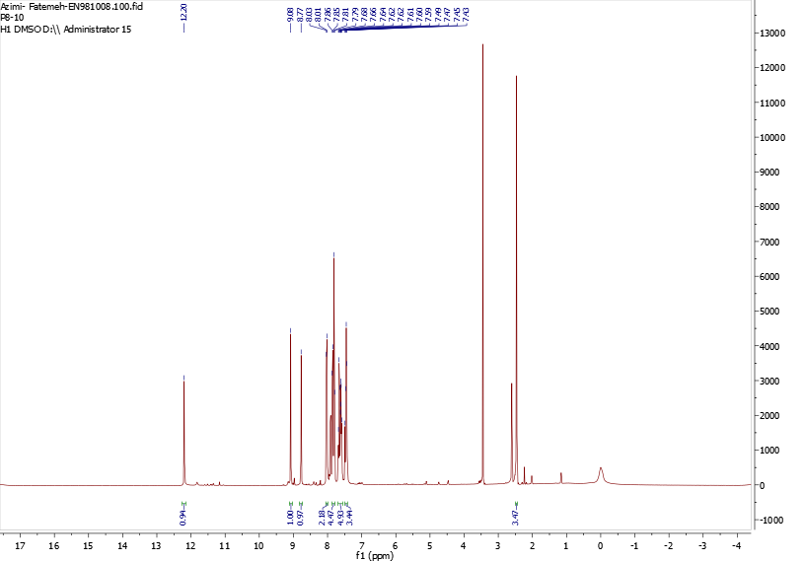
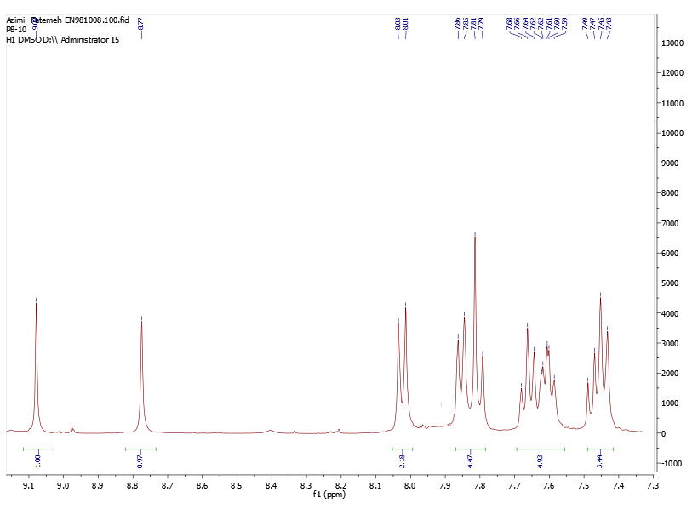
Fig. S19. ¹H NMR spectra of N'-((3-Phenyl-1-p-tolyl-1H-pyrazol-4-yl)methylene)benzofuran-2-carbohydrazide (8j)
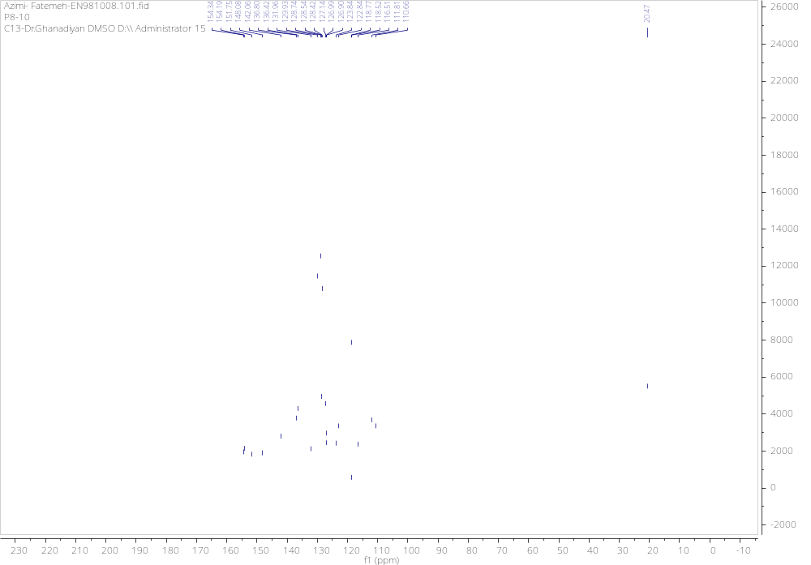 Fig. S20. ¹³C NMR spectra of N'-((3-Phenyl-1-p-tolyl-1H-pyrazol-4-yl)methylene)benzofuran-2-carbohydrazide (8j)

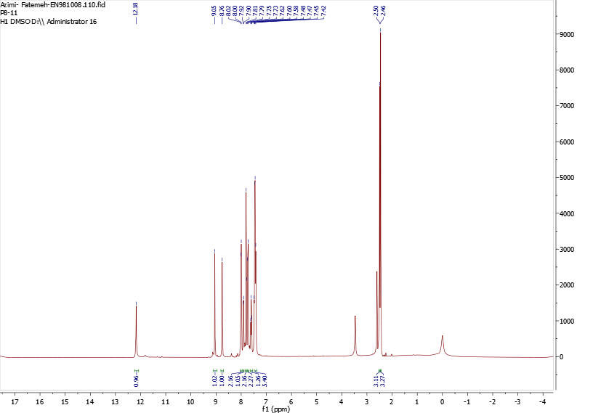
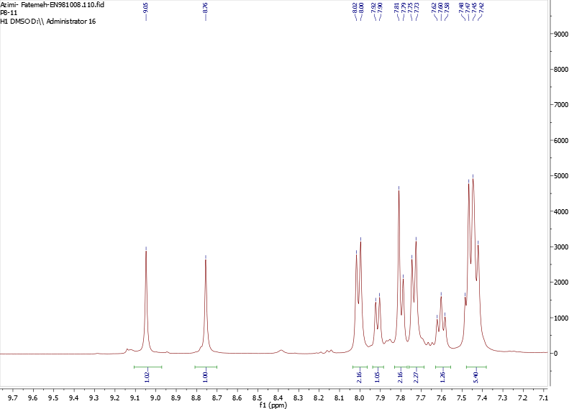
Fig. S21. ¹H NMR spectra of N'-((1,3-Dip-tolyl-1H-pyrazol-4-yl)methylene)benzofuran-2-carbohydrazide (8k)
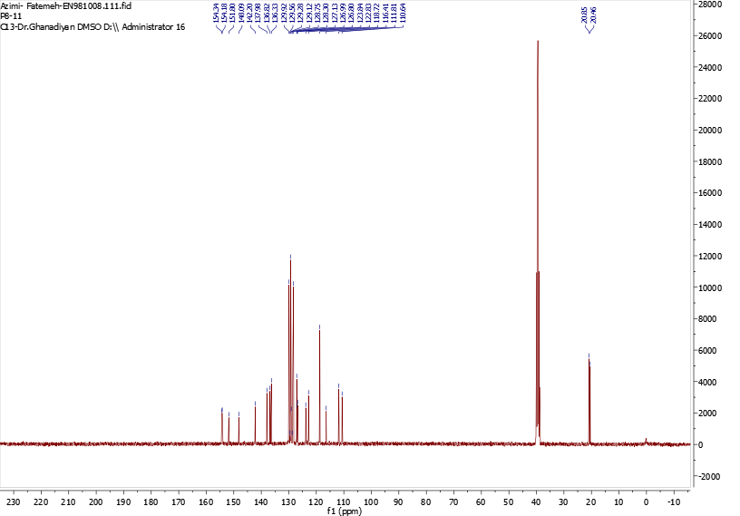
Fig. S22. ¹³C NMR spectra of N'-((1,3-Dip-tolyl-1H-pyrazol-4-yl)methylene)benzofuran-2-carbohydrazide (8k)

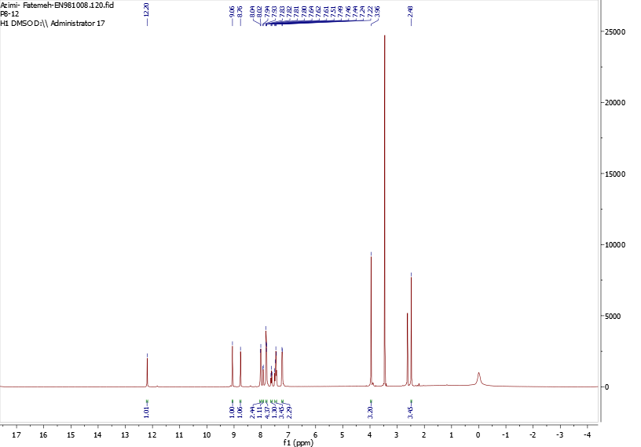
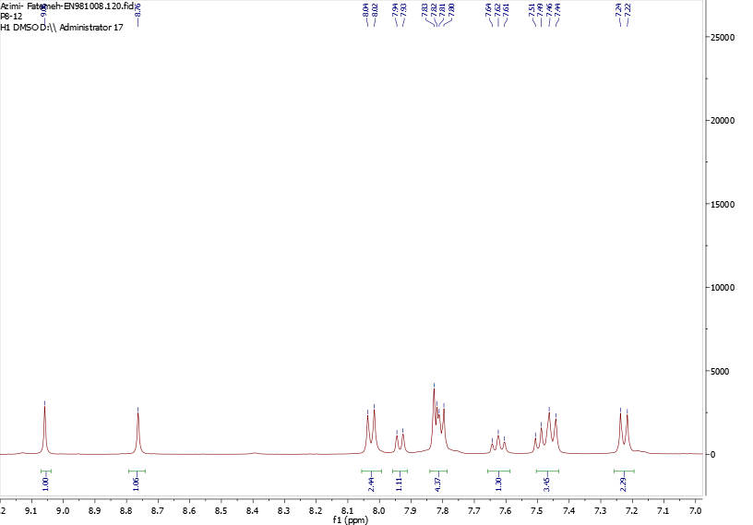
Fig. S23. ¹H NMR spectra of N'-((3-(4-Methoxyphenyl)-1-p-tolyl-1H-pyrazol-4-yl)methylene)benzofuran-2-carbohydrazide (8l)
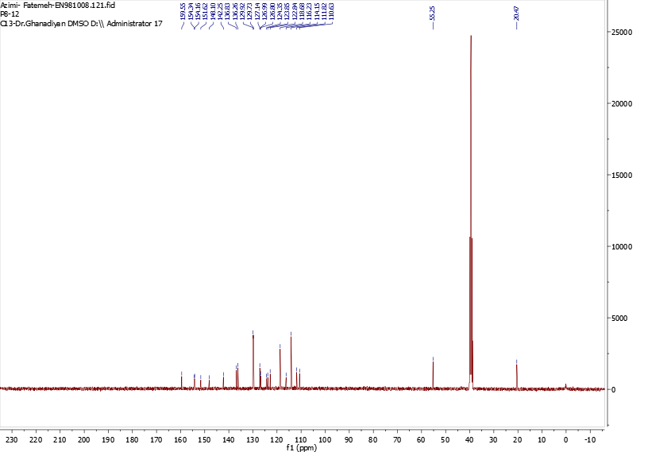
Fig. S24. ¹³C NMR spectra of N'-((3-(4-Methoxyphenyl)-1-p-tolyl-1H-pyrazol-4-yl)methylene)benzofuran-2-carbohydrazide (8l)

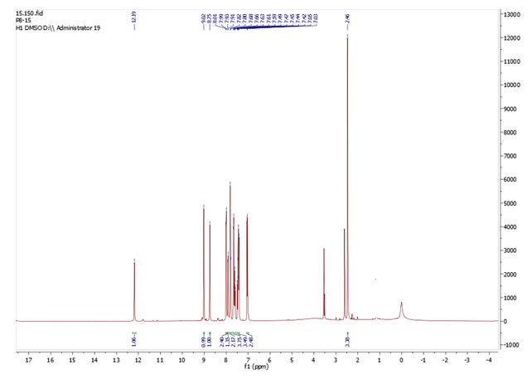
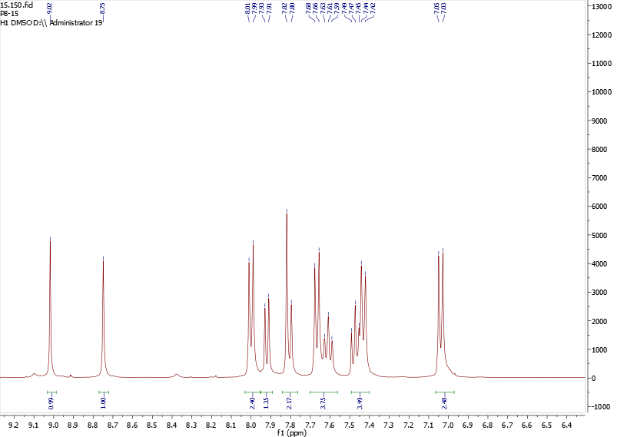
Fig. S25. ¹H NMR spectra of N'-((3-(4-Hydroxyphenyl)-1-p-tolyl-1H-pyrazol-4-yl)methylene)benzofuran-2-carbohydrazide (8m)
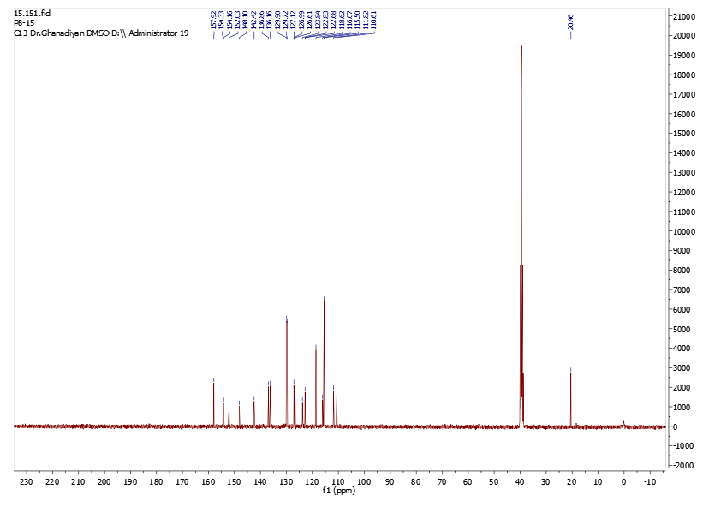
Fig. S26. ¹³C NMR spectra of N'-((3-(4-Hydroxyphenyl)-1-p-tolyl-1H-pyrazol-4-yl)methylene)benzofuran-2-carbohydrazide (8m)

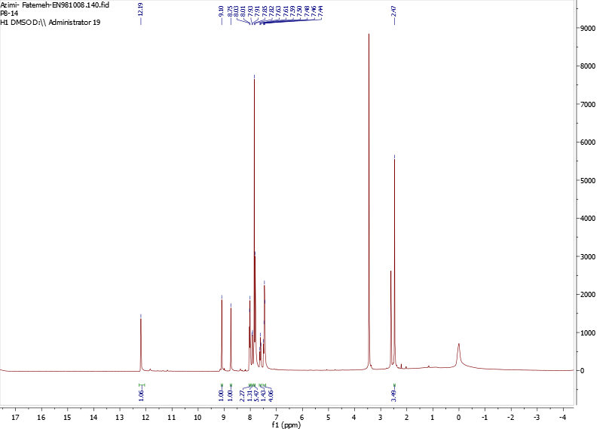
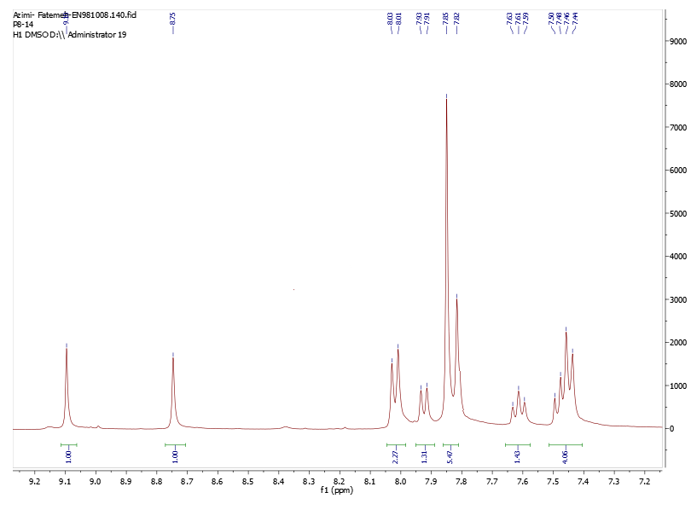
Fig. S27. ¹H NMR spectra of N'-((3-(4-Bromophenyl)-1-p-tolyl-1H-pyrazol-4-yl)methylene)benzofuran-2-carbohydrazide (8n)
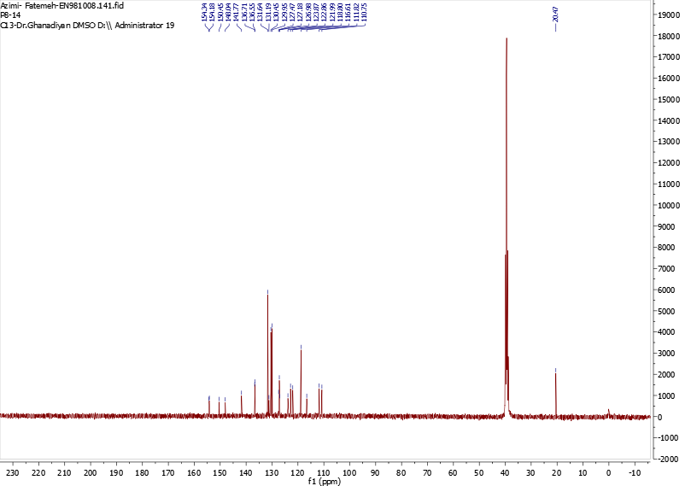
Fig. S28. ¹³C NMR spectra of N'-((3-(4-Bromophenyl)-1-p-tolyl-1H-pyrazol-4-yl)methylene)benzofuran-2-carbohydrazide (8n)

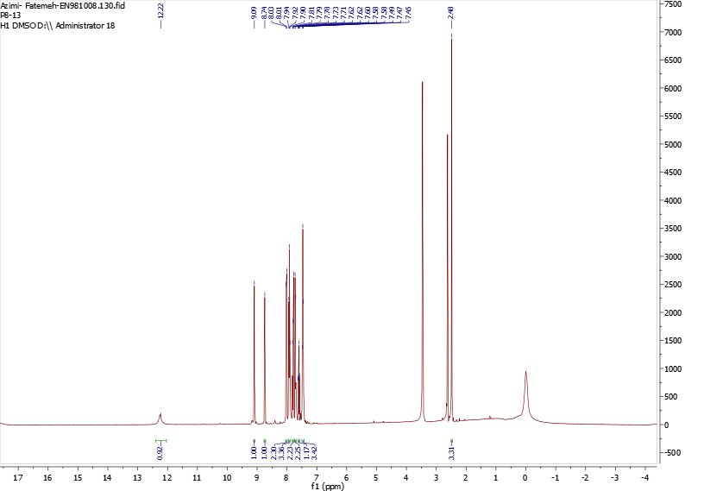
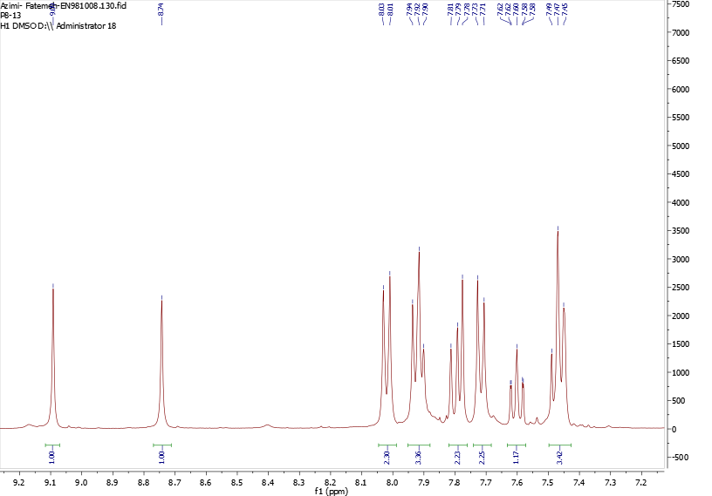
Fig. S29. ¹H NMR spectra of N'-((3-(4-Chlorophenyl)-1-p-tolyl-1H-pyrazol-4-yl)methylene)benzofuran-2-carbohydrazide (8o)
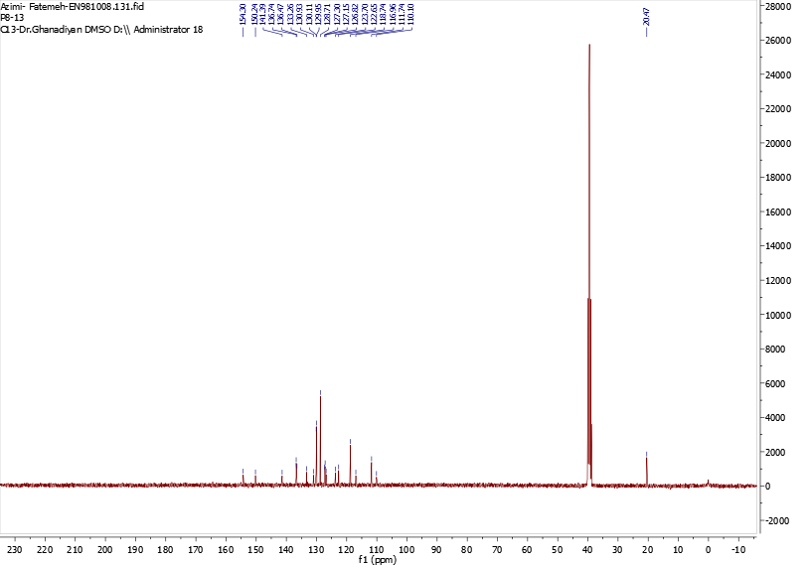
Fig. S30. ¹³C NMR spectra of N'-((3-(4-Chlorophenyl)-1-p-tolyl-1H-pyrazol-4-yl)methylene)benzofuran-2-carbohydrazide (8o)

* Corresponding authors. E-mail addresses: hassanzadeh@pharm.mui.ac.ir (F. Hassanzadeh), momahdavi@tums.ac.ir (M. Mahdavi)

