Biodiversity and Conservation

Where the toad crosses the road: Multi-method modelling of Texas herpetofauna roadkill for conservation planning

Supplement

Kristina Chyn (kristina.chyn@gmail.com)
James L. Tracy (james.tracy@ag.tamu.edu)
Wendy Wright (wendy.wright@tamu.edu)
Lee A. Fitzgerald (lee.fitzgerald@ag.tamu.edu)
Robert Coulson (robert.coulson@ag.tamu.edu)

Figures

Fig. S1 Texas Horned Lizard habitat kernel density estimate (KDE) surface (bottom left legend for KDE) from all iNaturalist occurrences (non-roadkill) in Texas down weighted by human population density through histogram bin ratio weighting method (PopDenHBRWt) to reduce sample bias (points with top right legend showing PopDenHBRWt) (yellow boundary is background evaluation extent, BEE, for the lizard). The KDE surface is masked to the Texas Open Street Map road network of included road classes in the BEE for use as a habitat index in the MaxEnt modeling.

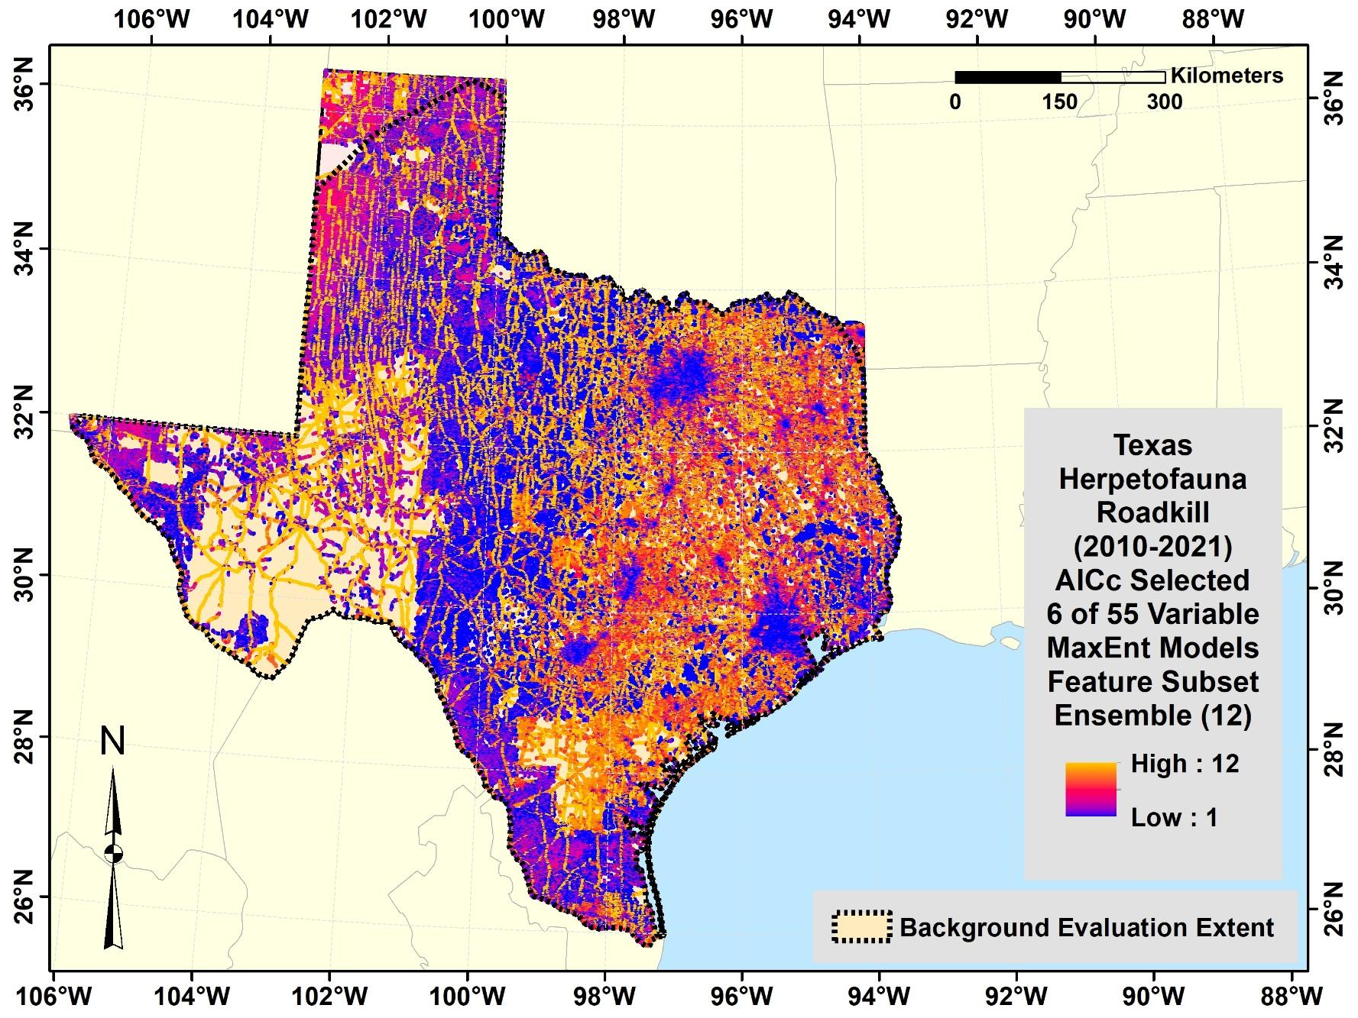

Fig. S2 Texas herpetofauna roadkill represented by MaxEnt feature subset ensemble of 12 models developed from subsets of six of 55 variables by cross validated random subset feature selection for low AICc.

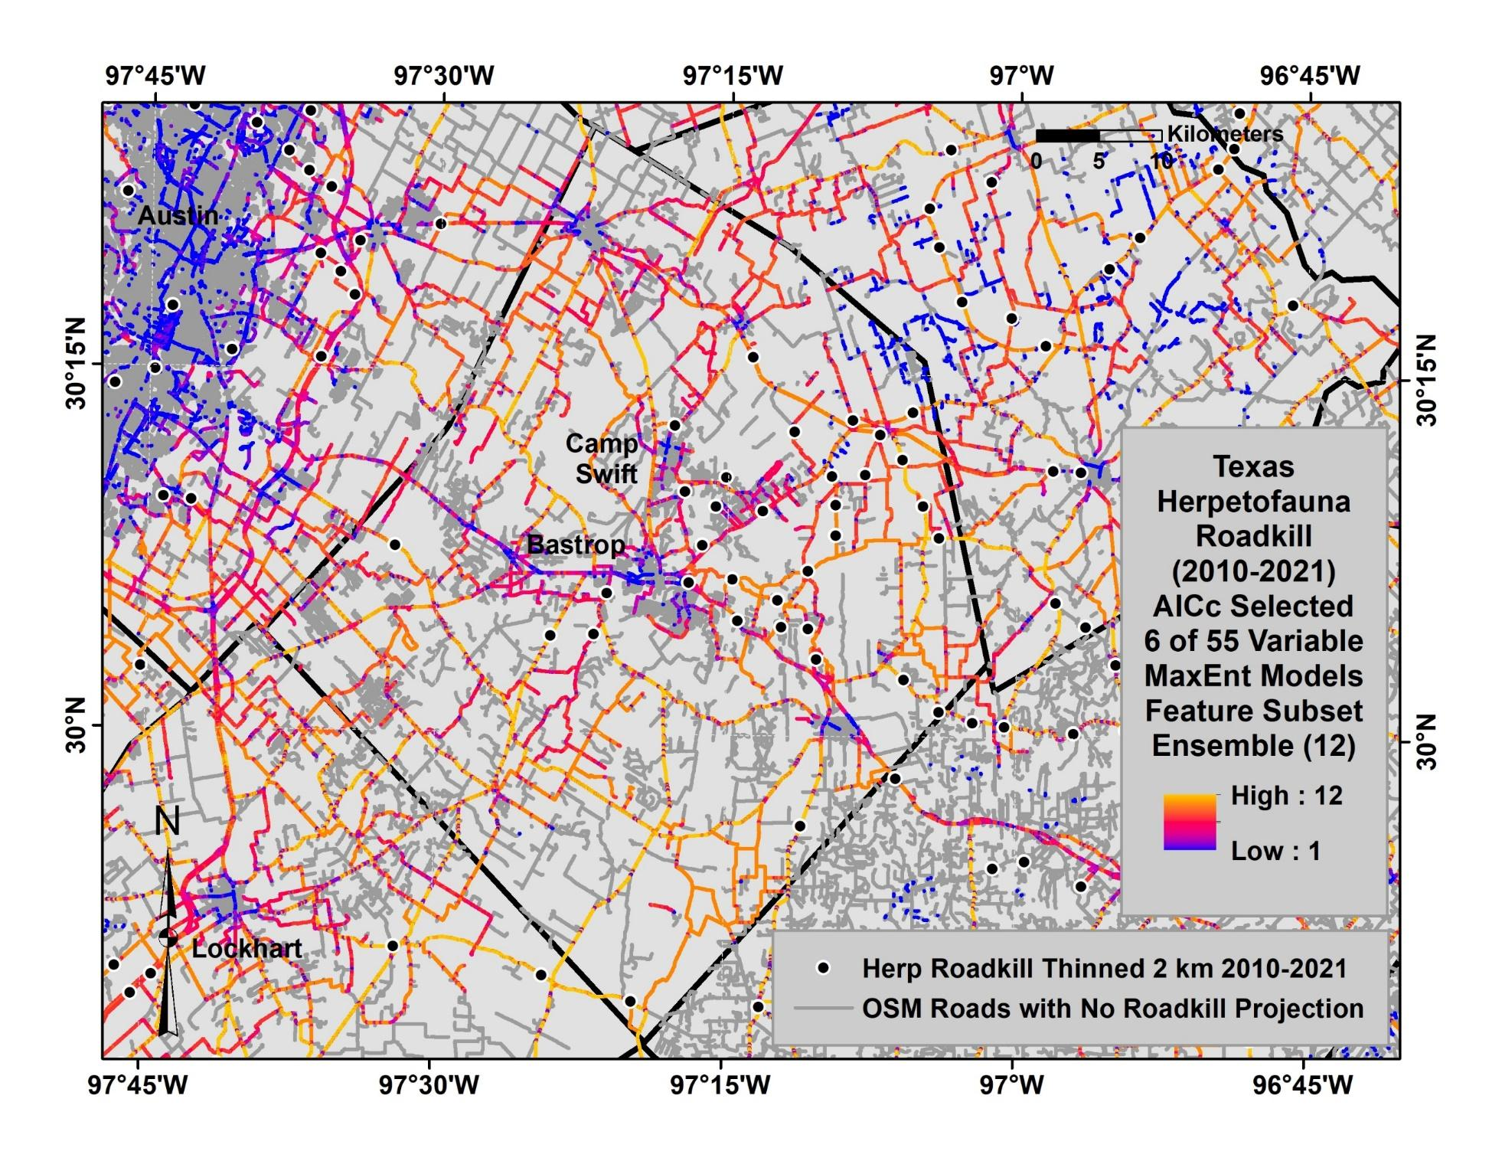
Fig. S3 Texas herpetofauna roadkill in Bastrop County represented by MaxEnt feature subset ensemble of 12 models developed from subsets of six of 55 variables (from Fig. S2).

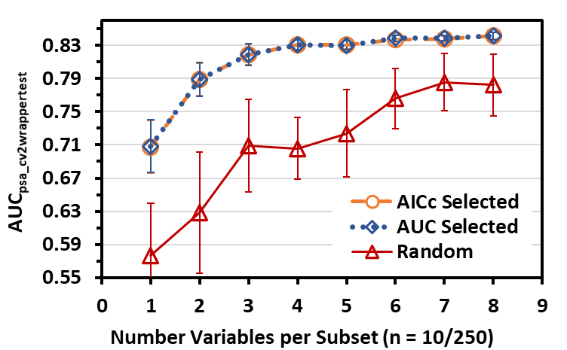
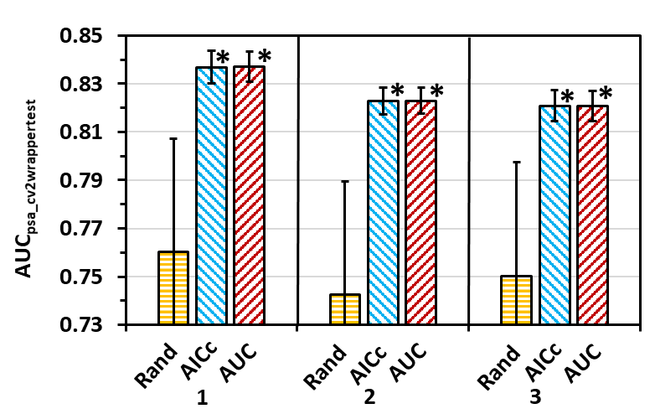
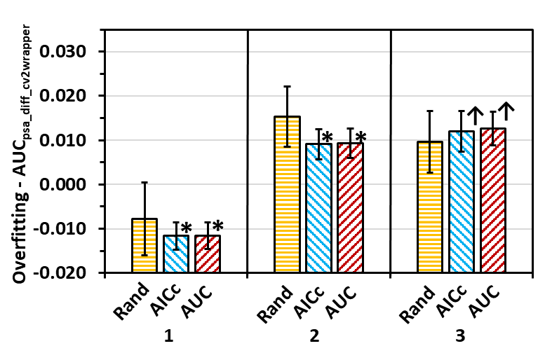
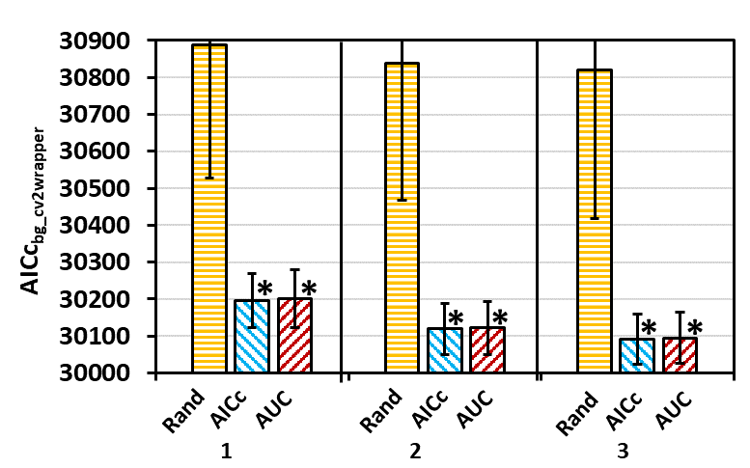
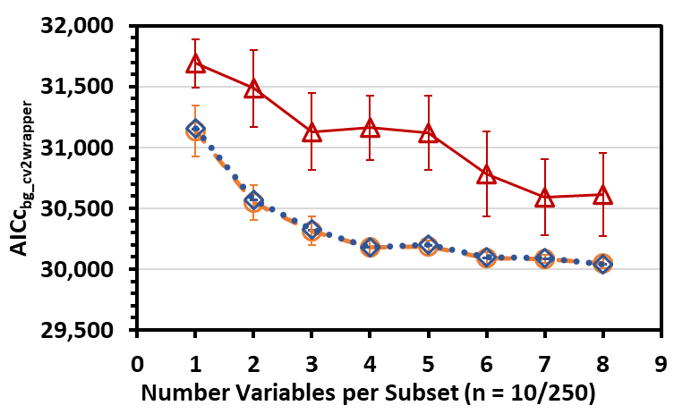
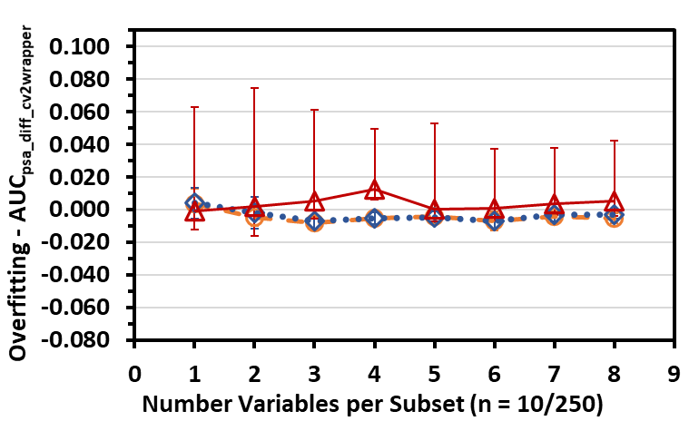

A

A
D

D
B

B
C

C
E

E
F

F
MaxEnt Models

MaxEnt Models
MaxEnt Models

MaxEnt Models
Fig. S4 Texas herpetofauna roadkill MaxEnt model evaluation statistics (mean ± SD) of AUC_{psa_finaltest} (A,D), AICc_{bg_final} (B,E), and AUC_{psa_diff_final} (overfitting; C,F) for models developed from (A-C) top ten variable subsets selected by AUC_{psa} or AICc using random subset feature selection (RSFSA) and ten random subsets out of 250 randomly generated subsets of various sizes derived from 55 variables; and (D-F) top 250 six-variable subsets out of 3,000 subsets per three training set replicates selected by AUC_{psa} or AICc using RSFSA and top 250 random generated six-variable subsets out of 3,000 subsets derived from 55 variables. Means for AUC_{psa} selected or AICc selected model statistics within a replicate with an asterisk are significantly more optimal (higher for AUC_{psa_finaltest} and lower for AICc_{bg_final} and AUC_{psa_diff_final}) and means with an arrow significantly less optimal than mean of random selected models (P < 0.05; Welch t test with Holm correction, preceded by significant Welch ANOVA test, P < 0.05).

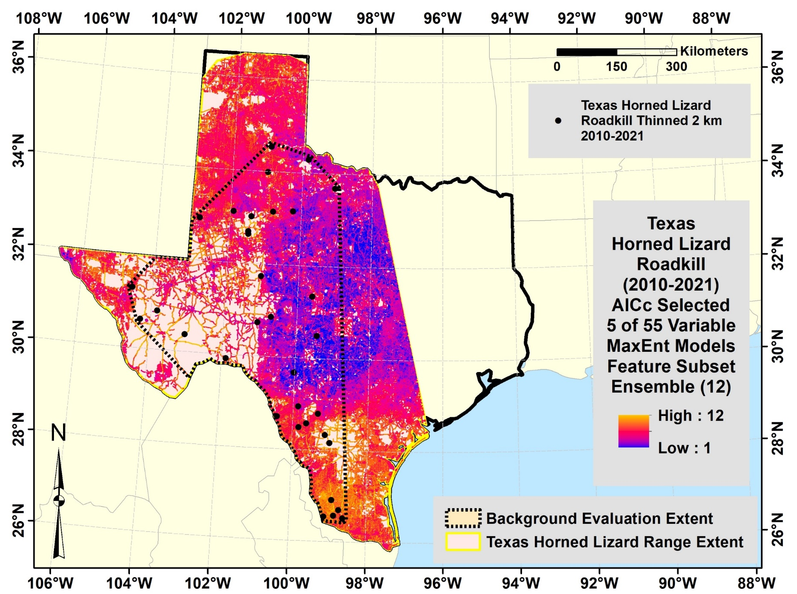
Fig. S5 Texas Horned Lizard roadkill represented by MaxEnt feature subset ensemble of 12 models developed from subsets of five of 55 variables by cross validated random subset feature selection for low AICc.

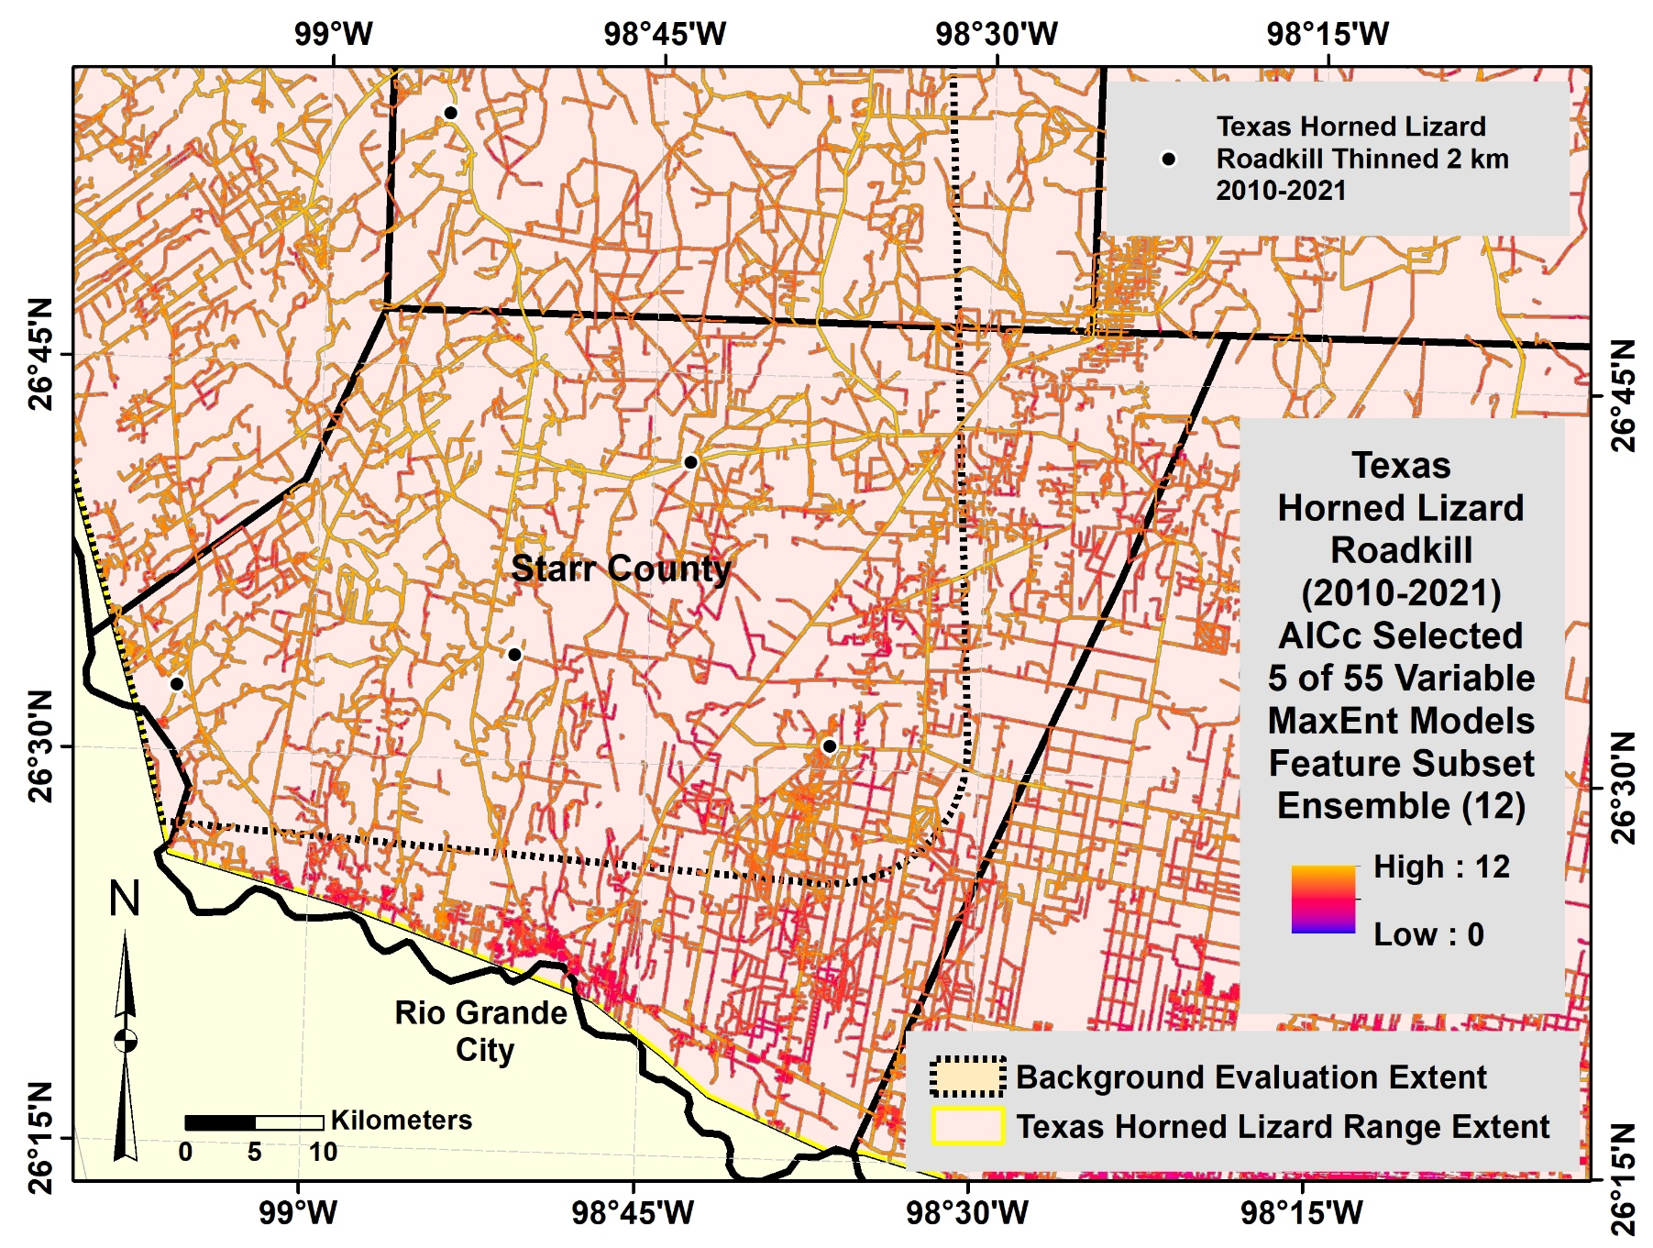

Fig. S6 Texas Horned Lizard roadkill in Starr County represented by MaxEnt feature subset ensemble of 12 models developed from subsets of five of 55 variables (from Fig. S7).

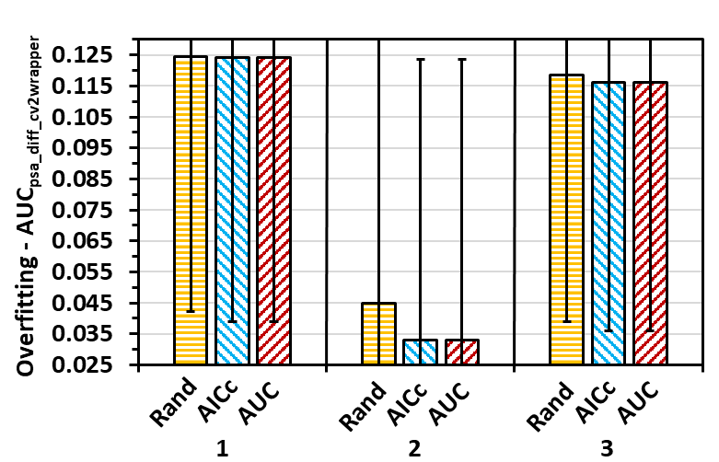
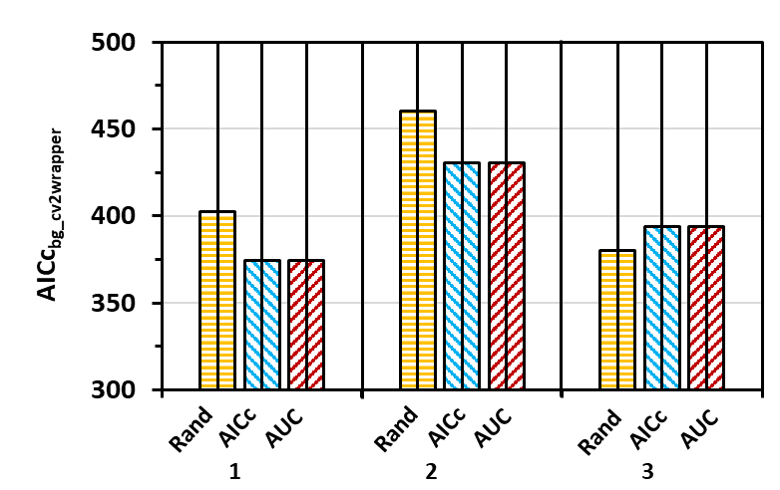
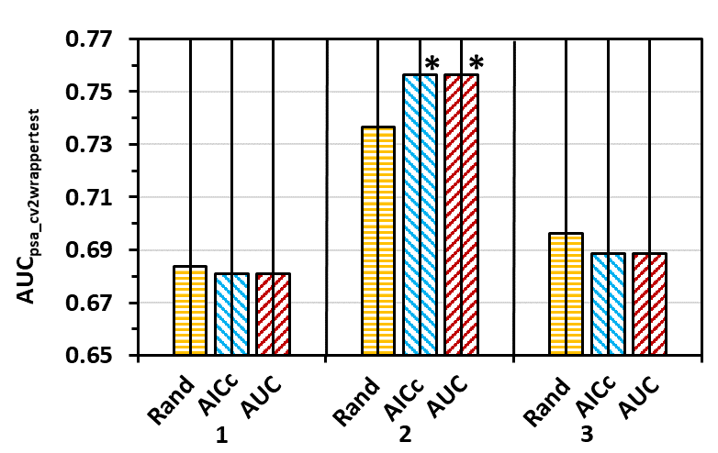
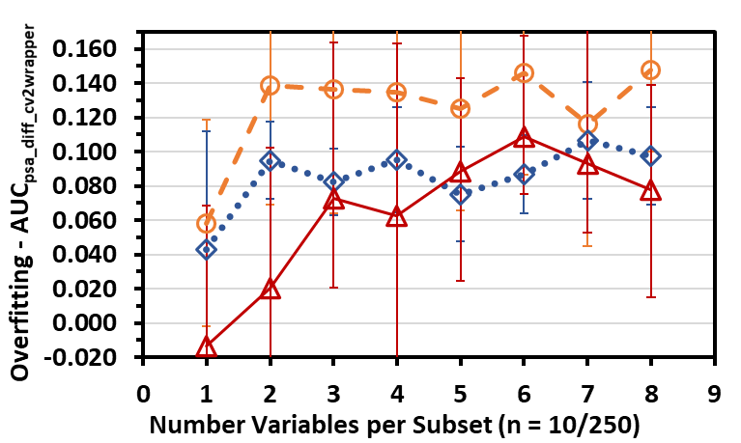
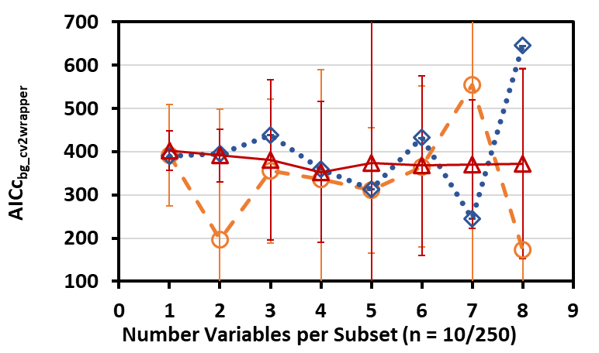
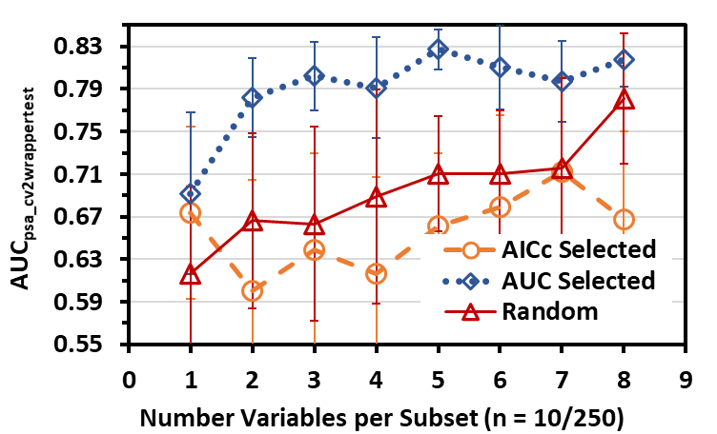

A

A
D

D
B

B
C

C
E

E
F

F
MaxEnt Models

MaxEnt Models
MaxEnt Models

MaxEnt Models
Fig. S7 Texas Horned Lizard roadkill MaxEnt model evaluation statistics (mean ± SD) of AUC_{psa_finaltest} (A,D), AICc_{bg_final} (B,E), and AUC_{psa_diff_final} (overfitting; C,F) for models developed from (A-C) top ten variable subsets selected by AUC_{psa} or AICc using random subset feature selection (RSFSA) and ten random subsets out of 250 randomly generated subsets of various sizes derived from 55 variables; and (D-F) top 250 six-variable subsets out of 3,000 subsets per three training set replicates selected by AUC_{psa} or AICc using RSFSA and top 250 random generated six-variable subsets out of 3,000 subsets derived from 55 variables. Means for AUC_{psa} selected or AICc selected model statistics within a replicate with an asterisk are significantly more optimal (higher for AUC_{psa_finaltest} and lower for AICc_{bg_final} and AUC_{psa_diff_final}) and means with an arrow significantly less optimal than mean of random selected models (P < 0.05; Welch t test with Holm correction, preceded by significant Welch ANOVA test, P < 0.05).

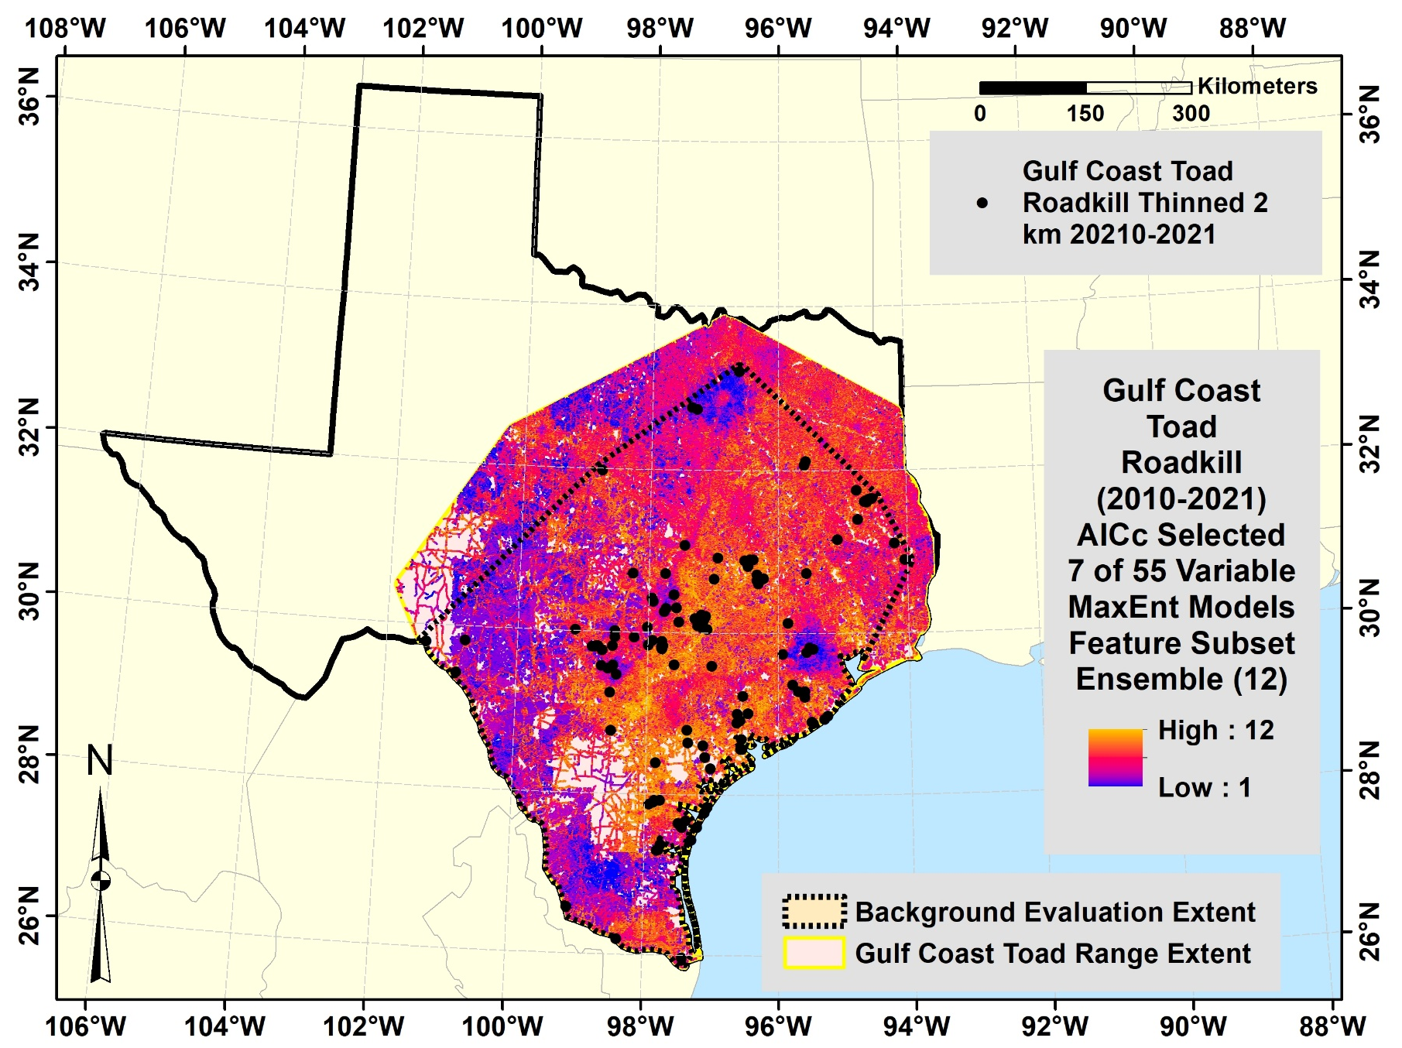

Fig. S8 Gulf Coast Toad roadkill represented by MaxEnt feature subset ensemble of 12 models developed from subsets of five of 55 variables by cross validated random subset feature selection for low AICc.

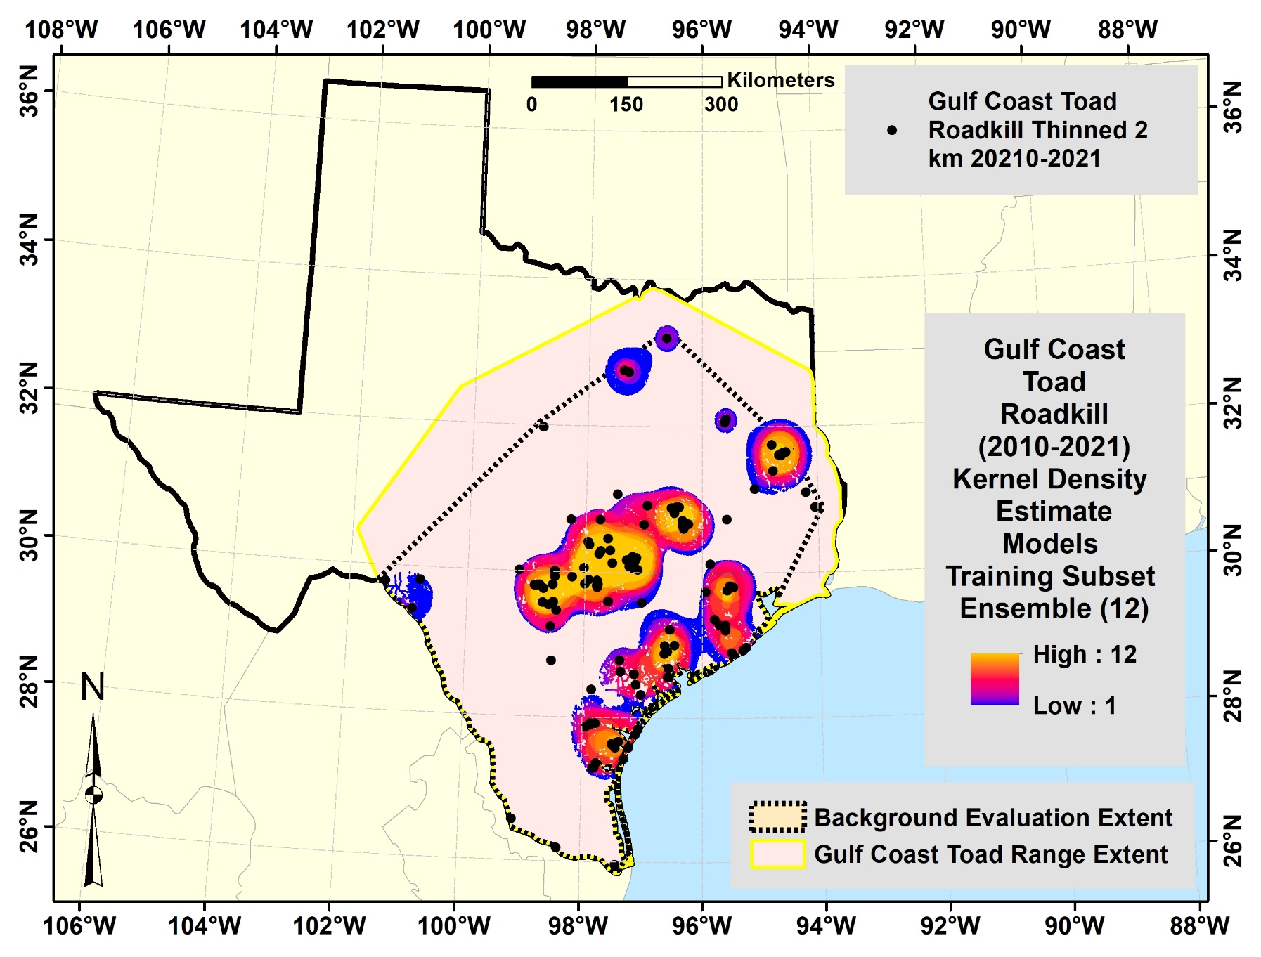

Fig. S9 Gulf Coast Toad roadkill represented by KDE model cross validated training subset ensemble of 12 models.

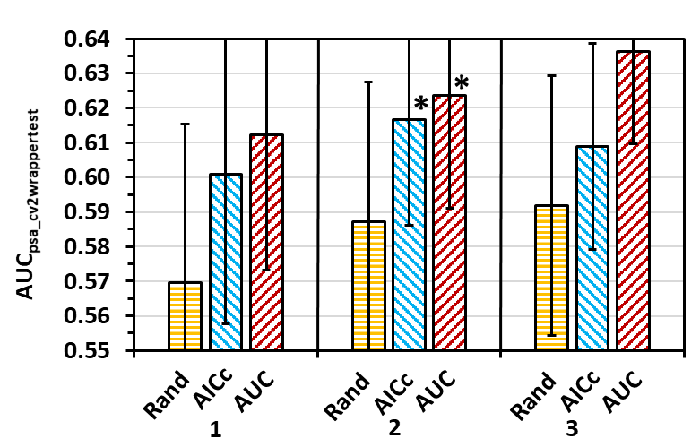
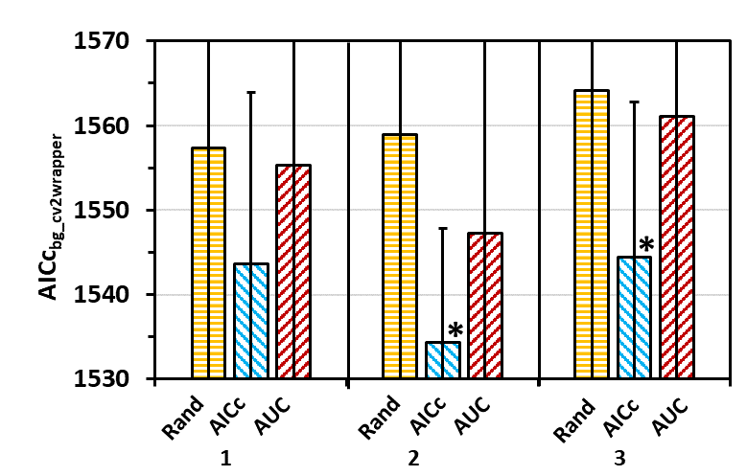
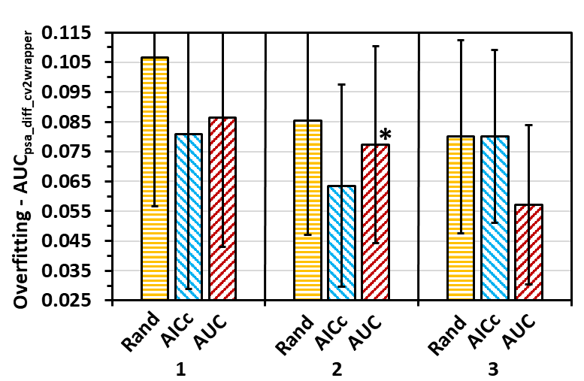
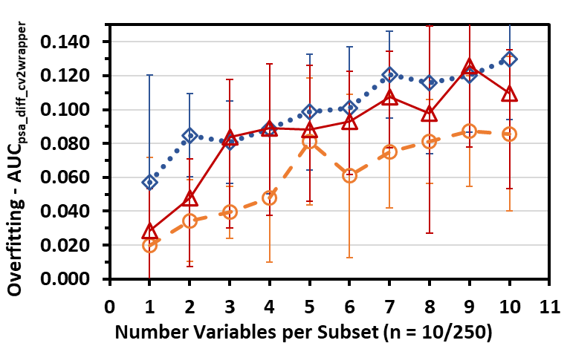
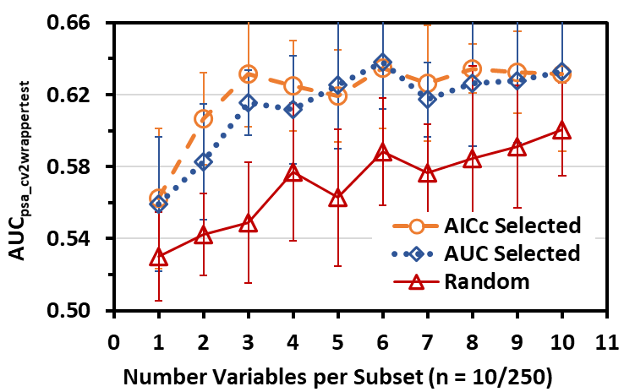
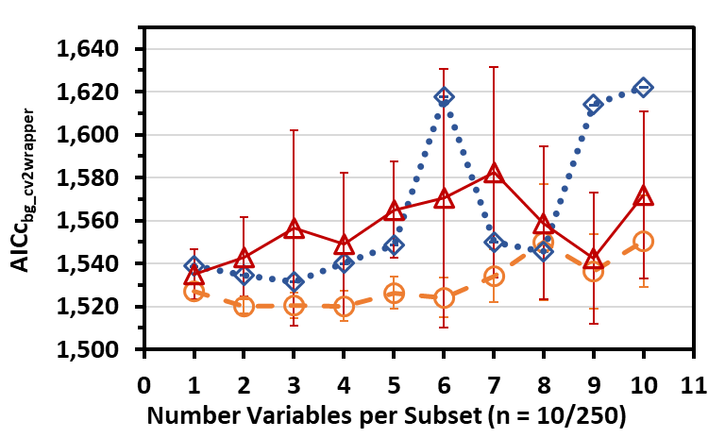

Fig. S10 Gulf Coast Toad roadkill MaxEnt model evaluation statistics (mean ± SD) of AUC_{psa_finaltest} (A,D), AICc_{bg_final} (B,E), and AUC_{psa_diff_final} (overfitting; C,F) for models developed from (A-C) top ten variable subsets selected by AUC_{psa} or AICc using random subset feature selection (RSFSA) and ten random subsets out of 250 randomly generated subsets of various sizes derived from 55 variables; and (D-F) top 250 seven-variable subsets out of 3,000 subsets per three training set replicates selected by AUC_{psa} or AICc using RSFSA and top 250 random generated seven-variable subsets out of 3,000 subsets derived from 55 variables. Means for AUC_{psa} selected or AICc selected model statistics within a replicate with an asterisk are significantly more optimal (higher for AUC_{psa_finaltest} and lower for AICc_{bg_final} and AUC_{psa_diff_final}) and means with an arrow significantly less optimal than mean of random selected models (P < 0.05; Welch t test with Holm correction, preceded by significant Welch ANOVA test, P < 0.05).
A

A
D

D
B

B
C

C
E

E
F

F
MaxEnt Models

MaxEnt Models
MaxEnt Models

MaxEnt Models

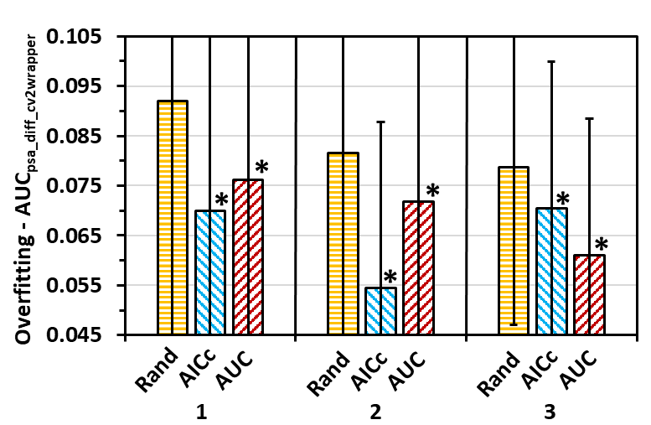
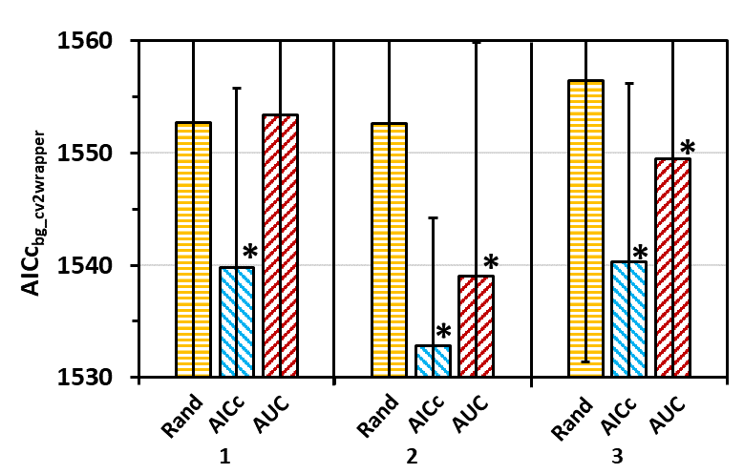
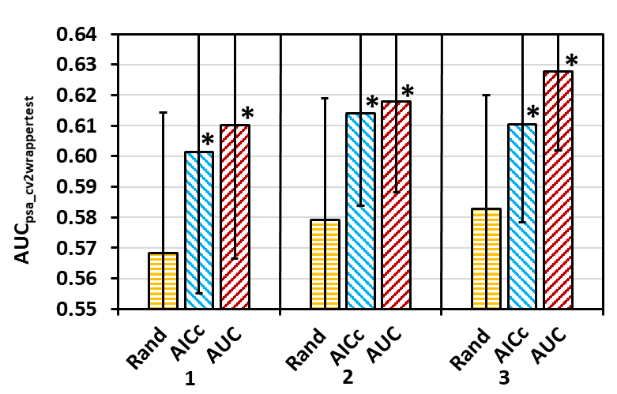

Fig. S11 Gulf Coast Toad roadkill MaxEnt model evaluation statistics (mean ± SD) of AUC_{psa_finaltest} (A,D), AICc_{bg_final} (B,E), and AUC_{psa_diff_final} (overfitting; C,F) for models developed from top 250 six-variable subsets out of 3,000 subsets per three training set replicates selected by AUC_{psa} or AICc using RSFSA and top 250 random generated six-variable subsets out of 3,000 subsets derived from 55 variables. Means for AUC_{psa} selected or AICc selected model statistics within a replicate with an asterisk are significantly more optimal (higher for AUC_{psa_finaltest} and lower for AICc_{bg_final} and AUC_{psa_diff_final}) and means with an arrow significantly less optimal than mean of random selected models (P < 0.05; Welch t test with Holm correction, preceded by significant Welch ANOVA test, P < 0.05).
A

A
B

B
C

C
MaxEnt Models

MaxEnt Models

Tables

Table S1 Texas herpetofauna roadkill MaxEnt model variable correlation groupings and importance rankings (high to low) for 55 variables in top 250 of 3,000 six-variable models (N = 3 maximum replicates) that were selected by the random subset feature selection algorithmª
Variable | Variable Cor-relation Group | Mean Rank by Permutation Importance and Frequency in Models | Mean Permutation Importance | Frequency in Models | N
residdist | 1 | 1.00 ± 0.00 | 66.11 ± 0.16 | 236.00 ± 4.58 | 3
roadden3kmr | 2 | 2.00 ± 0.00 | 31.89 ± 0.67 | 32.33 ± 6.66 | 3
devmd_500mr | 2 | 5.00 ± 1.00 | 20.71 ± 1.37 | 28.67 ± 2.89 | 3
mnpopden3kr | 2 | 5.33 ± 2.08 | 27.32 ± 0.91 | 22.67 ± 3.51 | 3
hiurbdist | 2 | 7.00 ± 3.46 | 19.02 ± 1.13 | 26.33 ± 3.06 | 3
roadden500mr | 2 | 7.00 ± 3.00 | 22.06 ± 3.78 | 24.67 ± 3.21 | 3
mnpopden9kr | 2 | 7.67 ± 4.16 | 22.58 ± 1.88 | 23.33 ± 3.21 | 3
devlo_500mr | 2 | 10.67 ± 3.79 | 18.66 ± 1.73 | 20.67 ± 4.51 | 3
popden | 2 | 11.00 ± 3.46 | 23.42 ± 1.31 | 18.67 ± 3.51 | 3
devhi_500mr | 2 | 12.67 ± 1.53 | 18.03 ± 1.19 | 16.33 ± 4.73 | 3
primarydist | 3 | 5.33 ± 3.21 | 14.83 ± 2.39 | 47.67 ± 6.51 | 3
seconddist | 4 | 8.00 ± 2.00 | 12.43 ± 0.58 | 48.67 ± 11.59 | 3
devop_500mr | 5 | 12.00 ± 3.46 | 12.75 ± 0.22 | 31.67 ± 5.69 | 3
prec_tann | 6 | 12.00 ± 0.00 | 12.97 ± 0.95 | 34.00 ± 4.36 | 3
srad_ann | 6 | 13.33 ± 2.89 | 11.27 ± 0.75 | 32.00 ± 8.54 | 3
shrscr_500mr | 7 | 17.67 ± 1.15 | 6.28 ± 0.84 | 30.33 ± 2.52 | 3
seadist | 8 | 18.33 ± 0.58 | 5.76 ± 0.71 | 30.00 ± 2.00 | 3
elev | 8 | 20.00 ± 4.00 | 5.87 ± 1.01 | 25.00 ± 7.00 | 3
latitude | 8 | 22.33 ± 0.58 | 4.84 ± 0.82 | 21.33 ± 0.58 | 3
tmin_ann | 8 | 22.67 ± 2.89 | 5.14 ± 0.40 | 20.33 ± 4.51 | 3
temp_ann | 8 | 24.33 ± 0.58 | 4.79 ± 0.85 | 17.67 ± 3.51 | 3
vapr_ann | 8 | 25.33 ± 7.64 | 5.13 ± 0.54 | 18.33 ± 13.65 | 3
unclassdist | 9 | 18.33 ± 2.52 | 5.26 ± 0.79 | 36.00 ± 6.08 | 3
tertiarydist | 10 | 18.67 ± 2.31 | 6.68 ± 1.61 | 25.00 ± 3.61 | 3
hwydist | 11 | 23.00 ± 4.00 | 3.21 ± 1.09 | 29.33 ± 4.62 | 3
evrfor_500mr | 12 | 24.00 ± 2.65 | 2.86 ± 0.74 | 29.00 ± 2.00 | 3
herptxkde | 13 | 25.33 ± 0.58 | 2.64 ± 0.65 | 26.33 ± 2.52 | 3
wind_ann | 14 | 28.67 ± 3.06 | 2.80 ± 0.62 | 19.67 ± 3.21 | 3
tmax_ann | 15 | 29.00 ± 0.00 | 2.62 ± 0.46 | 19.00 ± 2.00 | 3
emrhrb_500mr | 16 | 29.33 ± 2.31 | 1.94 ± 0.36 | 24.33 ± 4.04 | 3
opnwatdist | 17 | 31.00 ± 0.00 | 2.01 ± 0.12 | 20.00 ± 2.65 | 3
opnwat_500mr | 17 | 34.33 ± 3.79 | 1.05 ± 0.23 | 25.00 ± 5.57 | 3
mnslope150mr | 18 | 33.67 ± 0.58 | 1.23 ± 0.09 | 19.67 ± 4.04 | 3
mncti500mr | 18 | 36.33 ± 3.06 | 0.83 ± 0.19 | 21.00 ± 5.29 | 3
mnslope50mr | 18 | 37.33 ± 2.08 | 0.67 ± 0.08 | 22.00 ± 4.36 | 3
culcrp_500mr | 19 | 35.00 ± 4.58 | 1.34 ± 0.46 | 18.67 ± 5.51 | 3
pashay_500mr | 20 | 35.33 ± 0.58 | 1.11 ± 0.12 | 19.00 ± 1.00 | 3
decfor_500mr | 21 | 36.00 ± 5.29 | 1.05 ± 0.66 | 19.00 ± 3.00 | 3
mncti3kr | 22 | 36.67 ± 5.51 | 1.16 ± 0.25 | 20.00 ± 6.56 | 3
mixfor_500mr | 23 | 40.33 ± 2.08 | 0.74 ± 0.32 | 14.33 ± 3.51 | 3
tpi300mr | 24 | 40.33 ± 3.51 | 0.68 ± 0.11 | 15.67 ± 5.51 | 3
tpi90mr | 24 | 43.67 ± 2.52 | 0.26 ± 0.10 | 21.00 ± 2.65 | 3
diss90mr | 24 | 48.33 ± 3.21 | 0.13 ± 0.06 | 19.67 ± 7.77 | 3
grassl_500mr | 25 | 41.67 ± 2.08 | 0.40 ± 0.20 | 20.67 ± 2.08 | 3
curve | 26 | 45.00 ± 3.00 | 0.23 ± 0.08 | 21.67 ± 3.79 | 3
tpi30mr | 26 | 50.33 ± 4.62 | 0.19 ± 0.15 | 14.33 ± 1.53 | 3
cti | 27 | 45.67 ± 4.04 | 0.27 ± 0.06 | 15.67 ± 3.79 | 3
slope | 28 | 46.67 ± 3.21 | 0.27 ± 0.14 | 14.33 ± 0.58 | 3
mnfloac3kmr | 29 | 47.67 ± 2.08 | 0.23 ± 0.06 | 12.67 ± 5.13 | 3
mnfloac500mr | 29 | 53.00 ± 1.73 | 0.16 ± 0.09 | 9.33 ± 2.52 | 3
sei | 30 | 48.33 ± 1.53 | 0.13 ± 0.01 | 20.00 ± 3.46 | 3
scai | 30 | 53.00 ± 1.00 | 0.07 ± 0.03 | 15.33 ± 6.81 | 3
wdywet_500mr | 31 | 48.33 ± 4.62 | 0.19 ± 0.06 | 17.67 ± 3.21 | 3
err30mr | 32 | 50.00 ± 1.73 | 0.11 ± 0.04 | 16.67 ± 4.04 | 3
aspect | 33 | 55.00 ± 0.00 | 0.01 ± 0.01 | 3.00 ± 2.65 | 3
ªFor variable abbreviations, see Table 1. Correlation groupings by top ranking variables within groups correlated at |0.7| or higher, with variables in multiple groups placed in the group where they have the closest ranking below a top ranked group member. Variables ranked using multi multi-objective optimization ranking with MCDM R package by joint criteria of mean permutation importance (0.6 weight) and number appearances in top 250 models (0.4 weight). Shaded variables are top 15 variables according to sequenced ranking across groups, N = number of replicates in which variable appears in top selected 250 models (3 total replicates).

Table S2 Texas Horned Lizard roadkill MaxEnt model variable correlation groupings and importance rankings (high to low) for 55 variables in top 250 of 3,000 six-variable models (N = 3 maximum replicates) that were selected by the random subset feature selection algorithmª
Variable | Variable Correlation Group | Mean Rank by Permutation Importance and Frequency in Models | Mean Permutation Importance | Frequency in Models | N
residdist | 1 | 1.00 ± 0.00 | 81.76 ± 5.97 | 21.33 ± 7.02 | 3
seconddist | 2 | 3.00 ± 1.00 | 51.73 ± 3.55 | 28.67 ± 5.13 | 3
pcortxkde | 3 | 3.33 ± 1.53 | 55.61 ± 2.41 | 26.33 ± 4.16 | 3
roadden3kmr | 4 | 4.33 ± 1.53 | 50.39 ± 2.70 | 23.33 ± 2.52 | 3
prec_tann | 5 | 4.67 ± 2.31 | 50.42 ± 5.42 | 25.33 ± 2.89 | 3
grassl_500mr | 6 | 7.00 ± 2.65 | 36.84 ± 4.84 | 30.67 ± 3.51 | 3
mnpopden9kr | 7 | 7.33 ± 2.52 | 45.82 ± 9.57 | 22.33 ± 3.79 | 3
popden | 7 | 11.00 ± 0.00 | 36.58 ± 4.88 | 24.33 ± 2.52 | 3
mnpopden3kr | 7 | 18.00 ± 7.55 | 33.10 ± 11.17 | 19.33 ± 2.08 | 3
hiurbdist | 7 | 28.00 ± 8.19 | 16.14 ± 6.40 | 21.00 ± 3.00 | 3
tertiarydist | 8 | 9.67 ± 4.04 | 35.86 ± 10.46 | 27.67 ± 4.16 | 3
devlo_500mr | 9 | 13.67 ± 4.73 | 32.51 ± 7.76 | 22.67 ± 1.15 | 3
devop_500mr | 9 | 14.00 ± 1.00 | 33.71 ± 5.32 | 23.67 ± 4.04 | 3
devmd_500mr | 9 | 22.00 ± 4.58 | 20.54 ± 4.30 | 22.00 ± 2.65 | 3
vapr_ann | 10 | 13.67 ± 6.11 | 44.87 ± 13.55 | 15.33 ± 3.21 | 3
tmin_ann | 10 | 15.00 ± 6.24 | 37.45 ± 9.65 | 18.67 ± 1.53 | 3
seadist | 10 | 16.00 ± 9.17 | 38.44 ± 14.71 | 17.67 ± 3.21 | 3
temp_ann | 10 | 17.67 ± 2.08 | 31.64 ± 8.25 | 19.33 ± 6.81 | 3
elev | 10 | 24.67 ± 10.69 | 26.48 ± 15.80 | 15.67 ± 1.15 | 3
latitude | 10 | 25.00 ± 2.65 | 24.87 ± 2.53 | 16.33 ± 2.08 | 3
srad_ann | 10 | 29.00 ± 4.00 | 23.07 ± 4.69 | 12.67 ± 3.79 | 3
tmax_ann | 10 | 29.00 ± 11.27 | 18.54 ± 10.95 | 18.00 ± 0.00 | 3
wind_ann | 10 | 29.33 ± 5.51 | 17.93 ± 2.09 | 15.33 ± 4.73 | 3
evrfor_500mr | 11 | 15.00 ± 5.57 | 34.62 ± 7.11 | 19.00 ± 3.61 | 3
decfor_500mr | 11 | 39.33 ± 2.52 | 8.56 ± 0.90 | 12.67 ± 5.51 | 3
primarydist | 12 | 15.33 ± 2.52 | 30.04 ± 3.80 | 23.67 ± 3.06 | 3
roadden500mr | 13 | 17.33 ± 7.23 | 27.91 ± 7.99 | 23.00 ± 2.65 | 3
shrscr_500mr | 14 | 18.67 ± 5.03 | 30.51 ± 8.13 | 19.33 ± 2.89 | 3
cti | 15 | 23.00 ± 22.63 | 17.60 ± 17.28 | 26.50 ± 9.19 | 2
hwydist | 16 | 25.33 ± 8.08 | 23.15 ± 9.41 | 17.00 ± 3.00 | 3
mnfloac3kmr | 17 | 25.67 ± 7.23 | 19.30 ± 9.00 | 21.33 ± 1.53 | 3
mnfloac500mr | 17 | 35.33 ± 8.50 | 10.77 ± 4.83 | 17.00 ± 5.57 | 3
curve | 18 | 28.33 ± 4.16 | 16.89 ± 6.87 | 19.00 ± 2.00 | 3
emrhrb_500mr | 19 | 31.33 ± 0.58 | 10.53 ± 2.10 | 22.00 ± 1.00 | 3
mnslope150mr | 20 | 33.00 ± 13.75 | 13.31 ± 12.26 | 15.33 ± 6.51 | 3
mncti500mr | 20 | 42.00 ± 9.54 | 8.62 ± 8.34 | 10.00 ± 5.57 | 3
devhi_500mr | 21 | 34.33 ± 2.08 | 14.66 ± 2.30 | 12.67 ± 0.58 | 3
slope | 22 | 36.33 ± 5.51 | 9.05 ± 5.99 | 15.33 ± 3.21 | 3
mnslope50mr | 22 | 37.67 ± 9.50 | 8.91 ± 8.33 | 17.33 ± 3.21 | 3
unclassdist | 23 | 37.00 ± 9.85 | 9.65 ± 7.67 | 14.33 ± 6.35 | 3
tpi300mr | 24 | 37.67 ± 8.39 | 7.04 ± 2.73 | 19.00 ± 7.00 | 3
err30mr | 25 | 38.50 ± 2.12 | 5.05 ± 0.59 | 21.00 ± 1.41 | 2
mixfor_500mr | 26 | 39.00 ± 7.94 | 5.86 ± 4.10 | 21.33 ± 1.15 | 3
culcrp_500mr | 27 | 42.00 ± 9.17 | 4.21 ± 2.47 | 15.67 ± 13.32 | 3
aspect | 28 | 43.00 ± NA | 2.83 ± NA | 21.00 ± NA | 1
diss90mr | 29 | 43.33 ± 6.81 | 3.40 ± 1.45 | 15.67 ± 11.50 | 3
tpi30mr | 29 | 46.50 ± 7.78 | 2.89 ± 4.03 | 10.50 ± 13.44 | 2
opnwatdist | 30 | 43.33 ± 4.93 | 4.07 ± 1.05 | 13.67 ± 4.04 | 3
wdywet_500mr | 31 | 44.00 ± 6.56 | 3.91 ± 4.34 | 22.33 ± 5.51 | 3
sei | 32 | 44.67 ± 0.58 | 4.60 ± 1.28 | 12.67 ± 6.66 | 3
scai | 32 | 46.00 ± 0.00 | 2.80 ± 1.09 | 14.00 ± 5.20 | 3
mncti3kr | 33 | 49.33 ± 2.08 | 3.70 ± 2.61 | 4.33 ± 4.16 | 3
opnwat_500mr | 34 | 50.00 ± NA | 2.73 ± NA | 4.00 ± NA | 1
pashay_500mr | 35 | 50.00 ± 1.73 | 1.24 ± 0.63 | 5.67 ± 3.21 | 3
aspect | 33 | 55.00 ± 0.00 | 0.01 ± 0.01 | 3.00 ± 2.65 | 3
ªFor variable abbreviations, see Table 1. Correlation groupings by top ranking variables within groups correlated at |0.7| or higher, with variables in multiple groups placed in the group where they have the closest ranking below a top ranked group member. Variables ranked using multi multi-objective optimization ranking with MCDM R package by joint criteria of mean permutation importance (0.6 weight) and number appearances in top 250 models (0.4 weight). Shaded variables are top 36 variables according to sequenced ranking across groups, N = number of replicates in which variable appears in top selected 250 models (3 total replicates).

Table S3 Gulf Coast Toad roadkill MaxEnt model variable correlation groupings and importance rankings (high to low) for 55 variables in top 250 of 3,000 six-variable models (N = 3 maximum replicates) that were selected by the random subset feature selection algorithmª
Variable | Variable Correlation Group | Mean Rank by Permutation Importance and Frequency in Models | Mean Permutation Importance | Frequency in Models | N
devop_500mr | 1 | 1.67 ± 0.58 | 31.72 ± 1.59 | 85.67 ± 18.48 | 3
inebtxkde | 2 | 3.67 ± 2.52 | 38.16 ± 11.06 | 72.67 ± 40.28 | 3
devmd_500mr | 3 | 4.00 ± 1.73 | 30.67 ± 6.04 | 56.00 ± 14.73 | 3
roadden500mr | 3 | 9.67 ± 1.15 | 29.63 ± 8.29 | 27.00 ± 2.00 | 3
mnpopden9kr | 3 | 11.33 ± 2.52 | 39.00 ± 8.25 | 16.67 ± 5.86 | 3
devhi_500mr | 3 | 13.00 ± 3.00 | 20.60 ± 5.85 | 31.00 ± 8.72 | 3
hiurbdist | 3 | 17.00 ± 9.17 | 31.48 ± 15.02 | 19.33 ± 12.34 | 3
roadden3kmr | 3 | 26.33 ± 10.07 | 37.06 ± 9.25 | 5.00 ± 6.08 | 3
popden | 3 | 27.33 ± 16.26 | 25.09 ± 7.20 | 10.00 ± 13.86 | 3
mnpopden3kr | 3 | 38.00 ± 0.00 | 33.77 ± 22.42 | 2.50 ± 0.71 | 2
devlo_500mr | 3 | 42.67 ± 6.03 | 9.20 ± 3.26 | 5.00 ± 0.00 | 3
residdist | 4 | 4.00 ± 1.00 | 34.29 ± 3.21 | 49.00 ± 10.44 | 3
mnfloac3kmr | 5 | 5.33 ± 0.58 | 29.80 ± 3.45 | 47.00 ± 14.00 | 3
mnfloac500mr | 5 | 16.33 ± 1.15 | 19.92 ± 6.91 | 23.33 ± 3.06 | 3
hwydist | 6 | 6.00 ± 3.46 | 22.69 ± 5.52 | 56.00 ± 13.45 | 3
unclassdist | 7 | 10.67 ± 11.93 | 27.67 ± 10.99 | 49.67 ± 32.32 | 3
mncti3kr | 8 | 12.33 ± 3.79 | 17.40 ± 3.04 | 40.67 ± 14.01 | 3
mncti500mr | 8 | 33.33 ± 15.01 | 7.83 ± 4.21 | 19.33 ± 12.10 | 3
tmin_ann | 9 | 16.67 ± 8.08 | 19.98 ± 6.03 | 22.33 ± 7.64 | 3
vapr_ann | 9 | 18.00 ± 5.29 | 22.17 ± 3.21 | 18.33 ± 9.71 | 3
elev | 9 | 25.67 ± 6.66 | 11.01 ± 3.14 | 18.67 ± 5.69 | 3
temp_ann | 9 | 25.67 ± 10.12 | 11.64 ± 7.42 | 23.33 ± 4.16 | 3
latitude | 9 | 31.67 ± 8.14 | 8.72 ± 1.84 | 16.67 ± 8.74 | 3
seadist | 9 | 34.33 ± 10.60 | 13.29 ± 3.30 | 6.00 ± 2.65 | 3
tmax_ann | 9 | 35.00 ± 1.00 | 8.03 ± 1.81 | 12.67 ± 2.08 | 3
mixfor_500mr | 10 | 17.33 ± 8.74 | 14.21 ± 5.35 | 30.67 ± 13.05 | 3
err30mr | 11 | 18.33 ± 13.58 | 15.58 ± 8.48 | 31.33 ± 17.79 | 3
culcrp_500mr | 12 | 22.33 ± 11.02 | 11.64 ± 7.01 | 28.33 ± 10.50 | 3
evrfor_500mr | 13 | 23.00 ± 6.08 | 12.00 ± 3.94 | 26.00 ± 4.58 | 3
emrhrb_500mr | 14 | 24.33 ± 6.03 | 8.07 ± 1.66 | 33.67 ± 13.01 | 3
grassl_500mr | 15 | 24.33 ± 14.50 | 8.78 ± 5.94 | 37.67 ± 19.14 | 3
seconddist | 16 | 26.67 ± 16.50 | 10.24 ± 4.99 | 26.67 ± 13.65 | 3
wind_ann | 17 | 27.33 ± 6.03 | 11.44 ± 1.22 | 17.33 ± 4.51 | 3
opnwat_500mr | 18 | 28.33 ± 15.31 | 8.16 ± 5.09 | 26.33 ± 10.69 | 3
opnwatdist | 18 | 37.00 ± 13.00 | 7.13 ± 5.63 | 14.00 ± 7.00 | 3
srad_ann | 19 | 29.33 ± 7.37 | 10.25 ± 4.42 | 15.00 ± 5.57 | 3
prec_tann | 19 | 41.50 ± 2.12 | 8.42 ± 0.03 | 7.00 ± 4.24 | 2
aspect | 20 | 30.67 ± 15.04 | 7.09 ± 4.02 | 25.33 ± 11.55 | 3
primarydist | 21 | 32.67 ± 22.90 | 11.21 ± 12.22 | 17.00 ± 19.16 | 3
slope | 22 | 35.00 ± 14.18 | 6.70 ± 4.09 | 17.33 ± 10.69 | 3
mnslope50mr | 22 | 36.67 ± 5.13 | 5.95 ± 1.82 | 14.67 ± 4.73 | 3
pashay_500mr | 23 | 35.33 ± 4.93 | 7.95 ± 1.79 | 14.33 ± 3.06 | 3
shrscr_500mr | 24 | 35.67 ± 11.85 | 6.84 ± 4.09 | 18.33 ± 5.69 | 3
scai | 25 | 36.67 ± 18.15 | 5.27 ± 6.01 | 25.00 ± 15.72 | 3
sei | 25 | 42.00 ± 5.00 | 4.39 ± 1.06 | 13.33 ± 5.86 | 3
cti | 26 | 37.67 ± 11.93 | 4.33 ± 1.94 | 20.67 ± 11.02 | 3
mnslope150mr | 27 | 41.33 ± 12.42 | 4.47 ± 3.54 | 13.33 ± 12.74 | 3
wdywet_500mr | 28 | 42.00 ± 8.89 | 5.17 ± 3.31 | 13.67 ± 4.93 | 3
tertiarydist | 29 | 43.00 ± 9.90 | 5.28 ± 1.77 | 9.00 ± 11.31 | 2
decfor_500mr | 30 | 44.67 ± 13.80 | 2.24 ± 2.50 | 14.67 ± 8.96 | 3
tpi90mr | 31 | 44.67 ± 2.08 | 2.91 ± 1.37 | 16.67 ± 0.58 | 3
tpi30mr | 31 | 47.00 ± 8.00 | 2.21 ± 2.07 | 15.33 ± 10.97 | 3
diss90mr | 31 | 48.33 ± 4.93 | 2.33 ± 1.73 | 10.33 ± 6.43 | 3
tpi300mr | 31 | 51.67 ± 2.52 | 0.77 ± 0.43 | 8.00 ± 5.00 | 3
curve | 31 | 52.33 ± 1.15 | 1.11 ± 0.82 | 6.33 ± 1.53 | 3
ªFor variable abbreviations, see Table 1. Correlation groupings by top ranking variables within groups correlated at |0.7| or higher, with variables in multiple groups placed in the group where they have the closest ranking below a top ranked group member. Variables ranked using multi multi-objective optimization ranking with MCDM R package by joint criteria of mean permutation importance (0.6 weight) and number appearances in top 250 models (0.4 weight). Shaded variables are top 15 variables according to sequenced ranking across groups, N = number of replicates in which variable appears in top selected 250 models (3 total replicates).

