Supplementary Information

Injectable hydrogel electrodes as conduction highways to restore native pacing

Authors: Gabriel J. Rodriguez-Rivera,¹ Allison Post,² Mathews John,² Skylar Buchan,² Drew Bernard, ² Mehdi Razavi,^{2,3*} Elizabeth Cosgriff-Hernandez^{4*}

¹McKetta Department of Chemical Engineering, The University of Texas at Austin; Austin, TX 787212, USA.
²Electrophysiology Clinical Research and Innovations, Texas Heart Institute; Houston, TX 77030, USA.
³Division of Cardiology, Department of Medicine, Baylor College of Medicine; Houston, TX 77030, USA.
⁴Department of Biomedical Engineering, The University of Texas at Austin; Austin, TX 78712, USA.

*Corresponding authors:
Elizabeth Cosgriff-Hernandez: cosgriff.hernandez@utexas.edu
Mehdi Razavi: mrazavi@texasheart.org

This SI document includes:

Figure S1. Synthetic route for PEUDAm.
Figure S2. H¹ NMR Spectra of PEG-CDI.
Figure S3. H¹ NMR Spectra of PEG-EDA.
Figure S4. H¹ NMR Spectra of PEUDAm.
Figure S5. Effect of time to complete network formation. A) Effect of PEUDAm molecular weight (at 15 w/w%). B) Effect of adding 1% NAGA (to a PEUDAm 20k, 15% solution). Signiﬁcant differences between groups are marked as follows: ** (p < 0.01), **** (p < 0.0001).
Figure S6. Conductivity of hydrogel determined by 4-point probe and conductivity probe. A) Comparison of hydrogels conductivity using the four-point probe and the hand-held conductivity probe of hydrogels in equilibrium in deionized water (water gel) or PBS (ionic gel). B) Standard curve of conductivity vs. phosphate buffered saline solution concentration.
Figure S7. Hydrogel conductivity at different NaCl concentrations. Initial hydrogel conductivity at different NaCl concentrations and conductivity after reaching swelling equilibrium in PBS.
Figure S8. Network properties of PEUDAm prior to and after subcutaneous implantation in rats for 1, 2 or 4 weeks (n=8).
Figure S9. In vivo assessment of injectable electrode in coronary vein (middle cardiac vein) of a porcine model. Host response after 2 weeks implantation in MCV using slices of the location proximal to the injection site, middle of the vein, and distal to the injection site (green arrow). The white arrow indicates the approximate location of the hydrogel in the vein. The response includes damage induced at the hydrogel injection site, with 1) moderate perivascular and interstitial fibrosis with focal replacement fibrosis (blue arrows), and 2) fibrosing epicarditis with foreign body giant cell reaction (red arrows). Mid branch of the hydrogel injection show 3) mild perivascular and interstitial fibrosis, 4) mild focal replacement fibrosis, and fibrosing epicarditis. Distal branch indicated 5) preserved myocardium with 6) only fibrosing epicarditis with focal extension into myocardium.
Figure S10. In vivo assessment of injectable electrode in coronary vein (anterior interventricular vein) of a porcine model (Animal 1). Host response after 4 weeks implantation in AIV using slices of the location proximal to the injection site, middle of the vein (indicated by V), and the control that is distal to the hydrogel. The response includes damage induced at the hydrogel injection site, with 1) moderate perivascular and interstitial fibrosis with focal replacement fibrosis (blue arrows), and 2) fibrosing epicarditis (red arrows) with foreign body giant cell reaction (blue arrows). Mid branch of the hydrogel injection show 3) mild perivascular and interstitial fibrosis, 4) mild focal replacement fibrosis, and fibrosing epicarditis. The control images at the distal branch indicated 5) preserved myocardium with 6) only fibrosing epicarditis with focal extension into myocardium.
Figure S11. In vivo assessment of injectable electrode in coronary vein (anterior interventricular vein) of a porcine model (Animal 2). Host response after 4 weeks implantation in AIV using slices of the location proximal to the injection site, middle of the vein (indicated by V), and the control from an alternate section of the anterior wall. The response includes damage induced at the hydrogel injection site, with 1) moderate perivascular and interstitial fibrosis with focal replacement fibrosis (blue arrows), and 2) fibrosing epicarditis with foreign body giant cell reaction (green arrows). Mid branch of the hydrogel injection show 3) moderate perivascular and interstitial (black arrows) fibrosis, and replacement fibrosis (blue arrows), 4) focal replacement fibrosis, and fibrosing epicarditis. The control images at an alternate section of the anterior wall indicated 5) 6) preserved myocardium
Figure S12. In vivo assessment of injectable electrode in coronary vein (anterior intraventricular vein) of a porcine model. Animal AIV 1. ECG tracings from lead 1 of the cardiac activity before injection of the hydrogel (black tracing) and 4 weeks after injection (blue tracing). The overall QRS morphology is preserved. Heart rate differs between the two recordings, but this is not indicative of a disease state.
Figure S13. In vivo assessment of injectable electrode in coronary vein (anterior intraventricular vein) of a porcine model. Animal AIV 2. ECG tracings from lead 1 of the cardiac activity before injection of the hydrogel (black tracing) and 4 weeks after injection (blue tracing). The overall QRS morphology is preserved.
Figure S14. In vivo assessment of injectable electrode in coronary vein (anterior intraventricular vein) of a porcine model. Animal AIV 3. ECG tracings from lead 1 of the cardiac activity before injection of the hydrogel (black tracing) and 4 weeks after injection (blue tracing). The overall QRS morphology is similar, with nearly identical vectors. Heart rate differs between the two recordings, but this is not indicative of a disease state.
Figure S15. In vivo assessment of injectable electrode in coronary vein (middle cardiac vein) of a porcine model. Animal MCV 1. ECG tracings from lead 1 of the cardiac activity before injection of the hydrogel (black tracing) and 2 weeks after injection (blue tracing). The overall QRS morphology is similar, with nearly identical vectors. Heart rate differs between the two recordings, but this is not indicative of a disease state. The pre-injection ECG tracing contains low frequency baseline drift which is not reflective of the model’s electrophysiology.
Figure S16. Capture thresholds for each acute porcine study (n=3).
Figure S17. 12-lead ECG of the heart at sinus rhythm.
Figure S18. 12-lead ECG of unipolar pacing with a metal electrode placed directly on the left ventricular myocardium. Pacing artifacts can be seen as spikes in each of the channels. Pacing was performed at 120 bpm.
Figure S19. 12-lead ECG of unipolar pacing with a small blob of hydrogel electrode placed directly on the left ventricular myocardium. Pacing artifacts can be seen as spikes in each of the channels. Pacing was performed at 120 bpm.
Figure S20. 12-lead ECG of unipolar pacing with a linear hydrogel electrode (~4 cm) placed directly on the left ventricular myocardium close to the interventricular septum. Pacing artifacts can be seen as spikes in each of the channels. Pacing was performed at 120 bpm.
Figure S21. 12-lead ECG of unipolar pacing from hydrogel cured in situ in the AIV. Pacing artifacts can be seen as spikes in each of the channels. Pacing was performed at 120 bpm.
Figure S22. Animal02: 12-lead ECG of the heart at sinus rhythm.
Figure S23. Animal02: 12-lead ECG of unipolar pacing with a metal electrode placed directly on the left ventricular myocardium. Pacing artifacts can be seen as spikes in each of the channels. Pacing was performed at 120 bpm.
Figure S24. Animal02: 12-lead ECG of unipolar pacing with a small blob of hydrogel electrode placed directly on the left ventricular myocardium. Pacing artifacts can be seen as spikes in each of the channels. Pacing was performed at 120 bpm.
Figure S25. Animal02: 12-lead ECG of unipolar pacing with a linear hydrogel electrode (~4 cm) placed directly on the left ventricular myocardium close to the interventricular septum. Pacing artifacts can be seen as spikes in each of the channels. Pacing was performed at 120 bpm.
Figure S26. Animal02: 12-lead ECG of unipolar pacing from hydrogel cured in situ in the AIV. Pacing artifacts can be seen as spikes in each of the channels. Pacing was performed at 120 bpm.
Figure S27. Animal03: 12-lead ECG of the heart at sinus rhythm.
Figure S 28. Animal03: 12-lead ECG of unipolar pacing with metal electrode placed directly on the left ventricular myocardium. Pacing artifacts can be seen as spikes in each of the channels. Pacing was performed at 120 bpm.
Figure S29. Animal03: 12-lead ECG of unipolar pacing with a small blob of hydrogel electrode placed directly on the left ventricular myocardium. Pacing artifacts can be seen as spikes in each of the channels. Pacing was performed at 120 bpm.
Figure S30. Animal03: 12-lead ECG of unipolar pacing with a linear hydrogel electrode (~4 cm) placed directly on the left ventricular myocardium close to the interventricular septum. Pacing artifacts can be seen as spikes in each of the channels. Pacing was performed at 120 bpm.
Figure S31. Animal03: 12-lead ECG of unipolar pacing from hydrogel cured in situ in the AIV. Pacing artifacts can be seen as spikes in each of the channels. Pacing was performed at 120 bpm.
Figure S32. Epicardial and endocardial electroanatomical mapping for animal AIV 1. The AIV hydrogel pacing is indicated by the blue circles.
Figure S33. Epicardial and endocardial electroanatomical mapping for animal AIV 2. Point pacing location is indicated by a small white circle, and the AIV hydrogel pacing is indicated by the blue circles. Points of ablation are marked by the red circles.
Figure S34. Epicardial and endocardial electroanatomical mapping for animal AIV 3. Point pacing location is indicated by a small white circle, and the AIV is indicated by the blue circles. Points of ablation are marked by the red circles

Table S1. High sensitivity Troponin I measurements. Measurements from four separate studies from two weeks after occlusion of the MCV and from four weeks after occlusion of the AIV in a porcine model. The normal range for troponin I is from 3 to 70 ng.

Movie S1. Echocardiogram 2 weeks after injection on the MCV in a pig model. Echocardiograms show no evidence of regional wall motion abnormalities after two weeks. Press play to see the videos.
Movie S2. Echocardiogram prior and 4 weeks after injection on the AIV in a pig model. Echocardiograms show no evidence of regional wall motion abnormalities at four weeks compared to baseline imaging. Press play to see the videos.
Figure S1. Synthetic route for PEUDAm.

Figure S2. H¹ NMR Spectra of PEG-CDI.

Figure S3. H¹ NMR Spectra of PEG-EDA.

Figure S4. H¹ NMR Spectra of PEUDAm.

Figure S5. Effect on time to complete network formation. Effects were determined using a 15 wt% solution of PEUDAm 18kDa macromer A) Effect of redox concentration (APS:IG ratio 1:2) on hydrogel cure rate. B) Impact of blood using an APS concentration of 1mM. N=3. Signiﬁcant differences between groups are marked as follows: ** (p < 0.01), **** (p < 0.0001).

- B)
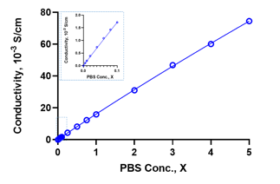

Figure S6. Conductivity of hydrogel determined by 4-point probe and conductivity probe. A) Comparison of hydrogels conductivity using the four-point probe and the hand-held conductivity probe of hydrogels in equilibrium in deionized water (water gel) or PBS (ionic gel). B) Standard curve of conductivity vs. phosphate buffered saline solution concentration.

Methods: The resistance of the hydrogel specimens (n = 4) was determined using a four-point probe and electrochemical impedance spectroscopy. The gels were placed over a glass slide and the 4-point probe (Signatone 4Pro) was placed in contact with the center of the specimen. The Voltage-Current characteristics of the hydrogels were recorded by varying the current from 0.001mA to 0.2mA. The resistance (R) of the sample was obtained from the slope of the V-I plot. Additionally, the conductivity of ionic species present was determined using an Oakton CON 450 portable conductivity meter. Specimens were submerged in 5mL of DI water and allowed to reach equilibrium. The recorded conductivity value was compared to a standard curve to determine the hydrogel's relative ion concentration and ionic conductivity.

Figure S7. Hydrogel conductivity at different NaCl concentrations. Initial hydrogel conductivity at different NaCl concentrations and conductivity after reaching swelling equilibrium in PBS.

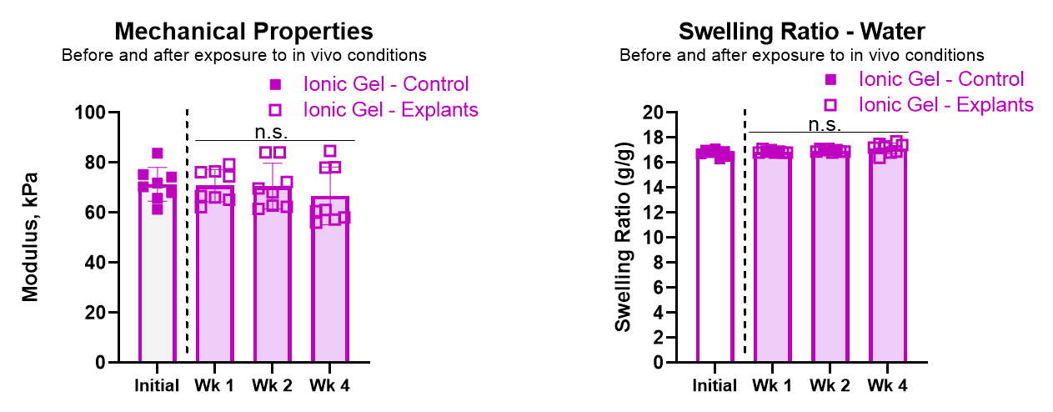

Figure S8. Network properties of PEUDAm prior to and after subcutaneous implantation in rats for 1, 2 or 4 weeks (n=8).

Methods: To determine the compressive modulus, specimens were strained to failure using a dynamic mechanical analyzer (RSAIII, TA Instruments) at a rate of 0.1 mm/s. All mechanical tests were performed at room temperature. To measure equilibrium swelling ratio, specimens were swelled in DI water for 24 hours and weighed (Ws). The specimens were then dried under vacuum for 24 hours and weighed (WD). The equilibrium mass swelling ratio was calculated as Q=Ws/WD.

Figure S9. In vivo assessment of injectable electrode in coronary vein (middle cardiac vein) of a porcine model. Host response after 2 weeks implantation in MCV using slices of the location proximal to the injection site, middle of the vein, and distal to the injection site (green arrow). The white arrow indicates the approximate location of the hydrogel in the vein. The response includes damage induced at the hydrogel injection site, with 1) moderate perivascular and interstitial fibrosis with focal replacement fibrosis (blue arrows), and 2) fibrosing epicarditis with foreign body giant cell reaction (red arrows). Mid branch of the hydrogel injection show 3) mild perivascular and interstitial fibrosis, 4) mild focal replacement fibrosis, and fibrosing epicarditis. Distal branch indicated 5) preserved myocardium with 6) only fibrosing epicarditis with focal extension into myocardium.

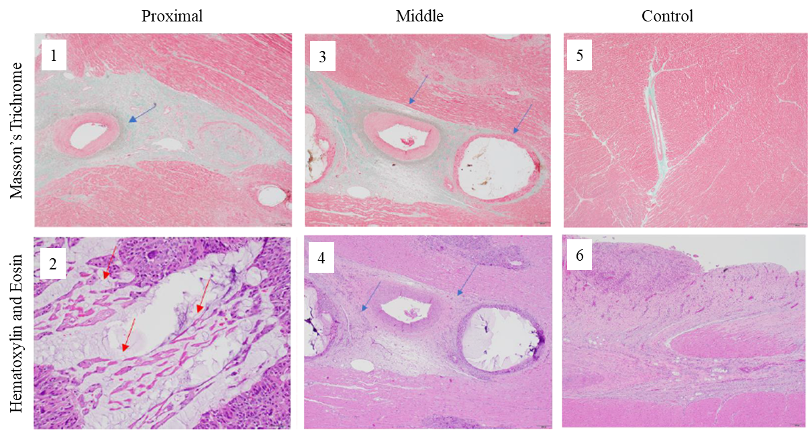
Figure S10. In vivo assessment of injectable electrode in coronary vein (anterior interventricular vein) of a porcine model (Animal 1). Host response after 4 weeks implantation in AIV using slices of the location proximal to the injection site, middle of the vein (indicated by V), and the control that is distal to the hydrogel. The response includes damage induced at the hydrogel injection site, with 1) moderate perivascular and interstitial fibrosis with focal replacement fibrosis (blue arrows), and 2) fibrosing epicarditis (red arrows) with foreign body giant cell reaction (blue arrows). Mid branch of the hydrogel injection show 3) mild perivascular and interstitial fibrosis, 4) mild focal replacement fibrosis, and fibrosing epicarditis. The control images at the distal branch indicated 5) preserved myocardium with 6) only fibrosing epicarditis with focal extension into myocardium.

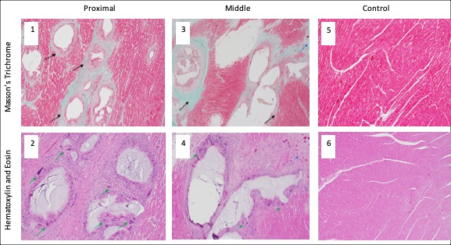

Figure S11. In vivo assessment of injectable electrode in coronary vein (anterior interventricular vein) of a porcine model (Animal 2). Host response after 4 weeks implantation in AIV using slices of the location proximal to the injection site, middle of the vein (indicated by V), and the control from an alternate section of the anterior wall. The response includes damage induced at the hydrogel injection site, with 1) moderate perivascular and interstitial fibrosis with focal replacement fibrosis (blue arrows), and 2) fibrosing epicarditis with foreign body giant cell reaction (green arrows). Mid branch of the hydrogel injection show 3) moderate perivascular and interstitial (black arrows) fibrosis, and replacement fibrosis (blue arrows), 4) focal replacement fibrosis, and fibrosing epicarditis. The control images at an alternate section of the anterior wall indicated 5) 6) preserved myocardium

Figure S12. In vivo assessment of injectable electrode in coronary vein (anterior intraventricular vein) of a porcine model. Animal AIV 1. ECG tracings from lead 1 of the cardiac activity before injection of the hydrogel (black tracing) and 4 weeks after injection (blue tracing). The overall QRS morphology is preserved. Heart rate differs between the two recordings, but this is not indicative of a disease state.

Figure S13. In vivo assessment of injectable electrode in coronary vein (anterior intraventricular vein) of a porcine model. Animal AIV 2. ECG tracings from lead 1 of the cardiac activity before injection of the hydrogel (black tracing) and 4 weeks after injection (blue tracing). The overall QRS morphology is preserved.

Figure S14. In vivo assessment of injectable electrode in coronary vein (anterior intraventricular vein) of a porcine model. Animal AIV 3. ECG tracings from lead 1 of the cardiac activity before injection of the hydrogel (black tracing) and 4 weeks after injection (blue tracing). The overall QRS morphology is similar, with nearly identical vectors. Heart rate differs between the two recordings, but this is not indicative of a disease state.

Figure S15. In vivo assessment of injectable electrode in coronary vein (middle cardiac vein) of a porcine model. Animal MCV 1. ECG tracings from lead 1 of the cardiac activity before injection of the hydrogel (black tracing) and 2 weeks after injection (blue tracing). The overall QRS morphology is similar, with nearly identical vectors. Heart rate differs between the two recordings, but this is not indicative of a disease state. The pre-injection ECG tracing contains low frequency baseline drift which is not reflective of the model’s electrophysiology.

Table S1. High sensitivity Troponin I measurements. Measurements from four separate studies from two weeks after occlusion of the MCV and from four weeks after occlusion of the AIV in a porcine model. The normal range for troponin I is from 3 to 70 ng.

Vein - Animal | Troponin levels (ng/L)
Vein - Animal | Pre-Op | Post-Op | Week 1 | Week 2 | Week 3 | Week 4
MCV - 1 | -- | 3313 | -- | 34 | -- | --
AIV - 1 | 17 | 421 | 99 | 97 | 99 | 49
AIV - 2 | 121 | N/A | 202 | 95 | 116 | 54
AIV - 3 | 17 | 140 | 44 | 28 | 62 | 45

2 weeks after injection on MCV (EF = 65%)
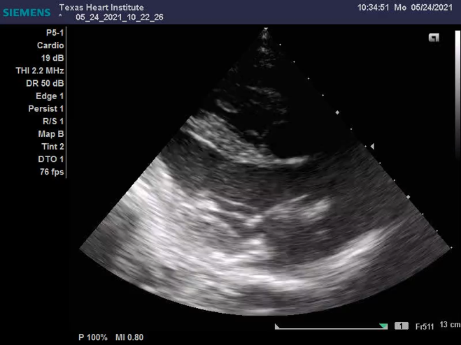

Movie S1. Echocardiogram 2 weeks after injection on the MCV in a pig model. Echocardiograms show no evidence of regional wall motion abnormalities after two weeks. Press play to see the videos.

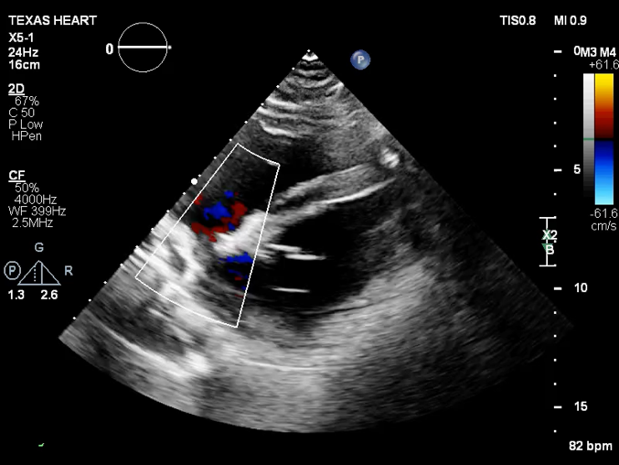
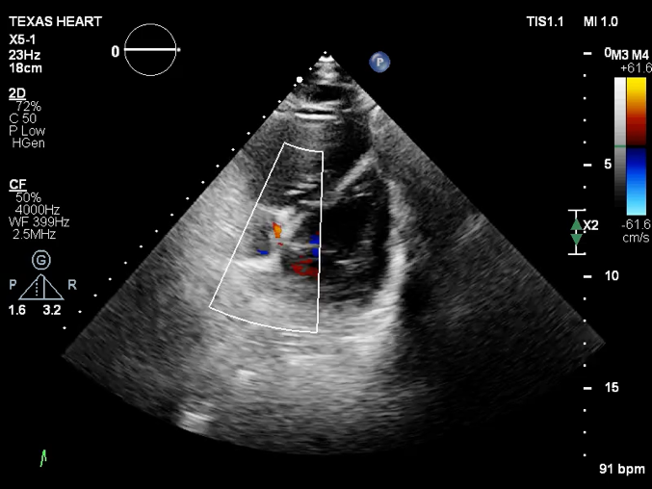
Baseline (Prior hydrogel injection) (EF = 70%). 4 weeks after injection on AIV (EF = 65%)

Movie S2. Echocardiogram prior and 4 weeks after injection on the AIV in a pig model. Echocardiograms show no evidence of regional wall motion abnormalities at four weeks compared to baseline imaging. Press play to see the videos.

Figure S16. Capture thresholds for each acute porcine study (n=3).

PW  (ms) | Animal 01 |  |  |  | Animal 02 |  |  |  | Animal 03
PW  (ms) | Metal | Blob | Line | AIV | Metal | Blob | Line | AIV | Metal | Blob |  | Line | AIV
0.5 | 4 | 8.5 | 5 | - | 8.3 | 7.5 | 3.5 | - | 7 | 11 | 7 |  | -
1 | 2 | 5 | 1.2 | 21 | 3.5 | 3.5 | 2.7 | 9 | 7 | 6 | 5 |  | 7
5 | 1.2 | 2.2 | 0.6 | 0.7 | 2 | 1.8 | 1 | 4 | 3.5 | 3 | 3 |  | 3.5
10 | 0.9 | 1.7 | 0.4 | 0.5 | 1.2 | 1.5 | 0.8 | 4 | 2.5 | 3 | 1.6 |  | 1.8
Table S2. Capture thresholds (in mA) for each material and acute animal tested (n=3). NC = no capture.

Figure S17. 12-lead ECG of the heart at sinus rhythm.

Figure S18. 12-lead ECG of unipolar pacing with a metal electrode placed directly on the left ventricular myocardium. Pacing artifacts can be seen as spikes in each of the channels. Pacing was performed at 120 bpm.

Figure S19. 12-lead ECG of unipolar pacing with a small blob of hydrogel electrode placed directly on the left ventricular myocardium. Pacing artifacts can be seen as spikes in each of the channels. Pacing was performed at 120 bpm.

Figure S20. 12-lead ECG of unipolar pacing with a linear hydrogel electrode (~4 cm) placed directly on the left ventricular myocardium close to the interventricular septum. Pacing artifacts can be seen as spikes in each of the channels. Pacing was performed at 120 bpm.

Figure S21. 12-lead ECG of unipolar pacing from hydrogel cured in situ in the AIV. Pacing artifacts can be seen as spikes in each of the channels. Pacing was performed at 120 bpm.

Figure S22. Animal02: 12-lead ECG of the heart at sinus rhythm.

Figure S23. Animal02: 12-lead ECG of unipolar pacing with a metal electrode placed directly on the left ventricular myocardium. Pacing artifacts can be seen as spikes in each of the channels. Pacing was performed at 120 bpm.

Figure S24. Animal02: 12-lead ECG of unipolar pacing with a small blob of hydrogel electrode placed directly on the left ventricular myocardium. Pacing artifacts can be seen as spikes in each of the channels. Pacing was performed at 120 bpm.

Figure S25. Animal02: 12-lead ECG of unipolar pacing with a linear hydrogel electrode (~4 cm) placed directly on the left ventricular myocardium close to the interventricular septum. Pacing artifacts can be seen as spikes in each of the channels. Pacing was performed at 120 bpm.

Figure S26. Animal02: 12-lead ECG of unipolar pacing from hydrogel cured in situ in the AIV. Pacing artifacts can be seen as spikes in each of the channels. Pacing was performed at 120 bpm.

Figure S27. Animal03: 12-lead ECG of the heart at sinus rhythm.

Figure S 28. Animal03: 12-lead ECG of unipolar pacing with metal electrode placed directly on the left ventricular myocardium. Pacing artifacts can be seen as spikes in each of the channels. Pacing was performed at 120 bpm.

Figure S29. Animal03: 12-lead ECG of unipolar pacing with a small blob of hydrogel electrode placed directly on the left ventricular myocardium. Pacing artifacts can be seen as spikes in each of the channels. Pacing was performed at 120 bpm.

Figure S30. Animal03: 12-lead ECG of unipolar pacing with a linear hydrogel electrode (~4 cm) placed directly on the left ventricular myocardium close to the interventricular septum. Pacing artifacts can be seen as spikes in each of the channels. Pacing was performed at 120 bpm.

Figure S31. Animal03: 12-lead ECG of unipolar pacing from hydrogel cured in situ in the AIV. Pacing artifacts can be seen as spikes in each of the channels. Pacing was performed at 120 bpm.

Figure S32. Epicardial and endocardial electroanatomical mapping for animal AIV 1. The AIV hydrogel pacing is indicated by the blue circles.

Figure S33. Epicardial and endocardial electroanatomical mapping for animal AIV 2. Point pacing location is indicated by a small white circle, and the AIV hydrogel pacing is indicated by the blue circles. Points of ablation are marked by the red circles.

Figure S34. Epicardial and endocardial electroanatomical mapping for animal AIV 3. Point pacing location is indicated by a small white circle, and the AIV is indicated by the blue circles. Points of ablation are marked by the red circles

