Supplemental Information
Preliminary work suggested a positive, significant correlation between dry tissue mass and internal Hg concentration. Subsequent analysis of clam mass (dry, wet, and total) vs Hg concentration yielded variable correlations that were not consistent between treatments or within treatments, including the control. This suggests that on short time scales, clam mass does not correlate with tissue Hg concentration in a consistent way across Hg concentrations and mass-specific endpoints (dry, wet, and total). We hypothesize this is the case as acute uptake rates will be affected by individual behavior more strongly than long term uptake, i.e. a clam may stay closed for a few days in response to stress or negative stimuli drastically changing its Hg exposure time compared to an actively feeding/filtering clam, but after a year, differences in exposure will be much less. Our data may represent the impact of clam mass and dosed concentration on the transient dynamics of Hg bioaccumulation in Corbicula; these factors may not have impact the equilibrium Hg concentrations in this species. This would partially explain the difference in tissue Hg vs tissue mass trends seen in the preliminary data and the experimental data.

Figure SI-1: No consistent tend was seen across all treatment levels in whole clam weight (shell + wet tissue) vs internal Hg concentration (dry weight basis). Magnitude, direction, and significance of the regression changed between treatments, suggesting no consistent controls. R-output included below.
Figure SI-2: Individual tanks shows variable correlations between clam dry weight and tissue Hg concentrations. Magnitude, slope direction, and correlation statistics varied between treatments, further suggesting no clear trend with clam size or weight in these tests. R-output included below.
Figure SI-3: The correlation between all of the clams in the study and the Hg concentration in their dry tissue resulted in no significant correlation (Multiple R-squared: 0.009954, Adjusted R-squared: 0.003265, P-value = 0.2245). R-output included below.
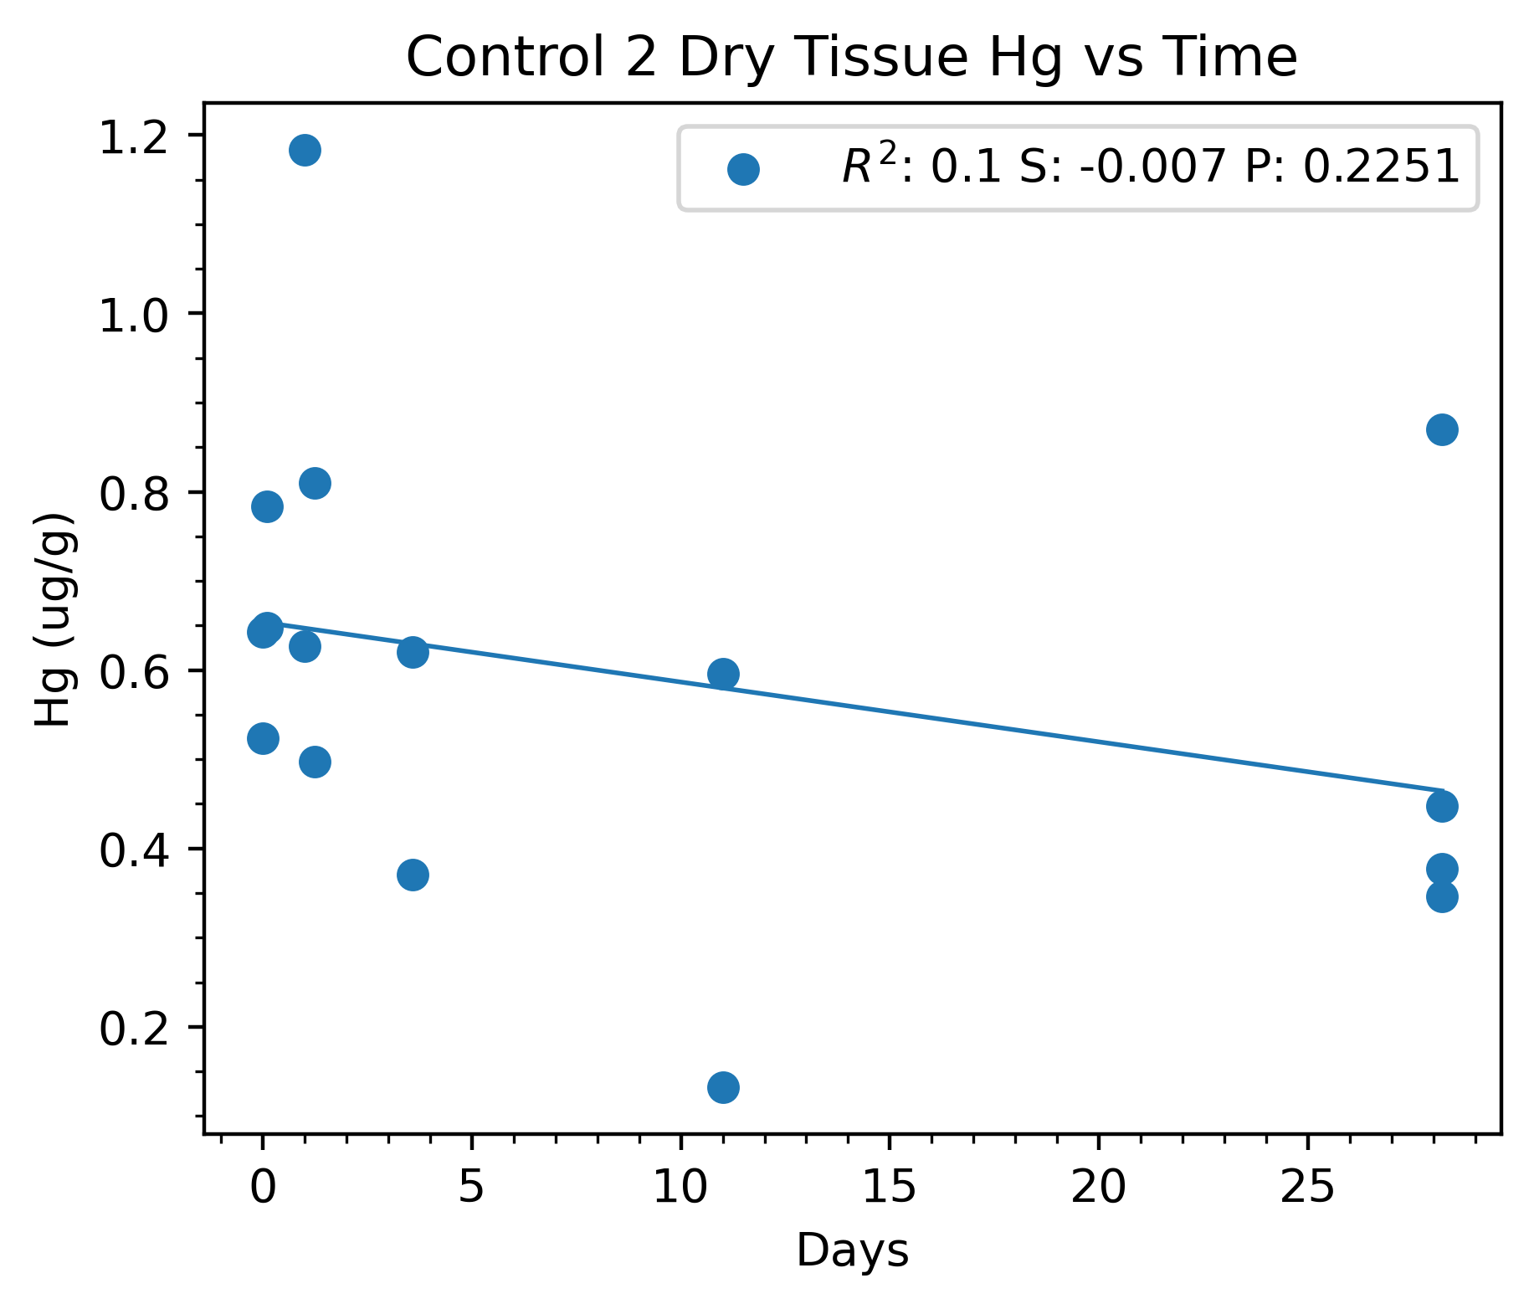
Figure SI-4: In Control 2, the regression of Hg concentration in dry clam tissue vs time resulted in a low R² value, low slope, and was not significant (p>0.05). This suggests that Hg concentration was not significantly changing through time in clam tissue in this control tank.

Figure SI-5: Preliminary testing of corbicula tissue Hg several months prior to the start of the experiment showed a clear trend of increasing Hg with increasing dry tissue mass.

Table SI-1: Hg concentration and statistical data for all treatments. The p-value during the uptake phase compares the treatments at the time of sampling to all the samples measured in Control 2. This was done due to the contamination in control 1 resulting in only 2 data points to compare against in control 2, leading to excessive penalties in t-statistics associated with only 2 data points. As shown in Figure SI-4, concentrations did not change appreciably through time in control 2. Std. Err(D) is the standard error of Cohen’s D (Cooper 2019).
Tank |  | Uptake |  |  |  |  | Depuration
Treatment | Avg, Hg(Aq) (ng/L) | Hg (ug/g) | Std. dev | p-value | Cohen's D | Std. Err(D) | Hg (ug/g) | Std. dev | Conc. Factor (L/g) | p-value | Cohen's D | Std. Err(D)
Cntrl 2 | 2.09 | 0.50 | 0.125 |  |  |  | 0.51 | 0.243
Cntrl 1 | 2.62 | 1.51 | 1.16 | 0.169 | 1.22 | 2.96 | 0.545 | 0.367 |  | 0.906 | 0.12 | 2.58
20 ppt | 14.93 | 1.06 | 0.196 | 0.0344 | 3.45 | 3.73 | 0.653 | 0.244 | 71.1 | 0.446 | 0.66 | 2.59
20 ppt | 14.31 | 0.77 | 0.185 | 0.0344 | 1.74 | 3.08 | 0.611 | 0.339 | 53.8 | 0.446 | 0.38 | 2.85
100 ppt | 68.45 | 0.92 | 0.306 | 4x10-4 | 1.81 | 3.11 | 1.424 | 0.306 | 13.4 | 2.61x10-5 | 3.74 | 3.04
100 ppt | 72.7 | 3.63 | 0.34 | 4x10-4 | 12.24 | 9.11 | 1.539 | 1.539 | 49.9 | 2.61x10-5 | 5.26 | 3.21
200ppt | 140 | 5.52 | 2.193 | 1.77x10-6 | 3.24 | 3.64 | 1.795 | 0.459 | 39.5 | 2.47x10-3 | 3.88 | 2.76
200ppt | 140.1 | 3.96 | 1.956 | 1.77x10-6 | 2.50 | 3.34 | 1.392 | 0.256 | 28.3 | 2.47x10-3 | 4.08 | 3.54

Tank |  | Uptake |  |  |  |  | Depuration
Treatment | Avg, Hg(Aq) (ng/L) | Hg (ug/g) | Std. dev | p-value | Cohen's D | Std. Err(D) | Hg (ug/g) | Std. dev | Conc. Factor (L/g) | p-value | Cohen's D | Std. Err(D)
Cntrl 2 | 2.09 | 0.50 | 0.125 |  |  |  | 0.51 | 0.243
Cntrl 1 | 2.62 | 1.51 | 1.16 | 0.169 | 1.22 | 2.96 | 0.545 | 0.367 |  | 0.906 | 0.12 | 2.58
20 ppt | 14.93 | 1.06 | 0.196 | 0.0344 | 3.45 | 3.73 | 0.653 | 0.244 | 71.1 | 0.446 | 0.66 | 2.59
20 ppt | 14.31 | 0.77 | 0.185 | 0.0344 | 1.74 | 3.08 | 0.611 | 0.339 | 53.8 | 0.446 | 0.38 | 2.85
100 ppt | 68.45 | 0.92 | 0.306 | 4x10-4 | 1.81 | 3.11 | 1.424 | 0.306 | 13.4 | 2.61x10-5 | 3.74 | 3.04
100 ppt | 72.7 | 3.63 | 0.34 | 4x10-4 | 12.24 | 9.11 | 1.539 | 1.539 | 49.9 | 2.61x10-5 | 5.26 | 3.21
200ppt | 140 | 5.52 | 2.193 | 1.77x10-6 | 3.24 | 3.64 | 1.795 | 0.459 | 39.5 | 2.47x10-3 | 3.88 | 2.76
200ppt | 140.1 | 3.96 | 1.956 | 1.77x10-6 | 2.50 | 3.34 | 1.392 | 0.256 | 28.3 | 2.47x10-3 | 4.08 | 3.54

Bibliography:
Cooper, H., Hedges, L. V., & Valentine, J. C. (2009). The handbook of research synthesis and meta-analysis 2nd edition. In The Hand. of Res. Synthesis and Meta-Analysis, 2nd Ed. (pp. 1-615). Russell Sage Foundation.

