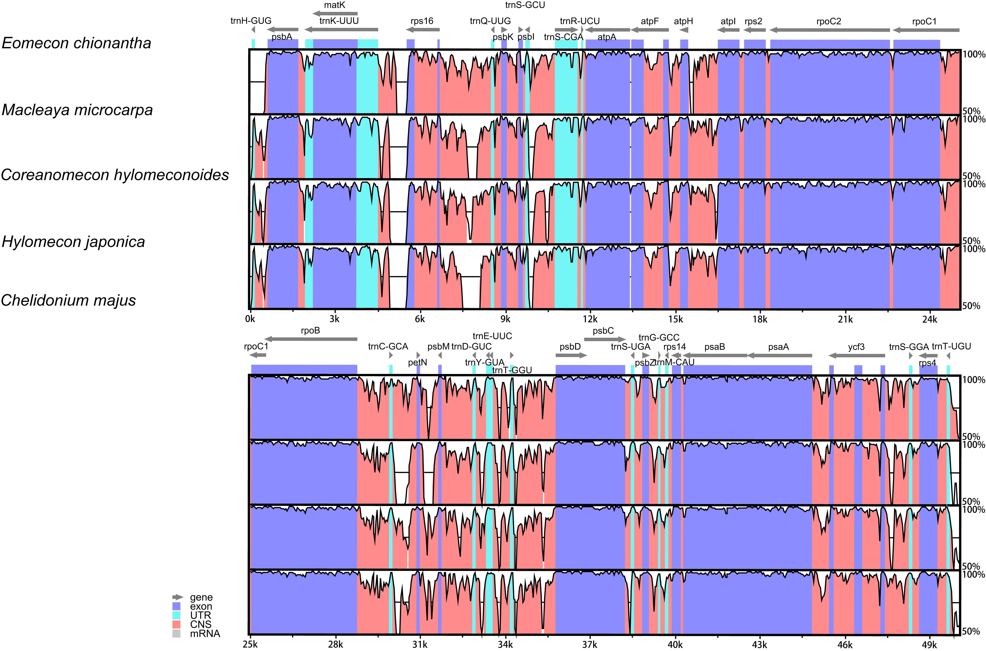
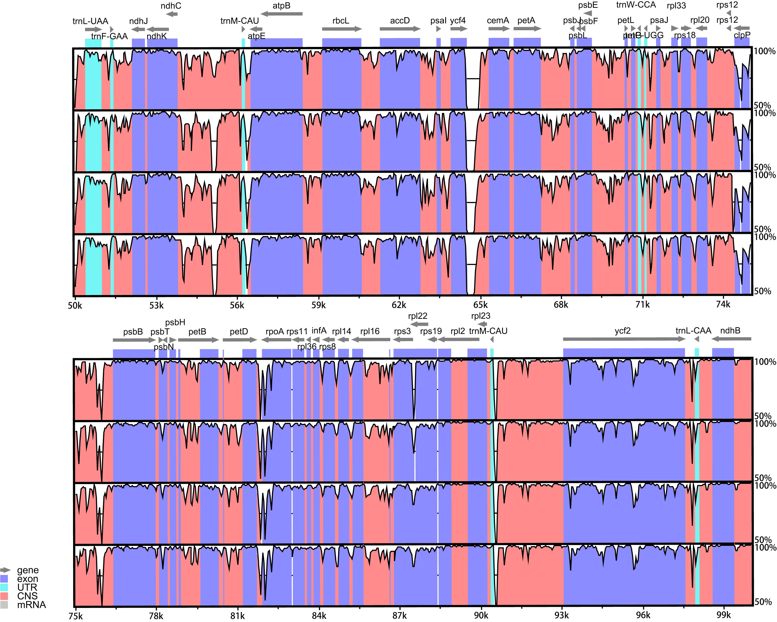

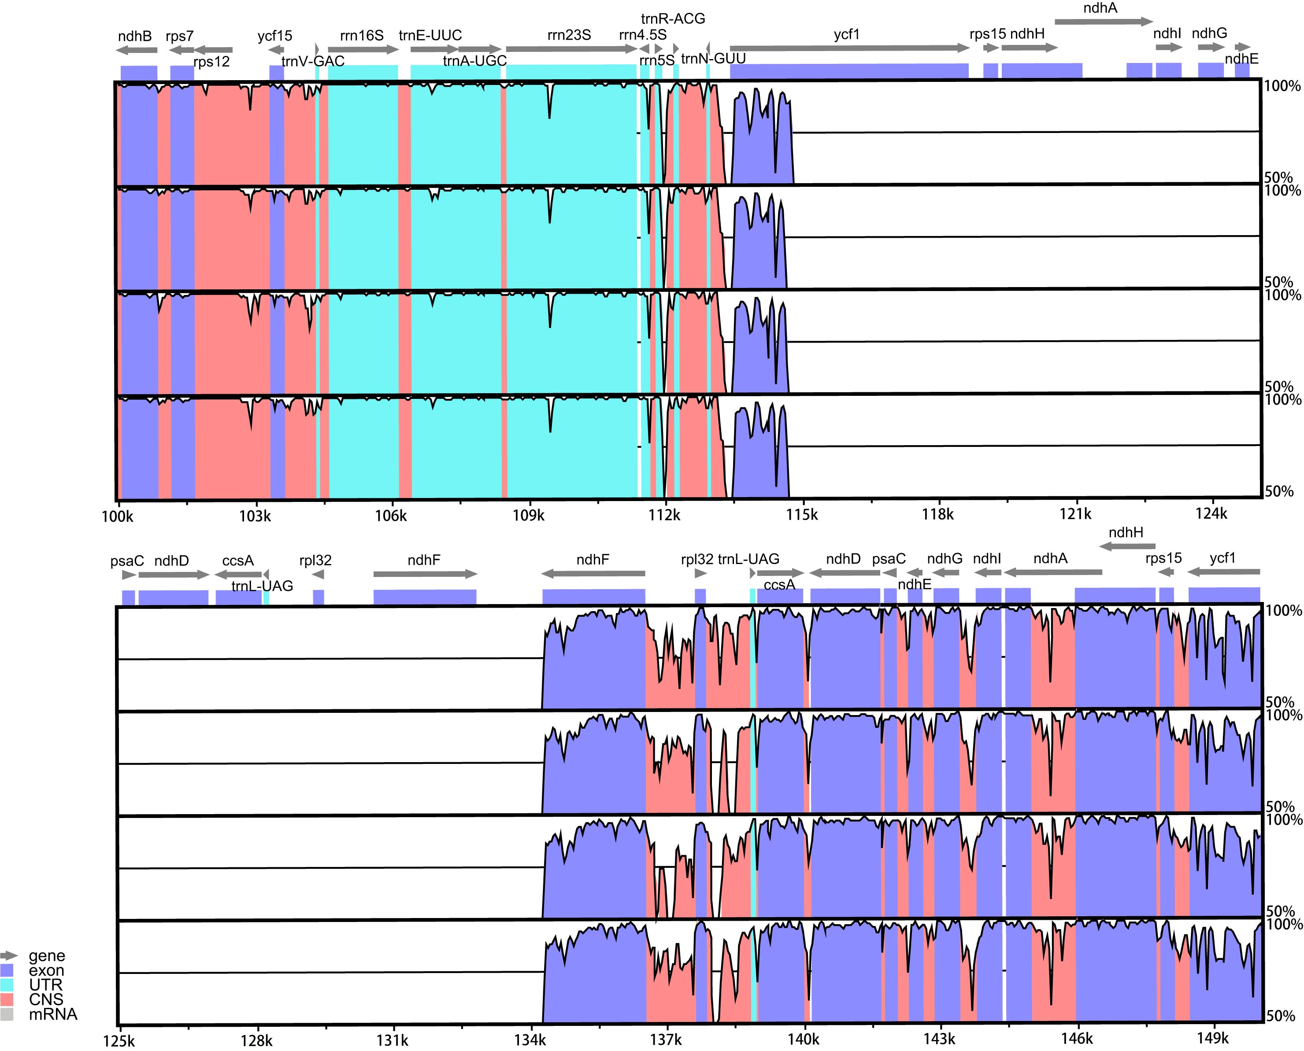
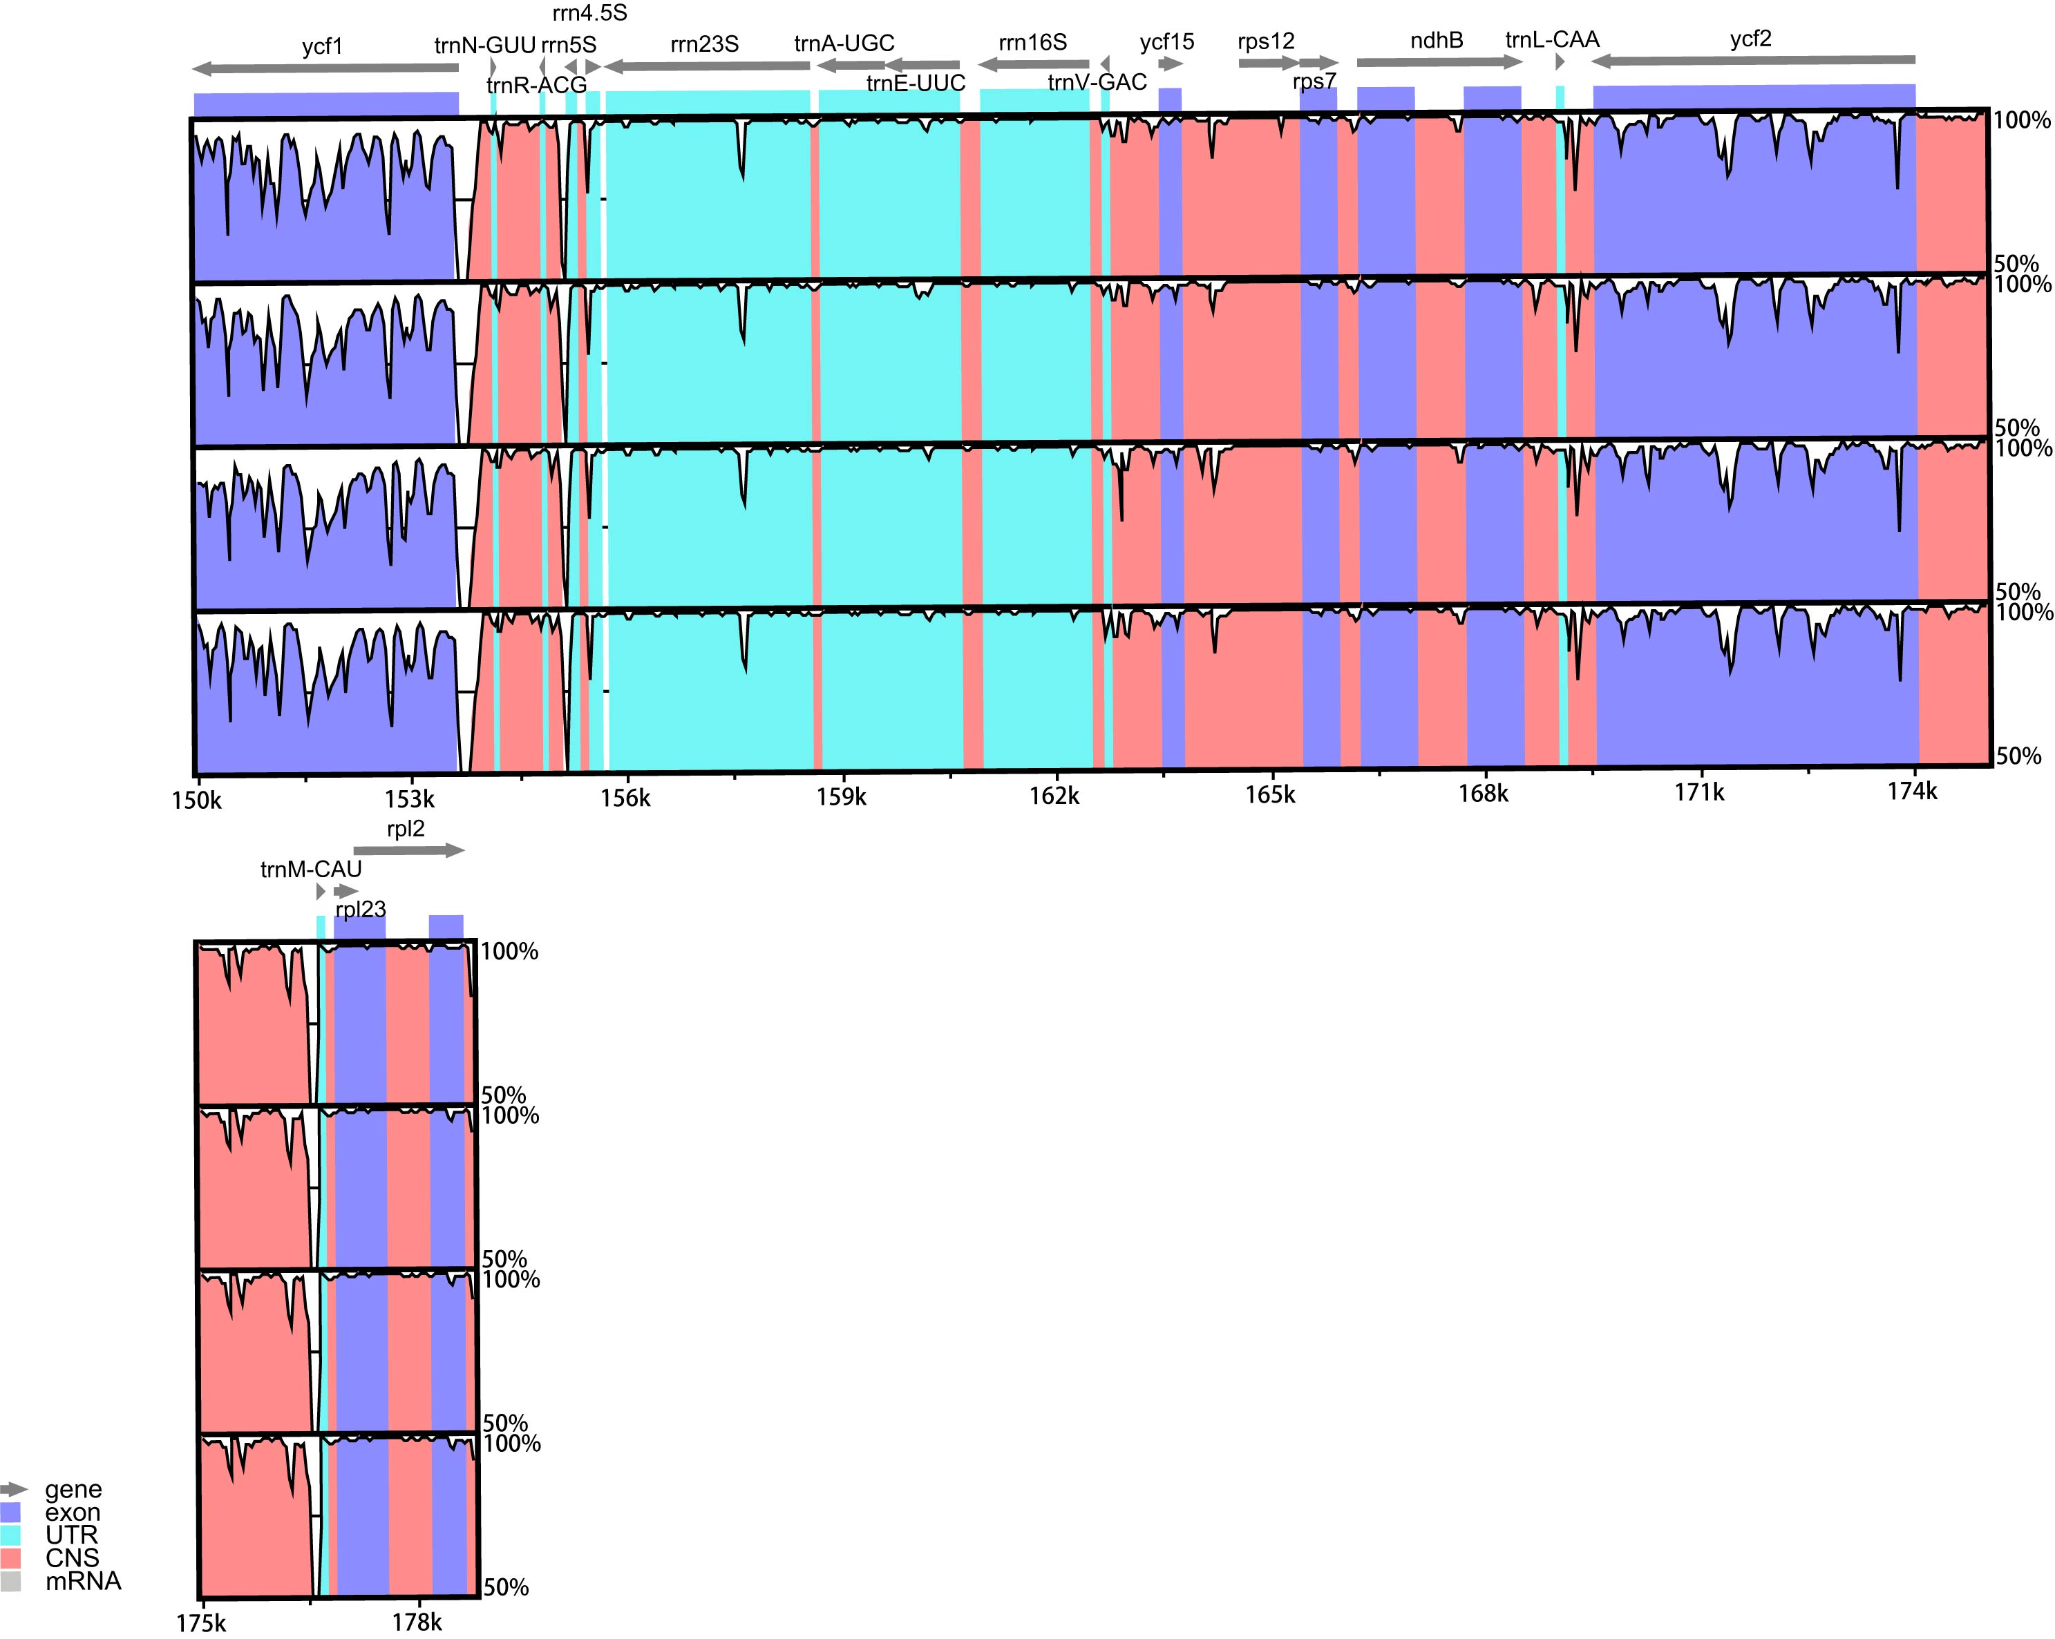
Supplement Fig 1: Comparison of the plastomes in five species by using mVISTA. The genes are represented as gray arrows on the top of the alignments. The different regions are labeled with different colors. The pink regions are “conserved noncoding sequences” (CNS), the dark blue regions are exons, and the light-blue regions are tRNAs or rRNAs. The percentages 50 and 100% refer to the similarity among sequences. The gray arrows above the aligned sequences represent genes and their orientation.

