The synergistic effect of degradation and adsorption for emerging pollutants removal from water and real wastewater by using immobilized activated carbon from pomegranate peels
Osamah J. Al-sareji ^{a,b}, Mónika Meiczinger ª, Raed A. Al-Juboori ^{c,d}, Ruqayah Ali Grmasha ^{b,e}, Manolia Andredaki ^{f}, Viola Somogyi ª, Ibijoke A. Idowu ^{f}, Csilla Stenger-Kovács ^{e,g}, Miklós Jakab ^{h}, Edina Lengyel ^{e,g}, Khalid S. Hashim ^{f,}*
ª Sustainability Solutions Research Lab, Faculty of Engineering, University of Pannonia, Egyetem str. 10, Veszprém H, 8200, Hungary
^{b} Environmental Research and Studies Center, University of Babylon, Babylon, Al-Hillah, Iraq
^{c} NYUAD Water Research Center, New York University-Abu Dhabi Campus, Abu Dhabi, P.O. Box 129188, Abu Dhabi, United Arab Emirates
^{d} Water and Environmental Engineering Research Group, Department of Built Environment, Aalto University, P.O. Box 15200, Aalto, FI-00076, Espoo, Finland
^{e} University of Pannonia, Faculty of Engineering, Center for Natural Science, Research Group of Limnology, H-8200 Veszprem, Egyetem u. 10, Hungary
^{f} School of Civil Engineering and Built Environment, Liverpool John Moores University, UK
^{g} ELKH-PE Limnoecology Research Group, H-8200 Veszprém, Egyetem utca 10, Hungary
^{h} Research Centre of Engineering Sciences, Department of Materials Sciences and Engineering, University of Pannonia, P.O. Box 158, H-8201 Veszprém, Hungary
* Corresponding authors: Khalid S. Hashim

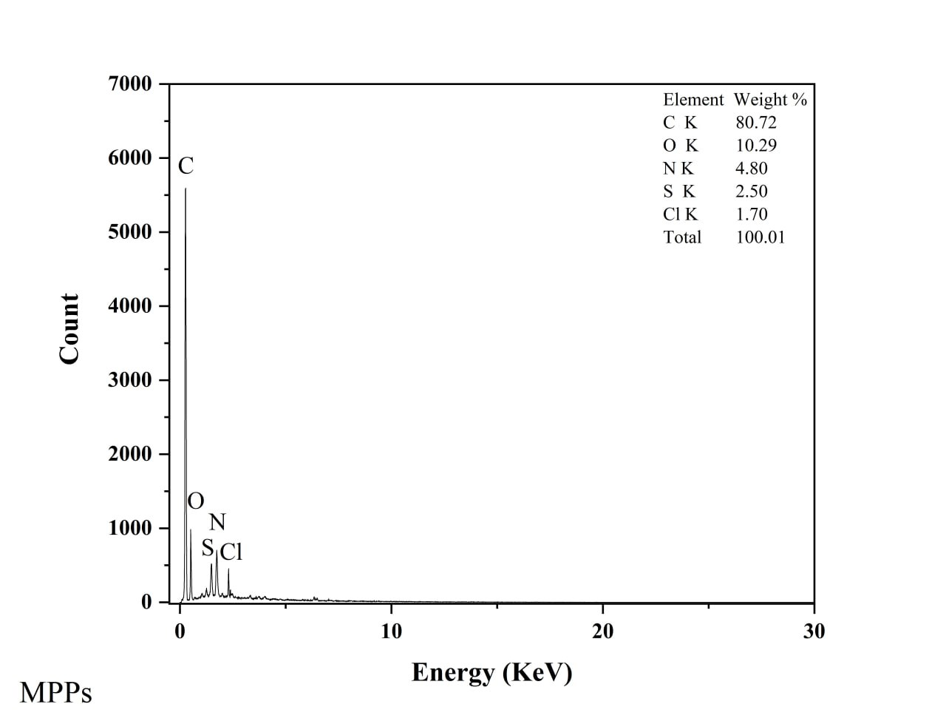
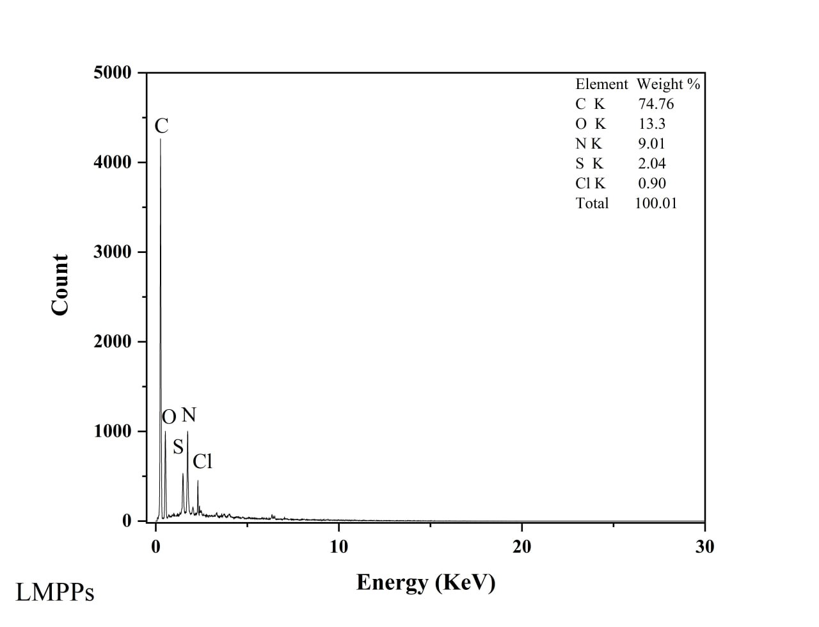

Figure S1 EDS for MPPs and LMPPs

Table S1 the parameter of Langmuir, Freundlich, Pseudo-1st-Order Model and Pseudo-2nd-Order Model
Langmuir | qmax (mg/g) | K_{L} | R_{L} | R²
Amoxicillin | 704.22 | 0.013 | 0.939 | 0.992
Ciprofloxacin | 598.80 | 0.013 | 0.937 | 0.996
Carbamazepine | 606.06 | 0.019 | 0.915 | 0.995
Diclofenac | 704.21 | 0.017 | 0.923 | 0.992
Freundlich | 1/n | K_{f} | R²
Amoxicillin | 0.78 | 12.38 | 0.984
Ciprofloxacin | 0.78 | 10.93 | 0.991
Carbamazepine | 0.80 | 13.20 | 0.975
Diclofenac | 0.79 | 14.58 | 0.988
Pseudo-1st-Order Model | qe (mg g⁻¹) | K1 | R²
Amoxicillin | 13.08 | 1.8E-05 | 0.995
Ciprofloxacin | 4.59 | 1.2E-05 | 0.995
Carbamazepine | 2.91 | 1.3E-05 | 0.984
Diclofenac | 6.69 | 1.2E-05 | 0.991
Pseudo-2nd-Order Model | qe (mg/g) | qe² | K2 | R²
Amoxicillin | 1.7E+02 | 3.0E+04 | 2.8E-04 | 0.899
Ciprofloxacin | 2.0E+02 | 4.0E+04 | 3.7E-04 | 0.913
Carbamazepine | 1.6E+02 | 2.5E+04 | 1.0E-03 | 0.918
Diclofenac | 2.5E+02 | 6.2E+04 | 5.5E-04 | 0.982

Table S2 Thermodynamic parameters of emerging pollutants adsorption on MPPs
Pharmaceutical Compound | Temperature (K) | Kl | ΔG° | ΔH° | ΔS° | R²
Amoxicillin | 283 | 6.95 | -4.56 | 9.89 | 50.99 | 0.980
Amoxicillin | 293 | 7.92 | -5.04 | 9.89 | 50.99 | 0.980
Amoxicillin | 303 | 8.85 | -5.49 | 9.89 | 50.99 | 0.980
Amoxicillin | 313 | 10.50 | -6.12 | 9.89 | 50.99 | 0.980
Ciprofloxacin | 283 | 5.88 | -4.17 | 10.18 | 50.83 | 0.950
Ciprofloxacin | 293 | 7.19 | -4.80 | 10.18 | 50.83 | 0.950
Ciprofloxacin | 303 | 7.64 | -5.12 | 10.18 | 50.83 | 0.950
Ciprofloxacin | 313 | 9.14 | -5.75 | 10.18 | 50.83 | 0.950
Carbamazepine | 283 | 6.75 | -4.49 | 14.60 | 67.44 | 0.996
Carbamazepine | 293 | 8.34 | -5.16 | 14.60 | 67.44 | 0.996
Carbamazepine | 303 | 9.97 | -5.79 | 14.60 | 67.44 | 0.996
Carbamazepine | 313 | 12.32 | -6.53 | 14.60 | 67.44 | 0.996
Diclofenac | 283 | 5.30 | -3.96 | 11.38 | 54.30 | 0.968
Diclofenac | 293 | 6.28 | -4.49 | 11.38 | 54.30 | 0.968
Diclofenac | 303 | 7.78 | -5.17 | 11.38 | 54.30 | 0.968
Diclofenac | 313 | 8.43 | -5.54 | 11.38 | 54.30 | 0.968

Table S3 Secondary efﬂuent characteristics.
Parameters | Concentration (mg/L)
Chemical oxygen demand | 67.2 ±2.3
Biochemical oxygen demand | 26.43 ±1.9 (5 days)
Suspended solids | 24.42±1.3
Volatile suspended solids | 18.84± 0.8
Total Phosphorus | 4.9±0.8
Ammonia | 15.93±1.7 (NH₃-NH₄)
Electrical conductivity | 853±5.4 µmoss/cm
Total Kjeldahl nitrogen | 11.53 ± 0.7
Nitrate-nitrite | 2.8 ± 0.6 (NO₂-NO₃)
Total solids | 584± 6.7
Total dissolved solids | 498± 3.6
pH | 6.7
Temperature | 26

