Supplemental material

PSII photochemical efficiency and chlororespiration of Acropora millepora zooxanthellae in carbonated seawater

Ashleigh McNie, Daniel Breen, Kay Vopel*

Department of Environmental Science, School of Science, Auckland University of Technology, Private Bag 92006, Auckland, New Zealand

*corresponding author, kay.vopel@aut.ac.nz, phone: +64212214242

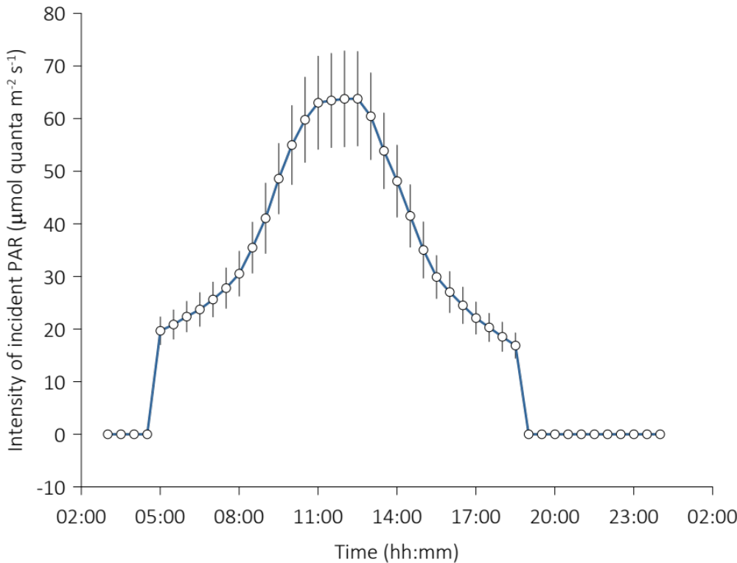

Figure S1. Time series of the intensity of photosynthetically active radiation (PAR, µmol quanta m^{–2} s^{–1}) incident at the surface of the coral nubbins (Mean ± SD, n = 9). Data points are averages of nine measurements, one on each of nine coral nubbins.

