Supporting Information
A dual-target fluorescent chemosensor for detecting indium (III) and hypochlorite with high selectivity
Duo Zhang, Dongkyun Gil*, Cheal Kim*
Department of Fine Chemistry, Seoul National Univ. of Sci. and Tech. (SNUT), Seoul 01811, Korea. Fax: +82-2-972-9149; Tel: +82-2-971-6680; E-mail: prmodel0131@protonmail.com and chealkim@snut.ac.kr

Table S1 Examples of chemosensors for detection of In³⁺ or In³⁺ with other analytes by a fluorescence turn-on method.
Entry | Sensor | Detection limit for In³⁺ (μM) | Target analyte | Reference
1 | 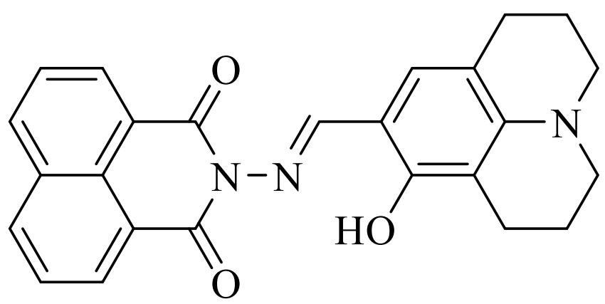 | 7.9 | In³⁺, Al³⁺ and Ga³⁺ | [1]
2 | 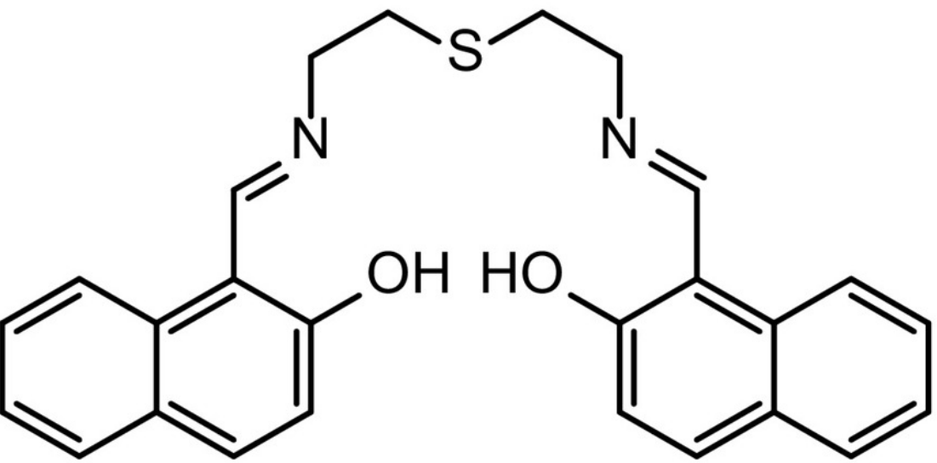 | 5.9 | In³⁺ (colorimetric: Fe³⁺) | [2]
3 | 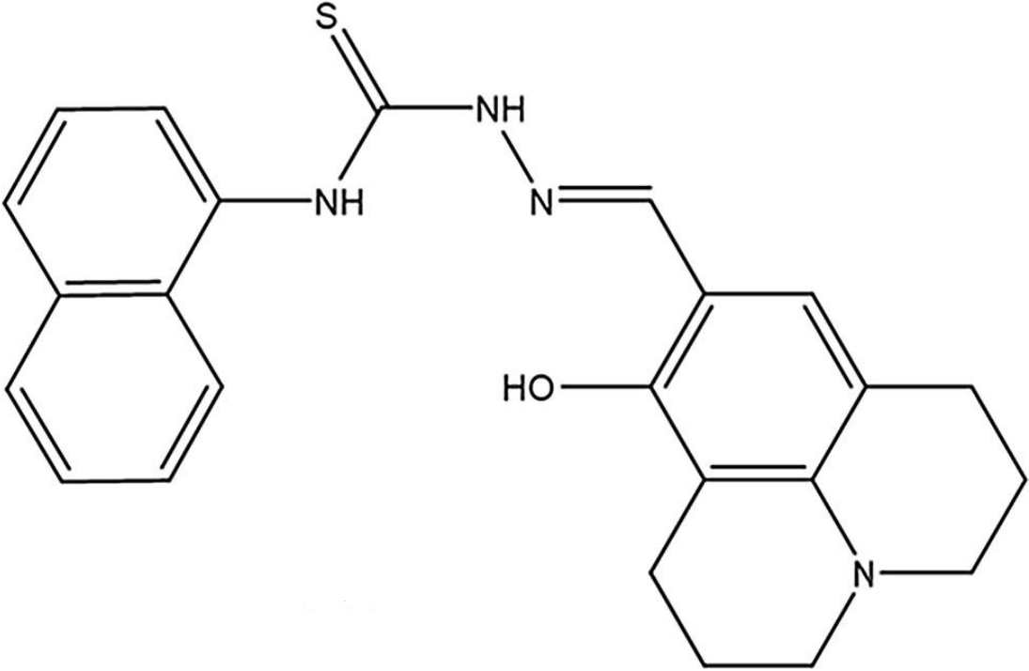 | 9.6 | In³⁺ | [3]
4 | 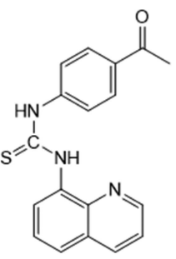 | 6.4×10⁻¹ | In³⁺ | [4]
5 | 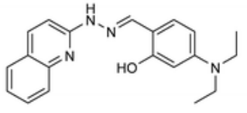 | 5.0×10⁻² | In³⁺ and Zn²⁺ (colorimetric: ClO⁻) | [5]
6 | 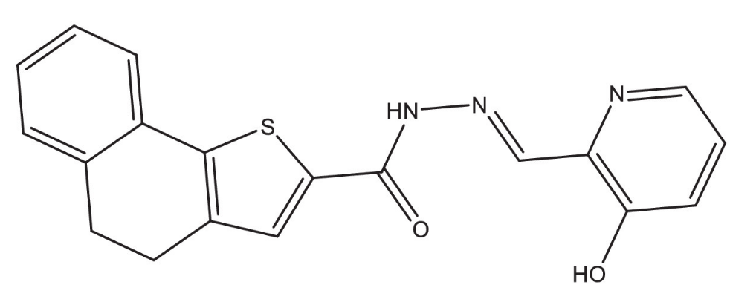 | 2.0×10⁻⁵ | In³⁺, Ga³⁺ and Fe³⁺ | [6]
7 | 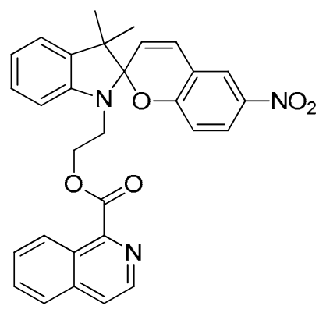 | 1.0×10 | In³⁺ and Co²⁺ | [7]
8 | 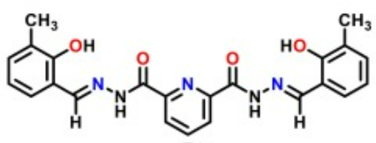 | 6.3×10⁻² | In³⁺ | [8]
9 | 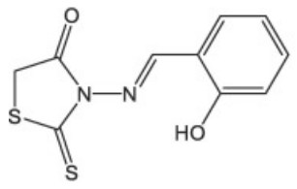 | 1.7 | In³⁺ | [9]
10 | 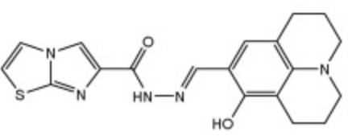 | 2.9×10⁻² | In³⁺, Zn²⁺ and PPi | [10]
11 | 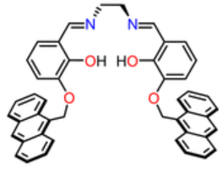 | 5.3×10⁻¹ | In³⁺, Fe²⁺ and Fe³⁺ | [11]
12 | 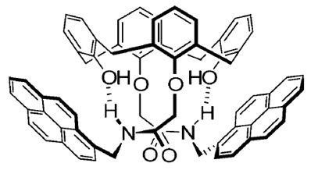 | No data | In³⁺ and Pb²⁺ | [12]
13 | 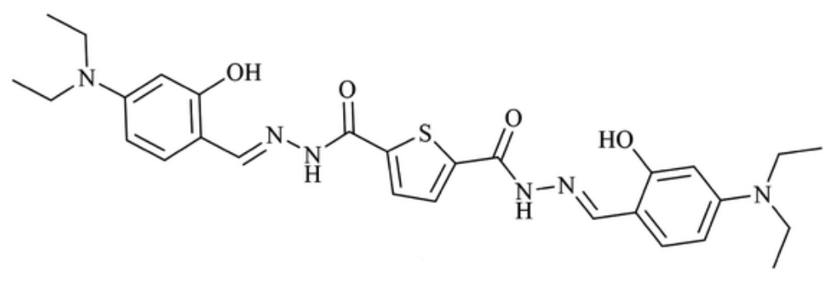 | 4.5×10⁻² | In³⁺ and PPi | [13]
14 | 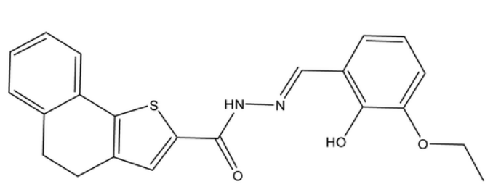 | 8.1×10⁻³ | In³⁺ and Fe³⁺ | [14]
15 | 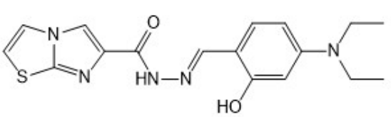 | 1.0×10⁻³ | In³⁺ and Zn²⁺ | [15]
16 | 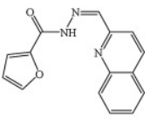 | No data | In³⁺ and Zn²⁺ (colorimetric: Cu²⁺ and Co²⁺) | [16]
17 | 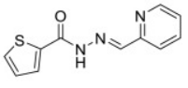 | 6.1×10⁻¹ | In³⁺ | [17]
18 | 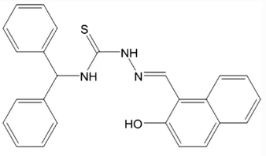 | 8.9×10⁻¹ | In³⁺ | [18]
19 | 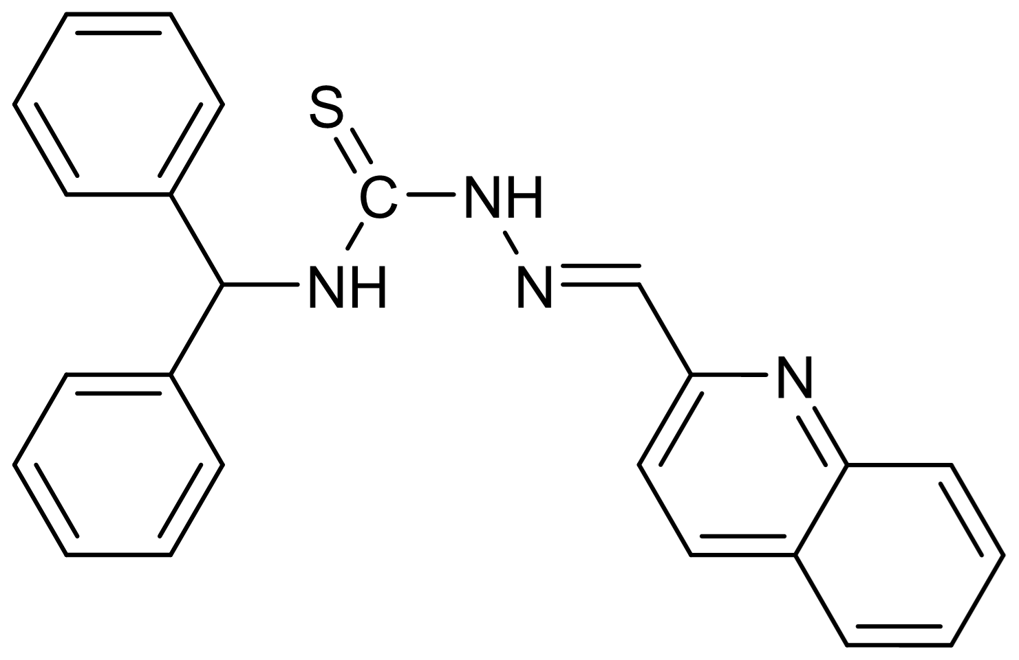 | 8.3×10⁻¹ | In³⁺ and ClO⁻ | This work

Reference
1. Jang HJ, Kang JH, Yun D, Kim C (2018) A multifunctional selective “turn-on” fluorescent chemosensor for detection of Group IIIA ions Al³⁺, Ga³⁺ and In³⁺. Photochem Photobiol Sci 17:1247–1255
2. Lee SY, Yang M, Kim C (2018) A dual target chemosensor for the fluorometric detection of In³⁺ and colorimetric detection of Fe³⁺. Spectrochim Acta A Mol Biomol Spectrosc 205:622–629
3. Lee SC, Kim C (2020) A thiourea-naphthol based turn-on fluorescent sensor for detecting In³⁺ and its application. Inorg Chem Commun 112:107752
4. Lee M, Lee JJ, Kim C (2022) Sensitive fluorescent determination of indium (III) by a thiourea–quinoline-based chemosensor. Instrum Sci Technol 50:481–495
5. Kim A, Kim C (2019) A hydrazono-quinoline-based chemosensor sensing In³⁺ and Zn²⁺ via fluorescence turn-on and ClO⁻ via color change in aqueous solution. New J Chem 43:7320–7328
6. Zhang Y, Li B (2022) A multifunctional selective fluorescent chemosensor for detection of Ga³⁺, In³⁺ and Fe³⁺ in different solvents. J Mol Struct 1250:131461
7. Kho YM, Shin EJ (2017) Spiropyran-Isoquinoline Dyad as a Dual Chemosensor for Co(II) and In(III) Detection. Molecules 22:1569
8. Mujthaba Aatif A, Selva Kumar R, Joseph S, et al (2023) Pyridinecarbohydrazide-based fluorescent chemosensor for In³⁺ ions and its applications in water samples, live cells, and zebrafish imaging. J Photochem Photobiol A Chem 434:114257
9. Yang M, Lee JJ, Yun D, et al (2023) In vitro and vivo application of a rhodanine-based fluorescence sensor for detection and bioimaging of In³⁺ at neutral pH. J Photochem Photobiol A Chem 434:114249
10. Xu Y, Yuan S, Zhang Y, et al (2020) A new multifunctional sensor for sequential recognizing of Zn²⁺ and PPi in acetonitrile solution and detection of In³⁺ in DMF solution. J Photochem Photobiol A Chem 392:112348
11. Finelli A, Chabert V, Hérault N, et al (2019) Sequential Multiple-Target Sensor: In³⁺, Fe²⁺, and Fe³⁺ Discrimination by an Anthracene-Based Probe. Inorg Chem 58:13796–13806
12. Sung KK, Su HK, Hyun JK, et al (2005) Indium(III)-induced fluorescent excimer formation and extinction in calix[4]arene-fluoroionophores. Inorg Chem 44:7866–7875
13. Xing Y, Liu Z, Xu Y, et al (2020) Double Schiff base from thiophene-2,5-dicarboxylic acid as an “off–on–off” fluorescence sensor for the sequential detection of In³⁺ and PPi. New J Chem 44:13875–13881
14. Li B, Liu Z, Li L, et al (2021) A Schiff base sensor for relay monitoring of In³⁺ and Fe³⁺ through “off–on–off” fluorescent signals. New J Chem 45:6753–6759
15. Xu Y, Zhao S, Zhang Y, et al (2020) A selective “turn-on” sensor for recognizing In³⁺ and Zn²⁺ in respective systems based on imidazo [2,1-Whiazole. Photochem Photobiol Sci 2020 192 19:289–298
16. Kim A, Kang JH, Jang HJ, Kim C (2018) Fluorescent detection of Zn(II) and In(III) and colorimetric detection of Cu(II) and Co(II) by a versatile chemosensor. J Ind Eng Chem 65:290–299
17. Cho H, Chae JB, Kim C (2018) A thiophene-based blue-fluorescent emitting chemosensor for detecting indium (III) ion. Inorg Chem Commun 97:171–175
18. Kim C, Chae JB (2018) A Highly Selective Fluorescent Chemosensor for Detecting Indium(III) with a Low Detection Limit and its Application. J Fluoresc 28:1363–1370
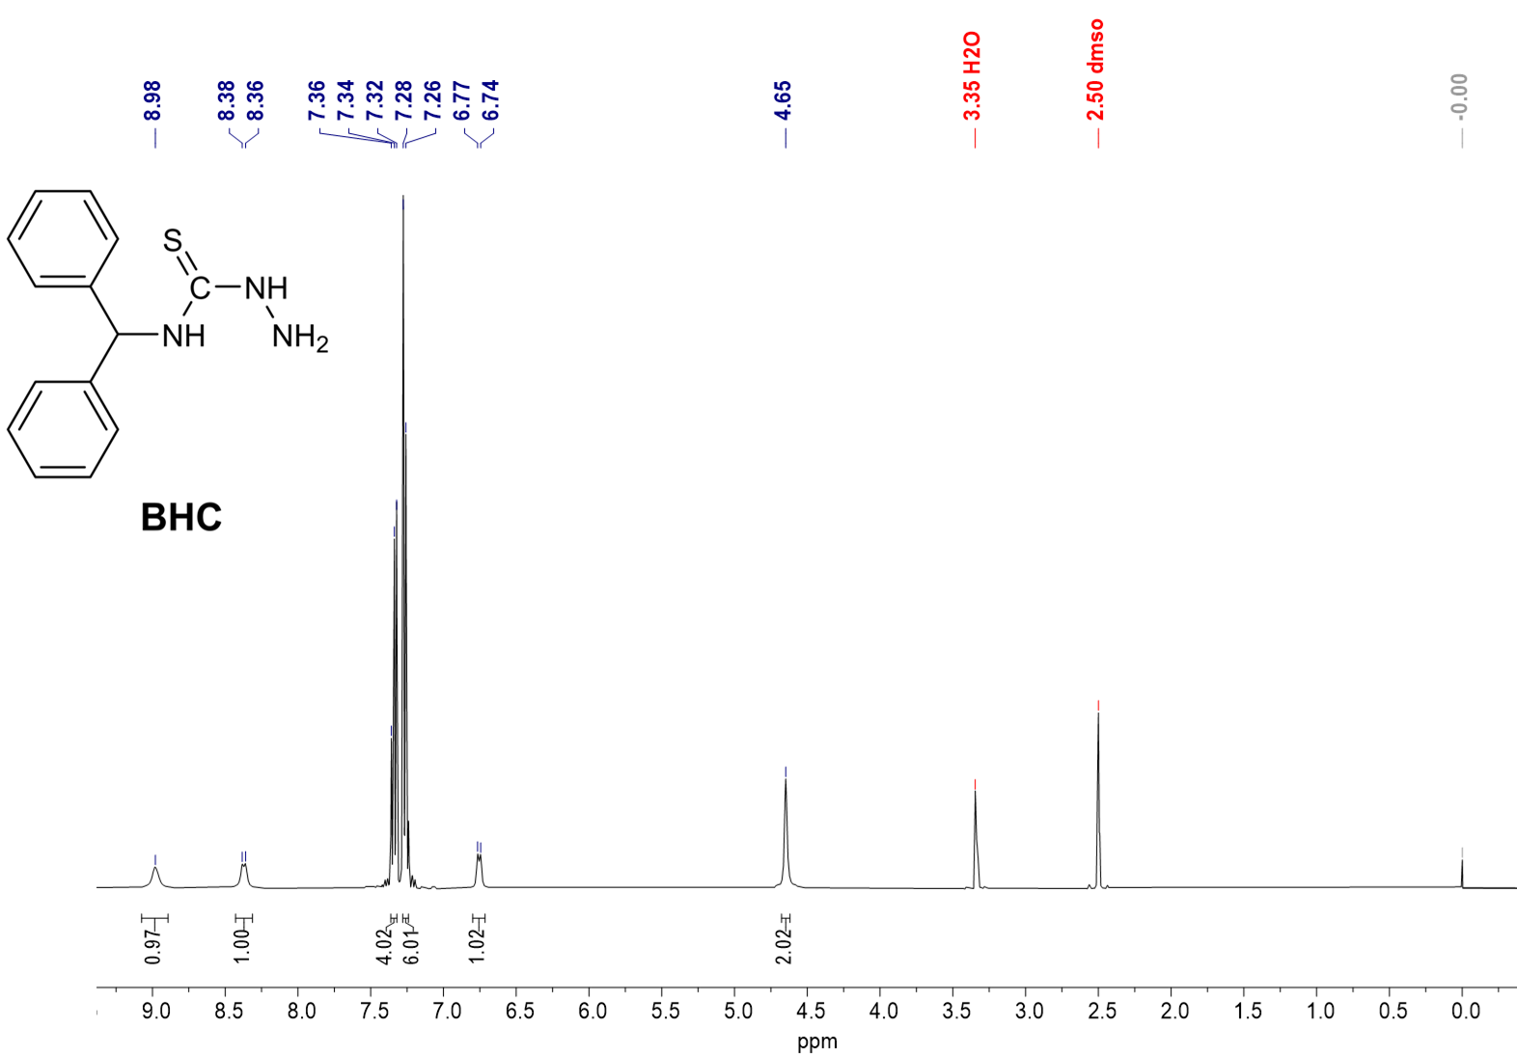
Figure S1 ¹H NMR spectrum of BHC in DMSO-d₆.

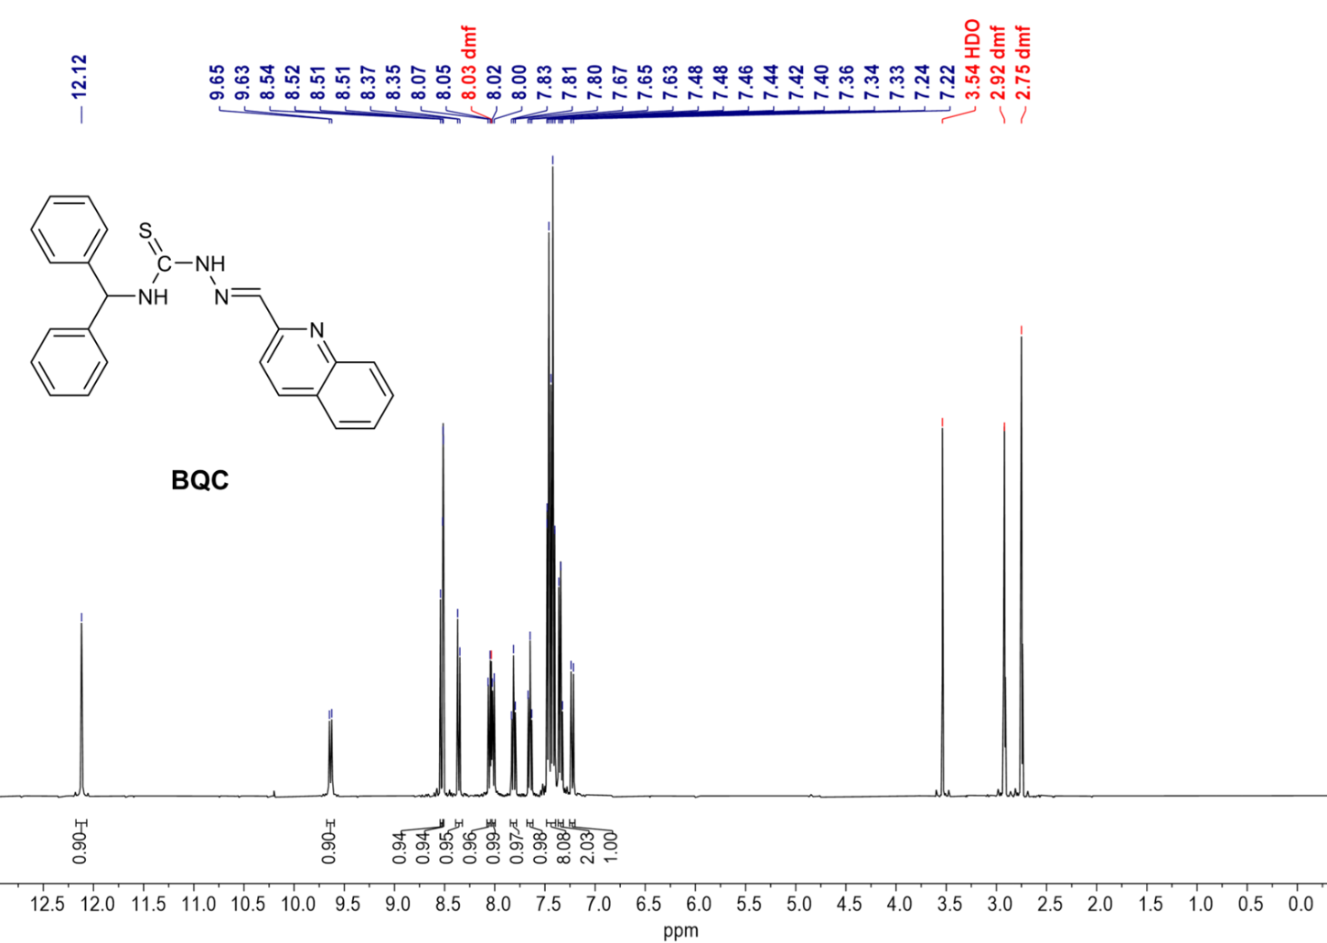
Figure S2 ¹H NMR spectrum of BQC in DMF-d₇.

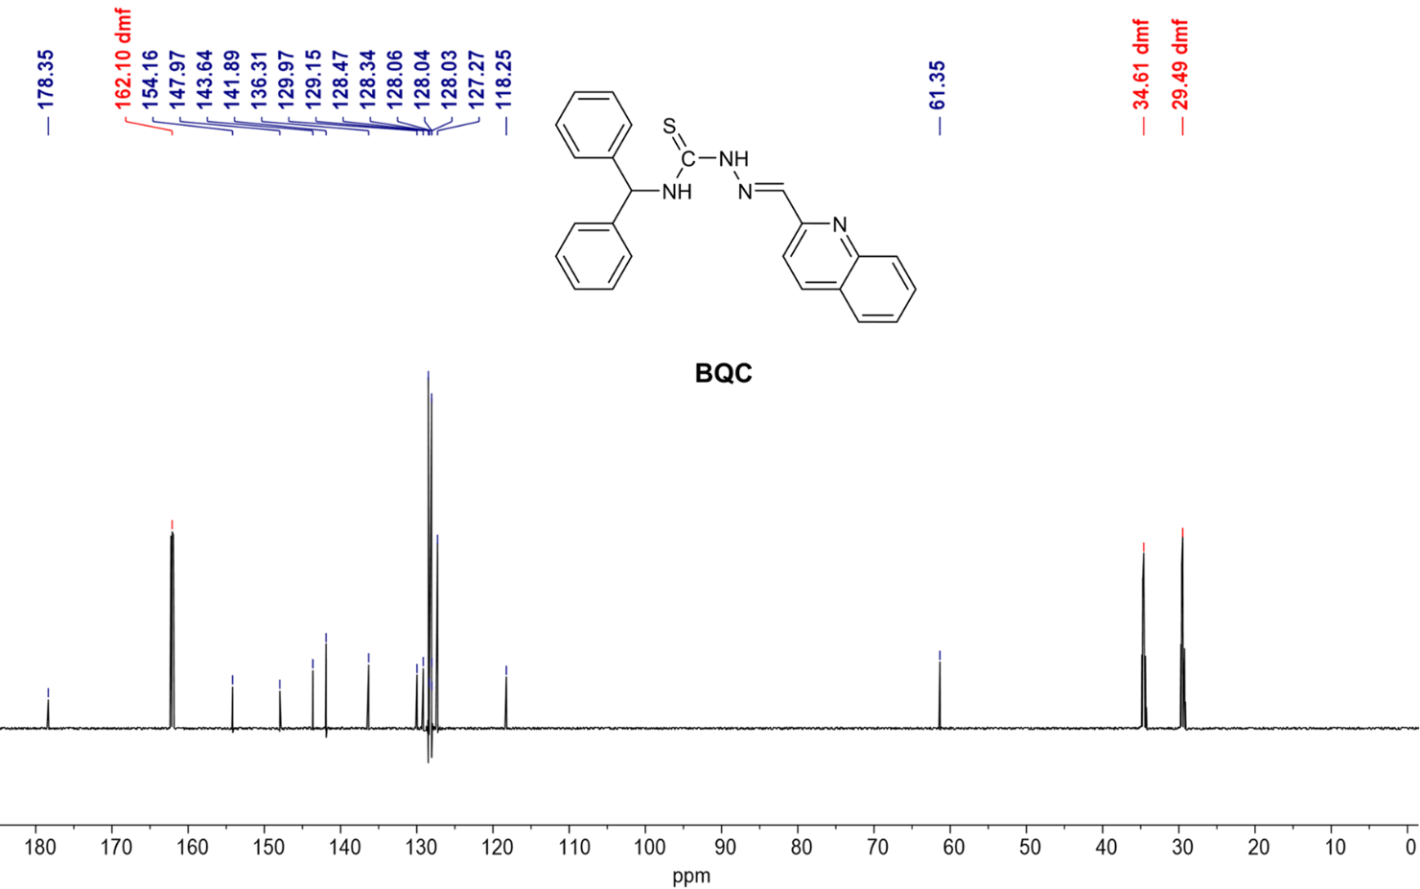
Figure S3 ¹³C NMR spectrum of BQC in DMF-d₇.

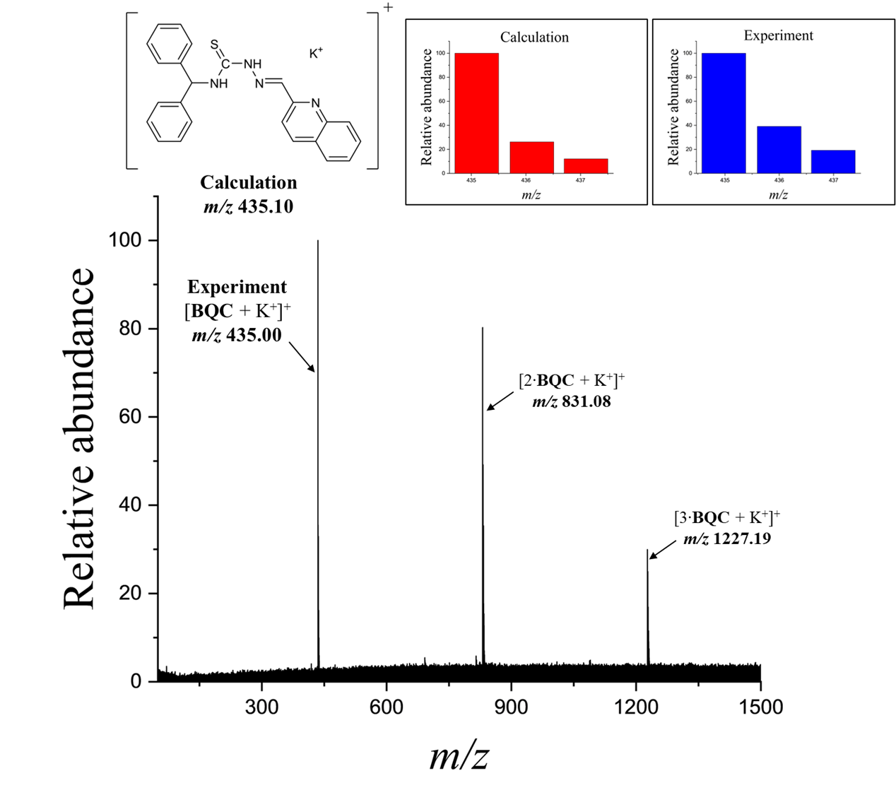
Figure S4 Positive-ion ESI-MS spectrum of BQC (300 µM).

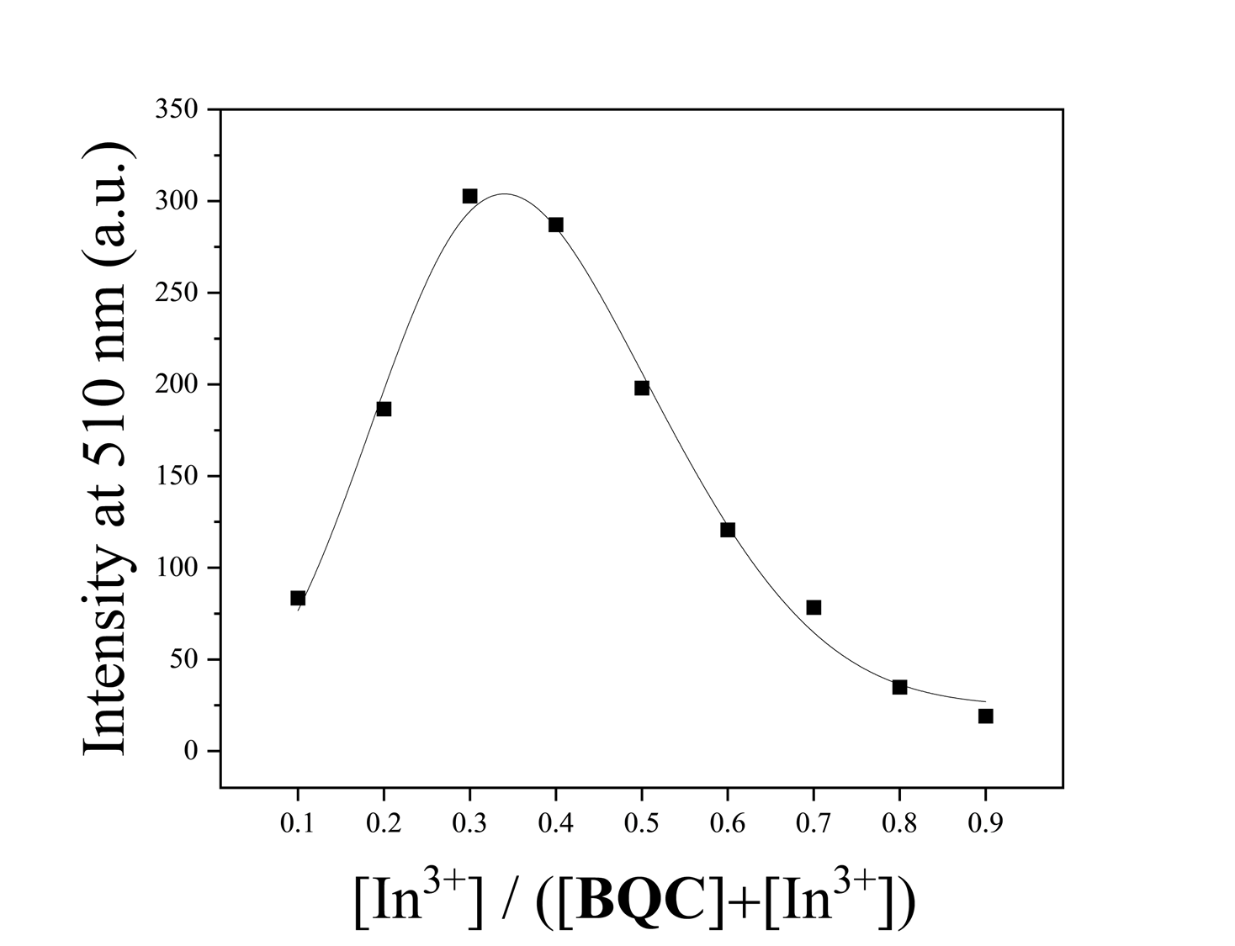
Figure S5 Job plot analysis of BQC with In³⁺.

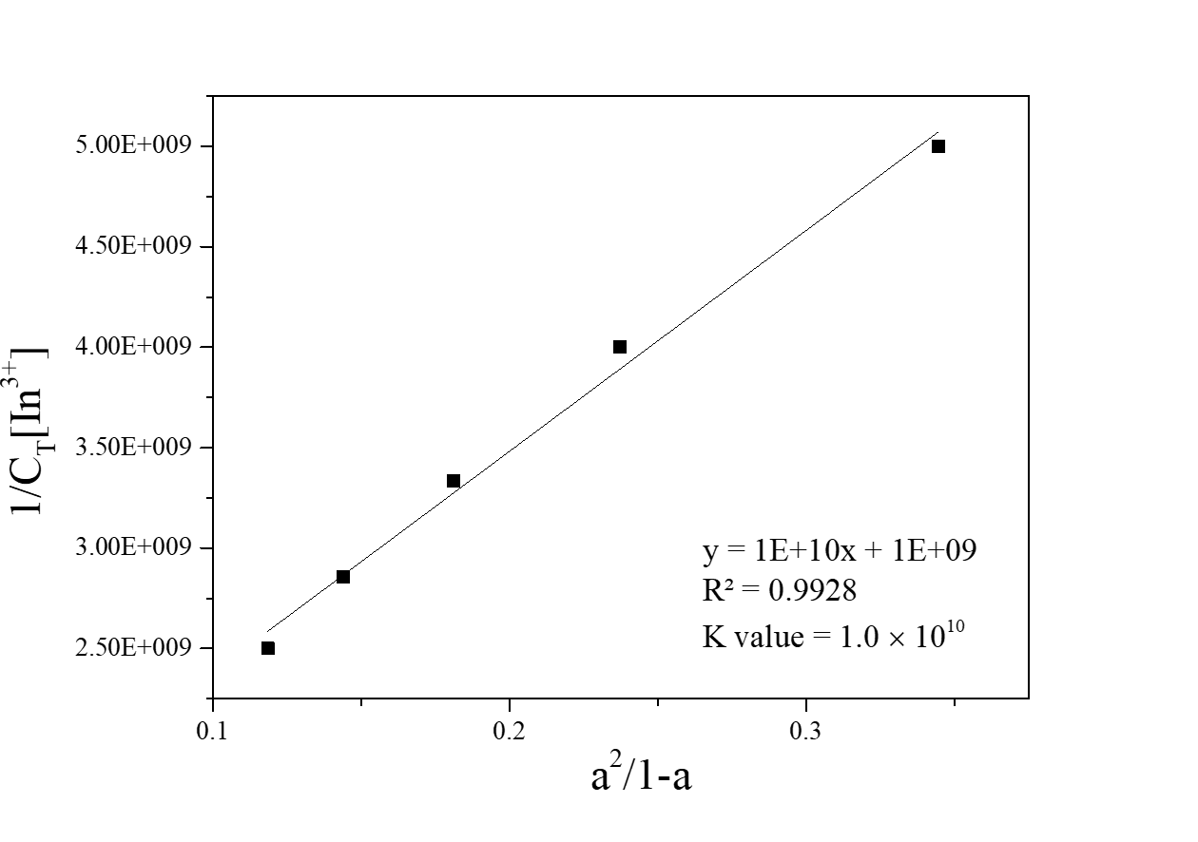
Figure S6 Li’s equation plot of BQC (10 µM) for In³⁺, assuming 2:1 stoichiometry for association of BQC with In³⁺.

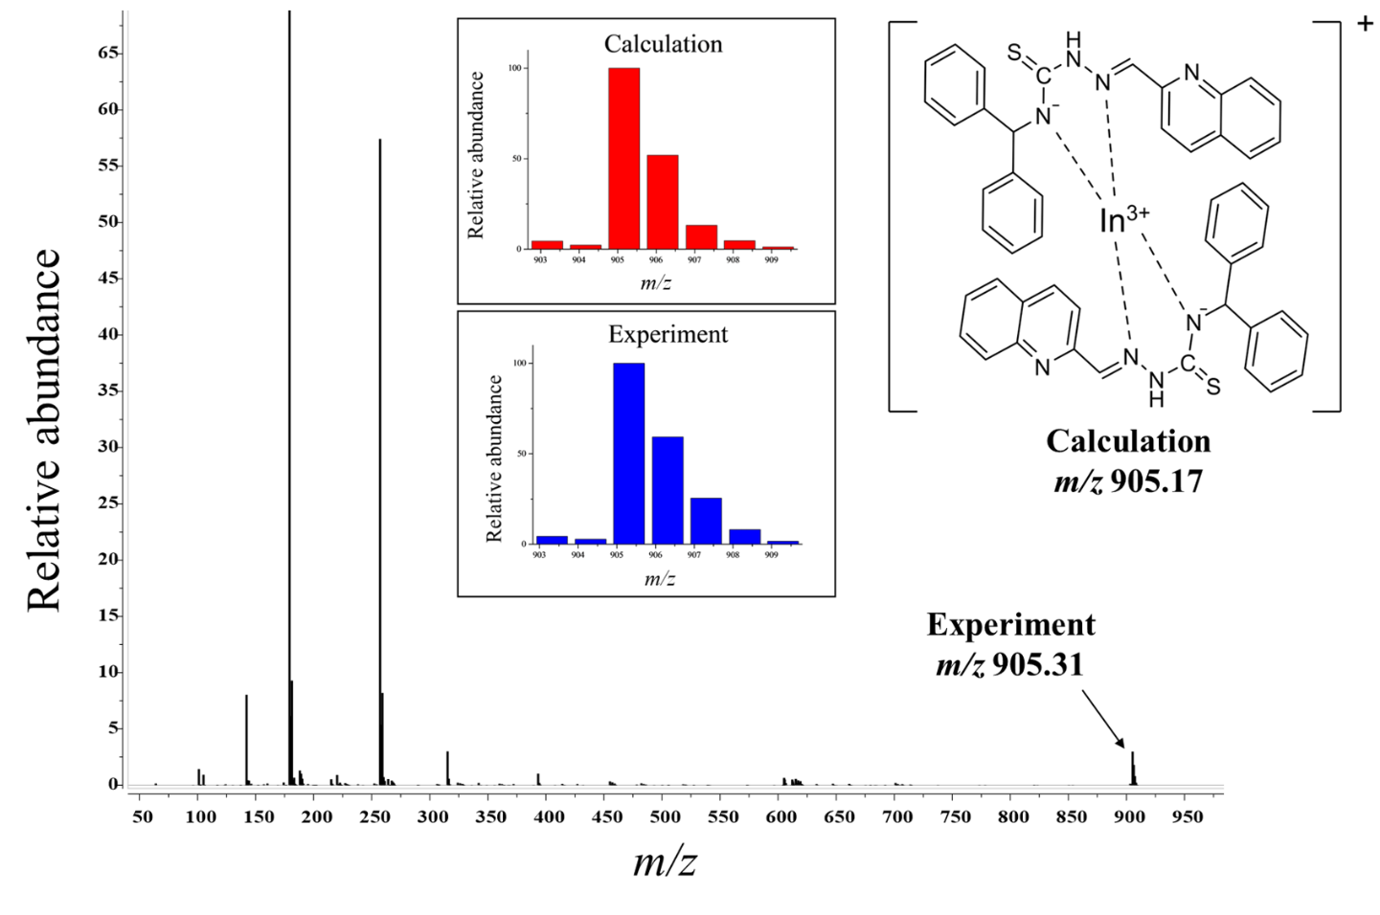
Figure S7 Positive-ion ESI-MS spectrum of BQC (100 µM) upon addition of In³⁺ (0.5 equiv).

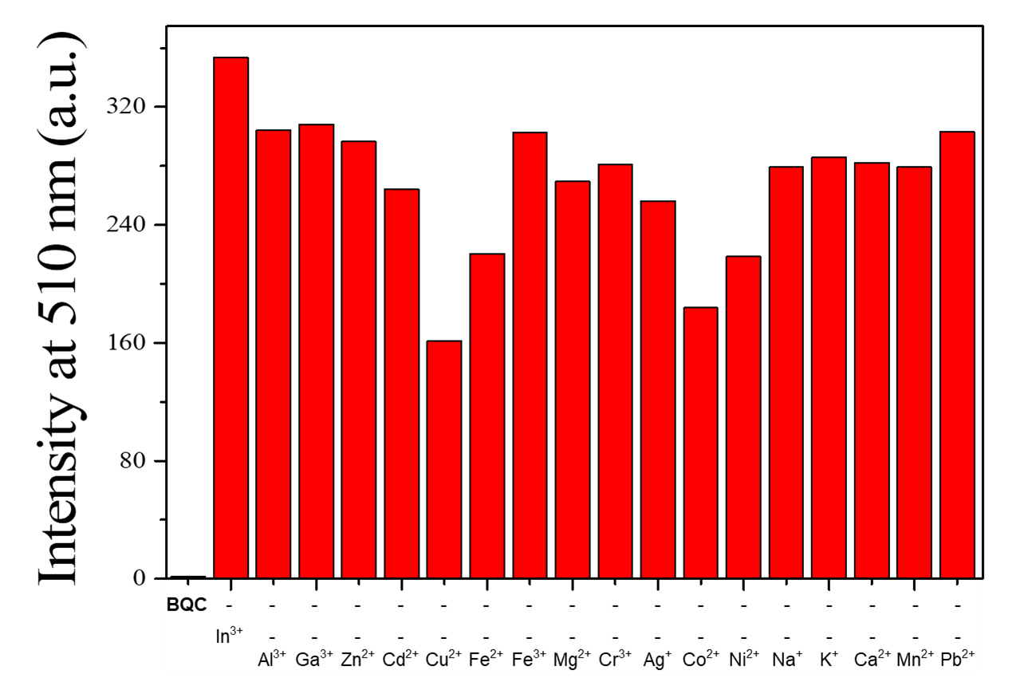
Figure S8 Fluorescence intensity (at 510 nm) of BQC (10 µM) toward In³⁺ (7.5 equiv) in the absence or presence of other metal ions (7.5 equiv).
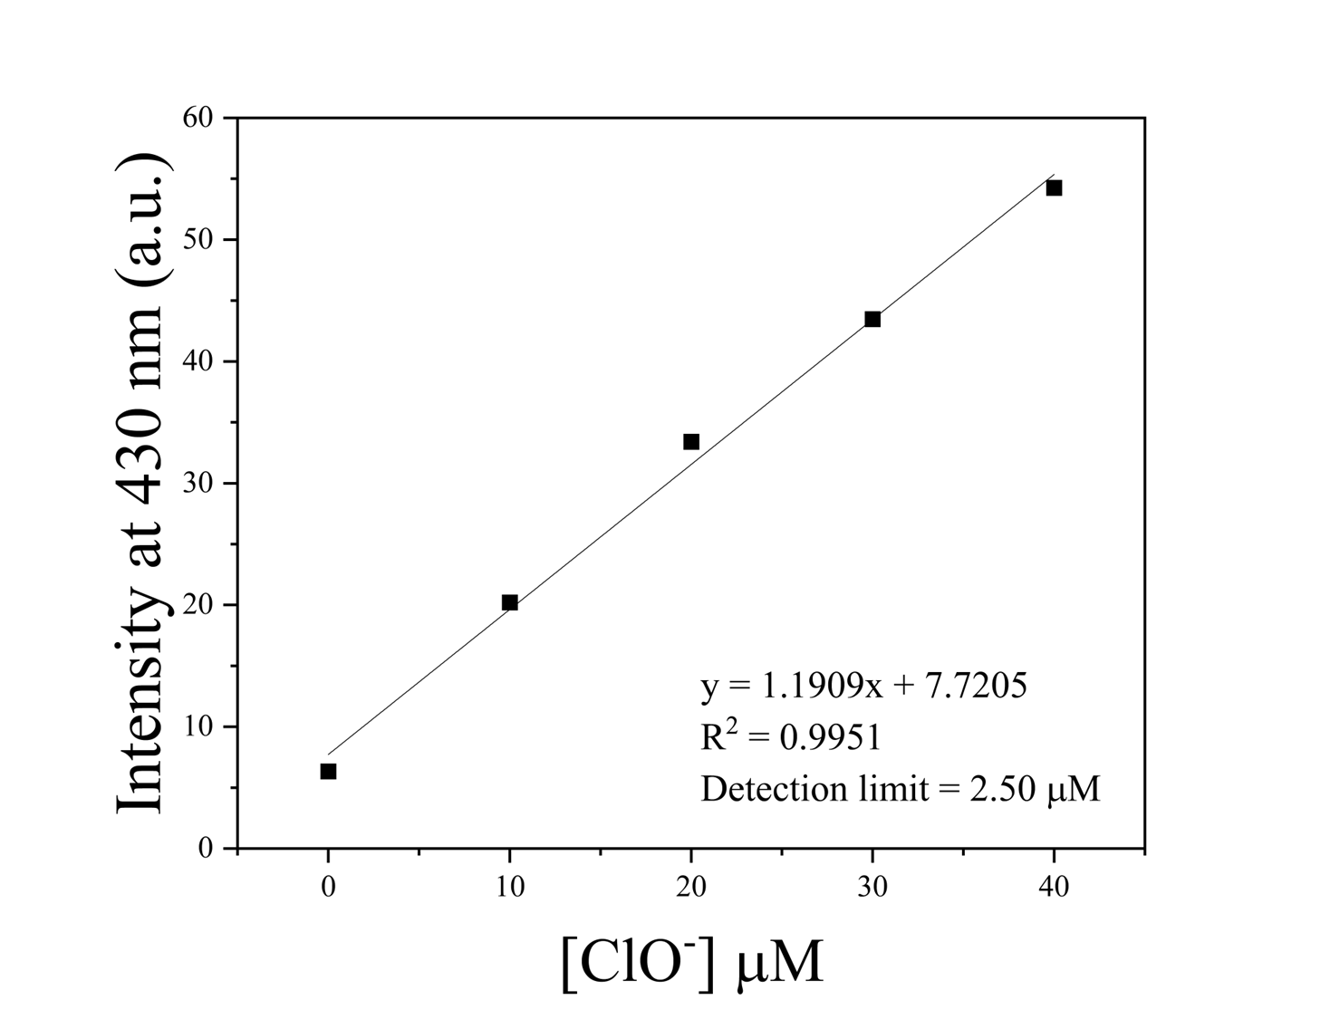
Figure S9 Linear relation of fluorescence emission changes (at 430 nm) of BQC with incremental addition of ClO⁻.

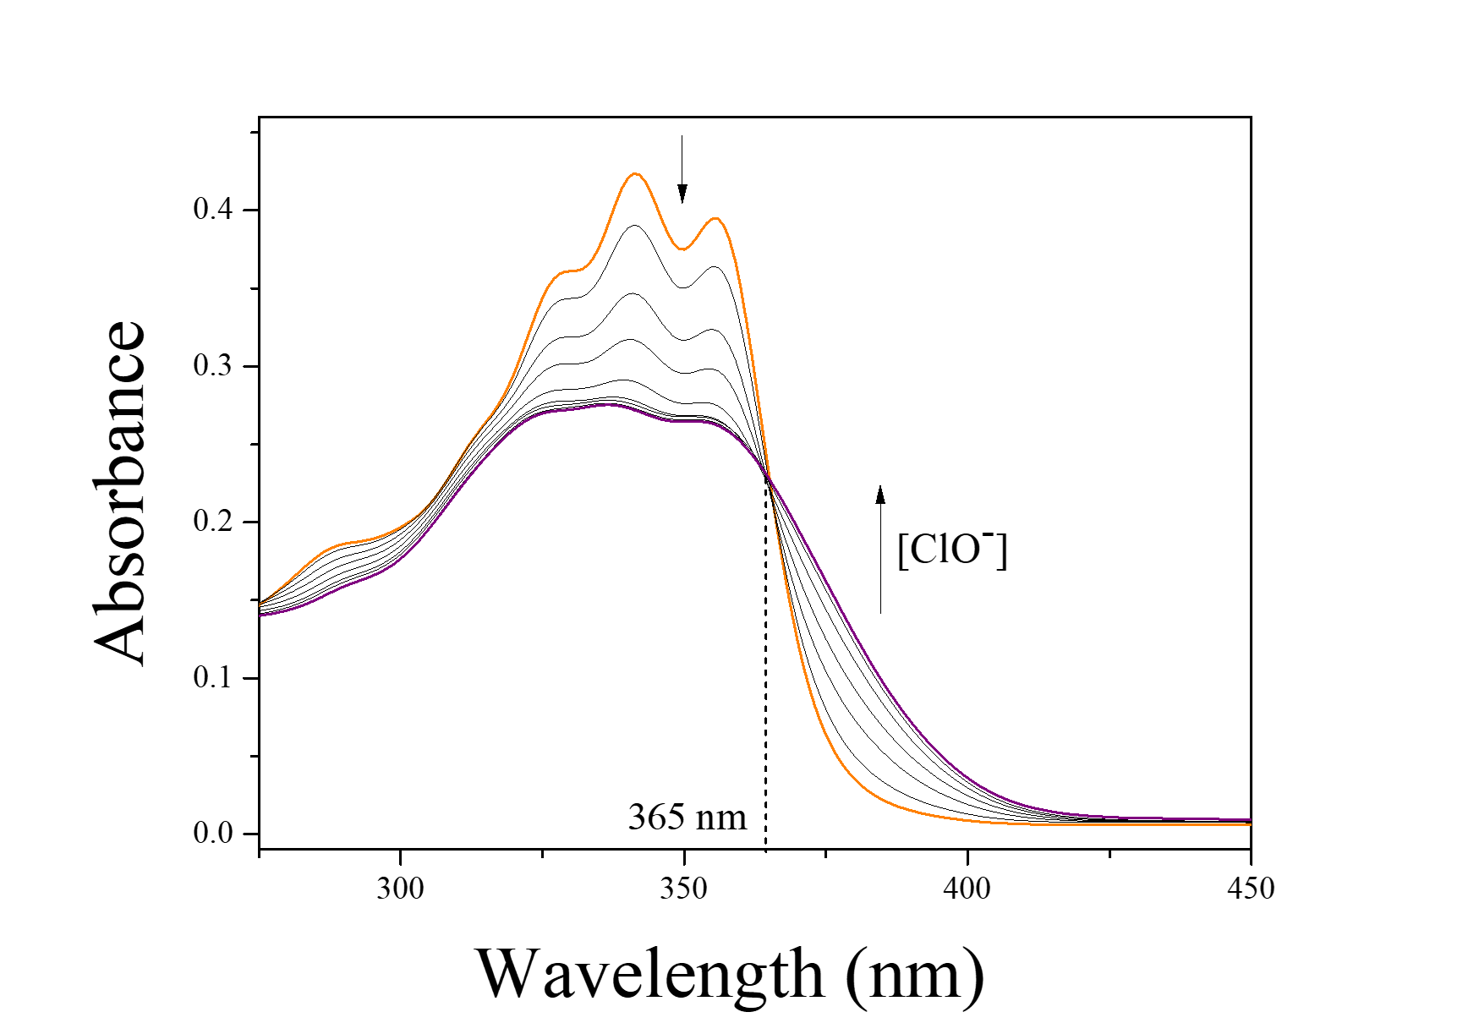
Figure S10 Absorption spectral changes of BQC (10 μM) upon the addition of 0-2.5 equiv of ClO⁻.

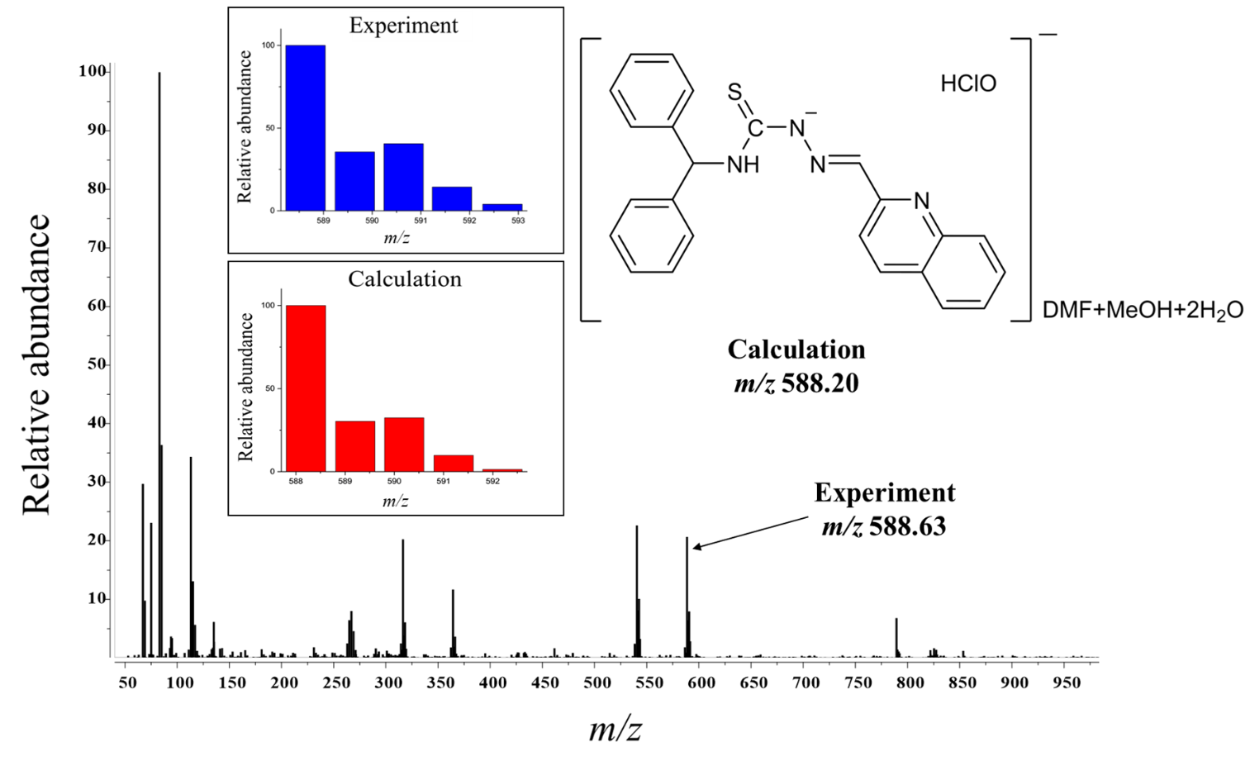
Figure S11 Negative-ion ESI-MS spectrum of BQC (100 µM) upon addition of ClO⁻ (1.0 equiv).

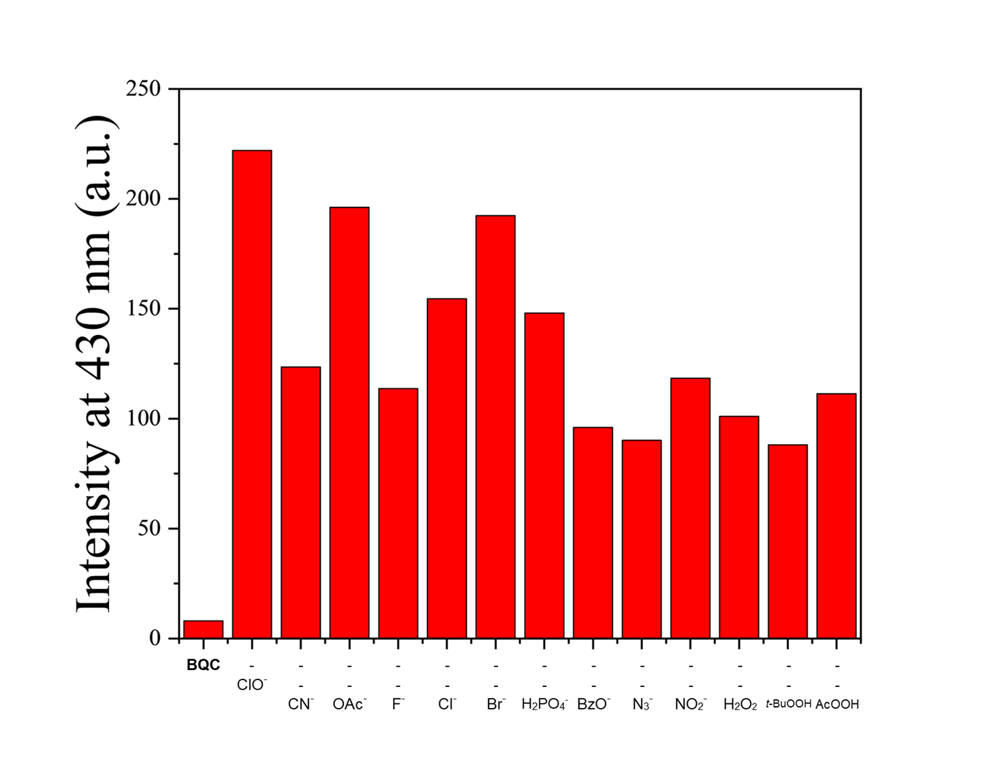
Figure S12 Fluorescence intensity (at 430 nm) of BQC (10 µM) toward ClO⁻ (19.0 equiv) in the absence or presence of other anions and ROS (19.0 equiv).

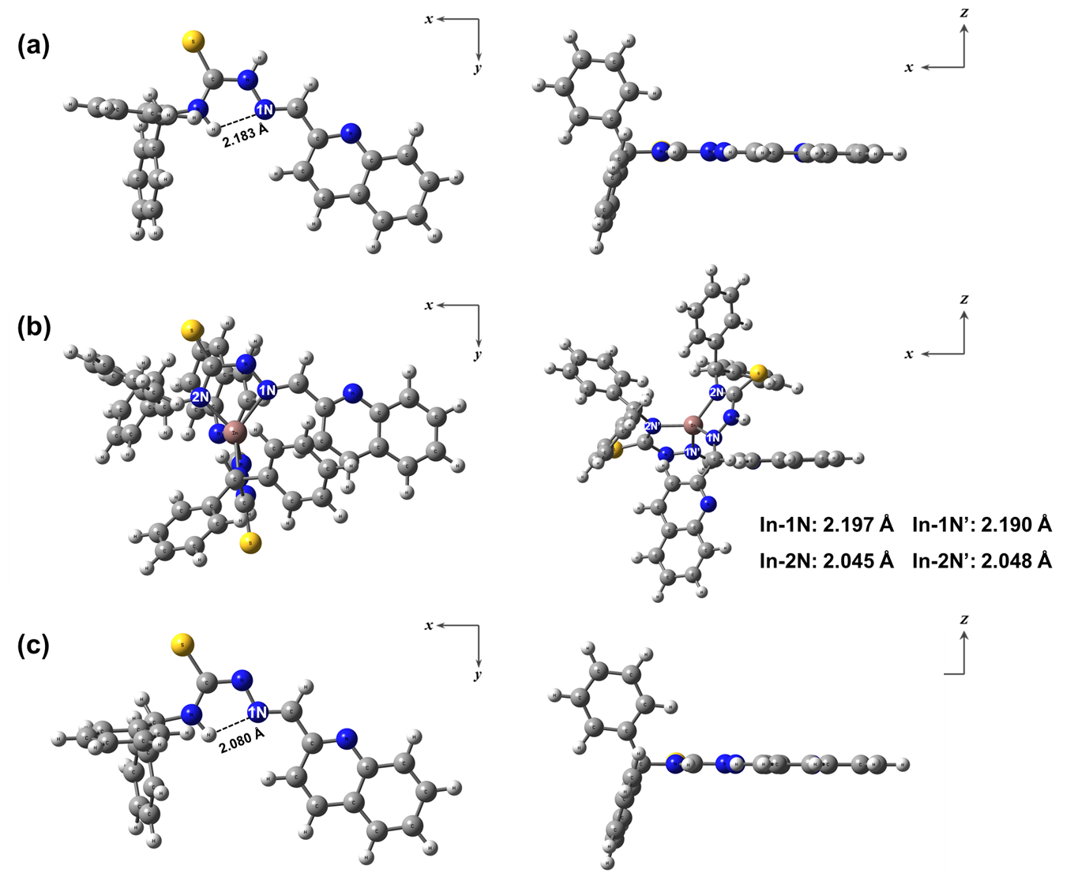
Figure S13 Energy-optimized structures of (a) BQC, (b) In³⁺-2∙BQC and (c) BQC-H⁺.

