Supplementary Material

Likelihood estimation
The likelihood was estimated via the following procedure:
- From the total number of new HIV diagnoses and person-quarters of follow-up time in the placebo arm of each efficacy trial, $S_{0T}$ and $Q_{0T}$, we randomly sampled the probability that an individual will have an HIV diagnosis during a given quarterly visit, $r_{T}$, from a beta distribution.
$$\begin{matrix}r_{T}∼β\left(1+S_{0,T},1+Q_{0,T}-S_{0,T}\right)\end{matrix}$$
- From the number of samples with and without quantifiable TFV among those with no HIV diagnosis, $Y_{+,T}$ and $Y_{-,T}$, and the total amount of followup in the active arms of each trial, $Q_{1,T}$, we randomly sampled the total amount of quarterly visits with and without quantifiable TFV.
$$\begin{matrix}Q_{+,T} & ∼Q_{1,T}β\left(1+Y_{+,T},1+Y_{-,T}\right) \\ Q_{-,T} & =Q_{1,T}-Q_{+,T}\end{matrix}$$
- For each trial, we calculated the HIV hazard ratio of individuals with and without quantifiable TFV compared to the placebo group, $h^{\left(±|T,\tilde{k}\right)}$ of HIV. For models $h_{1}$, $h_{2}$ and $h_{3}$, we imputed values of TFV-DP concentration as described above. We drew $Q_{+,T}$ and $Q_{-,T}$ values for follow-up time with and without quantifiable TFV, respectively. The probability of HIV acquisition with and without quantifiable TFV in each trial is then averaged across all follow-up time.
$$\begin{matrix}p_{±,T} & =\left(\sum_{j=1}^{Q_{±,T}}{1}-{\left(1-r_{T}\right)}^{h^{\left(j\right)}\left(±|\tilde{k},T\right)}\right)/Q_{±,T}\end{matrix}$$
- For models $h_{4}$ and $h_{5}$, there is no imputation step so the hazard ratio is completely determined by TFV quantification.
$$\begin{matrix}p_{±,T} & =1-{\left(1-r_{T}\right)}^{h\left(±|\tilde{k},T\right)}\end{matrix}$$
- The likelihood is computed by comparing the rates, $p_{P,T}$, to the observed number of seroconversions in the TDF/FTC arm of each trial $S_{P,T}$ and amount of follow-up time
Lk,Data=expP,T​PBinomSP,T;QP,T,pP,T
- Steps 1-4 were repeated 10 times and the final likelihood is the average across each repetition.

Supplementary Figures and Tables

Figure S1
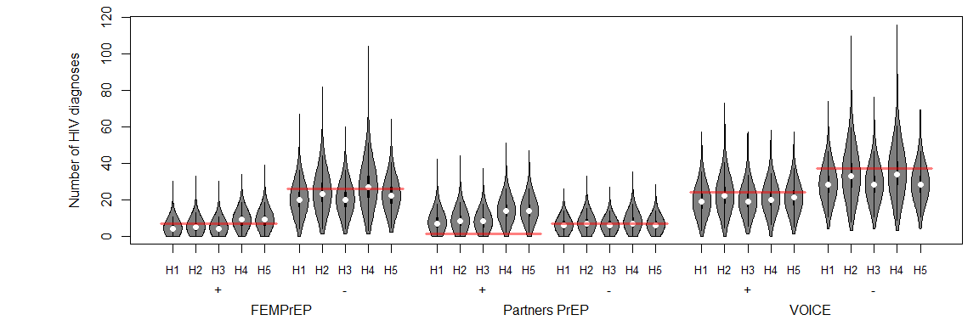
Figure S1: Comparison of efficacy models. For each model $h_{1-5}$, we calculate the distribution of the expected number of HIV diagnoses with quantifiable (+) and unquantifiable (-) plasma TFV as defined by each study in FEMPrEP, Partners PrEP, and VOICE (violin plots, where width indicates probability of an observation) and compare to the number observed in the trial (red horizontal line). For models H1-3, TFV-DP measures are multiply imputed ten-fold for each parameter set.

Figure S2

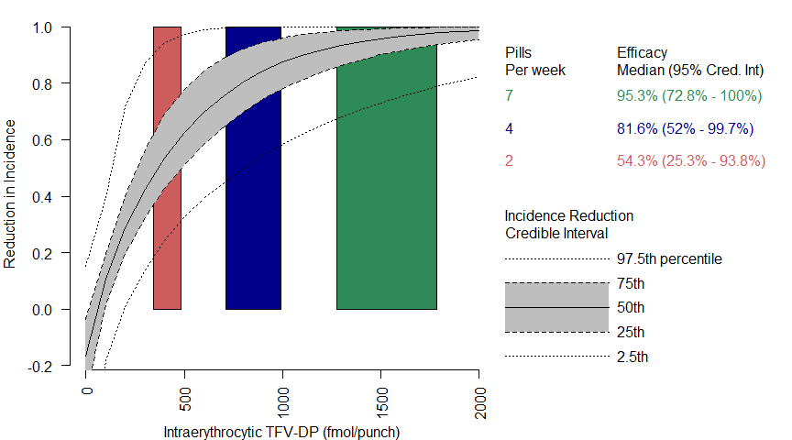
Figure S2: Efficacy of TDF/FTC by TFV-DP measurement in model $h_{2}$ Reduction in incidence in HIV as a function of tenofovir diphosphate (TFV-DP) levels in dried blood spots measurement according to model $h_{2}$. Grey ribbon = IQR, Dashed line = 95% Credible Interval. Colored rectangles represent the IQR of TFV-DP measurements associated with two pills per week (red), four pills per week (blue) and seven pills per week (green) derived from directly observed dosing⁶.

Figure S3
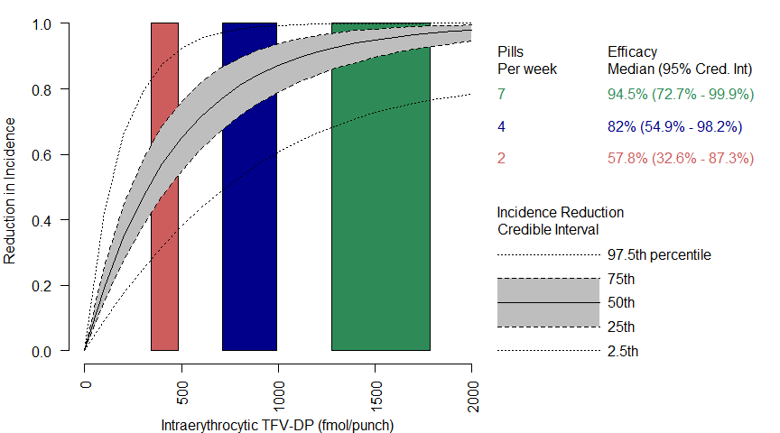
Figure S3: Efficacy of TDF/FTC by TFV-DP measurement in model $h_{3}$ Reduction in incidence in HIV as a function of tenofovir diphosphate (TFV-DP) levels in dried blood spots measurement according to model $h_{3}$. Grey ribbon = IQR, Dashed line = 95% Credible Interval. Colored rectangles represent the IQR of TFV-DP measurements associated with two pills per week (red), four pills per week (blue) and seven pills per week (green) derived from directly observed dosing⁶.

Figure S4
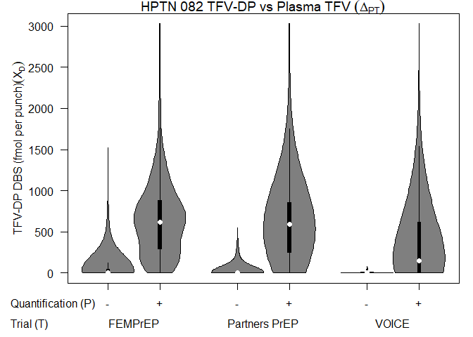
Figure S4: Imputation of TFV-DP from Plasma. Measurements of intraerythrocytic TFV-DP among HPTN 082 participants with quantifiable or unquantifiable plasma TFV using the quantification threshold of each trial (see Table 2). Width = frequency, white dot = median, black rectangle = interquartile range, black line = upper and lower adjacent values.

Table S1
Table S1: Deviance Information Criterion (DIC) by model. Lower values indicate a model is more predictive of number of seroconverters in FEMPrEP, Partners PrEP, and VOICE. H1 = primary TFV-DP DBS model, H2-3 = alternative TFV-DP DBS models, H4-5 plasma TFV models. DIC is composed of the mean log-likelihood across an ensemble of model fits to data (mean(-2LL)) measuring the goodness of fit and the variance of the log-likelihood across those same fits (var(2LL)/2) which measures model complexity.
Model | DIC | mean(-2 LL) | var(2 LL)/2
Base Model $(h_{1})$ | 42.0 | 39.8 | 2.27
First alternative Model$(h_{2})$ | 44.0 | 39.3 | 4.68
Second Alternative Model $(h_{3})$ | 41.9 | 39.9 | 2.00
Plasma TFV Model ($h_{4})$ | 47.2 | 43.7 | 3.50
Alternative TFV Model ($h_{5})$ | 46.5 | 44.0 | 2.48

