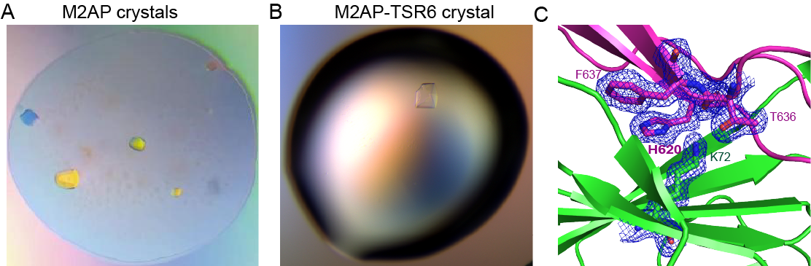

Figure S1. The crystals and electron density map.
A-B. M2AP and M2AP-TSR6 crystals. C. The 2mFo-DFc electron density map of the key residues in the complex. The residues His-620, Thr-636 and Phe-637 in TSR6 and K72 in M2AP are shown as sticks. 2mFo-DFc contoured at 1σ (blue).

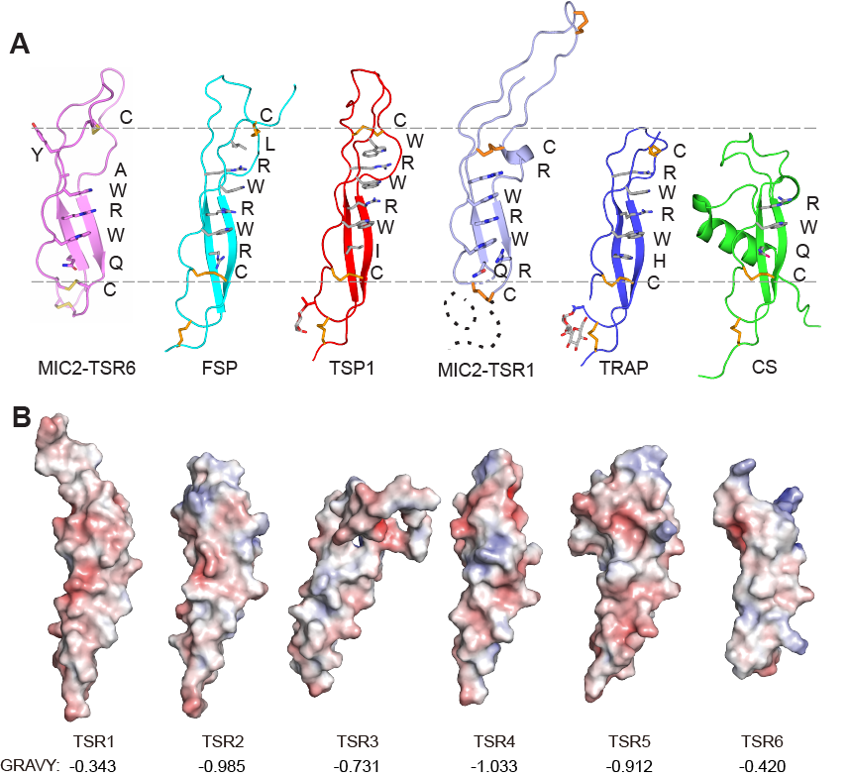

Figure S2. Electrostatics of MIC2 TSR domains and full-length architecture.
A. Comparison of MIC2 TSR6 and other structurally determined TSRs. Layered residues for each TSR domain are shown and labelled. Dashed lines mark the upper and bottom disulfide bonds of the layer. B. Electrostatics of TSR6 and other TSR domains within MIC2. The M2AP-binding face is shown for TSR6 and other TSR domains are shown in identical orientations. TSR1-5 structures are from the full-length of Alphafold MIC2 model. Electrostatic solvent accessible surfaces were calculated with scale of [−5 (red) to +5 (blue) kT/e].

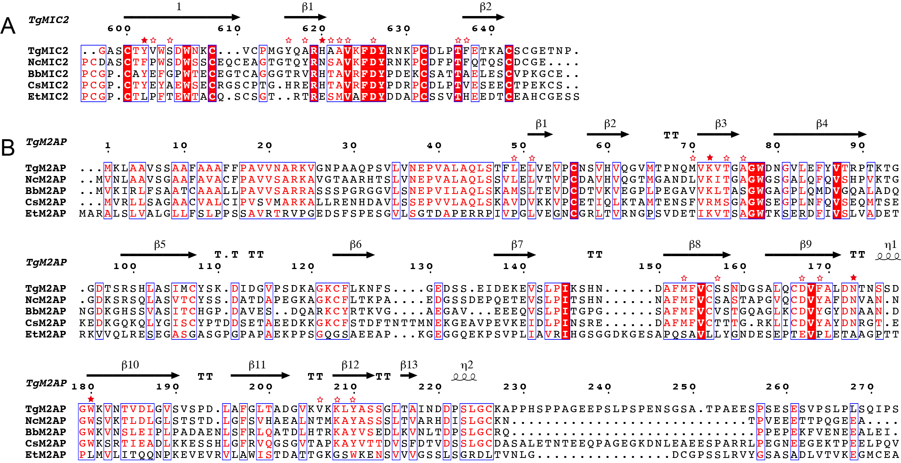

Figure S3. Sequence alignment of TSR6 (A) and M2AP (B).
Secondary structures of tgTSR6 and tgM2AP are highlighted on the top of the alignment, respectively. Residues involved in direct hydrogen bond interactions are shown as solid star, while other residues within the interface are shown as empty star.

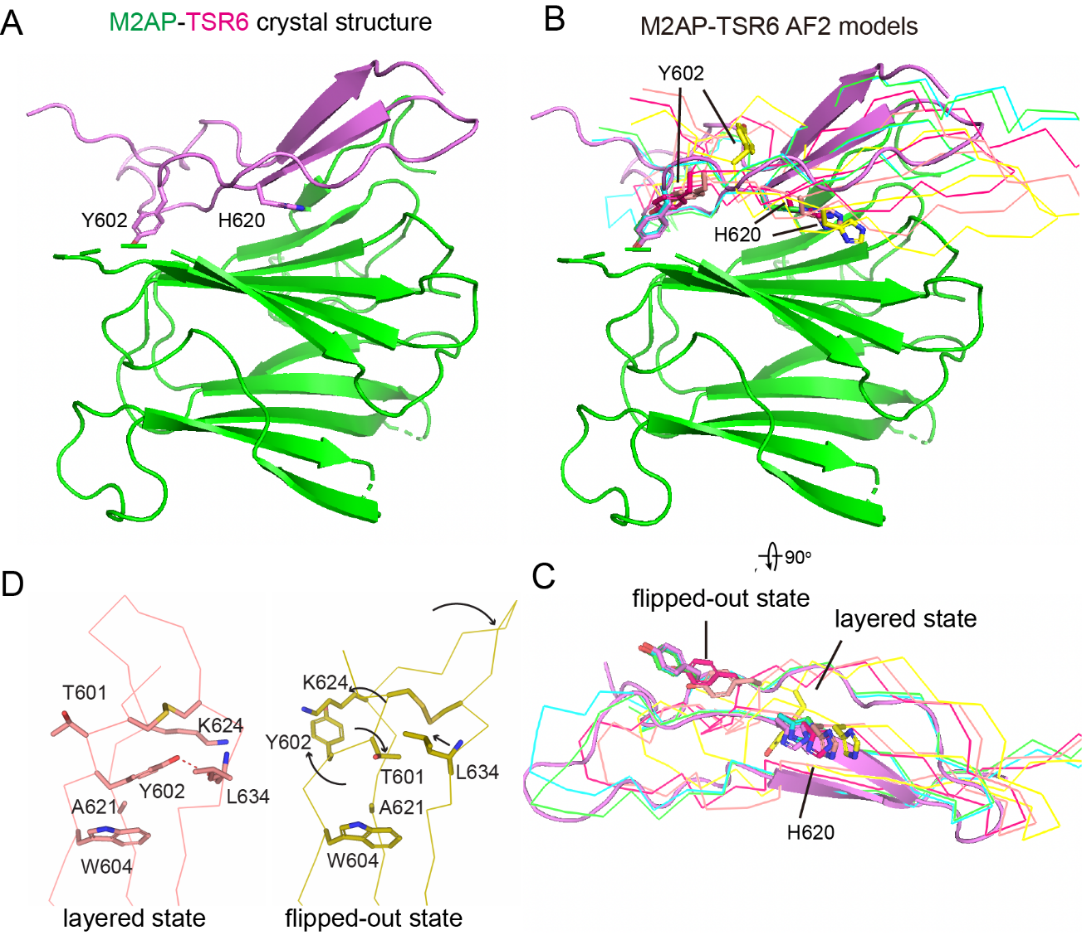

Figure S4. The predicted AlphaFold complex models and dynamics of Y602.
A. The determined crystal structure of MIC2-M2AP complex in current study. Two key residues are shown with sticks. B-C. The predicted complex models are superimposed with the crystal structure on M2AP. TSR6s in models are shown as ribbon and the M2APs are hidden for clarity. In panel C all M2APs are hidden to view the positions of Tyr-602 and His-620. D. Comformational changes around Tyr-602 of TSR6 between layered state and flipped-out state.

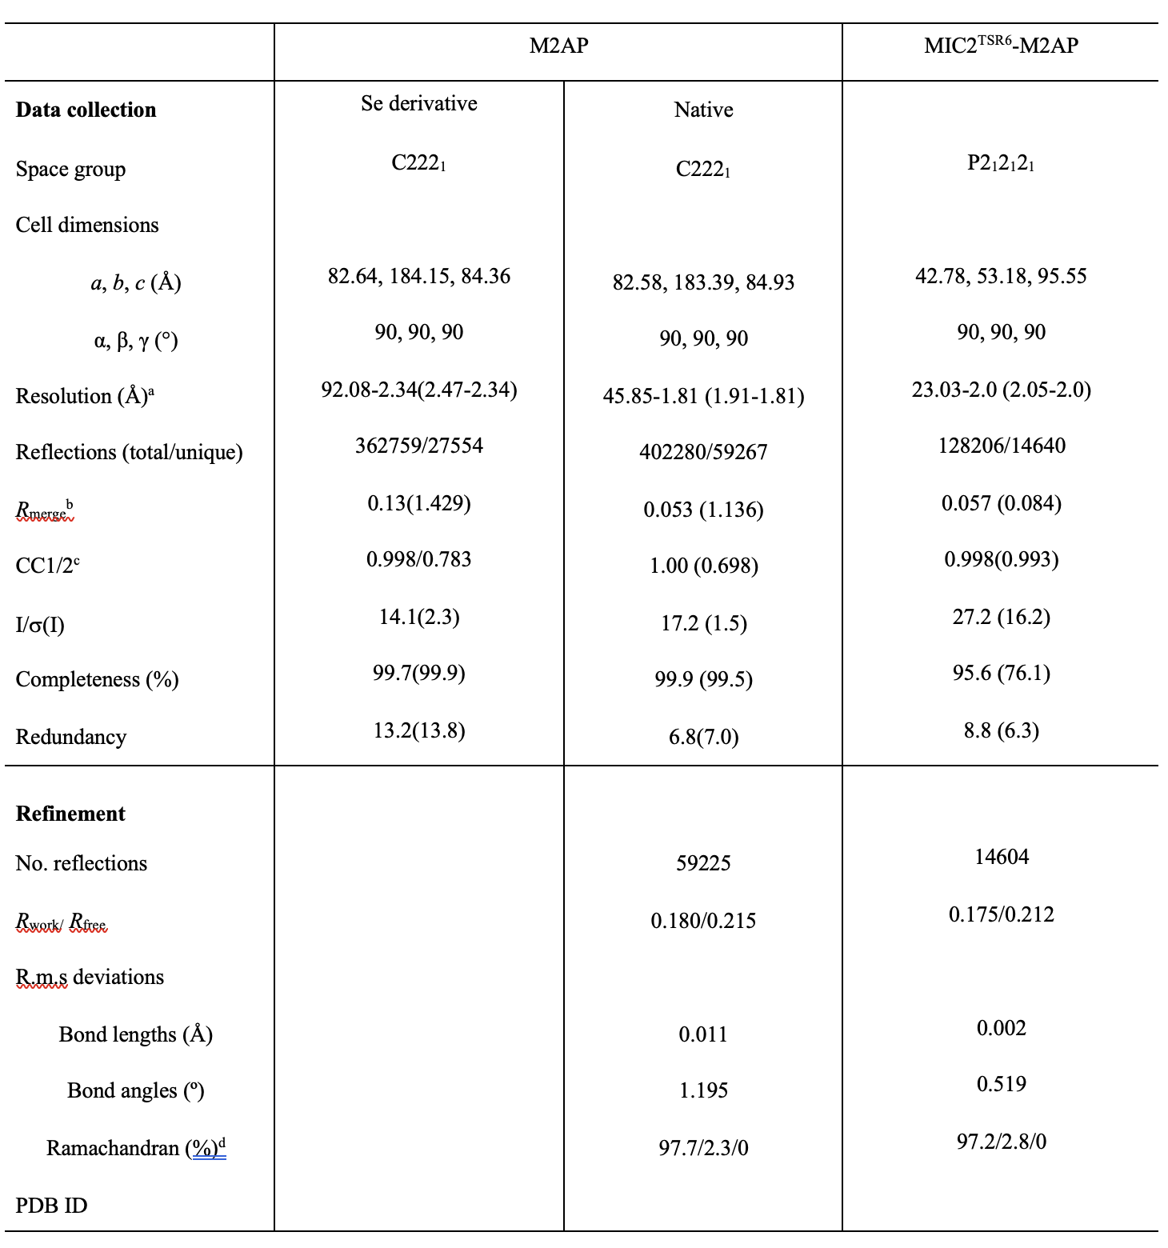
Table S1. data collection and refinement statistics
ªValues for highest resolution shells are given in parentheses.
^{b}Rmerge = ∑hkl∑_{i}|I_{i}(hkl) − <I(hkl)>|/∑hkl∑_{i}|I_{i}(hkl) where I_{i} (hkl) and <I(hkl)> are the i and mean measurement of intensity of reflection hkl.
^{c}CC1/2 = Pearson’s correlation coefficient between average intensities of random half data sets for each unique reflection.
^{d}Residues in favored, accepted, and outlier regions of the Ramachandran plot as reported by MOLPROBITY.

