Table 1. SARS-CoV-2 3CLpro inhibition SAR of monocyclic P1 replacements Pyrazole Series.
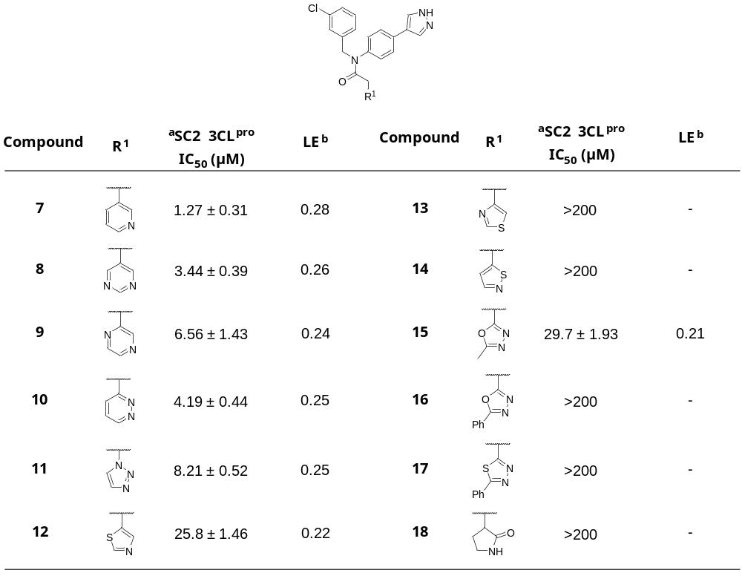
SARS-CoV-2 3CL^{pro} inhibitors 7-18, IC₅₀ values are average of at least 3 independent assays, each run as technical duplicates; ª SARS-CoV-2 3CL^{pro} biochemical assay inhibition; ^{b} Ligand efficiency.

Table 2. SARS-CoV-2 3CLpro inhibition SAR P1 replacements Imidazole Series.
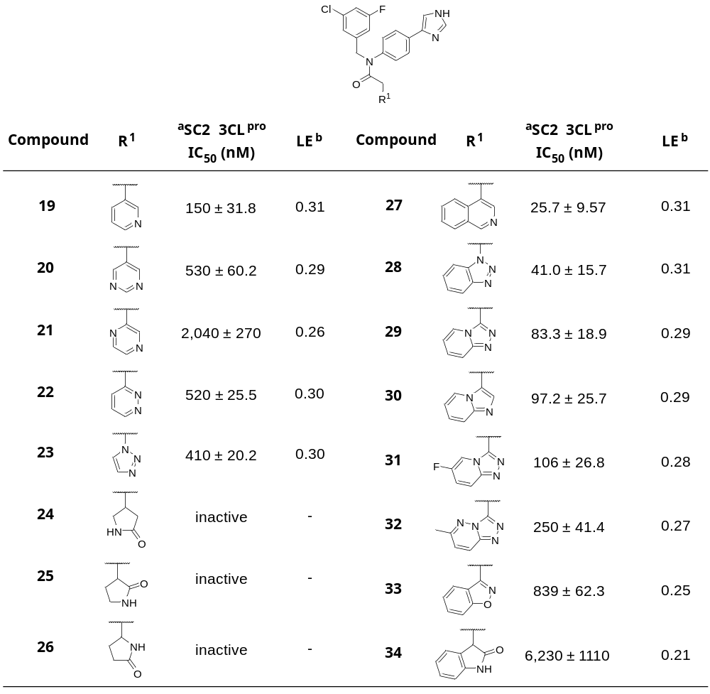
SARS-CoV-2 3CL^{pro} inhibitors 19-34, IC₅₀ values are average of at least 3 independent assays, each run as technical duplicates; ª SARS-CoV-2 3CL^{pro} biochemical assay inhibition; ^{b} Ligand efficiency.

Table 3: SARS-CoV-2 3CLpro SAR Simple Pyridyl P1 Imidazole Series.
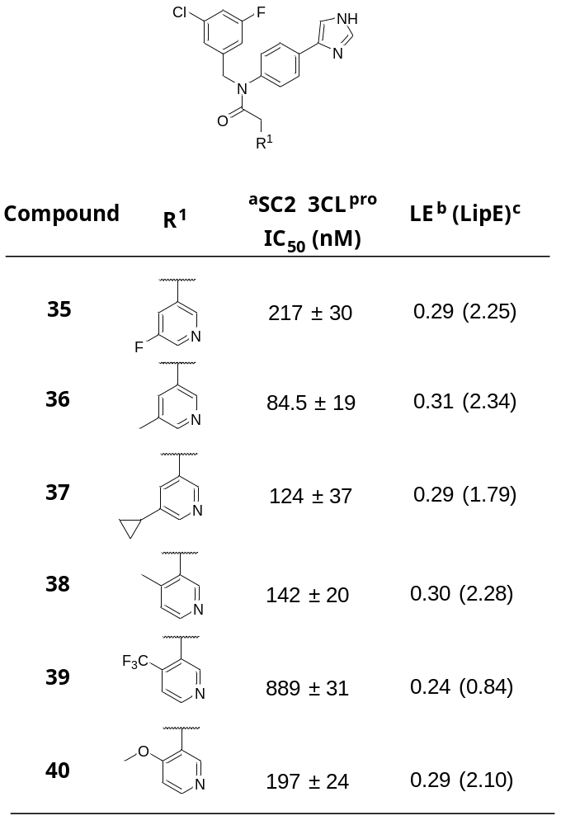
SARS-CoV-2 3CL^{pro} inhibitors 35-40, IC₅₀ values are average of at least 3 independent assays, each run as technical duplicates; ª SARS-CoV-2 3CL^{pro} biochemical assay inhibition; ^{b} Ligand efficiency; ^{c} Lipophilic efficiency.

