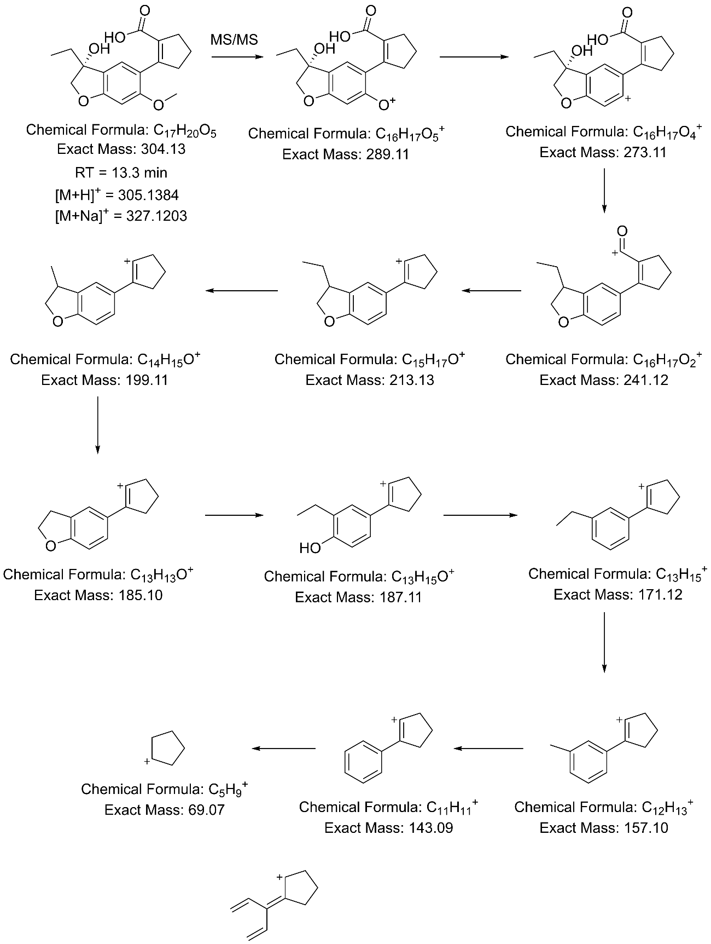

Fig S5. Proposed structure of peak 4 and MS/MS fragmentation observed.

