Supplementary Material 1
Interactive Effects of Zinc and Titanium Nanoparticles of Leaf Decomposition in Freshwater Ecosystems

Nawal Al Jabri, Raeid M.M. Abed, Abdulkadir Elshafie, Michael J. Barry

Index
- DLS ZnO₂ nanoparticles experiment 1
- DLS TiO nanoparticles experiment 1
- SEM ZnO₂ nanoparticles experiment 1
- SEM TiO nanoparticles experiment 1
- DLS TiO and ZnO₂ nanoparticles experiment 2
- SEM TiO and ZnO₂ nanoparticles experiment 2
- Zn²⁺ concentrations experiment 2

Fig. S1. DLS results for Top: 1 mg/L nZ, Middle: 10 mg/L nZ, Bottom: 100 mg/L nZ

Fig. S2. DLS results for Top: 1 mg/L nT, Middle: 10 mg/L nT, Bottom: 100 mg/L nT

Fig. S3. SEM images of ZnO nanoparticles at three different concentrations (1.0, 10.0, 100 mg/L) respectively (at 20,000 x magnification).

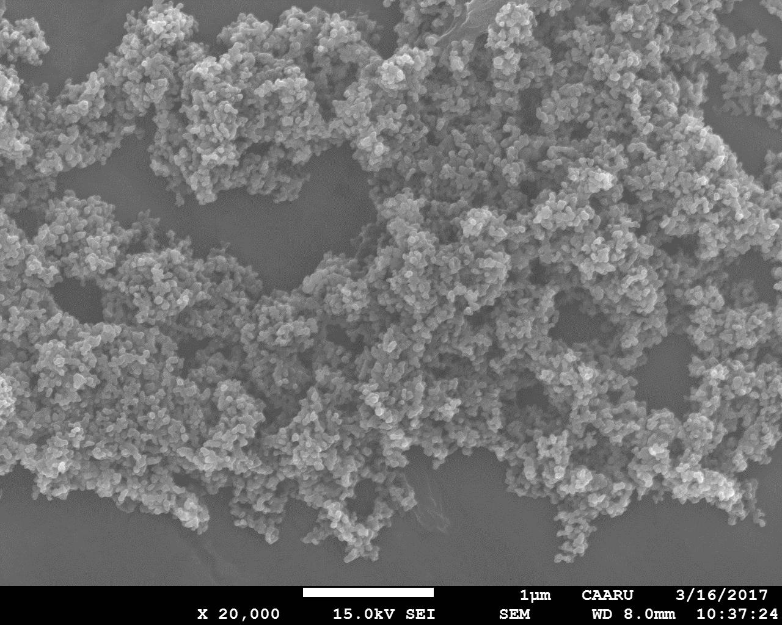
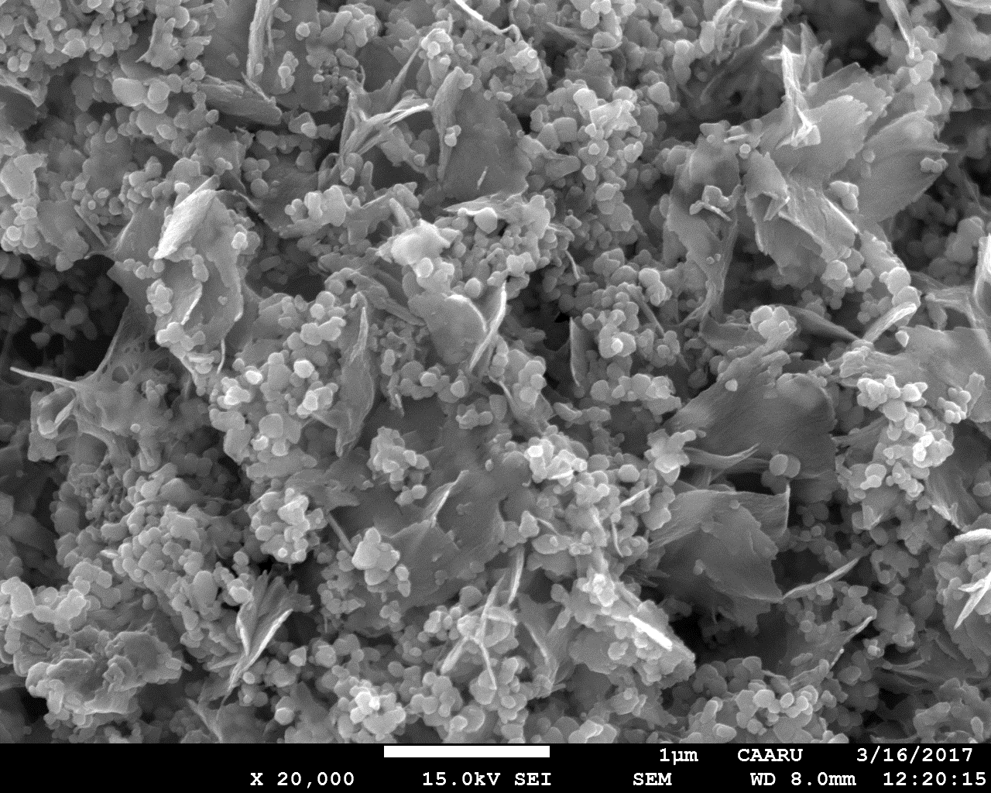
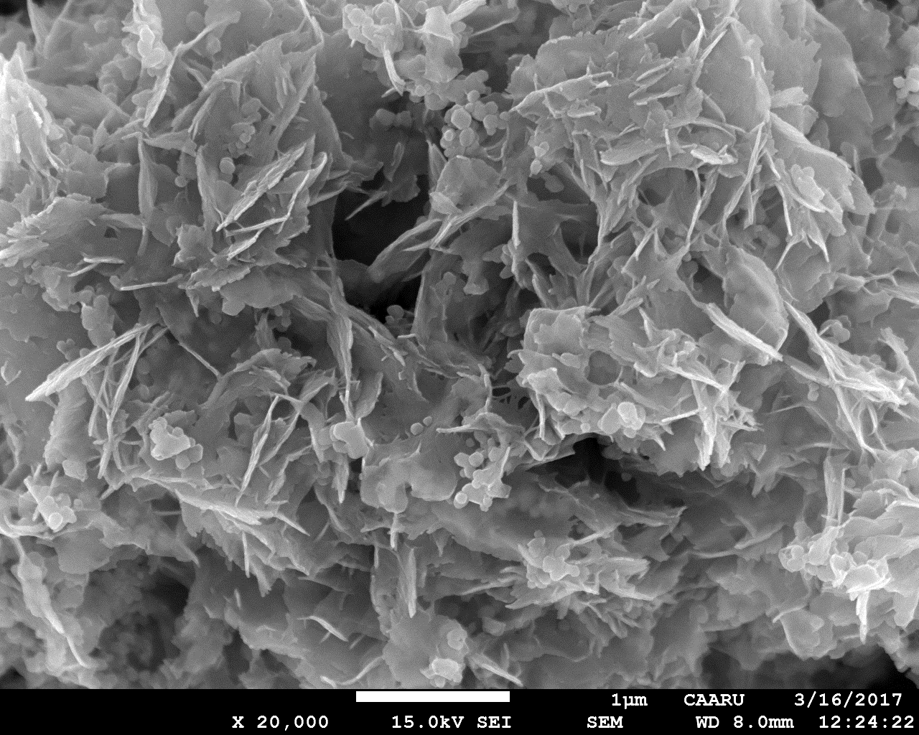
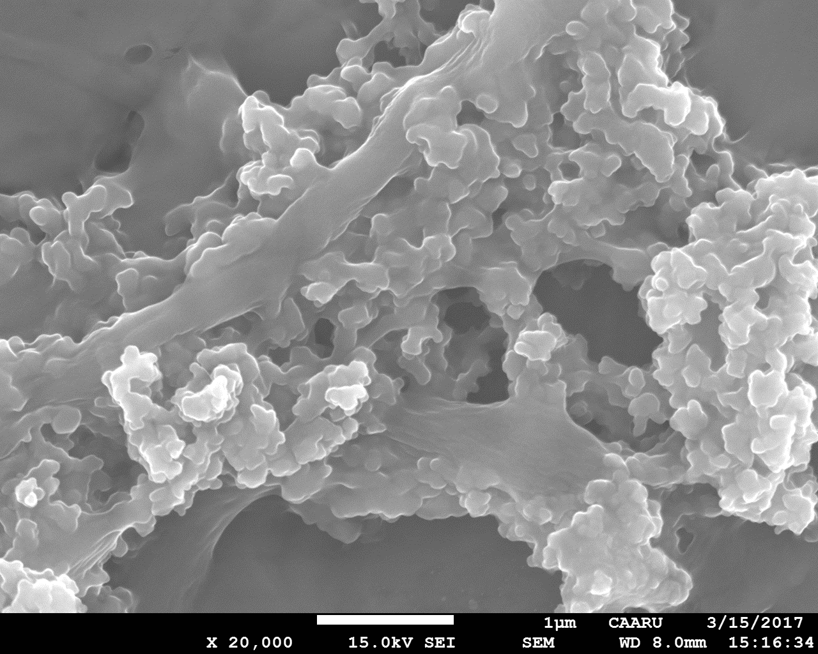
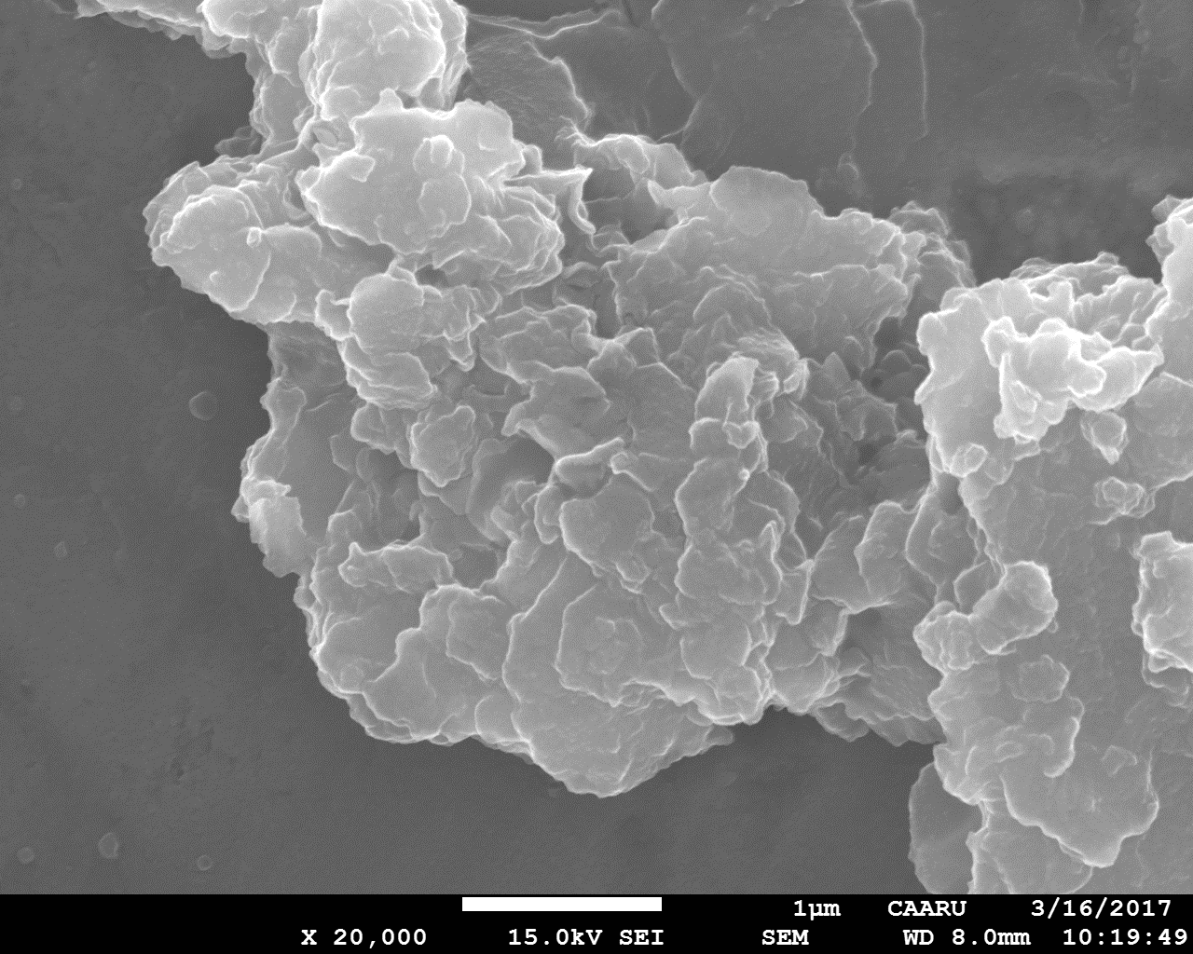
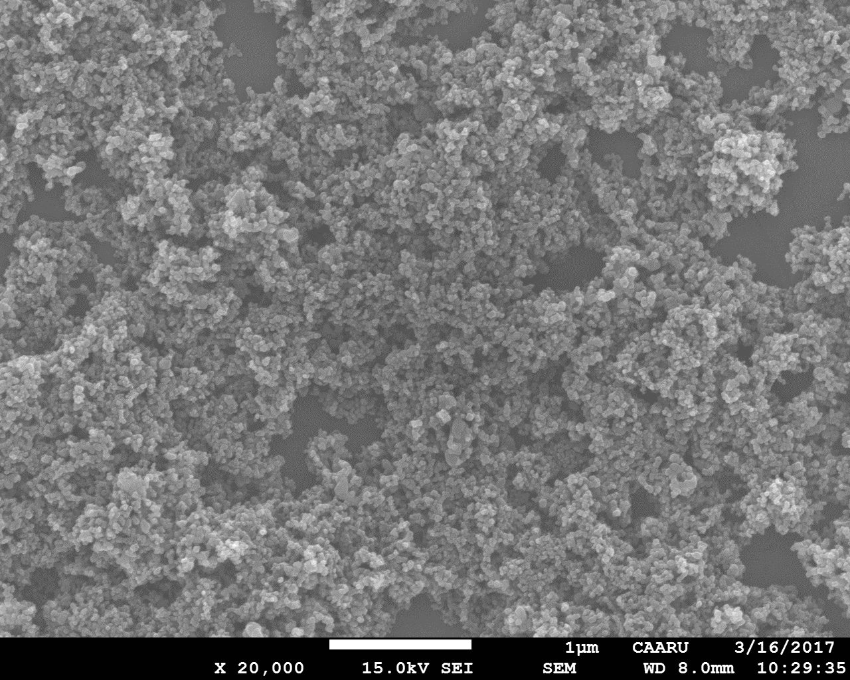
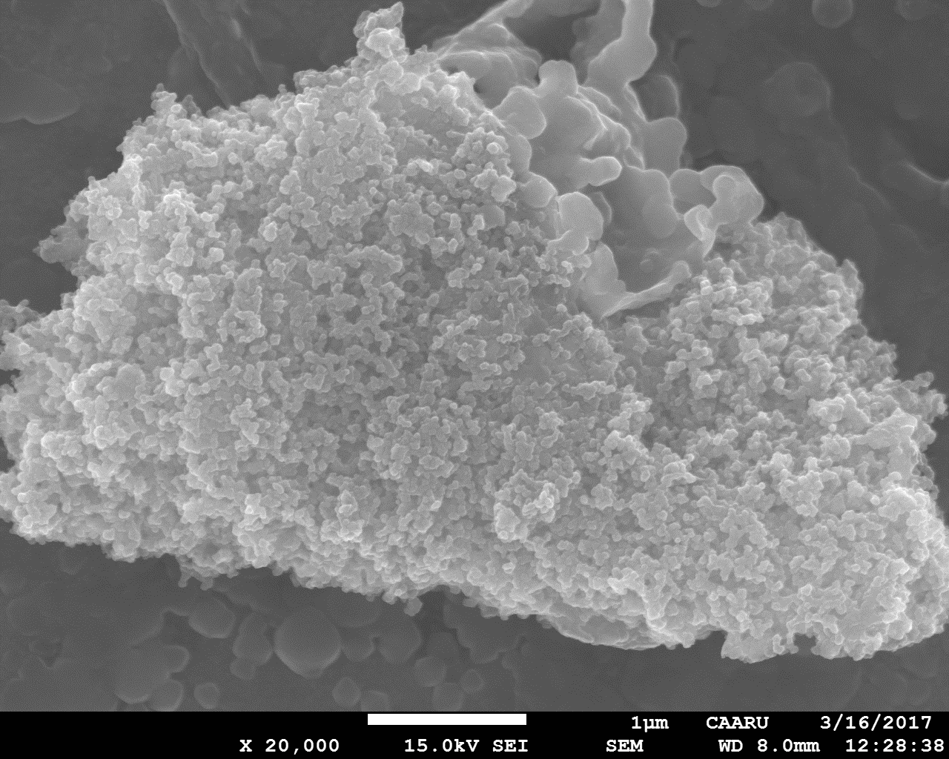
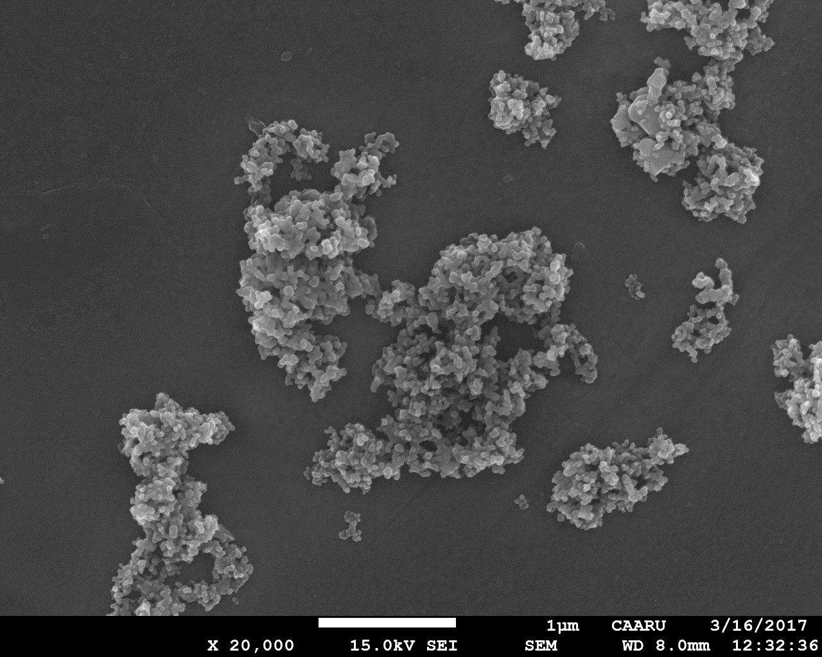
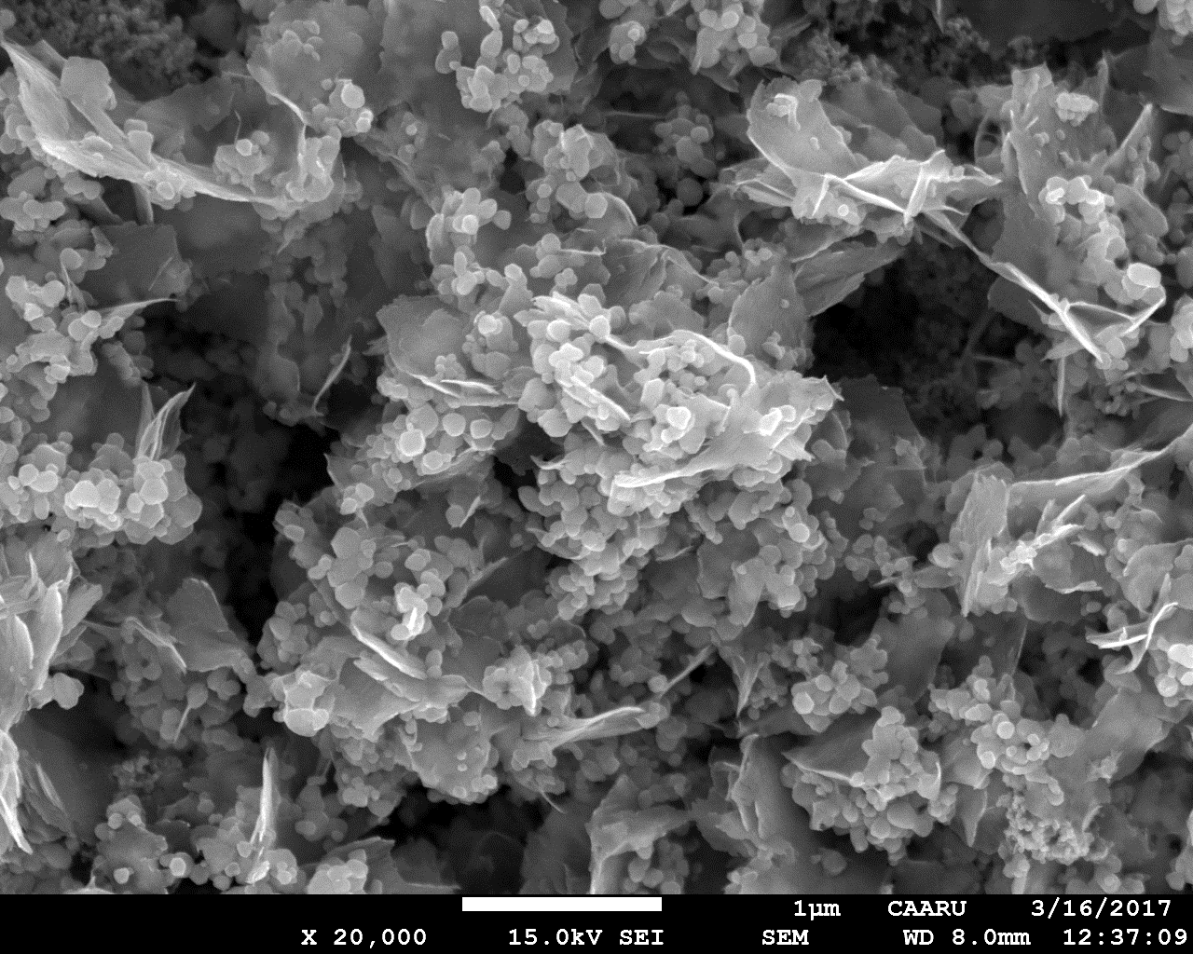
1.0mg/L
100.0mg/L
10.0mg/L
Fig. S4 SEM images of TiO₂ nanoparticles at three different concentrations ( 1.0, 10.0, 100 mg/L) respectively (at 20,000 x magifiacation).

Fig. S5. SEM images of combined solution of ZnO and TiO₂ nanoparticles at three concentrations (1.0, 10.0, 100 mg/L, respectively (at 20,000x magnification).

1.0mg/L
10.0mg/L
100.0mg/L

100.0mg/L
10.0mg/L
1.0mg/L

Fig. S6. DLS results for Experiment 2. Top: nZ 10 mg/L. Bottom nT 10 mg/L

Fig.s7. TEM images of A) ZnO-NPs (at magnifications 50 nm and 20 nm), B) TiO₂-NPs (at magnifications 20 nm and 5 nm).
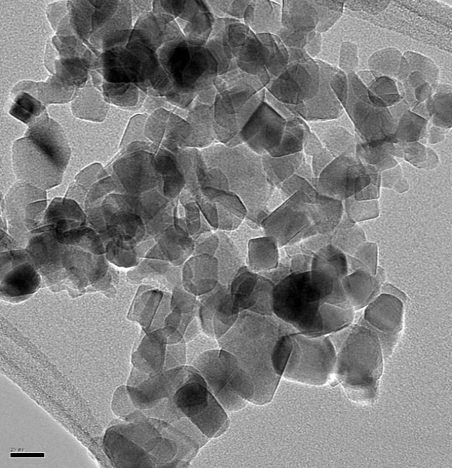
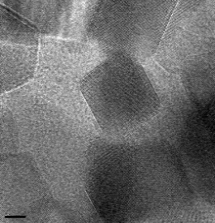
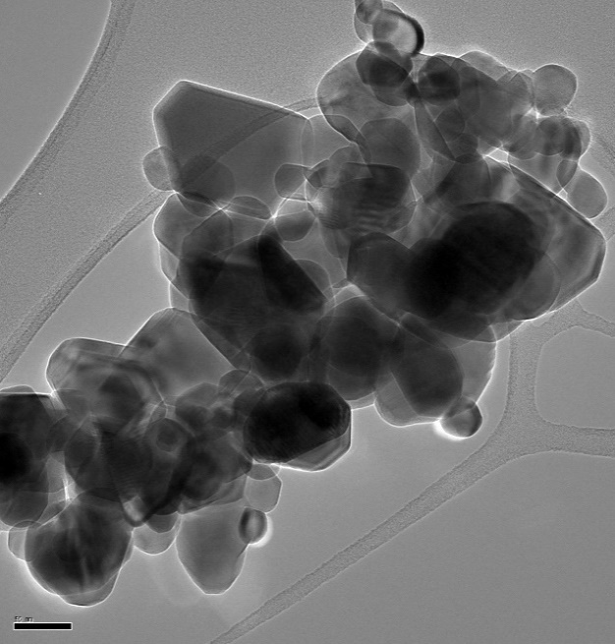
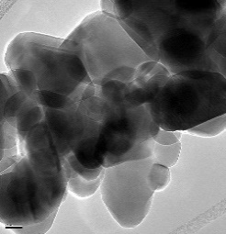
5 nm
20nm
20nm
20nm
50nm

Table S1. Experiment 2: concentrations of Zn²⁺ in sixteen treatments
Treatment | Zn (mg/L)
Light-control | 0.338
Light-Z10 | 0.79
Light-T10 | 0.17
Light –TZ10 | 0.65
Light+ chloramphenicol | 0.15
Light+ chloramphenicol-Z10 | 0.65
Light+ chloramphenicol-T10 | 0.345
Light+ chloramphenicol-TZ10 | 0.99
Dark-control | 0.42
Dark-Z10 | 1
Dark-T10 | 0.296
Darkt –TZ10 | 0.02
Dark+ chloramphenicol | 0.144
Dark+ chloramphenicol-Z10 | 0.92
Dark+ chloramphenicol-T10 | 0.38
Dark+ chloramphenicol-TZ10 | 0.64

