Figure S1
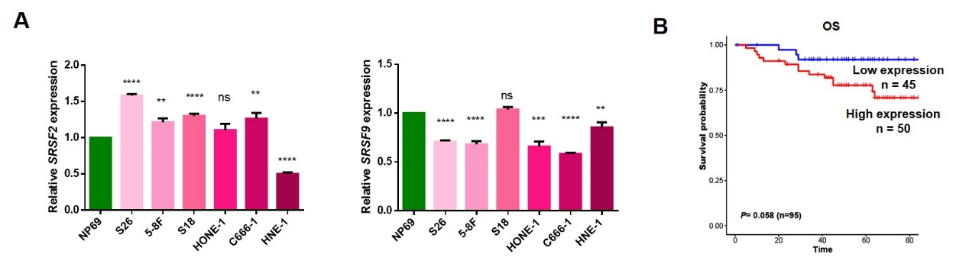
Figure S1. High expression of SRSF3 predicts worse prognosis in patients with NPC. A) qRT-PCR results showed the mRNA expression of SRSF2 and SRSF9 in NPC cell lines and NP69. ACTIN was used as an internal control. B) Kaplan-Meier survival analysis showed the correlation between the protein expression of SRSF3 and overall survival of NPC patients (n=95). *P<0.05, **P<0.01, ***P<0.001, ****P<0.0001.

Figure S2
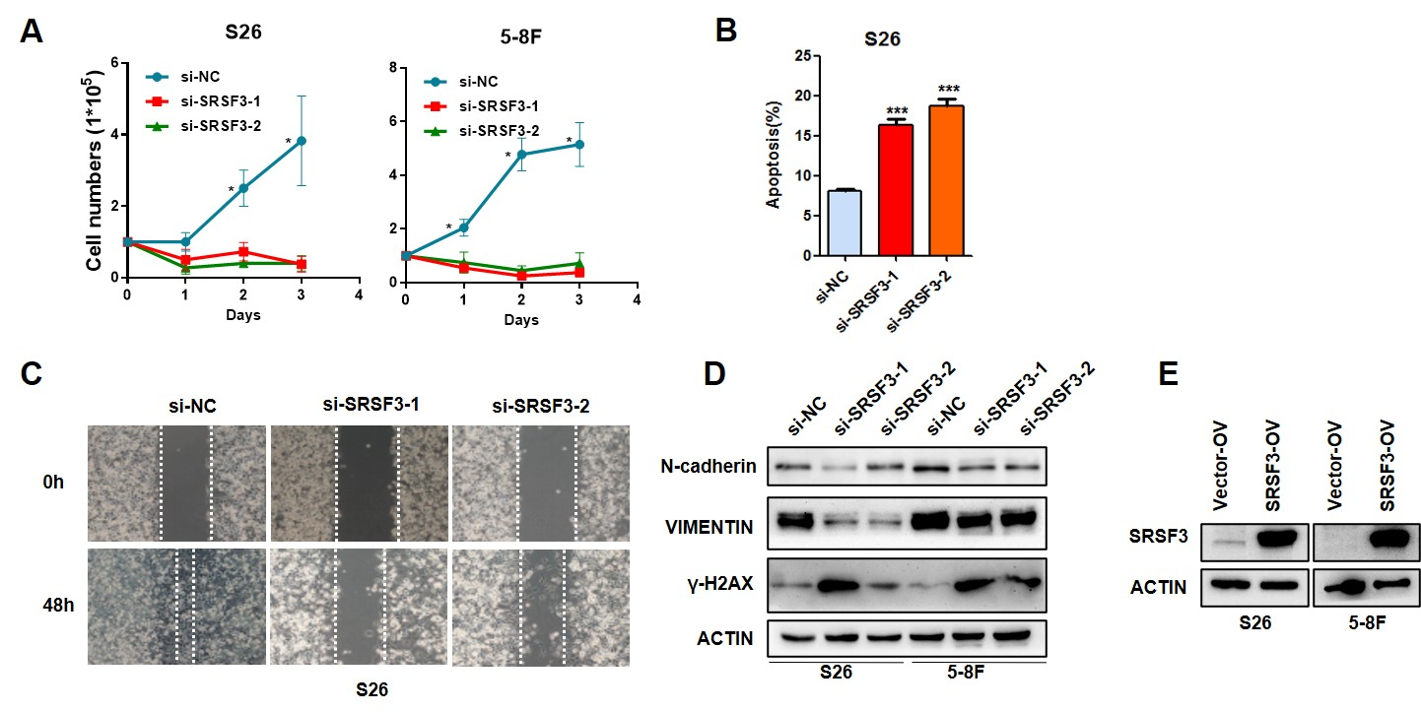
Figure S2. SRSF3 is required for the proliferation and migration of NPC cells. A) Cell growth curves were measured with S26 and 5-8F cells transfected with siRNAs targeting SRSF3 or control siRNA. B) Flow cytometry analysis of Annexin V in S26 cells described in A. C) Wound healing assays were performed with S26 cells described in A. D) Western blotting results showed the expression of indicated proteins in cells described in A. E) S26 and 5-8F cells were infected with lentivirus expressing SRSF3 or control vectors. Western blotting assay was performed to evaluate the overexpression of SRSF3, with ACTIN treated as control. *P<0.05, **P<0.01, ***P<0.001.

Figure S3
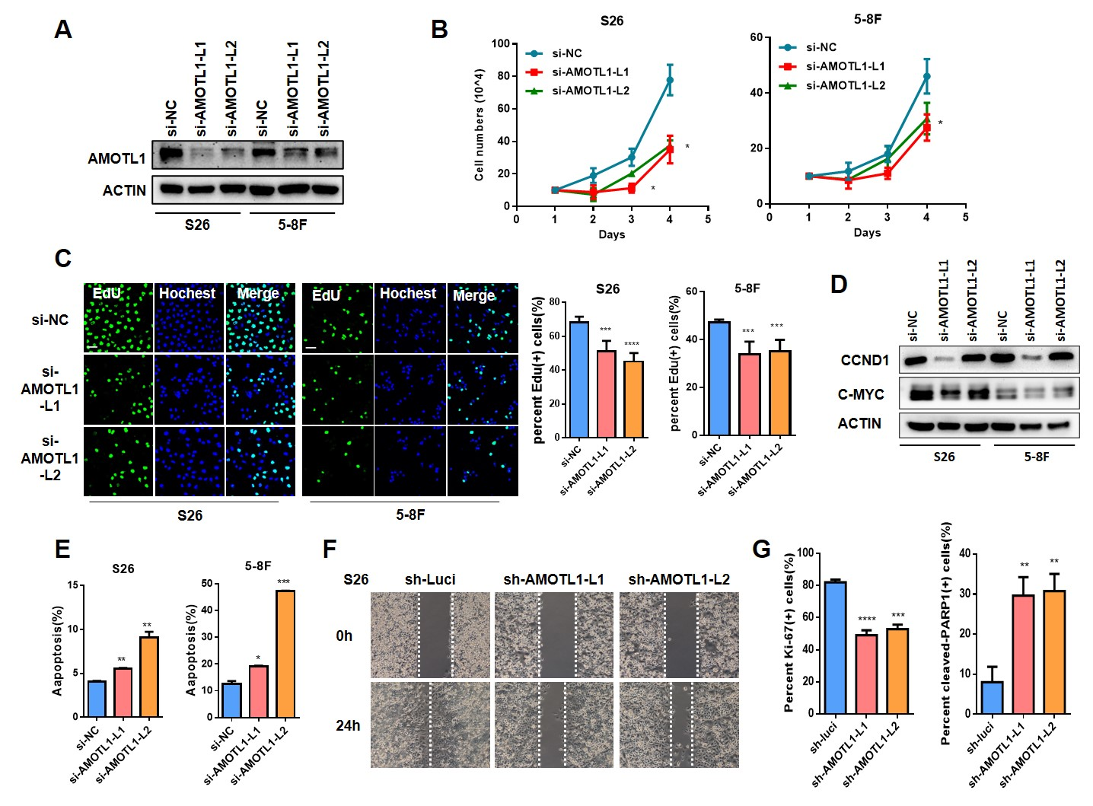
Figure S3. Knockdown of AMOTL1-L decreased the proliferation and migration of NPC cells. A) S26 and 5-8F cells were transfected with siRNAs specific against exon12 of AMOTL1 or control siRNA. Western blotting resulted showed the knockdown efficiency of AMOTL1-L. ACTIN was used as a loading control. B) Cell growth curves were measured with cells described in A. C) IF staining of EdU in cells described in A. The statistical analysis was presented at the right. D) Western blotting assays were performed to detect the protein expression of CCND1 and c-MYC in cells described in A. ACTIN was used as control. E) Flow cytometry analysis of Annexin V demonstrated the apoptosis of cells described in A. F) Wound healing assays were carried out with S26 cells infected with lentivirus stably expression shRNA specific targeting AMOTL1 exon12 or control shRNA. F) Statistical analysis of cells presented in Figure 5F. Scale bar, 100 μm. *P<0.05, **P<0.01, ***P<0.001, ****P<0.0001.

Figure S4
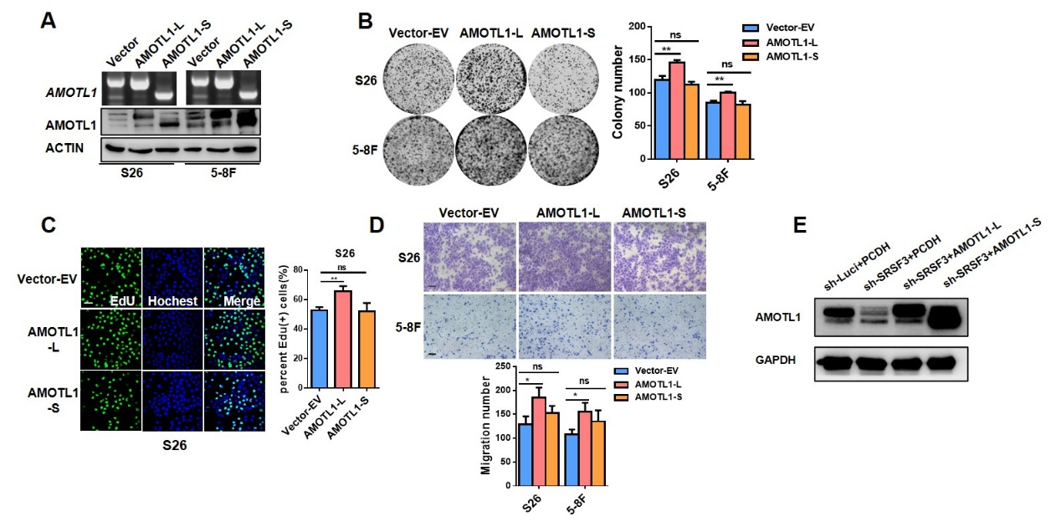
Figure S4. AMOTL1-L mediates the oncogenic function of SRSF3 in NPC. A) S26 and 5-8F cells were infected with lentivirus stably expressing AMOTL1-L/–S or control vectors. RT-PCR and western blotting results demonstrated the overexpression efficiency. B) Colony formation assays were performed with cells described in A. The statistical data were presented at the right. C) Representative images of EdU staining were presented with cells described in A and the corresponding statistic was showed at the right. D) Transwell assays were performed with cell described in A and the corresponding statistical analysis were demonstrate at the bottom. E) 5-8F cells stably expressing SRSF3 shRNAs or control shRNA were infected with lentivirus expressing AMOTL1-L/-S. Western blotting assay was performed to detect the overexpression efficiency. Scale bar, 100 μm. *P<0.05, **P<0.01, ***P<0.001.

Figure S5
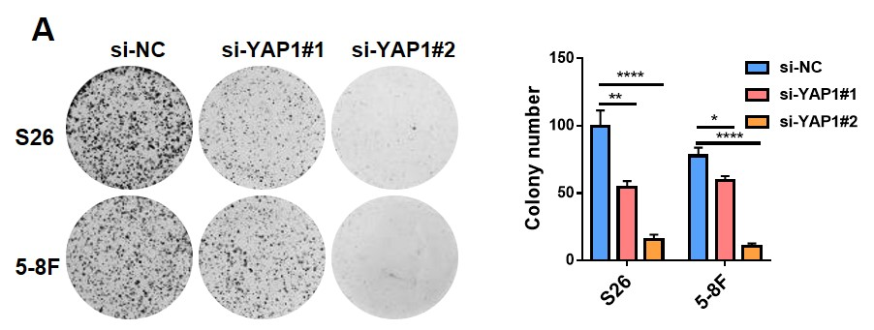
Figure S5. Depletion of YAP1 inhibited the cell growth of NPC cells. A) S26 and 5-8F cells were transiently transfected with YAP1 siRNAs or control siRNA. Colony formation assays were performed and the corresponding statistic was showed at the right. *P<0.05, **P<0.01, ***P<0.001, ****P<0.0001.

