Supporting Information
Conjugated microporous polymers containing benzothiazole groups for the efficient removal of small molecule dyes from water
Yu Yuan¹, Zhishun Yang, Wenwen Chen, Chenghuai Deng, Jingyu Cai^{1, 2}, Longqiang Xiao^{1, 2}, Yulai Zhao*^{1,2}, Linxi Hou*^{1, 2}
¹Department of Materials-Oriented Chemical Engineering, College of Chemical Engineering, Fuzhou University, Fuzhou 350116, China
²Qingyuan Innovation Laboratory, Quanzhou 362801, China
*Corresponding authors. Email:
yulai_zhao@fzu.edu.cn (Yulai Zhao); lxhou@fzu.edu.cn (Linxi Hou)
Tel: +86-591-22866244
Fax: +86-591-22865220

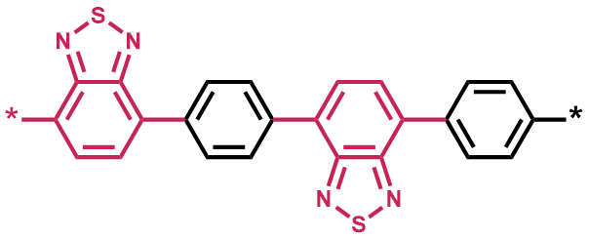
Figure S1. Structure of B-BTD-1,4

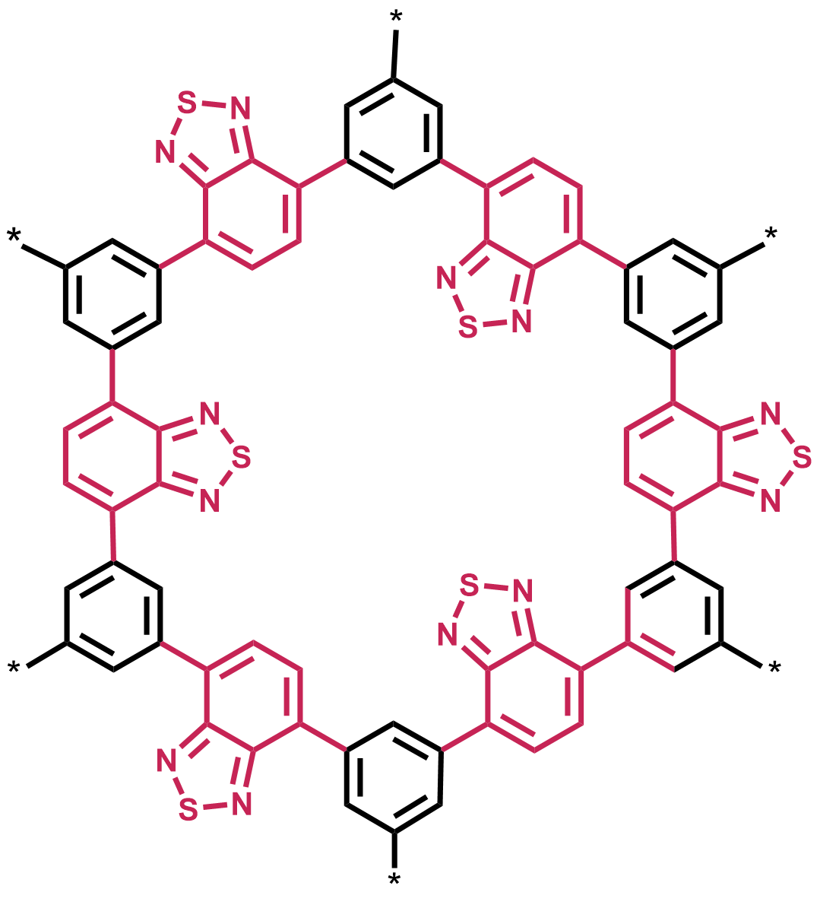
Figure S2. Structure of B-BTD-1,3,5

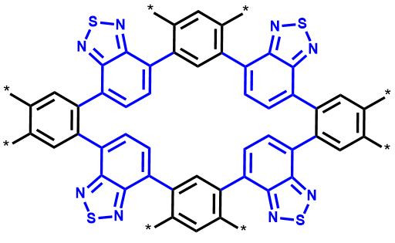
Figure S3. Structure of B-BTD-1,2,4,5

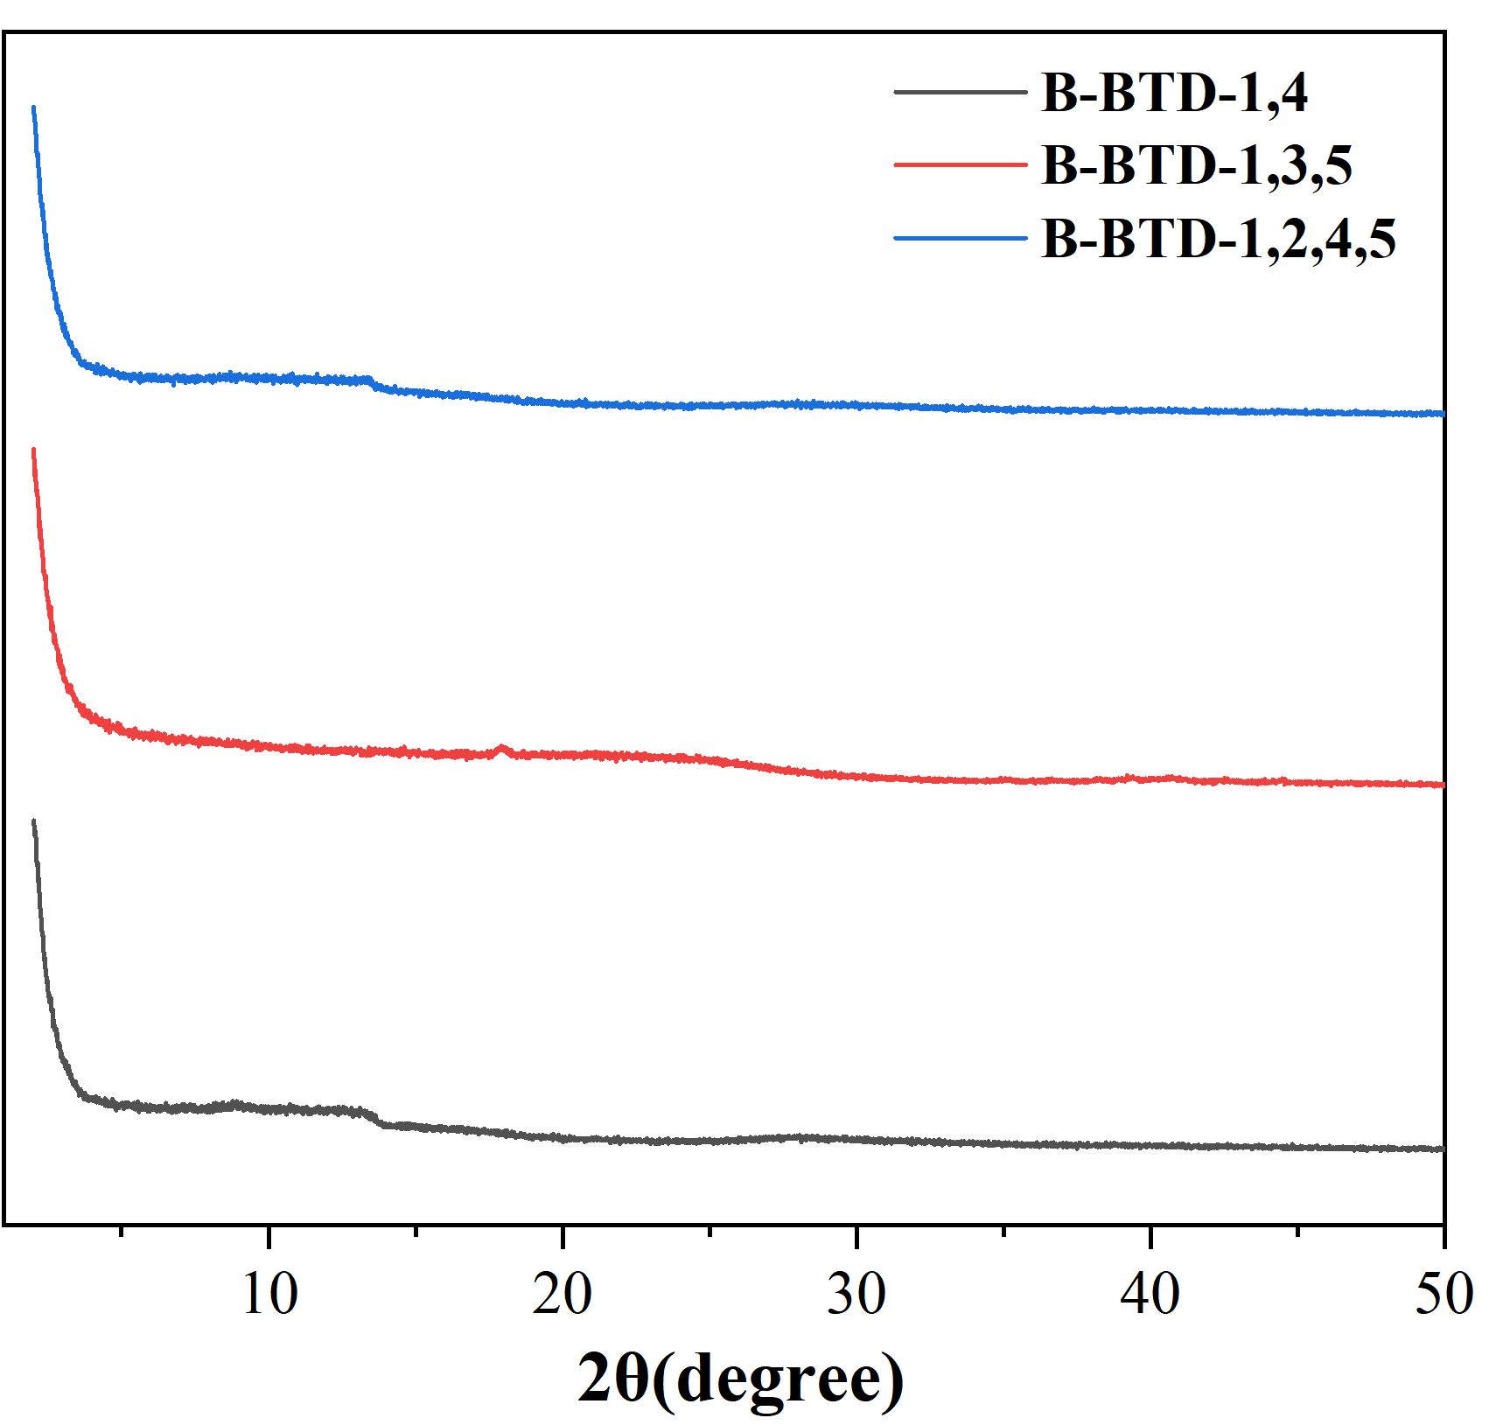
Figure S4. Powder X-ray diffraction (PXRD) of the three types of B-BTD-CMPs.

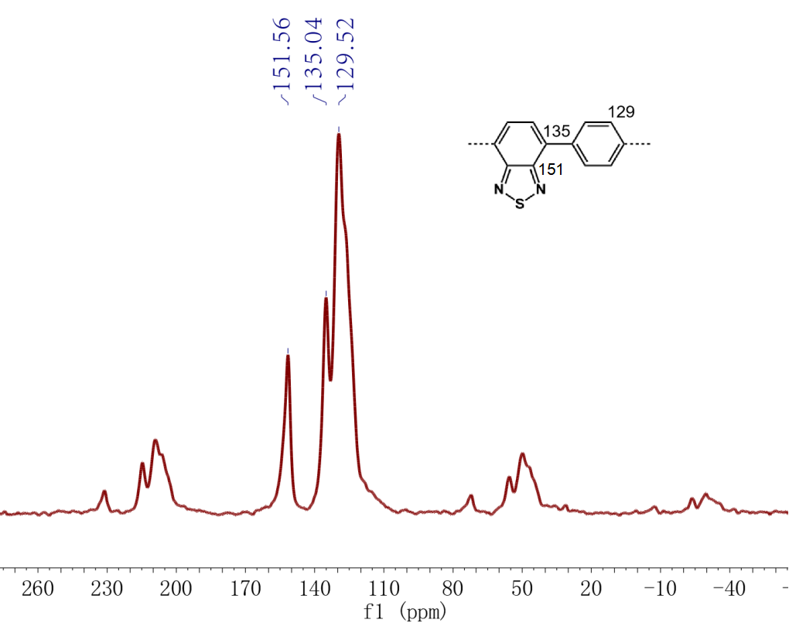

Figure S5. Solid state ¹³C CP/MAS NMR spectrum of B-BTD-1,4.

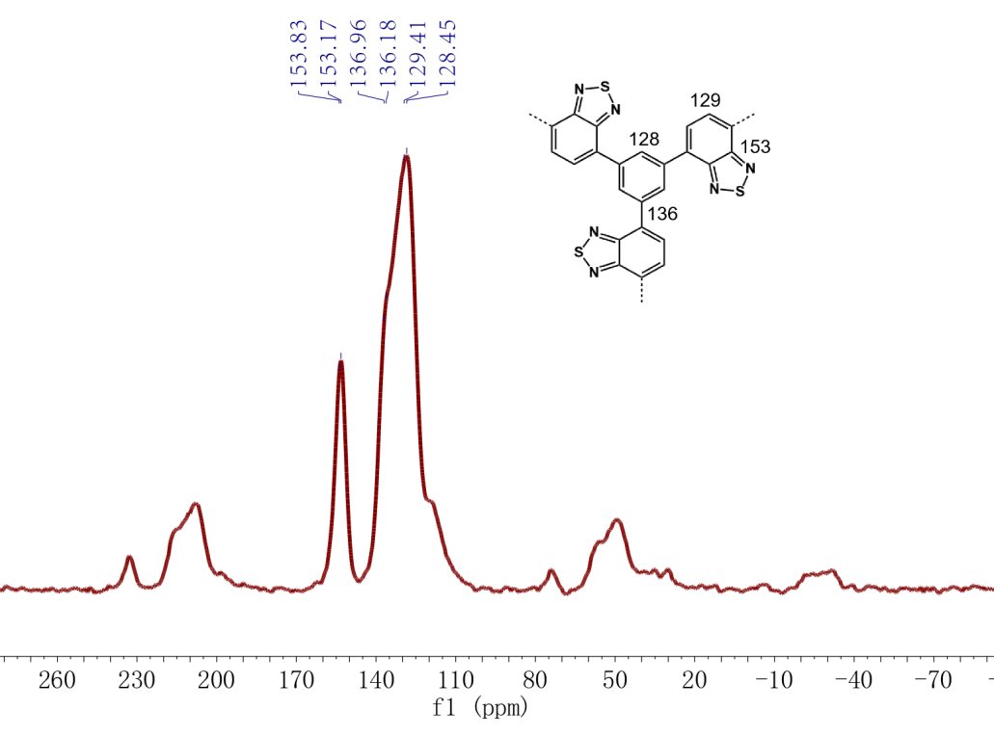
Figure S6. Solid state ¹³C CP/MAS NMR spectrum of B-BTD-1,3,5.

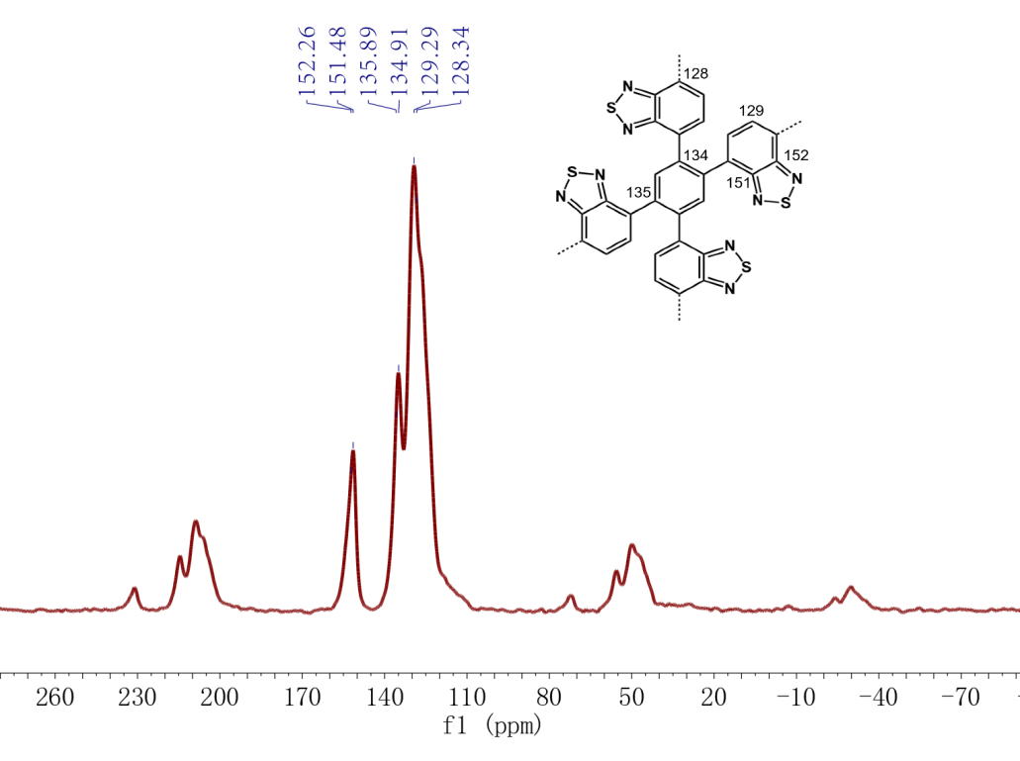
Figure S7. Solid state ¹³C CP/MAS NMR spectrum of B-BTD-1,2,4,5.

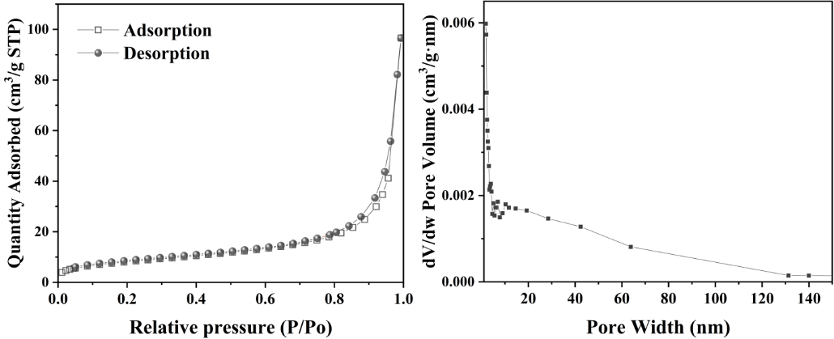

Figure S8. N₂ absorption/desorption isotherms and pore size distribution of the B-BTD-1,4.

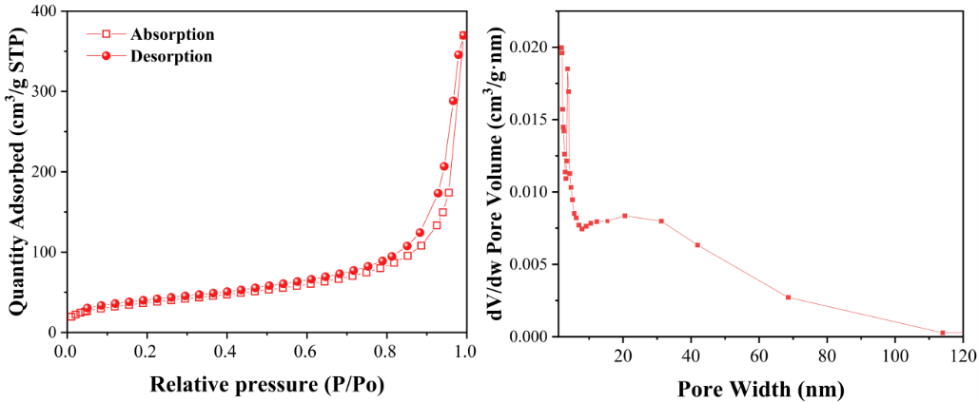

Figure S9. N₂ absorption/desorption isotherms and pore size distribution of the B-BTD-1,3,5

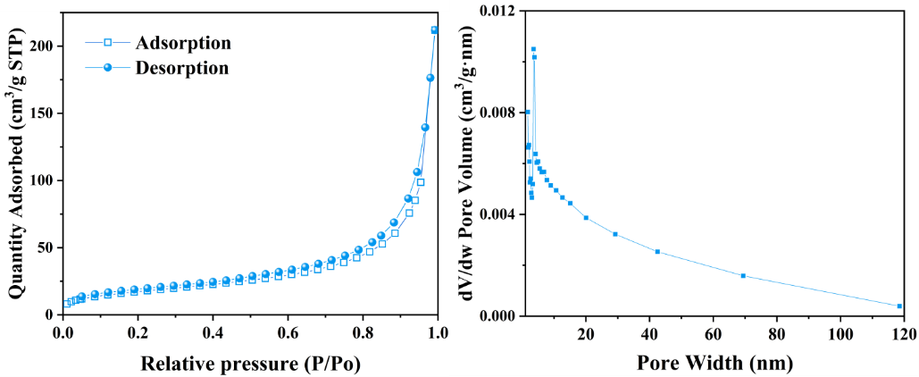
Figure S10. N₂ absorption/desorption isotherms and pore size distribution of the B-BTD-1,2,4,5

