Supplementary Table 1: The list of genes commonly up- or down-regulated both in IR/Ipsi-brain and IR/Contra-brain group, as compared to control group (Sham-IR/Brain).

Gene Symbol | IR/Ipis-brain vs.  Sham-IR/Brain |  | IR/Contra-brain  vs. Sham-IR/Brain |  | IR/Ipis-brain |  |  | IR/Contra-  brain |  |  | Sham-IR/Brain |  |  | Entrez Gene Name | Location | Type(s)
Gene Symbol | Fold Change | P-Value | Fold Change | P-Value | 1 | 2 | 3 | 1 | 2 | 3 | 1 | 2 | 3 | Entrez Gene Name | Location | Type(s)
OSM | 5.8 | 0.008 | 5.6 | 0.007 |  |  |  |  |  |  |  |  |  | oncostatin M | Extracellular Space | cytokine
LOXL4 | 2.5 | 0.030 | 3.4 | 0.013 |  |  |  |  |  |  |  |  |  | lysyl oxidase like 4 | Extracellular Space | enzyme
ADAMTS14 | 2.4 | 0.030 | 2.3 | 0.001 |  |  |  |  |  |  |  |  |  | ADAM metallopeptidase with thrombospondin type 1 motif 14 | Extracellular Space | peptidase
MMP9 | 2.2 | 0.046 | 2.5 | 0.015 |  |  |  |  |  |  |  |  |  | matrix metallopeptidase 9 | Extracellular Space | peptidase
LILRA5 | 15.7 | 0.007 | 4.7 | 0.033 |  |  |  |  |  |  |  |  |  | leukocyte immunoglobulin like receptor A5 | Plasma Membrane | other
DPEP2 | 7.9 | 0.003 | 8.9 | 0.001 |  |  |  |  |  |  |  |  |  | dipeptidase 2 | Plasma Membrane | peptidase
IL2RG | 4.6 | 0.044 | 6.4 | 0.028 |  |  |  |  |  |  |  |  |  | interleukin 2 receptor subunit gamma | Plasma Membrane | transmembrane receptor
HLA-A | 3.4 | 0.037 | 3.1 | 0.050 |  |  |  |  |  |  |  |  |  | major histocompatibility complex, class I, A | Plasma Membrane | other
PLAUR | 3.2 | 0.048 | 2.3 | 0.041 |  |  |  |  |  |  |  |  |  | plasminogen activator, urokinase receptor | Plasma Membrane | transmembrane receptor
RIPK3 | 3.2 | 0.032 | 2.8 | 0.046 |  |  |  |  |  |  |  |  |  | receptor interacting serine/threonine kinase 3 | Plasma Membrane | kinase
SLC1A7 | 3.2 | 0.009 | 2.9 | 0.013 |  |  |  |  |  |  |  |  |  | solute carrier family 1 (glutamate transporter), member 7 | Plasma Membrane | transporter
F2RL2 | 3.2 | 0.011 | 3.5 | 0.015 |  |  |  |  |  |  |  |  |  | coagulation factor II (thrombin) receptor-like 2 | Plasma Membrane | G-protein coupled receptor
CD6 | 3.0 | 0.023 | 2.0 | 0.046 |  |  |  |  |  |  |  |  |  | CD6 molecule | Plasma Membrane | transmembrane receptor
GPRC5A | 2.9 | 0.019 | 1.8 | 0.020 |  |  |  |  |  |  |  |  |  | G protein-coupled receptor, class C, group 5, member A | Plasma Membrane | G-protein coupled receptor
PVRL4 | 2.6 | 0.030 | 2.7 | 0.002 |  |  |  |  |  |  |  |  |  | poliovirus receptor-related 4 | Plasma Membrane | other
ADCY4 | 2.6 | 0.019 | 2.2 | 0.032 |  |  |  |  |  |  |  |  |  | adenylate cyclase 4 | Plasma Membrane | enzyme
CLDN19 | 2.5 | 0.003 | 2.2 | 0.015 |  |  |  |  |  |  |  |  |  | claudin 19 | Plasma Membrane | other
HLA-E | 2.5 | 0.031 | 2.1 | 0.019 |  |  |  |  |  |  |  |  |  | major histocompatibility complex, class I, E | Plasma Membrane | transmembrane receptor
CD37 | 2.4 | 0.003 | 2.6 | 0.025 |  |  |  |  |  |  |  |  |  | CD37 molecule | Plasma Membrane | other
P2RY14 | 2.3 | 0.009 | 2.3 | 0.029 |  |  |  |  |  |  |  |  |  | purinergic receptor P2Y, G-protein coupled, 14 | Plasma Membrane | G-protein coupled receptor
ROBO4 | 2.2 | 0.042 | 2.6 | 0.010 |  |  |  |  |  |  |  |  |  | roundabout guidance receptor 4 | Plasma Membrane | other
CD300LF | 2.2 | 0.046 | 2.1 | 0.007 |  |  |  |  |  |  |  |  |  | CD300 molecule like family member f | Plasma Membrane | other
SCARF1 | 1.9 | 0.026 | 2.4 | 0.005 |  |  |  |  |  |  |  |  |  | scavenger receptor class F member 1 | Plasma Membrane | transmembrane receptor
SLC12A4 | 1.5 | 0.026 | 1.5 | 0.004 |  |  |  |  |  |  |  |  |  | solute carrier family 12 (potassium/chloride transporter), member 4 | Plasma Membrane | transporter
NNAT | -1.6 | 0.021 | -1.6 | 0.021 |  |  |  |  |  |  |  |  |  | neuronatin | Plasma Membrane | transporter
LYPD1 | -1.6 | 0.042 | -1.8 | 0.003 |  |  |  |  |  |  |  |  |  | LY6/PLAUR domain containing 1 | Plasma Membrane | G-protein coupled receptor
SLC32A1 | -1.9 | 0.018 | -1.8 | 0.035 |  |  |  |  |  |  |  |  |  | solute carrier family 32 (GABA vesicular transporter), member 1 | Plasma Membrane | transporter
Mill1 | -2.0 | 0.025 | -1.7 | 0.046 |  |  |  |  |  |  |  |  |  | MHC I like leukocyte 1 | Plasma Membrane | other
GP1BA | -2.1 | 0.027 | -2.1 | 0.026 |  |  |  |  |  |  |  |  |  | glycoprotein Ib platelet alpha subunit | Plasma Membrane | transmembrane receptor
NPFFR1 | -2.8 | 0.001 | -2.9 | 0.001 |  |  |  |  |  |  |  |  |  | neuropeptide FF receptor 1 | Plasma Membrane | G-protein coupled receptor
HSH2D | 4.7 | 0.027 | 3.8 | 0.025 |  |  |  |  |  |  |  |  |  | hematopoietic SH2 domain containing | Cytoplasm | other
CA3 | 3.1 | 0.013 | 2.1 | 0.035 |  |  |  |  |  |  |  |  |  | carbonic anhydrase III | Cytoplasm | enzyme
PM20D1 | 3.0 | 0.048 | 3.1 | 0.048 |  |  |  |  |  |  |  |  |  | peptidase M20 domain containing 1 | Cytoplasm | peptidase
TAGAP | 2.9 | 0.001 | 2.8 | 0.031 |  |  |  |  |  |  |  |  |  | T-cell activation RhoGTPase activating protein | Cytoplasm | other
REEP4 | 2.7 | 0.012 | 2.7 | 0.019 |  |  |  |  |  |  |  |  |  | receptor accessory protein 4 | Cytoplasm | other
CASQ1 | 2.5 | 0.015 | 2.2 | 0.031 |  |  |  |  |  |  |  |  |  | calsequestrin 1 | Cytoplasm | other
HMHA1 | 2.1 | 0.044 | 2.1 | 0.048 |  |  |  |  |  |  |  |  |  | histocompatibility (minor) HA-1 | Cytoplasm | transporter
UNC13D | 2.0 | 0.015 | 2.1 | 0.039 |  |  |  |  |  |  |  |  |  | unc-13 homolog D (C. elegans) | Cytoplasm | other
SIPA1 | 2.0 | 0.018 | 2.1 | 0.032 |  |  |  |  |  |  |  |  |  | signal-induced proliferation-associated 1 | Cytoplasm | other
MICAL1 | 1.9 | 0.003 | 1.7 | 0.008 |  |  |  |  |  |  |  |  |  | microtubule associated monooxygenase, calponin and LIM domain containing 1 | Cytoplasm | enzyme
FUT2 | 1.8 | 0.021 | 2.0 | 0.012 |  |  |  |  |  |  |  |  |  | fucosyltransferase 2 | Cytoplasm | enzyme
Fhod1 | 1.7 | 0.007 | 1.7 | 0.018 |  |  |  |  |  |  |  |  |  | formin homology 2 domain containing 1 | Cytoplasm | other
SOAT1 | 1.7 | 0.035 | 1.9 | 0.044 |  |  |  |  |  |  |  |  |  | sterol O-acyltransferase 1 | Cytoplasm | enzyme
EXOC3L1 | 1.6 | 0.011 | 1.9 | 0.018 |  |  |  |  |  |  |  |  |  | exocyst complex component 3-like 1 | Cytoplasm | other
TRIP10 | 1.6 | 0.048 | 1.6 | 0.011 |  |  |  |  |  |  |  |  |  | thyroid hormone receptor interactor 10 | Cytoplasm | other
MYH7 | -2.0 | 0.047 | -2.5 | 0.045 |  |  |  |  |  |  |  |  |  | myosin, heavy chain 7, cardiac muscle, beta | Cytoplasm | enzyme
CDKN1A | 6.4 | 0.001 | 3.7 | 0.006 |  |  |  |  |  |  |  |  |  | cyclin-dependent kinase inhibitor 1A (p21, Cip1) | Nucleus | kinase
SPDEF | 2.4 | 0.038 | 3.5 | 0.007 |  |  |  |  |  |  |  |  |  | SAM pointed domain containing ETS transcription factor | Nucleus | transcription regulator
MAFB | 2.4 | 0.019 | 2.3 | 0.006 |  |  |  |  |  |  |  |  |  | v-maf avian musculoaponeurotic fibrosarcoma oncogene homolog B | Nucleus | transcription regulator
LYL1 | 2.3 | 0.041 | 2.6 | 0.026 |  |  |  |  |  |  |  |  |  | lymphoblastic leukemia associated hematopoiesis regulator 1 | Nucleus | transcription regulator
KLF1 | 2.0 | 0.006 | 1.8 | 0.014 |  |  |  |  |  |  |  |  |  | Kruppel-like factor 1 (erythroid) | Nucleus | transcription regulator
Hic1 | 1.6 | 0.036 | 2.2 | 0.047 |  |  |  |  |  |  |  |  |  | hypermethylated in cancer 1 | Nucleus | transcription regulator
CIART | -1.7 | 0.014 | -1.6 | 0.013 |  |  |  |  |  |  |  |  |  | circadian associated repressor of transcription | Nucleus | other
SLFN12 | 21.6 | 0.026 | 12.8 | 0.044 |  |  |  |  |  |  |  |  |  | schlafen family member 12 | Other | enzyme
CXCL17 | 3.6 | 0.027 | 3.0 | 0.039 |  |  |  |  |  |  |  |  |  | chemokine (C-X-C motif) ligand 17 | Other | other
SPATA45 | 2.6 | 0.004 | 2.2 | 0.006 |  |  |  |  |  |  |  |  |  | spermatogenesis associated 45 | Other | other
C10orf128 | 1.9 | 0.040 | 1.9 | 0.036 |  |  |  |  |  |  |  |  |  | chromosome 10 open reading frame 128 | Other | other
PLEKHD1 | 1.8 | 0.026 | 1.7 | 0.046 |  |  |  |  |  |  |  |  |  | pleckstrin homology and coiled-coil domain containing D1 | Other | other
PPM1J | 1.7 | 0.006 | 1.7 | 0.020 |  |  |  |  |  |  |  |  |  | protein phosphatase, Mg2+/Mn2+ dependent 1J | Other | phosphatase
Atp6ap1l | -1.5 | 0.038 | -2.4 | 0.027 |  |  |  |  |  |  |  |  |  | ATPase, H+ transporting, lysosomal accessory protein 1-like | Other | other
CFAP126 | -1.7 | 0.001 | -1.7 | 0.021 |  |  |  |  |  |  |  |  |  | cilia and flagella associated protein 126 | Other | other
LOC728392 | -2.0 | 0.034 | -2.3 | 0.017 |  |  |  |  |  |  |  |  |  | uncharacterized LOC728392 | Other | other
FBXO36 | -2.9 | 0.037 | -2.8 | 0.005 |  |  |  |  |  |  |  |  |  | F-box protein 36 | Other | other
ADGRE4P | 3.4 | 0.004 | 2.3 | 0.016 |  |  |  |  |  |  |  |  |  | EGF-Like Module-Containing Mucin-Like Hormone | N.F | N.F.

Supplementary Figure 1: Significantly impacted pathways in IR/Ipsi-brain and IR/Contra-brain.
The Venn diagram indicates the number of the significantly impacted pathways in IR/Ipsi-brain and IR/Contra-brain groups, as compared to the control group (Sham-IR/Brain).
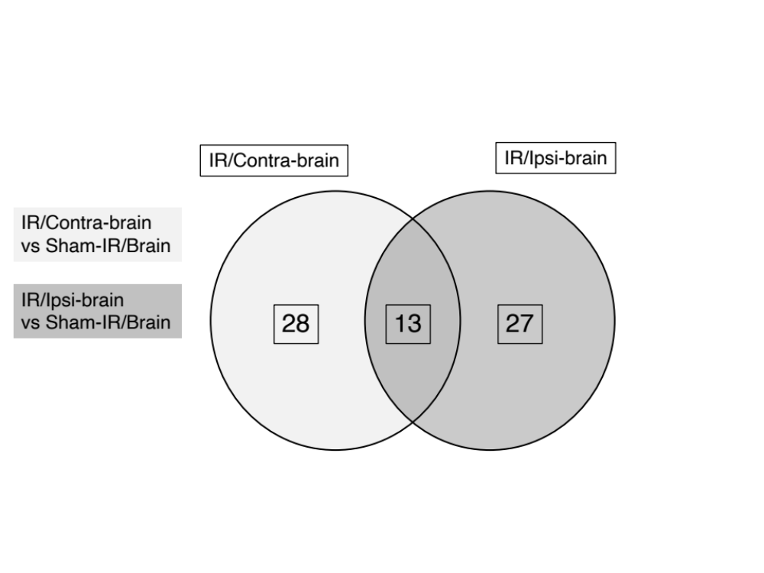

Supplementary information
Methods of the pathway analysis used in “iPathwayGuide” (Advita Corporation, Plymouth, MI, USA)
iPathwayGuide scores pathways using the Impact Analysis method (Draghici et al., 2007; Tarca et al., 2009, Khatri et al., 2007). Impact analysis uses two types of evidence: i) the over-representation of differentially expressed (DE) genes in a given pathway and ii) the perturbation of that pathway computed by propagating the measured expression changes across the pathway topology. These aspects are captured by two independent probability values, pORA and pAcc, that are then combined in a unique pathway-specific p-value. The underlying pathway topologies, comprised of genes and their directional interactions, are obtained from the KEGG database (Kanehisa et al., 2000; Kanehisa et al., 2014).
The first probability, pORA, expresses the probability of observing the number of DE genes in a given pathway that is greater than or equal to the one observed by random chance (Draghici et al., 2003; Draghici 2011). Let us consider there are N genes measured in the experiment, with M of these on the given pathway. Based on a priori selection of DE genes, K out of M genes were found to be differentially expressed. The probability of observing exactly x differentially expressed genes on the given pathway is computed based on the hypergeometric distribution:
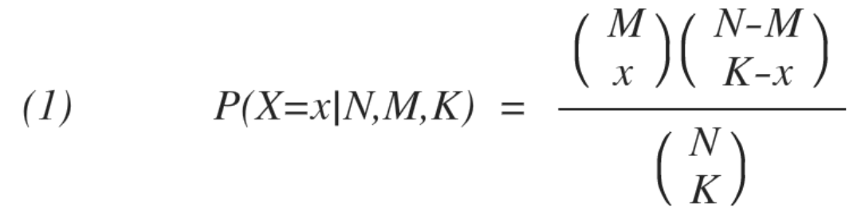

Because the hypergeometric distribution is discrete, the probability of observing fewer than x genes on the given pathway just by chance can be calculated by summing the probabilities of randomly observing 1, 2, ..., up to x-1 DE genes on the pathway:
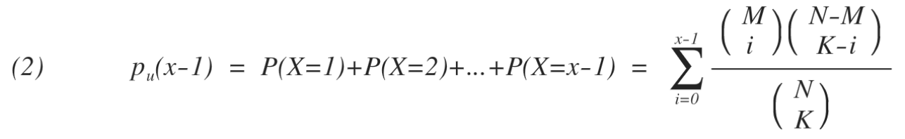

iPathwayGuide calculates the probability of randomly observing a number of DE genes on the given pathway that is greater than or equal to the number of DE genes obtained from data, by computing the over-representation p-value: pORA = po(x) = 1 - pu(x-1):
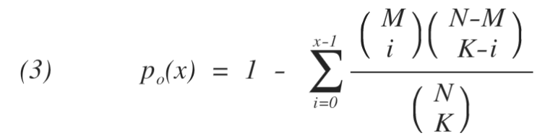

The second probability, pAcc, is calculated based on the amount of total accumulation measured in each pathway. A perturbation factor is computed for each gene on the pathway using:
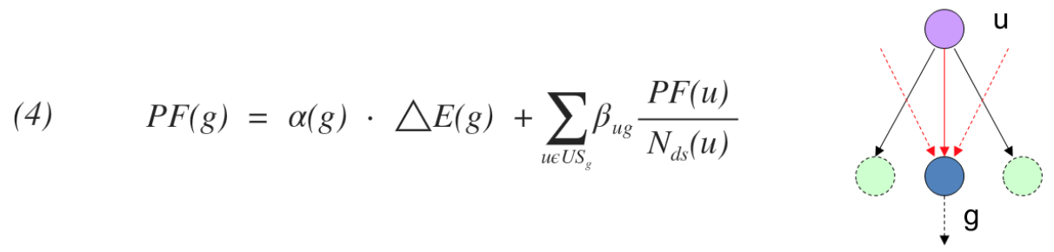

In Equation 4, the term ΔE(g) represents the signed normalized measured expression change of gene g, and α(g) is a priori weight based on the type of the gene. The last term is the sum of the perturbation factors of all genes u, directly upstream of the target gene g, normalized by the number of downstream genes of each such gene Nds(u). The value of βug quantifies the strength of the interaction between genes g and u. The sign of β represents the type of interaction: positive for activation-like signals, and negative for inhibition-like signals. Subsequently, iPathwayGuide calculates the accumulation at the level of each gene, Acc(g), as the difference between the perturbation factor PF(g) and the observed log fold-change:
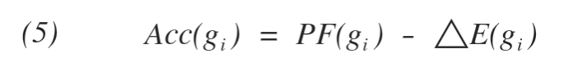

All perturbation accumulations are computed at the same time by solving the system of linear equations resulting from combining Equation 4 for all genes on a given pathway. Once all gene perturbation accumulations are computed, iPathwayGuide computes the total accumulation of the pathway as the sum of all absolute accumulations of the genes in a given pathway. The significance of obtaining a larger total accumulation (pAcc) just by chance is assessed through bootstrap analysis.
The two types of evidence, pORA and pAcc, are combined into one final pathway score by calculating a p-value using Fisher's method. This p-value is then corrected for multiple comparisons using false dicovery rate (FDR) or Bonferroni corrections. Bonferroni is simpler and more conservative of the two (Bonferroni, 1935; Bonferroni, 1936). It reduces the false discovery rate by imposing a stringent threshold on each comparison adjusted for the total number of comparisons. The FDR correction has more power but only controls the family-wise false positives rate (Benjamini and Hochberg, 1995; Benjamini and Yekutieli, 2001).

