Table

Table 1. Patient characteristics
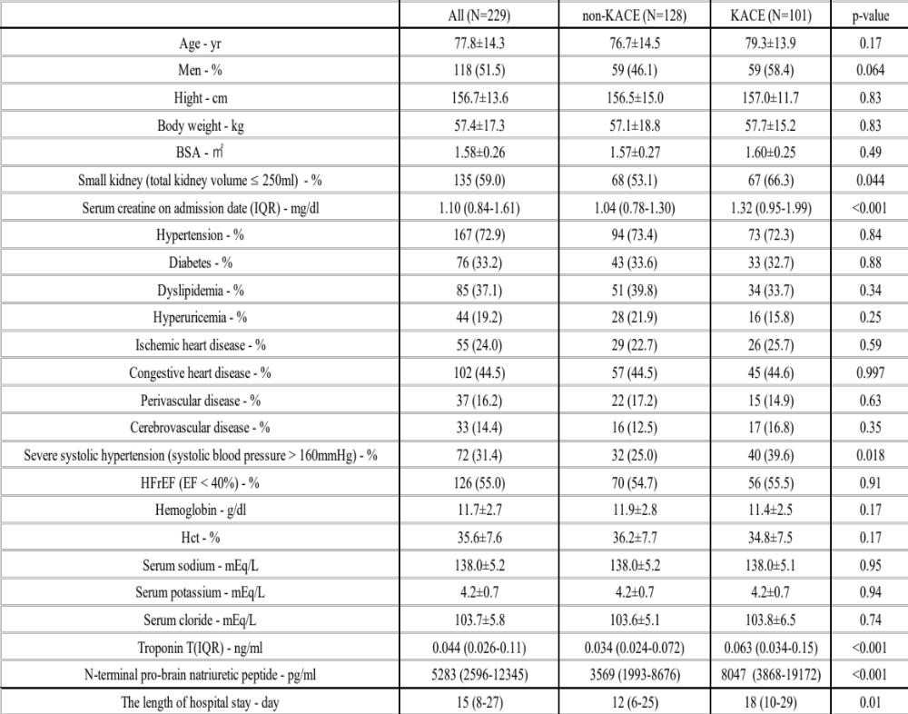
Plus minus values: mean ±SD. IQR: interquartile range

Table 2. Multivariate logistic analysis for the incidence of KACE
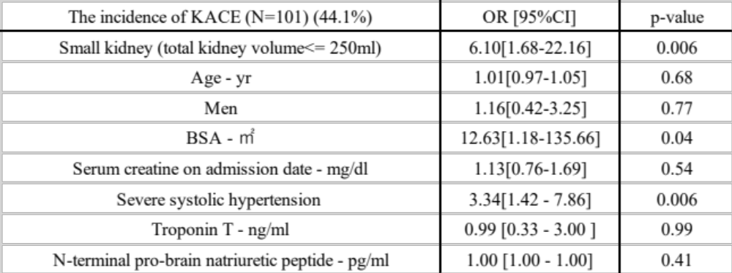

Table 3. Multivariate logistic analysis for the incidence of WRF
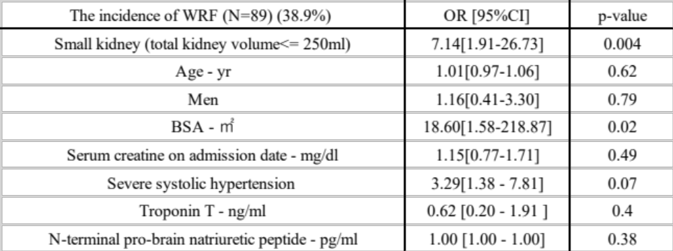

Table 4. Multivariate logistic analysis for the incidence of initiating RRT
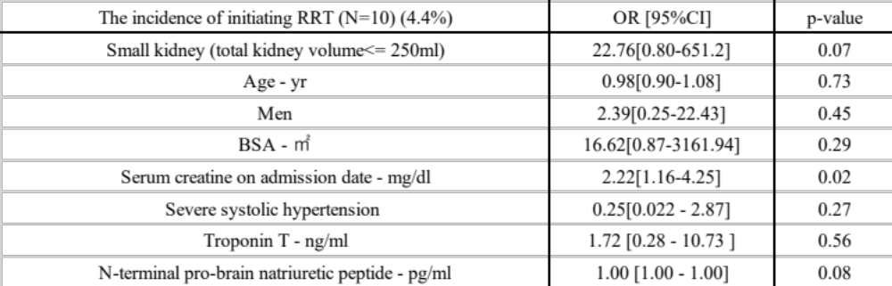
Table 5. Multivariate logistic analysis for the incidence of death from any cause
