Supplementary Information for:
" Chip-Integrated Metasurface Full-Stokes Polarimetric Imaging Sensor"
Jiawei Zuo^{1,2}, Jing Bai^{1,2}, Shinhyuk Choi^{1,2}, Ali Basiri^{1,2}, Xiahui Chen^{1,2}, Chao Wang^{1,2,3}, Yu Yao^{1,2}*
¹School of Electrical, Computer and Energy Engineering, Arizona State University, Tempe, AZ, USA, 85281
²Centre for Photonic Innovation, Arizona State University, Tempe, AZ, USA, 85281
³Biodesign Center for Molecular Design &Biomimetics

*Corresponding authors： yuyao@asu.edu

Contents
1. Comparison of full Stokes polarimetric imaging sensors 2
2. Design of VCDG and chiral metasurface structures 5
3. Fabrication and spectroscopic characterization of Chiral metasurface and VCDG 11
4. Analysis of degradation of optical performances of Chiral metasurface and VCDG due to fabrication 12
5. Instrument matrix calibration process 16
6. Full Stokes polarization measurement at different incidence angle 18
7. Full Stokes polarization imaging of ASU logo with polarization information 39

Comparison of full Stokes polarimetric imaging sensors
Table S1. Full Stokes polarimetric imagers based on metasurface structures.
Full Stokes polarimeters | materials | Chip integrated? | Detection error | FOV | Bandwidth | Pixel Number of polarization images
Our work | Dielectric-metal hybrid | Yes | <2% (S1,S2,S3) | Up to 40° | Dual color  630-670nm(red)  480-520nm(green) | 335×224
Dielectric metasurface diffraction grating | Dielectric | No  (requires spacing to diffract incoming light) | Polarization contrast error < 10%[1] | 10°[1] | Narrow band  527 to 537nm[1] | 3M
Microscale polarization metalens array | Dielectric | No  (requires spacing for focus) | averaged relative error  <4.85% (S1,S2,S3)[2] | normal incidence | Narrow band  1550 nm[2] | 5×10 [2]
Microscale polarization metalens splitter array | Dielectric | No  (requires spacing for focus) | 7.5-15%(S1,S2,S3)[3] | normal incidence | Narrow band  845-855nm[3] | 70×46 [3]
Plasmonic metasurface microscale polarization filter array | Plasmonic | No  (requires relay lens) | <6%(S1),  <8% (S2),  < 7%(S3)[4] | normal incidence | Broadband  4~9 μm[4] | 30×25

Table S2. State of the Art polarimetric imaging systems based on different types of technologies.
Full Stokes polarimetric imagers | Chip integrated? | Compactness of polarization filter/micro filter array (thickness) | Detection error | Full Stokes Parameter imaging /detection
Our Work  (metasurface-based) | Yes | ~600nm | <2%(S1,S2,S3), DOLP<1.5%, DOCP<2% AOP<0.8° at normal incidence  <4%(S1,S2,S3) DOLP<2.28%  DOCP<4%,  AOP<0.9° at ±20° incidence (red color) | Yes
Rotating QWP and linear polarizer | No | cm scale | DOP error <1% [5] | Yes
Rotational Liquid Crystal and a fixed linear polarizer | No | mm~cm scale [6] | Elliptical polarization:  DOCP error< 2%  DOLP error<3%[6] | Yes
Metallic wire-grid LP filters | Yes | 300nm [7] | LPER = 80~450[7]  DOLP error < 2% characterized in lab | No  (Cannot measure S3)
Birefringent polymer integrated on micro-LP filters array | Yes | 2 μm [8] | full Stokes image of LCD screen:  DOCP error <6.7%  DOLP error < 3.35%  AOP error < 1.90°[8] | Yes
Liquid crystal polymer based DoFP polarimeter | Yes | 1 μm[9] | DOCP error: < 25%  DOLP error:<18% [9] | Yes

Table S2. State of the Art polarimetric imaging systems based on different technologies (continued)
Polarimetric imagers | FOV demonstrated. | Operational wavelength | Pixel size | Detection Speed | Single shot?
Our Work | 40° for Red  10° for Green | 630-670nm(red)  480-520nm(green) | 6.2μm | 15fps to 30 fps | Yes *
Rotating QWP and linear polarizer | <2°[5] | 400 to 700nm[5] | NA | 30 sample/s to 400 sample /s[5] | No
Rotational Liquid Crystal and a fixed linear polarizer | NA | 520-550nm | NA | 15- 20 fps | No
Metallic wire-grid LP filters | 45° | 400-900nm | 3.45 μm | 22 fps | Yes
Birefringent polymer integrated on micro-LP filters array | NA | 400-700nm[8] | 6.9 μm[8] | 22 fps | Yes
Liquid crystal polymer based DoFP polarimeter | NA | 577.5-582.5nm | 7.4 μm | <1 fps  4.5S per frame | Yes

(* Full Stokes polarization images can be obtained with a single snapshot)

Design of VCDG and chiral metasurface structures
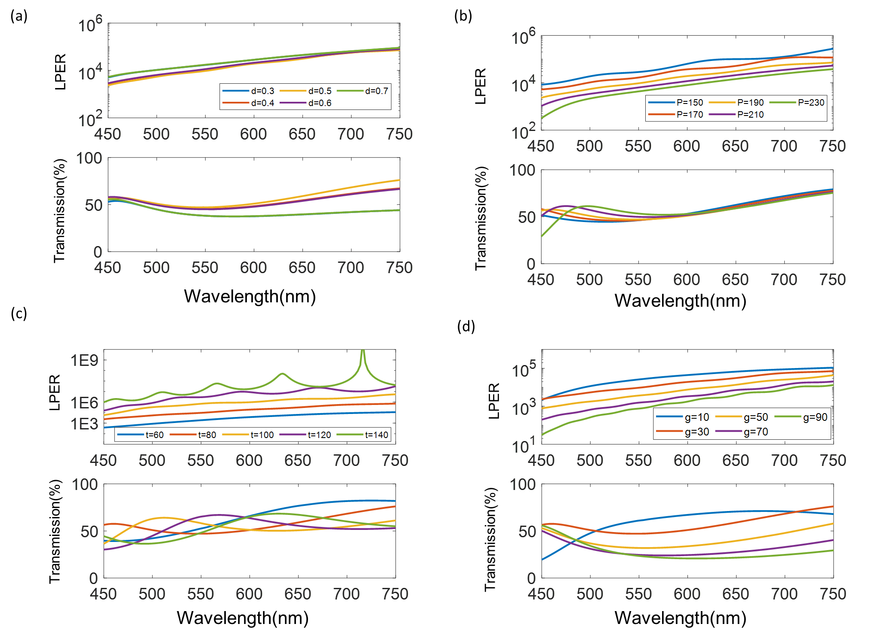
Figure S1. Parameter scan of VCDG’s duty cycle d, period P, Aluminum thickness t and vertical gap g. (a) Simulated transmission and LPER as a function of duty cycle written as d, here d is defined as ratio between the width of elevated Al grating and VCDG period. Al thickness, vertical gap and period is fixed to be 80nm, 30nm, 190nm respectively. (b) Simulated transmission and LPER as a function of VCDG period written as P. Al thickness, vertical gap and duty cycle is fixed to be 80nm, 30nm, 0.5 respectively. (c) Simulated transmission and LPER as a function of Aluminum thickness written as t. period, vertical gap and duty cycle is fixed to be 190nm, 30nm, 0.5 respectively. (d) Simulated transmission and LPER as a function of vertical gap written as g. period, Aluminum thickness and duty cycle are fixed to be 190nm, 80nm, 0.5 respectively.
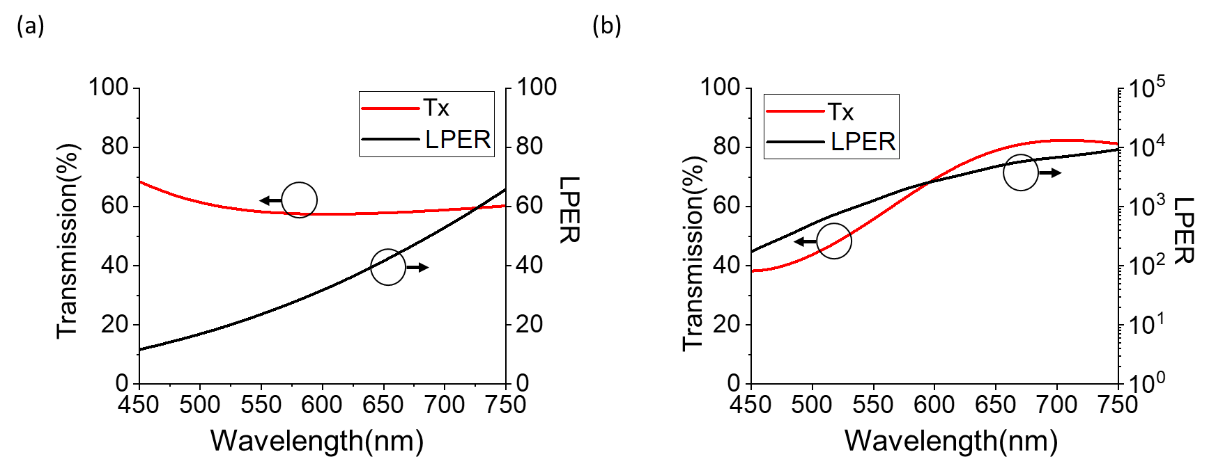
Figure S2. LPER and efficiency of single layered gratings with different thickness. (a) Transmission efficiency and LPER of single layered grating with Al deposition thickness of 80nm, which is the same as VCDG design. The period, duty cycle of Al grating are 190nm and 0.5. (b) Transmission efficiency and LPER of single layered grating with Al thickness of 180nm, the period, duty cycle of Al gratings are 190nm and 0.5.

Figure S2 shows the LPER and efficiency of single layered gratings with different Al deposition thickness. At same thickness(80nm), VCDG has 3 orders higher LPER than single layered gratings, we contribute such high LPER of VCDG to its bi-layer nature, which allows transmitted electric field from top Al nanowire to be further damped out by the lower grating. Further, we increased single grating thickness to 180nm to catch up the LPER difference (Supplementary Figure 1b). However, such thick Al requires Al etching in fabrication, which is a challenging task because both etching uniformity and etching reproducibility needs to be optimized for millimeter-scale fabrication. On the contrary, the fabrication of VCDG does not require the etching of Al but Al deposition, which is much simpler and robust.

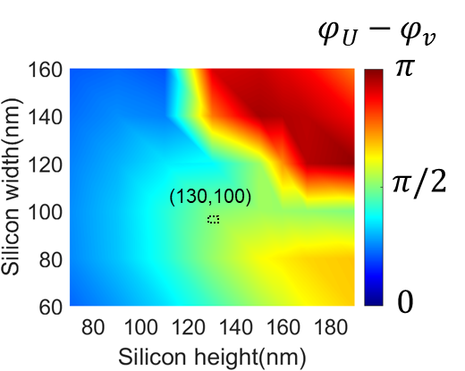
Figure S3. Tuning phase difference between U, V axes at 630nm by changing Si grating height and grating width. Si grating period is fixed at 297nm in FDTD simulation.

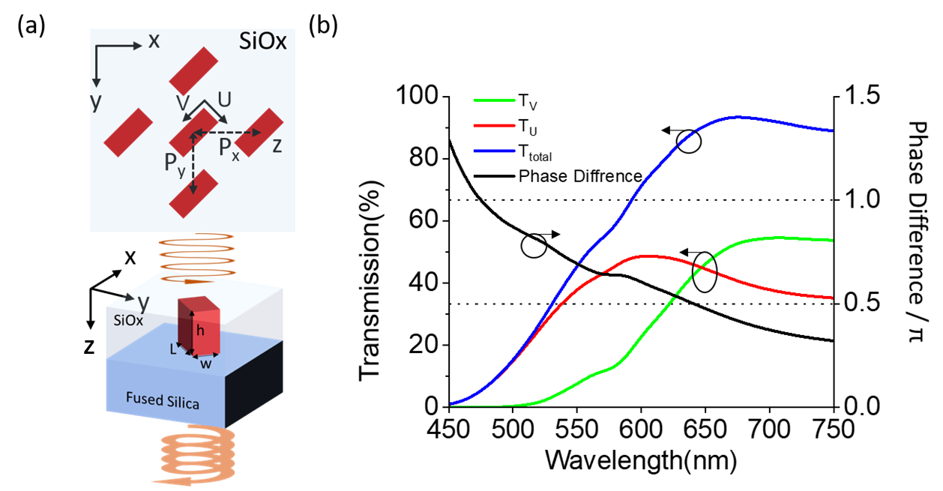
Figure S4. Optimized Si Bar nanopillars working as QWP at 645nm. (a) 2D illustration of Si nanobar array and 3D illustration of Si nanobarn unit cell. Si nanopillar is immersed in SiOx for on chip integration. The width w, length L and height h and period along x axis and y axis of Si nanopillar are w=60nm, L=250nm, h=260nm, Px=Py=190nm respectively. (b) Phase difference between fast axis(U axis) and slow axis (V axis), left axis, and correspondent transmission along U axis(red) and V axis(green) and total transmission (black) (right axis).

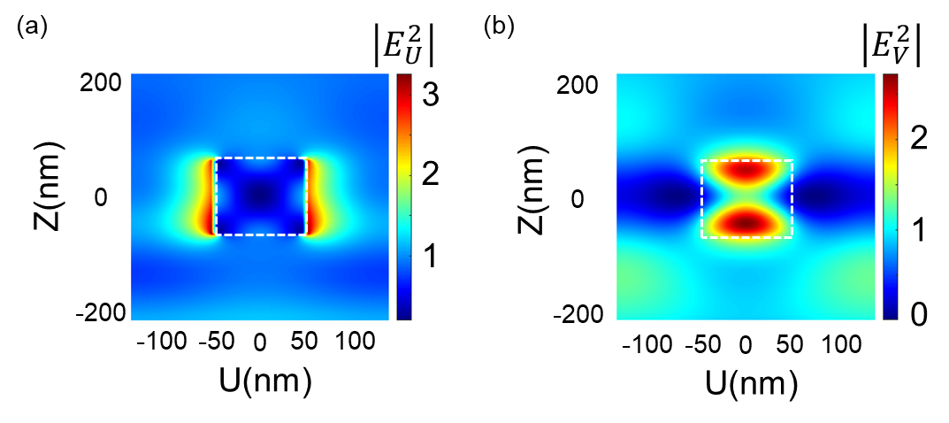
Figure S5. Cross-sectional near field distribution of Si gratings for input LP along grating U,V axes, respectively.
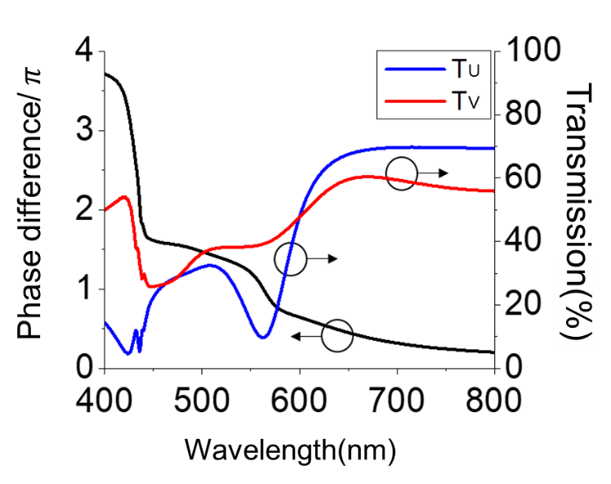
Figure S6. Phase difference between E_{U} and E_{V} calculated by FDTD simulation.

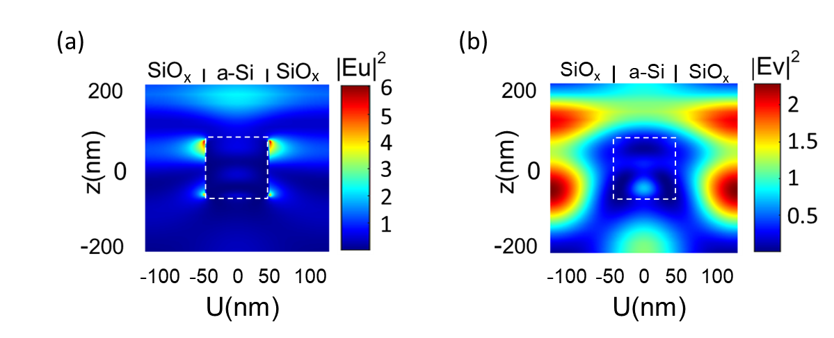
Figure S7. Cross-sectional near field distribution of Si grating at 500nm.

Fabrication and spectroscopic characterization of Chiral metasurface and VCDG
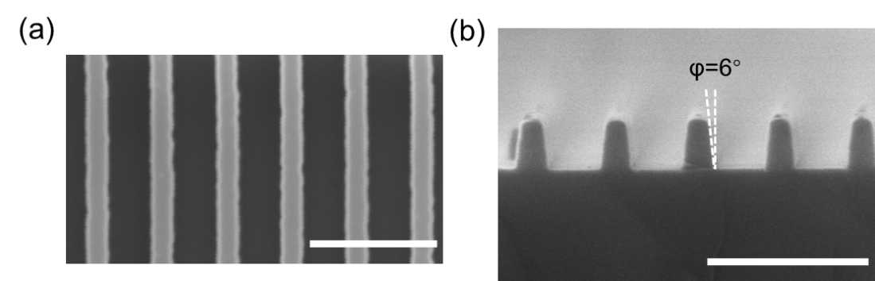
Figure S8. Top view and Cross-section SEM image of the dry etched Si gratings. (a) Top view SEM, scale bar: 500nm. (b) Cross-section SEM, scale bar: 500nm.

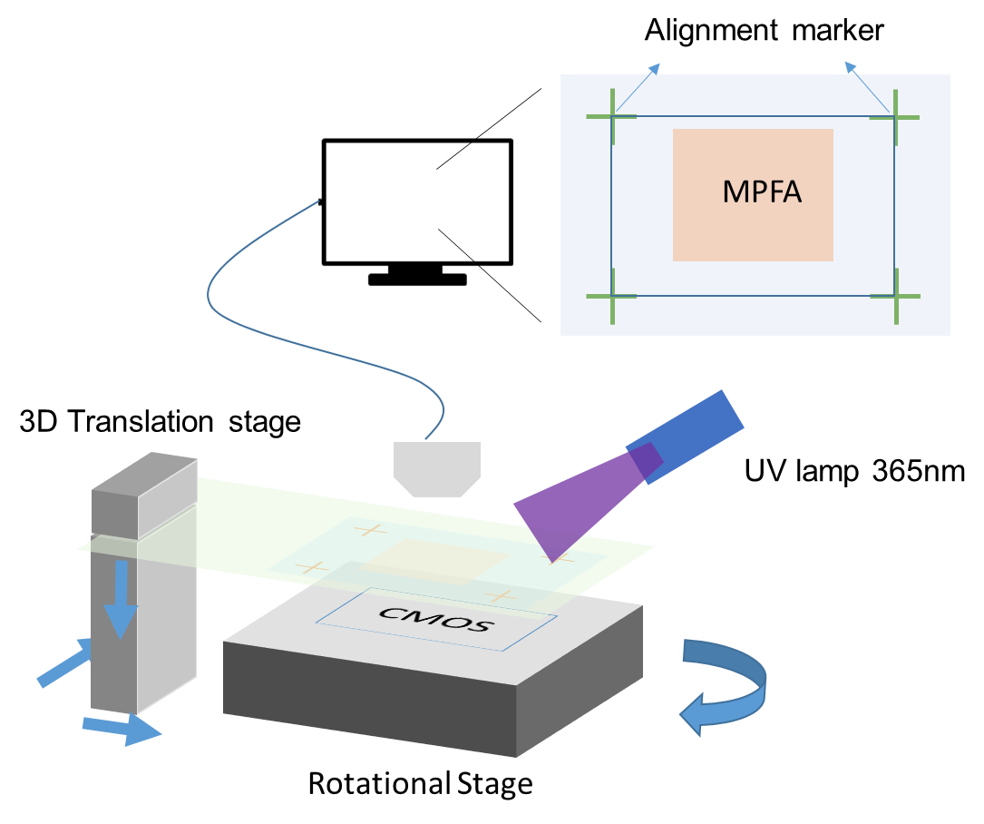
Figure S9. Homemade CMOS bonding setup. The device is taped onto a glass slide and then mounted on a 3D translation stage. Meanwhile, the CMOS imaging sensor is spin coated with UV resist and mounted onto the rotational stage. Then the device is visually aligned to the CMOS imaging sensor using pre-designed alignment marker. After alignment, the device is bonded on the CMOS imaging sensor via UV bonding.
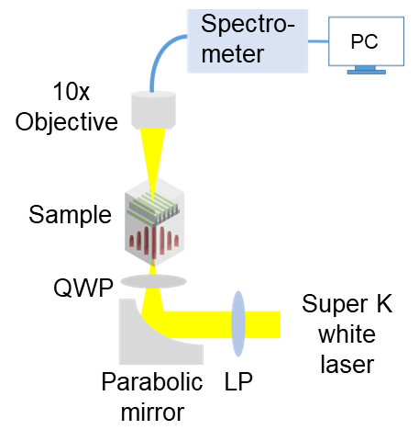
Figure S10. Schematic of the spectroscopy setup for chiral metasurface and VCDG characterization.

Analysis of degradation of optical performances of Chiral metasurface and VCDG due to fabrication
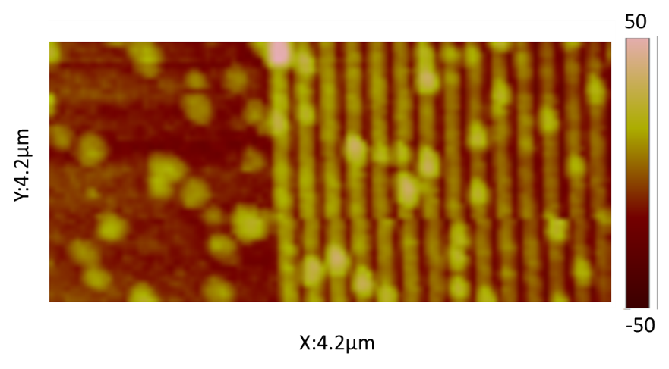
Figure S11. AFM image of VCDG before Al deposition. Surface roughness Ra=8.43nm at blank regions.

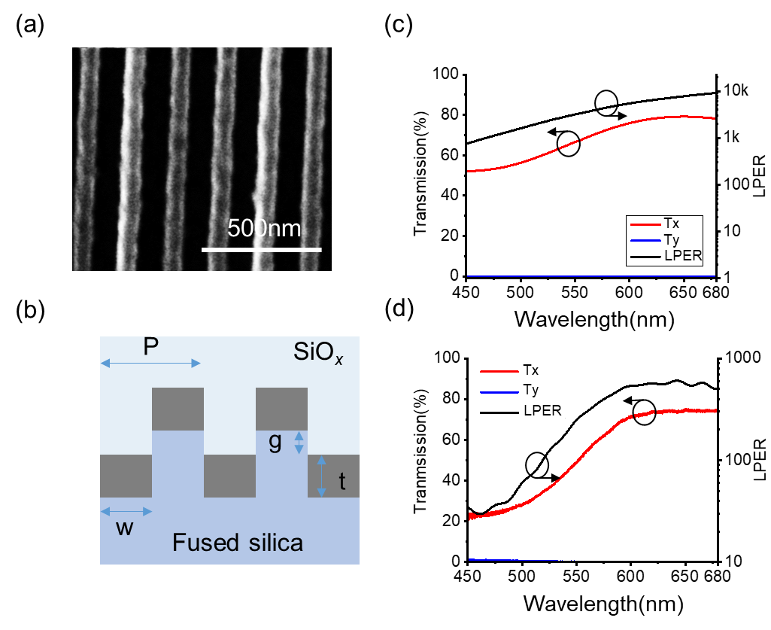
Figure S12. SEM image and characterization of VCDG fabricated by EBL patterning on fused silica wafer. (a) SEM image of VCDG, after taking SEM images, 200nm SiOx is sputtered as encapsulation layer on device. (b)2D cross sectional illustration of VCDG fabricated, the period, thickness of Al, vertical gap size and grating width are P=180nm, t=60nm, g=20nm and w=88nm respectively. (c) Simulated transmission and LPER of VCDG. (d) Measured transmission and LPER of VCDG.

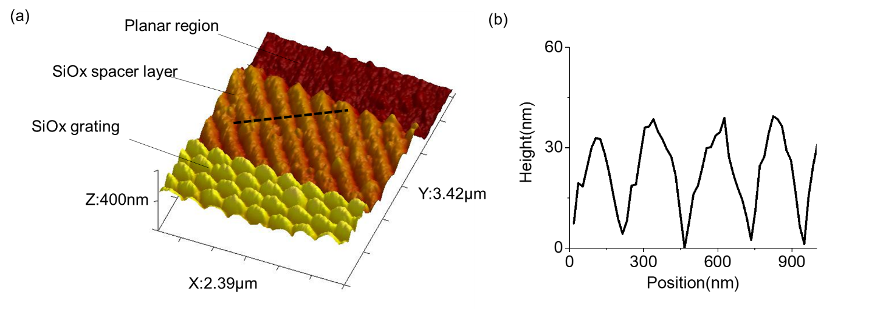
Figure S13. Fabrication of chiral metasurface. (a). Atomic Force Microscope (AFM) 3D image of SiOx spacer layer and SiOx grating after 2nd EBL patterning followed by dry etching of 100nm SiOx to form SiOx grating. (b) Height variation of SiOx spacer layer after SiOx etching, indicating surface roughness of SiOx spacer layer (Ra= 27.8nm).

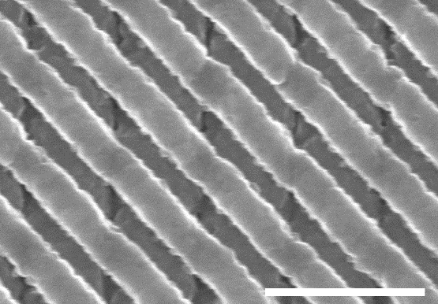
Figure S14. SEM of another chiral metasurface (Device B) fabricated by same fabrication procedures, scale bar: 500nm. The thickness, period, width, and tilted angle of Si nanograting are t_{si}=130nm, p₁=268nm, w=100nm. The thickness of Aluminum (Al), period, and vertical gap of bottom layer VCDG are t_{Al}= 60nm, p₂= 190nm, and g=20nm, respectively. The thickness of the SiO_{x} spacer layer is t=335nm measured by Atomic Force Microscope (AFM).

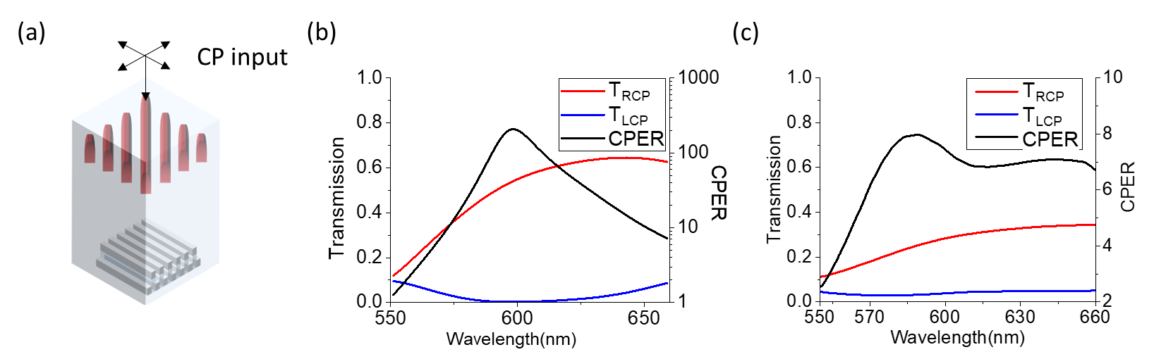
Figure S15. FDTD simulated and measured transmission/ CPER of chiral metasurface (device B) with CP light input from Si grating side of chiral metasurface. (a). 3D schematic to show CP input from the Si grating side of the chiral metasurface. (b). FDTD simulated CPER and efficiency of chiral metasurface. (c). Measured CPER and efficiency of chiral metasurface (device B).
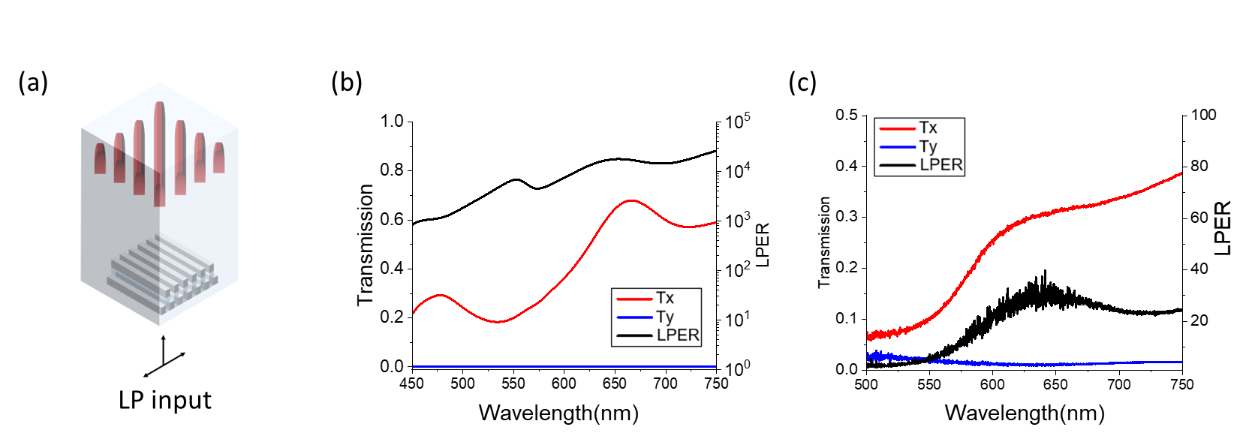
Figure S16. FDTD simulated and measured transmission/ LPER of VCDG with LP light incident from VCDG side of chiral metasurface (device B). (a). 3D schematic to show LP input from the VCDG side of the chiral metasurface. (b). FDTD simulated LPER and efficiency of chiral metasurface with LP input from VCDG side of chiral metasurface. (c). Measured LPER and efficiency of chiral metasurface with LP input from VCDG side of chiral metasurface.

Instrument matrix calibration process
The transmitted intensity of a linear grating which transmits LP light oriented in a horizontal direction, can be described by the input polarization state $\vec{s}$ And the first row of its Mueller matrix:
$s_{0}^{HG_out}$=$\left[\begin{matrix}\begin{matrix}m_{11}^{HG} & m_{12}^{HG}\end{matrix} & \begin{matrix}m_{13}^{HG} & m_{14}^{HG}\end{matrix}\end{matrix}\right]$×$\left[\begin{matrix}\begin{matrix}s_{0}^{in} \\ s_{1}^{in}\end{matrix} \\ \begin{matrix}s_{2}^{in} \\ s_{3}^{in}\end{matrix}\end{matrix}\right]$ (1)
Likewise, the output intensity of linear gratings responsible for detection of 90°, 45°, 135° LP light, and chrial metasurface responsible for detection of LCP and RCP light can also be described by the input polarization state and their first row of mueller matrix:
(2)
$$I=\left[\begin{matrix}\begin{matrix}s_{0}^{0G_out} \\ s_{0}^{90G_out}\end{matrix} \\ \begin{matrix}s_{0}^{135G_out} \\ s_{0}^{45G_out}\end{matrix} \\ \begin{matrix}s_{0}^{LCPG_out} \\ s_{0}^{RCPG_out}\end{matrix}\end{matrix}\right]=\left[\begin{matrix}\begin{matrix}\begin{matrix}\begin{matrix}m_{11}^{0G} & m_{12}^{0G}\end{matrix} & \begin{matrix}m_{13}^{0G} & m_{14}^{0G}\end{matrix}\end{matrix} \\ \begin{matrix}\begin{matrix}m_{11}^{90G} & m_{12}^{90G}\end{matrix} & \begin{matrix}m_{13}^{90G} & m_{14}^{90G}\end{matrix}\end{matrix}\end{matrix} \\ \begin{matrix}\begin{matrix}\begin{matrix}m_{11}^{135G} & m_{12}^{135G}\end{matrix} & \begin{matrix}m_{13}^{135G} & m_{14}^{135G}\end{matrix}\end{matrix} \\ \begin{matrix}\begin{matrix}m_{11}^{45G} & m_{12}^{45G}\end{matrix} & \begin{matrix}m_{13}^{45G} & m_{14}^{45G}\end{matrix}\end{matrix}\end{matrix} \\ \begin{matrix}\begin{matrix}\begin{matrix}m_{11}^{LCPG} & m_{12}^{LCPG}\end{matrix} & \begin{matrix}m_{13}^{LCPG} & m_{14}^{LCPG}\end{matrix}\end{matrix} \\ \begin{matrix}\begin{matrix}m_{11}^{RCPG} & m_{12}^{RCPG}\end{matrix} & \begin{matrix}m_{13}^{RCPG} & m_{14}^{RCPG}\end{matrix}\end{matrix}\end{matrix}\end{matrix}\right]×\left[\begin{matrix}\begin{matrix}s_{0}^{in} \\ s_{1}^{in}\end{matrix} \\ \begin{matrix}s_{2}^{in} \\ s_{3}^{in}\end{matrix}\end{matrix}\right]=A×S$$
The matrix A here is denoted as the instrument matrix of the metasurface filter array. For any unknown polarization state ${\vec{s}}^{'}$ , it can be inversely calculated via the transmission intensity (written as $I$) and the instrument matrix A using equation:
${\vec{s}}^{'}=A^{-1}×I$ (3)
The measurement of the instrument matrix A can be done by inputting more than four pre-known polarization states measured by traditional angle-resolved measurements:
$A=\left[\begin{matrix}\begin{matrix}\begin{matrix}\begin{matrix}m_{11}^{0G} & m_{12}^{0G}\end{matrix} & \begin{matrix}m_{13}^{0G} & m_{14}^{0G}\end{matrix}\end{matrix} \\ \begin{matrix}\begin{matrix}m_{11}^{90G} & m_{12}^{90G}\end{matrix} & \begin{matrix}m_{13}^{90G} & m_{14}^{90G}\end{matrix}\end{matrix}\end{matrix} \\ \begin{matrix}\begin{matrix}\begin{matrix}m_{11}^{135G} & m_{12}^{135G}\end{matrix} & \begin{matrix}m_{13}^{135G} & m_{14}^{135G}\end{matrix}\end{matrix} \\ \begin{matrix}\begin{matrix}m_{11}^{45G} & m_{12}^{45G}\end{matrix} & \begin{matrix}m_{13}^{45G} & m_{14}^{45G}\end{matrix}\end{matrix}\end{matrix} \\ \begin{matrix}\begin{matrix}\begin{matrix}m_{11}^{LCPG} & m_{12}^{LCPG}\end{matrix} & \begin{matrix}m_{13}^{LCPG} & m_{14}^{LCPG}\end{matrix}\end{matrix} \\ \begin{matrix}\begin{matrix}m_{11}^{RCPG} & m_{12}^{RCPG}\end{matrix} & \begin{matrix}m_{13}^{RCPG} & m_{14}^{RCPG}\end{matrix}\end{matrix}\end{matrix}\end{matrix}\right]=\left[\begin{matrix}\begin{matrix}\begin{matrix}\begin{matrix}s_{0}^{0G_1} & s_{0}^{0G_2}\end{matrix} & \begin{matrix}s_{0}^{0G_3} & s_{0}^{0G_4}\end{matrix}\end{matrix} \\ \begin{matrix}\begin{matrix}s_{0}^{90G_1} & s_{0}^{90G_2}\end{matrix} & \begin{matrix}s_{0}^{90G_3} & s_{0}^{90G_4}\end{matrix}\end{matrix}\end{matrix} \\ \begin{matrix}\begin{matrix}\begin{matrix}s_{0}^{135G_1} & s_{0}^{135G_2}\end{matrix} & \begin{matrix}s_{0}^{135G_3} & s_{0}^{135G_4}\end{matrix}\end{matrix} \\ \begin{matrix}\begin{matrix}s_{0}^{45G_1} & s_{0}^{45G_2}\end{matrix} & \begin{matrix}s_{0}^{45G_3} & s_{0}^{45G_4}\end{matrix}\end{matrix}\end{matrix} \\ \begin{matrix}\begin{matrix}\begin{matrix}s_{0}^{LCPG_1} & s_{0}^{LCPG_2}\end{matrix} & \begin{matrix}s_{0}^{LCPG_3} & s_{0}^{LCPG_4}\end{matrix}\end{matrix} \\ \begin{matrix}\begin{matrix}s_{0}^{RCPG_1} & s_{0}^{RCPG_2}\end{matrix} & \begin{matrix}s_{0}^{RCPG_3} & s_{0}^{RCPG_4}\end{matrix}\end{matrix}\end{matrix}\end{matrix}\right]×{\left[\begin{matrix}\begin{matrix}s_{0}^{1} \\ s_{1}^{1}\end{matrix} \\ \begin{matrix}s_{2}^{1} \\ s_{3}^{1}\end{matrix}\end{matrix}\begin{matrix}\begin{matrix}s_{0}^{2} \\ s_{1}^{2}\end{matrix} \\ \begin{matrix}s_{2}^{2} \\ s_{3}^{2}\end{matrix}\end{matrix}\begin{matrix}\begin{matrix}s_{0}^{3} \\ s_{1}^{3}\end{matrix} \\ \begin{matrix}s_{2}^{3} \\ s_{3}^{3}\end{matrix}\end{matrix}\begin{matrix}\begin{matrix}s_{0}^{4} \\ s_{1}^{4}\end{matrix} \\ \begin{matrix}s_{2}^{4} \\ s_{3}^{4}\end{matrix}\end{matrix}\right]}^{-1}=I×S^{-1}$ (4)
To guarantee a more stable calculation of the instrument matrix, eight polarization states are used for real measurements.
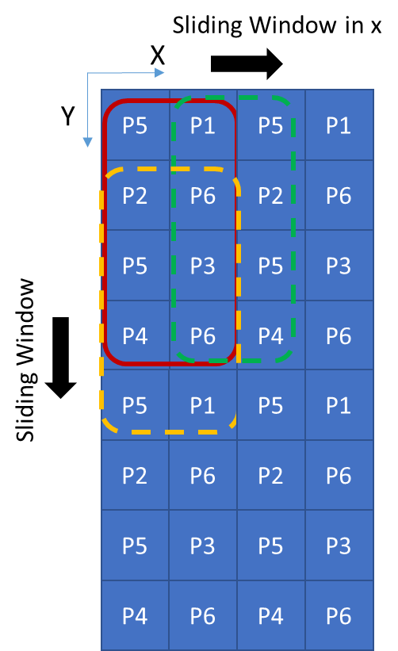
Figure S17. Illustration of the working principle of demosaicking during the instrument matrix calibration process. A new intensity vector can be obtained by sliding the superpixel registry window at both the x and y direction, 1 pixel per step, because of the periodic distribution of each pixel (P1-P6).

A sliding window sampling approach is applied during instrument matrix calibration process to increase the imaging resolution, as shown in Supplementary Figure S20. A sliding window is moving along x and y directions with one pixel, i.e., metasurface filter per step. Each newly registered superpixel has a complete set of LP filters and CP filters, a correspondent instrument matrix can thus be registered using method mentioned above.

Full Stokes polarization measurement at different incidence angle
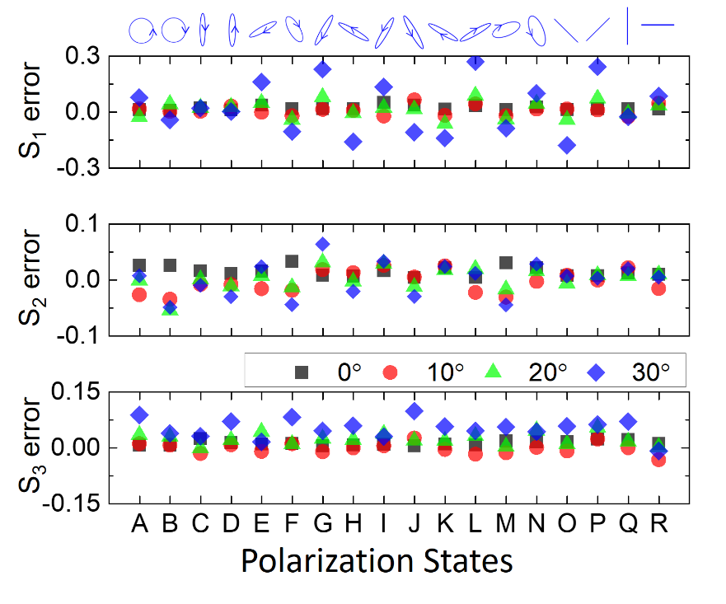
Figure S18. Full Stokes polarization measurement at different incidence angles, bandwidth 630-670nm.
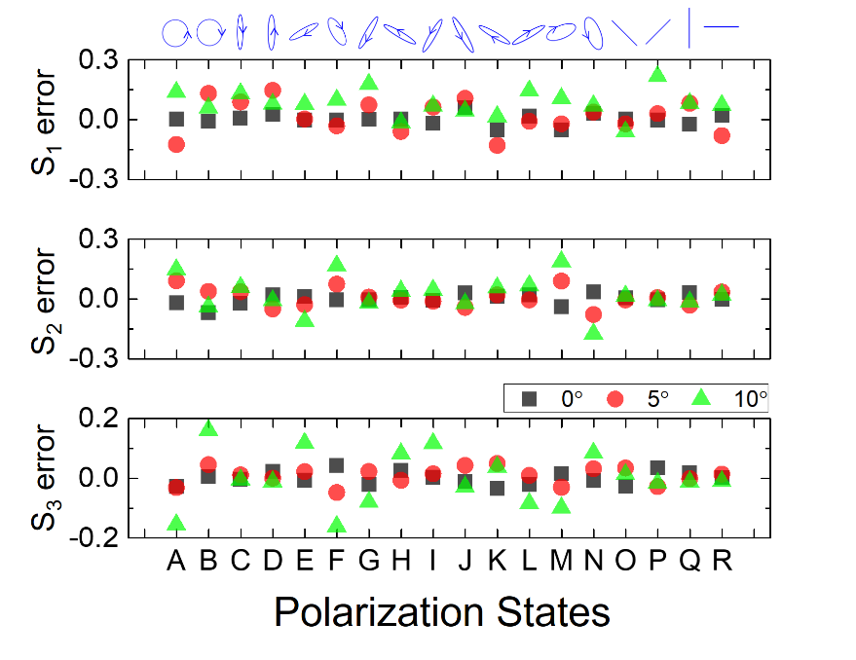
Figure S19. Full Stokes polarization measurement at different incidence angles, bandwidth 480-520nm.
Table S3. Table of mean absolute error and average standard deviation for 18 polarization states at different incidence angle at red color input.
Red (630-670nm) MAE ± SD
Name $φ$ | S₁/S₀ | S₂/S₀ | S₃/S₀ | DOCP | AOP | DOLP
0° | 1.03%±0.84% | 1.43%±0.77% | 1.99%±0.88% | 1.99%±0.88% | 0.26°±0.28° | 1.41%±0.72%
10° | 2.02%±3.97% | 1.57%±3.69% | 2.78%±4.35% | 2.78%±4.35% | 0.63°±1.24° | 1.71%±3.68%
20° | 3.29%±3.88% | 1.82%±3.85% | 3.84%±4.72% | 3.84%±4.72% | 0.85°±1.23° | 2.28%±3.80%
30° | 9.99%±5.93% | 5.19%±5.36% | 17.51%±7.14% | 17.51%±7.14% | 3.07°±1.54° | 6.41%±6.16%

Table S4. Table of mean absolute error and average standard deviation for 18 polarization states at different incidence angle at green color input.
Green (480-520nm) MAE± SD
Name  $$φ$$ | S₁/S₀ | S2/S₀ | S₃/S₀ | DOCP | AOP | DOLP
0° | 1.84%±0.85% | 1.93%±0.76% | 1.79%±2.38% | 1.79%±2.38% | 0.78°±0.25° | 1.26%±0.79%
5° | 1.88%±3.21% | 2.03%±3.09% | 4.44%±11.38% | 4.44%±11.38% | 0.85°±1.07° | 1.04%±2.97%
10° | 2.17%±3.54% | 3.71%±3.49% | 22.75%±15.39% | 22.75%±15.39% | 0.78°±1.15° | 3.52%±3.34%

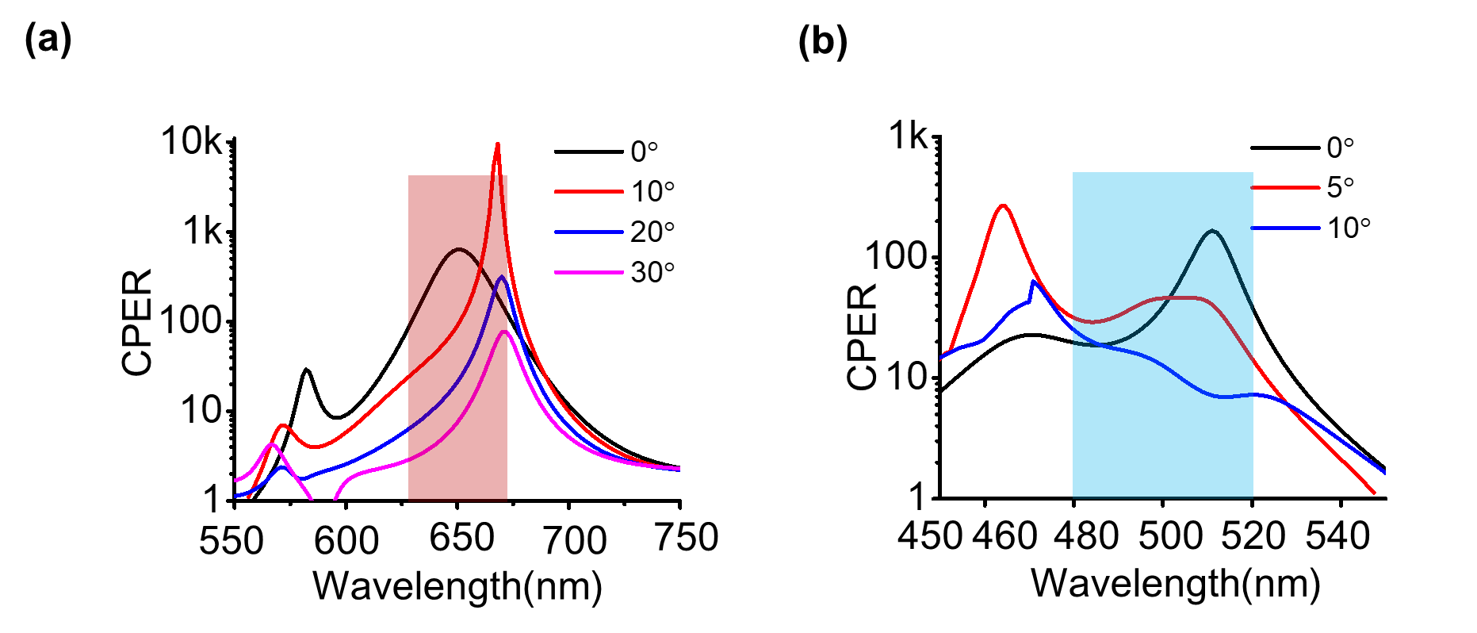
Figure S20. FDTD simulated CPER of chiral metasurface of under oblique incidence. (a,b).FDTD simulation at 550nm~750nm and 450nm~550nm respectively.
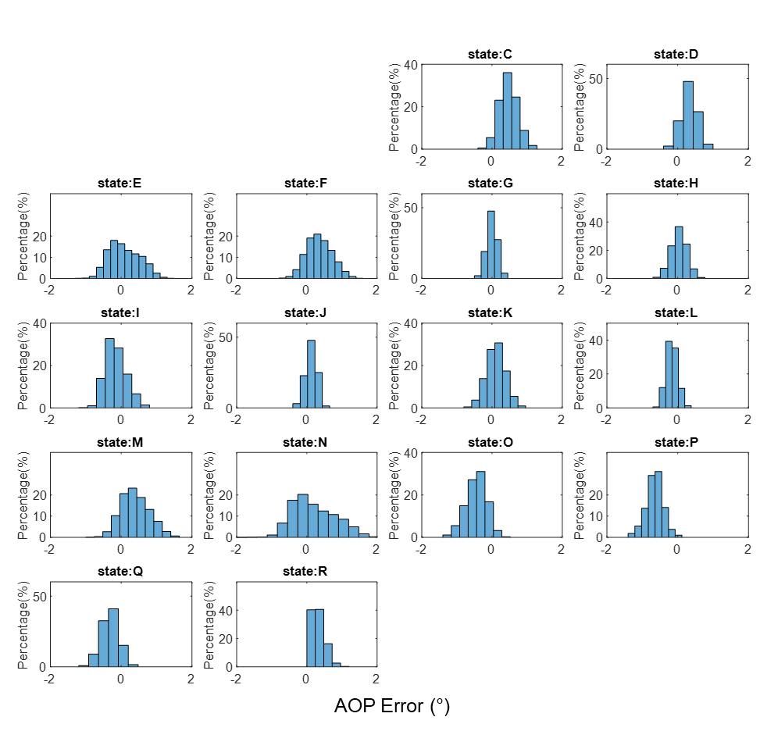
Figure S21. AOP measurement error distribution of MPFA under red color input, $φ=0$°.
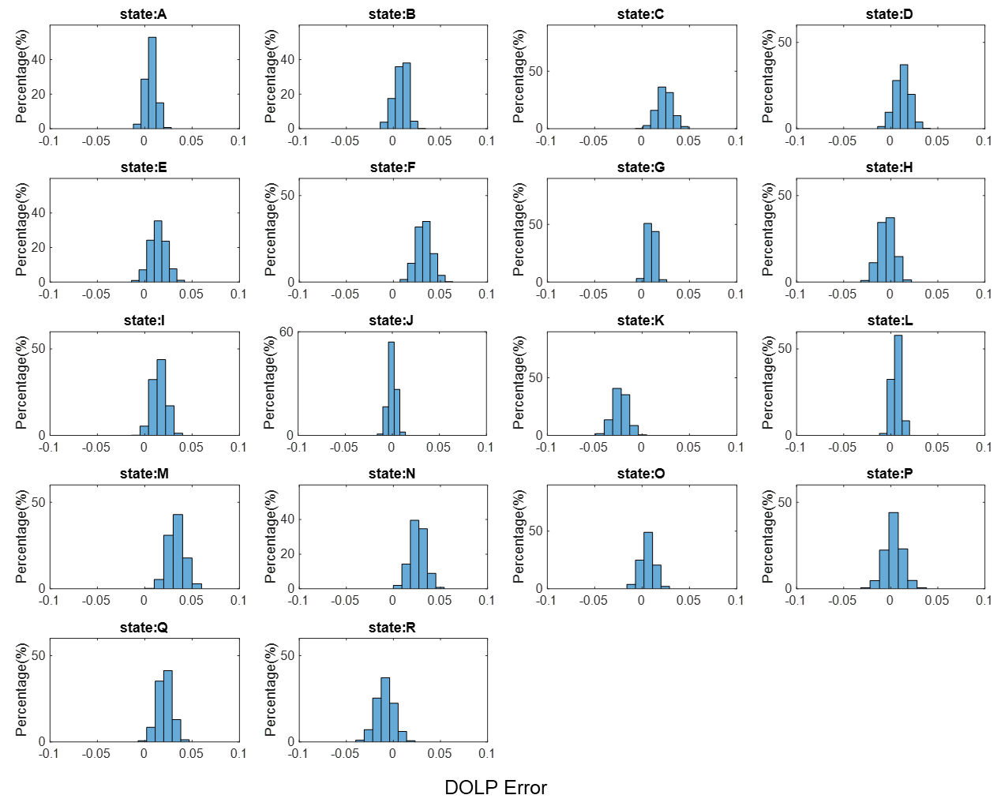
Figure S22. DOLP measurement error distribution of MPFA under red color input, $φ=0$°.
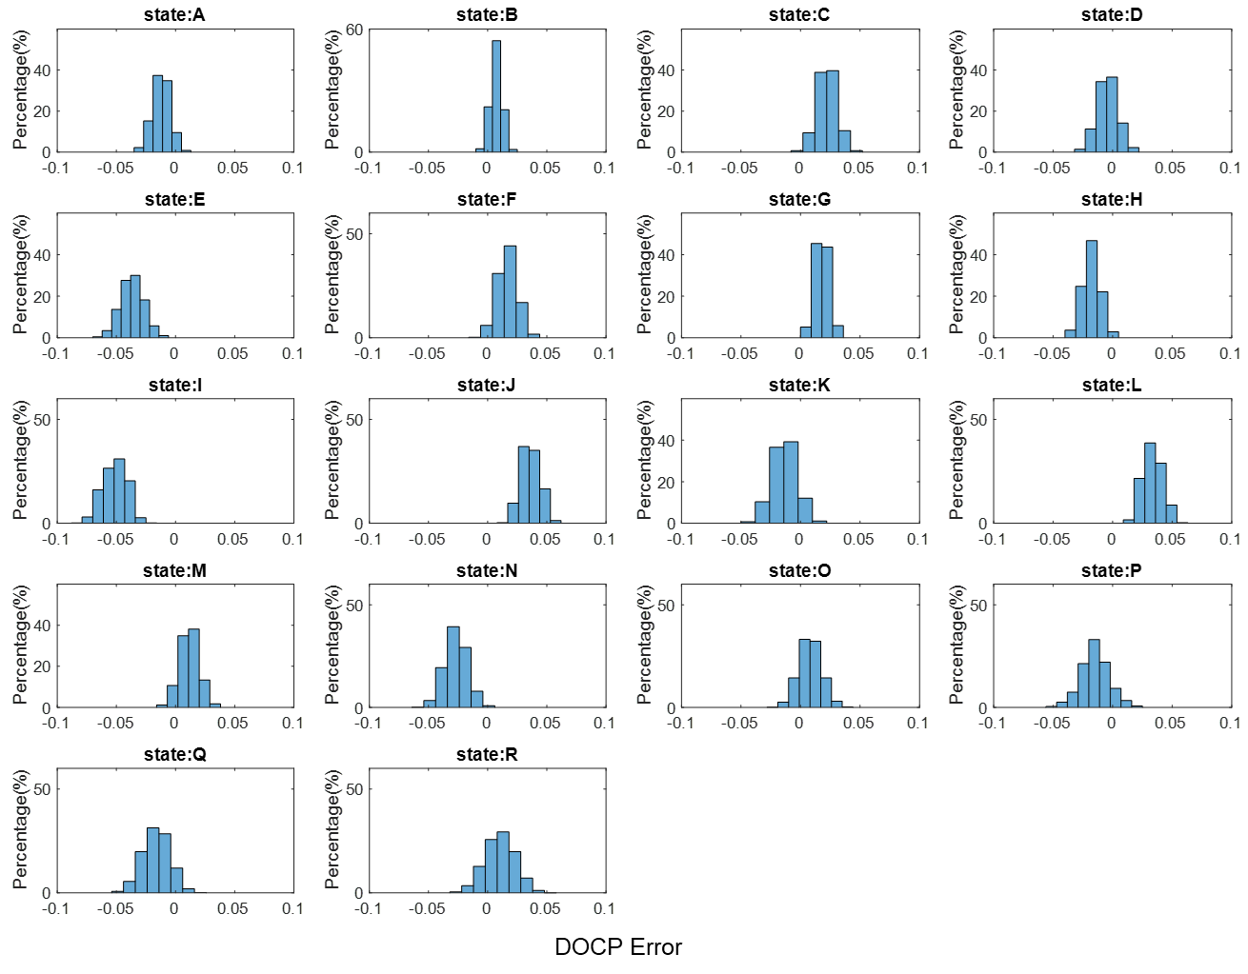
Figure S23. DOCP measurement error distribution of MPFA under red color input, $φ=0$°.
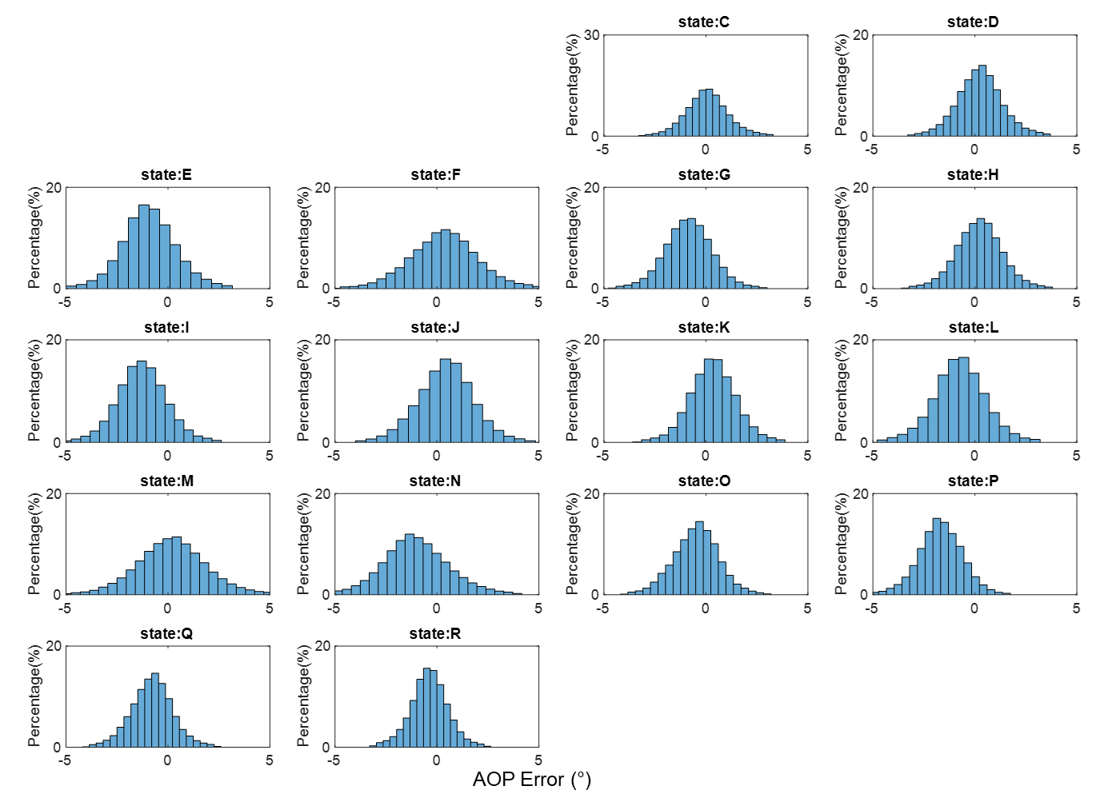
Figure S24. AOP measurement error distribution of MPFA under red color input, $φ=10$°.
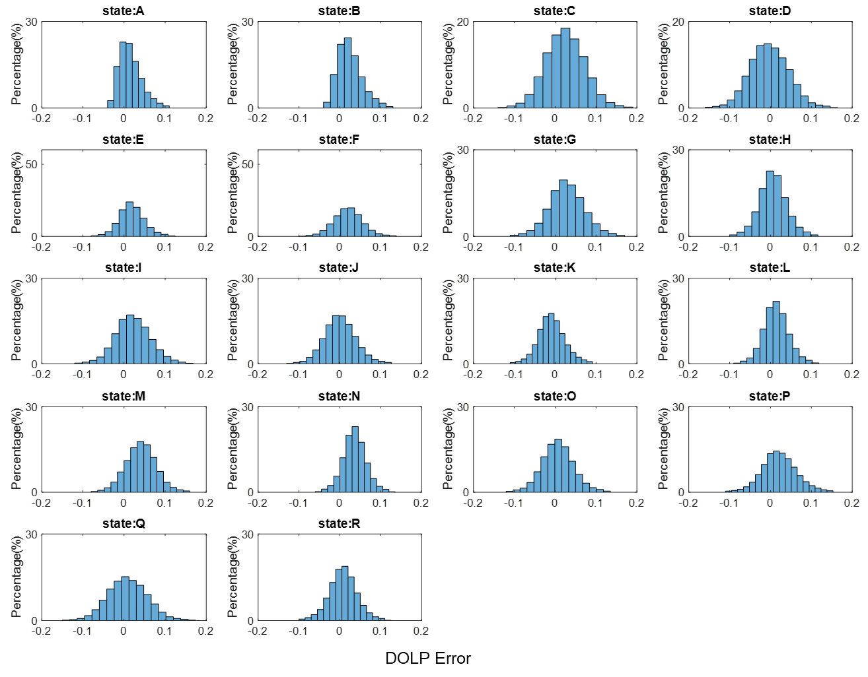
Figure S25. DOLP measurement error distribution of MPFA under red color input, $φ=10$°
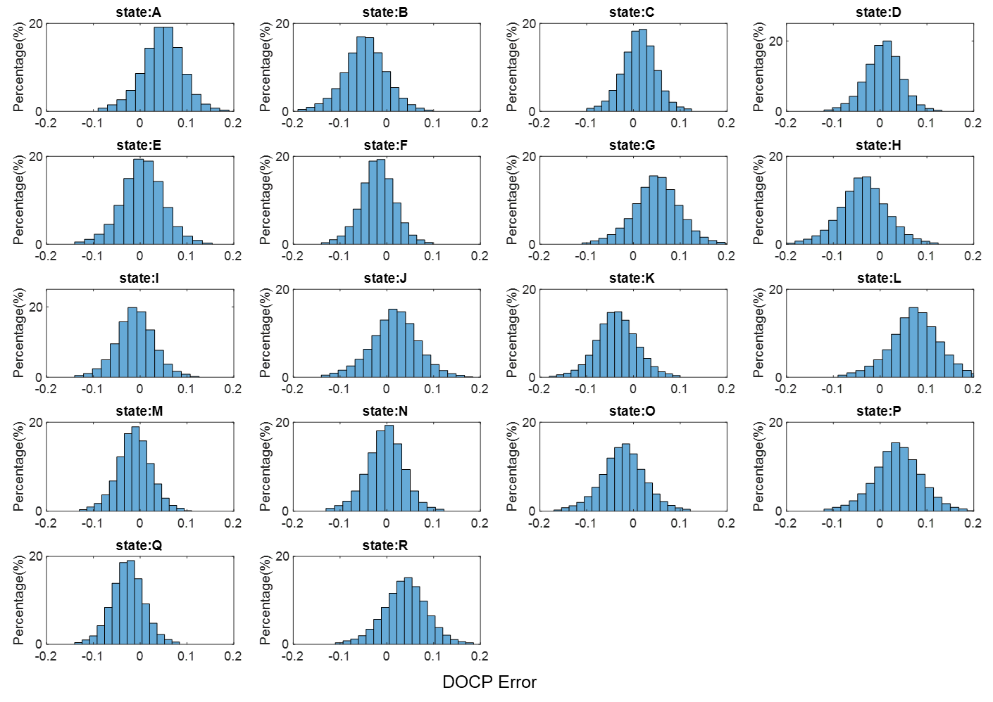
Figure S26. DOCP measurement error distribution of MPFA under red color input, $φ=10$°
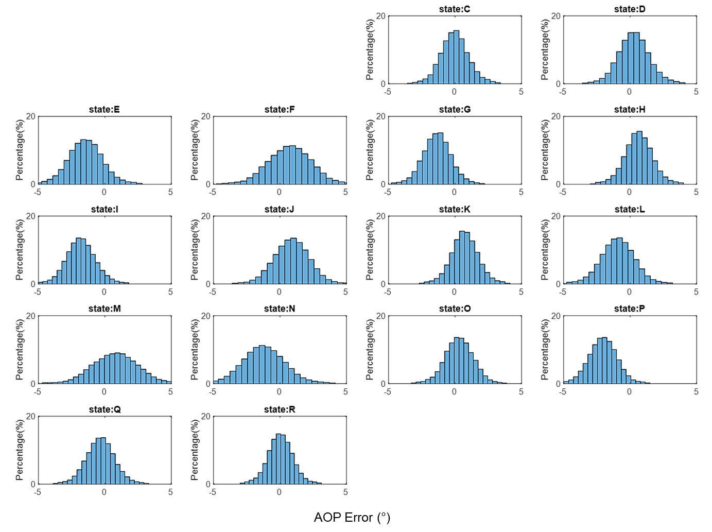Figure S27. AOP measurement error distribution of MPFA under red color input, $φ=20$°.
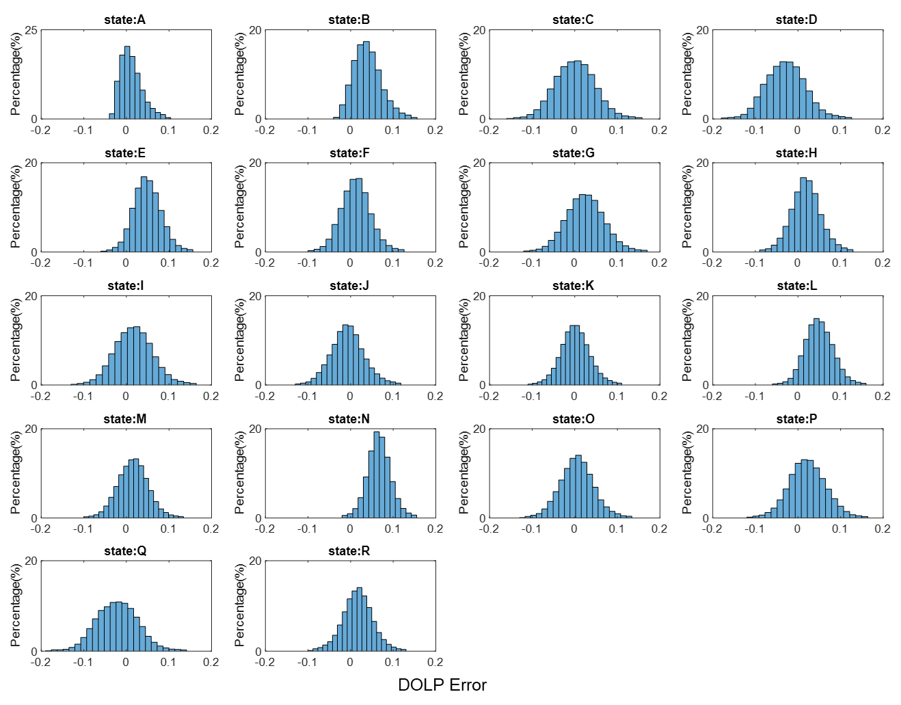
Figure S28. DOLP measurement error distribution of MPFA under red color input, $φ=20$°
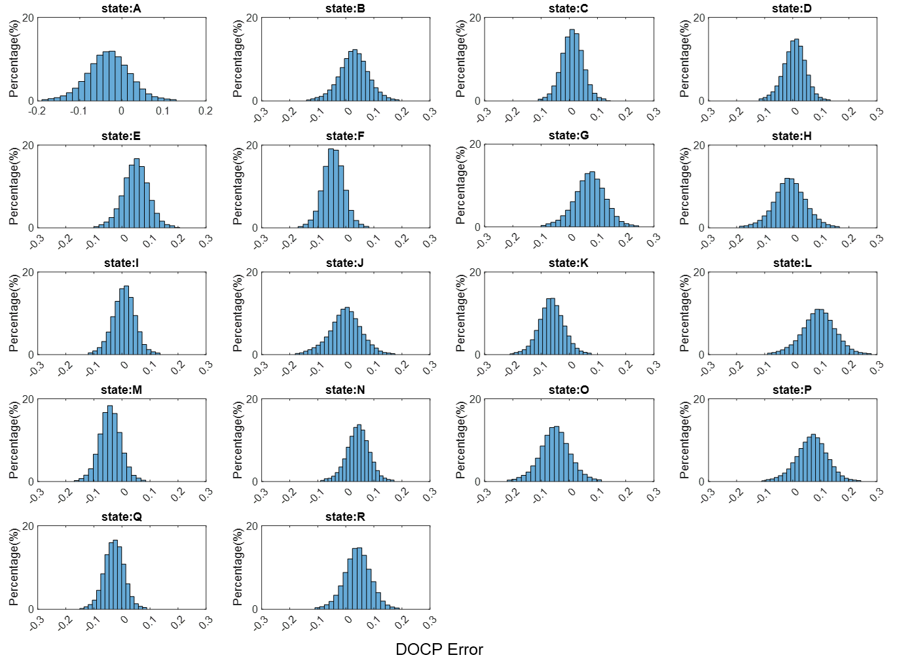
Figure S29. DOCP measurement error distribution of MPFA under red color input, $φ=20$°
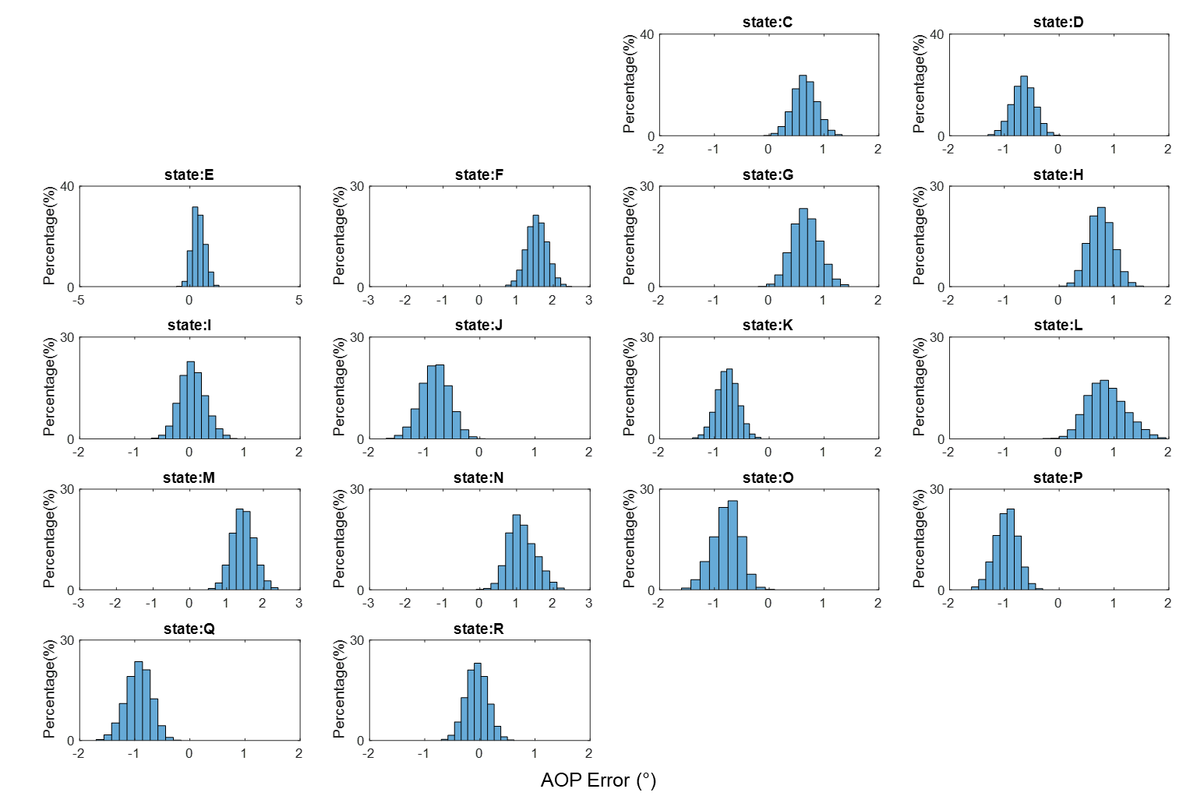
Figure S30. AOP measurement error distribution of MPFA under green color input, $φ=0$°.

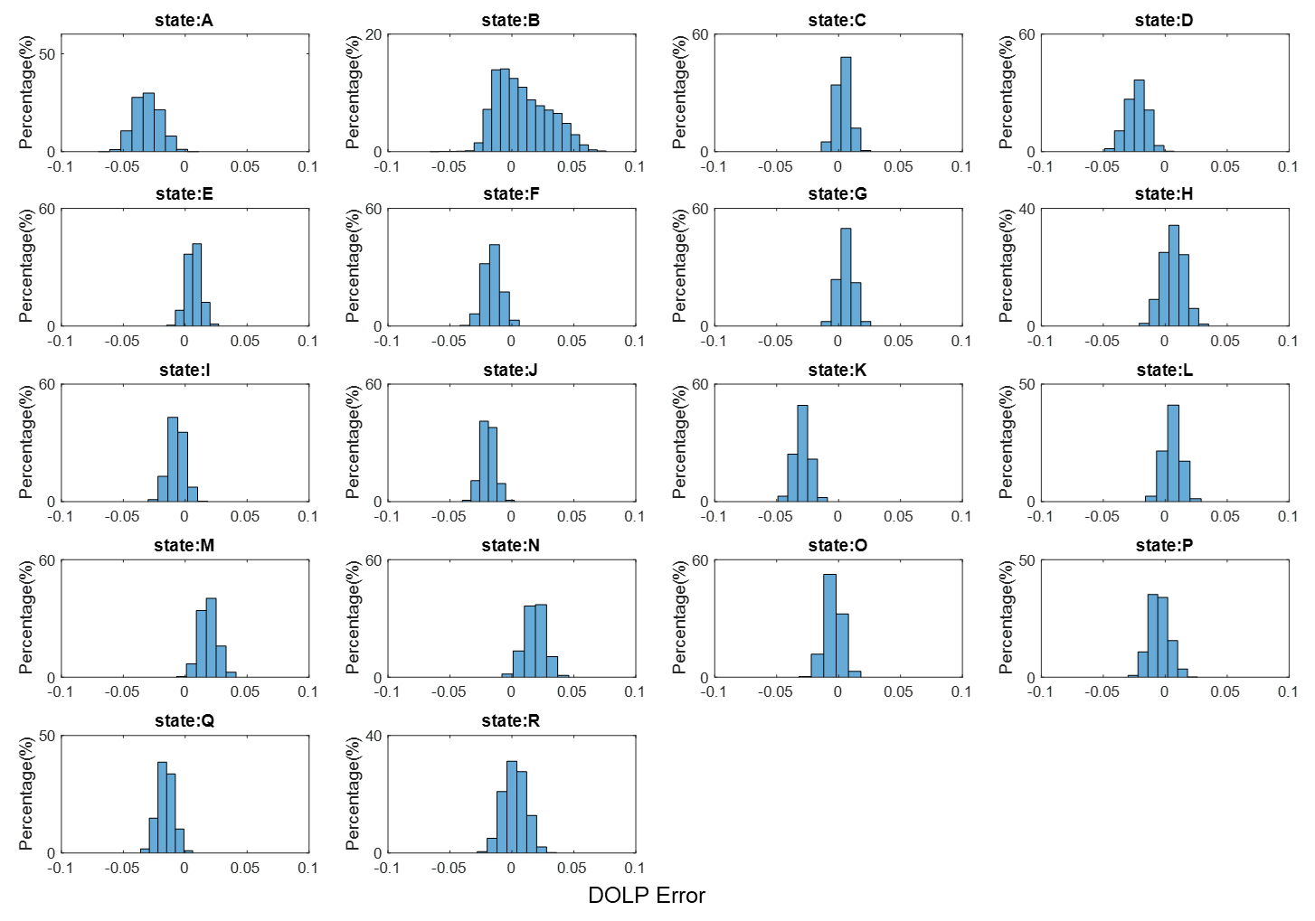
Figure S31. DOLP measurement error distribution of MPFA under green color input, $φ=0$°
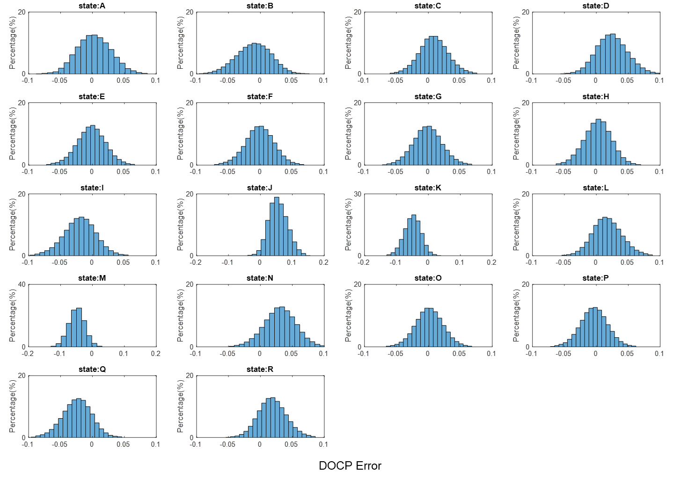
Figure S32. DOCP measurement error distribution of MPFA under green color input, $φ=0$°
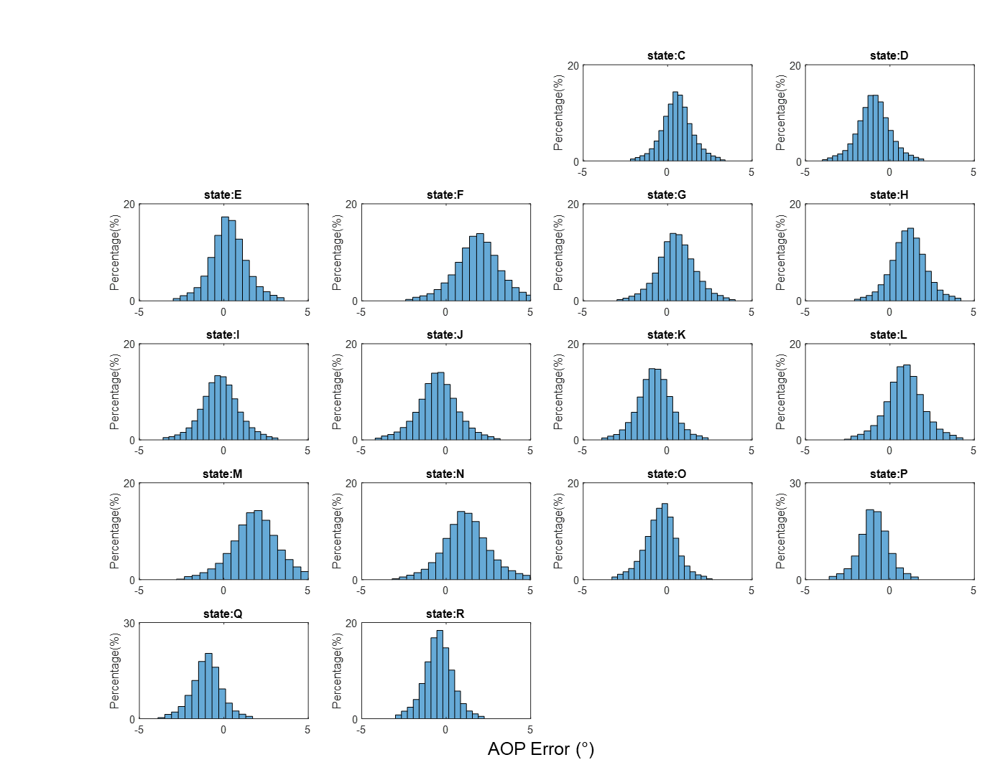
Figure S33. AOP measurement error distribution of MPFA under green color input, $φ=5$°.
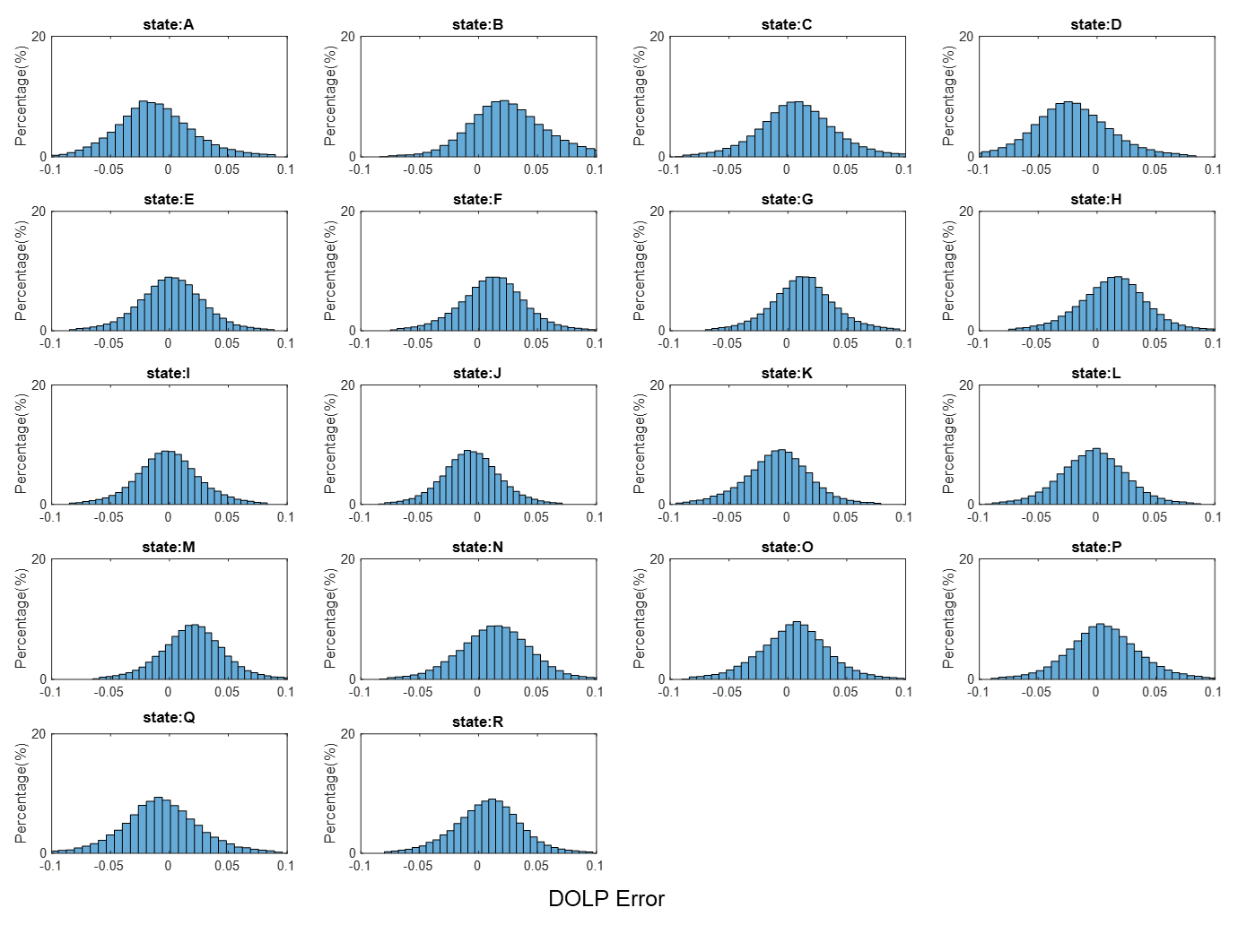
Figure S34. DOLP measurement error distribution of MPFA under green color input, $φ=5$°
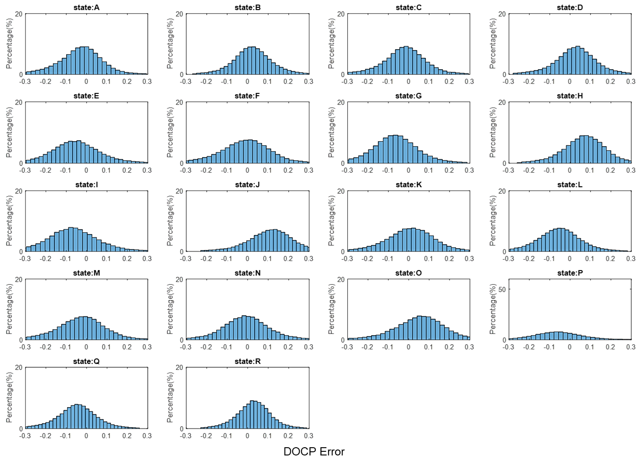
Figure S35. DOCP measurement error distribution of MPFA under green color input, $φ=5$°
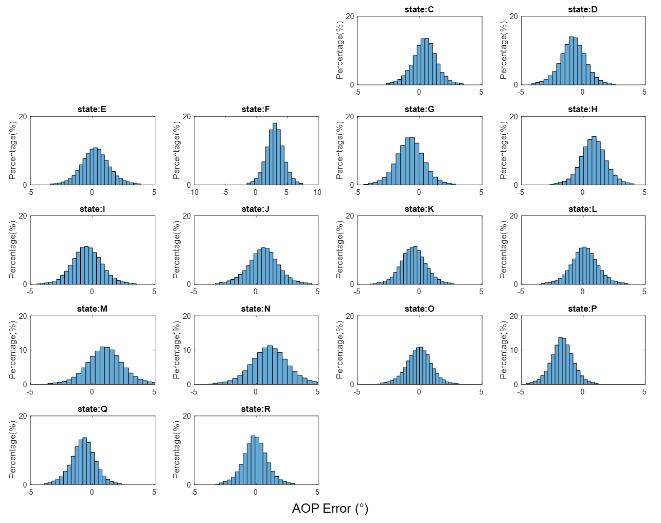
Figure S S36. AOP measurement error distribution of MPFA under green color input, $φ=10$°.
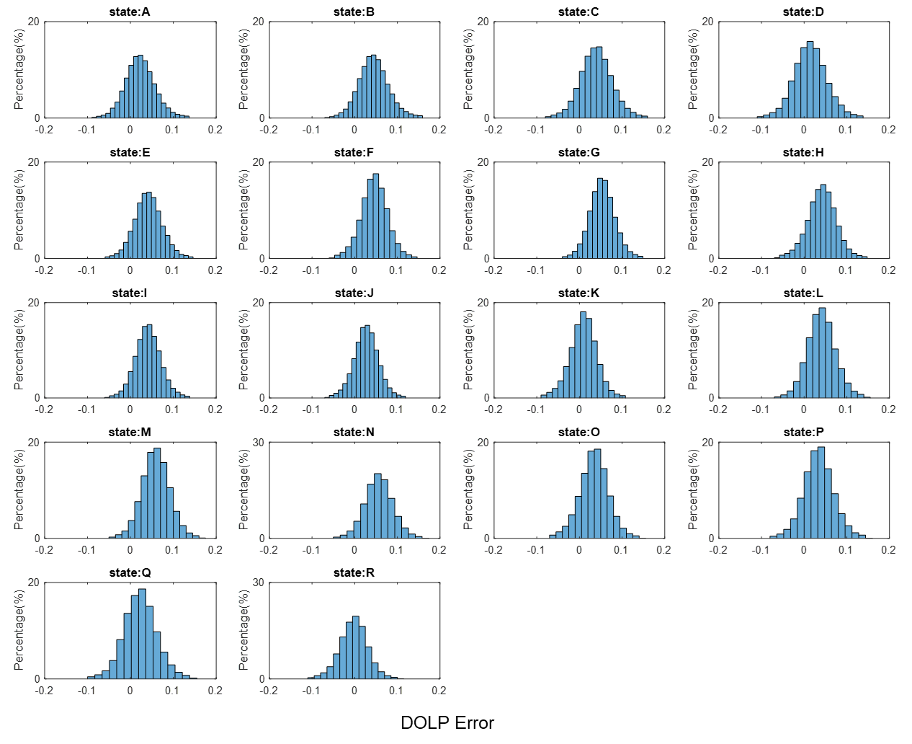
Figure S37. DOLP measurement error distribution of MPFA under green color input, $φ=10°$
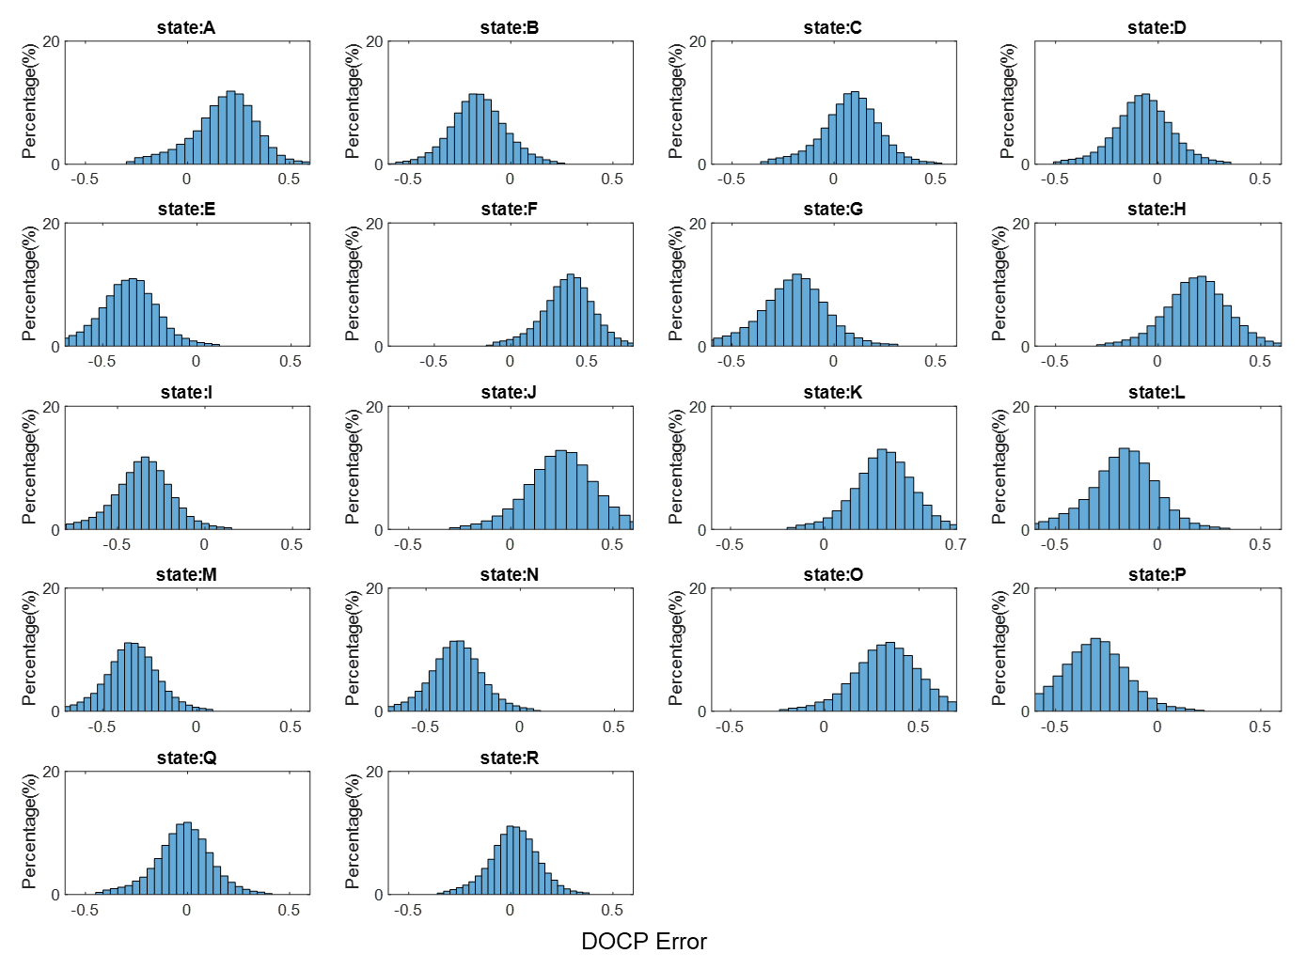
Figure S38. DOCP measurement error distribution of MPFA under green color input, $φ=10°$

Full Stokes polarization imaging of ASU logo with polarization information

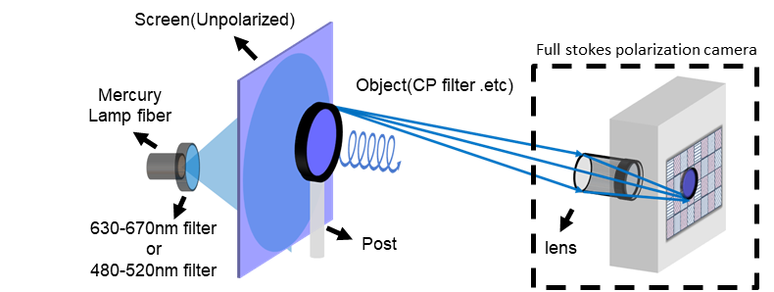
Figure S39. Illustration of full Stokes polarization imaging setup.

Supplementary References
1. Rubin, N.A., et al., Matrix Fourier optics enables a compact full-Stokes polarization camera. Science, 2019. 365(6448).
2. Yang, Z., et al., Generalized Hartmann-Shack array of dielectric metalens sub-arrays for polarimetric beam profiling. Nature communications, 2018. 9(1): p. 1-7.
3. Arbabi, E., et al., Full-Stokes imaging polarimetry using dielectric metasurfaces. Acs Photonics, 2018. 5(8): p. 3132-3140.
4. Bai, J., J. Zuo, and Y. Yao. Mid-Infrared Chip-Integrated Full-Stokes Polarimeter Array Based on Plasmonic Metasurfaces. in 2022 Conference on Lasers and Electro-Optics (CLEO). 2022. IEEE.
5. Thorlabs. PAX1000VIS/M - Polarimeter. Available from: https://www.thorlabs.com/thorproduct.cfm?partnumber=PAX1000VIS/M.
6. Vedel, M., S. Breugnot, and N. Lechocinski. Full Stokes polarization imaging camera. in Polarization Science and Remote Sensing V. 2011. International Society for Optics and Photonics.
7. Sony. Sony Polarsens 2022; Available from: https://www.sony-semicon.com/en/technology/industry/polarsens.html.
8. Tu, X., et al., Division of focal plane red–green–blue full-Stokes imaging polarimeter. Applied optics, 2020. 59(22): p. G33-G40.
9. Myhre, G., et al., Liquid crystal polymer full-stokes division of focal plane polarimeter. Optics express, 2012. 20(25): p. 27393-27409.

