Supplements Archives
Table S1. Chemical (1) and particle (2) analyses of the soils before the implementation of the experiments.
Soil chemistry (1) | Unit | Sandy soil | Clay soil
pH _{(CaCl2)} |  | 4.6 | 3.9
P_{resin} | mg dm⁻³ | 4 | 3
Organic matter | % | 0.9 | 1.3
Ca _{ion exchanger resin} | mmol_{c} dm⁻³ | 2 | 2
Mg _{ion exchanger resin} | mmol_{c} dm⁻³ | 1 | 1
H+Al | mmol_{c} dm⁻³ | 35 | 71
K _{ion exchanger resin} | mmol_{c} dm⁻³ | 0.5 | 0.2
Sum of bases | mmol_{c} dm⁻³ | 3 | 3
CEC | mmol_{c} dm⁻³ | 39 | 74
Base saturation | % | 3 | 4
Al³⁺_{(KCl)} | mmol_{c} dm⁻³ | 8 | 12
S Ca(H₂PO₄)₂ | mg dm⁻³ | 3 | 7
B _{(hot water)} | mg dm⁻³ | 0.17 | 0.24
Cu _{(DTPA)} | mg dm⁻³ | 0.7 | 2.7
Fe _{(DTPA)} | mg dm⁻³ | 30 | 36
Mn _{(DTPA)} | mg dm⁻³ | 0.6 | 2.2
Zn _{(DTPA)} | mg dm⁻³ | 0.4 | 0.2
Si (_{CaCl2 0.01 mol L}⁻¹₎ | mg kg ¹ | 4 | 3
Particle size (2) | Unit | Sandy soil | Clay soil
Clay | g kg ¹ | 319 | 857
Silt | g kg ¹ | 69 | 33
Sand | g kg ¹ | 612 | 110
Methodology: Raij et al. (2001) (1) and Claessen (1997) (2)

Table S2. Sources of potassium silicate used in the treatments
Source | Composition | Aspect | Chemical formula
Potassium silicate (application in soil) | 55.2 % SiO₂ and 34.5% K₂O | White powder | K₂OSiO₃
Potassium silicate (Spraying application) | 26.7% SiO₂ and 12.8% de K₂O | Colourless and semitransparent liquid | K₂OSiO₃
Source: Provided by manufacturers.

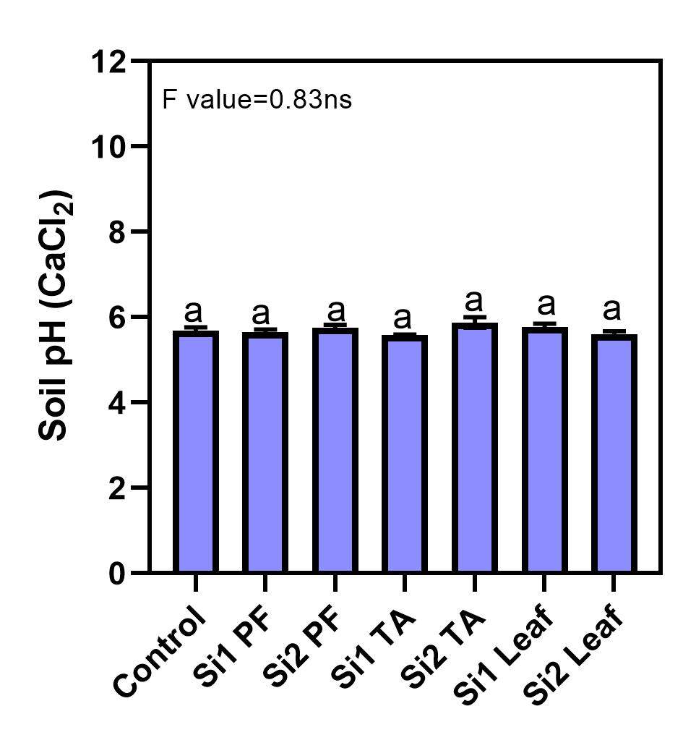
Fig S1. Effects of potassium silicate application methods and rates of silicon on soil pH. Experiment with sandy soil. Means followed by the same letter do not differ from each other by the Scott & Knott test. Error bars represent the standard error (n=4). Treatments abbreviations: control, no Si application; Si1 PF, 30 mg Si kg⁻¹ in planting furrow; Si2 PF, 120 mg Si kg⁻¹ in planting furrow; Si1 TA, 30 mg Si kg⁻¹ in total area of pot; Si2 TA, 120 mg Si kg⁻¹ in total area of pot; Si1 Leaf, spraying of 2.56 mg Si pot⁻¹; and Si2 Leaf spraying of 7.68 mg Si pot⁻¹. **= significant at 1 and 5% level. *= significant at 5% level. ns= no significant (Scott-Knott’s test).

Fig S2. Effects of potassium silicate application methods and rates of silicon on soil pH. Experiment with clay soil. Means followed by the same letter do not differ from each other by the Scott & Knott test. Error bars represent the standard error (n=4). Treatments abbreviations: control, no Si application; Si1 PF, 30 mg Si kg⁻¹ in planting furrow; Si2 PF, 120 mg Si kg⁻¹ in planting furrow; Si1 TA, 30 mg Si kg⁻¹ in total area of pot; Si2 TA, 120 mg Si kg⁻¹ in total area of pot; Si1 Leaf, spraying of 2.56 mg Si pot⁻¹; and Si2 Leaf spraying of 7.68 mg Si pot⁻¹. **= significant at 1 and 5% level. *= significant at 5% level. ns= no significant (Scott-Knott’s test).

References
Claessen MEC (1997) Manual de métodos de análise de solo. 2nd Edition, Embrapa CNPS, Rio de Janeiro, pp. 212
Raij BV et al. (2001) Análise Química para Avaliação da Fertilidade de Solos Tropicais. Instituto Agronômico, Campinas, pp. 285.

