Supplementary Information

Reducing continuous synchrony is an inherent property of tree growth in forests
Hengfeng Jia^{1,2,3}, Jiacheng Zheng^{1,2,3}, Ouya Fang^{1,2}, Jing Yang^{1,2,3}, Jia-Yang Langzhen^{1,2,3,4}, Richard J. Hebda⁵, Qi-Bin Zhang^{1,2}*
1 State Key Laboratory of Vegetation and Environmental Change, Institute of Botany, Chinese Academy of Sciences, Beijing, China
2 China National Botanical Garden, Beijing, China
3 University of the Chinese Academy of Sciences, Beijing, China
4 Linzhou Bureau of Meteorology, Linzhou, Lhasa, Tibet, China
5 Royal British Columbia Museum, Victoria, B.C., Canada
*Corresponding author. Email: qbzhang@ibcas.ac.cn

The file includes:

Figs. S1 to S4
Tables S1 to S2

Fig. S1.
Relationships between tree rings and climate for juniper trees in zones I and II on the Tibetan Plateau and for pine trees in zones III and IV in eastern China. ∆TRI, ∆PDSI₅₋₆, ∆Tmn₁₋₃ represent interannual differences of tree-ring indices, May-June Palmer Drought Severity Indices and January-March mean temperatures, respectively. The correlation coefficients were calculated in the interval between 1963-2000.

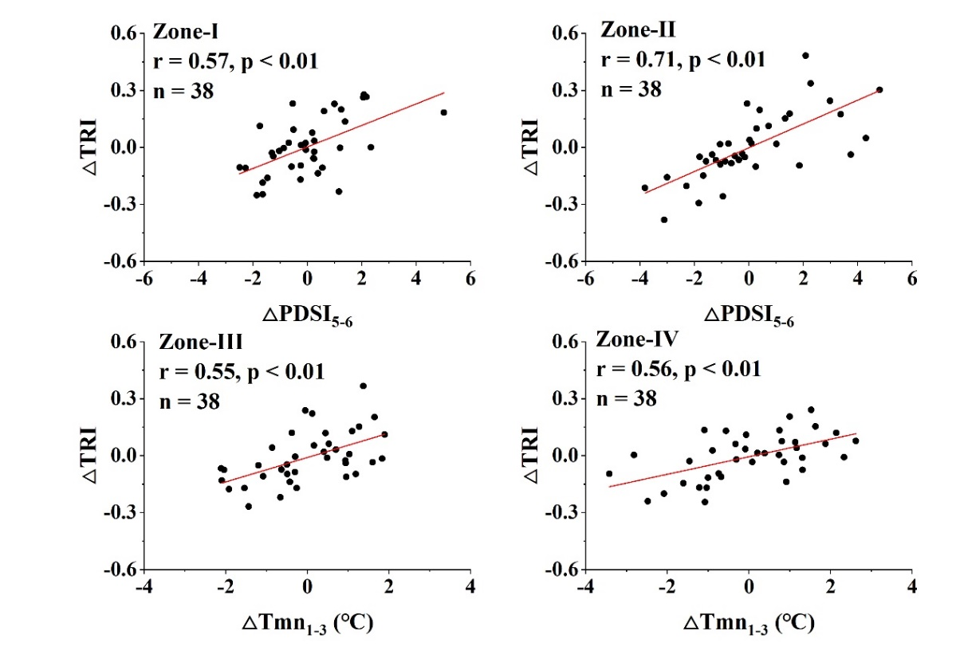

Fig. S2.
Occurrence of strong growth synchrony in 10-year interval for juniper trees in zones I and II on the Tibetan Plateau and for pine trees in zones III and IV in eastern China.

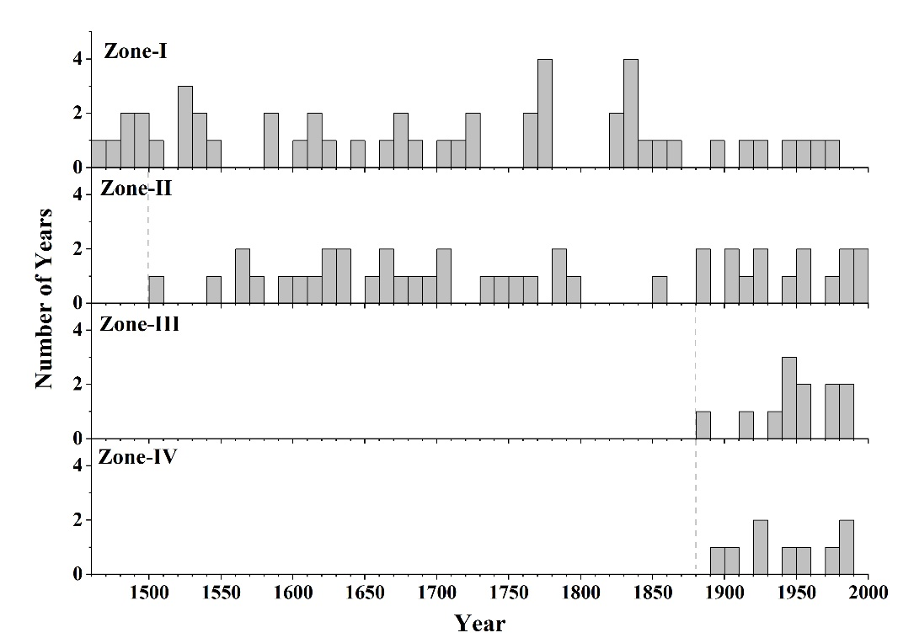

Fig. S3.
Patterns of number reduction in trees with continuous common growth change in the years following peaks of growth synchrony (i.e., the years outside the dashed lines in Fig. 1) for juniper forests in the Tibetan Plateau (zones I and II) and for pine forests in eastern China (zones III and IV). Theoretical curve refers to a stochastic process. Parameter b refers to the base parameter of exponential function.

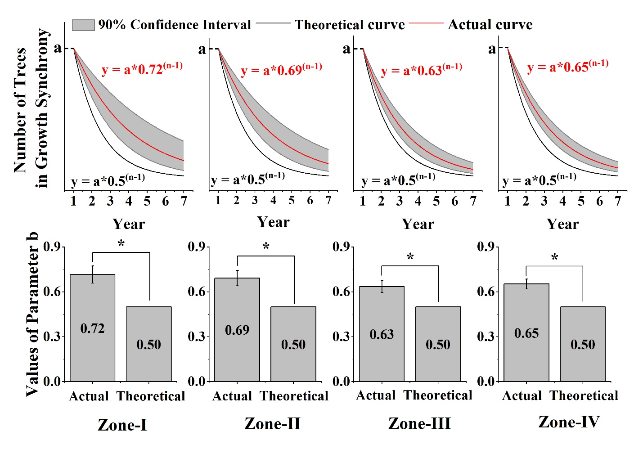

Fig. S4-1.
Percent of trees showing continuous common growth change (CCGC) in the years following peaks of growth synchrony for each site (in the order listed in Table 1) of juniper forests in the Tibetan Plateau (zones I and II). The box plots illustrate the distribution of the number of trees showing continuous common growth change after every strong synchronizing event, with the lines in the middle of the boxes indicating the mean, the lines outside the boxes indicating 1.5 standard deviation of the mean, and the dots outside the boxes indicating outliers. The curves refer to an exponential function fitted to each decline pattern in the number of trees remaining in synchronous growth.

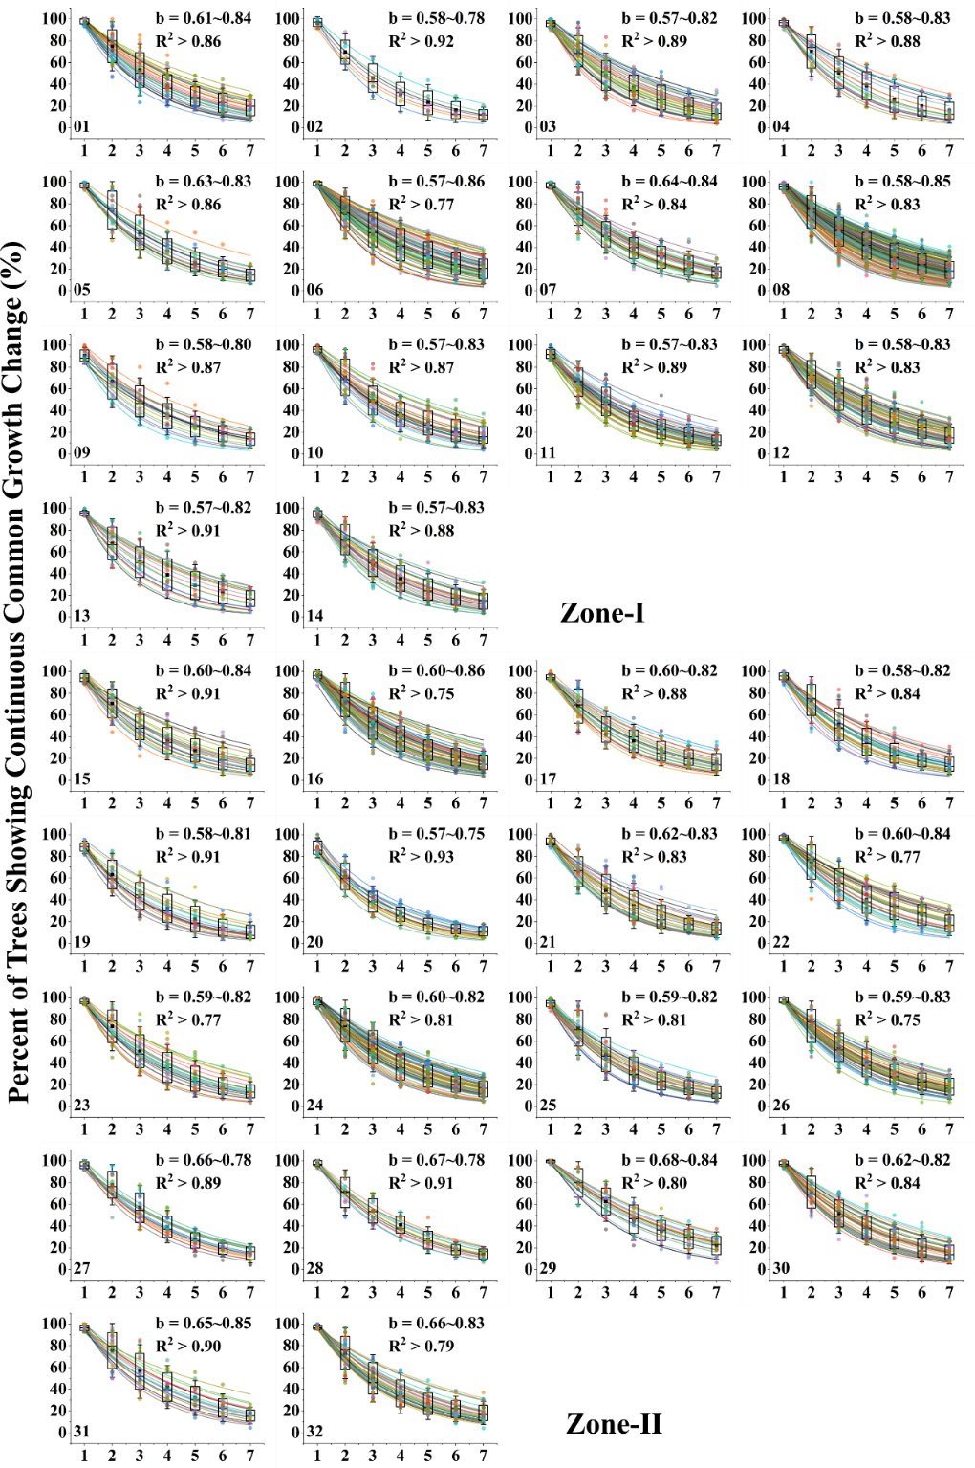

Fig. S4-2.
Percent of trees showing continuous common growth change (CCGC) in the years following peaks of growth synchrony for each site (in the order listed in Table 2) of pine forests in eastern China (zones III and IV). The box plots illustrate the distribution of the number of trees showing continuous common growth change after every strong synchronizing event, with the lines in the middle of the boxes indicating the mean, the lines outside the boxes indicating 1.5 standard deviation of the mean, and the dots outside the boxes indicating outliers. The curves refer to an exponential function fitted to each decline pattern in the number of trees remaining in synchronous growth.

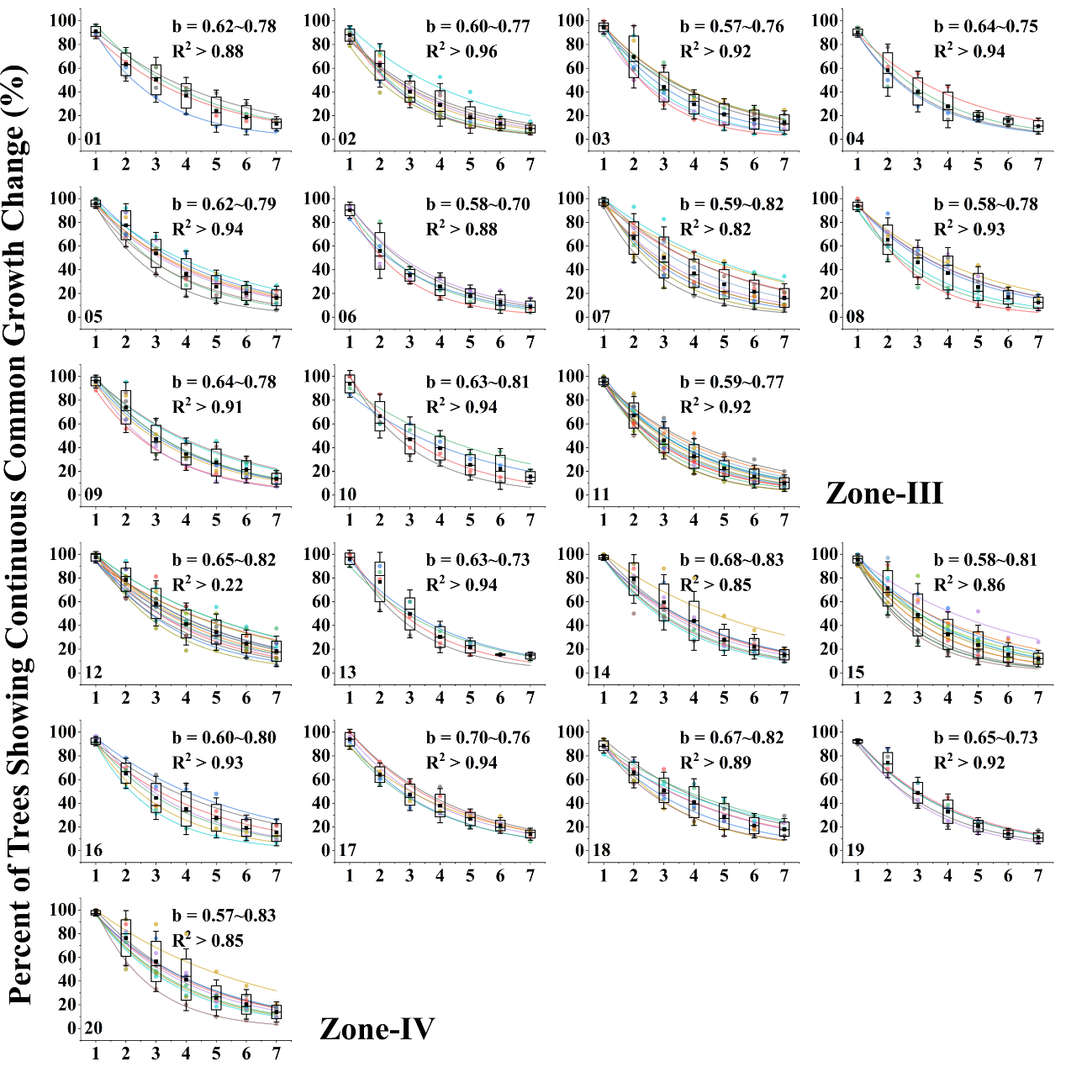

Table S1.
Information of the studied sites and tree rings on the Tibetan Plateau.

Group/  Species | No. |  | Site | Latitude  (N) |  | Longitude  (E) | Elevation  (m) | Sample Size | Span  (Years) * | Inter-series correlation coefficients
Zone-I  Juniper |  | 01 | QLZM | 38.27 | 99.99 |  | 3260 | 34 | 1275(1560)-2020 | 0.56
 |  | 02 | QLMZ | 38.21 | 100.73 |  | 2950 | 35 | 1742(1858)-2004 | 0.56
 |  | 03 | QLQY | 38.17 | 100.39 |  | 3420 | 40 | 1401(1536)-2004 | 0.51
 |  | 04 | QLYH | 38.02 | 100.02 |  | 3600 | 33 | 1500(1705)-2004 | 0.54
 |  | 05 | QLDG | 38.00 | 100.10 |  | 3500 | 31 | 1630(1679)-2004 | 0.57
 |  | 06 | DELH | 37.37 | 97.37 |  | 3820 | 45 | 976(1171)-2000 | 0.76
 |  | 07 | WLWL | 36.94 | 98.55 |  | 3640 | 27 | 1322(1612)-2001 | 0.58
 |  | 08 | DLDL | 36.37 | 98.13 |  | 3610 | 76 | 157 (1174)-2000. | 0.68
 |  | 09 | TRTR | 35.83 | 102.02 |  | 3260 | 31 | 1630(1781)-2001 | 0.43
 |  | 10 | XHZT | 35.05 | 100.1 |  | 3831 | 31 | 1470(1571)-2008 | 0.55
 |  | 11 | TDJQ | 35.02 | 100.35 |  | 3626 | 28 | 1465(1621)-2005 | 0.46
 |  | 12 | MQXS | 34.8 | 99.84 |  | 3644 | 35 | 1320(1531)-2005 | 0.65
 |  | 13 | TDHB | 34.76 | 100.81 |  | 3320 | 41 | 1442(1697)-2005 | 0.50
 |  | 14 | HNNM | 34.62 | 101.00 |  | 3575 | 34 | 1506(1576)-2008 | 0.52
Zone-II  Juniper |  | 15 | YSDZ | 32.53 | 97.67 |  | 4018 | 31 | 1319(1711)-2001 | 0.47
 |  | 16 | AQDB | 32.19 | 95.64 |  | 4192 | 29 | 1460(1581)-2001 | 0.66
 |  | 17 | YSJX | 32.08 | 97.08 |  | 3637 | 39 | 1343(1603)-2001 | 0.55
 |  | 18 | NQBZ | 31.87 | 96.52 |  | 3908 | 33 | 1314(1531)-2001 | 0.55
 |  | 19 | SXJQ | 31.63 | 94.29 |  | 3854 | 27 | 1494(1808)-2004 | 0.45
 |  | 20 | LWYR | 31.59 | 96.57 |  | 3882 | 22 | 1387(1812)-2006 | 0.37
 |  | 21 | DQSD | 31.16 | 95.24 |  | 4628 | 28 | 1550(1701)-2009 | 0.48
 |  | 22 | BRRY | 31.15 | 95.78 |  | 3453 | 30 | 1394(1749)-2006 | 0.72
 |  | 23 | NQBR | 31.12 | 93.87 |  | 4350 | 31 | 866(1601)-2005 | 0.55
 |  | 24 | BBMX | 31.08 | 94.58 |  | 4144 | 24 | 1141(1579)-2006 | 0.62
 |  | 25 | CDCD | 31.08 | 96.97 |  | 4388 | 32 | 1477(1658)-2010 | 0.52
 |  | 26 | CYKT | 31.06 | 97.68 |  | 4325 | 27 | 1252(1573)-2006 | 0.66
 |  | 27 | GJZB | 30.75 | 98.69 |  | 3817 | 24 | 1361(1745)-2006 | 0.46
 |  | 28 | JLAZ | 30.6 | 93.6 |  | 4250 | 30 | 1412(1783)-2004 | 0.61
 |  | 29 | LLLJ | 30.58 | 96.18 |  | 4440 | 32 | 1409(1656)-2006 | 0.74
 |  | 30 | LSLZ | 30.31 | 91.51 |  | 4233 | 30 | 1173(1562)-2004 | 0.56
 |  | 21 | BSLG | 30.06 | 97.12 |  | 4282 | 28 | 1683(1753)-2006 | 0.54
 |  | 32 | MKMB | 29.75 | 98.58 |  | 4050 | 28 | 1405(1517)-2006 | 0.55
*: The years in parentheses represent the years after which there are at least 15 sample replications.

Table S2.
Information of the studied sites and tree rings in eastern China

Group/  Species | No. | Site | Latitude  (N) | Longitude  (E) | Elevation  (m) | Sample Size | Span  (Years) * | Inter-series correlation coefficients
Zone-III  Pinus | 01 | MZL | 31.47 | 116.08 | 1460 | 28 | 1878(1939)-2007 | 0.45
Zone-III  Pinus | 02 | TTZ | 31.12 | 115.77 | 1320 | 32 | 1821(1899)-2007 | 0.41
Zone-III  Pinus | 03 | MC | 31.08 | 115.23 | 1129 | 24 | 1828(1913)-2008 | 0.49
Zone-III  Pinus | 04 | YX | 30.80 | 116.10 | 1077 | 18 | 1830(1960)-2007 | 0.39
Zone-III  Pinus | 05 | NG | 30.58 | 118.67 | 830 | 27 | 1857(1892)-2007 | 0.51
Zone-III  Pinus | 06 | QY | 30.48 | 117.80 | 589 | 31 | 1896(1955)-2006 | 0.41
Zone-III  Pinus | 07 | LA | 30.35 | 119.52 | 750 | 29 | 1791(1829)-2006 | 0.58
Zone-III  Pinus | 08 | JX | 30.13 | 118.85 | 1456 | 33 | 1863(1897)-2007 | 0.55
Zone-III  Pinus | 09 | QM | 30.02 | 117.53 | 280 | 44 | 1861(1898)-2007 | 0.53
Zone-III  Pinus | 10 | KH | 29.47 | 118.03 | 720 | 20 | 1881(1928)-2007 | 0.41
Zone-III  Pinus | 11 | XC | 29.40 | 121.12 | 380 | 28 | 1771(1854)-2007 | 0.48
Zone-IV  Pinus | 12 | TM | 27.73 | 117.67 | 737 | 18 | 1809(1889)-2008 | 0.56
Zone-IV  Pinus | 13 | YH | 27.33 | 116.15 | 124 | 20 | 1786(1914)-2008 | 0.46
Zone-IV  Pinus | 14 | NY | 27.27 | 112.70 | 603 | 33 | 1818(1861)-2008 | 0.55
Zone-IV  Pinus | 15 | DK | 26.98 | 115.25 | 864 | 33 | 1812(1839)-2008 | 0.50
Zone-IV  Pinus | 16 | SN | 26.57 | 110.28 | 403 | 33 | 1901(1919)-2008 | 0.44
Zone-IV  Pinus | 17 | JGS | 26.53 | 114.15 | 866 | 26 | 1806(1908)-2008 | 0.42
Zone-IV  Pinus | 18 | GD | 25.85 | 113.72 | 750 | 17 | 1864(1924)-2008 | 0.37
Zone-IV  Pinus | 19 | YZ | 25.47 | 112.97 | 502 | 29 | 1819(1904)-2008 | 0.43
Zone-IV  Pinus | 20 | AY | 25.02 | 115.43 | 704 | 15 | 1848(1861)-2008 | 0.37
*: The years in parentheses represent the years after which there are at least 15 sample replications.

