Supplementary Information
Table 1. Environmental variables with VIF values <= 4 were retained in the modelling framework. The environmental variables that showed multicollinearity (VIF > 4) for the benthic layers were: temperature, nitrate, phosphate, dissolved oxygen, phytoplankton and for the surface layers: salinity, diffuse attenuation, and PAR.
Type | Variables | VIF values <= 4
Chemico-physical surface layers | Temperature | 2.003443
Chemico-physical surface layers | Nitrate | 1.326016
Chemico-physical surface layers | Phosphate | 2.607566
Chemico-physical surface layers | Silicate | 2.439113
Chemico-physical surface layers | Current velocity | 2.542855
Chemico-physical surface layers | pH | 3.452158
Chemico-physical surface layers | Calcite | 1.410136
Chemico-physical benthic layers (average depth) | Salinity | 2.397499
Chemico-physical benthic layers (average depth) | Silicate | 2.515781
Chemico-physical benthic layers (average depth) | Current velocity | 1.648047
Chemico-physical benthic layers (average depth) | Light at bottom | 1.706335
Geophysical | Bathymetry | 2.348911
Geophysical | Concavity | 1.438825
Geophysical | Curvature | 1.468548
Geophysical | E-W Aspect | 1.040252

Table 2. For each environmental variables, the PCA loadings of the first three Principal component dimensions were reported. The PCA space was fitted using 10000 random locations within the study area.
Environmental Variables | PC1 | PC2 | PC3
Temperature (S) | -0.19 | 0.14 | 0.35
Nitrate (S) | 0.068 | -0.013 | -0.080
Phosphate (S) | 0.054 | -0.032 | -0.22
Silicate (S) | 0.33 | -0.11 | -0.51
Current velocity (S) | -0.36 | 0.049 | 0.23
pH (S) | 0.16 | -0.065 | -0.24
Calcite (S) | 0.023 | -0.010 | -0.025
Salinity (B) | -0.040 | 0.0017 | 0.040
Silicate (B) | -0.052 | -0.099 | -0.43
Current velocity (B) | -0.11 | -0.013 | 0.070
Light at bottom (B) | 0.037 | 0.00065 | -0.032
Bathymetry | 0.82 | 0.15 | 0.43
Concavity | 0.0035 | 0.0025 | 0.0083
Curvature | -0.0026 | 0.00059 | -0.0010
E-W Aspect | 0.041 | -0.96 | 0.26

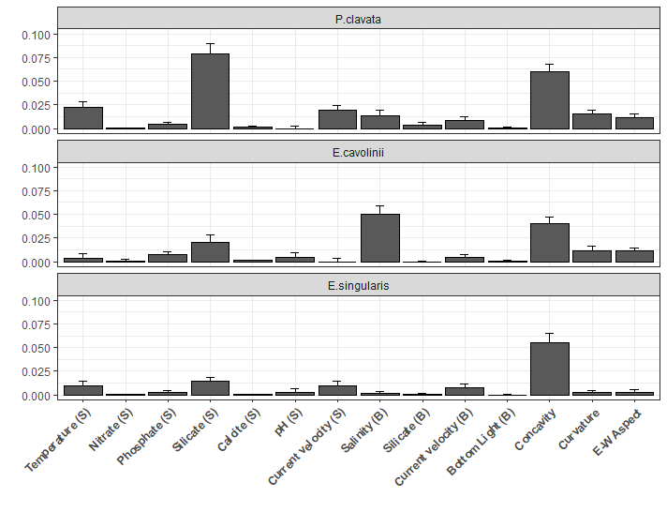
Fig. 1. For each species, the second order interaction terms between the most important variable (bathymetry) and the other environmental variables. The error bars represented the standard errors (1000 permutations). The nomenclature (S) and (B) referred to the surface and benthic layer, respectively.
Table 3. For each species, the fitted glm model coefficients, the estimated standard errors, the z values and the p-values were reported.
Species | Coefficient | Value | Estimate Std. Error | z value | p-value
P. clavata | Intercept | 4.20 | 0.64 | 6.50 | <0.0001
P. clavata | Temperature | -2.49 | -0.38 | -6.51 | <0.0001
E. cavolinii | Intercept | -3.70 | 2.75 | -1.35 | 0.17
E. cavolinii | Temperature | -0.36 | -1.70 | -0.21 | 0.83
E. singularis | Intercept | 10.7 | 1.10 | 9.55 | <0.0001
E. singularis | Temperature | -7.90 | -0.70 | -11.3 | <0.0001

