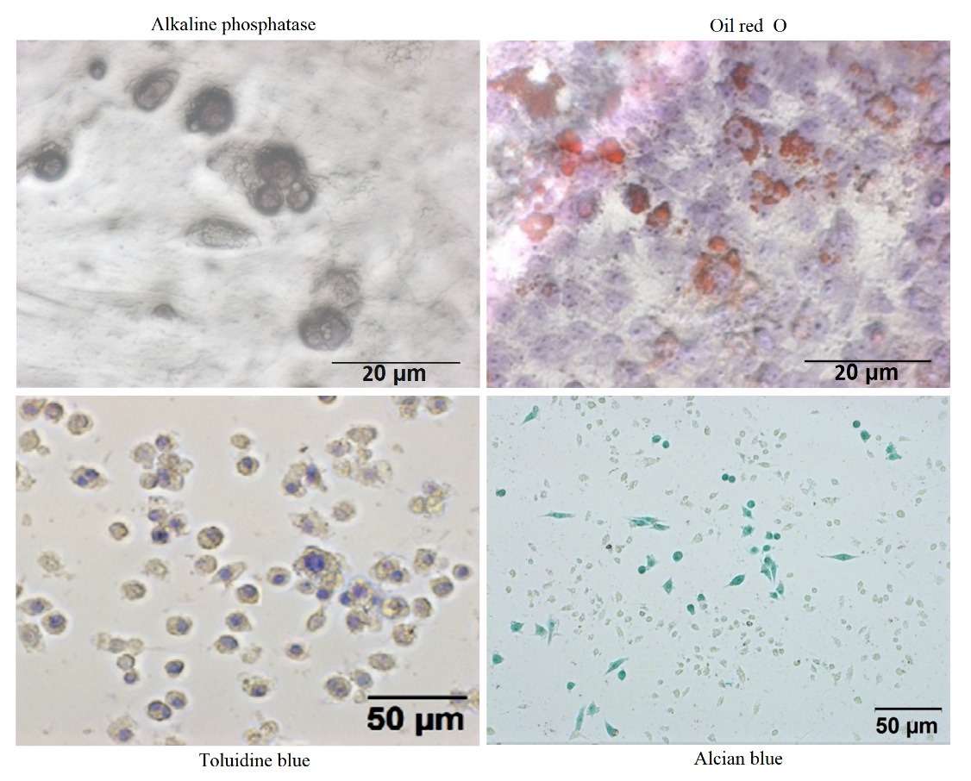
Supplement Fig.1
The BMSCs have maintained the multipotent differentiation capacity of stem cells even after pretreated with 50 μM H₂O₂ for 12 h. Morphology was visualized with phosphatase (Osteogenic differentiation), Oil red O (Adipogenic differentiation), Toluidine blue and Alcian blue (chondrocytic differentiation) staining. Osteoblasts, chondrocytes and adipocytes derived from H₂O₂-treated BMSCs experienced morphological changes.
Supplement Fig.2
HE staining of wound granulation tissue in PBS, BMSC and H₂O₂-preconditioned BMSCs groups at 5 days post-wounding, Scale bar = 50 μm.

