Appendix 1. Suicide survival curves by influencing factors of the elderly with dementia
- Sex (p<.001)  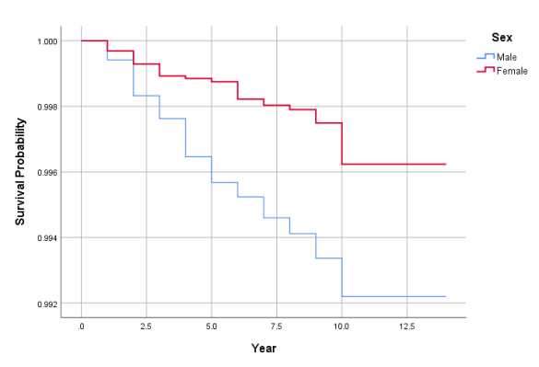 | - Age (p=.673)  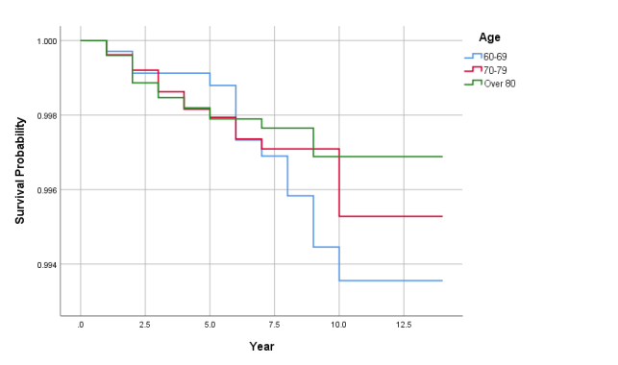
- Income Level (p=.883)  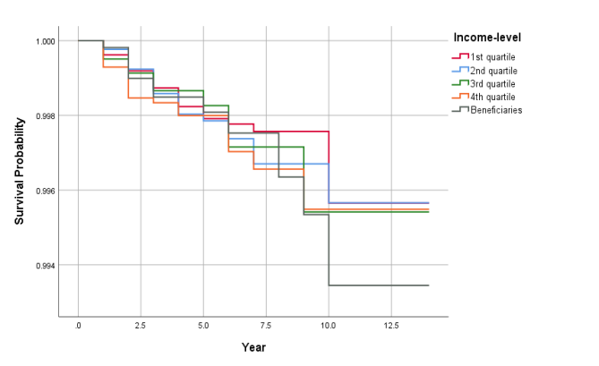 | ④ Activity Daily Limitation Independent (p<.001)  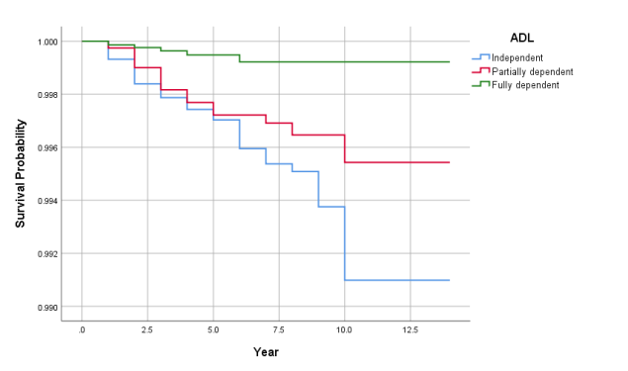
⑤ Cognitive ability (p<.001)  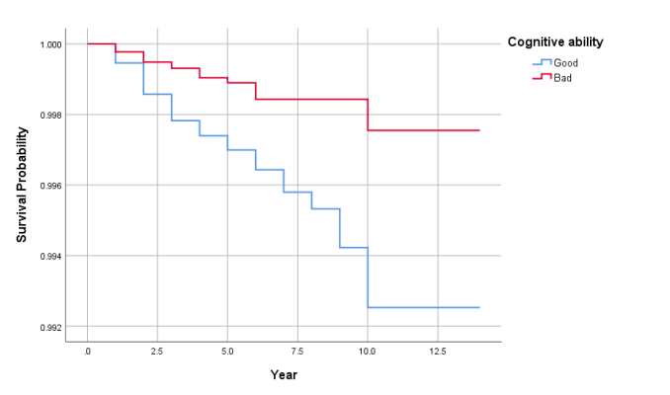 | ⑥ Caregivers (p<.001)  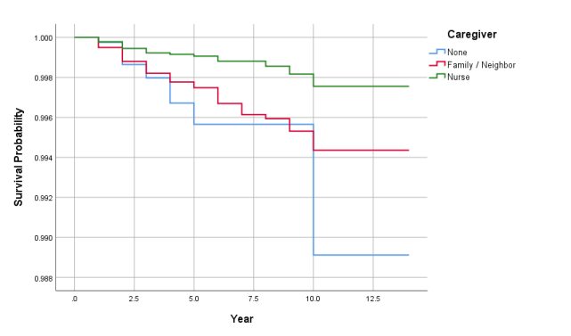
⑦ Long-Term Care Services (p<.001)
