One-pot, three-component synthesis, anti-bacterial and molecular modelling studies of novel benzimidazole based isoindoline-1,3-dione and benzo[4,5]imidazo[2,1-b]thiazol hybrids
Raju Chedupaka, Perugu Shyam^{b}, Srikanth Mamidalaª, Papisetti Venkateshamª, Santhosh Pentaª, Rajeswar Rao Vedula^{*a}
ªDepartment of chemistry, National Institute of Technology, Warangal, Telangana 506004, India.
rajeswarnitw@gmail.com
^{b}Biotechnology Department, National Institute of Technology, Warangal, Telangana, 506004, India

Table of contents
S.No. | Information | Page No.
2 | Characterization data of products | 1-12
3 | Spectra | 13-59

Characterization data of products
2-(2-(Benzylthio)-1H-benzo[d]imidazol-5-yl)isoindoline-1,3-dione. 4a
White solid: yield: 87%, mp 244-246 ºC; FT-IR (KBr, cm⁻¹): 3390 (-NH), 1735 (imide –C=O), 1602 (C=N), ¹H NMR (400 MHz, DMSO-d₆ δ ppm): 10.43 (s, 1H, Ar-H), 8.0-7.95 (m, 2H, Ar-H), 7.86 (s, 1H, Ar-H), 7.68 – 7.61 (m, 1H, Ar-H), 7.57-7.54 (m, 3H, Ar-H), 7.43 (t, J = 7.0 Hz, 2H, Ar-H), 7.32 (t, J = 7.2 Hz, 2H, Ar-H), 4.65 (s, 2H, S-CH₂); ¹³C NMR (100 MHz, DMSO-d₆ δ ppm): 167.90, 167.72, 155.96, 151.74, 136.76, 135.19, 135.03, 132.12, 130.18, 129.99, 129.39, 129.23, 128.34, 127.97, 125.01, 123.91, 123.76, 120.63, 114.08, 113.64, 108.71, 36.44; ESI-HRMS: m/z Calcd for Chemical Formula: C₂₂H₁₆N₃O₂S: 386.0958 [M+H] ⁺ found: 386.0956.
2-(2-((4-Methylbenzyl)thio)-1H-benzo[d]imidazol-5-yl)isoindoline-1,3-dione. 4b
White solid: Yield: 95%, mp 220-222 ºC; FT-IR (KBr, cm⁻¹): 3355 (-NH), 1735 (imide –C=O), 1629 (C=N); ¹H NMR (400 MHz, DMSO-d₆ δ ppm): 8.0-7.98 (m, 2H, Ar-H), 7.94-7.92 (m, 2H, Ar-H), 7.68 (d, J = 8.0 Hz, 2H), 7.35 (d, J = 8.0 Hz, 2H), 7.15 (d, J = 7.6 Hz, 2H), 4.64 (s, 2H, S-CH₂-protons), 2.27 (s, 3H, CH₃-protons), 2.09 (s, 1H, NH proton); ¹³C NMR (100 MHz, DMSO-d₆ δ ppm): 167.74, 151.80, 137.73, 135.92, 135.44, 135.23, 133.48, 132.03, 129.79, 129.30, 128.00, 123.92, 114.02, 113.55, 110.31, 36.36, 21.16; ESI-HRMS: m/z Calcd for Chemical Formula: C₂₃H₁₈N₃O₂S: 400.1114 [M+H] ⁺ found:400.1117.
2-(2-((4-Fluorobenzyl)thio)-1H-benzo[d]imidazol-5-yl)isoindoline-1,3-dione. 4c
White solid: Yield: 83% ; mp. 236-238 ºC; FT-IR (KBr, cm⁻¹): 3392 (NH), 1764 (imide –C=O), 1619 (C=N); ¹H NMR (400 MHz, DMSO) δ 7.99-7.97 (m, 2H, Ar-H), 7.94-7.92 (m, 2H, Ar-H), 7.68 (s, 1H, Ar-H, NH proton), 7.66-7.65 (m, 2H, Ar-H), 7.54 (d, J = 8.4 Hz, 2H), 7.43 (d, J = 8.4 Hz, 2H), 7.34 (dd, J = 8.4, 2.0 Hz, 2H), 4.65 (s, 2H, S-CH₂ protons); ¹³C NMR (100 MHz, DMSO-d₆) δ: 167.58, 151.03, 147.30, 145.39, 136.88, 136.36, 135.23, 131.94, 130.58, 127. 61, 124.20, 123.90, 123.61, 114.14, 11.77, 35.36; ESI-HRMS: m/z Cacld for Chemical Formula: C₂₂H₁₅FN₃O₂S: 404.0864 [M+H] ⁺ found: 404.0870.
2-(2-((4-Bromobenzyl)thio)-1H-benzo[d]imidazol-5-yl)isoindoline-1,3-dione. 4d
White solid: Yield: 85%; mp. 240-242 ºC; FT-IR (KBr, cm⁻¹): 3390 (NH), 1726 (imide –C=O), 1601 (C=N); ¹H NMR (400 MHz, CDCl₃+DMSO-d₆ ppm) δ 7.91-7.89 (m, 2H, Ar-H), 7.83-7.81 (m, 2H, Ar-H), 7.78 (s, 1H, Ar-H), 7.69 (s, 1H, Ar-H, NH proton), 7.67 (d, J = 2.0 Hz, Ar-H, 2H), 7.41 (d, J = 8.4 Hz, 2H, Ar-H), 7.33 (d, J = 8.4 Hz, 2H, Ar-H), 4.65 (s, 2H, S-CH₂ protons); ¹³C NMR (100 MHz, CDCl₃+DMSO-d₆) δ: 167.15, 151.00, 134.89, 134.68, 134.56, 133.88, 132.42, 131.99, 131.59, 131.08, 128.47, 123.80, 122.06, 113.92, 112.53, 36.39: ESI-HRMS: m/z Calcld for Chemical Formula: C₂₂H₁₅BrN₃O₂S: 464.0063 [M+H]⁺ found: 464.0068.
2-(2-((4-Nitrobenzyl)thio)-1H-benzo[d]imidazol-5-yl)isoindoline-1,3-dione. 4e
White solid: Yield: 86% ; mp. 287-289 ºC; FT-IR (KBr, cm⁻¹): 3427 (NH), 1732 (imide –C=O), 1613 (C=N); ¹H NMR (400 MHz, DMSO-d₆ δ ppm): 8.17 (d, J = 8.8 Hz, 2H, Ar-H), 7.97-7.95 (m, 2H, Ar-H), 7.92 – 7.89 (m, 2H, Ar-H), 7.73 (d, J = 8.8 Hz, 2H, Ar-H), 7.68 (s, 1H, Ar-H), 7.65-7.64, m, 2H, Ar-H), 7.33 (dd, J = 8.4, 2.0 Hz, 1H, Ar-H), 4.77 (s, 2H, S-CH₂ protons); ¹³C NMR (100 MHz, DMSO-d₆ ) δ: 167.84, 151.05, 147.28, 145. 52, 137.23, 136.71, 135.23, 131.95, 130.57, 127.44, 124.19, 123.90, 123.43, 114.17, 113.83, 35.28; ESI-HRMS: m/z Cacld for Chemical Formula: C₂₂H₁₅N₄O₄S: 431.0809 [M+H] ⁺ found: 431.0805.
Ethyl 2-((5-(1,3-dioxoisoindolin-2-yl)-1H-benzo[d]imidazol-2-yl)thio)acetate. 4f
White solid: Yield: 88%; mp. 188-190 ºC; FT-IR (KBr, cm⁻¹): 3385 (-NH), 1725 (imide –C=O), 1710 (O-C=O), 1625 (C=N) ¹H NMR (400 MHz, CDCl₃) δ 8.34 (s, 1H, Ar-H), 7.27 (d, J = 8.8 Hz, 2H, Ar-H), 6.99 (d, J = 9.2 Hz, 2H, Ar-H), 6.78 (s, 2H, Ar-H), 6.06 (s, 2H, Ar-H), 5.72-5.66 (m, 2H, aliphatic protons), 3.68 (s, 2H, S-CH₂ Protons), 1.50 (t, J = 7.2 Hz, 3H, CH₃ Protons); ¹³C NMR (100 MHz, CDCl₃+DMSO-d₆) δ: 167.72, 167.24, 151.18, 134.95, 131.76, 123.80, 113.88, 112.77, 62.23, 34.65, 14.28: ESI-HRMS: m/z Cacld for Chemical Formula: C₁₉H₁₆N₃O₄S: 382.0856 [M+H]⁺ found: 382.0857.
2-((5-(1,3-Dioxoisoindolin-2-yl)-1H-benzo[d]imidazol-2-yl)thio)acetic acid. 4g
White solid: Yield: 87%; mp. 243-245 ºC; FT-IR (KBr, cm⁻¹): 3465 (-COOH), 3390 (-NH), 1719 (imide –C=O), 1613 (C=N); ¹H NMR (400 MHz, CDCl₃+ DMSO-d₆ ppm) δ: 7.99-7.97 (m, 2H, Ar-H), 7.89-7.87 (m, 2H, Ar-H), 7.79 (s, 1H, Ar-H, NH proton), 7.77-7.76 (m, 2H, Ar-H), 7.71 (s, 1H, Ar-H), 7.52 (dd, J = 8.4, 1.6 Hz, 1H), 4.46 (s, 2H, S-CH₂ protons); ¹³C NMR ¹³C NMR (100 MHz, CDCl₃+DMSO-d₆) δ: 167.59, 167.16, 151.07, 134.93, 131.70, 123.81, 113.85, 112.62, 34.67; ESI-HRMS: m/z Cacld for Chemical Formula: C₁₇H₁₂N₃O₄S: 354.0543 [M+H] ⁺ found: 354.0540.
1-(2-((4-Fluorobenzyl)thio)-1H-benzo[d]imidazol-5-yl)pyrrolidine-2,5-dione. 4h
White solid: Yield: 82%; mp. 185-187 ºC; FT-IR (KBr, cm⁻¹): 3425 (-NH), 1718 (imide –C=O), 1623 (-C=N); ¹H NMR (400 MHz, CDCl₃+DMSO-d₆ δ ppm): 10.21 (s, 1H, Ar-H, NH proton), 7.90 (s, 1H, Ar-H), 7.53 – 7.51 (m, 2H, Ar-H), 7.45 (dd, J = 8.6, 5.4 Hz, 2H, Ar-H), 7.05 (t, J = 8.6 Hz, 2H, Ar-H), 4.72 (s, 2H, S-CH₂ prptons), 2.16 (s, 4H, aliphatic protons); ¹³C NMR (100 MHz, CDCl₃+DMSO-d₆) δ: 169.55, 163.63, 161.17, 148.05, 137.79, 132.69, 131.22, 131.14, 128.20, 118.57, 116.07, 115.85, 113.36, 103.15, 36.90, 24.36; ESI-HRMS: m/z Cacld for Chemical Formula: C₁₈H₁₅FN₃O₂S: 356.0864 [M+H] ⁺ found: 356.0865.

1-(2-((4-Nitrobenzyl)thio)-1H-benzo[d]imidazol-5-yl)pyrrolidine-2,5-dione. 4i
White solid: Yield: 85%; mp. 193-195 ºC; FT-IR (KBr, cm⁻¹): 3427 (-NH), 1735 (imide –C=O), 1626 (C=N); ¹H NMR (400 MHz, CDCl₃+DMSO-d₆ δ ppm): 10.15 (s, 1H, Ar-H, NH proton), 8.26 (s, 1H, Ar-H), 8.08 (d, J = 8.4 Hz, 2H, Ar-H), 7.66 (d, J = 8.8 Hz, 2H, Ar-H), 7.49 – 7.44 (m, 2H, Ar-H), 4.82 (s, 2H, S-CH₂ protons), 2.09 (s, 4H, aliphatic protons); ¹³C NMR (100 MHz, CDCl₃+DMSO-d₆) δ: 169.38, 147.56, 147.23, 142.98, 137.87, 132.94, 130.33, 128.47, 124.02, 118.53, 113.43, 103.15, 36.54, 24.39; ESI-HRMS: m/z Cacld for Chemical Formula: C₁₈H₁₅N₄O₄S: 383.0809 [M+H] ⁺ found: 383.0424.
2-(2-((4-Fluorobenzyl)thio)-1H-benzo[d]imidazol-5-yl)-4-nitroisoindoline-1,3-dione. 4j
Orange solid: Yield: 85%; mp. 226-228 ºC; FT-IR (KBr, cm⁻¹): 3426 (-NH), 1731 (imide –C=O), 1612 (C=N) ; ¹H NMR (400 MHz, CDCl₃+DMSO-d₆ δ ppm): 8.27 (d, J = 8.0 Hz, 1H, Ar-H), 8.22 (d, J = 6.8 Hz, 1H, Ar-H), 8.10 (t, J = 7.8 Hz, 2H, Ar-H), 7.64 (s, 1H, Ar-H, NH proton), 7.62 – 7.61 (m, 1H, Ar-H), 7.45 (d, J = 8.8 Hz, 2H, Ar-H), 7.38 (d, J = 8.4 Hz, 2H, Ar-H), 7.30 (dd, J = 8.6, 1.8 Hz, 1H, Ar-H), 4.61 (s, 2H, S-CH₂ protons); ¹³C NMR (100 MHz, DMSO-d₆ ) δ: 166.02, 163.45, 160.80, 151.89, 144.95, 137.07, 136.87, 131.46, 131.38, 128.80, 127.49, 123.41, 123.01, 116.02, 115.81, 114.20, 114.04, 35.19; ESI-HRMS: m/z Cacld for Chemical Formula: C₂₂H₁₄FN₄O₄S: 449.0714 [M+H] ⁺ found: 449.0710.
4-Nitro-2-(2-((4-nitrobenzyl)thio)-1H-benzo[d]imidazol-5-yl)isoindoline-1,3-dione. 4k
Orange solid: Yield: 84%; mp. 230-232 ºC; FT-IR (KBr, cm⁻¹): 3408 (-NH), 1729 (imide –C=O), 1623 (C=N) ¹H NMR (400 MHz, DMSO-d₆ δ ppm): 10. 34 (s, 1H, Ar-H, NH proton), 8.34 (d, J = 8.0 Hz, 1H, Ar-H), 8.27 – 8.23 (m, 1H, Ar-H), 8.13 (t, J = 7.8 Hz, 1H, Ar-H), 7.73 – 7.69 (m, 1H, Ar-H), 7.62 (d, J = 8.8 Hz, 1H, Ar-H), 7.47-7.41 (m, 2H, Ar-H), 7.35-7.27 (m, 3H, Ar-H), 4.71 (s, 2H, S-CH₂-protons); ¹³C NMR (100 MHz, CDCl₃+ DMSO-d₆) δ: 167.26, 151.50, 135.52, 134.75, 131.58, 129.08, 128.90, 128.16, 127.60, 123.76, 122.83, 113.95, 112.56, 37.14; ESI-HRMS: m/z Cacld for Chemical Formula: C₂₂H₁₄N₅O₆S: 476.0659 [M+H] ⁺ found: 476.0653.
2-(2-(Benzylthio)-1H-benzo[d]imidazol-5-yl)-1H-benzo[de]isoquinoline-1,3(2H)-dione. 4l
White solid: Yield: 88%; mp. 268-270 ºC; IR FT-IR (KBr, cm⁻¹): 3377 (-NH), 1737 (imide –C=O), 1622 (C=N) ; ¹H NMR (400 MHz, DMSO-d₆ δ ppm): 8.54-8.51 (m, 5H, Ar-H), 7.92 (t, J = 7.8 Hz, 1H, Ar-H), 7.77 (d, J = 8.0 Hz, 2H), 7.50 (d, J = 7.2 Hz, 2H), 7.43 – 7.31 (m, 4H, Ar-H), 4.76 (s, 2H, S-CH₂ Protons); ¹³C NMR (100 MHz, DMSO-d₆) δ: 164.45, 151.30, 136.50, 134.98, 131.93, 131.23, 129.39, 129.29, 128.45, 128.35, 127.73, 123.12, 114.97, 114.00, 36.70; ESI-HRMS: m/z: Cacld for Chemical Formula: C₂₆H₁₈N₃O₂S: 436.1114 [M+H] ⁺ found: 436.1121.
2-(2-((4-Fluorobenzyl)thio)-1H-benzo[d]imidazol-5-yl)-1H-benzo[de]isoquinoline-1,3(2H)-dione. 4m
White solid: Yield: 86%; mp. 268-270 ºC; FT-IR (KBr, cm⁻¹): 3398 (-NH), 1736 (imide –C=O), 1623 (C=N); ¹H NMR (400 MHz, DMSO-d₆) δ: 8.53-8.51 (m, 5H, Ar-H), 7.92 (t, J = 7.8 Hz, 2H, Ar-H), 7.71 (d, J = 8.8 Hz, 2H, Ar-H), 7.54 (t, J = 6.8 Hz, 2H, Ar-H), 7.34 (d, J = 8.0 Hz, 1H, Ar-H), 7.19 (t, J = 8.6 Hz, 2H, Ar-H), 4.71 (s, 2H, S-CH₂ Protons); ¹³C NMR (100 MHz, DMSO-d₆) δ: 164.47, 151.17, 134.93, 133.44, 131.93, 131.49, 131.41, 131.21, 128.35, 127.72, 125.12, 123.17, 116.12, 115.91, 115.09, 114.04, 35.53; ESI-HRMS: m/z: Cacld for Chemical Formula: C₂₆H₁₇FN₃O₂S: 454.1020 [M+H] ⁺ found: 454.1022.
2-(2-((4-Bromobenzyl)thio)-1H-benzo[d]imidazol-5-yl)-1H-benzo[de]isoquinoline-1,3(2H)-dione. 4n
White solid: Yield: 88%; mp. 268-270 ºC; FT-IR (KBr, cm⁻¹): 3366 (-NH), 1711 (imide –C=O), 1623 (C=N); ¹H NMR (400 MHz, DMSO-d₆ δ ppm): 8.54 – 8.51 (m, 5H, Ar-H), 7.92 (t, J = 7.8 Hz, 2H, Ar-H), 7.77 – 7.75 (m, 2H, Ar-H), 7.56 (d, J = 8.4 Hz, 2H, Ar-H), 7.46 (d, J = 8.4 Hz, 2H, Ar-H), 7.41 (dd, J = 8.6, 2.4 Hz, 1H, Ar-H), 4.73 (s, 2H, S-CH₂ protons); ¹³C NMR (100 MHz, DMSO-d₆ ) δ: 164.44, 151.00, 136.46, 134.95, 132.69, 132.16, 131.95, 131.57, 131.20, 128.38, 127.73, 125.82, 123.20, 121.58, 115.04, 114.04, 35.86; ESI-HRMS: m/z Cacld for Chemical Formula: C₂₆H₁₇BrN₃O₂S : 514.0219 [M+H] ⁺ found: 514.0217.
2-(2-((2-Oxo-2-phenylethyl)thio)-1H-benzo[d]imidazol-5-yl)isoindoline-1,3-dione. 4o
White solid: Yield: 95%; mp. 226-228 ºC; FT-IR (KBr, cm⁻¹): 3326 (-NH), 1735 (carbonyl –C=O), 1690 (imide –C=O), 1626 (C=N); ¹H NMR (400 MHz, DMSO-d₆ δ ppm): 8.07 (d, J = 7.2 Hz, 2H), 7.97-7.94 (m, 2H, Ar-H), 7.91-7.89 (m, 2H, Ar-H), 7.70 (t, J = 7.4 Hz, 1H, Ar-H), 7.64-7.56 (m, 5H, Ar-H), 7.30 (d, J = 8.4 Hz, 1H, Ar-H), 5.20 (s, 2H, S-CH₂ Protons); ¹³C NMR (100 MHz, DMSO-d₆ δ) δ: 193.33, 167.81, 152.06, 137.29, 136.79, 135.58, 135.18, 134.45, 132.03, 129.39, 128.94, 127.24, 123.87, 123.14, 113.94, 113.64, 40.74; ESI-HRMS: m/z Cacld for Chemical Formula: C₂₃H₁₆N₃O₃S: 414.0907 [M+H]⁺ found: 414.0905.
2-(2-((2-Oxo-2-(p-tolyl)ethyl)thio)-1H-benzo[d]imidazol-5-yl)isoindoline-1,3-dione. 4p
Yellow solid: yield: 95%; mp. 226-228 ºC; FT-IR (KBr, cm⁻¹): 3260 (-NH), 1727 (carbonyl –C=O), 1685 (imide –C=O), 1613 (C=N); ¹H NMR (400 MHz, DMSO) δ 8.10 (s, 1H, Ar-H), 7.97-7.91 (m, 2H, Ar-H), 7.87-7.85 (m, 2H, Ar-H), 7.62 (d, J = 8.4 Hz, 1H), 7.58 (s, 1H, Ar-H), 7.34 (d, J = 8.0 Hz, 2H, Ar-H), 7.29 (dd, J = 8.6, 1.8 Hz, 1H, Ar-H), 5.14 (s, 2H, S-CH₂ Protons), 2.40 (s, 3H, -CH₃ Protons); ¹³C NMR (100 MHz, DMSO-d₆) δ: 192.37, 167.49, 152.05, 144.93, 134.96, 132.93, 131.86, 129.73, 128.94, 127.29, 123.78, 122.85, 113.83, 113.12, 40.81, 21.77; ESI-HRMS: m/z Cacld for Chemical Formula: C₂₄H₁₈N₃O₃S: 428.1063 [M+H] ⁺ found: 428.1067.
2-(2-((2-(4-Methoxyphenyl)-2-oxoethyl)thio)-1H-benzo[d]imidazol-5-yl)isoindoline-1,3-dione. 4q
Yellow solid: yield: 95%; mp. 226-228 ºC; FT-IR (KBr, cm⁻¹): 3426 (-NH), 1733 (carbonyl –C=O), 1695 (imide –C=O), 1625 (C=N); ¹H NMR (400 MHz, DMSO-d₆ δ ppm): 8.04 (d, J = 8.8 Hz, 2H, Ar-H), 7.95-7.93 (m, 2H, Ar-H), 7.90-7.87 (m, 2H, Ar-H), 7.58 (s, 1H, Ar-H), 7.55 – 7.54 (m, 2H, Ar-H), 7.22 (dd, J = 8.4, 2.0 Hz, 1H), 7.08 (d, J = 8.8 Hz, 2H, Ar-H), 5.07 (s, 2H, S-CH₂- protons), 3.85 (s, 3H, OCH₃ protons); ¹³C NMR (100 MHz, DMSO-d₆) δ: 191.94, 167.90, 164.10, 152.01, 138.79, 135.12, 132.04, 131.35, 128.56, 126.48, 123.83, 122.33, 114.55, 113.87, 56.11, 40.92; ESI-HRMS: m/z Cacld for Chemical Formula: C₂₄H₁₈N₃O₄S: 444.1013 [M+H] ⁺ found: 444.1009.
2-(2-((2-(4-Chlorophenyl)-2-oxoethyl)thio)-1H-benzo[d]imidazol-5-yl)isoindoline-1,3-dione. 4r
Yellow solid: yield: 95%; mp. 226-228 ºC; FT-IR (KBr, cm⁻¹): 3327 (-NH), 1735 (carbonyl –C=O), 1692 (imide –C=O), 1619 (C=N); ¹H NMR (400 MHz, CDCl₃+DMSO-d₆ δ ppm): 8.08 (d, J = 8.4 Hz, 2H), 7.98-7.96 (m, 2H, Ar-H), 7.92-7.90 (m, 2H, Ar-H), 7.68 – 7.64 (m, 4H, Ar-H), 7.35 (dd, J = 8.6, 1.8 Hz, 1H), 5.30 (s, 1H, -NH Proton), 5.21 (s, 2H, S-CH₂ Protons); ¹³C NMR (100 MHz, DMSO-d₆) δ: 192.32, 167.76, 152.02, 139.40, 135.20, 134.26, 132.04, 130.88, 129.52, 123.90, 113.92, 113.56, 40.82; ESI-HRMS: m/z Cacld for Chemical Formula: C₂₃H₁₅ClN₃O₃S: 448.0517 [M+H] ⁺ found: 448.0519.
2-(2-((2-(4-Bromophenyl)-2-oxoethyl)thio)-1H-benzo[d]imidazol-5-yl)isoindoline-1,3-dione. 4s
White solid: yield: 91%; mp. 285-287 ºC; FT-IR (KBr, cm⁻¹): 3297 (-NH), 1721 (carbonyl –C=O), 1677 (imide –C=O), 1620 (C=N); ¹H NMR (400 MHz, CDCl₃+ DMSO- d₆ δ ppm): 8.10 (s, 1H, Ar-H), 7.99 (d, J = 8.4 Hz, 2H, Ar-H), 7.93-7.85 (m, 3H, Ar-H), 7.71 (d, J = 8.8 Hz, 2H, Ar-H), 7.55 – 7.50 (m, 2H, Ar-H), 7.19 (d, J = 8.4 Hz, 1H), 5.18 (s, 1H, Ar-H), 5.05 (s, 2H, S-CH₂ Protons): ¹³C NMR (100 MHz, DMSO-d₆) δ: 192.61, 170.03, 152.61, 145.17, 142.07, 139.77, 134.59, 132.98, 131.00, 130.62, 129.93, 129.57, 129.43, 129.29, 129.13, 126.35, 115.21, 110.35, 104.79, 41.34; ESI-HRMS: m/z Cacld for Chemical Formula: C₂₃H₁₅BrN₃O₃S: 492.0012 [M+H] ⁺ found: 492.0024.
2-(2-((2-([1,1'-Biphenyl]-4-yl)-2-oxoethyl)thio)-1H-benzo[d]imidazol-5-yl)isoindoline-1,3-dione. 4t
White solid: yield: 87%, mp. 199-201 ºC; FT-IR (KBr, cm⁻¹): 3336 (-NH), 1738 (carbonyl –C=O), 1696 (imide –C=O), 1628 (C=N); ¹H NMR (400 MHz, DMSO-d₆ δ ppm): 12.89 (s, 1H, Ar-H, NH Proton), 8.15 (d, J = 8.4 Hz, 2H, Ar-H), 7.93-7.85 (m, 6H, Ar-H), 7.75 (d, J = 7.2 Hz, 2H, Ar-H), 7.52-7.48 (m, 4H, Ar-H), 7.42 (t, J = 7.4 Hz, 1H, Ar-H), 7.16 (t, J = 7.4 Hz, 1H, Ar-H), 5.09 (s, 2H, S-CH₂ protons); ¹³C NMR (100 MHz, DMSO-d₆) δ: 193.39, 167.97, 151.75, 145.52, 139.23, 135.09, 134.66, 132.05, 129.68, 129.62, 129.01, 127.50, 123.80, 121.97, 117.37, 110.54, 41.15; ESI-HRMS: m/z Cacld for Chemical Formula: C₂₉H₂₀N₃O₃S: 490.1220 [M+H] ⁺ found: 490.1220.
2-(2-((2-Oxo-2-phenylethyl)thio)-1H-benzo[d]imidazol-5-yl)-1H-benzo[de]isoquinoline-1,3(2H)-dione. 4u
White solid: yield: 88%; mp. 246-248 ºC; FT-IR (KBr, cm⁻¹): 3320 (-NH), 1729 (carbonyl –C=O), 1698 (imide –C=O), 1626 (C=N); ¹H NMR (400 MHz, DMSO-d₆ δ ppm): 10.38 (s, 1H, Ar-H), 8.52 (t, J = 6.6 Hz 3H, Ar-H), 8.26 (d, J = 1.6 Hz, 1H, Ar-H), 8.10 (t, J = 7.8 Hz, 2H, Ar-H), 7.91 (t, J = 7.8 Hz, 1H, Ar-H), 7.79-7.77 (m, 1H, Ar-H), 7.75-7.74 (m, 1H, Ar-H), 7.67-7.60 (m, 3H, Ar-H), 7.52 (dd, J = 8.8, 2.0 Hz, 1H, Ar-H), 7.47-7.45 (m, 1H, Ar-H), 5.43 (s, 2H, S-CH₂ Protons); ¹³C NMR (100 MHz, DMSO-d₆ ) δ: 192.56, 169.26, 164.42, 152.02, 150.19, 137.61, 135.89, 135.30, 134.97, 132.94, 131.93, 131.19, 129.44, 129.05, 127.72, 123.17, 117.73, 114.76, 113.81, 102.55, 42.23; ESI-HRMS: m/z Cacld for Chemical Formula: C₂₇H₁₈N₃O₃S: 464.1063 [M+H] ⁺ found: 464.1070.
2-(2-((2-(4-Chlorophenyl)-2-oxoethyl)thio)-1H-benzo[d]imidazol-5-yl)-1H-benzo[de]isoquinoline-1,3(2H)-dione. 4v
White solid: yield: 86%, mp. 270-272 ºC; FT-IR (KBr, cm⁻¹): 3348 (-NH), 1738 (carbonyl –C=O), 1707 (imide –C=O), 1630 (C=N); ¹H NMR (400 MHz, CDCl₃+DMSO-d₆ δ ppm): 10.24 (s, 1H, Ar-H, NH Proton), 8.55 (dd, J = 7.2, 1.2 Hz, 1H), 8.46 (d, J = 8.0 Hz, 1H, Ar-H), 8.33 (d, J = 1.6 Hz, 1H, Ar-H), 8.10 (t, J = 9.0 Hz, 2H, Ar-H), 7.88 (t, J=7.8 Hz, 1H, Ar-H), 7.75 (d, J = 8.4 Hz, 1H, Ar-H), 7.69 (s, 1H, Ar-H), 7.61 (dd, J = 8.6, 1.8 Hz, 2H, Ar-H), 7.55 (d, J = 8.8 Hz, 1H, Ar-H), 7.47 (dd, J = 8.8, 1.6 Hz, 1H), 7.39 (dd, J = 8.6, 1.8 Hz, 1H, Ar-H), 5.32 (s, 2H, S-CH₂ Protons); ¹³C NMR (100 MHz, DMSO-d₆) δ: 192.16, 169.42, 164.48, 151.72, 150.02, 139.48, 137.22, 135.00, 133.88, 133.47, 132.43, 131.27, 130.89, 129.52, 127.73, 125.60, 123.03, 117.61, 114.86, 113.90, 41.63; ESI-HRMS: m/z Cacld for Chemical Formula: C₂₇H₁₇ClN₃O₃S: 498.0674 [M+H] ⁺ found: 498.0675.
2-(2-((2-(4-Bromophenyl)-2-oxoethyl)thio)-1H-benzo[d]imidazol-5-yl)-1H-benzo[de]isoquinoline-1,3(2H)-dione. 4w
White solid: yield: 89%; mp. 261-263 ºC; FT-IR (KBr, cm⁻¹): 3352 (-NH), 1731 (carbonyl –C=O), 1687 (imide –C=O), 1622 (C=N); ¹H NMR (400 MHz, DMSO-d₆ δ ppm): 10.34 (s, 1H, Ar-H, NH Proton), 8.57-8.50 (m, 3H, Ar-H), 8.24 (s, 1H, Ar-H), 8.01 (t, J= 9.2, 2H, Ar-H), 7.92 (t, J = 7.8 Hz, 1H, Ar-H), 7.85 (dd, J = 8.8, 3.2 Hz, 2H), 7.76 – 7.74 (m, 1H, Ar-H), 7.62 (d, J = 8.8 Hz, 1H, Ar-H), 7.49 (dd, J = 8.8, 1.6 Hz, 1H, Ar-H), 7.42 (dd, J = 8.6, 1.4 Hz, 1H, Ar-H), 5.36 (s, 2H, S-CH₂ Protons); ¹³C NMR (100 MHz, DMSO-d₆) δ: 192.24, 169.24, 164.42, 151.79, 150.00, 137.53, 135.89, 134.96, 132.94, 132.51, 131.20, 130.98, 128.76, 128.04, 127.72, 123.18, 113.87, 41.93: ESI-HRMS: m/z Cacld for Chemical Formula: C₂₇H₁₇BrN₃O₃S: 542.0169 [M+H] ⁺ found: 542.0170.
2-(3-Phenylbenzo[4,5]imidazo[2,1-b]thiazol-6-yl)isoindoline-1,3-dione. 5a
White solid: yield: 88%; mp. 216-218 ºC; FT-IR (KBr, cm⁻¹): 1747 (imide –C=O); ¹H NMR (400 MHz, DMSO-d₆ δ ppm): 7.97-7.89 (m, Ar-H, 5H), 7.83-7.80 (m, Ar-H, 2H), 7.67 – 7.66 (m, 2H, Ar-H), 7.60-7.59 (m, 2H, Ar-H), 7.42 (dd, J = 8.8, 1.6 Hz, 1H, Ar-H), 7.36 (s, 1H, Ar-H); ¹³C NMR (100 MHz, DMSO-d₆) δ: 166.93, 150.87, 136.79, 135.23, 134.71, 129.45, 129.01, 121.94, 113.57, 108.23; ESI-HRMS: m/z Cacld for Chemical Formula: C₂₃H₁₄N₃O₂S: 396.0801 [M+H] ⁺ found: 396.0802.
2-(3-(p-Tolyl)benzo[4,5]imidazo[2,1-b]thiazol-6-yl)isoindoline-1,3-dione. 5b
White solid: yield: 90%; mp. 233-235 ºC; FT-IR (KBr, cm⁻¹): 1742 (imide –C=O); ¹H NMR (400 MHz, CDCl₃+DMSO-d₆ δ ppm): 8.09 (s, 1H, Ar-H), 7.96-7.85 (m, 6H, Ar-H), 7.48-7.43 (m, 2H, Ar-H), 7.32 (d, J = 7.6 Hz, 2H, Ar-H), 7.10 (s, 1H, Ar-H), 2.40 (s, 3H, CH₃ Protons); ¹³C NMR (100 MHz, DMSO-d₆ δ ppm): 167.33, 150.81, 145.40, 139.66, 132.72, 129.98, 129.12, 128.98, 125.16, 124.20, 121.96, 113.50, 108.06, 21.74; ESI-HRMS: m/z Cacld for Chemical Formula: C₂₄H₁₆N₃O₂S: 410.0958 [M+H] ⁺ found: 410.0956.
2-(3-(4-Methoxyphenyl)benzo[4,5]imidazo[2,1-b]thiazol-6-yl)isoindoline-1,3-dione. 5c
White solid: yield: 89%; mp. 218-220 ºC; FT-IR (KBr, cm⁻¹): 1723 (imide –C=O); ¹H NMR (400 MHz, DMSO-d₆ δ ppm): 7.94-7.90 (m, 4H, Ar-H), 7.74-7.68 (m, 3H, Ar-H), 7.40 (s, 1H, Ar-H), 7.18 (d, J = 8.4 Hz, 2H, Ar-H), 7.13 (d, J = 8.4 Hz, 2H, Ar-H), 3.82 (s, 3H, OCH₃ Protons); ¹³C NMR (100 MHz, CDCl₃+ DMSO-d₆ ) δ: 164.44, 150.53, 139.42, 137.44, 131.29, 128.69, 127.81, 125.04, 124.15, 114.37, 113.16, 107.76, 55.93; ESI-HRMS: m/z Cacld for Chemical Formula: C₂₄H₁₆N₃O₃S: 426.0907 [M+H] ⁺ found: 426.0913.
2-(3-(4-Fluorophenyl)benzo[4,5]imidazo[2,1-b]thiazol-6-yl)isoindoline-1,3-dione. 5d
White solid: yield: 91%; mp. 232-234 ºC; FT-IR (KBr, cm⁻¹): 1747 (imide –C=O); ¹H NMR (400 MHz, DMSO-d₆ δ ppm): 8.17 (dd, J = 8.4, 5.6 Hz, 2H, Ar-H), 8.08 (s, 1H, Ar-H), 7.62 (d, J = 8.8 Hz, 1H, Ar-H), 7.53 (d, J = 7.6 Hz, 2H, Ar-H), 7.46 (t, J = 8.8 Hz, 3H, Ar-H), 7.35 (t, J = 8.0 Hz, 2H, Ar-H), 7.15 (s, 1H, Ar-H); ¹³C NMR (100 MHz, DMSO-d₆ δ) δ: 167.27, 164.75, 152.57, 132.10, 132.01, 129.04, 119.65, 116.95, 116.83, 116.49, 116.27, 114.67, 112.80, 108.28; ESI-HRMS: m/z Cacld for Chemical Formula: C₂₃H₁₃FN₃O₂S: 414.0707 [M+H] ⁺ found: 414.0707.

2-(3-(4-Chlorophenyl)benzo[4,5]imidazo[2,1-b]thiazol-6-yl)isoindoline-1,3-dione. 5e
White solid: yield: 93%; mp. 270-272 ºC; FT-IR (KBr, cm⁻¹): 1746 (imide –C=O); ¹H NMR (400 MHz, DMSO-d₆ δ ppm): 7.93-7.91 (m, 3H, Ar-H), 7.84-7.78 (m, 2H, Ar-H), 7.71 (d, J = 8.4 Hz, 2H, Ar-H), 7.64 (d, J = 8.4 Hz, 2H, Ar-H), 7.39 (s, 1H, Ar-H), 7.30-7.27 (m, 2H, Ar-H), 7.20 (dd, J = 8.4, 1.6 Hz, 1H, Ar-H); ¹³C NMR (100 MHz, DMSO-d₆) δ: 165.10, 150.57, 139.67, 139.58, 133.98, 130.90, 129.56, 128.97, 125.15, 124.20, 121.89, 113.54, 108.15; ESI-HRMS: m/z Cacld for Chemical Formula: C₂₃H₁₃ClN₃O₂S: 430.0412 [M+H] ⁺ found: 430.0420.
2-(3-(4-Nitrophenyl)benzo[4,5]imidazo[2,1-b]thiazol-6-yl)isoindoline-1,3-dione. 5f
Yellow solid: yield: 95%, mp. 263-265 ºC; FT-IR (KBr, cm⁻¹): 1748 (imide –C=O), (NO₂) 1525, 1341; ¹H NMR (400 MHz, DMSO-d₆ δ ppm): 8.36 (d, J = 9.2 Hz, 2H, Ar-H), 8.30 (d, J = 9.2 Hz, 2H, Ar-H), 7.96-7.91 (m, 4H, Ar-H), 7.53 (s, 1H, Ar-H), 7.51 – 7.50 (m, 2H, Ar-H), 7.18 (dd, J = 845, 2.0 Hz, 1H, Ar-H); ¹³C NMR (100 MHz, DMSO-d₆) δ: 166.11, 157.31, 153.82, 135.92, 132.47, 132.32, 131.66, 131.60, 128.83, 128.69, 127.03, 124.58, 123.70, 112.38, 109.77; ESI-HRMS: m/z Cacld for Chemical Formula: C₂₃H₁₃N₄O₄S: 441.0652 [M+H] ⁺ found: 441.0652.
2-(3-([1,1'-Biphenyl]-4-yl)benzo[4,5]imidazo[2,1-b]thiazol-6-yl)isoindoline-1,3-dione. 5g
White solid: yield: 89%, mp. 198-200 ºC; FT-IR (KBr, cm⁻¹): 1745 (imide –C=O); ¹H NMR (400 MHz, DMSO)-d₆ δ ppm): 8.17 (d, J = 8.4 Hz, 2H, Ar-H), 8.10 (s, 1H, Ar-H), 7.93 (d, J = 8.8 Hz, 2H, Ar-H), 7.80 (d, J = 7.2 Hz, 2H, Ar-H), 7.63 (d, J = 8.4 Hz, 2H, Ar-H), 7.55-7.53 (m, 3H, Ar-H), 7.48-7.44 (m, 2H, Ar-H), 7.35 (t, J = 8.0 Hz, 2H, Ar-H), 7.15 (s, 1H, Ar-H); ¹³C NMR (100 MHz, DMSO-d₆ δ) δ: 167.35, 150.70, 145.94, 139.75, 139.10, 137.14, 134.06, 129.78, 129.63, 129.14, 128.95, 127.56, 125.05, 124.08, 121.81, 113.53, 107.85; ESI-HRMS: m/z Cacld for Chemical Formula: C₂₉H₁₈N₃O₂S: 472.1114 [M+H] ⁺ found: 472.1117.
2-(3-Phenylbenzo[4,5]imidazo[2,1-b]thiazol-6-yl)-1H-benzo[de]isoquinoline-1,3(2H)-dione. 5h
White solid: yield: 89%; mp. 276-278 ºC; FT-IR (KBr, cm⁻¹): 1745 (imide –C=O); ¹H NMR (400 MHz, DMSO-d₆ δ ppm): 7.94 – 7.92 (m, 2H, Ar-H), 7.86 – 7.83 (m, 2H, Ar-H), 7.78 (d, J = 6.4 Hz, 2H, Ar-H), 7.73 (d, J = 8.4 Hz, 2H, Ar-H), 7.66 (s, 1H, Ar-H), 7.43 – 7.41 (m, 2H, Ar-H), 7.35-7.32 (m, 2H, Ar-H), 7.30 (s, 1H, Ar-H), 7.21 (dd, J = 8.8, 1.6 Hz, 1H, Ar-H); ¹³C NMR (100 MHz, DMSO-d₆) δ: 166.37, 157.29, 153.45, 141.82, 139.47, 136.02, 132.14, 131.42, 129.53, 128.50, 127.62, 127.33, 127.19, 126.61, 124.69, 111.81, 109.20, 105.42, 79.54; ESI-HRMS: m/z Cacld for Chemical Formula: C₂₇H₁₆N₃O₂S: 446.0958 [M+H] ⁺ found: 446.0995.

Spectral Data
¹H-NMR Spectrum of compound 4a in DMSO-d₆ (400 MHz):
¹³C-NMR Spectrum of compound 4a in DMSO-d₆ (100 MHz):
Mass spectrum of compound 4a:
¹H-NMR Spectrum of compound 4b in DMSO-d₆ (400 MHz):

¹³C-NMR Spectrum of compound 4b in DMSO-d₆ (100 MHz):
Mass spectrum of compound 4b:

¹H-NMR Spectrum of compound 4c in DMSO-d₆ (400 MHz):
¹³C-NMR Spectrum of compound 4c in DMSO-d₆ (100 MHz):

Mass spectrum of compound 4c:
¹H-NMR Spectrum of compound 4d in DMSO-d₆ (400 MHz):

¹³C-NMR Spectrum of compound 4d in CDCl₃-DMSO-d₆ (100 MHz):
Mass spectrum of compound 4d:

¹H-NMR Spectrum of compound 4e in DMSO-d₆ (400 MHz):
¹³C-NMR Spectrum of compound 4e in DMSO-d₆ (100 MHz):

Mass spectrum of compound 4e:
¹H-NMR Spectrum of compound 4f in DMSO-d₆ (400 MHz):

¹³C-NMR Spectrum of compound 4f in CDCl₃-DMSO-d₆ (100 MHz):
Mass spectrum of compound 4f

¹H-NMR Spectrum of compound 4g in DMSO-d₆ (400 MHz):
¹³C-NMR Spectrum of compound 4g in CDCl₃-DMSO-d₆ (100 MHz):

Mass spectrum of compound 4g:
¹H-NMR Spectrum of compound 4h in DMSO-d₆ (400 MHz):

¹³C-NMR Spectrum of compound 4h in CDCl₃-DMSO-d₆ (100 MHz):
Mass spectrum of compound 4h
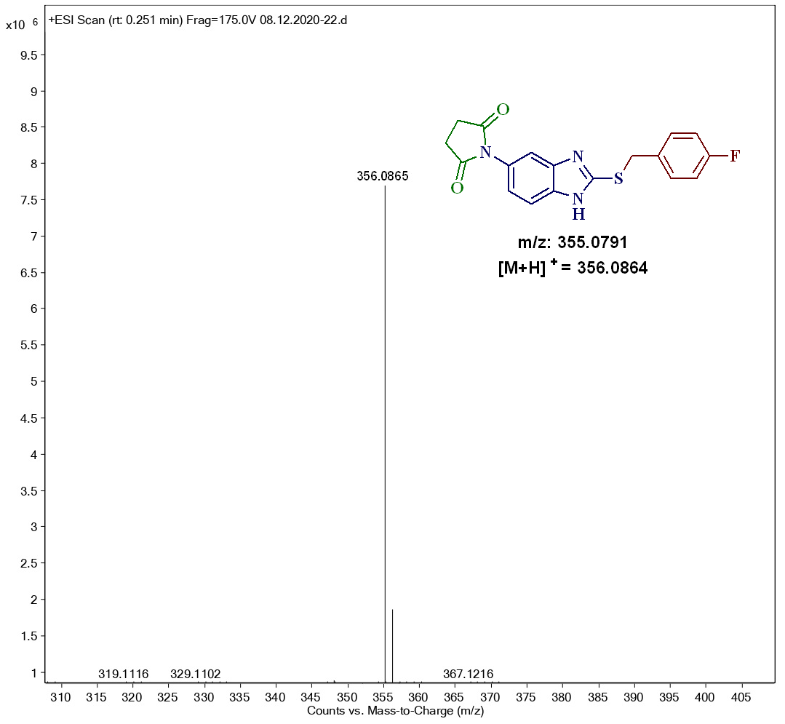

¹H-NMR Spectrum of compound 4i in DMSO-d₆ (400 MHz):
¹³C-NMR Spectrum of compound 4i in DMSO-d₆ (100 MHz):

Mass spectrum of compound 4i
¹H-NMR Spectrum of compound 4j in DMSO-d₆ (400 MHz):

¹³C-NMR Spectrum of compound 4j in DMSO-d₆ (100 MHz):
Mass spectrum of compound 4j:

¹H-NMR Spectrum of compound 4k in DMSO-d₆ (400 MHz):
¹³C-NMR Spectrum of compound 4k in CDCl₃-DMSO-d₆ (100 MHz):

Mass spectrum of compound 4k
¹H-NMR Spectrum of compound 4l in DMSO-d₆ (400 MHz):

¹³C-NMR Spectrum of compound 4l in DMSO-d₆ (100 MHz):

Mass spectrum of compound 4l
¹H-NMR Spectrum of compound 4m in DMSO-d₆ (400 MHz):

¹³C-NMR Spectrum of compound 4m in DMSO-d₆ (100 MHz):
Mass spectrum of compound 4m
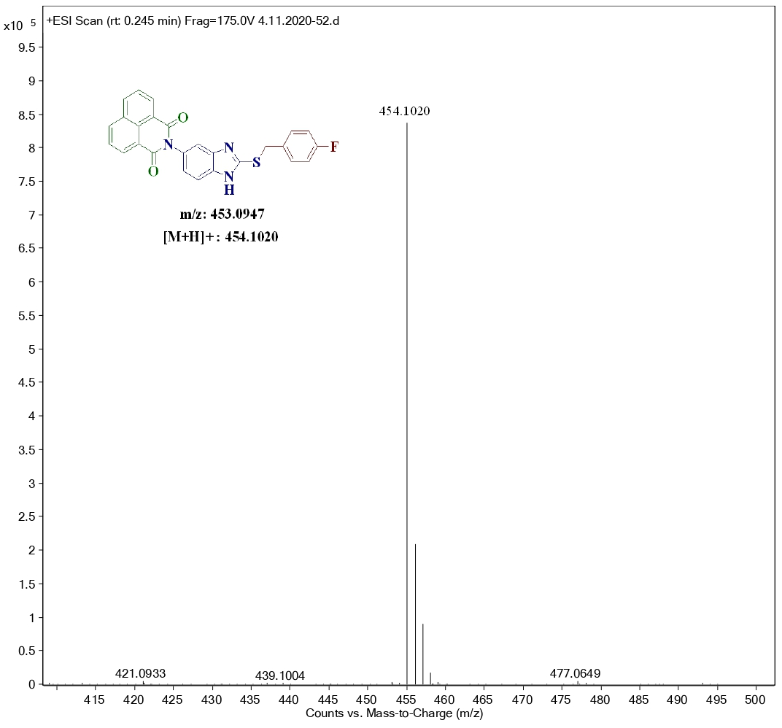

¹H-NMR Spectrum of compound 4n in DMSO-d₆ (400 MHz):
¹³C-NMR Spectrum of compound 4n in DMSO-d₆ (100 MHz):

Mass spectrum of compound 4n
¹H-NMR Spectrum of compound 4o in DMSO-d₆ (400 MHz):

¹³C-NMR Spectrum of compound 4o in DMSO-d₆ (100 MHz):
Mass spectrum of compound 4o
¹H-NMR Spectrum of compound 4p in DMSO-d₆ (400 MHz):

¹³C-NMR Spectrum of compound 4p in CDCl₃- DMSO-d₆ (100 MHz):

Mass spectrum of compound 4p
¹H-NMR Spectrum of compound 4q in DMSO-d₆ (400 MHz):

¹³C-NMR Spectrum of compound 4q in DMSO-d₆ (100 MHz):
Mass spectrum of compound 4q

¹H-NMR Spectrum of compound 4r in DMSO-d₆ (400 MHz):
¹³C-NMR Spectrum of compound 4r in CDCl₃- DMSO-d₆ (100 MHz):

Mass spectrum of compound 4r
¹H-NMR Spectrum of compound 4s in DMSO-d₆ (400 MHz):

¹³C-NMR Spectrum of compound 4s in DMSO-d₆ (100 MHz):
Mass spectrum of compound 4s
¹H-NMR Spectrum of compound 4t in DMSO-d₆ (400 MHz):

¹³C-NMR Spectrum of compound 4t in CDCl₃- DMSO-d₆ (100 MHz):
Mass spectrum of compound 4t

¹H-NMR Spectrum of compound 4u in DMSO-d₆ (400 MHz):
¹³C-NMR Spectrum of compound 4u in CDCl₃- DMSO-d₆ (100 MHz):

Mass spectrum of compound 4u
¹H-NMR Spectrum of compound 4v in DMSO-d₆ (400 MHz):

¹³C-NMR Spectrum of compound 4v in CDCl₃- DMSO-d₆ (100 MHz):
Mass spectrum of compound 4v
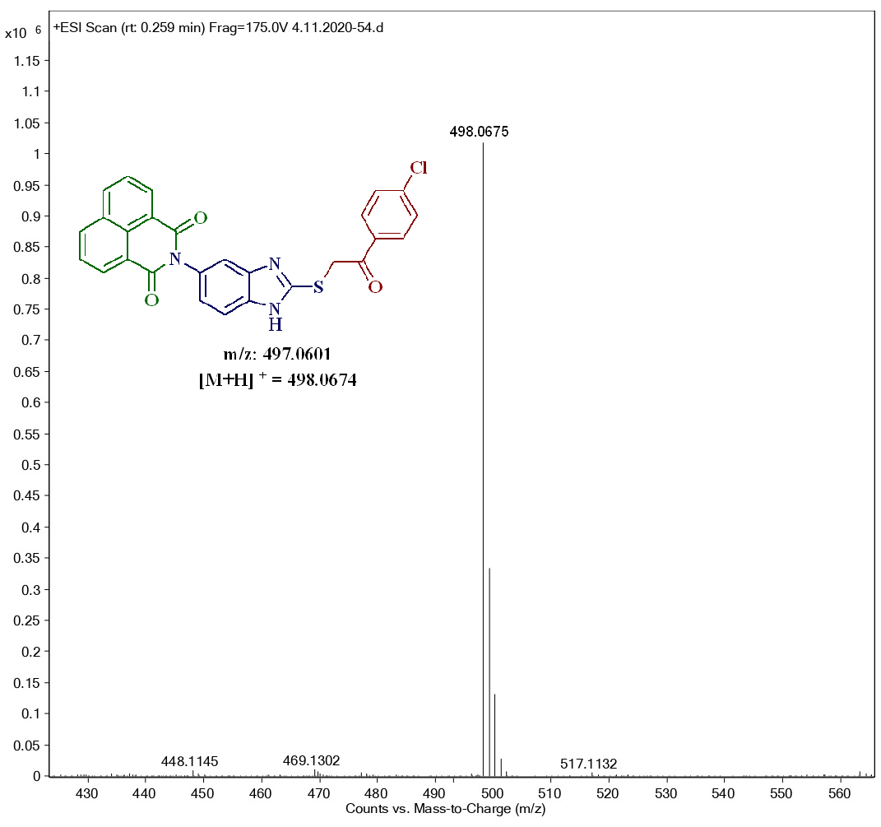

¹H-NMR Spectrum of compound 4w in DMSO-d₆ (400 MHz):
¹³C-NMR Spectrum of compound 4w in DMSO-d₆ (100 MHz):

Mass spectrum of compound 4w
¹H-NMR Spectrum of compound 5a in DMSO-d₆ (400 MHz):

¹³C-NMR Spectrum of compound 5a in DMSO-d₆ (100 MHz):
Mass spectrum of compound 5a

¹H-NMR Spectrum of compound 5b in DMSO-d₆ (400 MHz):

¹³C-NMR Spectrum of compound 5b in DMSO-d₆ (100 MHz):
Mass spectrum of compound 5b

¹H-NMR Spectrum of compound 5c in DMSO-d₆ (400 MHz):
¹³C-NMR Spectrum of compound 5c in CDCl₃-DMSO-d₆ (100 MHz):
Mass spectrum of compound 5c

¹H-NMR Spectrum of compound 5d in DMSO-d₆ (400 MHz):

¹³C-NMR Spectrum of compound 5d in CDCl₃-DMSO-d₆ (100 MHz):
Mass spectrum of compound 5d

¹H-NMR Spectrum of compound 5e in DMSO-d₆ (400 MHz):
¹³C-NMR Spectrum of compound 5e in DMSO-d₆ (100 MHz):

Mass spectrum of compound 5e
¹H-NMR Spectrum of compound 5f in DMSO-d₆ (400 MHz):

¹³C-NMR Spectrum of compound 5f in DMSO-d₆ (100 MHz):
Mass Spectrum of compound 5f
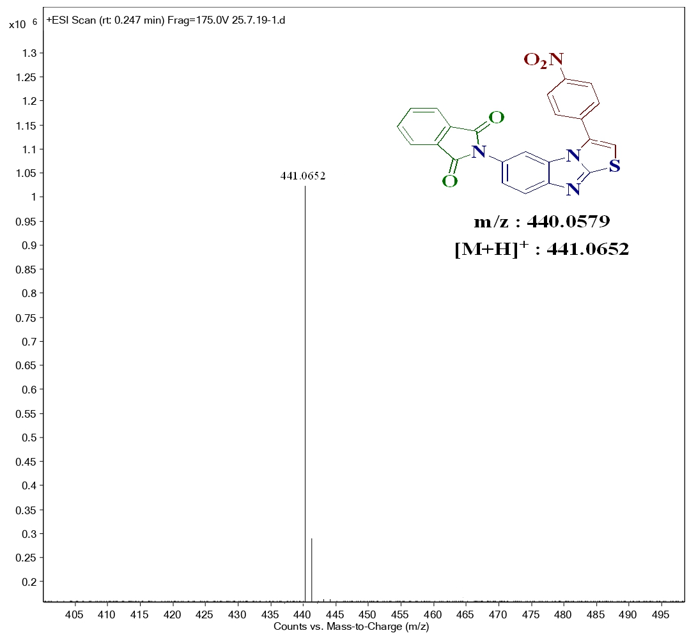
¹H-NMR Spectrum of compound 5g in DMSO-d₆ (400 MHz):

¹³C-NMR Spectrum of compound 5g in DMSO-d₆ (100 MHz):

Mass spectrum of compound 5g
¹H-NMR Spectrum of compound 5h in DMSO-d₆ (400MHz):
¹³C-NMR Spectrum of compound 5h in DMSO-d₆ (100MHz):

Mass spectrum of compound 5h

