Additional File 1
Aggresome Formation and Liquid-liquid Phase Separation Independently Induce Cytoplasmic Aggregation of TAR DNA-binding protein 43

Seiji Watanabe, Hidekazu Inami, Kotaro Oiwa, Yuri Murata, Shohei Sakai, Okiru Komine, Akira Sobue, Yohei Iguchi, Masahisa Katsuno, and Koji Yamanaka

Additional Figures

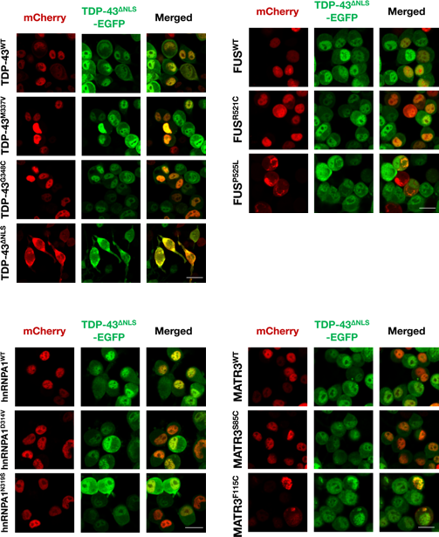

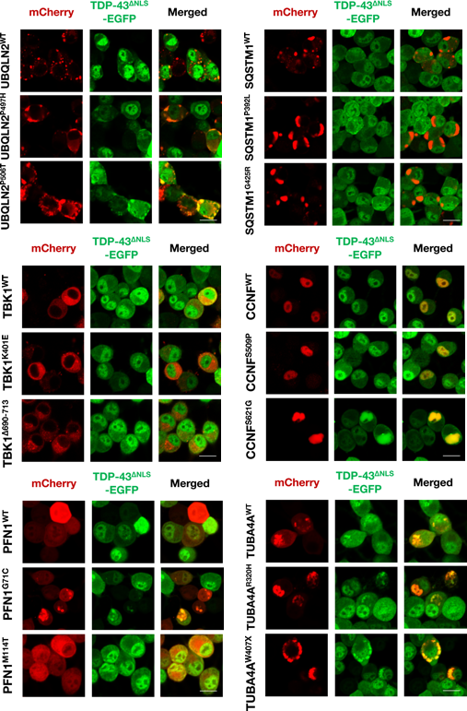
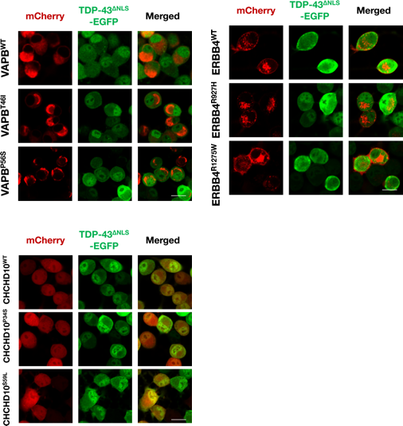
Additional Figure A1. Representative images of TDP-43^{∆NLS}-EGFP co-aggregation screening
The screening results are summurized in Table 1. Scale bars = 20 µm.

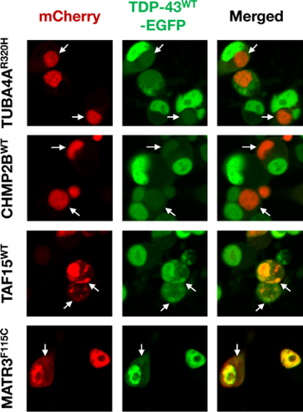
Additional Figure A2. Sequestration of nuclear TDP-43^{WT}-EGFP into the aggregates of ALS/FTLD-causative genes classified as Group 1
In addition to PFN1, UBQLN2, FUS and TIA1, all the other genes classified into Group 1 (TUBA4A, CHMP2B, TAF15, MATR3) also induced sequestration of TDP-43^{WT}-EGFP into their cytoplasmic aggregates. Arrows represent typical co-localization of the gene products labeled by mCherry (red) and TDP-43^{WT}-EGFP (green). Scale bar = 20 µm.

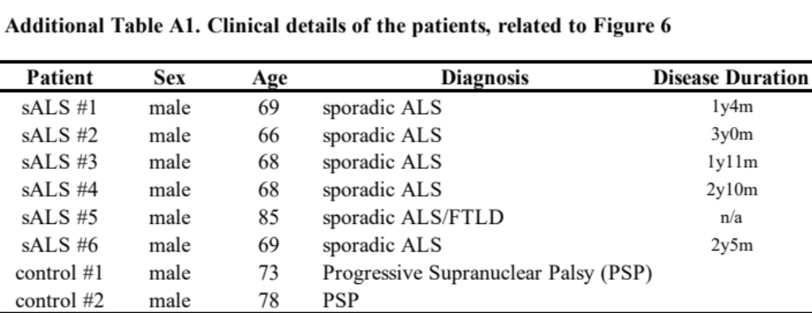
n/a: not available

