Supplementary Information (SI)

Highly Sensitive Colorimetric Detection of the Toxic Metal Cadmium in Rice Using a New TAA@AuNPs Sensor

Guona Li · Hongzhen Xie* · Xing Li*

School of Materials Science and Chemical Engineering, Ningbo University, Ningbo 315211, China
* Corresponding Author
E-mail addresses: lixing@nbu.edu.cn (X. Li); xiehongzhen@nbu.edu.cn (H. Xie)

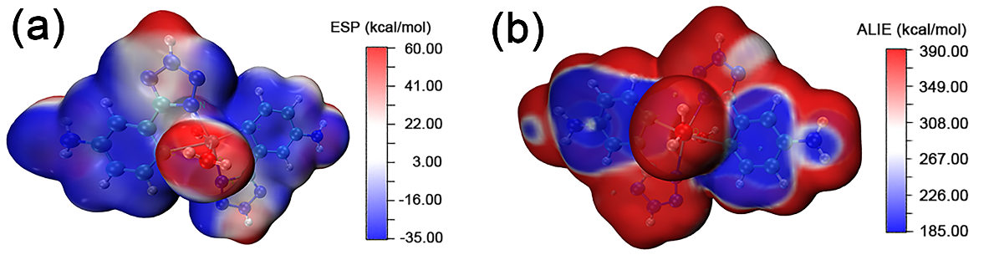
Fig. S1 (a) ESP of TAA-Cd²⁺. (b) ALIE of TAA-Cd²⁺.

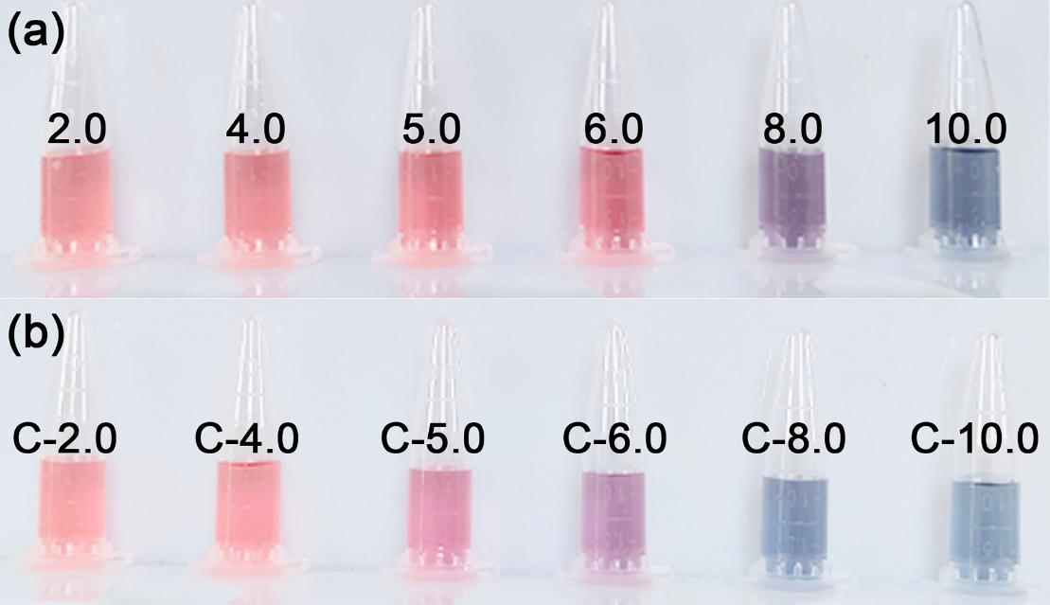
Fig. S2 Color response of TAA@AuNPs solution under the change of TAA concentration, (a) blank groups, (b) experimental groups.

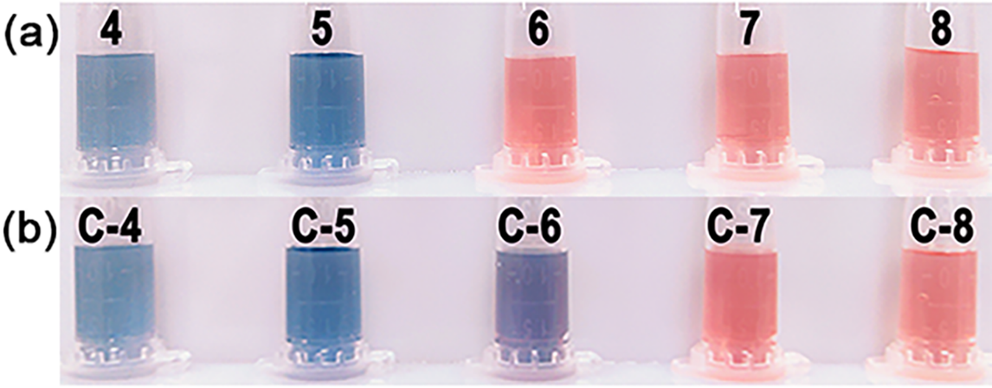
Fig. S3 Color response of TAA@AuNPs solution with TAA when the change of pH. (a) blank groups, (b) experimental groups.

