SUPPLEMENTARY MATERIALS
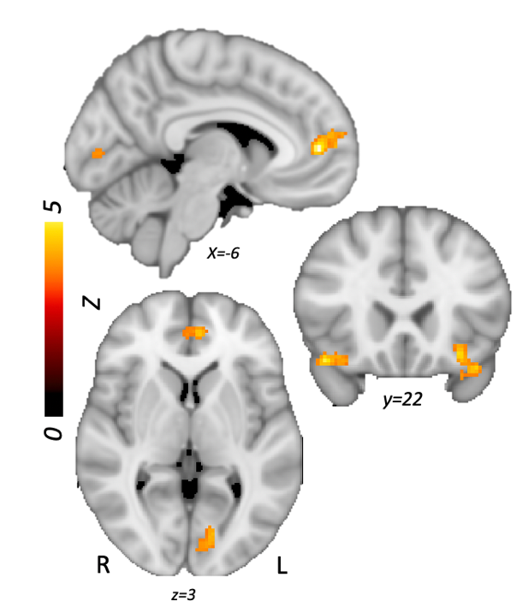
Supplementary figure 1: Error > No error models for trials students responded they were confident

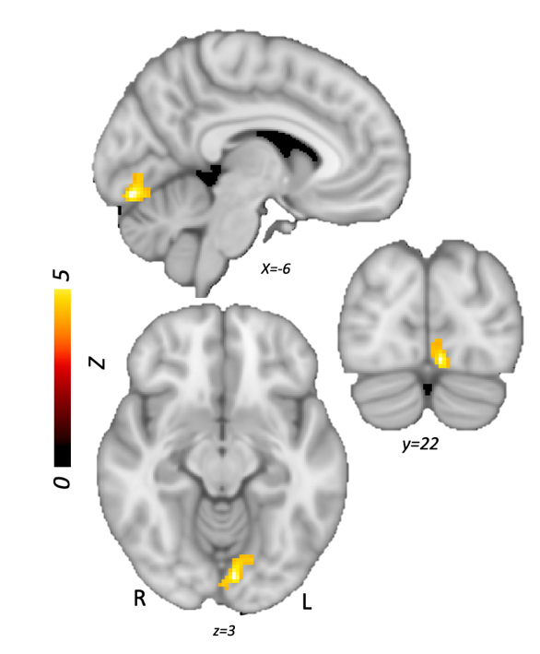’
Supplementary figure 2: Confident, accurate > Confident, inaccurate trials

Please view https://identifiers.org/neurovault.collection:13902 more information.
Corresponding findings are listed below:
- https://identifiers.org/neurovault.image:796396 (Figure 2)
- https://identifiers.org/neurovault.image:796399 (Figure 3)
- https://identifiers.org/neurovault.image:796400 (Figure 4)
- https://identifiers.org/neurovault.image:796401 (Figure 4)
- https://identifiers.org/neurovault.image:796402 (Figure 5)
- https://identifiers.org/neurovault.image:796397 (Supplementary figure 1
- https://identifiers.org/neurovault.image:796398 (Supplementary figure 2)

