Supplement Methods and results
1. Detailed measures of each CVH component
- Smoking status (UK Biobank Data-Fields: 20116, 2897, 2867 and 1259): CVH score of smoking were determined by self-reported use of cigarettes. Smoking score of CVH who are never and current smoker were calculated as 100 and 0 points, respectively. Former smokers with quitting smoking for at least 5 years were calculated as 75 points. Former smokers who have quit for less than 5 years but at least 1 year were calculated as 50 points. Former smokers with quitting smoking for less than 1 years were calculated as 25 points. All participants who lived with active indoor smoker in home were subtracted 20 points (unless score is 0).
- BMI (UK Biobank Data-Fields: 21001): Height and weight were measured in with standardized equipment and techniques. Body mass index (BMI) was calculated by body weight (kg) divided by height squared (m²). BMI score of CVH who BMI were <25.0 kg/m² were calculated as 100 points, ≥40.0 kg/m² were calculated as 0 points, 25.0-29.9kg/m² and 30.0-34.9kg/m², 35.0-39.9kg/m² were calculated as 75, 30 and 15 points, respectively.
- Physical activity (UK Biobank Data-Fields: 22038, 22039, 894 and 914): Physical activity level was determined using the Metabolic Equivalent Task minutes based on adopted items from the short International Physical Activity Questionnaire. CVH score of physical activity who reported zero minutes/week or more than 150 minutes/week of moderate and greater physical activity were calculated as 0 and 100 points, respectively. People with 120-149, 90-119, 60-89, 30-59, 1-29minutes/week of moderate and greater physical activity were calculated as 90, 80, 60, 40 and 20 points, respectively.
- Sleeping (UK Biobank Data-Fields: 1160): CVH score of sleeping were determined based on self-reported average hours of sleep per night. When average hours of sleep per night were <4h, CVH score of sleeping was calculated as 0 point. Scale 4-7h, 5-6h or ≥10h, 6-7h, 7-9h and 9-10h were calculated as 20, 40, 70, 100 and 90 points.
- Diet (UK Biobank Data-Fields: fruit [1309, 1319 and 100210], vegetables [1289 and 1299], red and processed meats [1349, 1369, 1379 and 1389], nuts [102430 and 102440], sweetened beverages [100160 and 100170], whole grains [1438, 1448, 1458 and 1468], sodium [1478], low fat [100920, 20106, 102090 and 102810]): CVH score of diet was determined by self-reported daily intake of a modified DASH-style eating pattern according to the data availability. After calculating the DASH diet score, the diet score of CVH were categorized as 100 and 0 points for those with a DASH diet score ≥25 and <14 points, respectively. Score 14-16.9, 17-19.9 and 20-24.9 DASH diet score were defined as 25, 50 and 75 points, respectively.
- Blood lipids (UK Biobank Data-Fields: 41202 and 41204): CVH score of Blood lipid was determined by non-HDL-cholesterol that calculated by plasma total cholesterol minus HDL-cholesterol. CVH score of Blood lipids who non-HDL-cholesterol were< 130 mg/dL were calculated as 100 points, ≥220 mg/dL were calculated as 0 points, 130-159 mg/dL and 160-189 mg/dL and 190-219 mg/dL were calculated as 60, 40 and 20 points, respectively.
- Blood glucose (UK Biobank Data-Fields:30740 and 20750): CVH score of blood glucose were determined by Fasting blood glucose (FBG) and casual hemoglobin A1c(HbA1c). If participants had no history of diabetes and FBG <100 (or HbA1c < 5.7), the score was calculated as 100 points. If participants were not diagnosed as diabetes and 100≤ FBG ≤125(or 5.7≤ HbA1c ≤6.4), the score was calculated as 60 points. If participants were diagnosed as diabetes with HbA1c <7, the score was calculated as 40 points. If participants were diagnosed as diabetes with HbA1c 7.0-7.9, the score was calculated as 30 points. If participants were diagnosed as diabetes with HbA1c 8.0-8.9, the score was calculated as 20 points. The score was calculated as 10 and 0 points when participants were diagnosed as diabetes with HbA1c 9.0-9.9 or HbA1c≥10.0, respectively.
- Blood pressure (UK Biobank Data-Fields: 30690, 30760, 6177 and 6153): CVH score of blood pressure were determined by systolic and diastolic blood pressure (SBP and DBP). CVH score of blood pressure was calculated as 100 points if SBP <120 /DBP <80. The score was calculated as 75 points if SBP=120-129mmHg/DBP <80mmHg, 50 points if SBP=130-139mmHg or DBP=80-89mmHg, 25 points if SBP=140-159mmHg /DBP=90-99mmHg, 0 point if SBP ≥160mmHg or DBP ≥100mmHg. Additionally, the score will be subtracted 20 points if participants were treated.
- Assessment of childhood adversity
Studies have shown that childhood adversity might affect CVH and incident depression/anxiety^{1,2}. We examined whether childhood adversity could affect the associations between CVH and incident depression/anxiety among 125,358 participants free of depression/anxiety at baseline with available childhood adversity data retrieved from follow-up survey. Five questions from the Childhood Trauma Screener representing physical neglect, emotional neglect, sexual abuse, physical abuse, and emotional abuse were used to assessed Childhood adversity. The Childhood Trauma Screener is a shortened version of the Childhood Trauma Questionnaire and is a cost-efficient, validated, and relatively reliable screening tool in large epidemiological studies^{3,4}: (1) felt hated by a family member (emotional abuse, Data-Field: 20487); (2) physically abused by family as a child (physical abuse, Data-Field: 20488); (3) felt loved as a child (emotional neglect, Data-Field: 20489); (4) sexually molested as a child (sexual abuse, Data-Field: 20490); and (5) someone to take to doctor when needed as a child (physical neglect, Data-Field: 20491).

For each question, there are five potential responses included never true, rarely true, sometimes true, often true, and very often true (1-5). If participants answered never true, rarely true, sometimes true, or often true, physical neglect was dichotomized as 1; if participants answered never true, rarely true, or sometimes true, emotional neglect was dichotomized as 1; if participants answered rarely true, sometimes true, often true, and very often true, sexual abuse, physical abuse, and emotional abuse were dichotomized as 1. The summary score of 5 items ranged from 0 to 5, with a higher score denoting more childhood adversities
References
1. Ege MA, Messias E, Thapa PB, Krain LP. Adverse childhood experiences and geriatric depression: results from the 2010 BRFSS. The American journal of geriatric psychiatry : official journal of the American Association for Geriatric Psychiatry. 2015;23(1):110-114.
2. Islam SJ, Hwan Kim J, Joseph E, et al. Association Between Early Trauma and Ideal Cardiovascular Health Among Black Americans: Results From the Morehouse-Emory Cardiovascular (MECA) Center for Health Equity. Circulation Cardiovascular quality and outcomes. 2021;14(9):e007904.
3. Grabe HJ, Schulz A, Schmidt CO, et al. [A brief instrument for the assessment of childhood abuse and neglect: the childhood trauma screener (CTS)]. Psychiatrische Praxis. 2012;39(3):109-115.
4. Glaesmer H, Brähler E. [Commentary to Grabe HJ et al.: a brief instrument for the assessment of childhood abuse and neglect: the Childhood Trauma Screener (CTS)]. Psychiatrische Praxis. 2013;40(1):21-22.

Table S1 Best-fitting parameters of the polygenic risk scores for depression, anxiety, and either disorder.
Outcomes | Full R-squares | Numbers of selected SNPs
Depression | 0.0556607 | 152817
Anxiety | 0.0123399 | 14193
Either disorder | 0.0489046 | 152587

Table S2 Associations of the odds of depression/anxiety and PHQ-4 score with polygenic risk scores at baseline ª
Trait | Coefficients | SE | R-squares (variance explained) | p-value
Prevalent depression | 0.4136 | 0.0068 | 0.0960 | <0.0001
Prevalent anxiety | 0.0371 | 0.0053 | 0.0772 | <0.0001
Prevalent either disorder | 0.3275 | 0.0049 | 0.0991 | <0.0001
PHQ-4 score | 0.2915 | 0.0031 | 0.0967 | <0.0001
a: Associations of depression, anxiety, and either disorder at baseline with polygenic risk scores were tested by logistic regression models; association of PHQ-4 score with polygenic risk score of depression and/or anxiety were tested by linear regression models. Models were adjusted for age, sex, ethnicity, BMI, smoking status, healthy alcohol intake, healthy physical activity, hypertension, diabetes, coronary heart disease, Townsend deprivation index and education.
Note: PHQ-4, Patient Health Questionnaire-4 questionnaire; Associations of polygenic risk scores with PHQ-4 score were tested with linear regression models and associations with the odds of either disorders, depression, and anxiety at baseline were tested with logistic regression models.

Table S3 Associations of the 7-itme CVH score with the odds of depression and/or anxiety symptoms at baseline (fully adjusted model) ª
CVH | Either disorder ^{b} |  |  | Depression |  |  | Anxiety
CVH | Odds ratio (95% CI) | p-value |  | Odds ratio (95% CI) | p-value |  | Odds ratio (95% CI) | p-value
7-item score ^{c} | 1.423(1.407-1.438) | <0.0001 |  | 1.452(1.431-1.474) | <0.0001 |  | 1.444(1.427-1.461) | <0.0001
a: Model adjusted for age, sex, hypertension, ethnicity, diabetes, coronary heart disease, Townsend deprivation index and education;
b: Either disorder: with depression and/or anxiety, based on PHQ-4 questionnaires and hospital records;
c: The score only based on based on the “Life’s Simple 7” components without the component of sleep health was calculated by summing the scores of diets, PA, smoking, BMI, blood lipids, blood glucose, and BP.
Note: Associations of CVH with the odds of either disorders, depression, and anxiety at baseline were tested with logistic regression models.

Table S4 Associations of the 7-itme CVH score at baseline with incident depression and/or anxiety symptoms at follow-up (fully adjusted model) ª
CVH | Either disorder ^{c} |  |  | Depression |  |  | Anxiety |  |  |  | Co-incident depression and anxiety ^{d}
CVH | Hazard ratio (95% CI) | p-value |  | Hazard ratio (95% CI) | p-value |  | Hazard ratio (95% CI) | p-value |  |  | Hazard ratio (95% CI) | p-value
7-item score ^{d} | 1.100(1.080-1.122) | <0.0001 |  | 1.174(1.148-1.202) | <0.0001 |  | 1.003(0.976-1.030) | 0.8548 |  |  | 1.081(1.034-1.130) | 0.0006
a: Model additionally adjusted for sex, hypertension, ethnicity, diabetes, coronary heart disease, Townsend deprivation index and education;
b: Either disorder: with depression and/or anxiety based on 7-year mental health survey and hospital records;
c: Co-incident depression and anxiety: with depression and anxiety based on 7-year mental health survey and hospital records;
d: The score only based on based on the “Life’s Simple 7” components without the component of sleep health was calculated by summing the scores of diets, PA, smoking, BMI, blood lipids, blood glucose, and BP.
Note: Associations of CVH with the incident either disorder, depression, and anxiety during the follow-up were tested with Cox proportional hazards models.

Table S5 Associations of components in CVH at baseline with incident depression and/or anxiety symptoms at follow-up (fully adjusted model) ª
Components | Incident either disorder ^{b} |  |  |  | Incident depression |  |  |  | Incident anxiety
Components | Hazard ratio (95% CI) | p-value |  | Hazard ratio (95% CI) |  | p-value |  | Hazard ratio (95% CI) |  | p-value
Blood lipids | 1.016(1.005-1.028) | 0.0051 |  | 1.027(1.013-1.042) |  | 0.0001 |  | 1.003(0.988-1.019) |  | 0.6715
Blood pressure | 0.920(0.907-0.934) | <0.0001 |  | 0.908(0.892-0.924) |  | <0.0001 |  | 0.934(0.915-0.953) |  | <0.0001
Blood glucose | 1.037(1.017-1.057) | 0.0002 |  | 1.056(1.031-1.081) |  | <0.0001 |  | 1.006(0.979-1.034) |  | 0.6525
BMI | 1.094(1.082-1.105) | <0.0001 |  | 1.148(1.133-1.162) |  | <0.0001 |  | 1.031(1.016-1.047) |  | <0.0001
Health assessments | 1.106(1.075-1.138) | <0.0001 |  | 1.200(1.159-1.242) |  | <0.0001 |  | 0.999(0.959-1.039) |  | 0.9455
Physical activity | 1.021(1.008-1.034) | 0.0019 |  | 1.024(1.011-1.043) |  | 0.0009 |  | 0.994(0.976-1.102) |  | 0.5143
Sleeping | 1.208(1.191-1.227) | <0.0001 |  | 1.253(1.230-1.275) |  | <0.0001 |  | 1.173(1.148-1.198) |  | <0.0001
Diet | 0.951(0.942-0.960) | <0.0001 |  | 0.960(0.949-0.972) |  | <0.0001 |  | 0.937(0.924-0.949) |  | <0.0001
Smoking | 1.105(1.095-1.115) | <0.0001 |  | 1.127(1.115-1.139) |  | <0.0001 |  | 1.076(1.062-1.090) |  | <0.0001
Health behaviors | 1.220(1.189-1.253) | <0.0001 |  | 1.315(1.274-1.356) |  | <0.0001 |  | 1.097(1.057-1.138) |  | <0.0001
Total | 1.149(1.128-1.170) | <0.0001 |  | 1.232(1.205-1.260) |  | <0.0001 |  | 1.045(1.018-1.072) |  | <0.0001
a: Model adjusted for age, sex, hypertension, ethnicity, diabetes, coronary heart disease, Townsend deprivation index and education;
b: Either disorder: with depression and/or anxiety based on 7-year mental health survey and hospital records.
Note: Associations of components in CVH at baseline with the incident either disorder, depression, and anxiety during the follow-up were tested with Cox proportional hazards models.

Table S6 Associations of CVH score with the PHQ-9 score, GDA-7 score and odds of depression and/or anxiety symptoms at 7-year follow-up (fully adjusted model) ª
CVH | PHQ-9-score |  |  | GDA-7 score |  |  | Either disorder ^{b} |  |  |  | Depression |  |  |  | Anxiety
CVH | Coefficients (SE) | p-value |  | Coefficients (SE) | p-value |  | Ncase/Ntotal | Odds ratio  (95% CI) | p-value |  | Ncase/Ntotal | Odds ratio  (95% CI) | p-value |  | Ncase/Ntotal | Odds ratio  (95% CI) | p-value
CVH score  (Continuous) | 0.4356(0.0107) | <0.0001 |  | 0.1369(0.0103) | <0.0001 |  | 8515/120974 | 1.316(1.281-1.353) | <0.0001 |  | 5808/129074 | 1.437(1.392-1.484) | <0.0001 |  | 4630/129074 | 1.166(1.124-1.210) | <0.0001
CVH score
(Quartiles)
Q4 | Ref |  |  | Ref |  |  | 1925/32815 | Ref |  |  | 1206/32815 | Ref |  |  | 1145/32815 | Ref
Q3 | 0.2531(0.0244) | <0.0001 |  | 0.1113(0.0233) | <0.0001 |  | 1810/31110 | 1.159(1.082-1.240) | 0.0206 |  | 1166/31110 | 1.228(1.129-1.336) | <0.0001 |  | 1057/31110 | 1.105(1.012-1.206) | 0.0258
Q2 | 0.4857(0.0250) | <0.0001 |  | 0.1602(0.0238) | <0.0001 |  | 2137/32881 | 1.379(1.289-1.476) | <0.0001 |  | 1450/32881 | 1.553(1.430-1.688) | <0.0001 |  | 1161/32881 | 1.201(1.099-1.313) | <0.0001
Q1 | 0.9238(0.0263) | <0.0001 |  | 0.2913(0.0251) | <0.0001 |  | 2640/32268 | 1.784(1.665-1.912) | <0.0001 |  | 1986/32268 | 2.216(2.039-2.408) | <0.0001 |  | 1267/32268 | 1.355(1.236-1.486) | <0.0001
a: Model adjusted for age, sex, hypertension, ethnicity, diabetes, coronary heart disease, Townsend deprivation index and education;
b: Either disorder: with depression and/or anxiety based on 7-year mental health survey and hospital records;
Note: PHQ-9, Patient Health Questionnaire-9 questionnaire; GAD-7, General Anxiety Disorder-7 questionnaire; Associations of CVH with PHQ-9 and GDA-7 score were tested with linear regression models and associations with the odds of either disorders, depression, and anxiety at 7-year follow-up were tested with logistic regression models.

Table S7 Interactions between CVH and age/sex in predicting incident depression/anxiety symptoms at follow-up (fully adjusted model) ª
P_{-interaction} | Either disorder ^{b} | Incident depression | Incident anxiety | Co-incident depression and anxiety
Sex | 0.1702 | 0.8289 | 0.1951 | 0.9117
Age (continuous variable) | 0.3291 | 0.5572 | 0.815 | 0.6058
a: Model adjusted for age, sex, hypertension, ethnicity, diabetes, coronary heart disease, Townsend deprivation index and education;
b: Either disorder: with depression and/or anxiety based on 7-year mental health survey and hospital records.

Table S8 Associations of CVH at baseline with incident depression/anxiety symptoms at follow-up among individuals with available follow-up survey data by additionally controlling for childhood adversity (fully adjusted model) ª
CVH | Either disorder ^{b} |  |  |  | Incident depression |  |  |  | Incident anxiety
CVH | Ncase/Ntotal | Hazard ratio (95% CI) | p-value |  | Ncase/Ntotal | Hazard ratio (95% CI) | p-value |  | Ncase/Ntotal | Hazard ratio (95% CI) | p-value
CVH score (Continuous) | 8230/125358 | 1.233(1.200-1.266) | <0.0001 |  | 5616/125358 | 1.339(1.297-1.382) | <0.0001 |  | 4474/125358 | 1.106(1.066-1.147) | <0.0001
CVH score (Quartiles)
Q1 | 1880/31976 | Ref |  |  | 1178/31976 | Ref |  |  | 1119/31976 | Ref
Q2 | 1746/30239 | 1.101(1030-1.1777) | 0.0045 |  | 1124/30239 | 1.162(1.069-1.263) | 0.0004 |  | 1015/30239 | 1.054(0.966-1.150) | 0.2394
Q3 | 2050/31822 | 1.261(1.180-1.347) | <0.0001 |  | 1395/31822 | 1.413(1.302-1.534) | <0.0001 |  | 1109/31822 | 1.107(1.013-1.209) | 0.0248
Q4 | 2554/31321 | 1.551(1.450-1.659) | <0.0001 |  | 1919/31321 | 1.899(1.750-2.061) | <0.0001 |  | 1231/31321 | 1.212(1.106-1.328) | <0.0001
a: Model adjusted for age, sex, hypertension, ethnicity, diabetes, coronary heart disease, education, Townsend deprivation index and childhood adversity;
b: Either disorder: with depression and/or anxiety based on 7-year mental health survey and hospital records;
Note: Associations of components in CVH at baseline with the incident either disorder, depression, and anxiety during the follow-up were tested with Cox proportional hazards models.

Table S9 Associations of CVH at baseline with incident depression/anxiety symptoms at follow-up among individuals with >2 years of follow-up (fully adjusted model) ª
CVH | Either disorder ^{b} |  |  |  | Incident depression |  |  |  | Incident anxiety
CVH | Ncase/Ntotal | Hazard ratio (95% CI) | p-value |  | Ncase/Ntotal | Hazard ratio (95% CI) | p-value |  | Ncase/Ntotal | Hazard ratio (95% CI) | p-value
CVH score (Continuous) | 17499/386684 | 1.147(1.126-1.168) | <0.0001 |  | 11700/386684 | 1.230(1.203-1.258) | <0.0001 |  | 8963/386684 | 1.044(1.017-1.071) | 0.0012
CVH score (Quartiles) | 3918/96671 | ref |  |  | 2482/96671 | ref |  |  | 2195/96671 | ref
Q1 | 3948/94760 | 1.080(1.032-1.130) | 0.0009 |  | 2554/94760 | 1.146(1.080-1.209) | <0.0001 |  | 2099/94760 | 1.002(0.942-1.065) | 0.9606
Q2 | 4462/98582 | 1.186(1.133-1.241) | <0.0001 |  | 2961/98582 | 1.302(1.230-1.378) | <0.0001 |  | 2283/98582 | 1.054(0.990-1.122) | 0.1012
Q3 | 5171/96671 | 1.374(1.311-1.440) | <0.0001 |  | 3703/96671 | 1.622(1.531-1.718) | <0.0001 |  | 2386/96671 | 1.111(1.041-1.186) | 0.0015
Q4 | 17499/386684 | 1.147(1.126-1.168) | <0.0001 |  | 11700/386684 | 1.230(1.203-1.258) | <0.0001 |  | 8963/386684 | 1.044(1.017-1.071) | 0.0012
a: Model adjusted for age, sex, hypertension, ethnicity, diabetes, coronary heart disease, Townsend deprivation index and education;
b: Either disorder: with depression and/or anxiety based on 7-year mental health survey and hospital records;
Note: Associations of components in CVH at baseline with the incident either disorder, depression, and anxiety during the follow-up were tested with Cox proportional hazards models.

Table S10 Joint associations of CVH score and polygenic risk score with the risks of depression and/or anxiety symptoms during follow-up (fully adjusted model) ª

Levels (quartile of CVH score & quartile of PRs) | Incident either disorder |  |  | Incident depression
Levels (quartile of CVH score & quartile of PRs) | HR (95%CI) | p-values |  | HR (95%CI) | p-values
Level 1 (Q4&Q1) | Ref |  |  | Ref
Level 2 (Q3&Q1) | 1.146(1.017-1.291) | 0.0255 |  | 1.116(0.945-1.318) | 0.1952
Level 3 (Q2&Q1) | 1.190(1.056-1.342) | 0.0044 |  | 1.298(1.103-1.528) | 0.0017
Level 4 (Q1&Q1) | 1.476(1.314-1.659) | <0.0001 |  | 1.921(1.648-2.238) | <0.0001
Level 5 (Q4&Q2) | 1.535(1.376-1.713) | <0.0001 |  | 1.745(1.508-2.020) | <0.0001
Level 6 (Q3&Q2) | 1.542(1.378-1.725) | <0.0001 |  | 1.895(1.634-2.198) | <0.0001
Level 7 (Q2&Q2) | 1.879(1.687-2.094) | <0.0001 |  | 2.107(1.820-2.439) | <0.0001
Level 8 (Q1&Q2) | 2.219(1.995-2.469) | <0.0001 |  | 2.728(2.367-3.144) | <0.0001
Level 9 (Q4&Q3) | 2.018(1.818-2.240) | <0.0001 |  | 2.425(2.110-2.786) | <0.0001
Level 10 (Q3&Q3) | 2.215(1.995-2.458) | <0.0001 |  | 2.771(2.412-3.184) | <0.0001
Level 11 (Q2&Q3) | 2.383(2.149-2.643) | <0.0001 |  | 3.225(2.814-3.695) | <0.0001
Level 12 (Q1&Q3) | 2.668(2.408-2.957) | <0.0001 |  | 4.016(3.513-4.592) | <0.0001
Level 13 (Q4&Q4) | 3.155(2.861-3.48) | <0.0001 |  | 4.030(3.537-4.591) | <0.0001
Level 14 (Q3&Q4) | 3.334(3.022-3.678) | <0.0001 |  | 4.599(4.038-5.237) | <0.0001
Level 15 (Q2&Q4) | 3.540(3.211-3.903) | <0.0001 |  | 5.151(4.528-5.859) | <0.0001
Level 16 (Q1&Q4) | 3.992(3.623-4.399) | <0.0001 |  | 6.126(5.391-6.962) | <0.0001
a: Model additionally adjusted for sex, hypertension, ethnicity, diabetes, coronary heart disease, Townsend deprivation index and education;
b: Either disorder: with depression and/or anxiety based on 7-year mental health survey and hospital records.
Note: Joint associations of CVH score and polygenic risk score with the incident either disorder and depression during the follow-up were tested with Cox proportional hazards models.

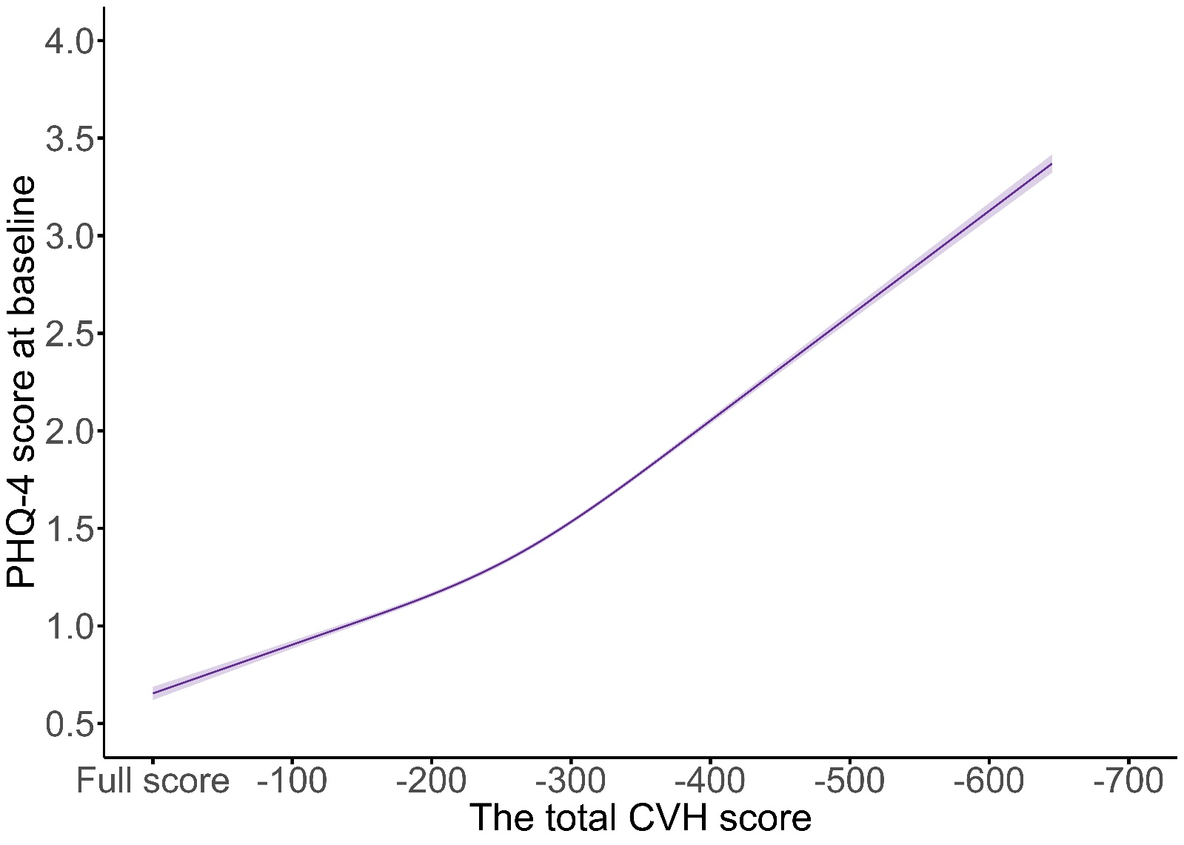
Figure S1. Graph of the best fitting models for relationships between CVH score and PHQ-4 score for 447,622 participants at baseline. Solid line: Point estimation; Shadows: Confidence limits; The restricted cubic spline regression model adjusted for age, sex, ethnicity (White, Black, Asian, and other), years of education (<10 years) and prevalent hypertension, CHD, Townsend deprivation index and diabetes (yes/no).
Note: CHD, coronary heart disease; Full-score =800 points; PHQ-4 = Patient Health Questionnaire-4 questionnaire

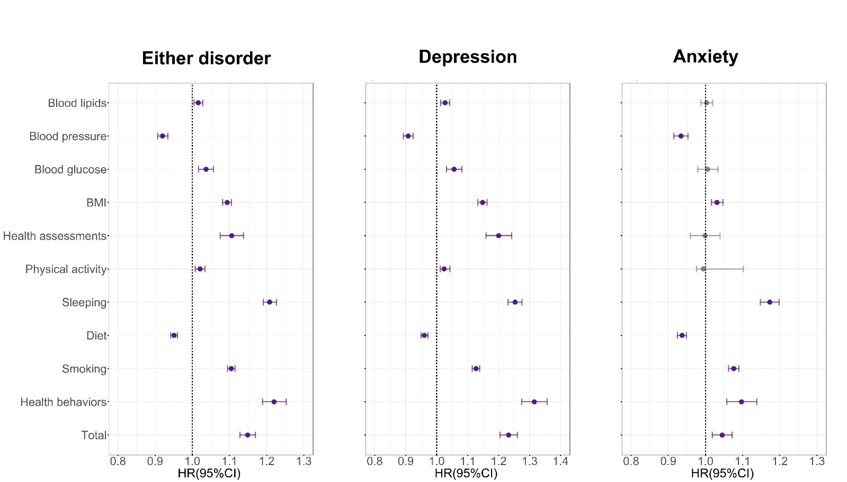
Figure S2. Prospective associations of CVH score at baseline with incident depression/anxiety at follow-up for the 338,394 participants with available data. Dots: Point estimate; Error bar: 95% confidence limits; Dash line: Reference line; Dots and error bars colored in purple are statistically significant, otherwise are colored in grey. Associations of CVH with the risk of either disorder, depression, and anxiety were tested with Cox proportional hazards models. Model adjusted for age, sex, ethnicity (White, Black, Asian, and other), years of education (<10 years) and prevalent hypertension, CHD, Townsend deprivation index and diabetes (yes/no). Point estimates and corresponding confidence intervals were shown in Table S5.
Note: CHD, coronary heart disease; HR, Hazard ratio; CI, confidence interval; Associations of components in CVH at baseline with the incident either disorder, depression, and anxiety during the follow-up were tested with Cox proportional hazards models.

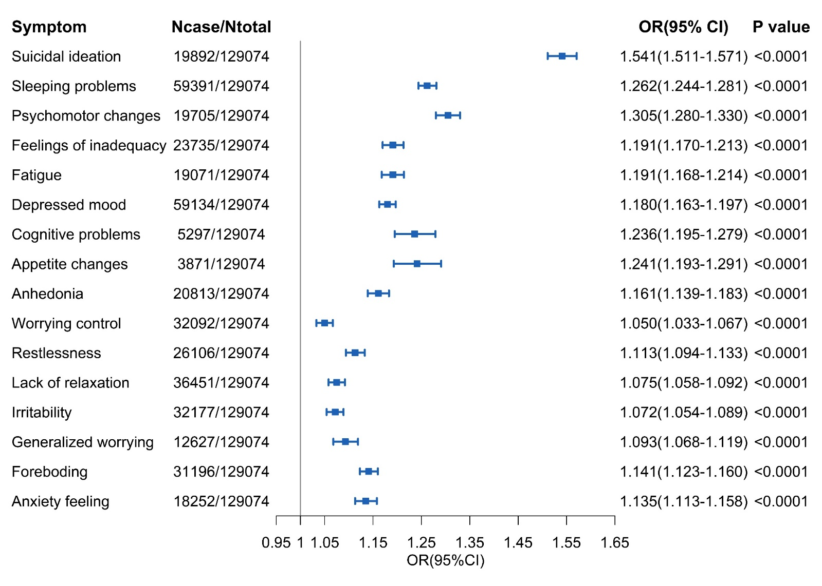
Figure S3. Prospective associations of CVH score at baseline with odds of depression/anxiety at 7-year survey for the 129,074 participants with available data. Boxs: Point estimate; Error bar: 95% confidence limits; Solid line: Reference line; Associations of CVH with the odds of either disorders, depression, and anxiety at 7-year survey were tested with logistic regression models. Model adjusted for age, sex, ethnicity (White, Black, Asian, and other), years of education (<10 years) and prevalent hypertension, CHD, Townsend deprivation index and diabetes (yes/no).
Note: CHD, coronary heart disease; OR, odds ratio; CI, confidence interval; Associations of CVH with the odds of depression/anxiety at 7-year follow-up for the 128,456 participants were tested with logistic regression models.

