Table 1 Optimization of model reaction in the synthesis of 1,4-DHPsª
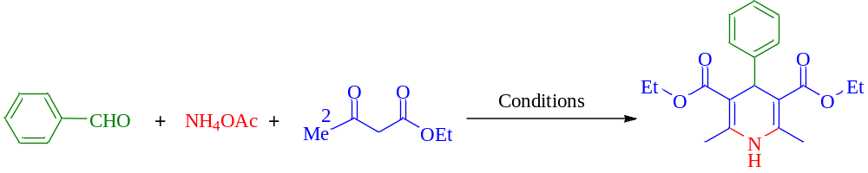
Entry | Catalyst | Solvent | Temperature (^{ο}C) | Time (min) | Catalyst (g) | Yield (%)^{b}
1 | - | Solvent-free | R.T. | 15 | - | -
2 | Magnetic CS-SA | Solvent-free | R.T. | 15 | 0.02 | 30
3 | Magnetic CS-SA | Toluene | R.T. | 15 | 0.02 | 35
4 | Magnetic CS-SA | THF | R.T. | 15 | 0.02 | 35
5 | Magnetic CS-SA | H₂O | R.T. | 15 | 0.02 | 40
6 | Magnetic CS-SA | CH₃CN | R.T. | 15 | 0.02 | 45
7 | Magnetic CS-SA | MeOH | R.T. | 15 | 0.02 | 50
8 | Magnetic CS-SA | EtOH | R.T. | 15 | 0.02 | 60
9 | Magnetic CS-SA | EtOH | R.T. | 15 | 0.03 | 75
10 | Magnetic CS-SA | EtOH | R.T. | 15 | 0.035 | 85
11 | Magnetic CS-SA | EtOH | 40 ^{ο}C | 15 | 0.035 | 92
12 | Magnetic CS-SA | EtOH | 50 ^{ο}C | 15 | 0.035 | 96
13 | Magnetic CS-SA | EtOH | 60 ^{ο}C | 15 | 0.04 | 96
14 | Magnetic CS-SA | EtOH | 50 ^{ο}C | 30 | 0.035 | 96
15 | Fe₃O₄ | EtOH | 50 ^{ο}C | 15 | 0.035 | 50
16 | CS | EtOH | 50 ^{ο}C | 15 | 0.035 | 45
17 | CS-SA | EtOH | 50 ^{ο}C | 15 | 0.035 | 84
ª Reaction conditions: Benzaldehyde (1 mmol), ammonium acetate (1 mmol), ethyl acetoacetate (2 mmol), under different conditions and 2 mL of each solvent.
^{b} Isolated yield.

Table 2 Optimization of model reaction for the synthesis of polyhidroquinolinesª
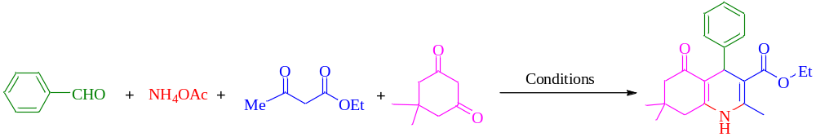
Entry | Catalyst | Solvent | Temperature (^{ο}C) | Time (min) | Catalyst (g) | Yield (%)^{b}
1 | - | Solvent-free | R.T. | 15 | - | -
2 | Magnetic CS-SA | Solvent-free | R.T. | 15 | 0.02 | 30
3 | Magnetic CS-SA | Toluene | R.T. | 15 | 0.02 | 33
4 | Magnetic CS-SA | THF | R.T. | 15 | 0.02 | 35
5 | Magnetic CS-SA | H₂O | R.T. | 15 | 0.02 | 40
6 | Magnetic CS-SA | CH₃CN | R.T. | 15 | 0.02 | 45
7 | Magnetic CS-SA | MeOH | R.T. | 15 | 0.02 | 52
8 | Magnetic CS-SA | EtOH | R.T. | 15 | 0.02 | 60
9 | Magnetic CS-SA | EtOH | R.T. | 15 | 0.03 | 75
10 | Magnetic CS-SA | EtOH | R.T. | 15 | 0.035 | 83
11 | Magnetic CS-SA | EtOH | 40 ^{ο}C | 15 | 0.035 | 86
12 | Magnetic CS-SA | EtOH | 50 ^{ο}C | 15 | 0.035 | 93
13 | Magnetic CS-SA | EtOH | 60 ^{ο}C | 15 | 0.04 | 92
14 | Magnetic CS-SA | EtOH | 50 ^{ο}C | 30 | 0.035 | 92
15 | Fe₃O₄ | EtOH | 50 ^{ο}C | 15 | 0.035 | 50
16 | CS | EtOH | 50 ^{ο}C | 15 | 0.035 | 45
17 | CS-SA | EtOH | 50 ^{ο}C | 15 | 0.035 | 80
ª Reaction conditions: Benzyaldehyde (1 mmol), ethyl acetoacetate (1 mmol), dimedone (1 mmol), ammonium acetate (1 mmol), under different conditions and 2 mL of each solvent.
^{b} Isolated yield.

Table 3 Formation of diverse derivatives of 1,4-dihydropyridine and polyhydroquinolineª
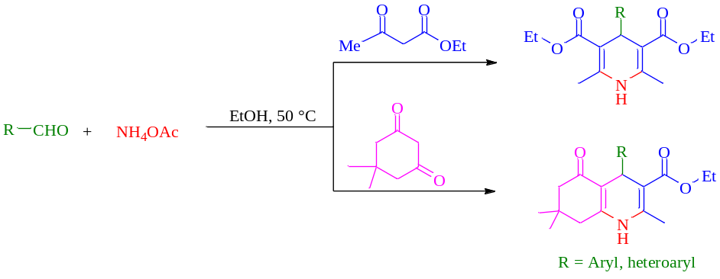
Entry | Aldehyde | Product | Time (min) | Yield (%)^{b} | M.p (°C)
 |  |  |  |  | Measured / Reported [Ref]
1 | 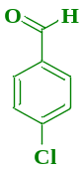  1a | 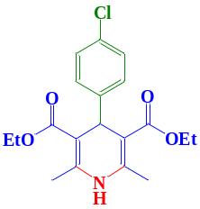  5a | 28 | 92 | 140-142 (144-146) [32]
2 | 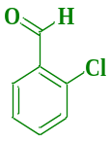  1b | 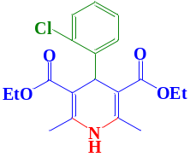  5b | 33 | 88 | 126-128 (127-128) [32]
3 | 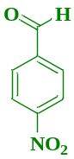  1c | 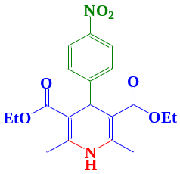  5c | 23 | 90 | 127-129 (127-129) [33]
4 | 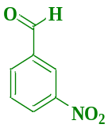  1d | 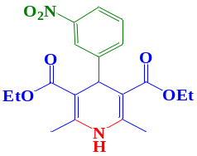  5d | 27 | 89 | 160-163 (163-164) [33]
5 | 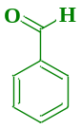  1e | 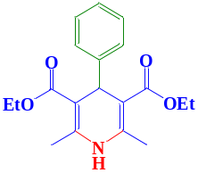  5e | 15 | 96 | 154-157 (157-158) [33]
6 | 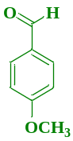  1f | 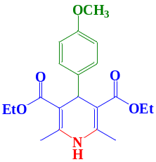  5f | 33 | 92 | 160-162 (160-162) [33]
7 | 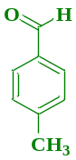  1g | 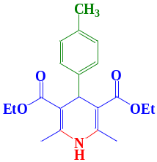  5g | 20 | 87 | 133-135 (134-135) [33]
8 | 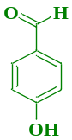  1h | 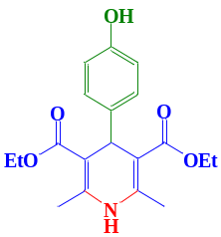  5h | 22 | 90 | 229-232 (230-231) [33]
9 | 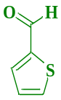  1i | 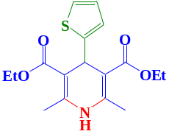  5i | 18 | 88 | 159-162 (160-162) [34]
10 | 1a | 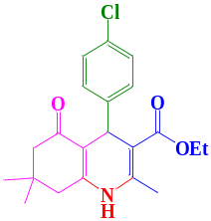  6a | 30 | 87 | 240-243 (242-244) [35]
11 | 1b | 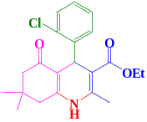  6b | 33 | 85 | 202-204 (200-203) [35]
12 | 1c | 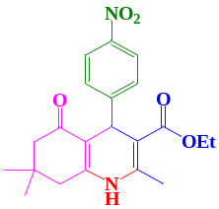  6c | 25 | 88 | 252-254 (252-254) [35]
13 | 1d | 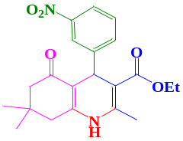  6d | 20 | 89 | 176-178 (176-178) [35]
14 | 1e | 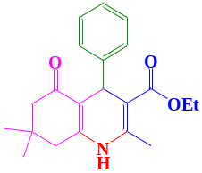  6e | 15 | 93 | 201-204 (202-203) [35]
15 | 1f | 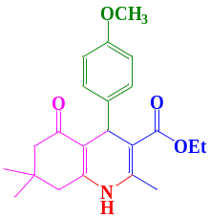  6f | 33 | 92 | 258-261 (259-261) [35]
16 | 1g | 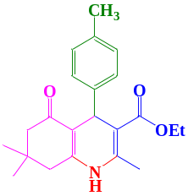  6g | 27 | 85 | 254-256 (255-256) [35]
17 | 1h | 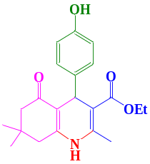  6h | 34 | 85 | 230-232 (231-233) [35]
18 | 1i | 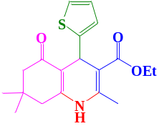  6i | 16 | 90 | 237-240 (238-240) [36]
^{a,b}1,4-DHPs (5a-5i): aldehyde (1 mmol), ethyl acetoacetate (2 mmol) and ammonium acetate (1mmol), EtOH (2 mL) and magnetic CS-SA (0.035 g).; polyhydroquinolines (6a-6i): aldehyde (1 mmol), ethyl acetoacetate (1 mmol), dimedone (1 mmol), ammonium acetate (1 mmol), EtOH (2 mL) and magnetic CS-SA (0.035 g).

